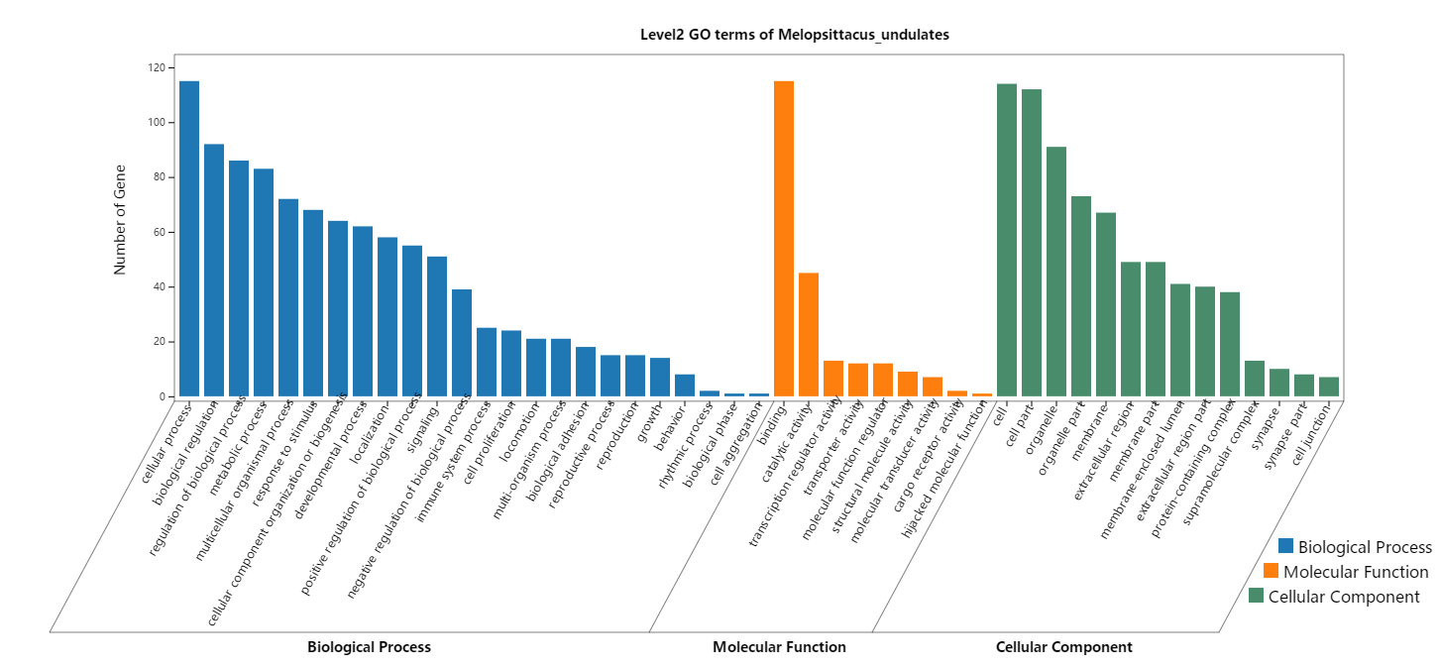
Fig. S2. GO enrichment analysis of 148 overlapping differentially expressed genes. Gene ontology (GO) terms illustrated changes in Biological Process (BP), Molecular Function (MF), and Cellular Component (CC) of overlapping mRNAs. Y-axis represents number of genes enriched in each GO term.

