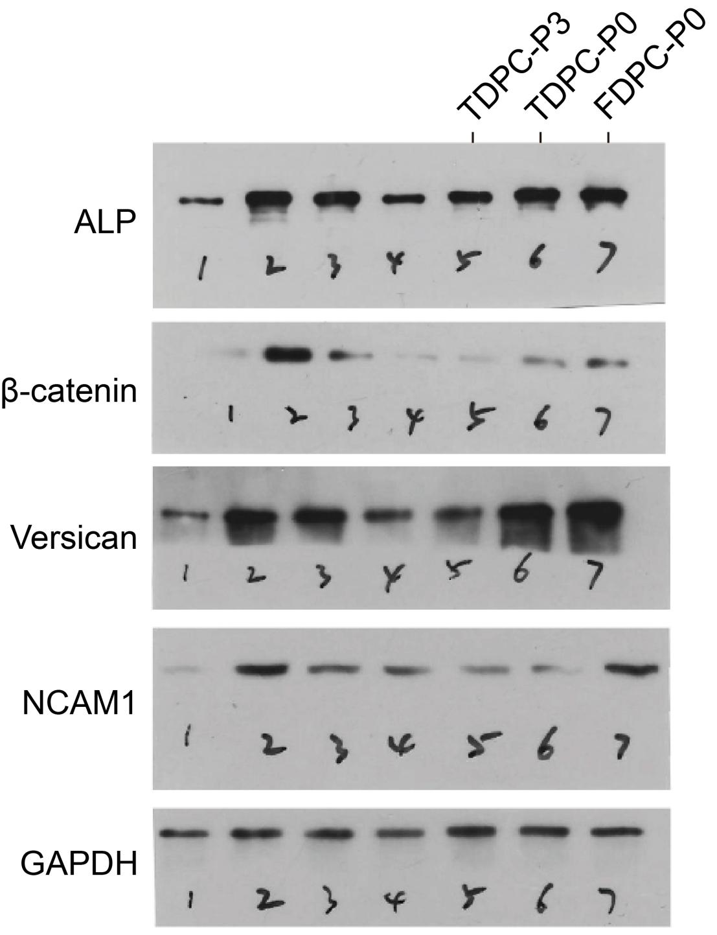
Fig. S4. Full-length blots/gels of western blot analysis of fDPC-P0, tDPC-P0, and tDPC-P3 with DP-specific markers ALP, β-catenin, versican, and NCAM1. (n = 3).

