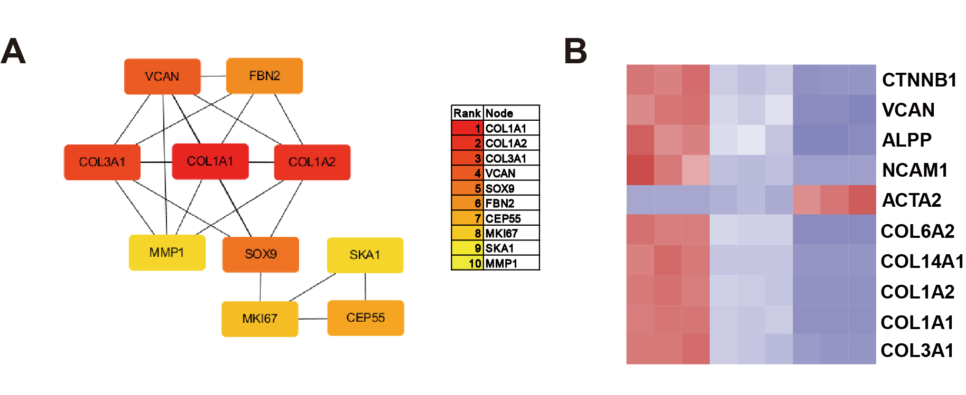
Fig. S3. Most significant module in protein-protein interaction network of overlapping genes. (A) COL1A1 was identified as hub gene with highest score (6.0) in most significant module of 148 overlapping differentially expressed genes. Relative score levels are colour-coded as colour key. (B) Heatmap showing relative expression levels of hub genes related to HF regeneration.

