Supplementary Information to Towards a business case for CO₂ mineralisation in the cement industry
Till Strunge^{1,2}, Phil Renforth¹, Mijndert Van der Spek¹
¹ Research Centre for Carbon Solutions, School of Engineering and Physical Sciences, Heriot-Watt University, Edinburgh EH14 4AS, UK.
² Institute for Advanced Sustainability Studies e.V., Potsdam, Germany
Content
Supplementary notes 2
Note 1: Market analysis for CO₂ mineralisation products 2
Note 2: Scope definition for the assessment 2
Note 3: SCM_{CCU} product specification 2
Note 4: Improved process designs for SCM production 3
Supplementary figures 4
Figure 1: Current demands in Europe and the potential supply from CO₂ carbonation 4
Figure 2: Flowsheets of proposed full-scale processes 5
Figure 3: Description of the techno-economic modelling sequence 6
Figure 4: Cost comparison of different process routes and mid scenario 7
Figure 5: Distribution of costs for the mid scenario 8
Figure 6: Material use for the mid scenario 9
Figure 7: Sensitivity analysis with the assumptions of the mid scenario 10
Figure 8: Probability density functions for the input parameters for the MonteCarlo simulations 11
Supplementary tables 12
Table 1: Literature review 12
Table 2: Review of carbonated material use in standardized cement products following EN 197-1 13
Table 3: Equations used for mass balance of feed recycling and separation in direct process. 13
Table 4: Used Equations for Density and viscosity 13
Table 5: Heat capacity calculation for different compounds 14
Table 6: Equations for electricity consumption 14
Table 7: Used equations for deriving the total direct costs 15
Table 8: Process assumptions 17
Table 9: Major equipment design assumptions 18
Table 10: Assumptions carbon footprint reduction assessment 18
Table 11: Capital Cost factor assumptions 19
Table 12: Operational cost factor assumptions 19
Table 13: Probability density function for Monte Carlo Simulation and Scenario definition 20
References 21

Supplementary notes

Note 1: Market analysis for CO₂ mineralisation products
The goal of implementing CO₂ mineralisation in a cement production facility is to capture most of the plant’s emissions while creating revenue through utilizing mineralisation products. Numerous small volume applications have been proposed to use carbonates (e.g., carbonates used as polymer additives or aggregate feedstock for land reclamation projects) ^{1,2}. While at first these seem promising, niche markets offer only limited CO₂ storage potential^{1,2} . Furthermore, these markets may not be located close to the cement production facilities³ or have stringent product specifications which can only be achieved at high costs¹. Carbonating only the process-inherent emissions of cement would lead to a production of magnesite/calcite and silica 60x and 200x respectively greater than the current European market (Supporting Figure 1). Therefore, targeting niche markets such as selling high purity MgCO₃ or CaCO₃ and silica will not significantly lower emissions from cement production. Instead, we consider the use of these materials in cement products.

Note 2: Scope definition for the assessment
A typical European cement production facility has an annual capacity of 1.4 Mt_{cement}/a emitting 850kt_{CO2}/a⁴, and will be used as the baseline in this work. We propose retrofitting post-combustion capture onto this facility to obtain a pure CO₂ gas with sufficient capacity to meet the demands of a mineralisation system that will be located on the same site. Suitable feedstock minerals occur in distinct locations in south and northern Europe⁵⁻⁷, we assume a transport of 1200 km via a combination of train, ship and truck, which would allow to transport mineral from a site in Norway (Region of Steinsvik) to northern Germany (Region of Hamburg), where multiple cement plants are located⁸. On the cement site the carbonation products are used as SCM to create blended cement. The stoichiometry of the carbonation reaction produces inert material (carbonates) with limited application in cementitious products². Unused material is stored in the limestone quarry, which are assumed to be located within 10 km of the cement production facility.

Note 3: SCM_{CCU} product specification
The by-product silica (SiO₂) from mineralisation reactions has been described of being of amorphous nature ^{6,9,10}. Amorphous silica is a widely accepted pozzolanic additive in cement production. When added to cement, amorphous silica and calcium hydroxide react to produce additional binding products (e.g. calcium silicate hydrates), leading to a comparable or increased strength to using cement alone ^{11,12}. Experimental work suggests that replacing 5-30wt% of cement using SiO₂ increases the strength by 5-38wt%, with the strongest effect observed at 10-15wt% replacement^{11,13-15}. Initial applicability studies by Benhelal, et al. ⁹ showed that a mixture of at least 5wt% carbonated material could be used as an SCM without significant workability (i.e. curing time, water demand) and strength changes of resulting mortars. As such, SCMs must have high concentrations of small particles of silica as the major drivers for the pozzolanic effect^{9,16}.Fine particle silica increases the surface area of the cement, resulting in increased water requirements or the need for a superplasticizer to maintain workability^{11,16}. Commonly, replacing cement with silica does not exceed 10wt%¹⁷. Some consider 25-35wt% replacement of ordinary Portland cement by carbonated material containing 30-50wt% silica to be the upper limit ^{18,19}. As cement is highly standardized we additionally reviewed the European standard for cement products EN-197¹² showing that all cement types currently allow the usage of up to 5wt% of SCM via CO₂ carbonation. Additionally, if carbonated minerals can be classified as natural pozzolanic material they could be used as SCM in certain blends (e.g. Portland pozzolana cement). That would allow displacements of up to 35wt% or 55wt% under current product specifications

Note 4: Improved process designs for SCM production
Two pathways for mineral carbonation are typically distinguished⁵: a direct pathway where ground minerals are reacted with CO₂ in a pressurized stirred tank using an aqueous slurry with additives such as NaCl and NaHCO₃ ^{10,20-23}; and an indirect pathway where alkaline earth metal oxides are first extracted and in a later step reacted with CO₂ to form carbonates. We selected one direct route and one indirect route to analyse and compare their technical and economic performance. We only selected processes that use natural minerals as feedstock: availability of some industrial wastes ²⁴ might be limited in the future due to more sustainable production processes, and heavy metal contents of some wastes might limit their usability ²⁵. Due to the availability of the mg-rich silicates in Europe⁵⁻⁷, we focused our assessment on olivine and serpentine-bearing feedstocks.
We compared multiple reaction conditions for the selection of a direct route which either use serpentine or olivine bearing rocks and differ in pressure, temperature, additive concentration as well as mechanical pre-treatment. Post-combustion CO₂ capture (i.e., MEA capture) was used to capture the CO₂ from the cement kiln flue gas^{20,22,26}. The minerals are first mined, crushed and grinded. In the case of serpentine, thermal pre-treatment was added to activate the minerals. In a next step the water and the additives sodium bicarbonate (NaHCO₃) and sodium chloride (NaCl) are added and the mixture is compressed to the desired reaction pressure (100-150 bar) and heated in a heat exchanger, recovering the heat from the reaction solution leaving the reactor. To create a process that resembles a large scale process as close as possible we implemented heat integration proposed by Ostovari, et al. ² and developed a separation process based on initial findings from Kremer and Wotruba ²⁷ that allows us to increase the efficiency of using mineral feedstock and to produce a SCM with alterable silica concentrations. As the reaction of the direct process are not complete, when leaving the reactor, we here propose a post-processing train; first, cyclones are used to partially separate unreacted mineral via gravity separation (<10-75µm, depending on the grinding size)^{21,22} from the reaction products (3-5µm for magnesite and <1µm for silica)²⁷. Unreacted mineral is cycled back into the process to increase the efficiency of utilizing the mineral feedstock. In a second step a share of the resulting product-rich slurry is fed into a classification centrifuge where magnesite and unreacted mineral are separated from the stream. Afterwards this silica-rich slurry is added to the residual slurry, producing a desired silica content. The SCM_{CCU} is dewatered using solid bowl centrifuges, which have been reported to be suitable for this task²⁸. The SCM_{CCU} is assumed to be used with a residual humidity of 10%. We selected the conditions with the lowest costs (Supplementary Figure 4) leading to a design for a direct carbonation route based on Eikeland, et al. ²² (Olivine, 100bar, 190°C).
As one of the most eminent indirect routes we selected a liquid/liquid approach, also referred to as the Nottingham route ^{2,29}. The Nottingham route uses serpentine as a feedstock, which is crushed, grinded and reacted in a three step aqueous process; First, an ammonium bisulphate solution (NH₄HSO_{4aq}) is used to extract magnesium oxide and impurities (e.g. iron oxide), leaving silica behind. Second, impurities are precipitated via pH adjustment. Third, the extracted magnesium reacts with ammonium bicarbonate (NH₄HCO₃_{aq}) which acts as CO₂ carrier and is recycled in an integrated post-combustion capture process, in which ammonia reacts with the flue gas-inherent CO₂ to ammonium bicarbonate. After the separation of the carbonation products, the remainder of the ammonium sulphate–rich solution ((NH₄)₂SO₄), is evaporated leading to a thermal treatment to recover NH₃ and NH₄HSO₄³⁰⁻³³. Here, a jacked mechanical scraped-surface crystallizer was selected to evaporate water from the additive (ammonium sulphate) and a indirect rotary drum dryer was selected for the thermal treatment. We selected this route for this study because it is possible to obtain high purity separated products² so no purification step has to be designed. We implemented heat integration proposed by Ostovari, et al. ² which also incorporates recompression of steam created during the additive regeneration. To produce the SCM_{CCU,} silica is separated from the slurry after the first reaction and blended with separated carbonates from the third reaction. Solid bowl centrifuges are again used for dewatering. Simplified flowsheets are³⁴ shown in Supplementary Figure 2.

Supplementary figures

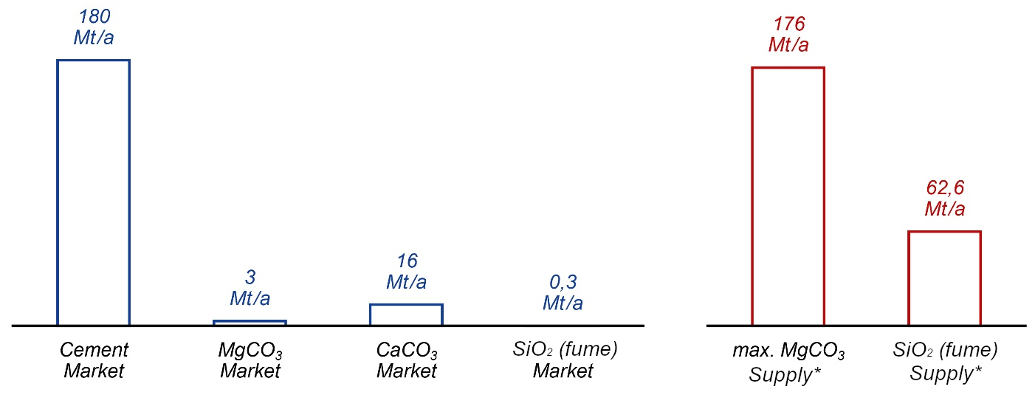
Figure 1: Current demands in Europe and the potential supply from CO₂ carbonation
; Left, market sizes for cement, magnesite (MgCO₃), calcium carbonate (CaCO₃) and silica fume (SiO₂)³⁵⁻³⁹. Right, supply from potential reaction of CO₂ with Mg₂SiO₄; *Stoichiometric reaction yield assumed, only process CO₂ emissions (60% of total emissions) taken into amount.

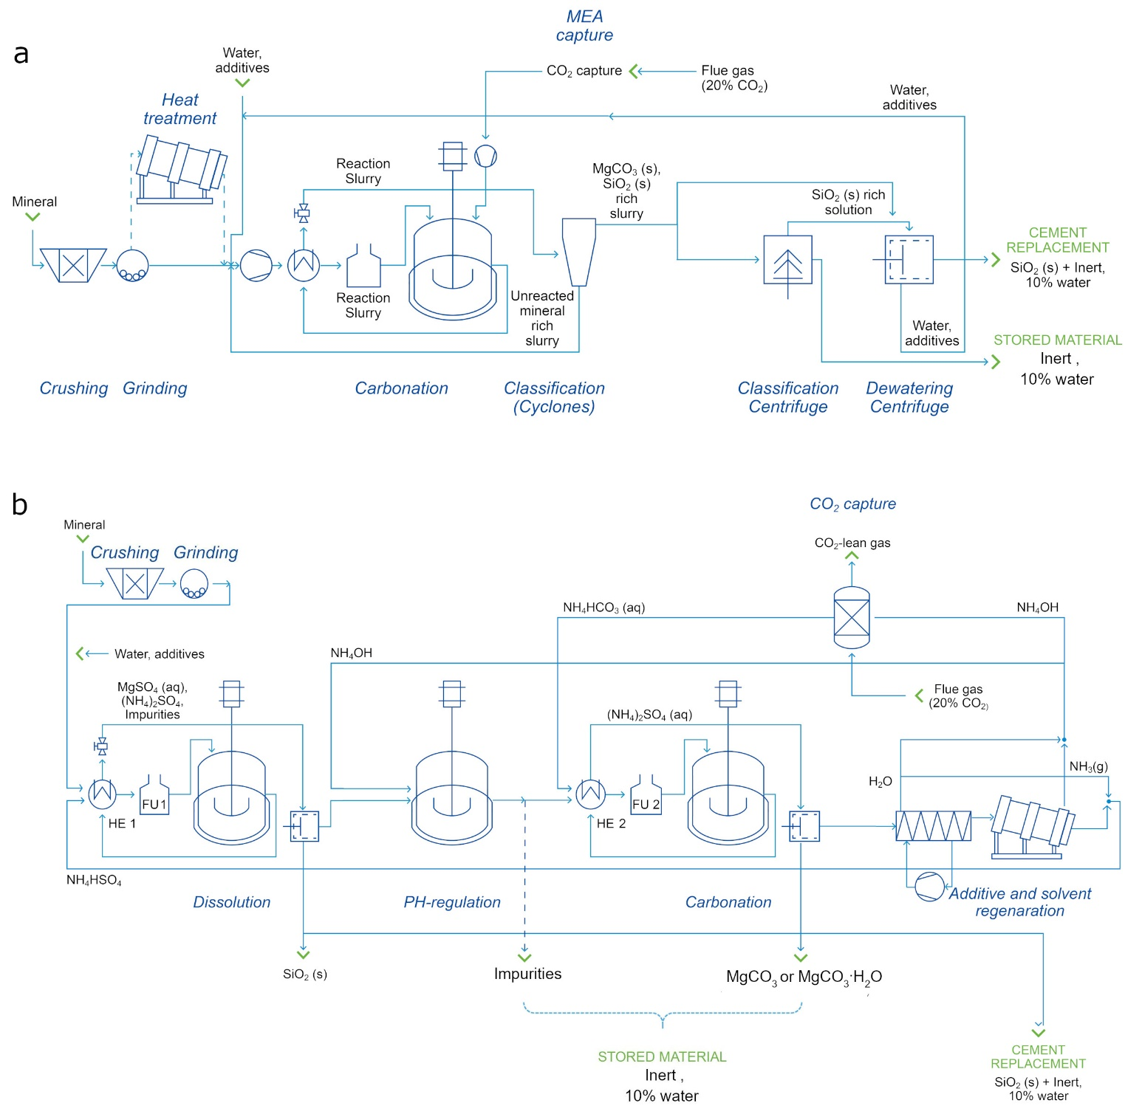
Figure 2: Flowsheets of proposed full-scale processes
. Panel a :direct process based on Eikeland, et al. ²² with heat treatment only being considered when serpentine is used as mineral feedstock. Panel b: indirect process
based on Wang and Maroto-Valer ³⁰ and Ostovari, et al. ².

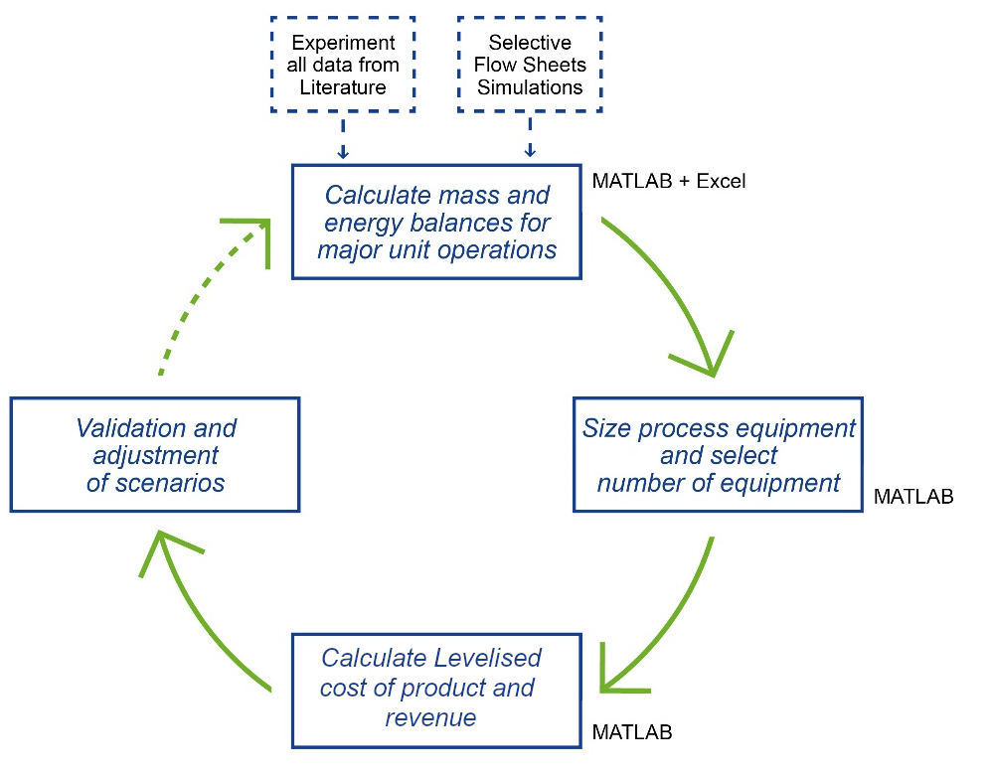
Figure 3: Description of the techno-economic modelling sequence
used in this study.

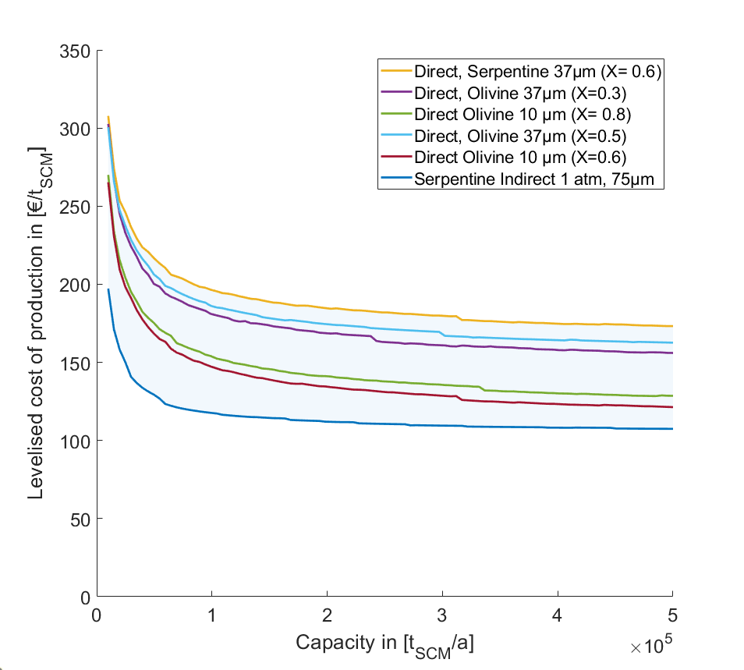
Figure 4: Cost comparison of different process routes and mid scenario
. Process assumptions are shown in Supplementary Table 8. Note all mentioning in the main article of “direct process” refers to “Direct, Olivine, 10µm (X=0.6)” and “indirect process” refers to “Indirect, Serpentine 75µ (X = 0.87)”.

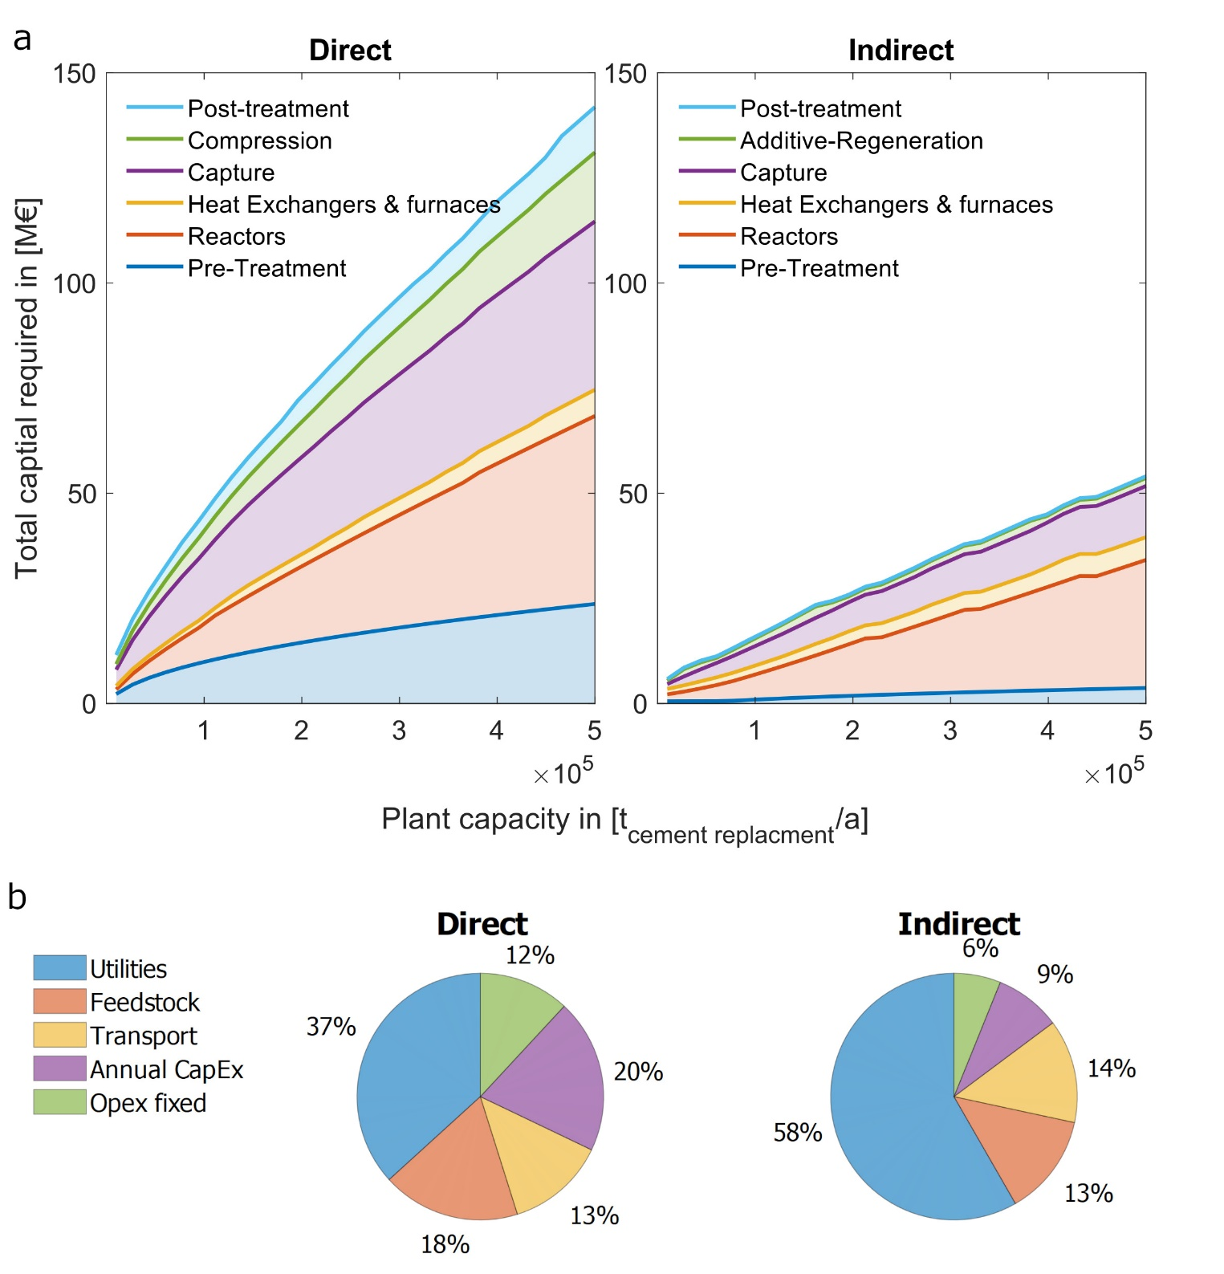
Figure 5: Distribution of costs for the mid scenario
: Panel a: Total capital required; Panel b: distribution of levelised costs of production.

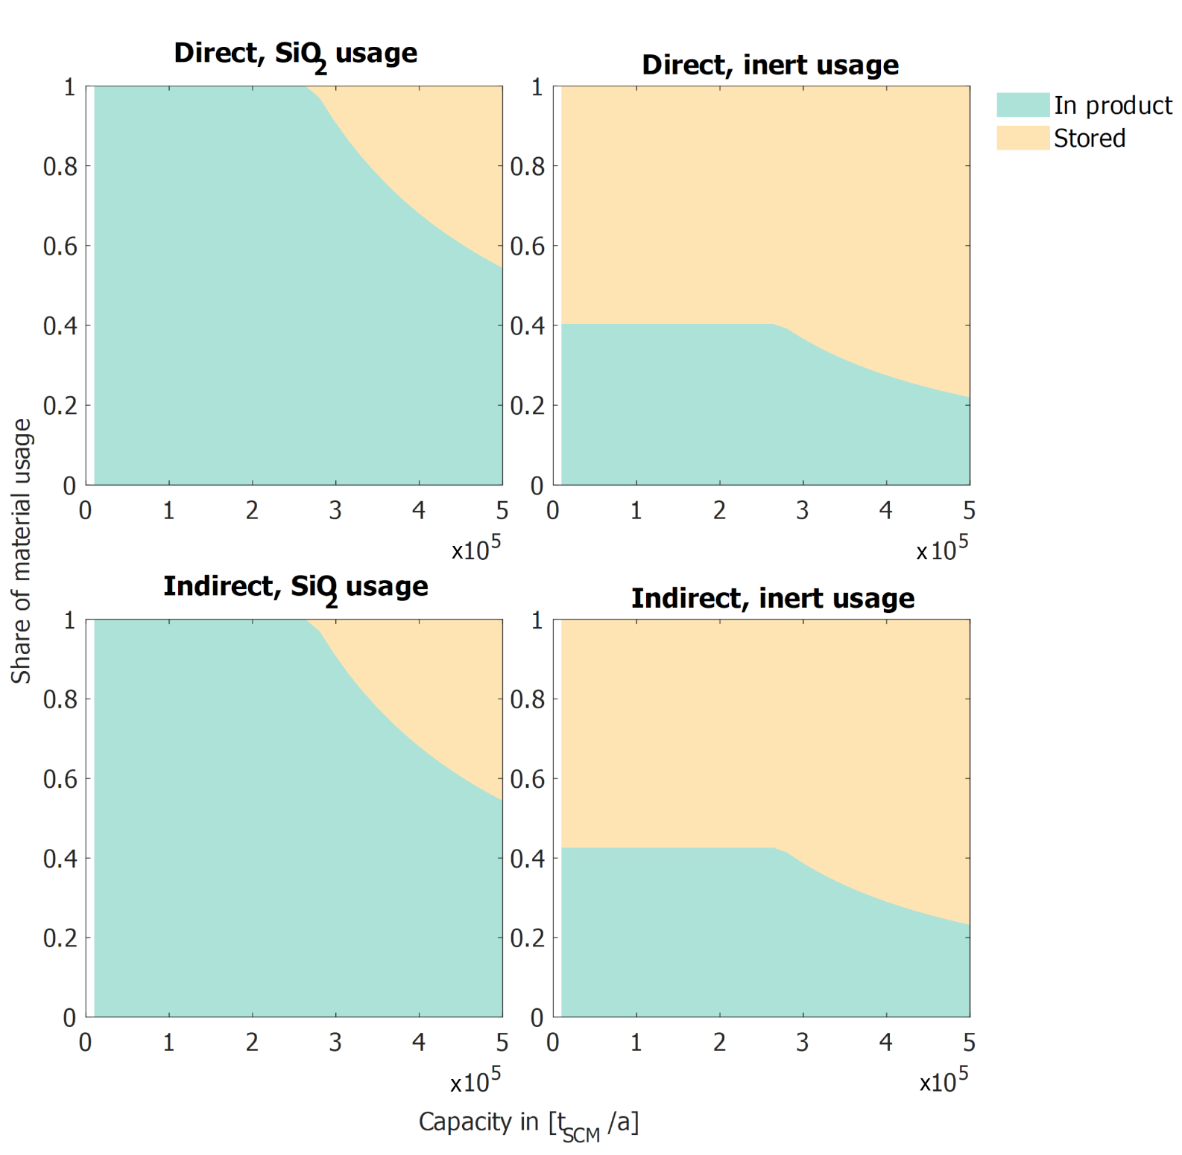
Figure 6: Material use for the mid scenario
. Note, this figure displays the amount of material being used for the production of SCM_{CCU} (In product) and how much material has to be stored (Stored). Inert material consists of unreacted mineral, carbonate and impurities.

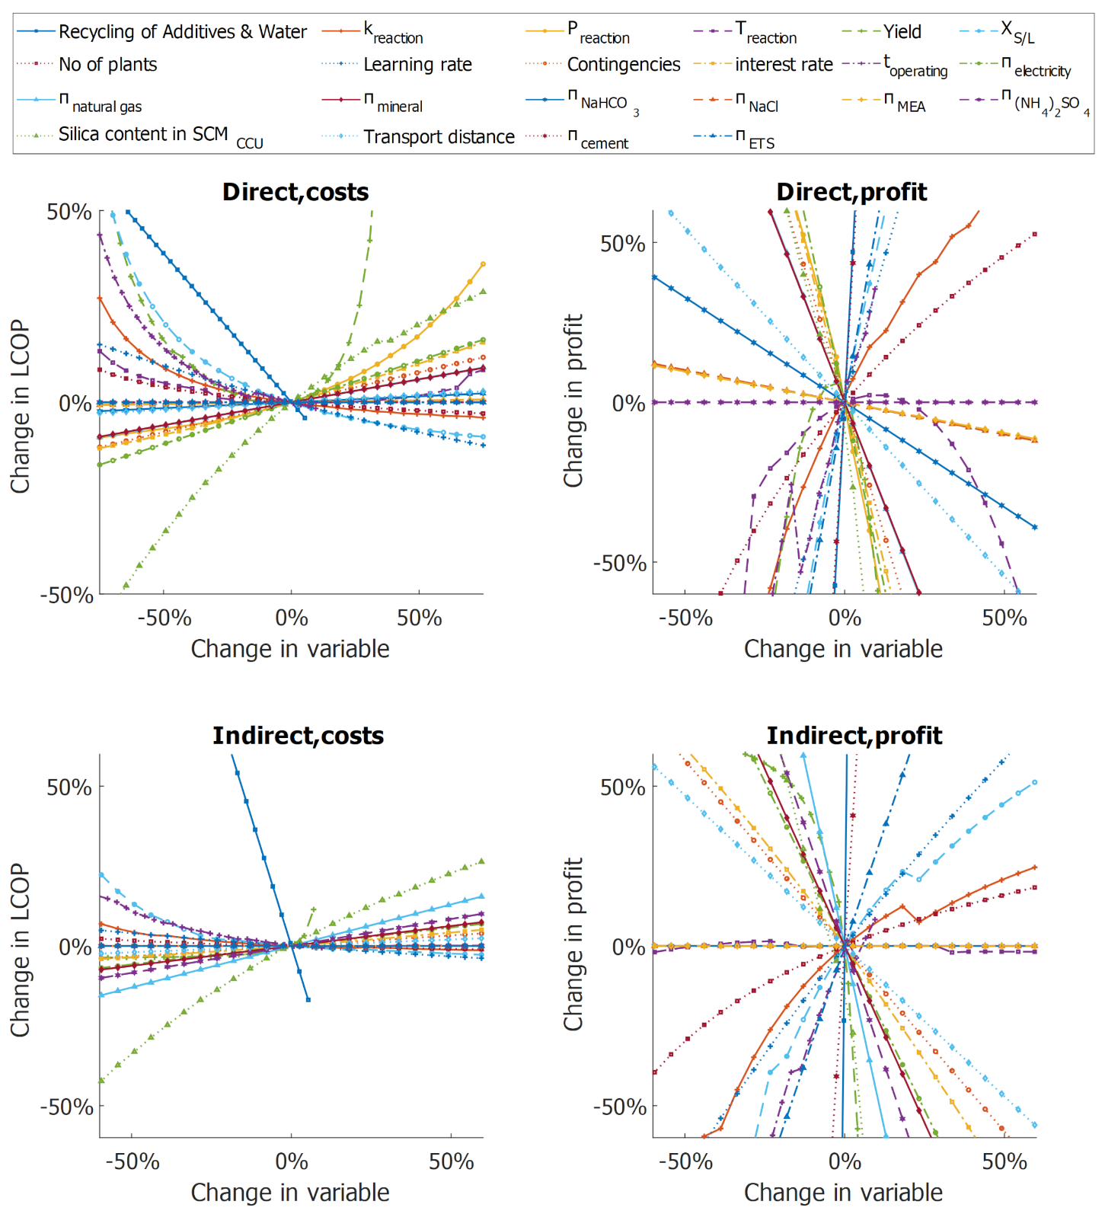
Figure 7: Sensitivity analysis with the assumptions of the mid scenario
and changing input parameters: additive recovery (Recycling of Additives & Water), reaction constant (k_{reaction}), reaction pressure (P_{reaction}), reaction temperature (T_{reaction}), reaction yield (Yield), solid-liquid ratio in reactor (X_{S/L}), Number of plants to reach NOAK (No of plants), Learning rate on CAPEX (Learning rate), combined process and project contingencies (Contingencies), interest rate on capital (i), operation hours per year (t_{operating}), electricity price (π_{electricity}), natural gas price (π_{natural gas}), mineral price (π_{mineral}), Sodium bicarbonate price (π_{NaHCO3}), Sodium chloride price (π_{NaCl}), monoethanolamine price (π_{MEA}), Ammonium sulphate price (π_{(NH4)2SO4}) , content of SiO₂ in product (Silica content in SCM_{CCU}), distance of feedstock minerals (Transport distance), cement price (π_{cement}), ETS price (π_{ETS}). Note that only one factor is changed at a time even when related (e.g. an increase in pressure does not change the yield). Hence, for the Monte Carlo Simulations only the reaction constant is used to cover the reaction conditions (see “Sensitive factors to lower costs” in the main article).

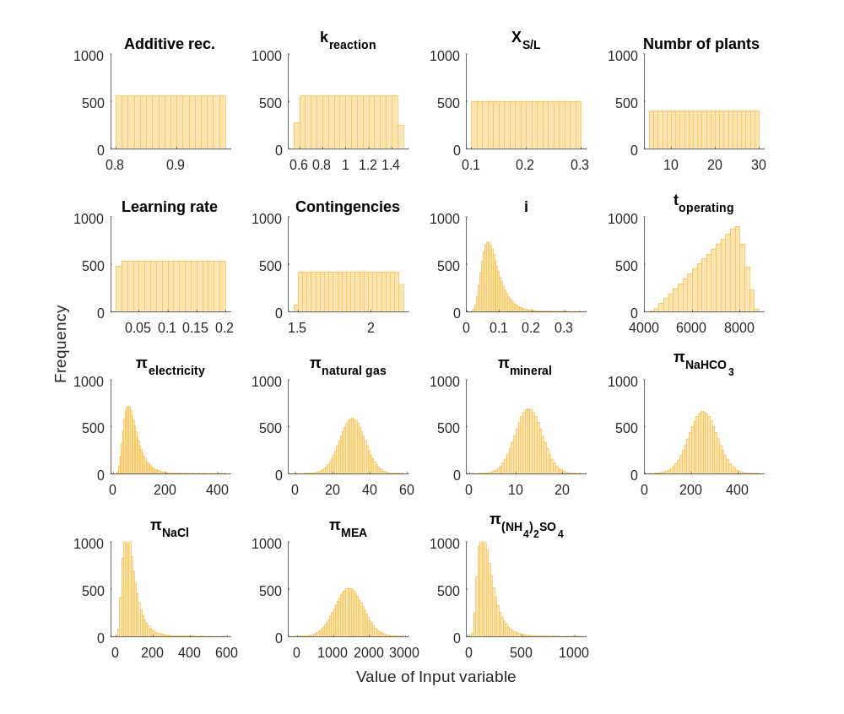
Figure 8: Probability density functions for the input parameters for the MonteCarlo simulations
using 10,000 runs: additive recovery (Additive Rec.), reaction constant (k_{reaction}), solid-liquid ratio in reactor (X_{S/L}), Number of plants to reach NOAK (No of plants), Learning rate on CAPEX (Learning rate), combined process and project contingencies (Contingencies), interest rate on capital (i), operation hours per year (t_{operating}), electricity price (π_{electricity}), natural gas price (π_{natural gas}), mineral price (π_{mineral}), Sodium bicarbonate price (π_{NaHCO3}), Sodium chloride price (π_{NaCl}), monoethanolamine price (π_{MEA}), Ammonium sulphate price (π_{(NH4)2SO4}).

Supplementary tables
Table 1: Literature review
of existing economic assessments in the field of CO₂ carbonation
Author | Costs | Unit | Comment | Feedstock
Sanna, et al. ⁵ | 44-264* | €/ t_{CO2, sequestered} | / | mg -silicates
Hitch and Dipple ⁴⁰ | 73*⁺ | €/ t_{CO2, sequestered} | direct | mg -silicates
IEA GHG 2000 | 95* | €/ t_{CO2, avoided} | direct | mg-silicate
IEA GHG 2000 | >150* | €/ t_{CO2, avoided} | indirect | mg-silicate
Naraharisetti, et al. ⁴¹ | 410*# | €/ t_{CO2, avoided} | direct | olivine
Naraharisetti, et al. ⁴¹ | 443*# | €/ t_{CO2, avoided} | direct | olivine
W.K. O’Connor and L.R. Penner ²¹ | 65* | €/ t_{CO2, avoided} | direct | olivine
Naraharisetti, et al. ⁴¹ | 302*# | €/ t_{CO2, avoided} | direct | serpentine
W.K. O’Connor and L.R. Penner ²¹ | 258* | €/ t_{CO2, avoided} | direct | serpentine
Sanna, et al. ¹ | 16-75*⁺ | €/ t_{CO2, sequestered} | post processing only | serpentine
Naraharisetti, et al. ⁴¹ | 349*# | €/ t_{CO2, avoided} | direct | serpentine
Huijgen, et al. ⁴² | 77 | €/ t_{CO2, avoided} | direct | steel slag
Katsuyama, et al. ⁴³ | 128-284* | €/ t_{CaCO3} | / | waste cement
Iizuka, et al. ⁴⁴ | 25*⁺⁺ | €/ t_{CO2, avoided} | indirect | waste cement
Naraharisetti, et al. ⁴¹ | 304*# | €/ t_{CO2, avoided} | direct | wollastonite
W.K. O’Connor and L.R. Penner ²¹ | 93* | €/ t_{CO2, avoided} | direct | wollastonite
Huijgen, et al. ⁴² | 102 | €/ t_{CO2, avoided} | direct | wollastonite
Kakizawa et al 2001 | 57*⁺⁺ | €/ t_{CO2, avoided} | indirect | wollastonite
Pérez-Fortes, et al. ⁴⁵ | M65.5§ | €/ t_{CO2, sequestered} | direct | fly ash
Mehleri, et al. ⁴⁶ | 228 | €/ t_{CO2, avoided} | direct | fly ash
Pedraza, et al. ⁴⁷ | 33-39* | €/ t_{CO2, sequestered} | direct | Cement kiln dust
* Currency adapted to €
# Cost of CO₂ capture included
⁺ Only operational expenditures assessed
§ Only capital expenditures assessed
⁺⁺ Only operational expenditures in the form of power generation assessed and revenue from CaCO₃ included.

Table 2: Review of carbonated material use in standardized cement products following EN 197-1
¹².* Carbonated material has to be acknowledged as a natural pozzolan and must exhibit a silica content of at least 25 wt%.
Description |  | Max SCM_{CCU} allowance in current standard
CEM I | Portland cement | 5%
CEM II | Portland-slag cement | 5%
CEM II | Portland-silica fume cement | 5%
CEM II | Portland pozzolana cement | 20-35%*
CEM II | Portland-fly ash cement | 5%
CEM II | Portland burnt shale cement | 5%
CEM II | Portland limestone cement | 5%
CEM II | Portland composite cement | 20-35%*
CEM III | Blast furnace cement | 5%
CEM IV | Pozzolanic cement | 35-55%*
CEM V | Composite cement | 30-50%*

Table 3: Equations used for mass balance of feed recycling and separation in direct process.
Use | Formula
Recycling unreacted mineral, direct aqueous process
  $${\dot{m}}_{Mg2SiO4,theo}= \frac{{\dot{m}}_{CO2,reacted}}{M_{CO2}}*\frac{ν_{Mg2SiO4}}{ν_{CO2}}*M_{Mg2SiO4}$$
  $${\dot{m}}_{Mg2SiO4,real}={\dot{m}}_{Mg2SiO42,theo}*\frac{1}{Yield}-{\dot{m}}_{Mg2SiO42,theo}*\left(\frac{1}{Yield}*\left(1-Yield\right)*recovery factor\right)$$
Split of stream for classification centrifuge
  $$z =\frac{1-\left(\frac{1-x}{x}\right)*\left(\frac{y}{1-y}\right)+\left(\frac{1-y}{y}\right)-\left(\frac{1-x}{x}\right)}{1+\left(\frac{1-y}{y}\right)}$$  $$x = content of SiO_{2}in final product$$  $$y = content of SiO_{2}in cyclone output$$  $$z = split of stream fed to classification centrifuge$$ | Eq. 1

Table 4: Used Equations for Density and viscosity
Description | Equation | Reference
Density slurry | $$ρ_{slurry}=\frac{100}{\left(\frac{X_{solid, liquid}}{ρ_{solid}*1000}\right)+\left(\frac{100-X_{solid, liquid}}{ρ_{H2O}*1000}\right)}$$ | Shashi ⁴⁸
Viscosity slurry | $$υ_{slurry}= υ_{H_{2}O}*\left(1+2.5*V_{fraction}+10.06*{V_{fraction}}^{2}*0.00273*\exp\left(16.6*V_{fraction}\right)\right)$$ | Shashi ⁴⁸
Density ABS_{(aq)} | $$ρ_{ABS\left(aq\right)}=0.99671 + \left(0.604706*{10}^{-1}\right)* c_{ABS} - \left(0.108981*{10}^{-2}\right)*{c_{ABS}}^{2}+ \left(0.106394*{10}^{-4}\right)*{c_{ABS}}^{3}$$ | Stelson and Seinfeld ⁴⁹
Density AS_{(aq)} | $$ρ_{ABS\left(aq\right)}= 0.0771*{c_{ABS}}^{0.8463}+0.9945$$ | Adapted from The Engineering ToolBox ⁵⁰
Density MS_{(aq)} | $$density = 0.9943 + -0.001323*c_{wt\%, MS}+ 0.003697*T$$ | handymath.com ⁵¹

Table 5: Heat capacity calculation for different compounds
: The integral of the heat capacity is derived using the Shomate equation: $\int_{T_{0}=25°C}^{T}{cp dT}=a*\left(T-T_{0}\right)+b*\frac{T^{2}-T_{0}^{2}}{2}+c*\frac{T^{3}-T_{0}^{3}}{3}+d*\frac{T^{4}-T_{0}^{4}}{4}-e*\left(\left({\left(T\right)}^{-1}\right)-\left({\left(T_{0}\right)}^{-1}\right)\right)$
Description | a | b | c | d | e | Reference
H₂O_{(l)} | -203.606 | 1523.29 | -3196.41 | 2474.455 | 3.855326 | Chase ⁵²
Fe₂(SO₄)_{3(s)} | 85.69794 | 803.9765 | -695.757 | 215.6099 | -0.396145 | Chase ⁵²
CO_{2(g)} | 24.99735 | 55.18696 | -33.6914 | 7.948387 | -0.136638 | Chase ⁵²
NH_{3(g)} | 19.99563 | 49.77119 | -15.376 | 1.921168 | 0.189174 | Chase ⁵²
SiO₂ | -6.076591 | 251.6755 | -324.796 | 168.5604 | 0.002548 | Chase ⁵²
Fe(OH)_{3 (s)} | 56.70701 | 132.1357 | -83.5997 | 17.25465 | 0.711267 | Chase ⁵²
MgCO_{3 (s)} | 44.937 | 149.7085 | -74.1827 | 11.9767 | -0.629261 | Chase ⁵²
H₂O_{(g)} | 30.092 | 6.832514 | 6.793435 | -2.53448 | 0.082139 | Chase ⁵²
MgO | 47.25995 | 5.681621 | -0.872665 | 0.1043 | -1.053955 | Chase ⁵²
Fe₂O₃ | 93.43834 | 108.3577 | -50.86447 | 25.58683 | -1.61133 | Chase ⁵²
NH₄OH _{(l)} | 9.8 | - | - | - | - | Southard and Green ⁵³
Mg₃Si₂O₅.(OH)_{4(s)} | 1.09 | - | - | - | - | Engineering Toolbox ⁵⁰
MgSO₄ _{(l)} | 111.713 | - | - | - | - | Southard and Green ⁵³
NH₄HSO₄ _{(l)} | 1.423 | - | - | - | - | National Center for Biotechnology Information ⁵⁴
(NH₄)₂SO₄ _{(l)} | 1.419 | - | - | - | - | MatWeb ⁵⁵
NH₄HCO₃ _{(l)} | 1.119 | - | - | - | - | Rademaekers, et al. ³⁴

Table 6: Equations for electricity consumption
Description | Equation | Reference
Crushing | $$w_{crushing}=2* {\dot{m}}_{mineral}$$ | Gerdemann, et al. ²⁰
Grinding | $$w_{grinding,≤75µm}=10*K_{Bond}*\left(\frac{1}{\sqrt{75}}-\frac{1}{\sqrt{d_{mineral,feed}}}\right) {*\dot{m}}_{mineral}$$ | Schwister and Leven ⁵⁶
Grinding | $$w_{grinding,75µm to 37µm}=70.31{*\dot{m}}_{mineral}$$ | Gerdemann, et al. ²⁰
Grinding | $$w_{grinding,37µm to 10µm}=150{*\dot{m}}_{mineral}$$ | Hangx and Spiers ⁵⁷
Slurry Pumping | $$w_{pump}= \left(\frac{\left(\left(\frac{V_{slurry}}{t_{space}*3600}\right)\right)*g_{earth}*pump_{head}*\frac{ρ_{slurry}}{η_{pump}}}{1000}\right)*t_{operating}$$ | Costa, et al. ⁵⁸
Slurry stirring | $$w_{stirring}=\frac{V_{slurry}*G^{2}*t_{operating}*ν_{slurry}}{1000}$$ | Costa, et al. ⁵⁸
CO₂ compression (5 stage) | $$w_{comp}=\left(17.501*\ln\left(p\right)+12.876\right)*{\dot{m}}_{CO_{2}}$$ | Aspen Plus Simulation
Steam compression | $$w_{compression}= \left(52.897*p- 52.668\right)*{\dot{m}}_{steam}$$ | Aspen Plus Simulation
Solid bowl centrifuge | $$w_{centrifuge}=\left(P_{solid}+ P_{water}+ P_{empty}\right)*η_{motor}*t_{operation}$$  $$P_{solid}= m_{solid}*{\left(2*π*u_{bowl}*r_{exit,solid }\right)}^{2}$$  $$P_{liquid}= m_{solid}*{\left(2*π*u_{bowl}*r_{exit,water }\right)}^{2}$$  $$P_{loss}= m_{shell}*f_{drag}*g_{earth}*2*π*u_{bowl}*r_{shell }$$ | Adapted from Bell ⁵⁹
Disc centrifuge | $$w_{centrifuge}= 1.9339*exp\left(0.0039*diameter\right)$$ | Regression from specification sheets

Table 7: Used equations for deriving the total direct costs
, derived from Aspen capital cost estimator.
Equipment | Limits | Function | Coefficients | R²
Centr. Pump | V = 10-150L/s  P= 10-150bar | $$TDC= a+ b*x^{n}+ c*y^{m}+ d*x*y$$ | a = -5.534e+04  b = 3.169e+04  c = 9.356  d = 19.64  m = 2.306  n = 0.409 | 98.81%
Ball Mill | Power = 290-21540 kW | $$TDC= a*x^{n}+b$$ | a = 1.233e+05  b = -9.006e+05  n = 0.4977 | 99.89%
Furnace | V = 50-150L/s  Duty = 100-1000MW | $$TDC= a+ b*x^{n}+c*y^{m}$$ | a = 2.37e+05  b = 6686  c = 7.102  m = 1.988  n = 0.5224 | 99.91%
Cone Crusher | m = 75-300t/h | $$TDC= a*x^{n}+b$$ | a = 5040  b = 3.818e+04  n = 0.7435 | 99.83%
Agitator | Power = 10-75kW | $$TDC= a*x^{n}+b$$ | a = 909  b = 1.753e+04  n = 1.084 | 99.84%
Reactor | V = 50-200m3  P = 20-140bar | $$TDC= a+ b*x^{n}+ c*y^{m}+ d*x*y$$ | a = 3.153e+05  b = 0.2124  c = 437.7  d = 90.18  m = 1.347  n = 2.698 | 99.85%
Heat exchanger max 10 bar | A = 25-75m2 | $$TDC= a*x^{n}+b$$ | a = 462  b = 7.943e+04  n = 1 | 90.05%
Heat exchanger max 10 bar | A = 100-200m2 | $$TDC= a*x^{n}+b$$ | a = 169.6  b = 1.261e+05  n = 1 | 99.24%
Heat exchanger max 10 bar | A = 225-500m2 | $$TDC= a*x^{n}+b$$ | a = 164.5  b = 1.577e+05  n = 1 | 98.64%
Heat exchanger max 10 bar | A = 550-900m2 | $$TDC= a*x^{n}+b$$ | a = 114.2  b = 2.074e+05  n = 1 | 98.71%
Heat exchanger max 10 bar | A = 950-1200m2 | $$TDC= a*x^{n}+b$$ | a = 115  b = 2.423e+05  n = 1 | 100.00%
Heat- exchanger  10-100 bar | A = 100-200m2  P = 10-100bar | $$TDC= a+b*x^{n}+c*y^{m}+d*x*y$$ | a = 1.257e+05  b = 4.525  c = 0.02784  d = 1.000  m = 3.284  n = 1.705 | 99.42%
Heat- exchanger  10-100 bar | A = 225-500m2  P = 10-100bar | $$TDC= a+b*x^{n}+c*y^{m}+d*x*y$$ | a = 1.441e+05  b = 44.82  c = 16.96  d = 1 .000  m = 1.999  n = 1.242 | 97.97%
Heat- exchanger  10-100 bar | A = 600-900m2  P = 10-100bar | $$TDC= a+b*x^{n}+c*y^{m}+d*x*y$$ | a = 1.915e+05  b = 14.7  c = 23.76  d = 1 .000  m = 2 .000  n = 1.318 | 98.40%
Heat- exchanger  10-100 bar | A = 950-1200m2  P = 10-100bar | $$TDC= a+b*x^{n}+c*y^{m}+d*x*y$$ | a = 9.173e+07  b = -9.052e+07  c = -2.057e+05  d = 6.274  m = 0.1789  n = 0.0009788 | 98.21%
Heat- exchanger  125-150bar | A = 100-200m2  P = 125-150bar | $$TDC= a+b*x^{n}+c*y^{m}+d*x*y$$ | a = 2.474e+05  b = 14.09  c = 31.46  d = 4.678  m = -19.47  n = -5.865 | 99.03%
Heat- exchanger  125-150bar | A = 225-500m2  P = 125-150bar | $$TDC= a+b*x^{n}+c*y^{m}+d*x*y$$ | a = 2.417e+05  b = 999.2  c = 5.187  d = 2.141  m = 2.000  n = 0.8516 | 99.93%
Heat- exchanger  125-150bar | A = 600-900m2  P = 125-150bar | $$TDC= a+b*x^{n}+c*y^{m}+d*x*y$$ | a = -1.478e+05  b = 1081  c = 1.899e+05  d = 2.302  m = 0.2334  n = 0.7631 | 95.76%
Heat- exchanger  125-150bar | A = 950-1200m2  P = 125-150bar | $$TDC= a+b*x^{n}+c*y^{m}+d*x*y$$ | a = 4.067e+05  b = 308.1  c = 3.595e+04  d = 2.465  m = 0.3395  n = 0.9353 | 99.85%
Mechanical scraped-surface crystalliser | l = 8-150m | $$TDC= a+b*x^{n}$$ | a = 2238  b = 9615  n = 0.8106 | 100.00%
Indirect rotary dryer | A = 10-185m² | $$TDC= a+b*x^{n}$$ | a = 69.7  b = 6513  n = 0.9392 | 100.00%
Hydro-cyclones | d = 100-290mm  pcs per manifold = 10-100 | $$TDC= a+b*x^{n}+c*y^{m}$$ | a = -0.4077  b = 27.36  c = 0.0003486  m = 1.616  n = -0.3809 | 99.80%
Hydro-cyclones | d=300-370mm  pcs per manifold = 10-100 | $$TDC= a+b*x^{n}+c*y^{m}$$ | a = 6.806  b = 1880  c = 0.0001596  m = 1.741  n = -2.428 | 99.72%
Hydro-cyclones | d=375-500mm  pcs per manifold = 10-100 | $$TDC= a+b*x^{n}+c*y^{m}$$ | a = -47.25  b = 77.37  c = 0.001123  m = 1.443  n = -0.06914 | 99.24%
Solid bowl centrifuge | d = 450-1250mm  l = 750-3000mm | $$TDC= a+ b*x*y + c*y^{m}$$ | a = 4.192e+04  b = 0.1509  c = 13.29  m = 1.384 | 99.75%
Highspeed disc centrifuge | d = 37.5-125cm | $$TDC= a+b*x$$ | a = 1.848e+05  b = 4.784e+05 | 99.98%

Table 8: Process assumptions
Description | Direct, Serpentine 37µm (X= 0.6)¹¹ | Direct, Olivine 37µm (X= 0.3)¹¹ | Direct, Olivine 37µm (X= 0.5)¹¹ | Direct*, Olivine 10 µm (X= 0.6)¹³ | Direct, Olivine 10 µm (X= 0.8)¹³ | Indirect^{30,32,33}*
Yield | 0.6 | 0.3 | 0.5 | 0.6 | 0.8 | Overall: 0.87  Mineral diss.: 0.91  PH-Adjus.: 1.0  Carbonation: 0.95
particle size [µm] | 37 | 37 | 37 | 10 | 10 | 75
P [bar] | 115 | 150 | 150 | 100 | 100 | 1
T [°C] | 155 | 185 | 185 | 190 | 190 | 80
c_{NaHCO3} [mol/l] | 0.64 | 0.64 | 0.64 | 0.5 | 0.5 | /
c_{NaCl} [mol/l] | 1 | 1 | 1 | 0.75 | 0.75 | /
c_{(NH4)2SO4} [mol/l] | / | / | / | / | / | 5.96
Reaction constant | 0.1822** | 0.3022** | 0.3022** | 1.4717** | 1.4717** | Mineral diss.:1.2839**  Carbonation: 4.186**
* Selected as routes for this study (referred to as “direct process” and “indirect process”).
**derived regression of published lab data^{11130,32,33}
Table 9: Major equipment design assumptions
Equipment | Description | Reference
Reactor | Max size 500 m³ (for p> 50 bar)  Max size 1000 m³ (for p < 10 bar)  Gas phase in reactor: 0.3 (direct), 0.05(indirect)  Joint efficiency 1  Vessel security factor 0.1 | Own estimation, Towler and Sinnott ⁶⁰
Centrifugal Pump and compressor | Pump efficiency 0.80  Isentropic compressor efficiency 0.85 | Anantharaman, et al. ⁴
Heat exchanger | Minimal Temp difference 10K  Heat transfer coefficient liquid-liquid 675 W/m²K  Heat transfer coefficient liquid-gas 40 W/m²K  Heat transfer coefficient steam evaporation 1950 W/m²K  Heat transfer coefficient indirect dryer 293 W/m²K | Njeng, et al. ⁶¹,The Engineering ToolBox ⁶²
Hydro Cyclone | Separation efficiency unreacted mineral 0.6  Max pressure drop 0.3 bar  Max number per manifold 100 | Parametric study in Aspen Plus
Classification Centrifuge | Separation efficiency Silica 0.85  Purity of Silica stream 0.99  Speed 4000 rpm | Parametric study in Aspen Plus
Dewatering Centrifuge | Wall thickness 0.02m  Speed 3000 rpm | Own estimation, Parametric study in Aspen Plus

Table 10: Assumptions carbon footprint reduction assessment
: the assessment was adapted from Ostovari, et al. ².
Description | Name of data set | Database | Value
Electricity grid emission | Electricity grid mix [EU-28] | GaBi ts | /
Natural gas emission | Thermal energy from natural gas [EU-28] | GaBi ts | /
Transport Train | Rail transport, average train, gross tonne weight 1000t / 726t payload capacity [EU-28] | GaBi ts | /
Transport Truck | Transport, small truck (up to 14 t total cap., 9.3t payload) [EU-28] | GaBi ts | /
Water | Process water [EU-28] | GaBi ts | /
NaHCO₃ | Sodium bicarbonate | GaBi ts | /
NaCl | Sodium chloride (rock salt) [EU-28] | GaBi ts | /
(NH₄)₂SO₄ | Ammonium sulfate production [RoW] | ecoinvent 3.3 |  | /
Construction | / | Ostovari, et al. ² |  | 0.04 kg_{COeq}/t_{CO2stored}
Mining Mineral | / | Ostovari, et al. ² |  | 5.23 kWh/t
Cement production | / | Voldsund, et al. ⁶³ | 850 kg_{CO2eq}/t_{clinker}

Table 11: Capital Cost factor assumptions
Description | Value | Basis | Reference
Indirect costs | 14% | TDC | Anantharaman, et al. ⁴
Process contingencies | 40% | EPC | EPRI ⁶⁴, AACE ⁶⁵
Project contingencies | 30% | EPC | EPRI ⁶⁴
Owner’s costs | 7% | TPC | Grande, et al. ⁶⁶
Learning rate | 10.55% | / | Rubin, et al. ⁶⁷
Number of plants for NOAK | 20 | / | Greig, et al. ⁶⁸
Lifetime of the plant | 30 years | / | /

Table 12: Operational cost factor assumptions
Description | Value | Basis | Reference
Insurance and local tax | 2% | TPC | Anantharaman, et al. ⁴
Maintenance | 2.5% | TPC | Anantharaman, et al. ⁴
Administration and support | 30% | Operating and Maintenance | Anantharaman, et al. ⁴

Table 13: Probability density function for Monte Carlo Simulation and Scenario definition
Variable | Min | Max | Assumption in mid scenario#’ | Probability density function | Reference
Recycling of Additives & Water | 0.8 | 0.98 | 0.95 | Uniform | own estimations, Wang and Maroto-Valer ³⁰,Eikeland, et al. ²²
Reaction constant§ | 0.5759*  0.6420** | 1.4717*  1.2839** | 1.4717*  1.2839** | Uniform | **Wang and Maroto-Valer ³⁰,*Eikeland, et al. ²²
Solid content in Reactor* | 0.125 | 0.3 | 0.125*  0.3** | Uniform | Wang and Maroto-Valer ³⁰,Eikeland, et al. ²²  W.K. O’Connor and L.R. Penner ²¹
Number of plants to reach NOAK | 5 | 30 | 20 | Uniform | own estimations, Greig, et al. ⁶⁸
Learning rate | 1.1% | 20% | 10.55% | Uniform | Rubin, et al. ⁶⁷
Process and project contingencies | 30%, 15% | 70%, 30% | 40%  30% | Uniform | EPRI ⁶⁴, AACE ⁶⁵
Interest rate on debt | 1.40% | 3.72% | / | / | European Central Bank ⁶⁹
Return on equity | 5% | 20.20% | / | / | Gurufocus ⁷⁰
Debt/equity | 31.00% | 73.00% | / | / | Macrotrends ^{71,72}
Overall interest # | 4% | 17 % | 7.69% | Lognormal | /
Working hours | 4380 | 8688 | 8000 | Triangular | own estimations, Deolalkar ⁷³
Electricity price (in 2030) | 38 | 200 | 62 | Lognormal | European Commission ⁷⁴
Natural gas price (in 2030) | 16.18 | 40.94 | 32 | Normal | Duić, et al. ⁷⁵
Extraction Costs Mineral | 3.52 | 22.95 | 12 | Normal | Brown, et al. ⁷⁶ , Béarat, et al. ⁷⁷ Huijgen, et al. ⁴² et al.
Price NaHCO₃* | 100* | 400* | 209 | Normal | Comparison of vendor prices⁷⁸
Price NaCl* | 20* | 300* | 61.6 | Lognormal | Comparison of vendor prices⁷⁸
Price MEA* | 600* | 2050* | 1320 | Normal | Comparison of vendor prices⁷⁸
Price (NH₄)₂SO₄** | 90** | 740** | 140 | Lognormal | Comparison of vendor prices⁷⁸
Cement price§$ | 78 | 172 | 102 | Lognormal | de Vet, et al. ⁷⁹, Statista ⁸⁰
ETS price (in 2030)§§ | 32 | 89 | 32 | Triangular | Schjølset ⁸¹, Watson ⁸², Carbon Tracker Initiative ⁸³, Carbon Pulse ⁸⁴, ArgusMedia ⁸⁵
* for direct process only
** for indirect process only
§ Note the reaction constant for the indirect process is taken from the slowest step, the mineral dissolution.
# derived from Monte Carlo simulation on interest on debt, ROE and debt/equity ratio
§§used for scenario definition.
## when multiple assumptions could be used (>5 references), the median was chosen.

References
1 Sanna, A., Hall, M. R. & Maroto-Valer, M. Post-processing pathways in carbon capture and storage by mineral carbonation (CCSM) towards the introduction of carbon neutral materials. Energy & Environmental Science 5, 7781, doi:10.1039/c2ee03455g (2012).
2 Ostovari, H., Sternberg, A. & Bardow, A. Rock ‘n’ use of CO2: carbon footprint of carbon capture and utilization by mineralization. Sustainable Energy & Fuels, doi:10.1039/D0SE00190B (2020).
3 Mario, M.-A., Vicente, N., José María del, C., José Santos, L.-G. & Esteban, M. D. Review of coastal Land Reclamation situation in the World. Journal of coastal research 75, 667-671, doi:10.2112/SI75-133.1 (2016).
4 Anantharaman, R. et al. CEMCAP Framework for Comparative Techno-economic Analysis of CO2 Capture From Cement Plants-D3. 2. (Zenodo, 2018).
5 Sanna, A., Uibu, M., Caramanna, G., Kuusik, R. & Maroto-Valer, M. M. A review of mineral carbonation technologies to sequester CO2. Chem Soc Rev 43, 8049-8080, doi:10.1039/c4cs00035h (2014).
6 Kremer, D. et al. Geological Mapping and Characterization of Possible Primary Input Materials for the Mineral Sequestration of Carbon Dioxide in Europe. Minerals 9, doi:10.3390/min9080485 (2019).
7 Park, A.-h. A., Kelemen, P., Matter, J. & Gadikota, G.
8 CemNet. The Global Cement Report - Online Database of Cement Plants, <https://www.cemnet.com/global-cement-report/> (2021).
9 Benhelal, E. et al. The utilisation of feed and byproducts of mineral carbonation processes as pozzolanic cement replacements. Journal of Cleaner Production 186, 499-513 (2018).
10 Stopic, S. et al. Synthesis of Nanosilica via Olivine Mineral Carbonation under High Pressure in an Autoclave. Metals 9, 708 (2019).
11 Wong, H. S. & Abdul Razak, H. Efficiency of calcined kaolin and silica fume as cement replacement material for strength performance. Cement and Concrete Research 35, 696-702, doi:https://doi.org/10.1016/j.cemconres.2004.05.051 (2005).
12 European standard. (British Standards Institute, 2000).
13 Khedr, S. A. & Abou-Zeid, M. N. Characteristics of silica-fume concrete. Journal of Materials in Civil Engineering 6, 357-375 (1994).
14 Bhanja, S. & Sengupta, B. Investigations on the compressive strength of silica fume concrete using statistical methods. Cement and Concrete Research 32, 1391-1394, doi:https://doi.org/10.1016/S0008-8846(02)00787-1 (2002).
15 Hooton, R. D. Influence of Silica Fume Replacement of Cement on Physical Properties and Resistance to Sulfate Attack, Freezing and Thawing, and Alkali-Silica Reactivity. ACI Materials Journal 90, doi:10.14359/4009 (1993).
16 Lothenbach, B., Scrivener, K. & Hooton, R. Supplementary cementitious materials. Cement and concrete research 41, 1244-1256 (2011).
17 Mindess, S. in Developments in the Formulation and Reinforcement of Concrete (Second Edition) (ed Sidney Mindess) 3-17 (Woodhead Publishing, 2019).
18 Blaum, P. (ed Till Strunge) (Personal Communication).
19 Strunge, J. (ed Till Strunge) (Personal Communication).
20 Gerdemann, S. J., O'Connor, W. K., Dahlin, D. C., Penner, L. R. & Rush, H. Ex situ aqueous mineral carbonation. Environmental science & technology 41, 2587-2593 (2007).
21 W.K. O’Connor, D. C. D., G.E. Rush, S.J. Gerdemann, & L.R. Penner, a. D. N. N. Aqueous Mineral Carbonation : Mineral Availability, Pretreatment, Reaction Parametrics, And Process Studies. (National Energy Technology Laboratory, 2005).
22 Eikeland, E., Blichfeld, A. B., Tyrsted, C., Jensen, A. & Iversen, B. B. Optimized carbonation of magnesium silicate mineral for CO2 storage. ACS applied materials & interfaces 7, 5258-5264 (2015).
23 Huijgen, W. J. J. Carbon dioxide sequestration by mineral carbonation, S.n., (2007).
24 Wörtler, M. et al. Steel’s contribution to a low-carbon Europe 2050: Technical and economic analysis of the sector’s CO2 abatement potential. London: BCG. Retrieved April 20, 2015 (2013).
25 Yu, Q., Nagataki, S., Lin, J., Saeki, T. & Hisada, M. The leachability of heavy metals in hardened fly ash cement and cement-solidified fly ash. Cement and concrete research 35, 1056-1063, doi:10.1016/j.cemconres.2004.03.031 (2005).
26 Nduagu, E., Bergerson, J. & Zevenhoven, R. Life cycle assessment of CO2 sequestration in magnesium silicate rock – A comparative study. Energy Conversion and Management 55, 116-126, doi:10.1016/j.enconman.2011.10.026 (2012).
27 Kremer, D. & Wotruba, H. Separation of Products from Mineral Sequestration of CO2 with Primary and Secondary Raw Materials. Minerals 10, 1098 (2020).
28 Pinkerton, A. P. & Klima, M. S. Evaluation of a solid-bowl centrifuge for ultrafine size separations. Mining, Metallurgy & Exploration 18, 162-166 (2001).
29 Geerlings, H. & Zevenhoven, R. CO2 mineralization-bridge between storage and utilization of CO2. Annu Rev Chem Biomol Eng 4, 103-117, doi:10.1146/annurev-chembioeng-062011-080951 (2013).
30 Wang, X. & Maroto-Valer, M. M. Optimization of carbon dioxide capture and storage with mineralisation using recyclable ammonium salts. Energy 51, 431-438 (2013).
31 Sanna, A., Dri, M. & Maroto-Valer, M. Carbon dioxide capture and storage by pH swing aqueous mineralisation using a mixture of ammonium salts and antigorite source. Fuel 114, 153-161 (2013).
32 Wang, X. & Maroto-Valer, M. M. Dissolution of serpentine using recyclable ammonium salts for CO2 mineral carbonation. Fuel 90, 1229-1237 (2011).
33 Wang, X. & Maroto‐Valer, M. M. Integration of CO2 capture and mineral carbonation by using recyclable ammonium salts. ChemSusChem 4, 1291-1300 (2011).
34 Rademaekers, K. et al. Atmospheric Gas-Aerosol Equilibrium: IV. Thermodynamics of Carbonates. Aerosol Science and Technology 23, 131-154, doi:10.1080/02786829508965300 (1995).
35 European Association of Mining Industries Metal Ores & Industrial Minerals. The European Magnesite/Magnesia Industry: enabler in the transition to a low-carbon economy. (Brussels, 2020).
36 European Cement Association. Key Facts & Figures, <https://cembureau.eu/about-our-industry/key-facts-figures/> (2017).
37 Markets and Markets. Silica Fume Market by Application, by Geography - Global Analysis and Forecast to 2020. (2015).
38 Industry ARC. Silica Fume Market - Forecast(2021 - 2026), <https://www.industryarc.com/Report/15138/silica-fume-market.html> (2020).
39 Markets and Markets. Calcium Carbonate Market by Type (GCC and PCC), End-Use Industry (Paper, Plastic, Paints & Coatings, Adhesive & Sealants), and Region (APAC, North America, Europe, South America, Middle East & Africa) - Global Forecast to 2024, <https://www.marketsandmarkets.com/Market-Reports/calcium-carbonate-market-86344547.html> (2018).
40 Hitch, M. & Dipple, G. Economic feasibility and sensitivity analysis of integrating industrial-scale mineral carbonation into mining operations. Minerals Engineering 39, 268-275 (2012).
41 Naraharisetti, P. K., Yeo, T. Y. & Bu, J. New classification of CO2 mineralization processes and economic evaluation. Renewable and Sustainable Energy Reviews 99, 220-233 (2019).
42 Huijgen, W. J., Comans, R. N. & Witkamp, G.-J. Cost evaluation of CO2 sequestration by aqueous mineral carbonation. Energy Conversion and Management 48, 1923-1935 (2007).
43 Katsuyama, Y. et al. Development of a process for producing high-purity calcium carbonate (CaCO3) from waste cement using pressurized CO2. Environmental Progress 24, 162-170, doi:10.1002/ep.10080 (2005).
44 Iizuka, A., Fujii, M., Yamasaki, A. & Yanagisawa, Y. Development of a new CO2 sequestration process utilizing the carbonation of waste cement. Industrial & Engineering Chemistry Research 43, 7880-7887 (2004).
45 Pérez-Fortes, M., Bocin-Dumitriu, A. & Tzimas, E. Techno-economic assessment of carbon utilisation potential in Europe. Chemical Engineering Transactions (2014).
46 Mehleri, E., Bhave, A., Shah, N., Fennell, P. & MacDowell, N. in Fifth International Conference on Accelerated Carbonation for Environmental and Material Engineering (ACEME 2015), New York.
47 Pedraza, J., Zimmermann, A., Tobon, J., Schomäcker, R. & Rojas, N. On the road to net zero-emission cement: Integrated assessment of mineral carbonation of cement kiln dust. Chemical engineering journal (Lausanne, Switzerland : 1996) 408, doi:10.1016/j.cej.2020.127346 (2021).
48 Shashi, E. Piping calculations manual. (McGraw-Hill, 2005).
49 Stelson, A. W. & Seinfeld, J. H. Prediction of the density of ammonium bisulfate solutions. The Journal of Physical Chemistry 85, 3730-3733, doi:10.1021/j150624a042 (1981).
50 The Engineering ToolBox. Density of aqueous solutions of some inorganic substances, <https://www.engineeringtoolbox.com/density-aqueous-solution-inorganic-salt-acid-concentration-d_1958.html> (n. d.).
51 handymath.com. The Complete Aqueous Magnesium Sulfate Solutions Density-Concentration Calculator, <https://www.handymath.com/cgi-bin/mgsulftble.cgi?submit=Entry> (n. d.).
52 Chase, M. W. J. NIST-JANAF Themochemical Tables. J. Phys. Chem. Ref. Data, Monograph 9, 1-1951 (1998).
53 Southard, M. Z. & Green, D. W. Perry's chemical engineers' handbook. (McGraw-Hill, 2018).
54 National Center for Biotechnology Information. PubChem Compound Summary for CID 6097028, Ammonium sulfate., <https://pubchem.ncbi.nlm.nih.gov/compound/Ammonium-sulfate> (2004).
55 MatWeb. Material Property data, <http://www.matweb.com/search/datasheet.aspx?matguid=71feb59d7edd41e798c032c1d63de8dd&ckck=1> (n. d.).
56 Schwister, K. & Leven, V. Verfahrenstechnik für Ingenieure: Ein Lehr-und Übungsbuch (mit umfangreichem Zusatzmaterial). (Carl Hanser Verlag GmbH Co KG, 2020).
57 Hangx, S. J. & Spiers, C. J. Coastal spreading of olivine to control atmospheric CO2 concentrations: A critical analysis of viability. International Journal of Greenhouse Gas Control 3, 757-767 (2009).
58 Costa, G., Polettini, A., Pomi, R., Stramazzo, A. & Zingaretti, D. Energetic assessment of CO2 sequestration through slurry carbonation of steel slag: a factorial study. Greenhouse Gases: Science and Technology 7, 530-541 (2017).
59 Bell, G. R. A. Analysis and Development of a Decanter Centrifuge
60 Towler, G. & Sinnott, R. Chemical engineering design: principles, practice and economics of plant and process design. (Elsevier, 2012).
61 Njeng, A. S. B., Vitu, S., Clausse, M., Dirion, J.-L. & Debacq, M. Wall-to-solid heat transfer coefficient in flighted rotary kilns: Experimental determination and modeling. Experimental Thermal and Fluid Science 91, 197-213 (2018).
62 The Engineering ToolBox. Heat Exchanger Heat Transfer Coefficients, <https://www.engineeringtoolbox.com/heat-transfer-coefficients-exchangers-d_450.html> (2003).
63 Voldsund, M. et al. D4. 6: CEMCAP Comparative Techno-Economic Analysis of CO2 Capture in Cement Plants. H2020 Project: CO2 Capture from Cement Production (2018).
64 EPRI. Technical Assessment Guide Volume 1: Electricity Supply—1993, TR-102276-V1R1. Electric Power Research Institute, Palo Alto, California (1993).
65 AACE. Cost estimate classification system – as applied in engineering, procurement, and construction for the process industries, AACE International Recommended Practice No. 18R-97 (Rev. November 29, 2011). (2011).
66 Grande, C., Roussanaly, S., Anantharaman, R. & Lindqvist, K. CO2 Capture in Natural Gas Production by Adsorption Processes for CO2 Storage, EOR and EGR. IEAGHG, editor (2016).
67 Rubin, E. S., Azevedo, I. M., Jaramillo, P. & Yeh, S. A review of learning rates for electricity supply technologies. Energy Policy 86, 198-218 (2015).
68 Greig, C., Garnett, A., Oesch, J. & Smart, S. Guidelines for scoping and estimating early mover ccs projects. Univ. Queensl., Brisbane (2014).
69 European Central Bank. Cost of borrowing for corporations - Euro area, <https://sdw.ecb.europa.eu/browseSelection.do?type=series&q=MIR.M.U2.B.L22.A.R.A.2240.EUR.N+MIR.M.U2.B.A2I.AM.R.A.2240.EUR.N&node=SEARCHRESULTS> (2021).
70 Gurufocus. ROE % Sector Distribution, <https://www.gurufocus.com/term/ROE/OTCPK:HDELY/ROE-Percentage/HeidelbergCement%20AG> (2020).
71 Macrotrends. Holcim Debt to Equity Ratio 2010-2020, <https://www.macrotrends.net/stocks/charts/HCMLY/holcim/debt-equity-ratio> (2020).
72 Macrotrends. HeidelbergCement AG Debt to Equity Ratio 2008-2020, <https://www.macrotrends.net/stocks/charts/HDELY/heidelbergcement-ag/debt-equity-ratio> (2020).
73 Deolalkar, S. P. in Designing Green Cement Plants (ed S. P. Deolalkar) 83-86 (Butterworth-Heinemann, 2016).
74 European Commission. Communication from the commission to the European Parliament, the Council, the European Economic and Social Committee and the Committee of the regions - Energy prices and costs in Europe (COM (2019) 1 final). (Brussels, 2019).
75 Duić, N. et al. Heat Roadmap Europe: EU28 fuel prices for 2015, 2030 and 2050 - Deliverable 6.1: Future fuel price review. (University of Zagreb, Zagreb, 2017).
76 Brown, T. J. et al. Underground mining of aggregates. Main report. (2010).
77 Béarat, H. et al. Carbon sequestration via aqueous olivine mineral carbonation: role of passivating layer formation. Environmental science & technology 40, 4802-4808 (2006).
78 Alibaba. Product search at Alibaba.com, <https://www.alibaba.com/> (2020).
79 de Vet, J.-M. et al. Competitiveness of the European Cement and Lime Sectors. (2018).
80 Statista. Forecast in percentage change in cement prices worldwide from 2013 to 2016 with a forecast from 2017 to 2020, <https://www.statista.com/statistics/248359/change-in-global-cement-prices/> (2017).
81 Schjølset, S. The MSR: Impact on market balance and prices. (Thomson Reuters,, 2014).
82 Watson, F. Analysts see EU carbon prices at Eur56-Eur89/mt by 2030, <https://www.spglobal.com/platts/en/market-insights/latest-news/coal/120320-analysts-see-eu-carbon-prices-at-eur56-eur89mt-by-2030> (2020).
83 Carbon Tracker Initiative. EU carbon prices could double by 2021 and quadruple by 2030, <https://carbontracker.org/eu-carbon-prices-could-double-by-2021-and-quadruple-by-2030/> (2018).
84 Carbon Pulse. EU carbon prices to double on raised 2030 climate target, over €100 possible from other reforms -analysts, <https://carbon-pulse.com/109931/> (2020).
85 ArgusMedia. EU ETS price €32-65/t under 2030 scenarios, <https://www.argusmedia.com/en/news/2142240-eu-ets-price-3265t-under-2030-scenarios> (2020).

