Supporting Information
for
Alkyl Triflimidate-Mediated Electrochemical Deaminative Functionalization
Hui Shu,ª Xiangzhang Tao,*^{,a} Shengyang Ni,ª Jiyang Liu,ª Jia Xu,ª Yi Panª and Yi Wang*^{,a}
ª State Key Laboratory of Coordination Chemistry, Jiangsu Key Laboratory of Advanced Organic Materials, School of Chemistry and Chemical Engineering, Nanjing University, Nanjing 210023, China
* Email address: yiwang@nju.edu.cn
* E-mail: taoxz941006@163.com

Contents
General Experimental 1
Optimizations of the Reaction Conditions 2
Experimental procedure 4
Scale Up Experiments 9
Characterization Data 10
References 97
Spectral data 31

General Experimental
All reactions were performed in flame-dried glassware with magnetic stirring bar and sealed with a rubber septum. The solvents were distilled by standard methods. Reagents were obtained from commercial suppliers and used without further purification unlessotherwise noted. Silica gel column chromatography was carried out using silica Gel 60 (230–400 mesh). Analytical thin layer chromatography (TLC) was done using silica Gel (silica gel 60 F254). TLC plates were analyzed by an exposure to ultraviolet (UV) light. NMR experiments were measured on a Bruker AVANCE III-400 or 500 spectrometer and carried out indeuterochloroform (CDCl₃) ¹H NMR and ¹³C NMR spectra were recorded at 400 MHz or 500 MHz and 100 MHz or 125 MHz spectrometers respectively. ¹⁹F NMR spectra were recorded at 376 MHz or 470 MHz spectrometers. Chemical shifts are reported as δ valuesrelative to chloroform (δ 7.26 for ¹H NMR), chloroform (δ 77.16 for ¹³C NMR). The following abbreviations are used for the multiplicities: s: singlet, d: doublet, dd:doublet of doublet, t: triplet, q: quadruplet, m: multiplet, br: broad signal for proton spectra; Coupling constants (J) are reported in Hertz (Hz). Infrared spectra were obtained on agilent Cary630. HRMS were recorded on a Bruker microTOF-Q111. GC-MS spectra were performed on Shimadzu QP2010 (EI Source). Unless otherwise noted, all reagents were weighed and handled in air, and all reactions were underargon.

Optimizations of the Reaction Conditions
Table S1. Optimization of electrode
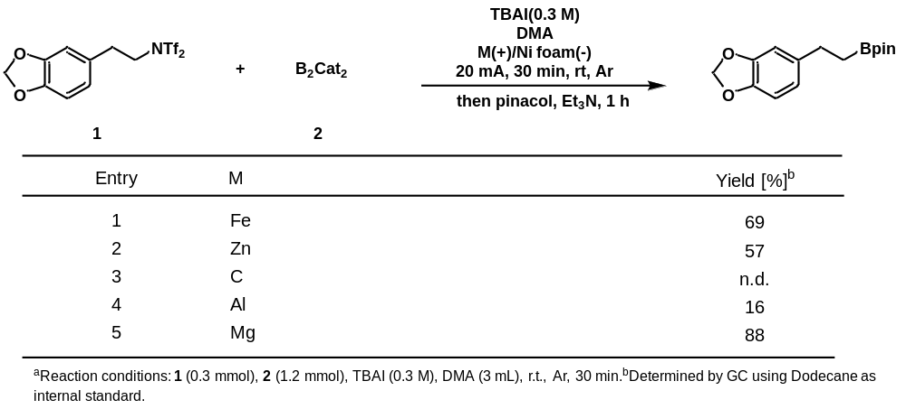
Table S2. Optimization of solvent
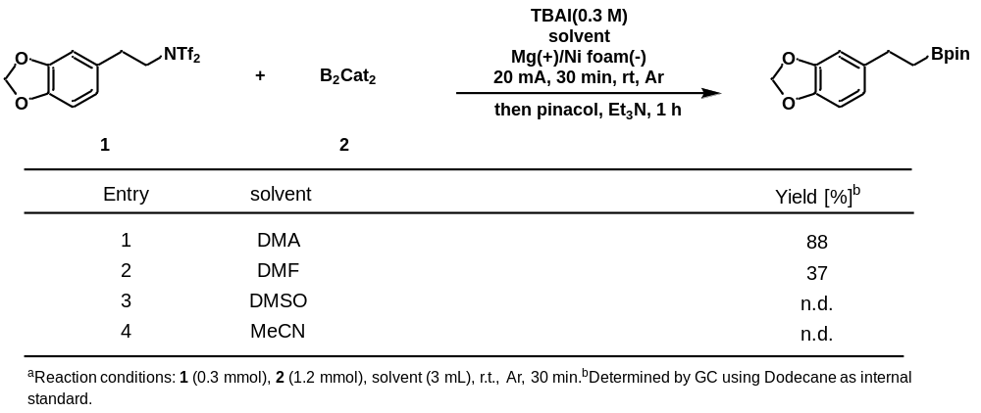
Table S3. Optimization of current and time
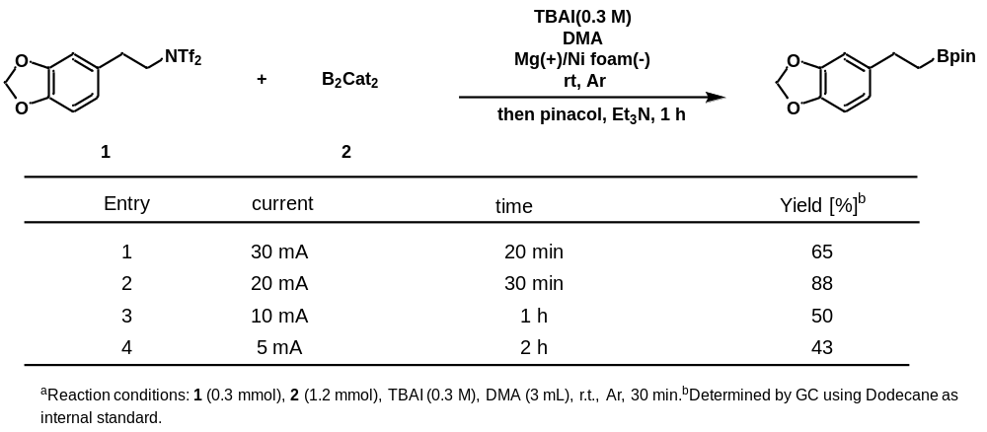
Table S3. Optimization of electrolyte
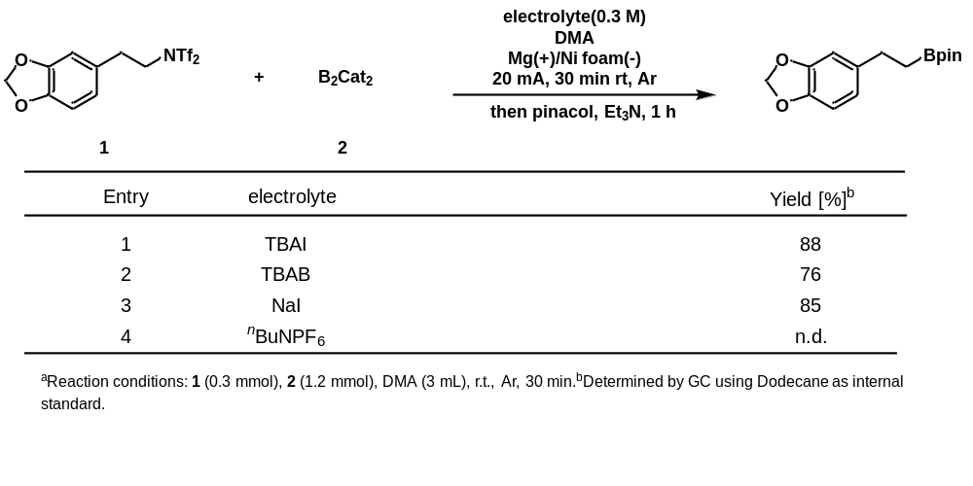

Experimental procedure
General Procedure for the synthesis of the starting material (From primary alkyl amines)
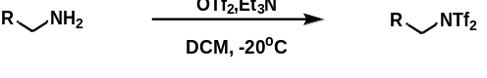
An oven dried round-bottom flask equipped with a stir bar was charged with amine (5.0 mmol, 1.0 equiv), CH₂Cl₂ (20 ml, 0.25M) and Et₃N (2.1 mL, 15 mmol, 3.0 equiv). The flask was cooled to -20 °C, and trifluoromethanesulfonic anhydride (1.7 mL, 2.8 g, 5.0 mmol, 2.0 equiv) was added dropwise. The reaction was stirred vigorously at -20 °C for 1 h and allowed to gradually warm up to room temperature. The reaction was then quenched with 20 mL H₂O. The reaction mixture was partitioned between H₂O and CH₂Cl₂ and layers were separated. The aqueous layer was extracted with CH₂Cl₂ (20 ml × 3). The organic layers were combined, dried over Na₂SO₄, filtered, and concentrated under reduced pressure. The reaction mixture was applied directly to a flash silica column for purification.
General Procedure for the synthesis of the product 3-32
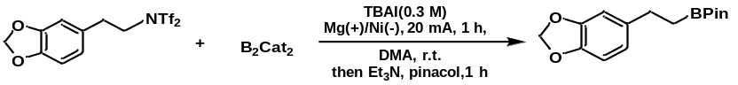
TBAI (332 mg, 0.9 mmol), B₂cat₂ (477 mg, 2.0 mmol), alkyl triflimidate (0.5 mmol) and DMA (3 ml) in a tube and place in a glove box. Magnesium plate (52.5 × 8 × 2 mm) was used as the anode, foamed nickel electrode (52.5 × 8 × 2 mm) was used as the cathode and then the reaction mixture was electrolyzed at a constant current of 20 mA. Afterwards, a solution of pinacol (2.0 mmol, 4.0 equiv., 236 mg) in triethylamine (1.0 mL) was added to the electrolyzer cell and the reaction mixture kept stirring at room temperature for 1 h. The mixture was then quenched with ethyl acetate, dried onto silica gel, and purified by rapid column chromatography.
General Procedure for the synthesis of the product 33-36
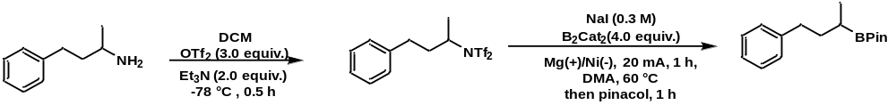
An oven dried tube flask equipped with a stir bar placed in a glove box was charged with amine (0.5 mmol, 1.0 equiv), CH₂Cl₂ (1 ml, 0.5 M) and Et₃N (0.28 mL, 1 mmol, 2.0 equiv). The flask was cooled to -78 °C, and trifluoromethanesulfonic anhydride (0.26 mL, 0.42 g, 1.5 mmol, 3.0 equiv) was added dropwise. The reaction was stirred vigorously at -78 °C for 0.5 h. Then NaI (135 mg, 0.9 mmol), B₂cat₂ (477 mg, 2.0 mmol), and DMAc (3 ml) in the tube and place in a glove box. Magnesium plate (52.5 × 8 × 2 mm) was used as the anode, foamed nickel electrode (52.5 × 8 × 2 mm) was used as the cathode and then the reaction mixture was electrolyzed at a constant current of 20 mA at 60 °C. Afterwards, a solution of pinacol (2.0 mmol, 4.0 equiv., 236 mg) in triethylamine (1.0 mL) was added to the electrolyzer cell and the reaction mixture kept stirring at room temperature for 1 h. The mixture was then quenched with ethyl acetate, dried onto silica gel, and purified by rapid column chromatography.
General Procedure for the synthesis of the product 37-39,41-44
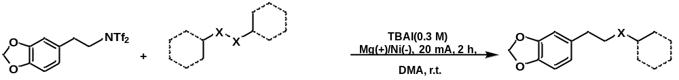
TBAI (332 mg, 0.9 mmol), disulfides (0.5 mmol), alkyl triflimidate (0.2 mmol) and DMAc (3 ml) in a tube and place in a glove box. Magnesium plate (52.5 × 8 × 2 mm) was used as the anode, foamed nickel electrode (52.5 × 8 × 2 mm) was used as the cathode and then the reaction mixture was electrolyzed at a constant current of 20 mA. The mixture was then quenched with ethyl acetate, dried onto silica gel, and purified by rapid column chromatography.
General Procedure for the synthesis of the product 40
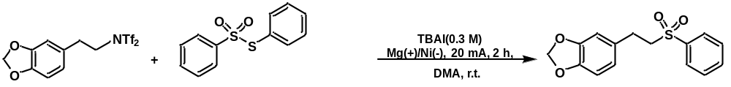
TBAI (332 mg, 0.9 mmol), benzenethiosulfonic acid s-phenyl ester (0.5 mmol), alkyl triflimidate (0.2 mmol) and DMAc (3 ml) in a tube and place in a glove box. Magnesium plate (52.5 × 8 × 2 mm) was used as the anode, foamed nickel electrode (52.5 × 8 × 2 mm) was used as the cathode and then the reaction mixture was electrolyzed at a constant current of 20 mA. The mixture was then quenched with ethyl acetate, dried onto silica gel, and purified by rapid column chromatography.
General Procedure for the synthesis of the product 46-48
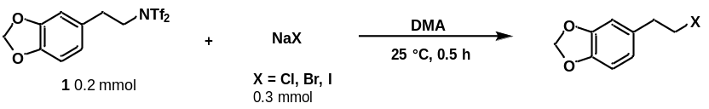
An oven dried round-bottom flask equipped with a stir bar was charged with alkyl triflimidate (0.2 mmol, 1.0 equiv), NaX (0.3 mmol, 1.1 equiv) and DMA (1 ml). The reaction was stirred at room temperature for 0.5 h. The reaction was then quenched with 20 mL H₂O. The reaction mixture was partitioned between H₂O and CH₂Cl₂ and layers were separated. The aqueous layer was extracted with CH₂Cl₂ (20 ml × 3). The organic layers were combined, dried over Na₂SO₄, filtered, and concentrated under reduced pressure. The reaction mixture was applied directly to a flash silica column for purification.
General Procedure for the synthesis of the product 49
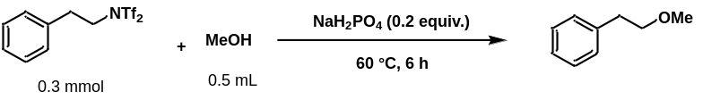
An oven dried round-bottom flask equipped with a stir bar was charged with alkyl triflimidate (0.2 mmol, 1.0 equiv), NaH₂PO₄ (0.04 mmol, 0.2 equiv) and MeOH (0.5 ml). The reaction was stirred at 60 °C for 6 h. The reaction was then quenched with 20 mL H₂O. The reaction mixture was partitioned between H₂O and CH₂Cl₂ and layers were separated. The aqueous layer was extracted with CH₂Cl₂ (20 ml × 3). The organic layers were combined, dried over Na₂SO₄, filtered, and concentrated under reduced pressure. The reaction mixture was applied directly to a flash silica column for purification.
General Procedure for the synthesis of the product 50-53
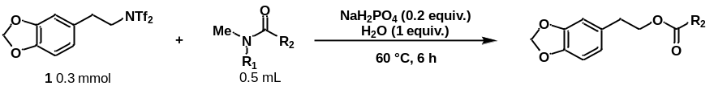
An oven dried round-bottom flask equipped with a stir bar was charged with alkyl triflimidate (0.2 mmol, 1.0 equiv), H₂O (0.2 mmol, 1.0 equiv), NaH₂PO₄ (0.04 mmol, 0.2 equiv) and amide (0.5 ml). The reaction was stirred at 60 °C for 6 h. The reaction was then quenched with 20 mL H₂O. The reaction mixture was partitioned between H₂O and CH₂Cl₂ and layers were separated. The aqueous layer was extracted with CH₂Cl₂ (20 ml × 3). The organic layers were combined, dried over Na₂SO₄, filtered, and concentrated under reduced pressure. The reaction mixture was applied directly to a flash silica column for purification.
General Procedure for the synthesis of the product 54-61
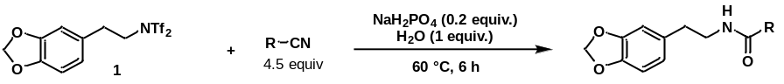
An oven dried round-bottom flask equipped with a stir bar was charged with alkyl triflimidate (0.2 mmol, 1.0 equiv), H₂O (0.2 mmol, 1.0 equiv), NaH₂PO₄ (0.04 mmol, 0.2 equiv) and nitrlie (0.9 mmol, 4.5 equiv). The reaction was stirred at 60 °C for 6 h. The reaction was then quenched with 20 mL H₂O. The reaction mixture was partitioned between H₂O and CH₂Cl₂ and layers were separated. The aqueous layer was extracted with CH₂Cl₂ (20 ml × 3). The organic layers were combined, dried over Na₂SO₄, filtered, and concentrated under reduced pressure. The reaction mixture was applied directly to a flash silica column for purification.
One pot synthesis of products
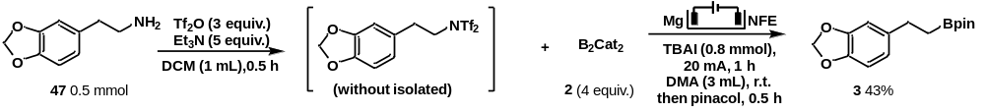
An oven dried round-bottom flask equipped with a stir bar was charged with amine (0.5 mmol, 1.0 equiv.), CH₂Cl₂ (1 ml, 0.5 M) and Et₃N (2.5 mmol, 5.0 equiv.). The flask was cooled to -20 °C, and trifluoromethanesulfonic anhydride (1.5 mmol, 3.0 equiv.) was added dropwise. The reaction was stirred vigorously at -20 °C for 0.5 h and allowed to gradually warm up to room temperature. Then added TBAI (0.9 mmol), B₂cat₂ (2.0 mmol, 4 equiv.) and DMAc (3 ml) in the tube and place in a glove box. Magnesium plate (15 mm × 15 mm × 0.5 mm) was used as the anode, carbon cloth electrode (15 mm × 15 mm) was used as the cathode and then the reaction mixture was electrolyzed at a constant current of 20 mA. Afterwards, a solution of pinacol (2.0 mmol, 4.0 equiv., 236 mg) in triethylamine (1.0 mL) was added to the electrolyzer cell and the reaction mixture kept stirring at room temperature for 1 h. The crude yields were determined by GC using dodecane as internal standard.
Graphical Guide for Borylation of Alkyl triflimidate
1. Materials used set-up.
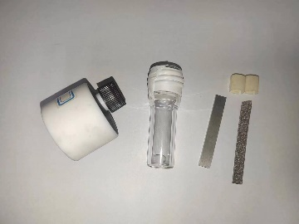
Supplementary Figure 1: A electrochemical reaction bottle
2. Reagents used for borylation: TBAI, B₂Cat₂, DMA, Pinacol, Et₃N and the Substrate.
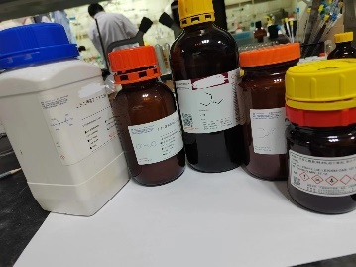
Supplementary Figure 2: Electrochemical reaction reagents
3.TBAI (0.9 mmol, 332.0 mg) and B₂Cat₂ (1.2 mmol, 4 equiv., 286.0 mg) were added to a vessel equipped with a Teflon-coated magnetic stir bar. The vessel was wraped with teflon tape.
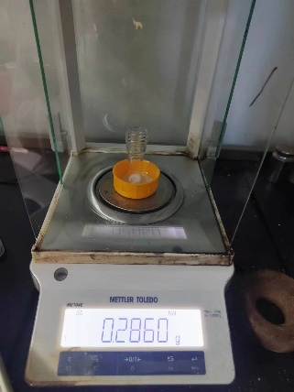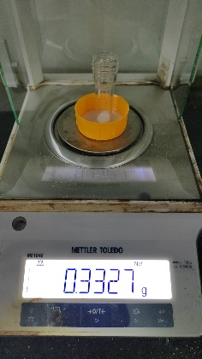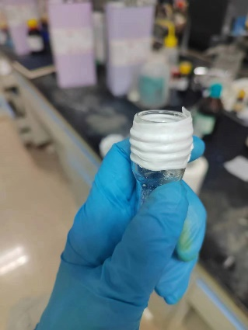
Supplementary Figure 3
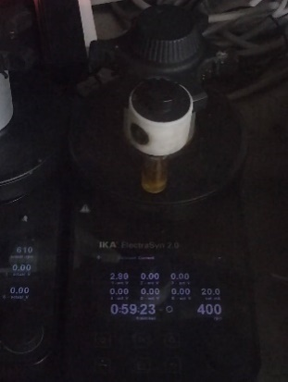
4. the vessel was moved to the glove box. Alkyl triflimidate and DMA (3 ml) was added to the reaction mixture. The reaction mixture was connected to a potentiostat with the current kept at 20 mA.
Supplementary Figure 4: Duing reaction
Procedure for continuous-flow reactor
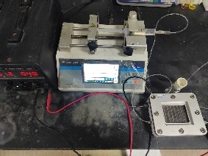
Supplementary Figure 5: Electrochemical Continuous-Flow System
First, assembled and installed the flow electrochemistry device, the anode as Fe electrode, cathode as nickel electrode and the cell volume was 3 mL. Second, 1 (0.1 M), 2 (0.4 M), TBAI (0.3 M) were dissolved in DMA (30 mL). n-dodecane as internal standard. The reaction mixture was pumped into the flow cell via a syringe and electrolyzed at a constant current of 20 mA at room temperature. The flow rate was 0.0125 mL/min and residence time was 4 h. Then added triethylamine (0.8 M) and pinacol (0.8 M) and stired at room temperature for one hour. The out flow of the reaction mixture was collected and monitored by GCMS.

Procedure for cyclic voltammetry (CV)
Cyclic voltammetry was performed in a three-electrode cell connected to a schlenk line under nitrogen at room temperature. The working electrode was a steady glassy carbon disk electrode, the counter electrode a platinum wire. The reference was an Ag/AgCl electrode submerged in saturated aqueous KCl solution.
^{n}Bu₄NClO₄ (0.4 mmol) and a solvent (DMA, 10 mL) were poured into the electrochemical cell in cyclic voltammetry experiments. The scan rate was 0.025 V/s, ranging from -0.5 V to -4 V. (2) B₂cat₂ (4 mM) and a mixed solvent (DMA, 10 mL) containing ^{n}Bu₄NClO₄ (0.4 mmol) were poured into the electrochemical cell in cyclic voltammetry experiments. The scan rate was 0.025 V/s, ranging from -0.5 V to -4 V. (3) alkyl triflimidate (1 mM) and a mixed solvent (DMA, 10 mL) containing ^{n}Bu₄NClO₄ (0.4 mmol) were poured into the electrochemical cell in cyclic voltammetry experiments. The scan rate was 0.025 V/s, ranging from -0.5 V to -4 V. (4) Alkyl iodide (1 mM) and a mixed solvent (DMA, 10 mL) containing ^{n}Bu₄NClO₄ (0.4 mmol) were poured into the electrochemical cell in cyclic voltammetry experiments. The scan rate was 0.025 V/s, ranging from -0.5 V to -4 V. (5) alkyl triflimidate (1 mM), B₂Cat₂ (4 mM) and a mixed solvent (DMA, 10 mL) containing ^{n}Bu₄NClO₄ (0.4 mmol) were poured into the electrochemical cell in cyclic voltammetry experiments. The scan rate was 0.025 V/s, ranging from -0.5 V to -4 V(Supplementary Figure 6).
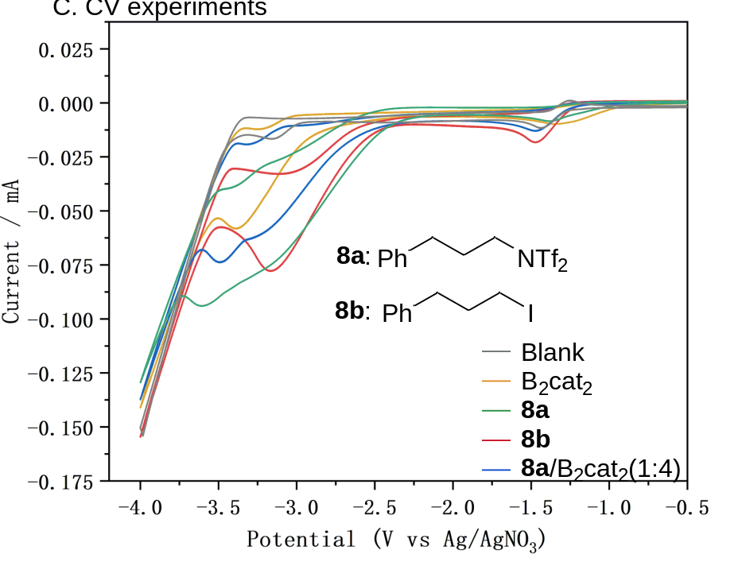
Supplementary Figure 6: Cyclic voltammetry

Scale Up Experiments
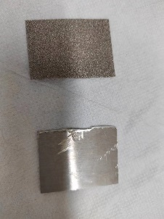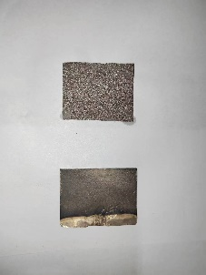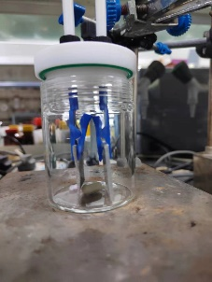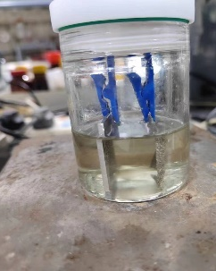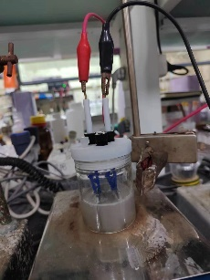
Supplementary Figure 7: Scale Up Experiments
TBAI (3.32 g, 9 mmol), B₂Cat₂ (2.86 g, 12 mmol), 1 (1.28 g, 3 mmol) and DMAc (30 ml) in a tube. Magnesium plate (35 mm × 40 mm × 0.2 mm) was used as the anode, carbon cloth electrode (35 mm × 40 mm) was used as the cathode and then the reaction mixture was electrolyzed at a constant current of 100 mA until the alkyl triflimidate was consumed. Then added triethylamine (2.42 g, 24 mmol) and pinacol (2.83 g, 24 mmol) and stired at room temperature for one hour. The mixture was then quenched with ethyl acetate, dried onto silica gel, and purified by rapid column chromatography.

Characterization Data
Compound 3
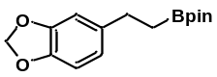
0.5 mmol scale. Purification by PTLC (Hexane: ethyl acetate=20:1) afforded 108 mg (78%). Physical State: colorless oil. R_{f}= 0.35 (Hexane: ethyl acetate=20:1).
¹H NMR (400 MHz, Chloroform-d) δ 6.70 (m, 3H), 5.90 (s, 2H), 3.19 – 2.39 (m, 2H), 1.22 (s, 12H), 1.09 (m, 2H).
¹³C NMR (101 MHz, Chloroform-d) δ 147.4, 145.3, 138.4, 120.6, 108.6, 108.0, 100.6, 83.1, 29.8, 24.8. The signal of the α-B-carbon was not observed.
All data matched that reported in the literature^{[1]}
Compound 4
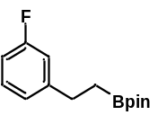
0.5 mmol scale. Purification by PTLC (Hexane: ethyl acetate=20:1) afforded 94 mg (75%). Physical State: colorless oil. R_{f}= 0.35 (Hexane: ethyl acetate=20:1).
¹H NMR (400 MHz, Chloroform-d) δ 7.28 – 7.14 (m, 1H), 7.02 – 6.88 (m, 2H), 6.89 – 6.79 (m, 1H), 2.74 (t, J = 8.1 Hz, 2H), 1.22 (s, 12H), 1.17 – 1.08 (m, 2H).
¹³C NMR (101 MHz, Chloroform-d) δ 161.2 (d, J = 242.6 Hz), 147.2 (d, J = 7.0 Hz), 129.7 (d, J = 8.4 Hz), 123.8 (d, J = 2.8 Hz), 115.0 (d, J = 20.9 Hz), 112.5 (d, J = 21.0 Hz), 83.4, 29.9, 24.9. The signal of the α-B-carbon was not observed.
¹⁹F NMR (376 MHz, Chloroform-d) δ -114.26.
All data matched that reported in the literature^{[1]}
Compound 5
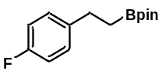
0.5 mmol scale. Purification by PTLC (Hexane: ethyl acetate=20:1) afforded 91.1 mg (73%). Physical State: colorless oil. R_{f}= 0.30 (Hexane: ethyl acetate=20:1).
¹H NMR (400 MHz, Chloroform-d) δ 7.18 – 7.13 (m, 2H), 6.97 – 6.89 (m, 2H), 2.72 (t, J = 8.1 Hz, 2H), 1.21 (s, 12H), 1.16 – 1.07 (m, 2H).
¹³C NMR (101 MHz, Chloroform-d) δ 161.24 (d, J = 242.6 Hz), 140.4 (d, J = 3.1 Hz), 129.8 (d, J = 7.7 Hz), 115.3 (d, J = 21.0 Hz), 83.6, 29.6, 25.3. The signal of the α-B-carbon was not observed.
All data matched that reported in the literature^{[1]}

Compound 6
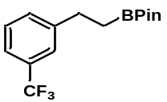
0.5 mmol scale. Purification by PTLC (Hexane: ethyl acetate=20:1) afforded 105 mg (70%). Physical State: colorless oil. R_{f}= 0.45 (Hexane: ethyl acetate=20:1).
¹H NMR (400 MHz, Chloroform-d) δ 7.49 (s, 1H), 7.44 – 7.34 (m, 3H), 2.81 (t, J = 7.9 Hz, 2H), 1.20 (s, 12H), 1.16 (t, J = 7.9 Hz, 2H).
¹³C NMR (101 MHz, Chloroform-d) δ 145.4 , 131.7 , 130.5 (q, J = 31.7 Hz), 128.7 , 127.5 (d, J = 266.0 Hz).125.0 (q, J = 3.9 Hz), 122.6 (q, J = 4.1 Hz), 83.4, 30.0, 24.9. The signal of the α-B-carbon was not observed.
¹⁹F NMR (376 MHz, Chloroform-d) δ -62.60.
All data matched that reported in the literature^{[7]}
Compound 7
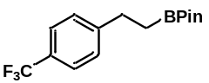
0.5 mmol scale. Purification by PTLC (Hexane: ethyl acetate=20:1) afforded 90 mg (60%). Physical State: colorless oil. R_{f}= 0.30 (Hexane: ethyl acetate=20:1).
¹H NMR (400 MHz, Chloroform-d) δ 7.51 (d, J = 8.0 Hz, 2H), 7.32 (d, J = 8.0 Hz, 2H), 2.80 (t, J = 8.1 Hz, 2H), 1.22 (s, 12H), 1.15 (t, J = 8.1 Hz, 2H).
¹³C NMR (101 MHz, Chloroform-d) δ 148.6, 128.5, 128.1 (q, J = 32 Hz), 125.2 (q, J = 270 Hz), 124.6 (q, J = 8.1 Hz, 2H), 83.4, 30.0, 24.9. The signal of the α-B-carbon was not observed.
¹⁹F NMR (376 MHz, Chloroform-d) δ -62.27.
All data matched that reported in the literature^{[1]}
Compound 8
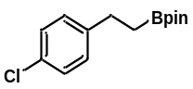
0.5 mmol scale. Purification by PTLC (Hexane: ethyl acetate=20:1) afforded 89.1 mg (67%). Physical State: colorless oil. R_{f}= 0.45 (Hexane: ethyl acetate=20:1).
¹H NMR (400 MHz, Chloroform-d) δ 7.21 (d, J = 8.4 Hz, 2H), 7.13 (d, J = 8.4 Hz, 2H), 2.71 (t, J = 8.1 Hz, 2H), 1.21 (s, 12H), 1.15 – 1.07 (m, 2H).
¹³C NMR (101 MHz, Chloroform-d) δ 142.9, 131.3, 129.5, 128.3, 83.3, 29.5, 25.0. The signal of the α-B-carbon was not observed.
All data matched that reported in the literature^{[2]}
Compound 9
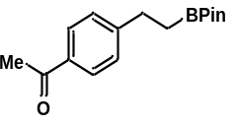
0.5 mmol scale. Purification by PTLC (Hexane: ethyl acetate=15:1) afforded 91.8 mg (67%). Physical State: colorless oil. R_{f}= 0.45 (Hexane: ethyl acetate=15:1).
¹H NMR (400 MHz, Chloroform-d) δ 7.89 – 7.82 (m, 2H), 7.37 – 7.25 (m, 2H), 2.79 (t, J = 8.1 Hz, 2H), 2.56 (s, 3H), 1.21 (s, 12H), 1.14 (t, J = 8.1 Hz, 2H).
¹³C NMR (101 MHz, Chloroform-d) δ 198.1, 150.4, 135.0, 128.6, 128.3, 83.4, 30.2, 26.7, 25.0. The signal of the α-B-carbon was not observed.
All data matched that reported in the literature^{[1]}
Compound 10
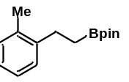
0.5 mmol scale. Purification by PTLC (Hexane: ethyl acetate=20:1) afforded 92 mg (75%). Physical State: colorless oil. R_{f}= 0.40 (Hexane: ethyl acetate=20:1).
¹H NMR (400 MHz, Chloroform-d) δ 7.09 (s, 4H), 2.76 – 2.67 (m, 2H), 2.30 (s, 3H), 1.22 (s, 12H), 1.14 – 1.05 (m, 2H).
¹³C NMR (101 MHz, Chloroform-d) δ 142.6, 135.9, 130.1, 128.2, 125.9, 125.8, 83.0, 27.3, 24.9, 19.4. The signal of the α-B-carbon was not observed.
All data matched that reported in the literature^{[2]}
Compound 11
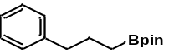
0.5 mmol scale. Purification by PTLC (Hexane: ethyl acetate=20:1) afforded 86 mg (70%). Physical State: colorless oil. R_{f}= 0.40 (Hexane: ethyl acetate=20:1).
¹H NMR (400 MHz, Chloroform-d) δ 7.32 – 7.03 (m, 5H), 2.70 – 2.43 (m, 2H), 1.84 – 1.61 (m, 2H), 1.23 (s, 12H), 0.81 (t, J = 7.9 Hz, 2H).
¹³C NMR (101 MHz, Chloroform-d) δ 142.8, 128.7, 128.3, 125.7, 83.0, 38.7, 26.2, 25.0, 11.0.
All data matched that reported in the literature^{[2]}
Compound 12
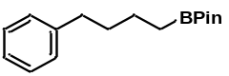
0.5 mmol scale. Purification by PTLC (Hexane: ethyl acetate=20:1) afforded 90 mg (71%). Physical State: colorless oil. R_{f}= 0.40 (Hexane: ethyl acetate=20:1).
¹H NMR (400 MHz, Chloroform-d) δ 7.43 – 7.03 (m, 5H), 2.72 – 2.35 (m, 2H), 1.76 – 1.53 (m, 2H), 1.53 – 1.37 (m, 2H), 1.24 (s, 12H), 0.88 – 0.79 (m, 2H).
¹³C NMR (101 MHz, Chloroform-d) δ 143.1, 128.5, 128.3 0, 125.6 0, 83.0 0, 35.9 0, 34.3 0, 29.9 0, 25.0, 23.9. The signal of the α-B-carbon was not observed.
All data matched that reported in the literature^{[2]}
Compound 13
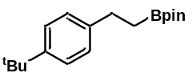
0.5 mmol scale. Purification by PTLC (Hexane: ethyl acetate=20:1) afforded 108.1 mg (75%). Physical State: colorless oil. R_{f}= 0.45 (Hexane: ethyl acetate=20:1).
¹H NMR (400 MHz, Chloroform-d) δ 7.43 – 7.28 (m, 2H), 7.28 – 7.13 (m, 2H), 2.86 – 2.69 (m, 2H), 1.36 (s, 9H), 1.27 (s, 12H), 1.23 – 1.13 (m, 2H).
¹³C NMR (101 MHz, Chloroform-d) δ 148.3, 141.4, 127.8, 125.2, 83.1, 34.4, 31.6, 29.5, 24.9. The signal of the α-B-carbon was not observed.
All data matched that reported in the literature^{[1]}
Compound 14
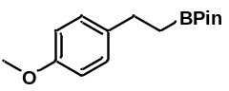
0.5 mmol scale. Purification by PTLC (Hexane: ethyl acetate=20:1) afforded 92 mg (71%). Physical State: white solid. R_{f}= 0.5 (Hexane: ethyl acetate=20:1).
¹H NMR (400 MHz, Chloroform-d) δ 7.13 (m, 2H), 6.86 – 6.75 (m, 2H), 3.77 (s, 3H), 2.71 – 2.67 (m, 2H), 1.22 (s, 12H), 1.11 (m, 2H).
¹³C NMR (101 MHz, Chloroform-d) δ 157.7, 136.7, 129.0, 113.7, 83.2, 55.4, 29.2, 24.9. The signal of the α-B-carbon was not observed.
All data matched that reported in the literature^{[1]}
Compound 15
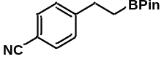
0.5 mmol scale. Purification by PTLC (Hexane: ethyl acetate=20:1) afforded 88 mg (69%). Physical State: white solid. R_{f}= 0.55 (Hexane: ethyl acetate=20:1).
¹H NMR (400 MHz, Chloroform-d) δ 7.54 (d, J = 8.3 Hz, 2H), 7.34 – 7.26 (m, 2H), 2.79 (t, J = 8.0 Hz, 2H), 1.20 (s, 12H), 1.13 (t, J = 8.1 Hz, 2H).
¹³C NMR (101 MHz, Chloroform-d) δ 150.2, 132.2, 128.9, 119.3, 109.5 , 83.4, 30.3, 24.9. The signal of the α-B-carbon was not observed.
All data matched that reported in the literature^{[3]}
Compound 16
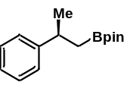
0.5 mmol scale. Purification by PTLC (Hexane: ethyl acetate=20:1) afforded 80 mg (65%). Physical State: white solid. R_{f}= 0.55 (Hexane: ethyl acetate=20:1).
¹H NMR (400 MHz, Chloroform-d) δ 7.28 – 7.21 (m, 4H), 7.17 – 7.11 (m, 1H), 3.06 – 2.98 (m, 1H), 1.27 (d, J = 6.9 Hz,3H), 1.15 (s, 14H).
¹³C NMR (101 MHz, Chloroform-d) δ 149.4, 128.3, 126.8, 125.8, 83.1, 35.9, 25.0, 24.9, 24.8, 21.3.
All data matched that reported in the literature^{[8]}
Compound 17
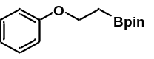
0.5 mmol scale. Purification by PTLC (Hexane: ethyl acetate=20:1) afforded 82.3 mg (67%). Physical State: colorless oil. R_{f}= 0.55 (Hexane: ethyl acetate=20:1).
¹H NMR (400 MHz, Chloroform-d) δ 7.30 – 7.21 (m, 2H), 7.08 – 6.86 (m,3H), 4.11 (t, J = 7.8 Hz, 2H), 1.37 (t, J = 7.8 Hz,2H), 1.26 (s, 12H).
¹³C NMR (101 MHz, Chloroform-d) δ 159.2, 129.4, 120.5, 114.8, 83.5, 64.9, 24.9. The signal of the α-B-carbon was not observed.
All data matched that reported in the literature^{[5]}
Compound 18
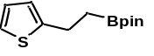
0.5 mmol scale. Purification by PTLC (Hexane: ethyl acetate=20:1) afforded 90 mg (76%). Physical State: colorless oil. R_{f}= 0.40 (Hexane: ethyl acetate=20:1).
¹H NMR (400 MHz, Chloroform-d) δ 7.08 – 7.06 (m, 1H), 6.90 – 6.88 (m, 1H), 6.80 – 6.79 (m, 1H), 2.94 – 2.98 (m, 2H), 1.20 (s, 12H), 0.85 – 0.89 (m, 2H)
¹³C NMR (101 MHz, Chloroform-d) δ 147.9, 126.7, 123.5, 122.7, 83.4, 29.8, 24.9, 14.3.
All data matched that reported in the literature^{[2]}
Compound 19
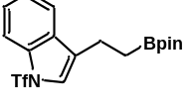
0.5 mmol scale. Purification by PTLC (Hexane: ethyl acetate=10:1) afforded 135 mg (67%). Physical State: white solid. R_{f}= 0.40 (Hexane: ethyl acetate=10:1).
¹H NMR (400 MHz, Chloroform-d) δ 7.91 – 7.84 (m, 1H), 7.65 – 7.57 (m, 1H), 7.37 (ddd, J = 7.0, 5.2, 1.6 Hz, 2H), 7.16 (d, J = 1.4 Hz, 1H), 2.88 – 2.79 (m, 2H), 1.27 – 1.20 (m, 14H).
¹³C NMR (101 MHz, Chloroform-d) δ 135.9, 131.4, 128.0, 125.8, 124.6, 122.1, 120.2, 119.8 (q, J = 324.1 Hz), 113.9, 83.5, 24.9, 19.3. The signal of the α-B-carbon was not observed.
¹⁹F NMR (376 MHz, Chloroform-d) δ -75.19.
HRMS(ESI) m/z: calced for C₁₇H₂₂BF₃NO₄S⁺ [M+H]⁺: 404.1309, found: 404.1310.
Compound 20
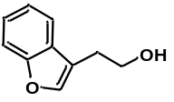
0.5 mmol scale. Purification by PTLC (Hexane: ethyl acetate=20:1) afforded 78 mg (58%). Physical State: colorless oil. R_{f}= 0.45 (Hexane: ethyl acetate=20:1).
¹H NMR (400 MHz, Chloroform-d) δ 7.58 – 7.54 (m, 1H), 7.52 – 7.45 (m, 2H), 7.33 – 7.21 (m, 2H), 3.91 (t, J = 6.4 Hz, 2H), 2.95 – 2.88 (m, 2H), 1.73 (s, 1H).
¹³C NMR (101 MHz, Chloroform-d) δ 155.8, 142.6, 128.4, 124.8, 122.9, 120.0, 117.2, 112.0, 62.2, 27.5.
All data matched that reported in the literature^{[21]}
Compound 21
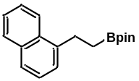
0.5 mmol scale. Purification by PTLC (Hexane: ethyl acetate=20:1) afforded 96 mg (68%). Physical State: white solid. R_{f}= 0.55 (Hexane: ethyl acetate=20:1).
¹H NMR (400 MHz, Chloroform-d) δ 8.14 – 8.05 (m, 1H), 7.88 – 7.81 (m, 1H), 7.73 – 7.65 (m, 1H), 7.55 – 7.42 (m, 2H), 7.39 (d, J = 6.2 Hz, 2H), 3.27 – 3.18 (m, 2H), 1.35 – 1.26 (m, 2H), 1.25 (s, 12H).
¹³C NMR (101 MHz, Chloroform-d) δ 140.6, 133.9, 131.9, 128.8, 126.4, 125.7, 125.7, 125.5, 125.1, 124.1, 83.3, 27.1, 25.0. The signal of the α-B-carbon was not observed.
All data matched that reported in the literature^{[2]}
Compound 22
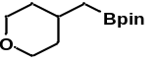
0.5 mmol scale. Purification by PTLC (Hexane: ethyl acetate=20:1) afforded 73.5 mg (65%). Physical State: colorless oil. R_{f}= 0.30 (Hexane: ethyl acetate=20:1).
¹H NMR (400 MHz, Chloroform-d) δ 3.91 – 3.82 (m, 2H), 3.38 – 3.34 (m, 2H), 1.71 – 1.67 (m,1H), 1.60 – 1.55 (m, 2H), 1.31 – 1.25 (m, 2H), 1.22 (s, 12H), 0.76 (d, J = 7.1 Hz, 2H).
¹³C NMR (101 MHz, Chloroform-d) δ 83.1, 68.3, 35.5, 31.5, 25.0. The signal of the α-B-carbon was not observed.
All data matched that reported in the literature^{[6]}
Compound 23
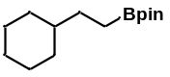
0.5 mmol scale. Purification by PTLC (Hexane: ethyl acetate=20:1) afforded 56 mg (47%). Physical State: colorless oil. R_{f}= 0.35 (Hexane: ethyl acetate=20:1).
¹H NMR (400 MHz, Chloroform-d) δ 1.74 – 1.56 (m, 5H), 1.26 – 1.23 (m, 15H), 0.94 – 0.81 (m, 5H), 0.71 (d, J = 7.2 Hz, 2H).
¹³C NMR (101 MHz, Chloroform-d) δ 82.9, 36.1, 34.4, 29.9, 26.7, 26.5, 24.9. The signal of the α-B-carbon was not observed.
All data matched that reported in the literature^{[4]}
Compound 24
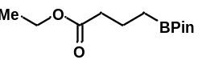
0.5 mmol scale. Purification by PTLC (Hexane: ethyl acetate=20:1) afforded 66.6 mg (55%). Physical State: colorless oil. R_{f}= 0.30 (Hexane: ethyl acetate=20:1).
¹H NMR (400 MHz, Chloroform-d) δ 4.08 (q, J = 7.1 Hz, 2H), 2.28 (t, J = 7.6 Hz, 2H), 1.81 – 1.57 (m, 2H), 1.22 (t, J = 7.1 Hz, 3H), 1.21 (s, 12H), 0.78 (t, J = 7.9 Hz, 2H).
¹³C NMR (101 MHz, Chloroform-d) δ 173.8, 83.1, 60.2, 36.7, 24.9, 19.8, 14.4, 10.8.
All data matched that reported in the literature^{[4]}
Compound 25
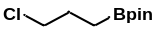
0.5 mmol scale. Purification by PTLC (Hexane: ethyl acetate=20:1) afforded 51.1 mg (71%). Physical State: colorless oil. R_{f}= 0.45 (Hexane: ethyl acetate=20:1).
¹H NMR (400 MHz, Chloroform-d)δ 3.53 (t, J = 6.8 Hz, 2H), 1.90 – 1.86 (m, 2H), 1.24 (s, 12H), 0.91 (t, J = 7.8 Hz, 2H).
¹³C NMR (101 MHz, Chloroform-d) δ 83.3, 47.3, 27.5, 25.0. The signal of the α-B-carbon was not observed.
All data matched that reported in the literature^{[7]}
Compound 26

0.5 mmol scale. Purification by PTLC (Hexane: ethyl acetate=20:1) afforded 157.6 mg (80%). Physical State: colorless oil. R_{f}= 0.30 (Hexane: ethyl acetate=10:1).
¹H NMR (400 MHz, Chloroform-d)δ 1.37 (m, 4H), 1.24 – 1.20 (m, 36H), 0.74 (t, J = 7.8 Hz, 4H).
¹³C NMR (101 MHz, Chloroform-d) δ 83.0, 32.6, 29.8, 29.6, 25.0, 24.2. The signal of the α-B-carbon was not observed.
All data matched that reported in the literature^{[10]}
Compound 27
0.5 mmol scale. Purification by PTLC (Hexane: ethyl acetate=20:1) afforded 111 mg (63%). Physical State: colorless oil. R_{f}= 0.45 (Hexane: ethyl acetate=20:1).
¹H NMR (400 MHz, Chloroform-d) δ 1.39 (t, J = 7.6 Hz, 2H), 1.28 – 1.24 (m, 38H), 0.88 (t, J = 6.8 Hz, 3H), 0.76 (t, J = 7.8 Hz, 2H).
¹³C NMR (101 MHz, Chloroform-d) δ 82.8, 32.6, 32.1, 29.9, 29.8, 29.82 29.7, 29.6, 29.5, 25.0, 24.2, 22.9, 14.3, 11.3. The signal of the α-B-carbon was not observed.
All data matched that reported in the literature^{[9]}
Compound 28

0.5 mmol scale. Purification by PTLC (Hexane: ethyl acetate=20:1) afforded 95.2 mg (71%). Physical State: colorless oil. R_{f}= 0.55 (Hexane: ethyl acetate=20:1).
¹H NMR (400 MHz, Chloroform-d) δ 1.40 – 1.33 (m, 2H), 1.31 – 1.17 (m, 26H), 0.85 (t, J = 6.8 Hz, 3H), 0.73 (t, J = 7.7 Hz, 2H).
¹³C NMR (101 MHz, Chloroform-d) δ 82.9, 32.56, 32.1, 29.8, 29.7, 29.5, 29.5, 24.9, 24.1, 22.8, 14.2. The signal of the α-B-carbon was not observed.
All data matched that reported in the literature^{[10]}
Compound 29
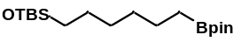
0.5 mmol scale. Purification by PTLC (Hexane: ethyl acetate=20:1) afforded 116.2 mg (68%). Physical State: colorless oil. R_{f}= 0.45 (Hexane: ethyl acetate=20:1).
¹H NMR (400 MHz, Chloroform-d) δ 3.58 (t, J = 6.7 Hz, 2H), 1.53 – 1.45 (m, 2H), 1.43 – 1.36 (m, 2H), 1.29 (p, J = 3.8 Hz, 4H), 1.23 (s, 12H), 0.88 (s, 9H), 0.76 (t, J = 7.7 Hz, 2H), 0.03 (s, 6H).
¹³C NMR (101 MHz, Chloroform-d) δ 83.0, 63.5, 33.0, 32.4, 25.8, 25.0, 24.1, 18.5, -5.1. The signal of the α-B-carbon was not observed.
HRMS(ESI) m/z: calced for C₁₈H₄₀BO₃Si⁺ [M+H]⁺: 343.2834, found: 343.2836.
Compound 30
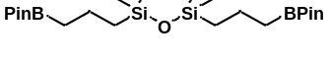
0.5 mmol scale. Purification by PTLC (Hexane: ethyl acetate=20:1) afforded 176 mg (75%). Physical State: colorless oil. R_{f}= 0.45 (Hexane: ethyl acetate=20:1).
¹H NMR (400 MHz, Chloroform-d) δ 1.50 – 1.37 (m, 4H), 1.24 (s, 24H), 0.82 (t, J = 7.6 Hz, 4H), 0.54 (m, 4H), 0.02 (s, 12H).
¹³C NMR (101 MHz, Chloroform-d) δ 83.0, 25.0, 21.8, 18.1, 0.6. The signal of the α-B-carbon was not observed.
All data matched that reported in the literature^{[3]}
Compound 31
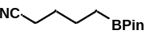
0.5 mmol scale. Purification by PTLC (Hexane: ethyl acetate=20:1) afforded 63 mg (55%). Physical State: colorless oil. R_{f}= 0.45 (Hexane: ethyl acetate=20:1).
¹H NMR (400 MHz, Chloroform-d) δ 2.29 (t, J = 7.1 Hz, 2H), 1.68 – 1.58 (m, 2H), 1.57 – 1.46 (m, 2H), 1.20 (s, 12H), 0.76 (t, J = 7.7 Hz, 2H).
¹³C NMR (101 MHz, Chloroform-d) δ 119.6, 82.9, 27.5, 24.5, 23.0, 16.6. The signal of the α-B-carbon was not observed.
All data matched that reported in the literature^{[4]}
Compound 32
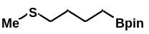
0.5 mmol scale. Purification by PTLC (Hexane: ethyl acetate=20:1) afforded 78 mg (68%). Physical State: colorless oil. R_{f}= 0.30 (Hexane: ethyl acetate=10:1).
¹H NMR (400 MHz, Chloroform-d) δ 2.54 – 2.39 (m, 2H), 2.07 (s, 3H), 1.80 – 1.63 (m, 2H), 1.24 – 1.23(m, 14H), 0.86 (m, 2H).
¹³C NMR (101 MHz, Chloroform-d) δ 83.2, 36.7, 29.8, 24.9, 23.8, 15.5. The signal of the α-B-carbon was not observed.
All data matched that reported in the literature^{[1]}
Compound 33
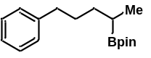
0.5 mmol scale. Purification by PTLC (Hexane: ethyl acetate=20:1) afforded 61.7 mg (45%). Physical State: colorless oil. R_{f}= 0.30 (Hexane: ethyl acetate=20:1)
¹H NMR (400 MHz, Chloroform-d) δ 7.31 – 7.08 (m, 5H), 2.62 – 2.57 (m, 2H), 1.84 – 1.71 (m, 1H), 1.61 – 1.53 (m, 1H), 1.23 (s, 12H), 1.07 – 0.99 (m, 4H).
¹³C NMR (101 MHz, Chloroform-d) δ 143.2, 128.6, 128.3, 125.6, 83.0, 35.5, 29.9, 24.9, 15.6. The signal of the α-B-carbon was not observed.
All data matched that reported in the literature^{[3]}
Compound 34
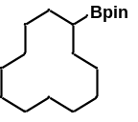
0.5 mmol scale. Purification by PTLC (Hexane: ethyl acetate=20:1) afforded 56 mg (38%). Physical State: colorless oil. R_{f}= 0.30 (Hexane: ethyl acetate=20:1)
¹H NMR (500 MHz, Chloroform-d) δ 1.45 – 1.35 (m, 10H), 1.34 – 1.26 (m, 12H), 1.23 (s, 12H), 0.92 – 0.85 (m, 1H).
¹³C NMR (126 MHz, Chloroform-d) δ 29.9, 25.1, 24.9, 24.4, 24.3, 23.6, 23.6, 23.5. The signal of the α-B-carbon was not observed.
All data matched that reported in the literature^{[3]}
Compound 35
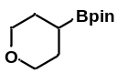
0.5 mmol scale. Purification by PTLC (Hexane: ethyl acetate=20:1) afforded 43.5 mg (41%). Physical State: colorless oil. R_{f}= 0.30 (Hexane: ethyl acetate=20:1)
¹H NMR (500 MHz, Chloroform-d) δ 3.82 (m, 2H), 3.52 – 3.41 (m, 2H), 1.68 – 1.53 (m, 5H), 1.24 (s, 12H).
¹³C NMR (126 MHz, Chloroform-d) δ 83.3, 69.0, 27.8, 24.9. The signal of the α-B-carbon was not observed.
All data matched that reported in the literature^{[2]}
Compound 36
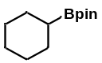
0.5 mmol scale. Purification by PTLC (Hexane: ethyl acetate=20:1) afforded 39 mg (38%). Physical State: colorless oil. R_{f}= 0.30 (Hexane: ethyl acetate=20:1)
¹H NMR (400 MHz, Chloroform-d) δ 1.69 – 1.62 (m, 4H), 1.60 – 1.53 (m, 6H), 1.22 (s, 12H), 1.03 – 0.91 (m, 1H).
¹³C NMR (101 MHz, Chloroform-d) δ 82.9, 28.1, 27.3, 26.9, 24.9. The signal of the α-B-carbon was not observed.
All data matched that reported in the literature^{[3]}
Compound 37
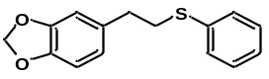
0.2 mmol scale. Purification by PTLC (Hexane: ethyl acetate=20:1) afforded 48 mg (92%). Physical State: colorless oil. R_{f}= 0.30 (Hexane: ethyl acetate=20:1)
¹H NMR (400 MHz, Chloroform-d) δ 7.36 – 7.32 (m, 2H), 7.30 – 7.25 (m, 2H), 7.20 – 7.14 (m, 1H), 6.72 (d, J = 7.9 Hz, 1H), 6.67 (d, J = 1.7 Hz, 1H), 6.62 (m, 1H), 5.90 (s, 2H), 3.14 – 3.08 (m, 2H), 2.87 – 2.78 (m, 2H).
¹³C NMR (101 MHz, Chloroform-d) δ 147.8, 146.2, 136.4, 134.1, 129.3, 129.3, 126.1, 121.5, 109.1, 108.4, 101.0, 35.5 (2C).
All data matched that reported in the literature ^{[11]}
Compound 38
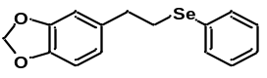
0.2 mmol scale. Purification by PTLC (Hexane: ethyl acetate=20:1) afforded 57.5 mg (94%). Physical State: colorless oil. R_{f}= 0.30 (Hexane: ethyl acetate=20:1)
¹H NMR (400 MHz, Chloroform-d) δ 7.62 – 7.48 (m, 2H), 7.38 – 7.19 (m, 3H), 6.86 – 6.52 (m, 3H), 5.94 (s, 2H), 3.19 – 3.07 (m, 2H), 3.00 – 2.83 (m, 2H).
¹³C NMR (101 MHz, Chloroform-d) δ 147.8, 146.2, 135.0, 132.7, 130.3, 129.2, 127.0, 121.4, 109.0, 108.3, 101.0, 36.4, 29.1.
HRMS(ESI) m/z: calced for C₁₅H₁₅O₂S⁺ [M+H]⁺: 307.0232, found: 307.0233.
Compound 39
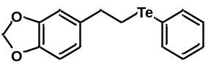
0.2 mmol scale. Purification by PTLC (Hexane: ethyl acetate=20:1) afforded 65 mg (91%). Physical State: colorless oil. R_{f}= 0.30 (Hexane: ethyl acetate=20:1)
¹H NMR (400 MHz, Chloroform-d) δ 7.84 – 7.49 (m, 2H), 7.30 – 7.07 (m, 3H), 6.81 – 6.39 (m, 3H), 5.90 (s, 2H), 3.14 – 3.03 (m, 2H), 3.06 – 2.96 (m, 2H).
¹³C NMR (101 MHz, Chloroform-d) δ 147.4, 145.8, 138.2, 136.3, 129.0, 127.4, 120.8, 111.5, 108.4, 108.0, 100.6, 37.7, 9.4.
HRMS(ESI) m/z: calced for C₁₅H₁₅O₂Te⁺ [M+H]⁺: 357.0129, found: 357.01130.
Compound 40
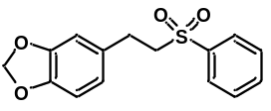
0.2 mmol scale. Purification by PTLC (Hexane: ethyl acetate=20:1) afforded 34.8 mg (61%). Physical State: colorless oil. Rf= 0.30 (Hexane: ethyl acetate=20:1)
¹H NMR (400 MHz, Chloroform-d) δ 8.02 – 7.82 (m, 2H), 7.82 – 7.60 (m, 1H), 7.61 – 7.49 (m, 2H), 6.71– 6.66 (m, 1H), 6.60 – 6.49 (m, 2H), 5.89 (s, 2H), 3.38 – 3.23 (m, 2H), 3.06 – 2.85 (m, 2H).
¹³C NMR (101 MHz, Chloroform-d) δ 148.0, 146.6, 139.1, 133.9, 131.2, 129.4, 128.1, 121.4, 108.8, 108.5, 101.1, 57.8, 28.6.
HRMS(ESI) m/z: calced for C₁₅H₁₅O₄S⁺ [M+H]⁺: 291.0686, found: 291.0688.
Compound 41
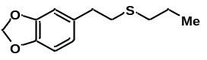
0.2 mmol scale. Purification by PTLC (Hexane: ethyl acetate=20:1) afforded 41.6 mg (93%). Physical State: colorless oil. R_{f}= 0.30 (Hexane: ethyl acetate=20:1)
¹H NMR (400 MHz, Chloroform-d) δ 6.75 – 6.63 (m, 3H), 5.92 (s, 2H), 2.82 – 2.78 (m, 2H), 2.74 – 2.70 (m, 2H), 2.53 – 2.46 (m, 2H), 1.62 (m, 2H), 0.99 (t, J = 7.2 Hz, 3H)
¹³C NMR (101 MHz, Chloroform-d) δ 147.7, 146.1, 134.7, 121.4, 109.0, 108.3, 101.0, 36.2, 34.5, 34.0, 23.1, 13.6.
HRMS(ESI) m/z: calced for C₁₂H₁₇O₂S⁺ [M+H]⁺: 225.0944, found: 225.0943.
Compound 42
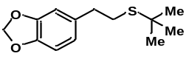
0.2 mmol scale. Purification by PTLC (Hexane: ethyl acetate=20:1) afforded 42mg (93%). Physical State: colorless oil. R_{f}= 0.30 (Hexane: ethyl acetate=20:1)
¹H NMR (400 MHz, Chloroform-d) δ 6.77 – 6.56 (m, 3H), 5.92 (s, 2H), 2.92 – 2.54 (m, 4H), 1.33 (s, 9H).
¹³C NMR (101 MHz, Chloroform-d) δ 148.0, 146.4, 135.2, 121.7, 109.3, 108.6, 101.3, 42.6, 36.5 , 31.4, 30.7.
HRMS(ESI) m/z: calced for C₁₃H₁₉O₂S⁺ [M+H]⁺: 239.1100, found: 239.1101.
Compound 43
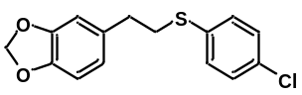
0.2 mmol scale. Purification by PTLC (Hexane: ethyl acetate=20:1) afforded 54 mg (91%). Physical State: colorless oil. R_{f}= 0.30 (Hexane: ethyl acetate=20:1)
¹H NMR (400 MHz, Chloroform-d) δ 7.26 (s, 4H), 6.96 – 6.49 (m, 3H), 5.92 (s, 2H), 3.10 (m, 2H), 2.83 (m, 2H).
¹³C NMR (101 MHz, Chloroform-d) δ 133.4, 130.3, 128.8, 121.2, 108.6, 108.0, 100.7, 35.3, 35.0.
All data matched that reported in the literature^{[11]}
Compound 44
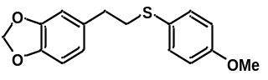
0.2 mmol scale. Purification by PTLC (Hexane: ethyl acetate=20:1) afforded 52 mg (90%). Physical State: colorless oil. R_{f}= 0.30 (Hexane: ethyl acetate=20:1)
¹H NMR (400 MHz, Chloroform-d) δ 7.41 – 7.30 (m, 2H), 6.92 – 6.82 (m, 2H), 6.77 – 6.57 (m, 3H), 5.92 (s, 2H), 3.81 (s, 3H), 3.07 – 2.96 (m, 2H), 2.86 – 2.70 (m, 2H).
¹³C NMR (101 MHz, Chloroform-d) δ 159.0, 147.7, 146.1, 134.3, 133.3, 126.4, 121.5, 114.7, 109.1, 108.3, 101.0, 55.4, 37.6, 35.7.
HRMS(ESI) m/z: calced for C₁₆H₁₇O₃S⁺ [M+H]⁺: 289.0893, found: 289.0892.
Compound 46
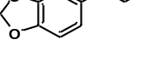
0.2 mmol scale. Purification by PTLC (Hexane: ethyl acetate=20:1) afforded 52 mg (97%). Physical State: colorless oil. R_{f}= 0.30 (Hexane: ethyl acetate=20:1)
¹H NMR (400 MHz, Chloroform-d) δ 6.76 (d, J = 7.9 Hz, 1H), 6.71 (d, J = 1.7 Hz, 1H), 6.67 (m, 1H), 5.94 (s, 2H), 3.66 (t, J = 7.4 Hz, 2H), 2.98 (t, J = 7.4 Hz, 2H).
¹³C NMR (101 MHz, Chloroform-d) δ 148.9, 144.5, 132.0, 122.0, 109.3, 108.5, 101.1, 45.3, 39.0.
All data matched that reported in the literature ^{[12]}
Compound 47
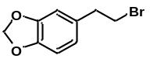
0.2 mmol scale. Purification by PTLC (Hexane: ethyl acetate=20:1) afforded 52 mg (97%). Physical State: colorless oil. R_{f}= 0.30 (Hexane: ethyl acetate=20:1)
¹H NMR (400 MHz, Chloroform-d) δ 6.76 (d, J = 7.9 Hz, 1H), 6.71 – 6.61 (m, 2H), 5.94 (s, 2H), 3.52 (t, J = 7.6 Hz, 2H), 3.07 (t, J = 7.6 Hz, 2H).
¹³C NMR (101 MHz, Chloroform-d) δ 147.9, 146.6, 132.8, 121.9, 109.1, 108.5, 101.1, 39.2, 33.4.
All data matched that reported in the literature ^{[19]}
Compound 48
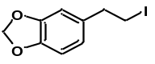
0.2 mmol scale. Purification by PTLC (Hexane: ethyl acetate=20:1) afforded 52 mg (97%). Physical State: colorless oil. R_{f}= 0.30 (Hexane: ethyl acetate=20:1)
¹H NMR (400 MHz, Chloroform-d) δ 6.75 (m, 1H), 6.70 – 6.54 (m, 2H), 5.94 (s, 2H), 3.38 – 3.16 (m, 2H), 3.08 (t, J = 7.7 Hz, 2H).
¹³C NMR (101 MHz, Chloroform-d) δ 147.9, 146.5, 134.6, 121.5, 108.8, 108.5, 101.1, 40.2, 6.2.
All data matched that reported in the literature ^{[20]}
Compound 49
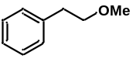
0.2 mmol scale. Purification by PTLC (Hexane: ethyl acetate=20:1) afforded 18 mg (66%). Physical State: colorless oil. R_{f}= 0.60 (Hexane: ethyl acetate=25:1)
¹H NMR (400 MHz, Chloroform-d) δ 7.41 – 7.26 (m, 5H), 3.68 (t, J = 7.1 Hz, 2H), 3.43 (s, 3H), 2.97 (t, J = 7.1 Hz, 2H).
¹³C NMR (101 MHz, Chloroform-d) δ 139.0, 128.9, 128.4, 126.2, 73.7, 58.7, 36.3.
All data matched that reported in the literature ^{[16]}
Compound 50
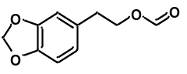
0.2 mmol scale. Purification by PTLC (Hexane: ethyl acetate=20:1) afforded 33.3 mg (86%). Physical State: colorless oil. R_{f}= 0.30 (Hexane: ethyl acetate=10:1)
¹H NMR (400 MHz, Chloroform-d) δ 8.04 (s, 1H), 6.98 – 6.58 (m, 3H), 5.93 (s, 2H), 4.87 – 3.96 (m, 2H), 2.89 (t, J = 7.0 Hz, 2H).
¹³C NMR (101 MHz, Chloroform-d) δ 161.1, 147.9, 146.5, 131.2, 122.0, 109.4, 108.5, 101.1, 64.7, 34.8.
HRMS(ESI) m/z: calced for C₁₀H₁₀NaO₄⁺ [M+Na]⁺: 217.0471, found: 217.0469.
Compound 51
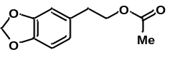
0.2 mmol scale. Purification by PTLC (Hexane: ethyl acetate=20:1) afforded 37.4 mg (90%). Physical State: colorless oil. R_{f}= 0.30 (Hexane: ethyl acetate=10:1)
¹H NMR (500 MHz, Chloroform-d) δ 6.79 – 6.51 (m, 3H), 5.91 (s, 2H), 4.21 (t, J = 7.0 Hz, 2H), 2.83 (t, J = 7.0 Hz, 2H), 2.03 (s, 3H).
¹³C NMR (126 MHz, Chloroform-d) δ 170.8, 147.5, 146.0, 131.4, 121.6, 109.1, 108.1, 100.8, 64.9, 34.6, 20.8.
HRMS(ESI) m/z: calced for C₁₁H₁₂NaO₄⁺ [M+Na]⁺: 231.0628, found: 231.0630.
Compound 52
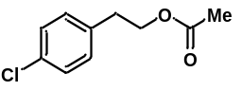
0.2 mmol scale. Purification by PTLC (Hexane: ethyl acetate=20:1) afforded 31 mg (78%). Physical State: colorless oil. R_{f}= 0.30 (Hexane: ethyl acetate=10:1)
¹H NMR (400 MHz, Chloroform-d) δ 7.31 – 7.24 (m, 2H), 7.19 – 7.11 (m, 2H), 4.25 (t, J = 6.9 Hz, 2H), 2.90 (t, J = 7.0 Hz, 2H), 2.03 (s, 3H).
¹³C NMR (101 MHz, Chloroform-d) δ 171.4, 136.8, 132.9, 130.7, 129.1, 65.0, 34.9, 21.4.
HRMS(ESI) m/z: calced for C₁₀H₁₁ClNaO₂⁺ [M+Na]⁺: 221.0340, found: 221.0339.
Compound 53
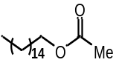
0.2 mmol scale. Purification by PTLC (Hexane: ethyl acetate=20:1) afforded 37.5 mg (66%). Physical
State: colorless oil. R_{f}= 0.30 (Hexane: ethyl acetate=10:1)
¹H NMR (500 MHz, Chloroform-d) δ 4.05 (s, 2H), 2.04 (s, 3H), 1.76 – 1.53 (m, 2H), 1.33 – 1.26 (m, 26H), 0.88 (t, J = 6.9 Hz, 3H).
¹³C NMR (126 MHz, Chloroform-d) δ 171.2, 64.6, 31.8, 29.59, 29.59, 29.57, 29.56, 29.56, 29.54, 29.47, 29.42, 29.3, 29.2, 28.5, 25.8, 22.6, 20.9, 14.0.
HRMS(ESI) m/z: calced for C₁₇H₁₄F₃NNaO₃⁺ [M+Na]⁺: 307.2608, found: 307.2606.
Compound 54
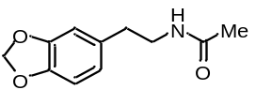
0.2 mmol scale. Purification by PTLC (Hexane: ethyl acetate=20:1) afforded 33.5 mg (81%). Physical State: colorless oil. R_{f}= 0.30 (Hexane: ethyl acetate=5:1)
¹H NMR (400 MHz, Chloroform-d) δ 6.84 – 6.52 (m, 3H), 5.94 (s, 2H), 5.45 (s, 1H), 3.57 – 3.28 (m, 2H), 2.72 (t, J = 6.9 Hz, 2H), 1.94 (s, 3H).
¹³C NMR (101 MHz, Chloroform-d) δ 170.5, 148.3, 146.7, 133.0, 122.1, 109.5, 108.8, 101.4, 41.3, 35.9, 23.8.
All data matched that reported in the literature ^{[14]}
Compound 55
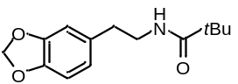
0.2 mmol scale. Purification by PTLC (Hexane: ethyl acetate=20:1) afforded 43 mg (86%). Physical State: colorless oil. R_{f}= 0.30 (Hexane: ethyl acetate=5:1)
¹H NMR (400 MHz, Chloroform-d) δ 6.93 – 6.45 (m, 3H), 5.93 (s, 2H), 5.71 (s, 1H), 3.61 – 3.17 (m, 2H), 2.72 (t, J = 6.9 Hz, 2H), 1.15 (s, 9H).
¹³C NMR (101 MHz, Chloroform-d) δ 178.8, 148.2, 146.6, 133.2, 122.1, 109.5, 108.7, 101.3, 41.2, 39.1, 35.8, 28.0.
All data matched that reported in the literature ^{[15]}
Compound 56
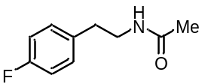
0.2 mmol scale. Purification by PTLC (Hexane: ethyl acetate=20:1) afforded 26.8 mg (74%). Physical State: colorless oil. R_{f}= 0.30 (Hexane: ethyl acetate=4:1)
¹H NMR (400 MHz, Chloroform-d) δ 7.15 – 7.11 (m, 2H), 7.00 – 6.94 (m, 2H), 5.86 (s, 1H), 3.46 (m, 2H), 2.77 (t, J = 7.1 Hz, 2H), 2.06 (s, 3H).
¹³C NMR (101 MHz, Chloroform-d) δ 171.0, 161.7 (d, J = 244.6 Hz), 134.5 (d, J = 3.3 Hz), 130.2 (d, J = 8.0 Hz), 115.5 (d, J = 21.2 Hz), 41.0, 34.8, 23.2.
¹⁹F NMR (376 MHz, Chloroform-d) δ -116.60.
All data matched that reported in the literature^{[15]}
Compound 57
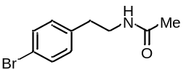
0.2 mmol scale. Purification by PTLC (Hexane: ethyl acetate=20:1) afforded 38.6 mg (80%). Physical State: colorless oil. R_{f}= 0.30 (Hexane: ethyl acetate=4:1)
¹H NMR (400 MHz, Chloroform-d) δ 7.61 – 7.33 (m, 2H), 7.20 – 6.82 (m, 2H), 5.72 (s, 1H), 3.45 m, 2H), 2.75 (t, J = 7.0 Hz, 2H), 1.92 (s, 3H).
¹³C NMR (101 MHz, Chloroform-d) δ 170.0, 137.7, 131.4, 130.2, 120.1, 40.3, 34.9, 23.0.
All data matched that reported in the literature^{[17]}
Compound 58
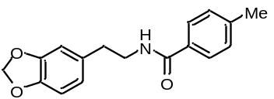
0.2 mmol scale. Purification by PTLC (Hexane: ethyl acetate=20:1) afforded 45 mg (80%). Physical State: colorless oil. R_{f}= 0.50 (Hexane: ethyl acetate=4:1)
¹H NMR (400 MHz, Chloroform-d) δ 7.70 – 7.56 (m, 2H), 7.20 (d, J = 7.9 Hz, 2H), 6.82 – 6.56 (m, 3H), 6.18 (s, 1H), 5.93 (s, 2H), 3.69 – 3.60 (m, 2H), 2.83 (t, J = 6.9 Hz, 2H), 2.38 (s, 3H).
¹³C NMR (101 MHz, Chloroform-d) δ 167.5, 148.0, 146.4, 141.9, 132.8, 131.9, 129.3, 126.9, 121.8, 109.2, 108.5, 101.0, 41.4, 35.6, 21.5.
All data matched that reported in the literature^{[18]}
Compound 59
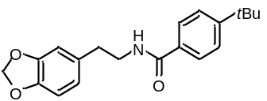
0.2 mmol scale. Purification by PTLC (Hexane: ethyl acetate=20:1) afforded 56 mg (76%). Physical State: colorless oil. R_{f}= 0.50 (Hexane: ethyl acetate=4:1)
¹H NMR (400 MHz, Chloroform-d) δ 7.69 – 7.58 (m, 2H), 7.53 – 7.36 (m, 2H), 6.83 – 6.57 (m, 3H), 6.10 (s, 1H), 5.94 (s, 2H), 3.66 (t, J = 6.6 Hz, 2H), 2.84 (t, J = 6.8 Hz, 2H), 1.32 (s, 9H).
¹³C NMR (101 MHz, Chloroform-d) δ 167.5, 155.0, 148.1, 146.4, 132.8, 131.9, 126.8, 125.7, 121.9, 109.2, 108.6, 101.1, 41.3, 39.0, 35.6, 31.3.
All data matched that reported in the literature^{[18]}
Compound 60
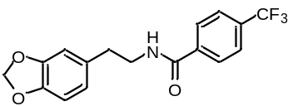
0.2 mmol scale. Purification by PTLC (Hexane: ethyl acetate=20:1) afforded 44.5 mg (66%). Physical State: colorless oil. R_{f}= 0.50 (Hexane: ethyl acetate=4:1)
¹H NMR (400 MHz, Chloroform-d) δ 7.83 – 7.76 (m, 2H), 7.67 (d, J = 8.1 Hz, 2H), 6.80 – 6.59 (m, 3H), 6.18 (s, 1H), 5.94 (s, 2H), 3.77 – 3.51 (m, 2H), 2.86 (t, J = 6.8 Hz, 2H).
¹³C NMR (101 MHz, Chloroform-d) δ 166.2, 148.0, 146.4, 138.0, 133.2 (q, J = 32.6 Hz), 132.3, 127.3, 125.7 (q, J = 3.7 Hz), 123.6 (q, J = 272.5 Hz), 121.7, 109.0, 108.5, 101.0, 41.4, 35.3, 29.7.
¹⁹F NMR (376 MHz, Chloroform-d) δ -62.98.
HRMS(ESI) m/z: calced for C₁₇H₁₅F₃NO₃⁺ [M+H]⁺: 338.0999, found: 338.1001.
Compound 61
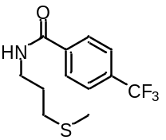
0.2 mmol scale. Purification by PTLC (Hexane: ethyl acetate=20:1) afforded 45.4 mg (82%). Physical State: colorless oil. R_{f}= 0.50 (Hexane: ethyl acetate=4:1)
¹H NMR (400 MHz, Chloroform-d) δ 7.96 – 7.79 (m, 2H), 7.73 – 7.60 (m, 2H), 6.76 (s, 1H), 3.79 – 3.53 (m, 2H), 2.61 (t, J = 6.9 Hz, 2H), 2.11 (s, 3H), 1.94 (t, J = 6.8 Hz, 2H).
¹³C NMR (101 MHz, Chloroform-d) δ 166.1, 137.6, 133.0 (q, J = 32.9 Hz), 127.2, 125.4 (q, J = 3.8 Hz), 123.7 (q, J = 272.5 Hz), 39.4, 31.9, 28.0, 15.3.
¹⁹F NMR (376 MHz, Chloroform-d) δ -62.97.
HRMS(ESI) m/z: calced for C₁₂H₁₅F₃NOS⁺ [M+H]⁺: 278.0821, found: 278.0820.

Spectral data
Compound 3 ¹H NMR
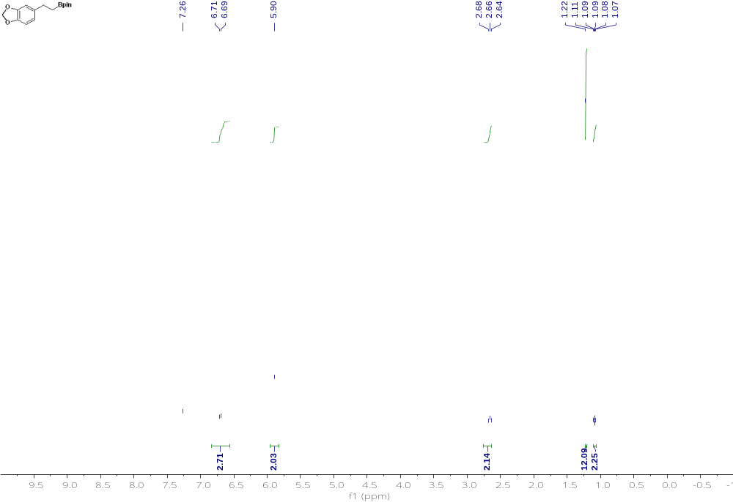 Compound 4 ¹³C NMR 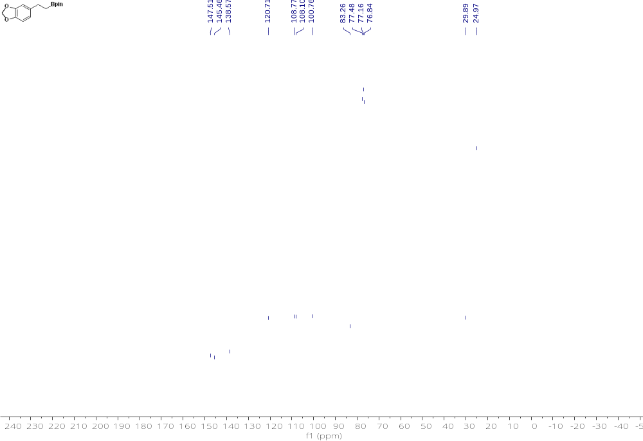

Compound 4 ¹H NMR 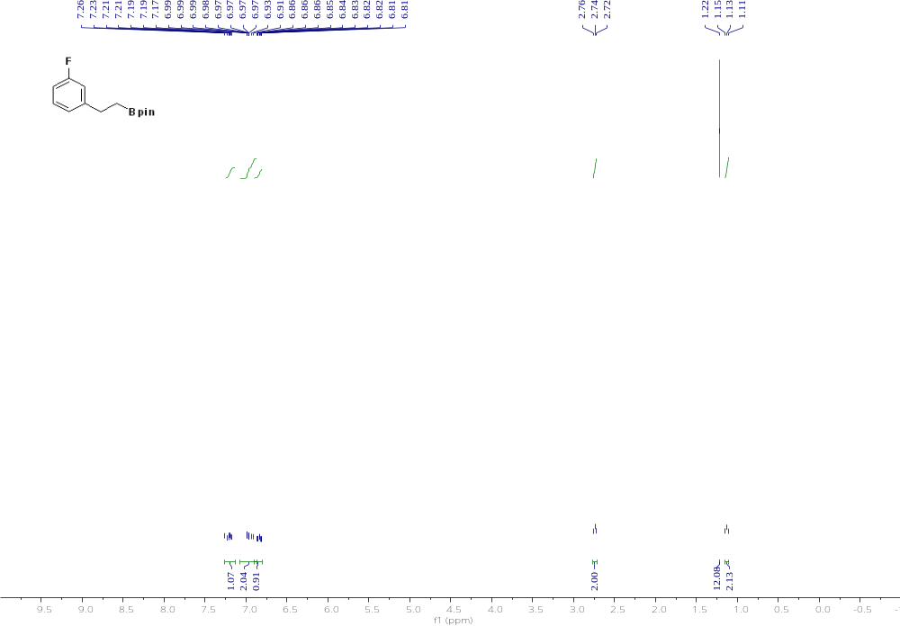 Compound 4 ¹³C NMR
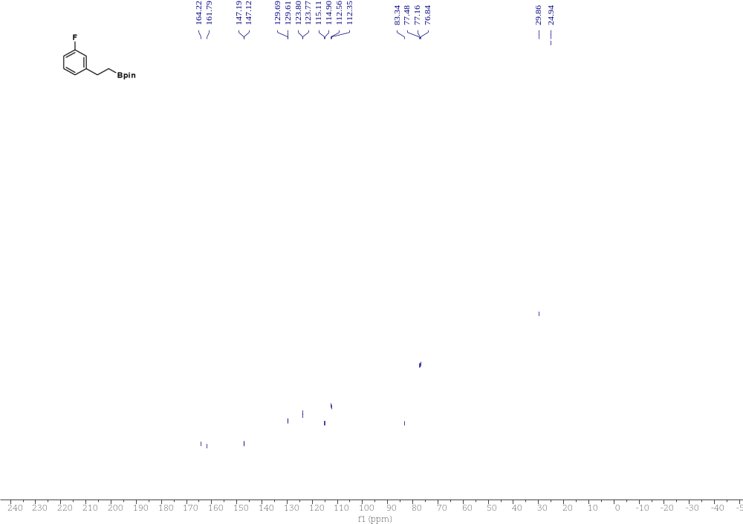

Compound 4 ¹⁹F NMR
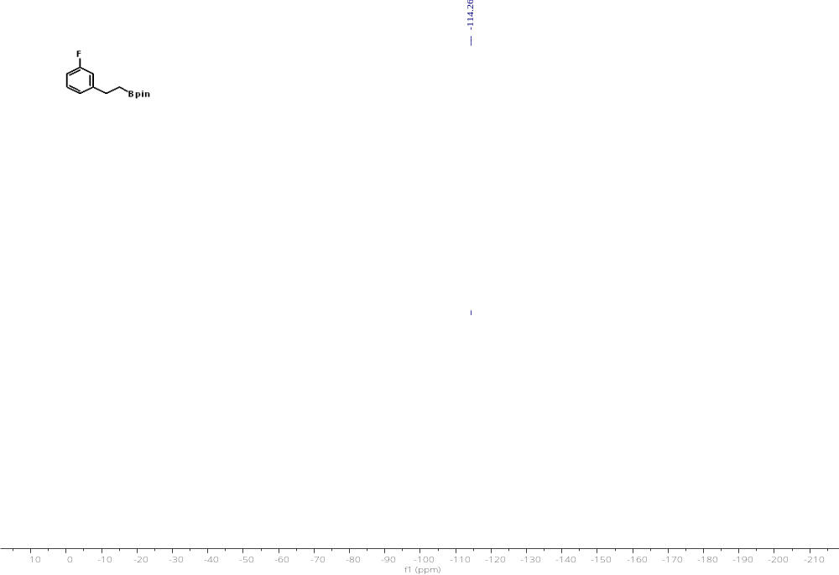

Compound 5 ¹H NMR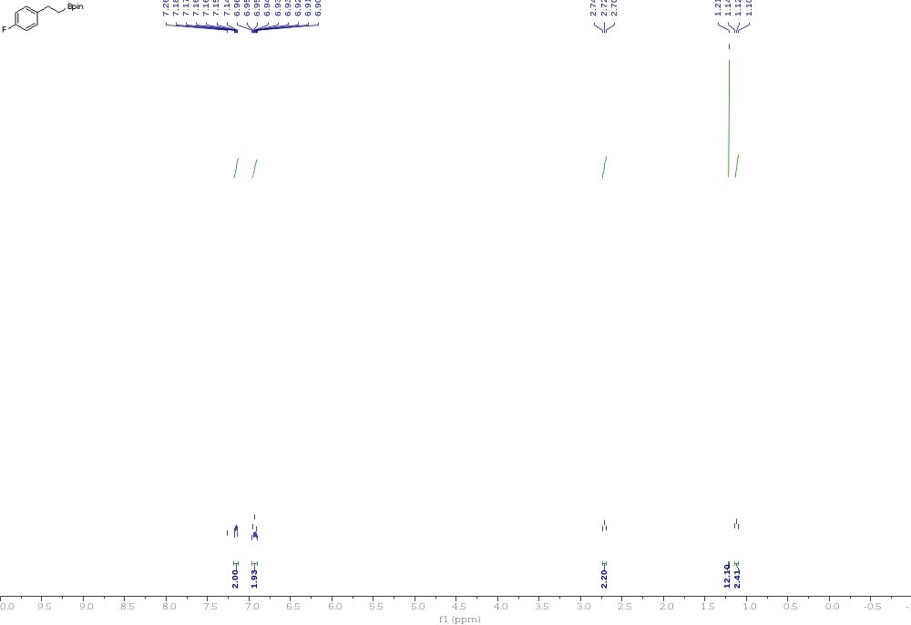

Compound 5 ¹³C NMR 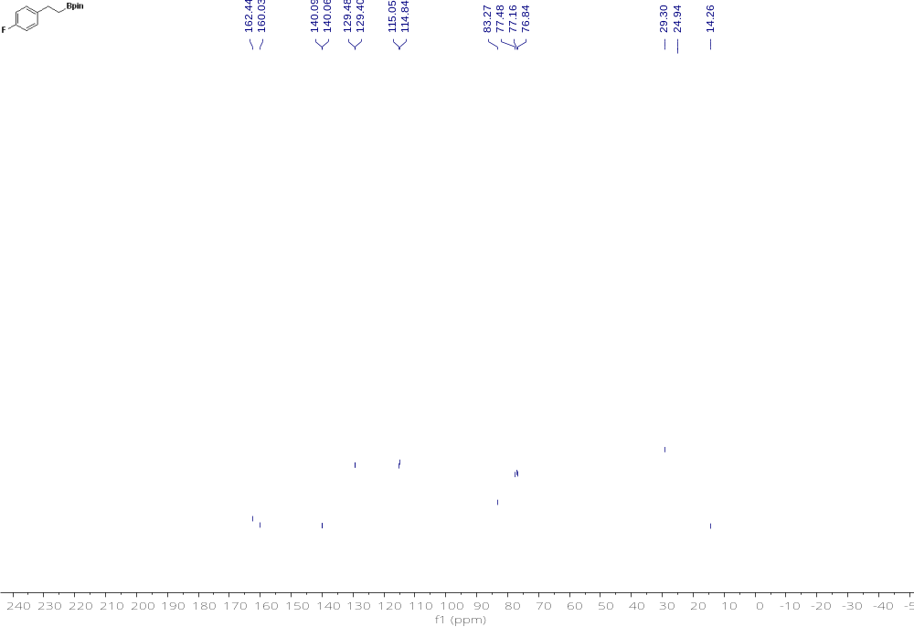

Compound 5 ¹⁹F NMR
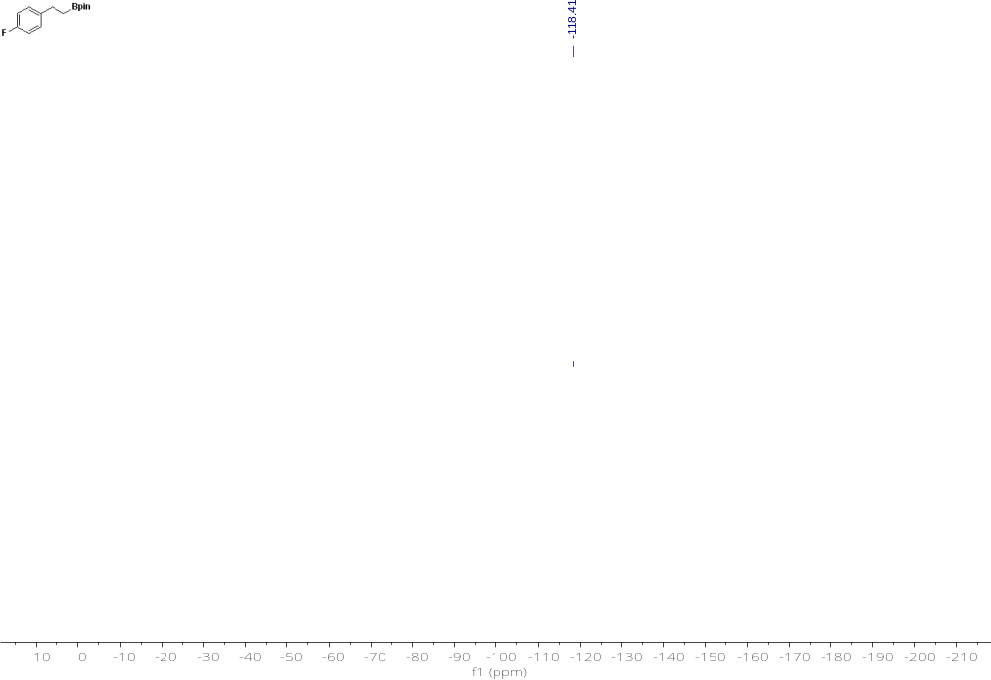

Compound 6 ¹H NMR
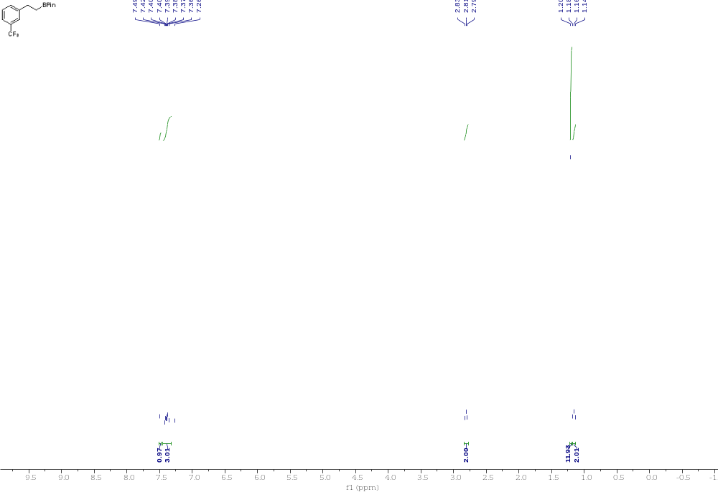

Compound 6 ¹³C NMR
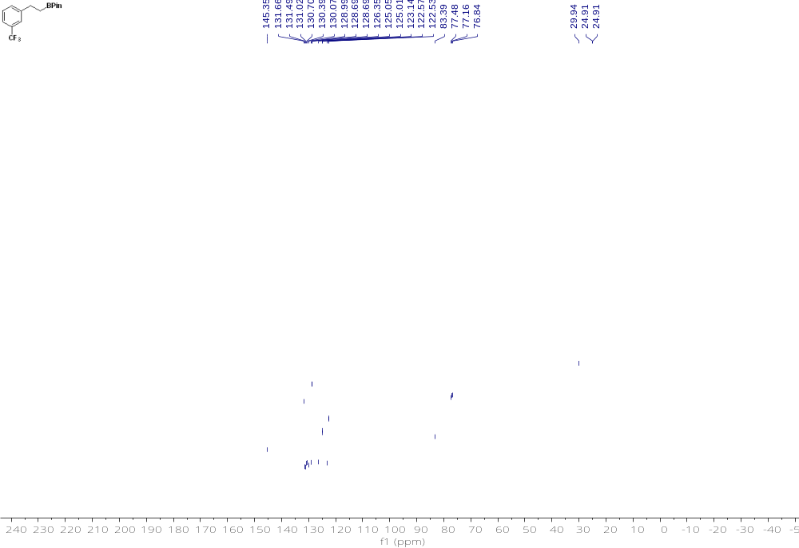

Compound 6 ¹⁹F NMR
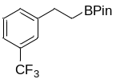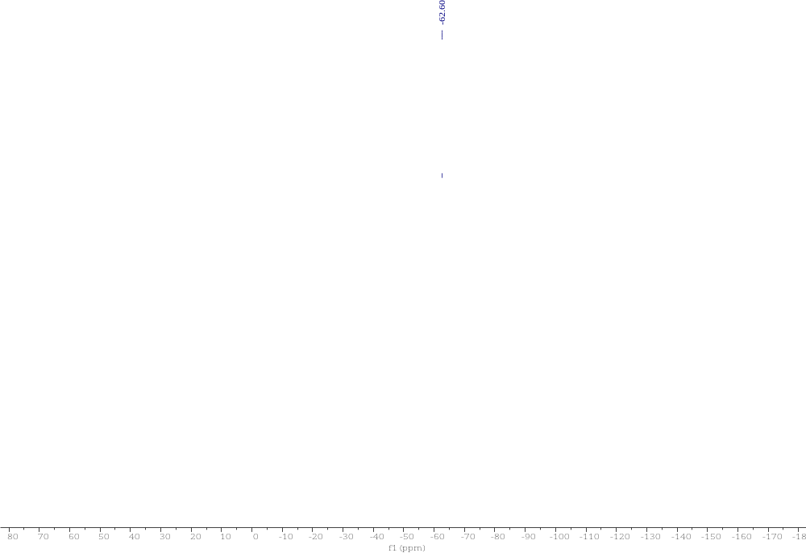

Compound 7 ¹H NMR
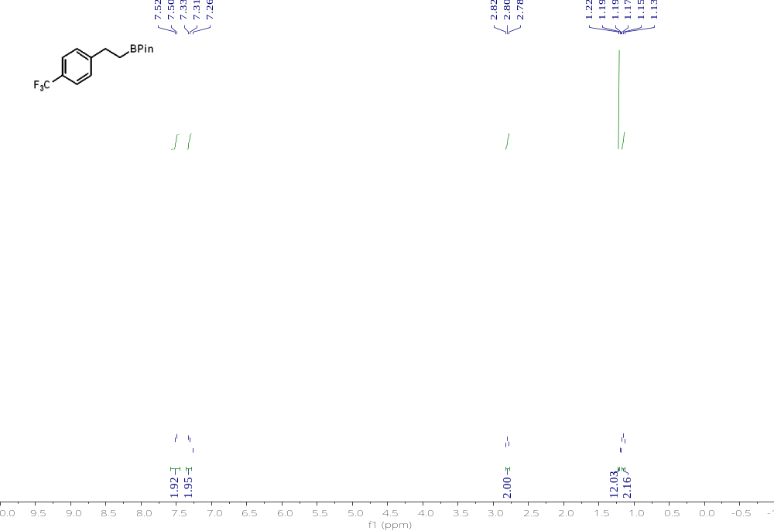

Compound 7 ¹³C NMR
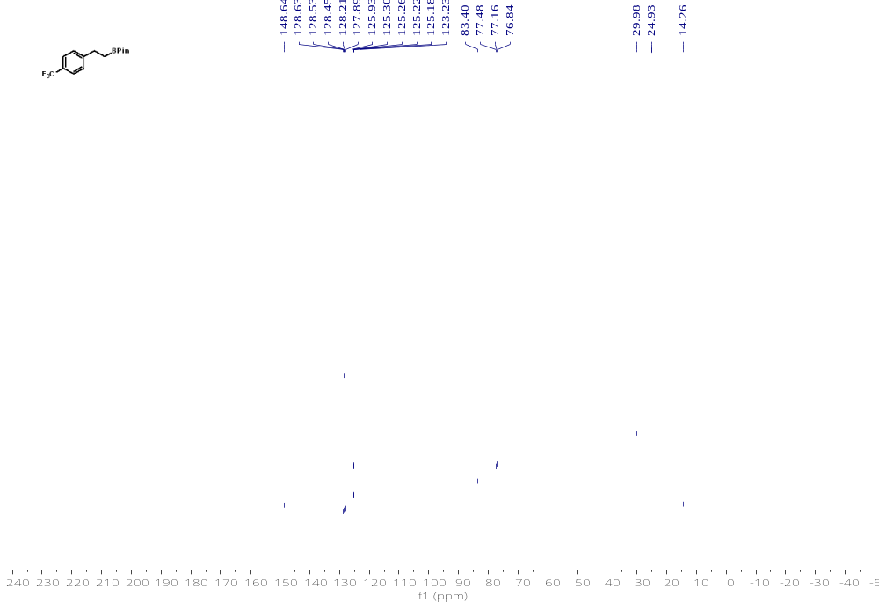

Compound 7 ¹⁹F NMR
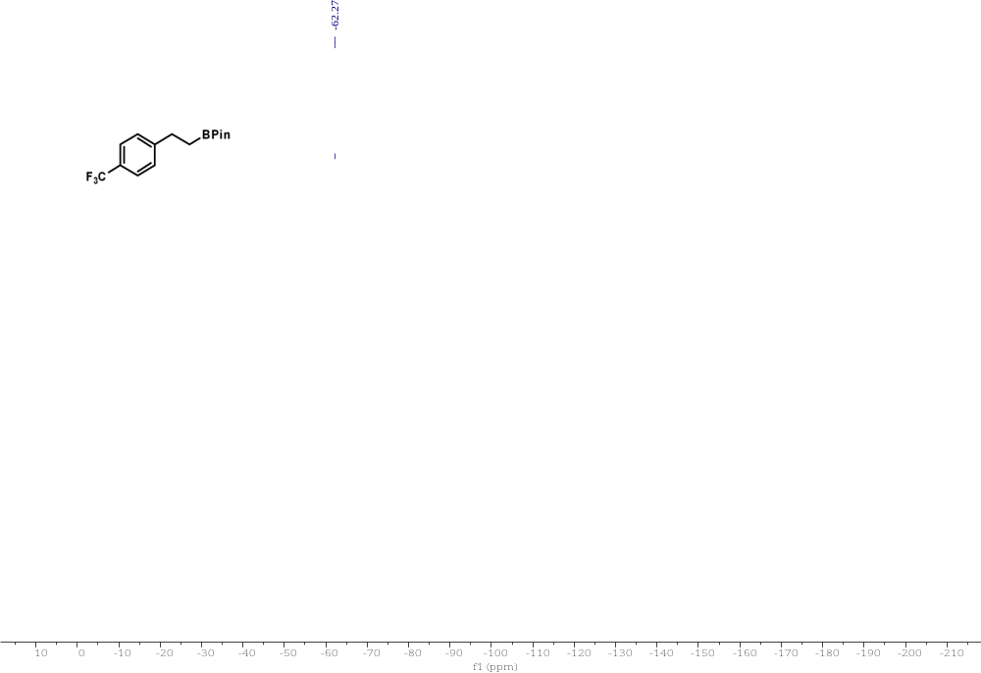

Compound 8 ¹H NMR
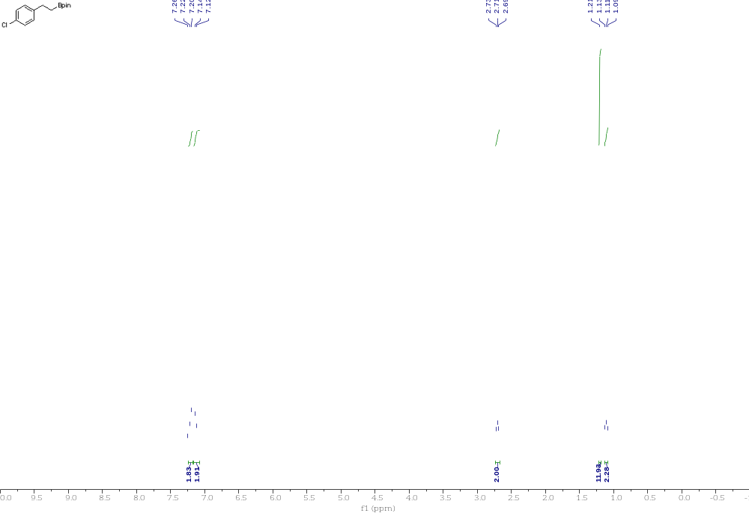

Compound 8 ¹³C NMR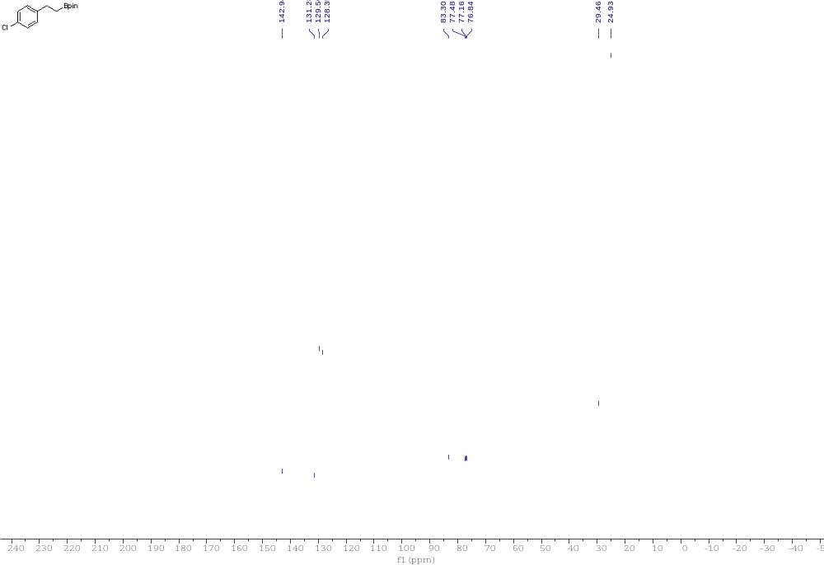

Compound 9 ¹H NMR
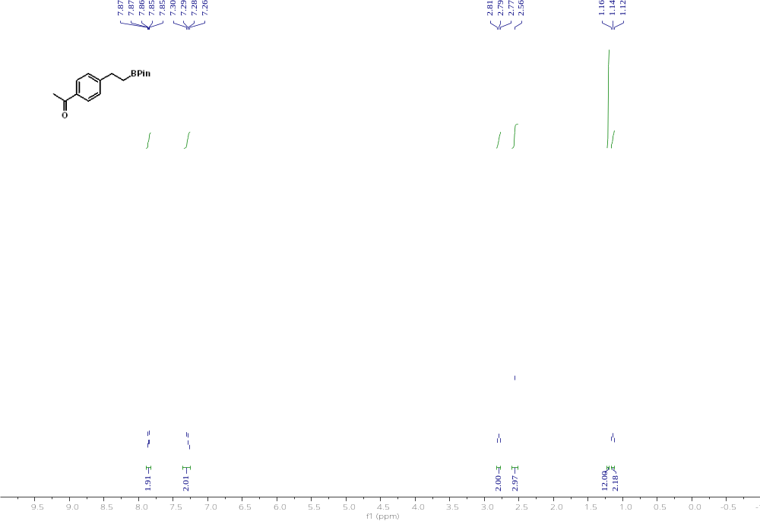

Compound 9 ¹³C NMR 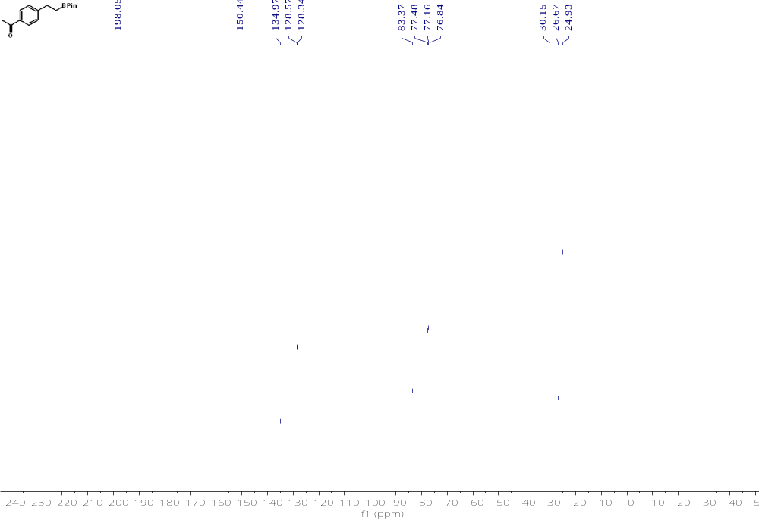

Compound 10 ¹H NMR
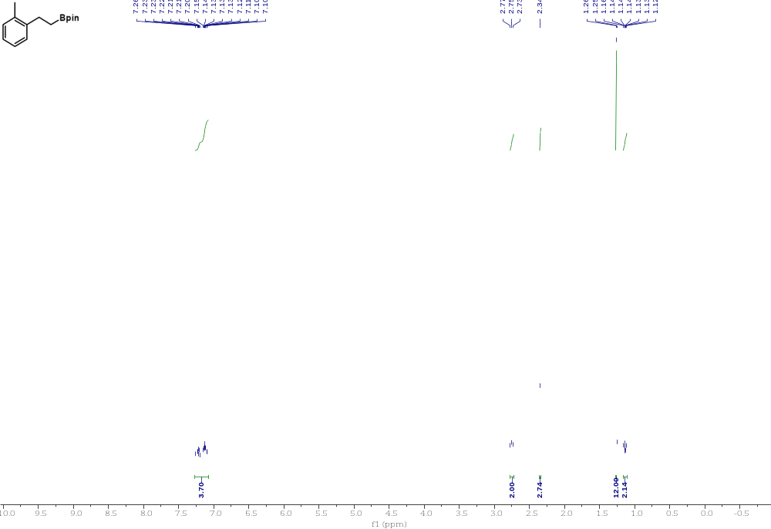

Compound 10 ¹³C NMR
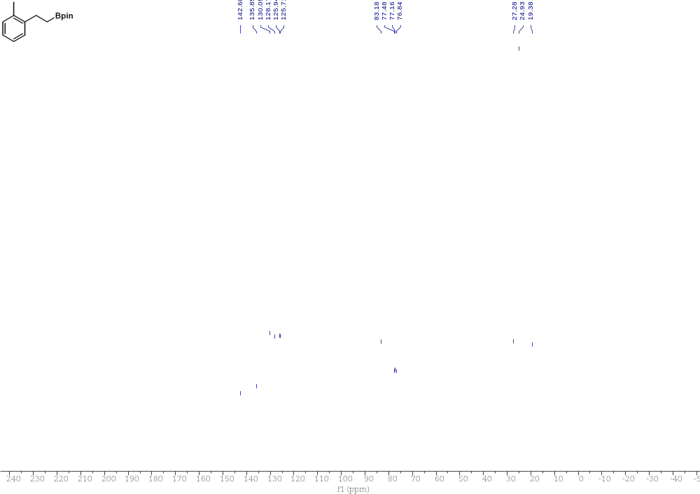

Compound 11 ¹H NMR 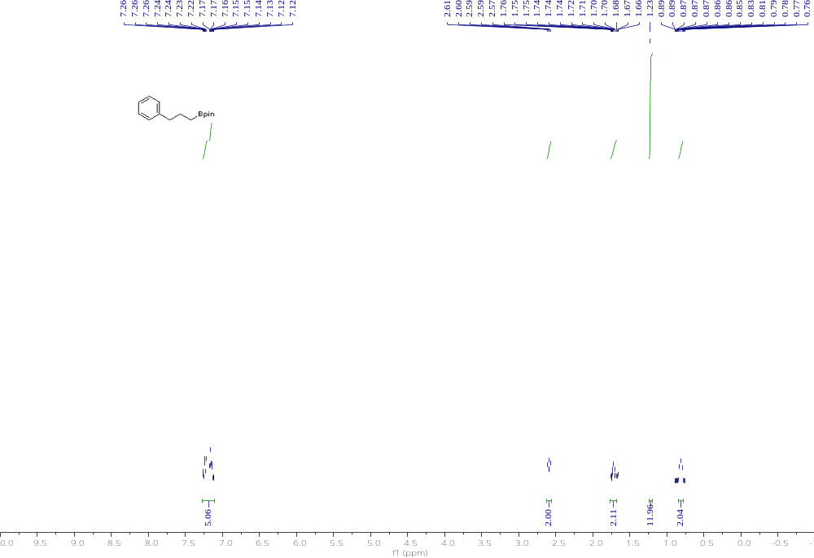

Compound 11 ¹³C NMR 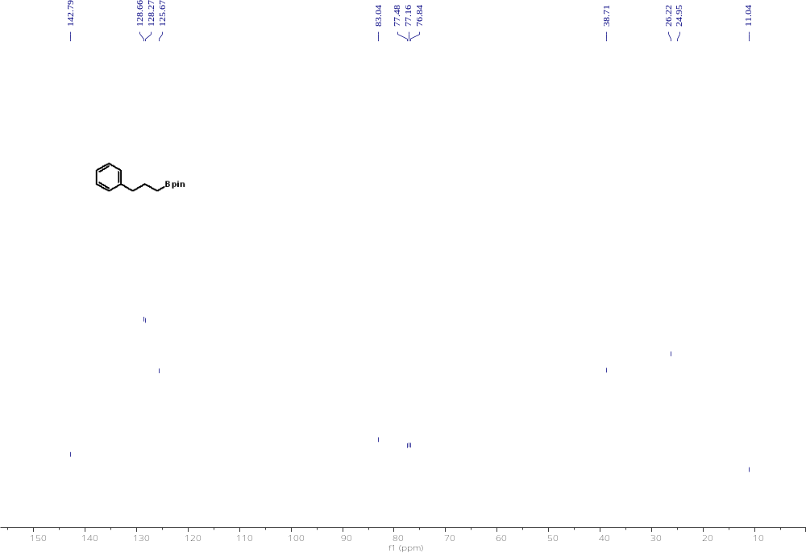

Compound 12 ¹H NMR
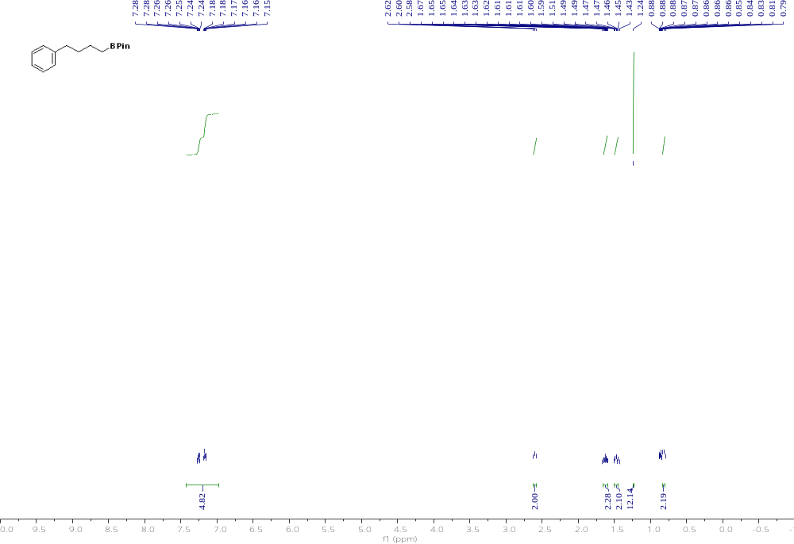

Compound 12 ¹³C NMR 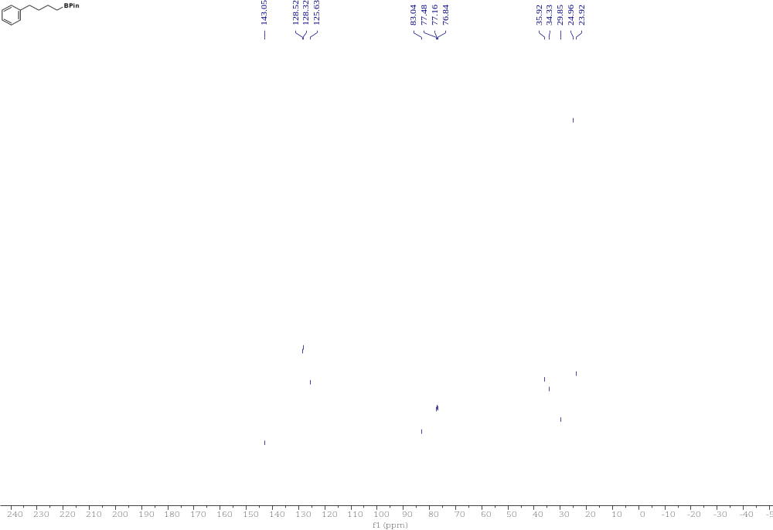

Compound 13 ¹H NMR 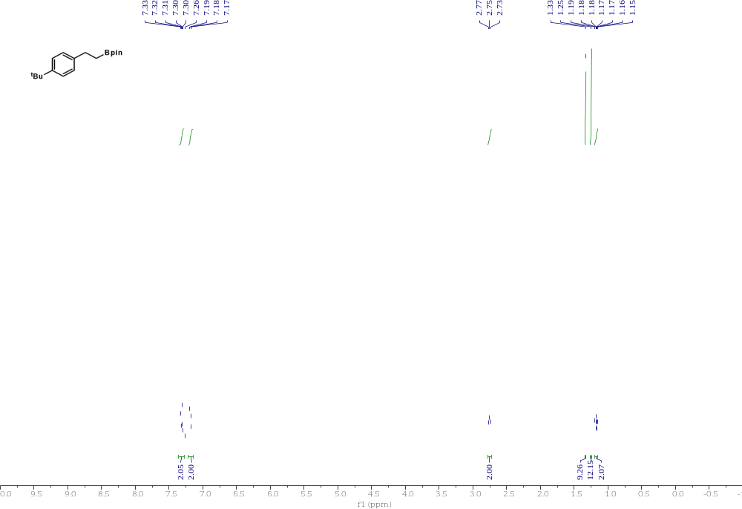

Compound 13 ¹³C NMR
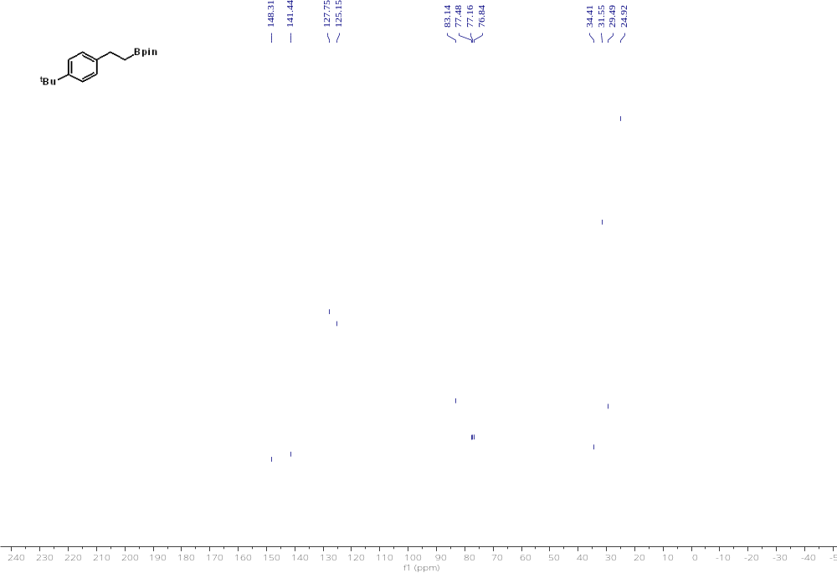

Compound 14 ¹H NMR
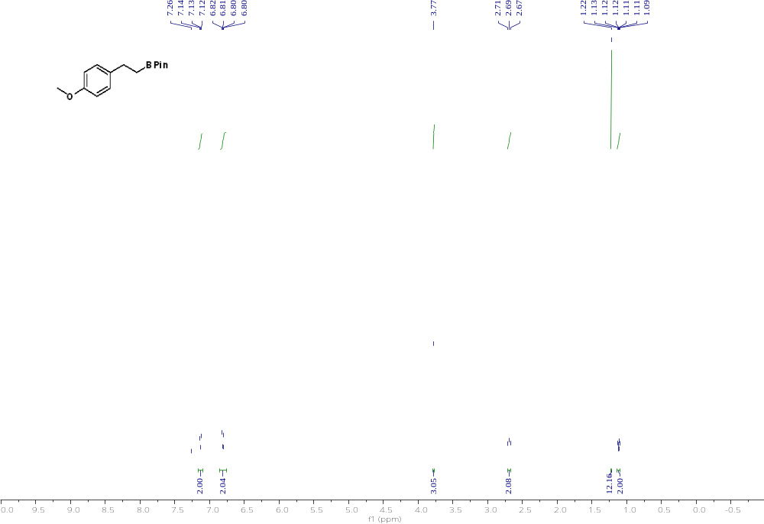

Compound 14 ¹³C NMR 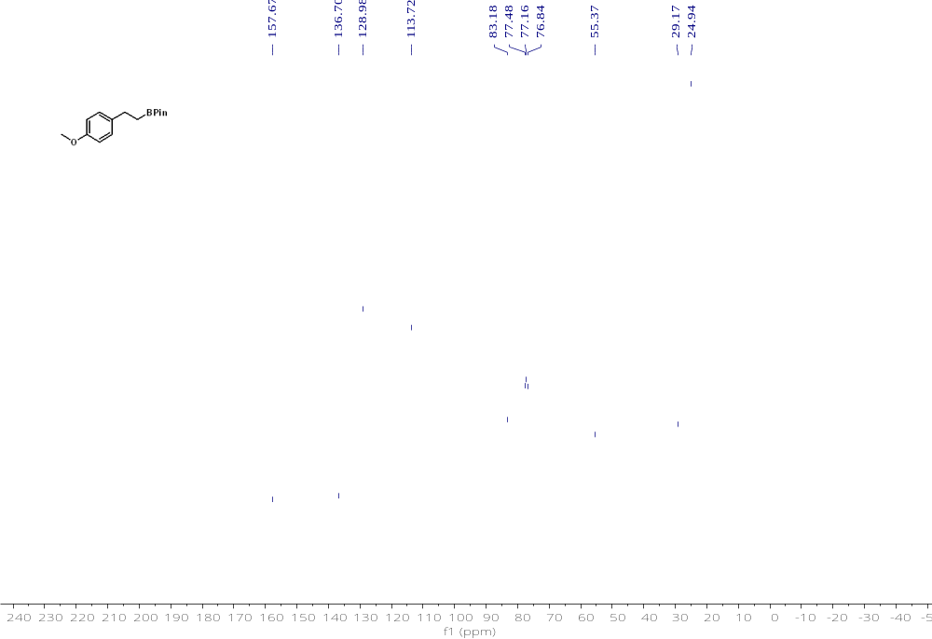
Compound 15 ¹H NMR 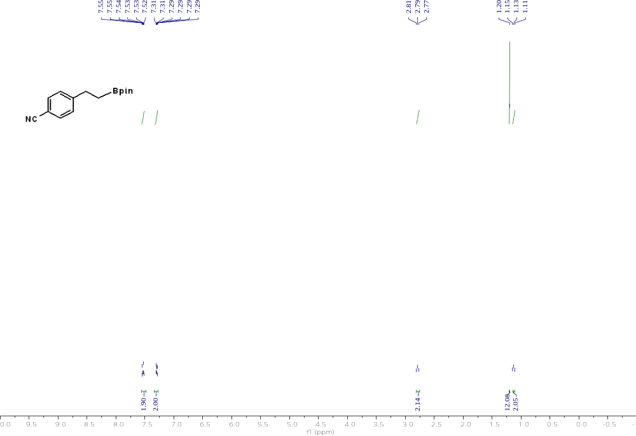

Compound 15 ¹³C NMR
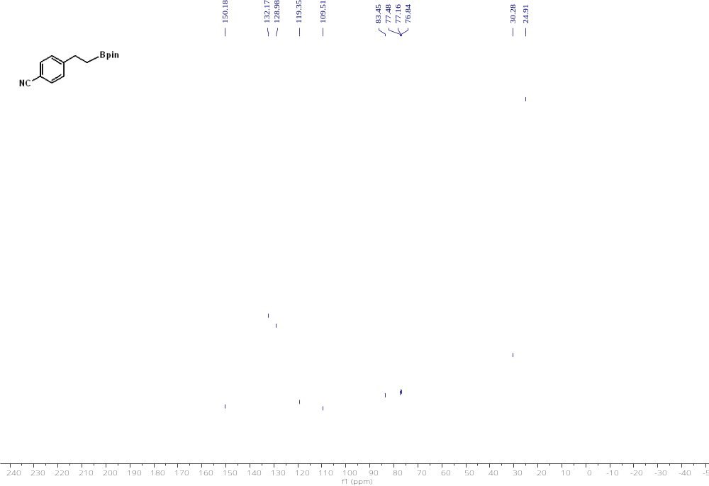

Compound 16 ¹H NMR 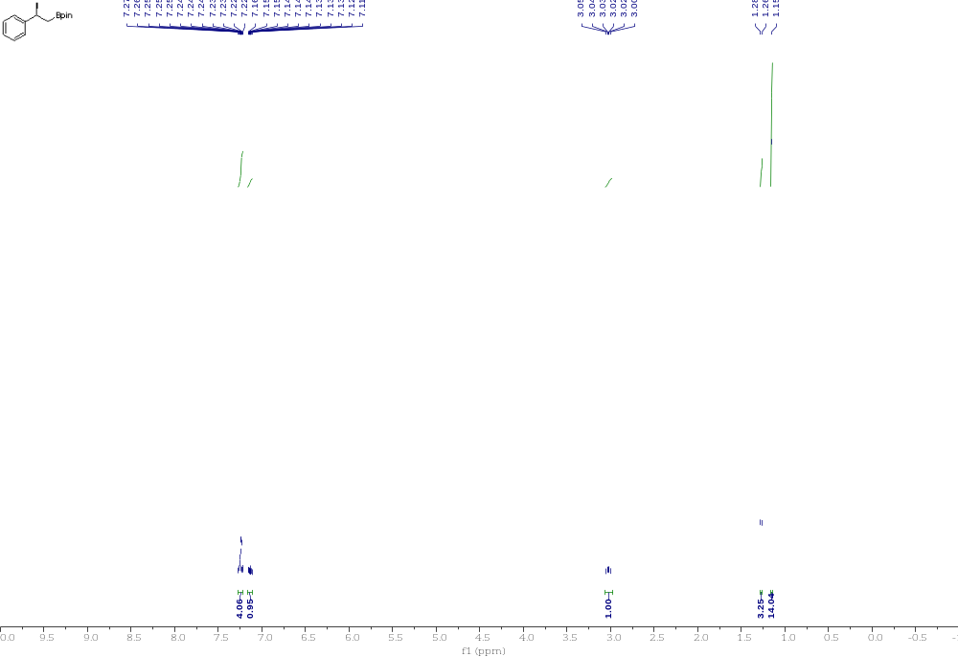
Compound 16 ¹³C NMR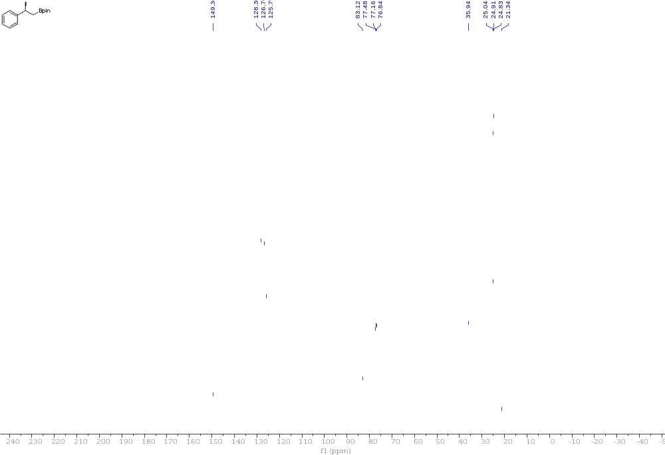

Compound 17 ¹H NMR 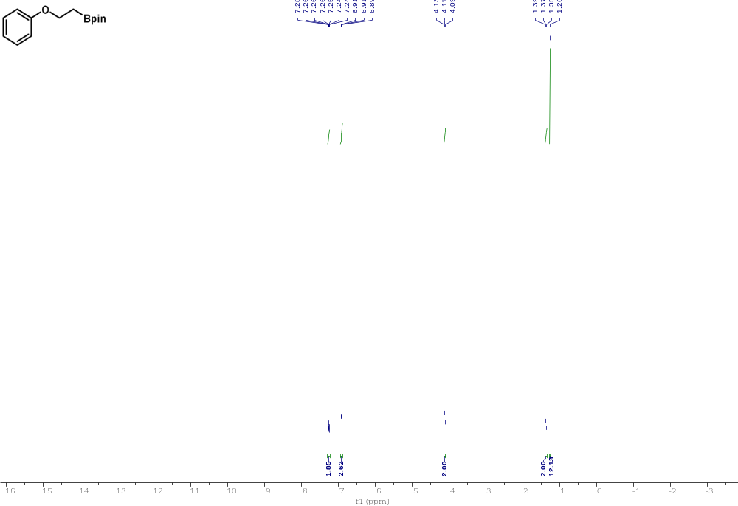

Compound 17 ¹³C NMR 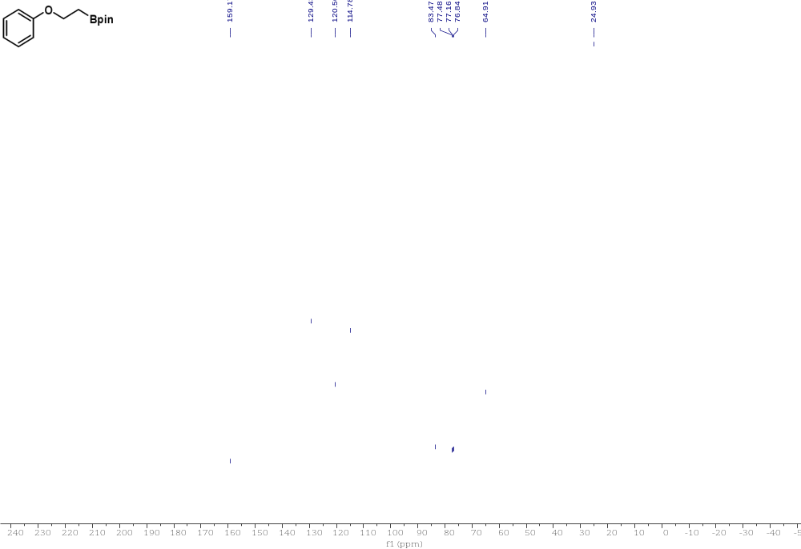

Compound 18 ¹H NMR 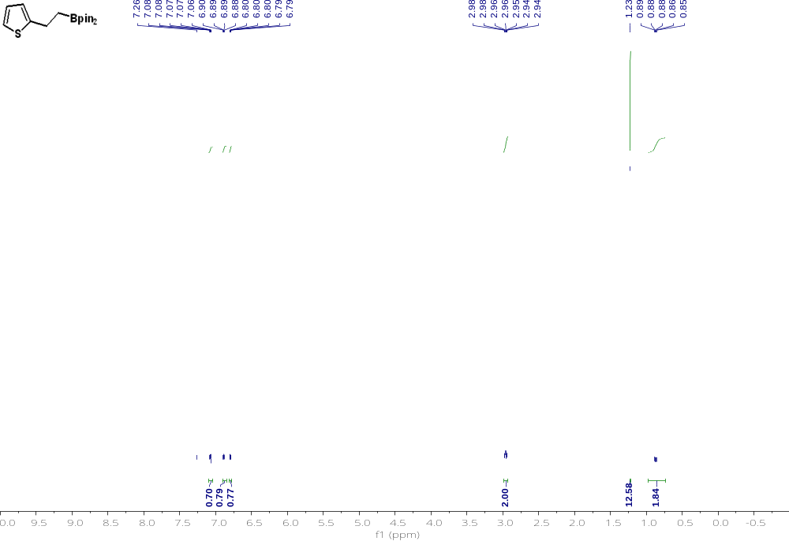

Compound 18 ¹³C NMR 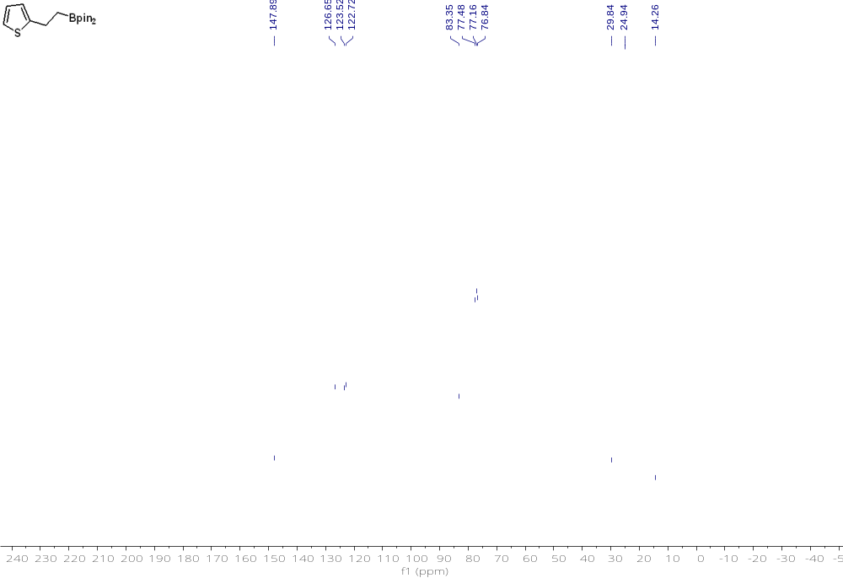

Compound 19 ¹H NMR 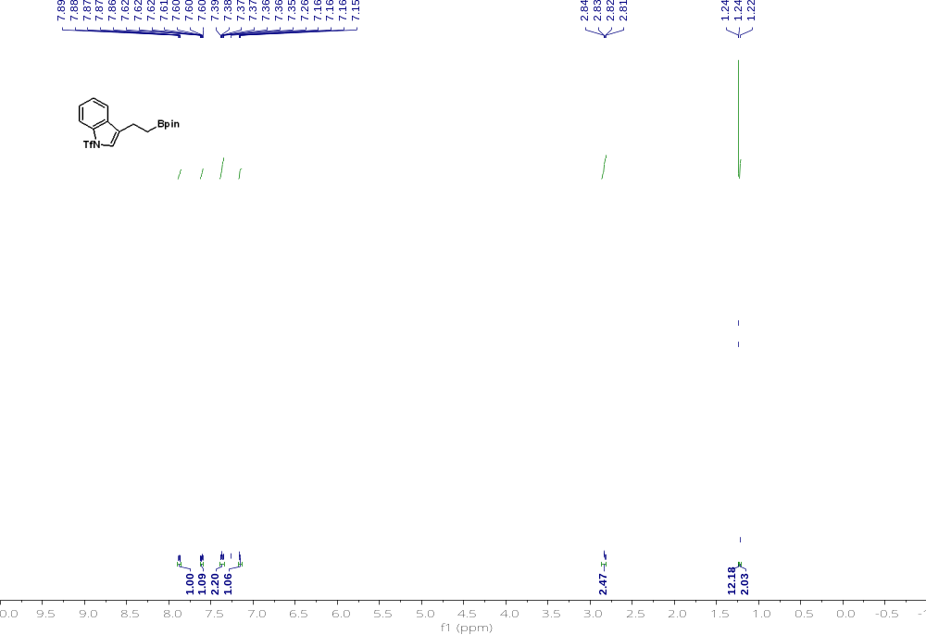

Compound 19 ¹³C NMR 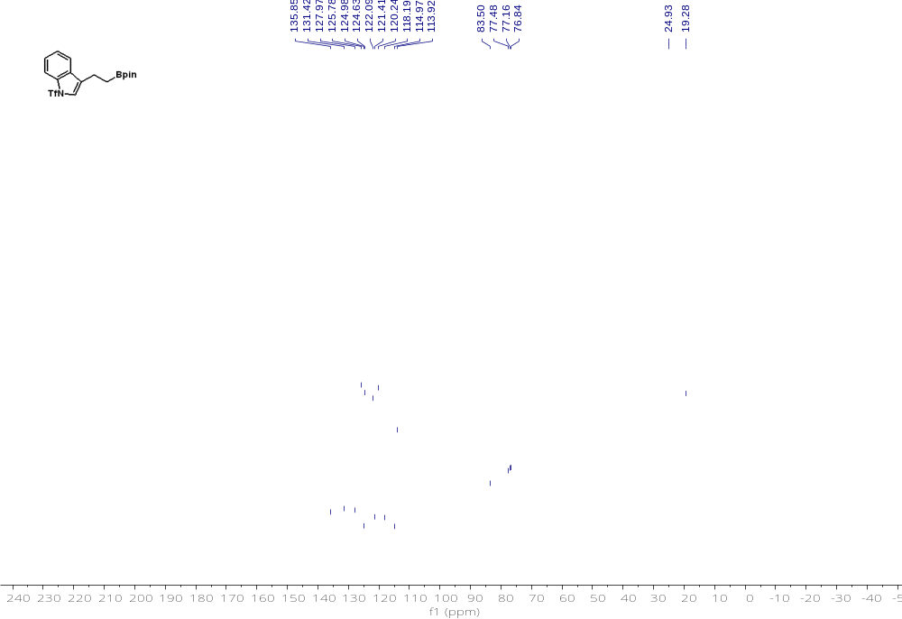

Compound 19 ¹⁹F NMR
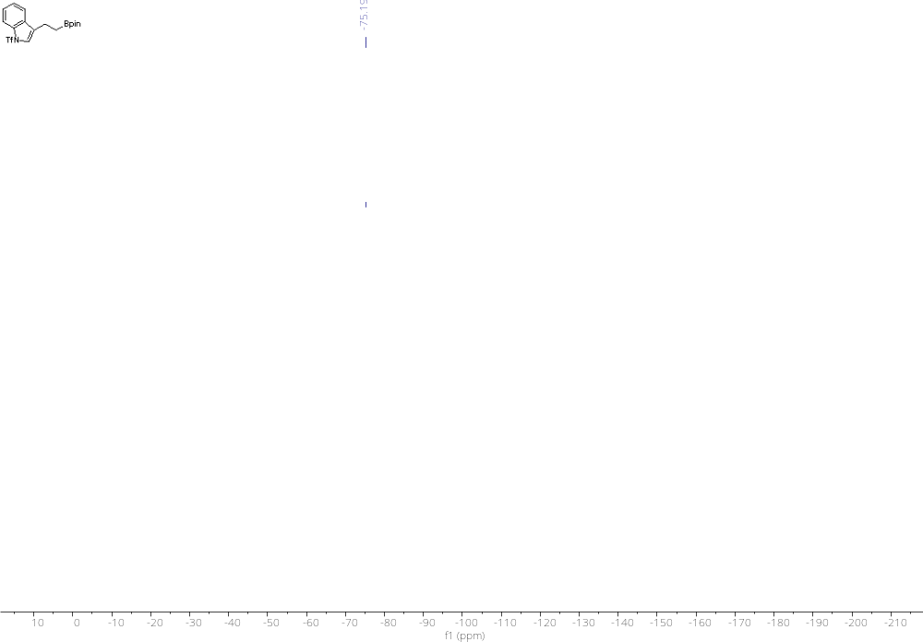

Compound 20 ¹H NMR
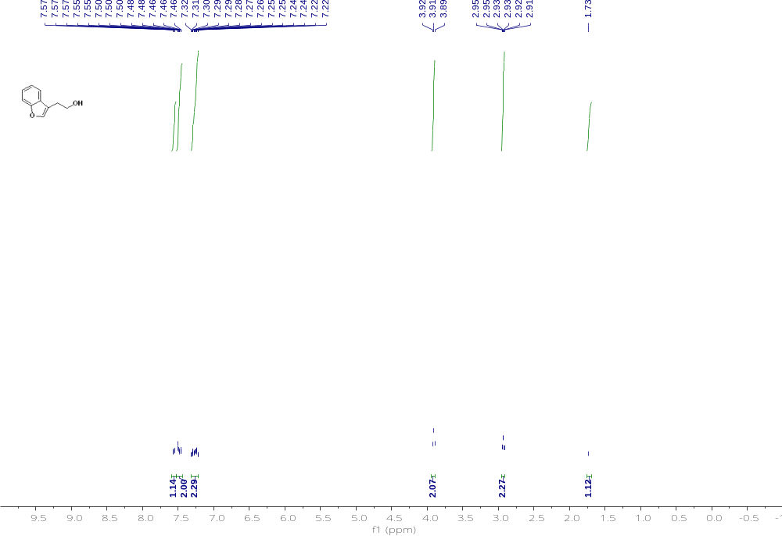

Compound 20 ¹³C NMR 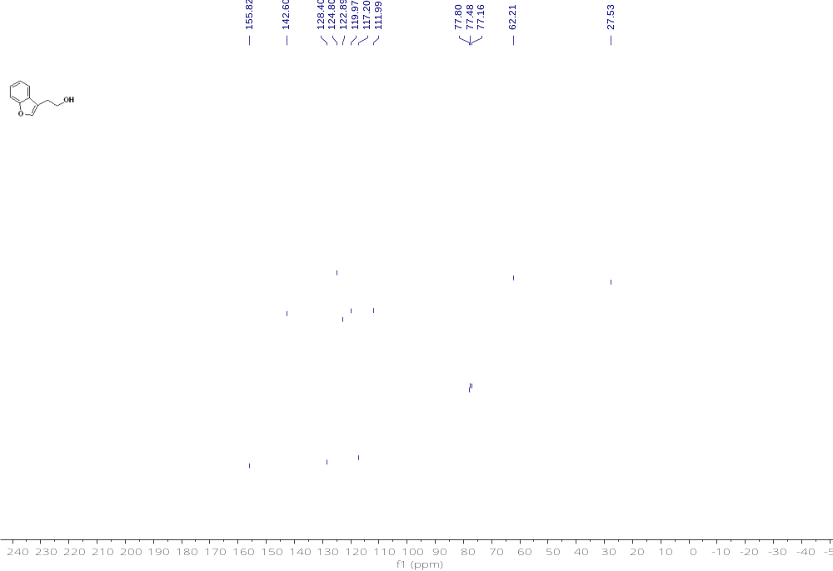

Compound 21 ¹H NMR
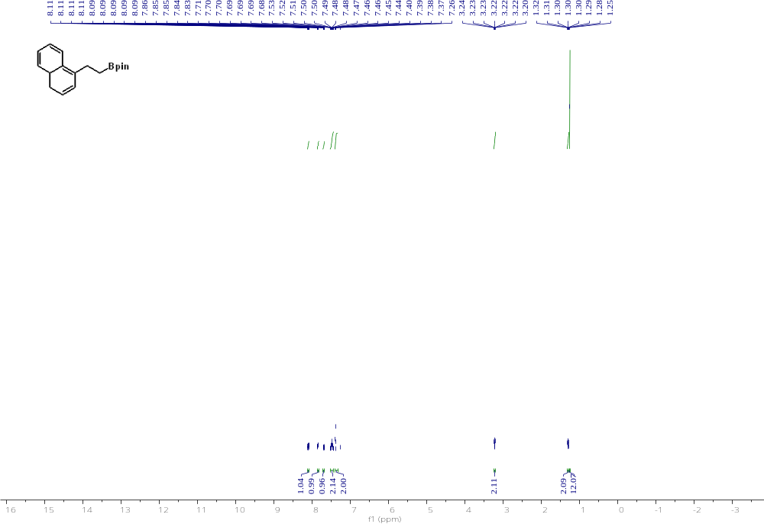

Compound 21 ¹³C NMR
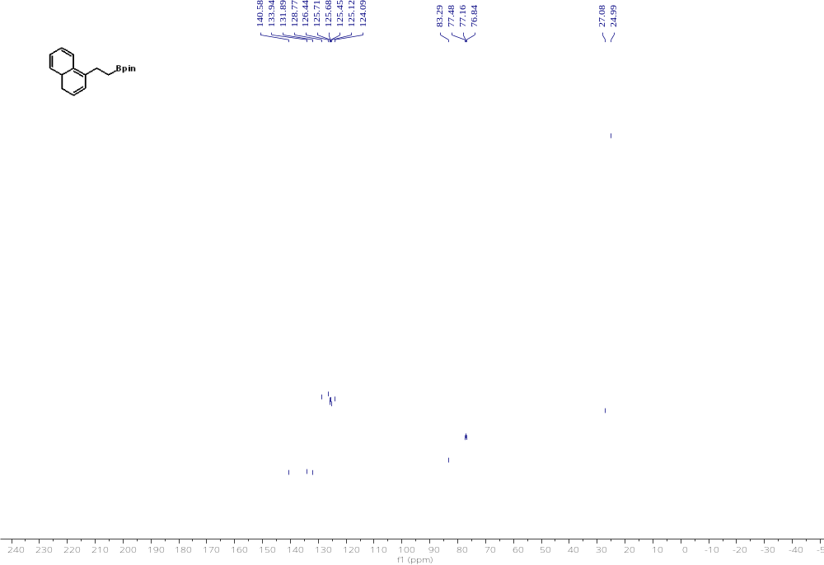

Compound 22 ¹H NMR 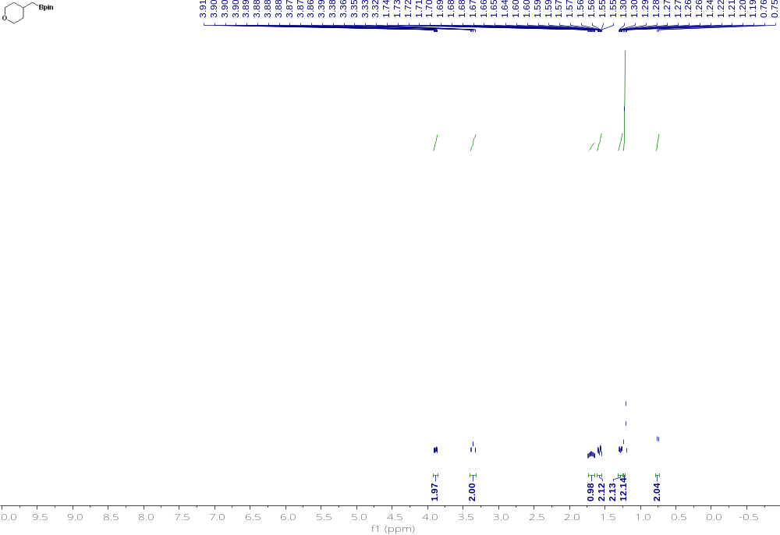

Compound 22 ¹³C NMR 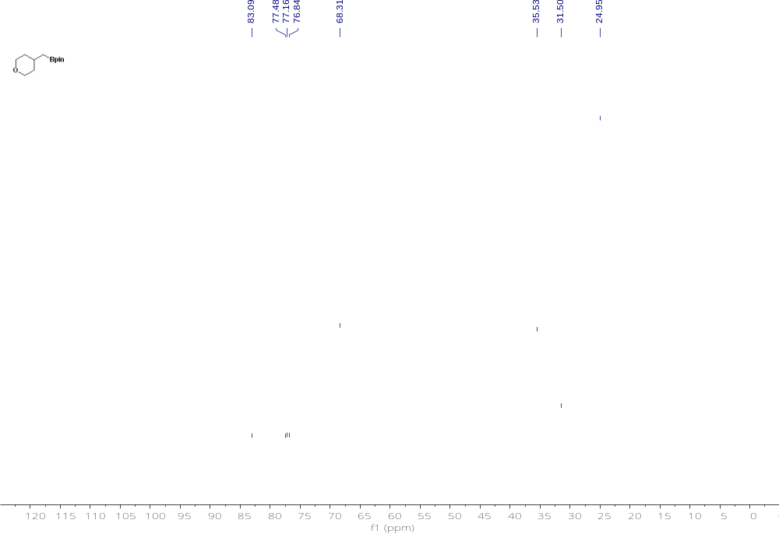

Compound 23 ¹H NMR
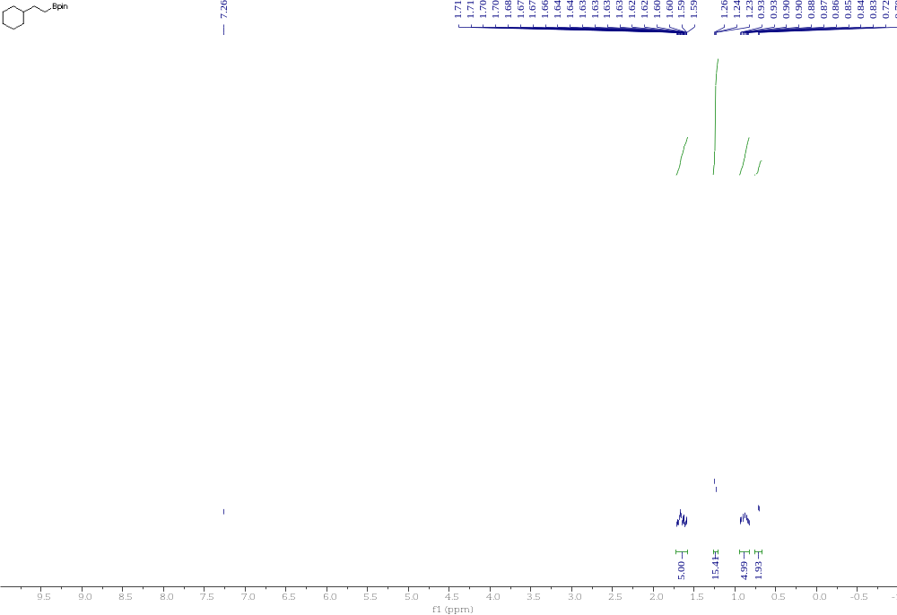

Compound 23 ¹³C NMR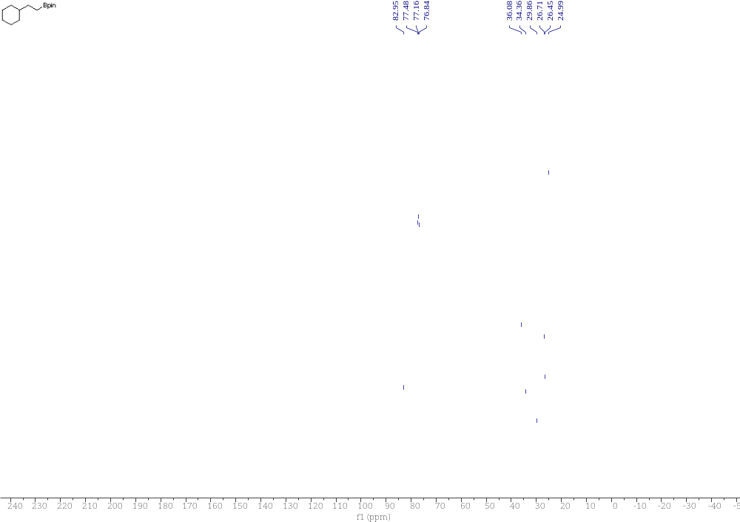

Compound 24 ¹H NMR
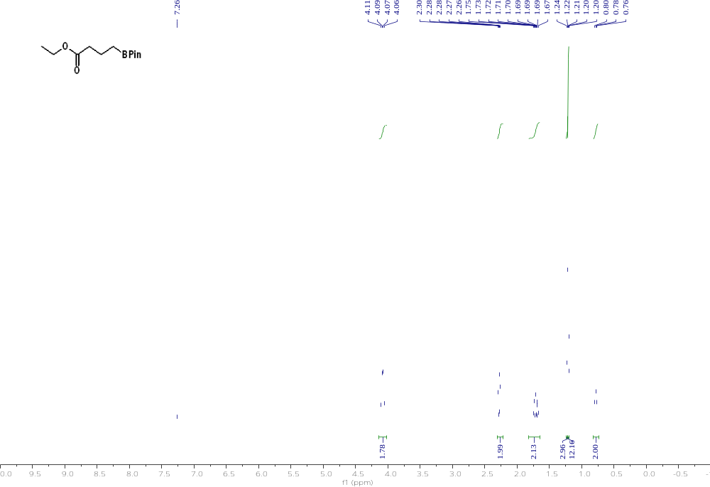

Compound 24 ¹³C NMR
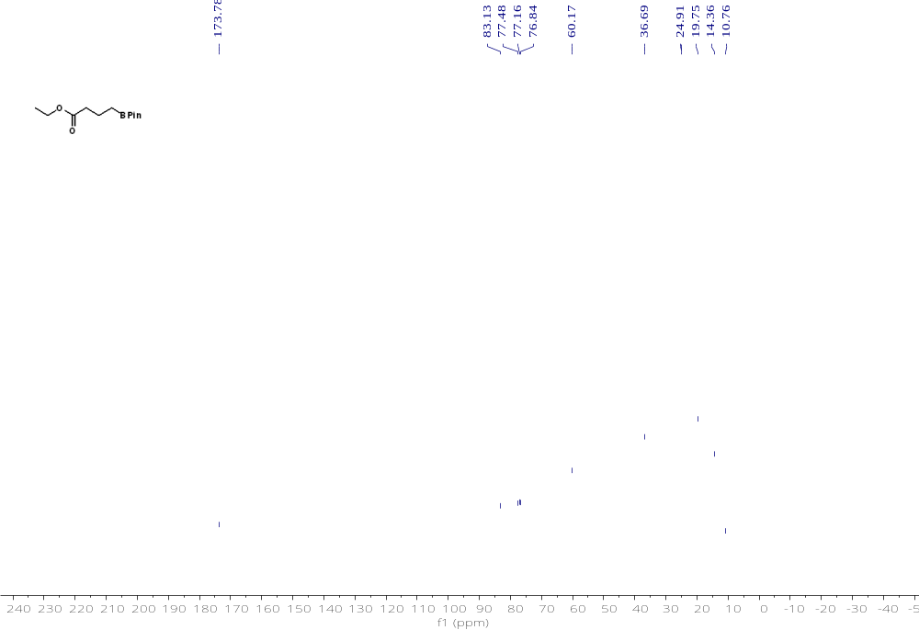

Compound 25 ¹H NMR 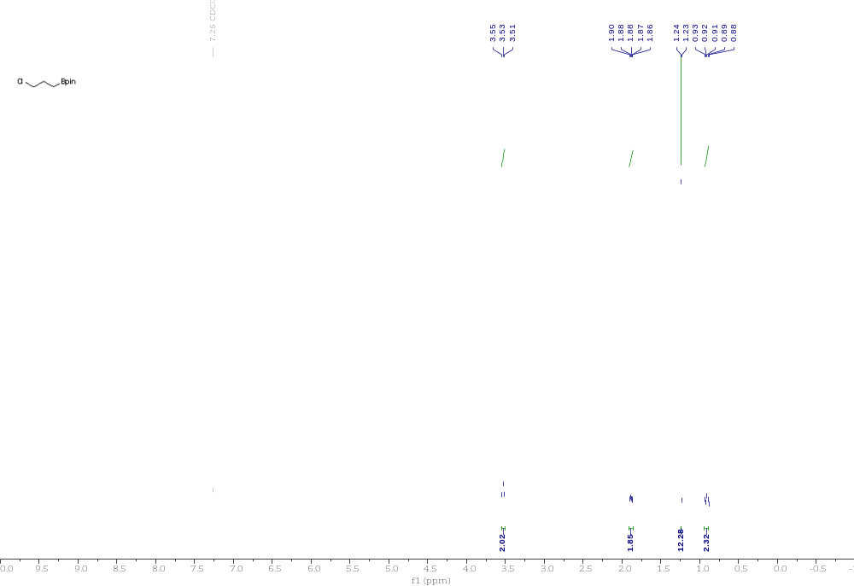 Compound 25 ¹³C NMR 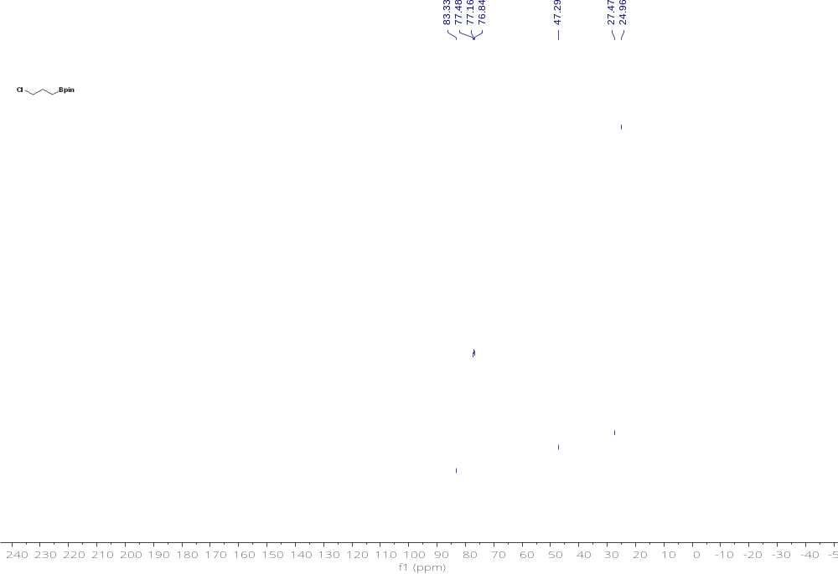

Compound 26 ¹H NMR 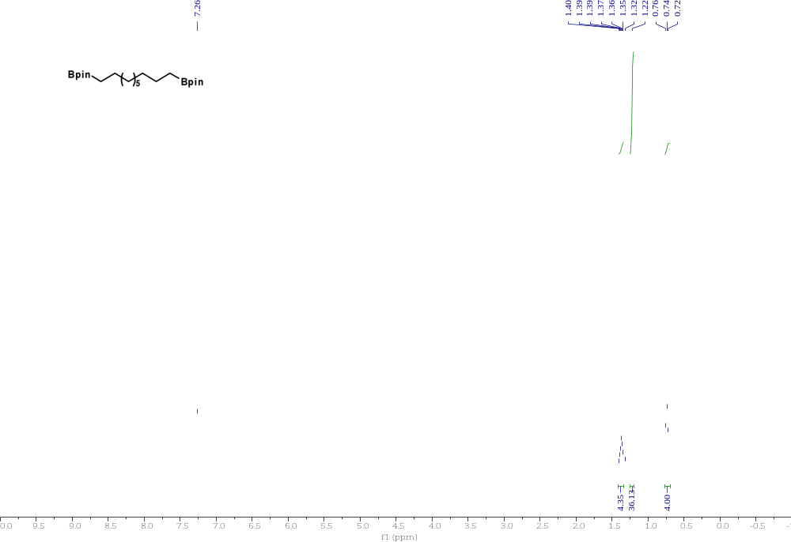
Compound 26 ¹³C NMR 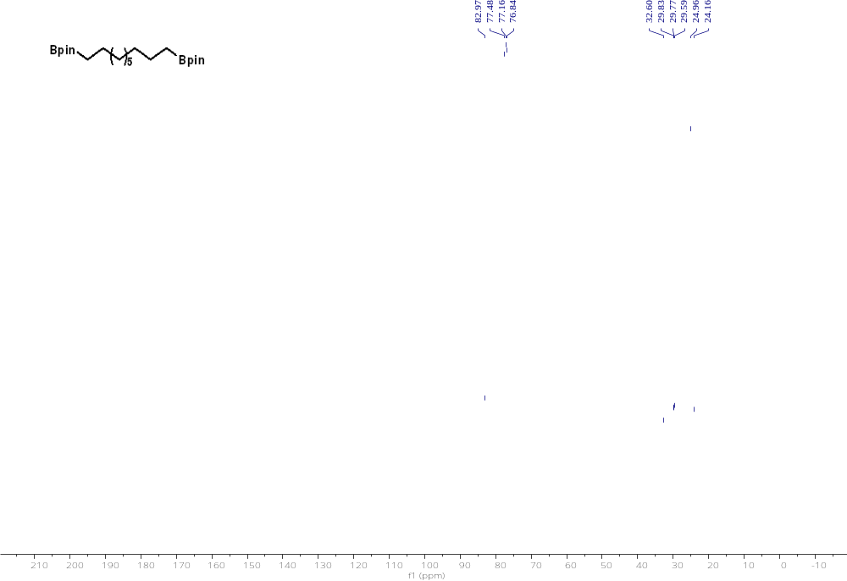

Compound 27 ¹H NMR 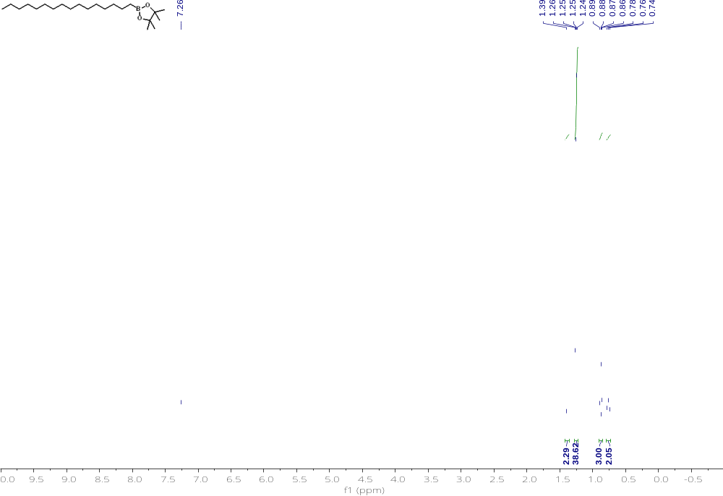

Compound 27 ¹³C NMR 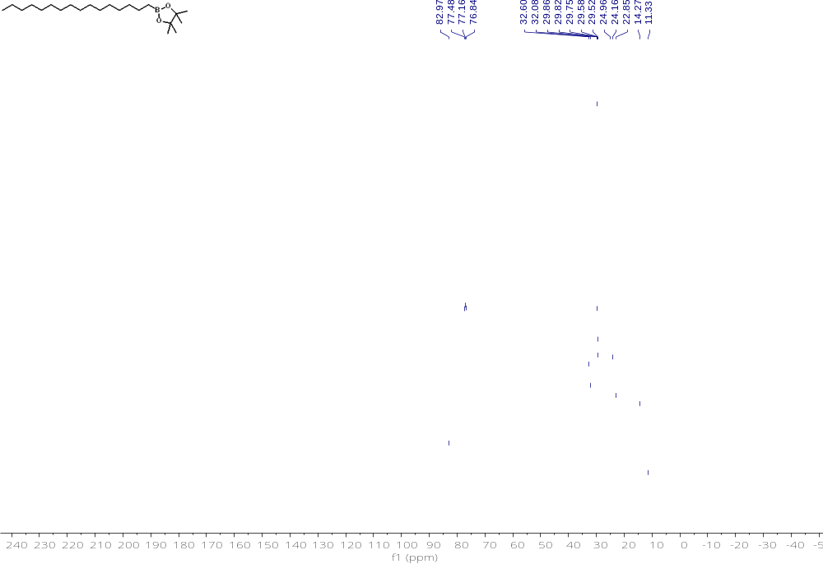

Compound 28 ¹H NMR 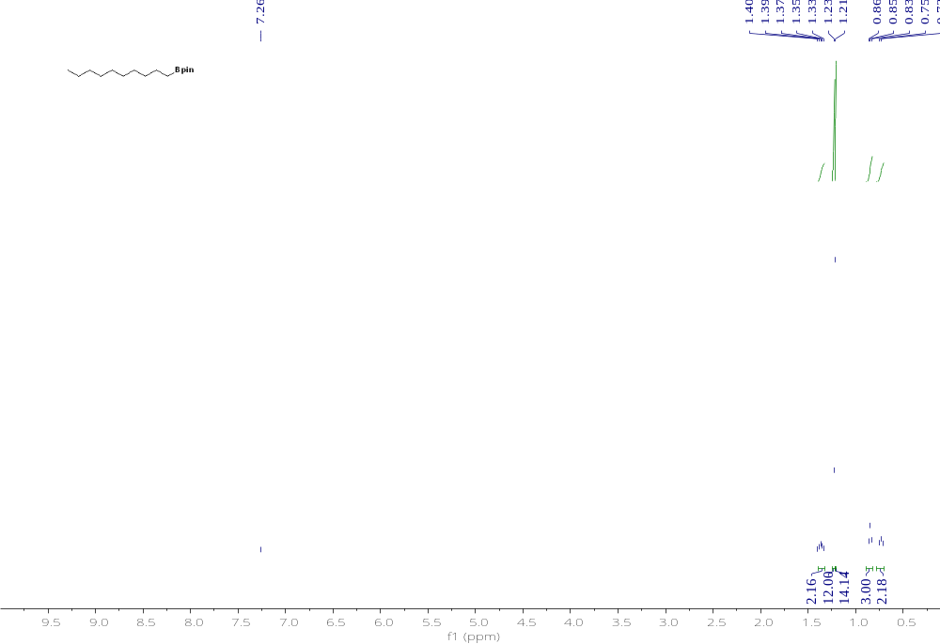

Compound 28 ¹³C NMR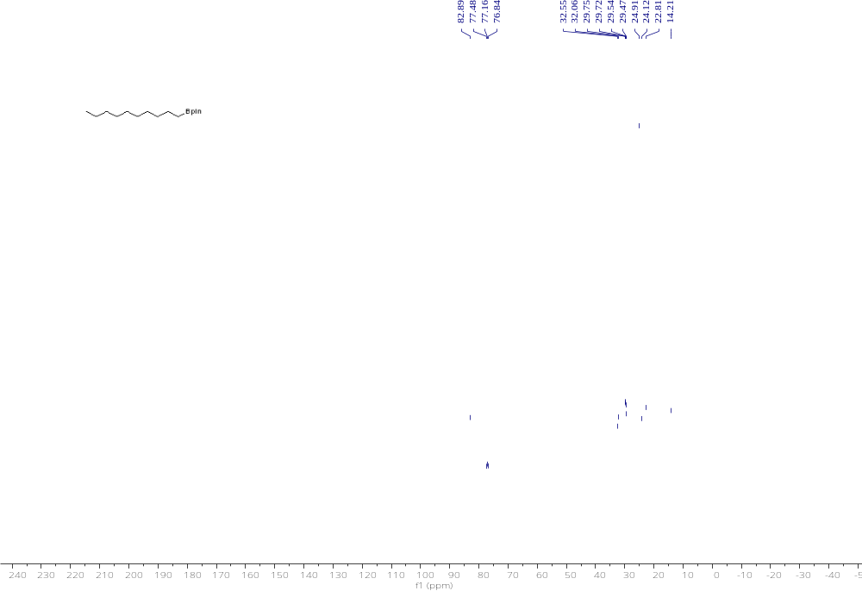

Compound 29 ¹H NMR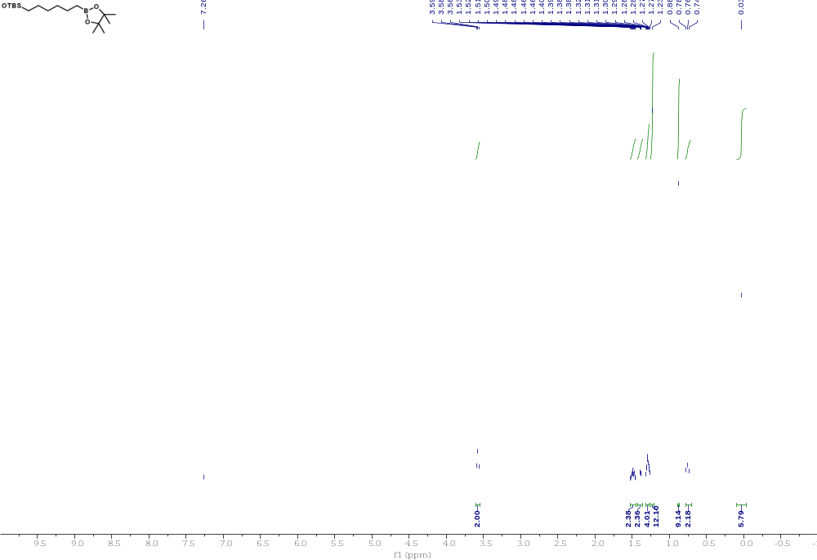

Compound 29 ¹³C NMR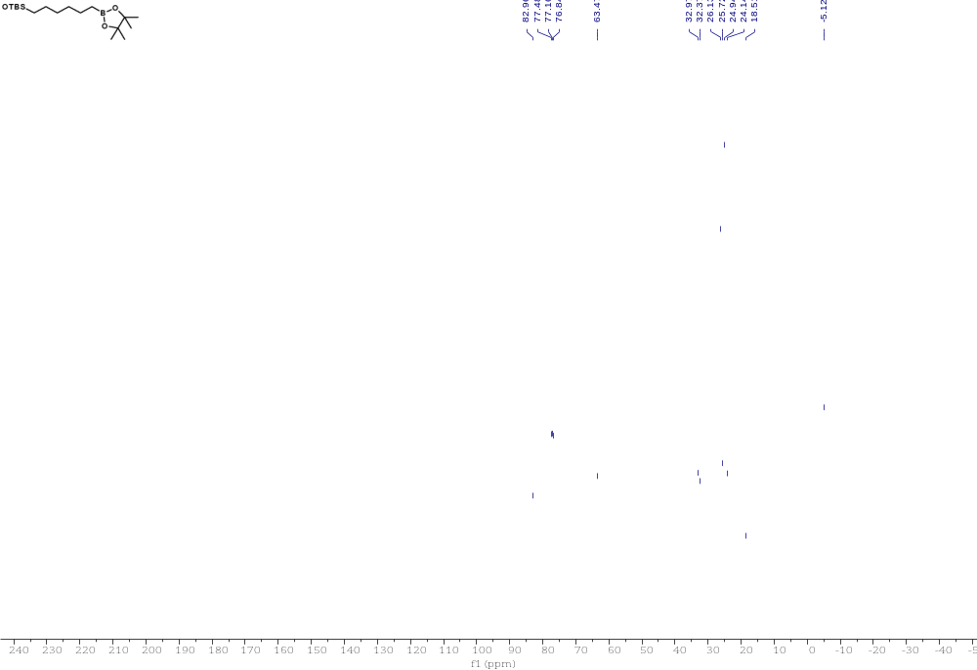

Compound 30 ¹H NMR 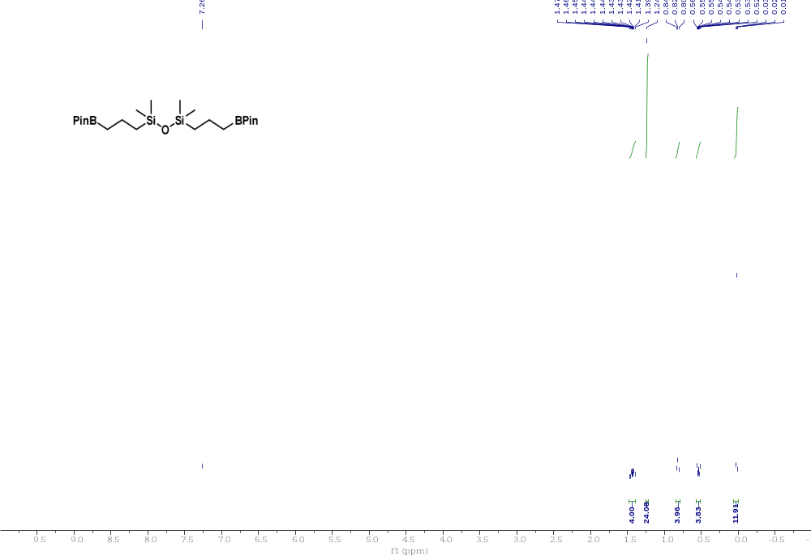

Compound 30 ¹³C NMR 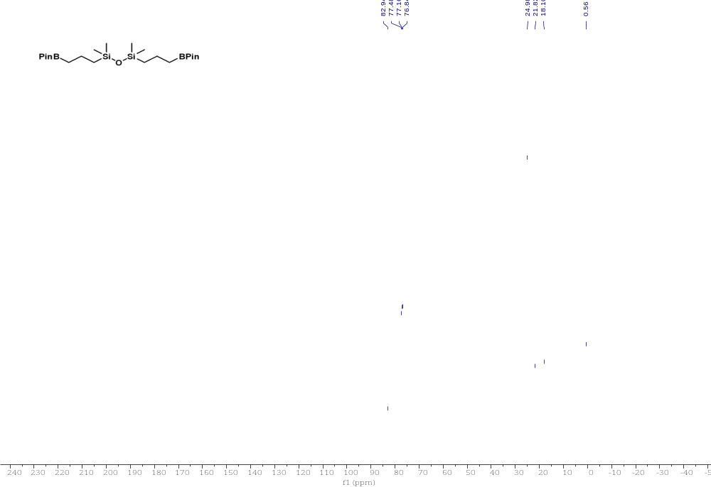

Compound 31 ¹H NMR 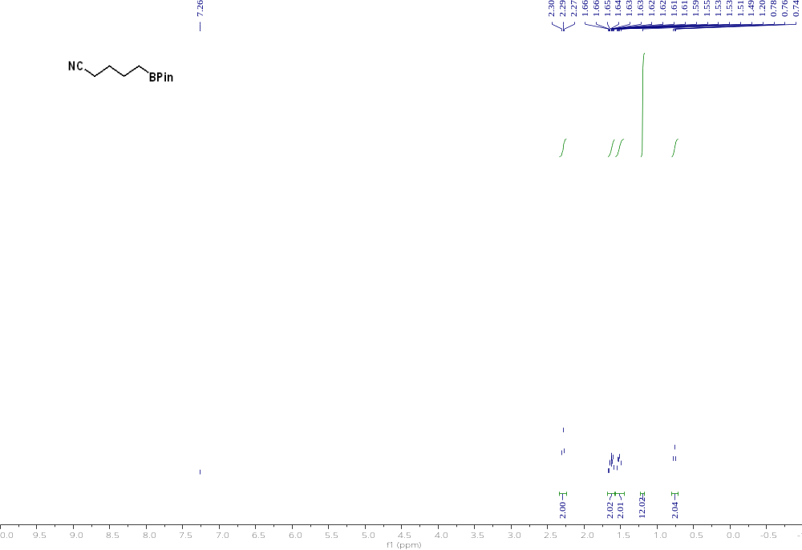

Compound 31 ¹³C NMR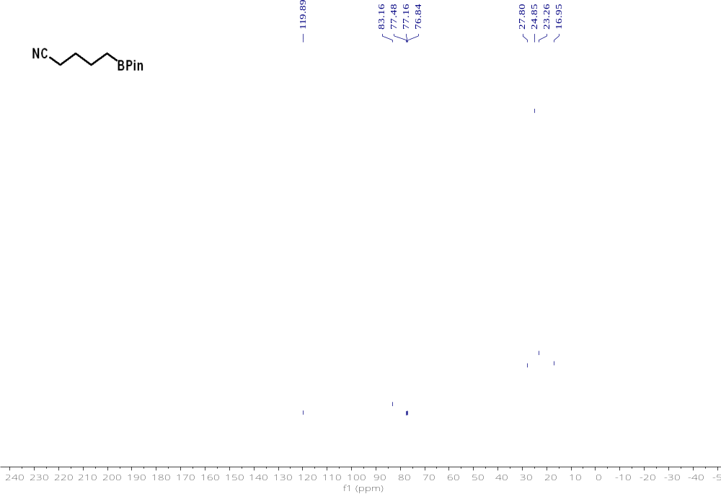

Compound 32 ¹H NMR
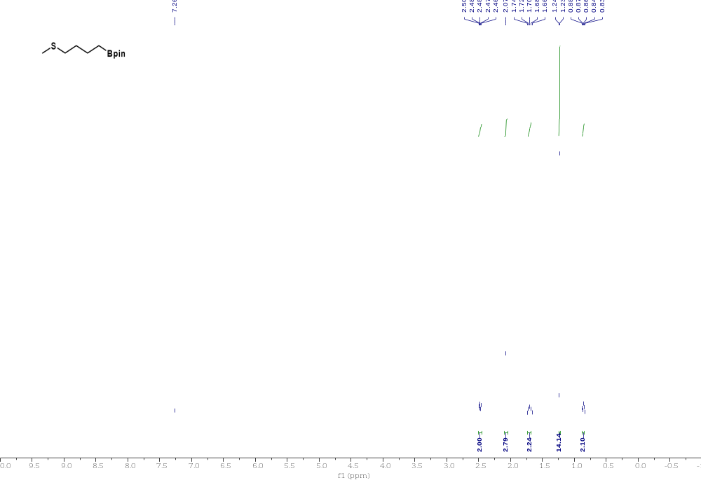

Compound 32 ¹³C NMR
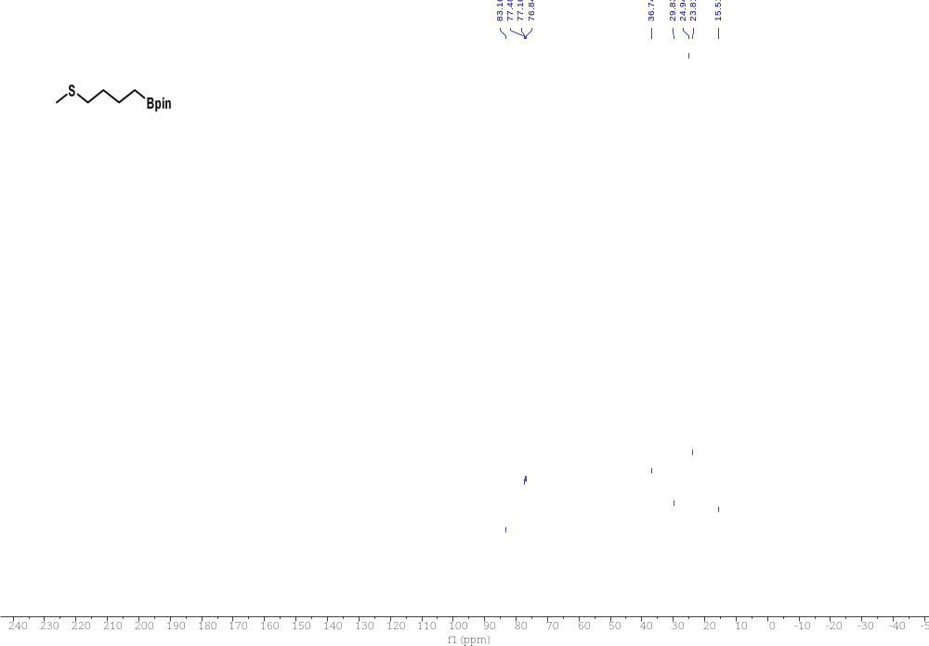

Compound 33 ¹H NMR 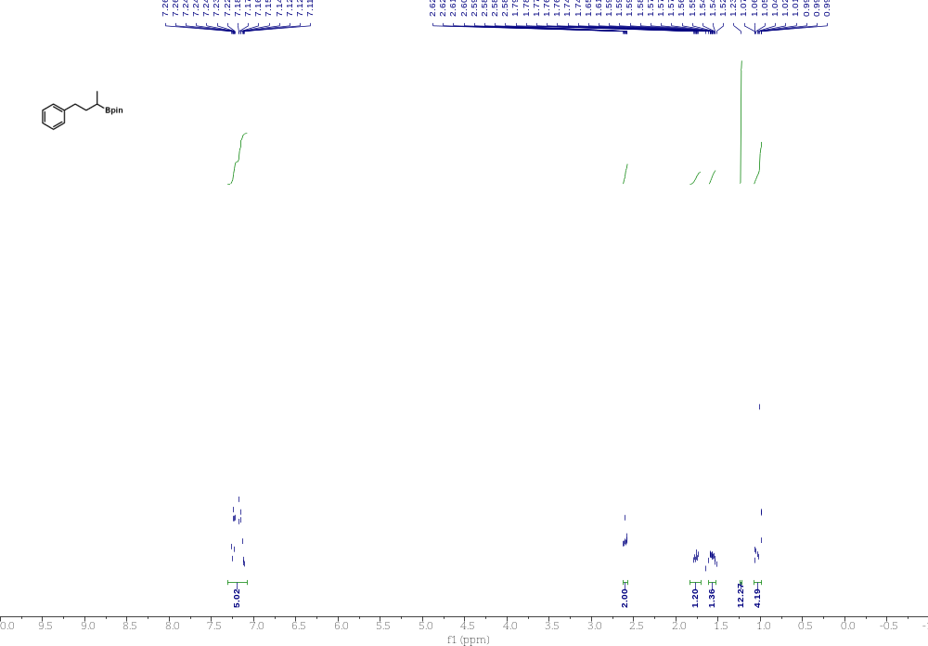

Compound 33 ¹³C NMR 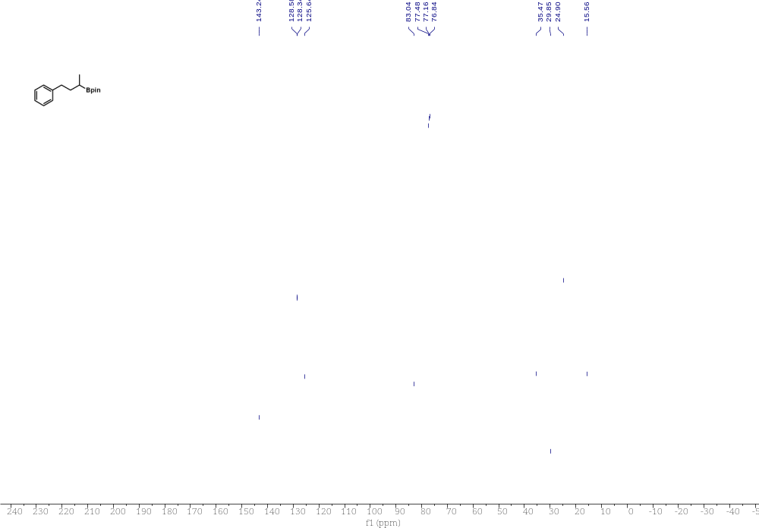

Compound 34 ¹H NMR 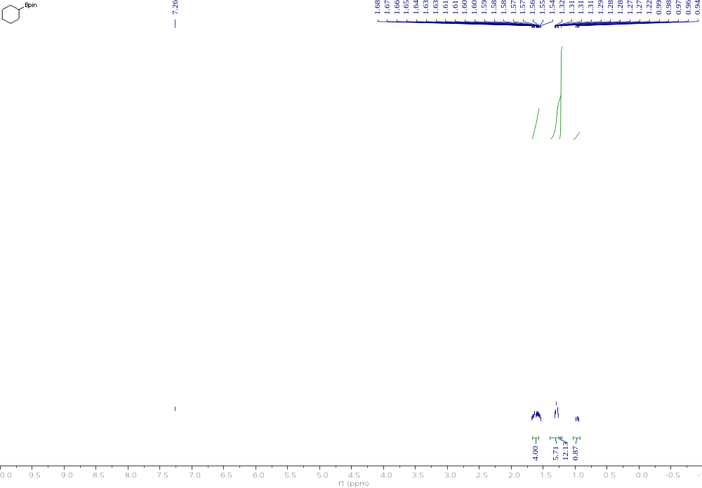

Compound 34 ¹³C NMR 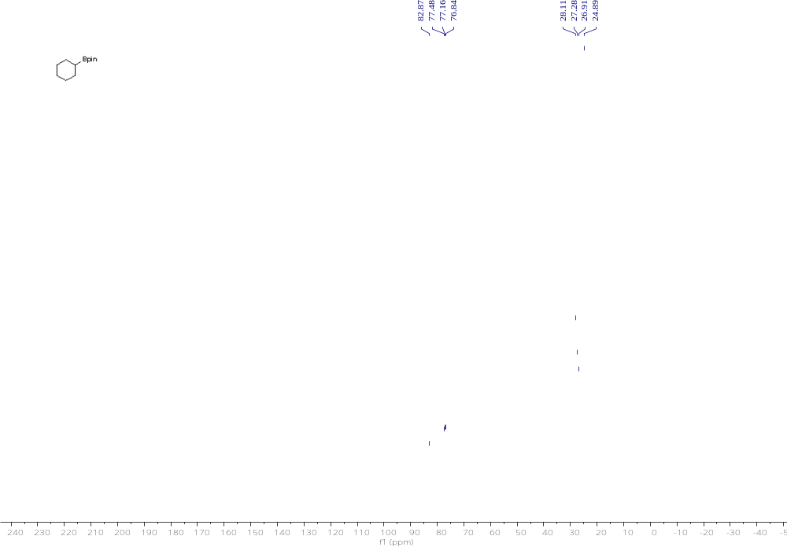

Compound 35 ¹H NMR 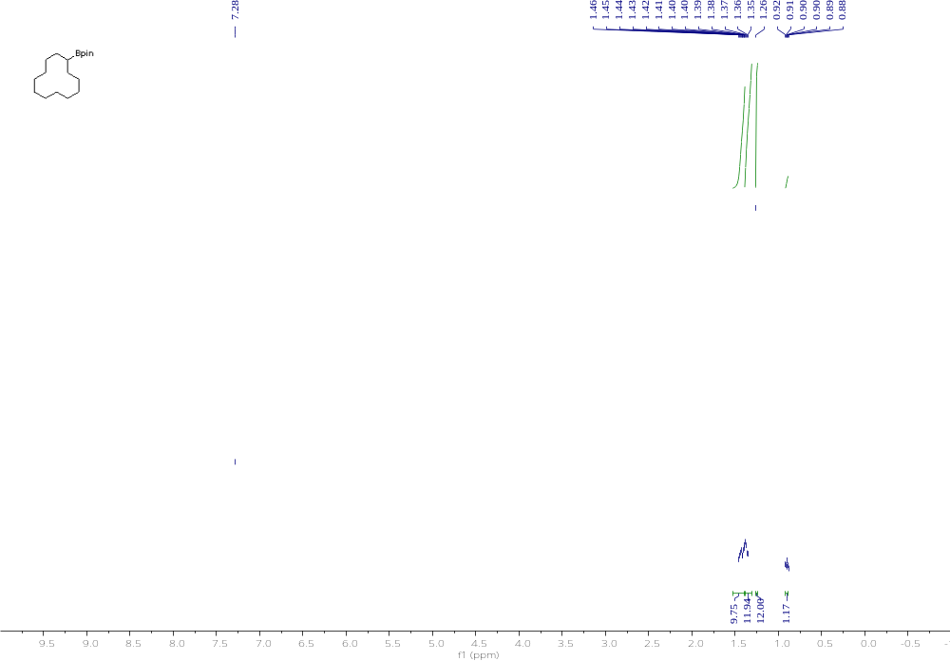

Compound 35 ¹³C NMR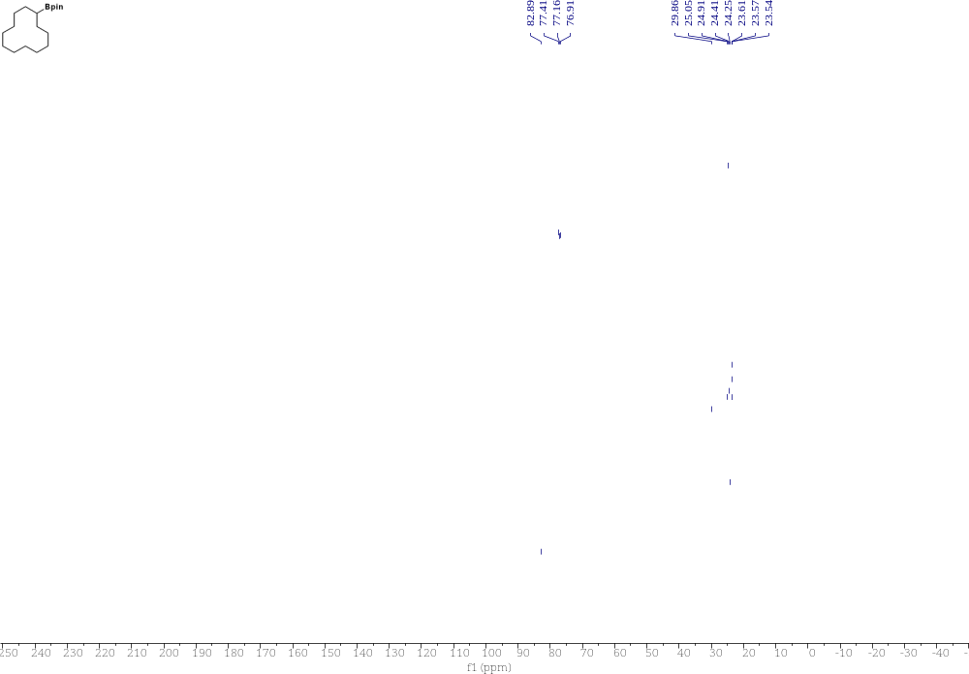

Compound 36 ¹H NMR 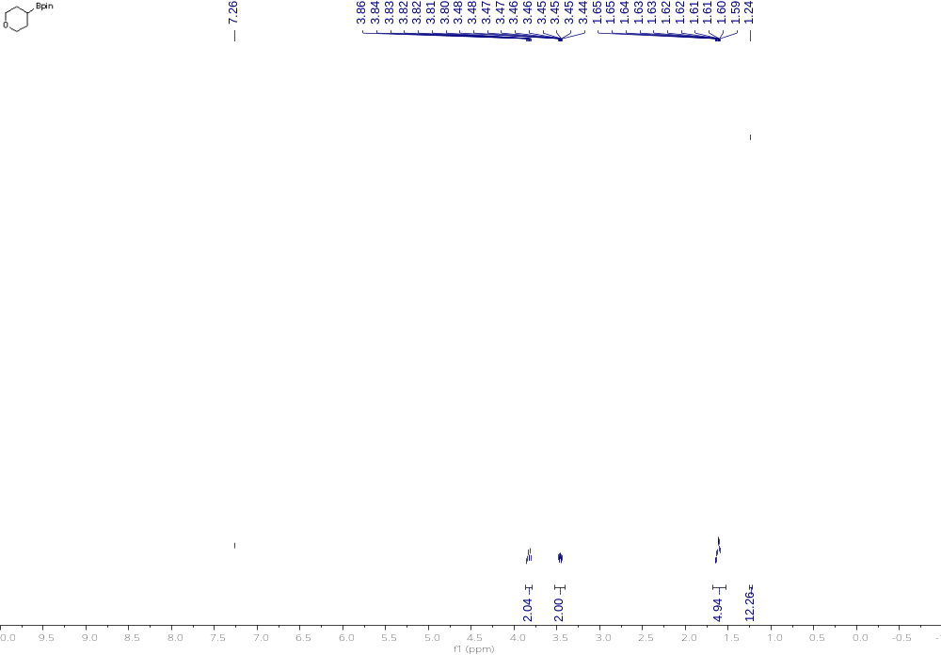

Compound 36 ¹³C NMR 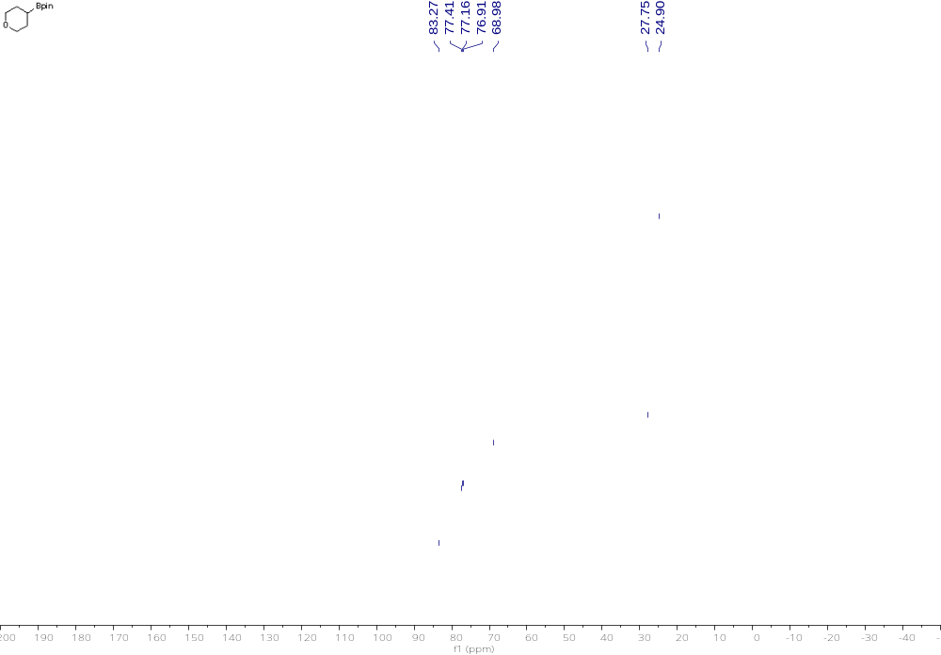

Compound 37 ¹H NMR
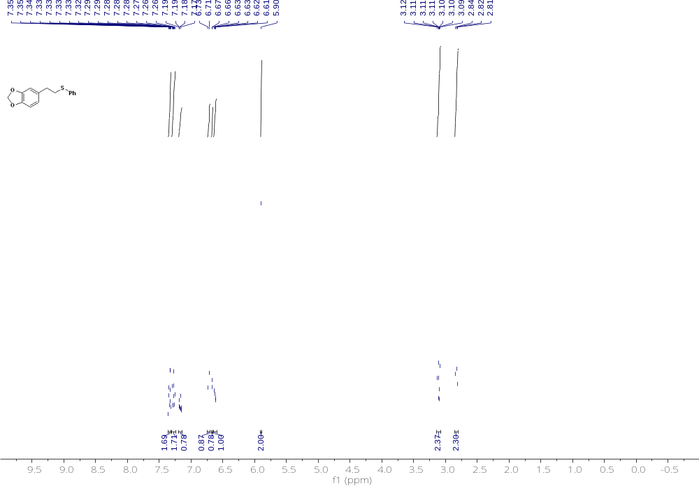

Compound 37 ¹³C NMR 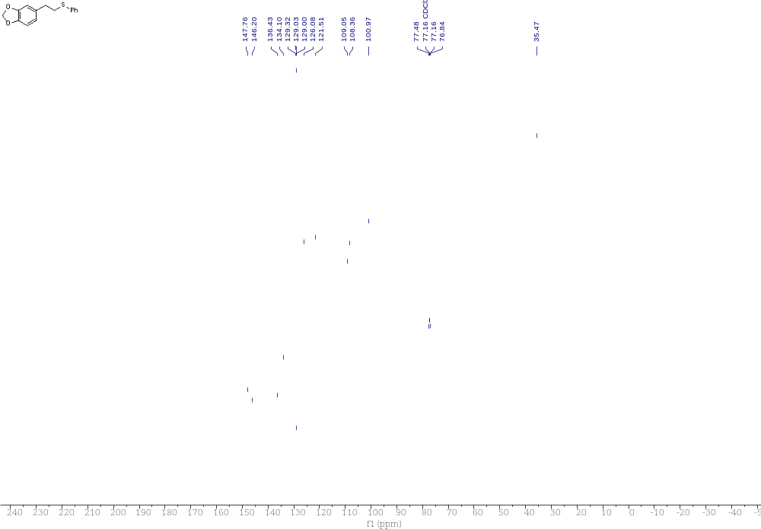

Compound 38 ¹H NMR 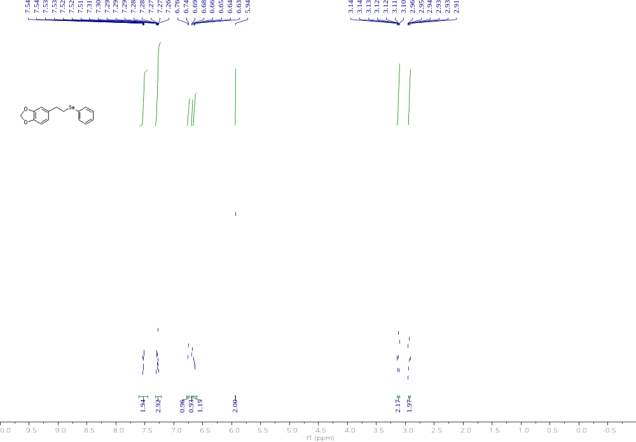
Compound 38 ¹³C NMR 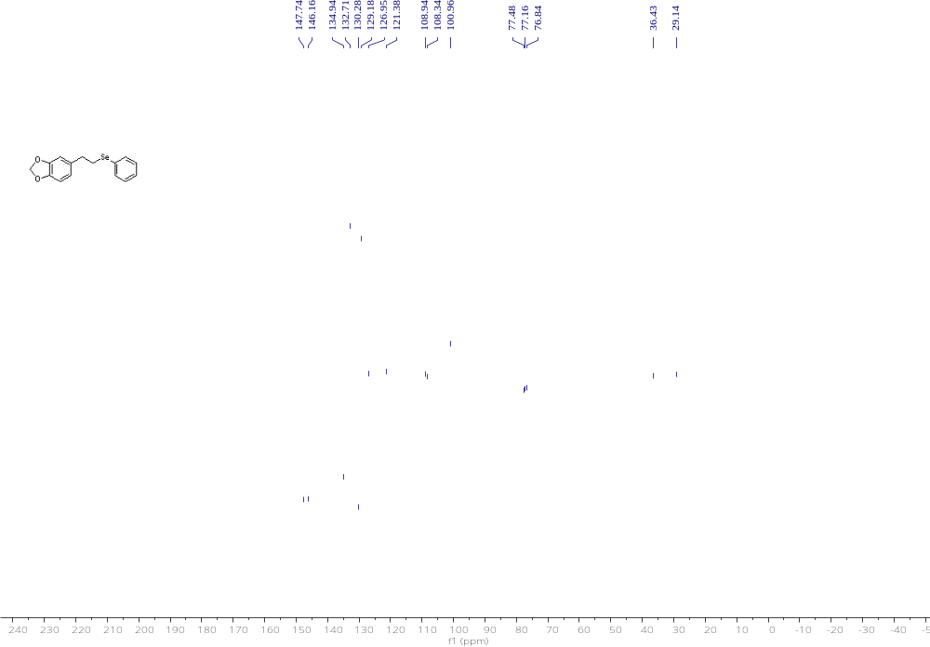

Compound 39 ¹H NMR 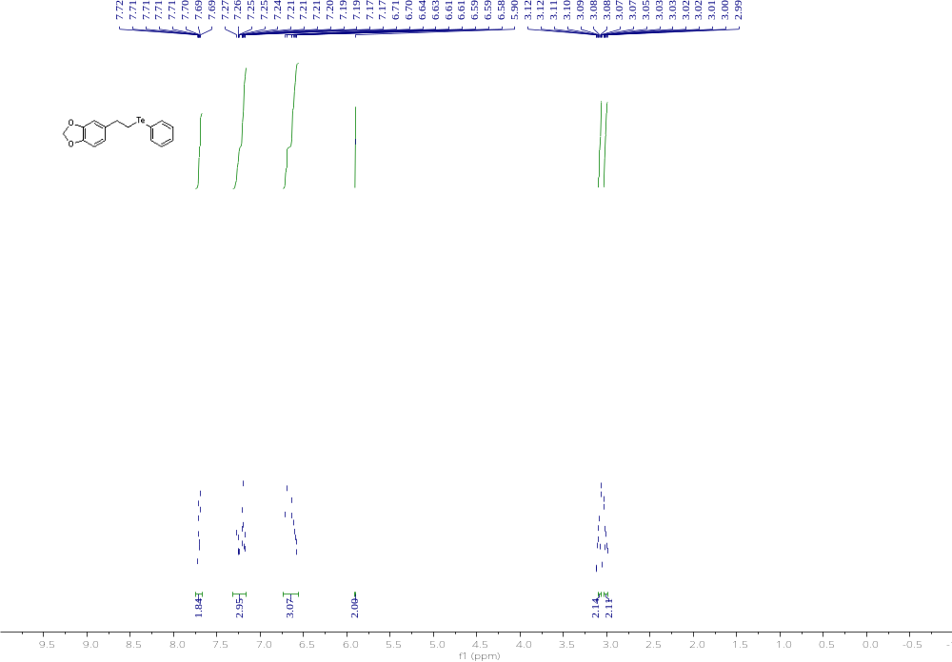

Compound 39 ¹³C NMR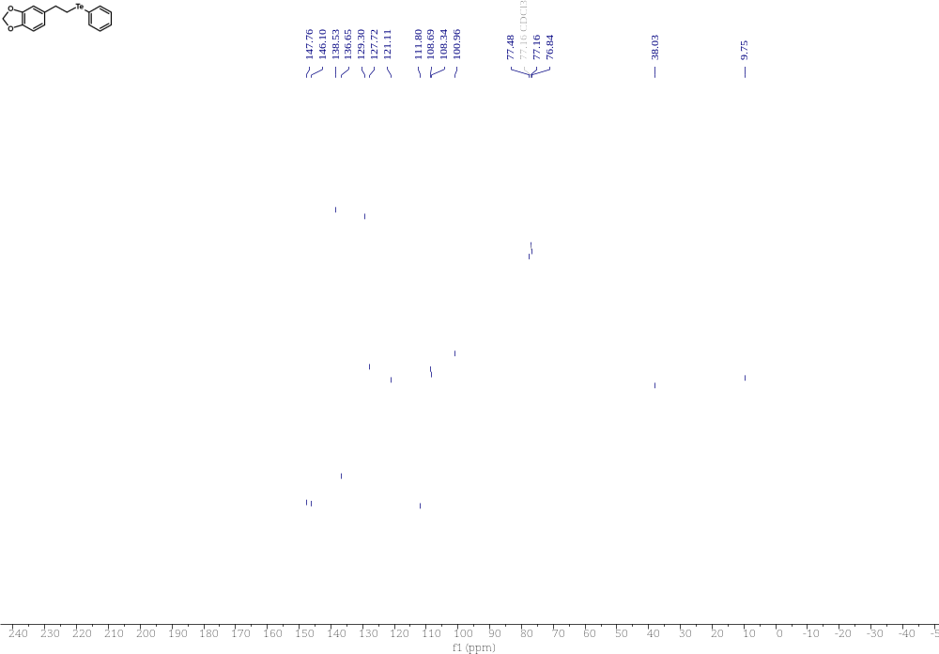

Compound 40 ¹H NMR 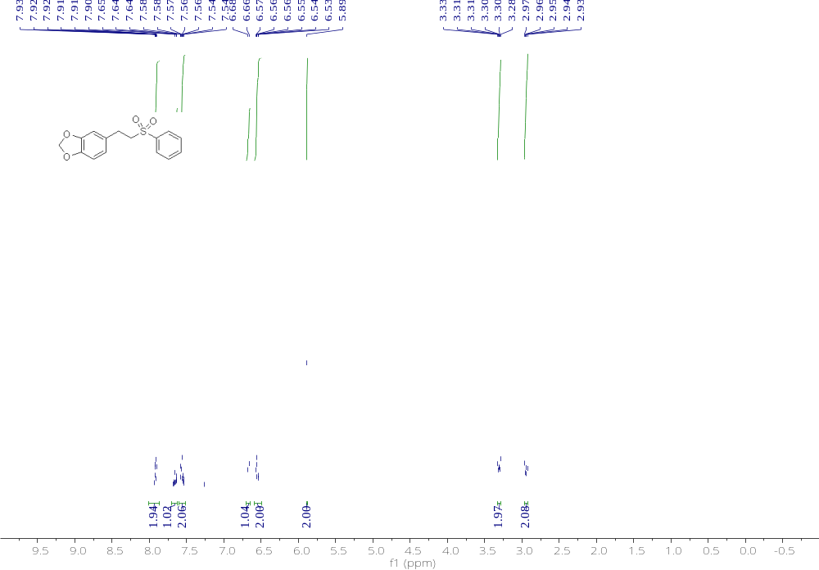

Compound 40 ¹³C NMR 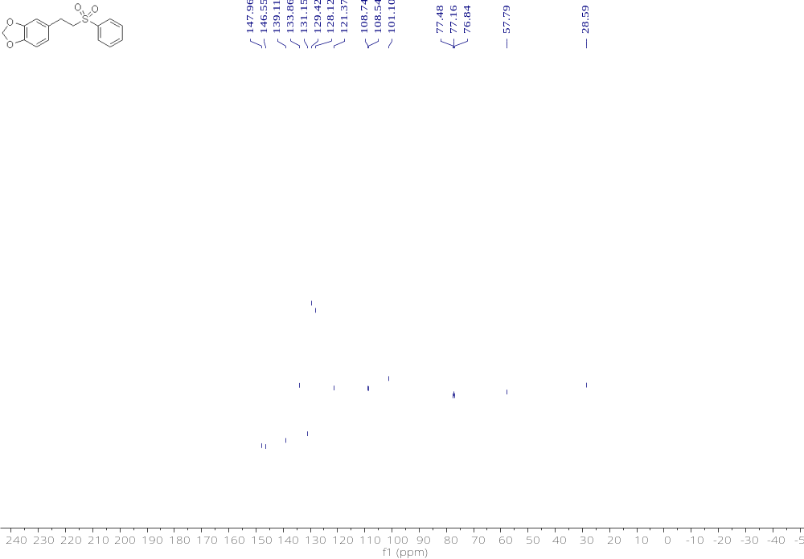

Compound 41 ¹H NMR 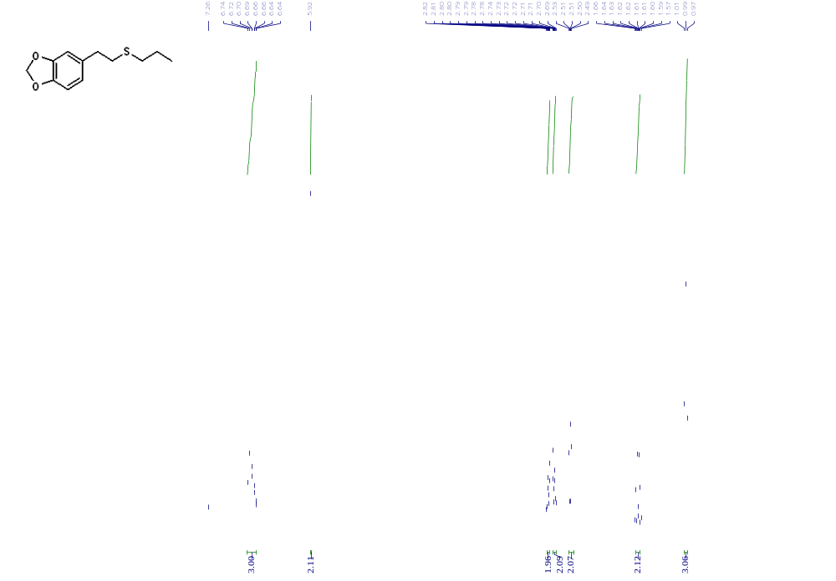

Compound 41 ¹³C NMR 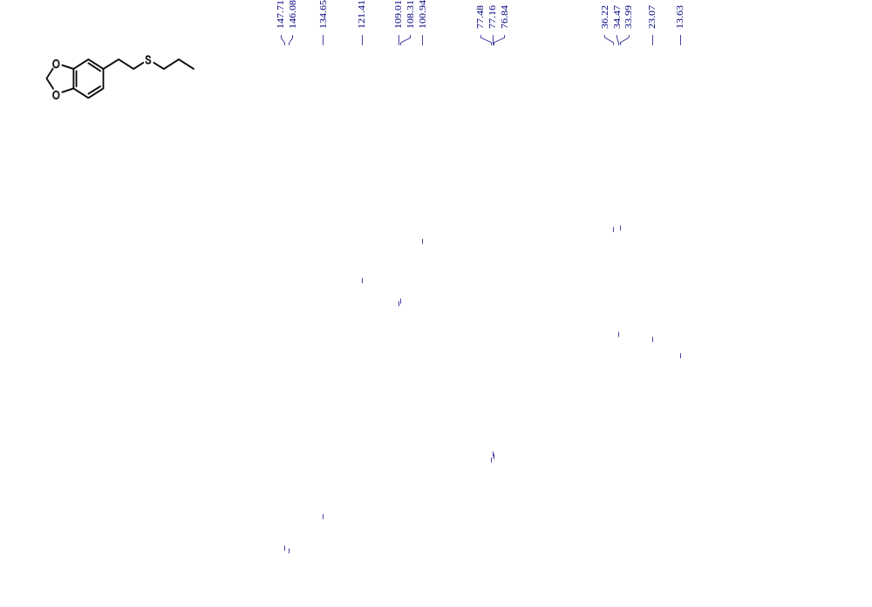

Compound 42 ¹H NMR 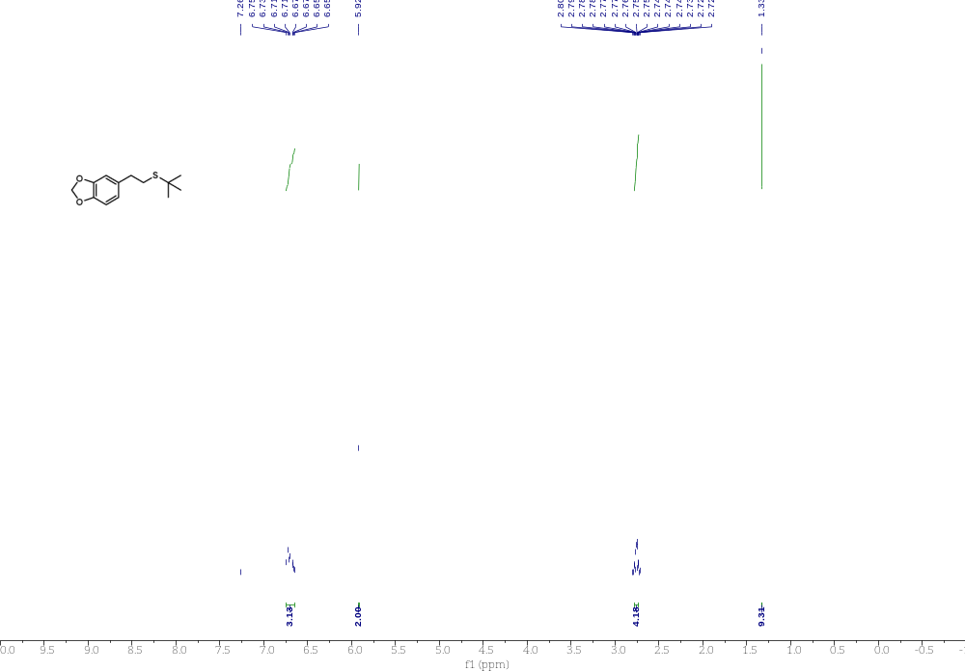

Compound 42 ¹³C NMR 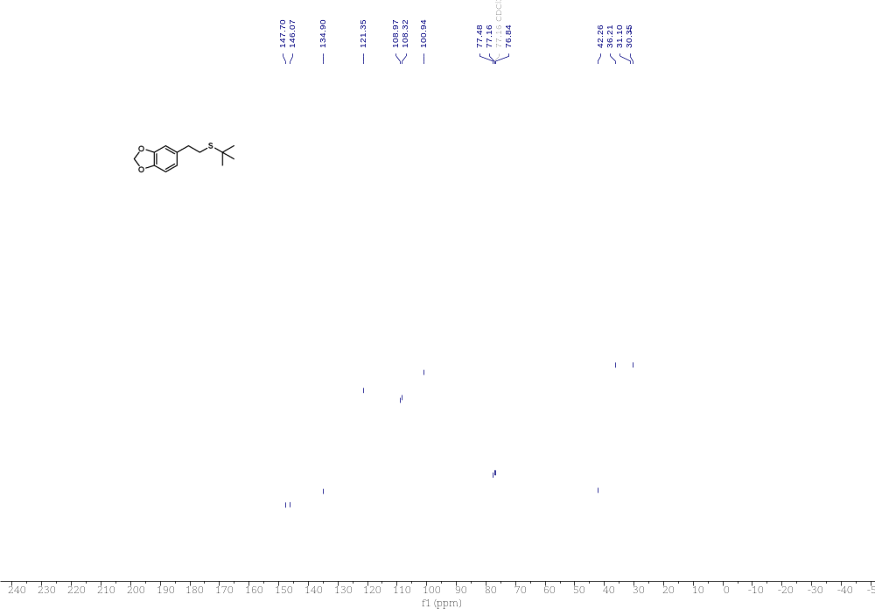

Compound 43 ¹H NMR 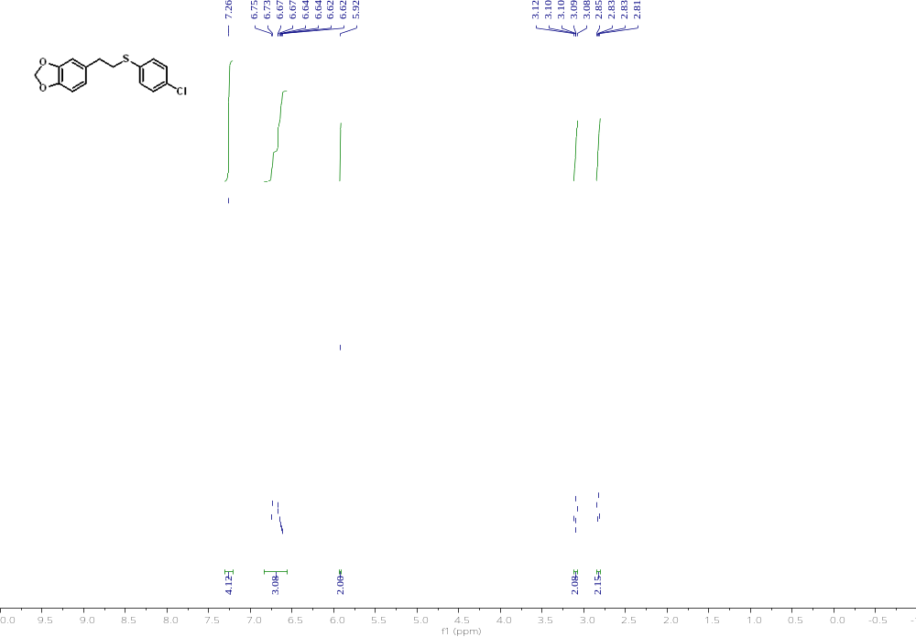

Compound 43 ¹³C NMR 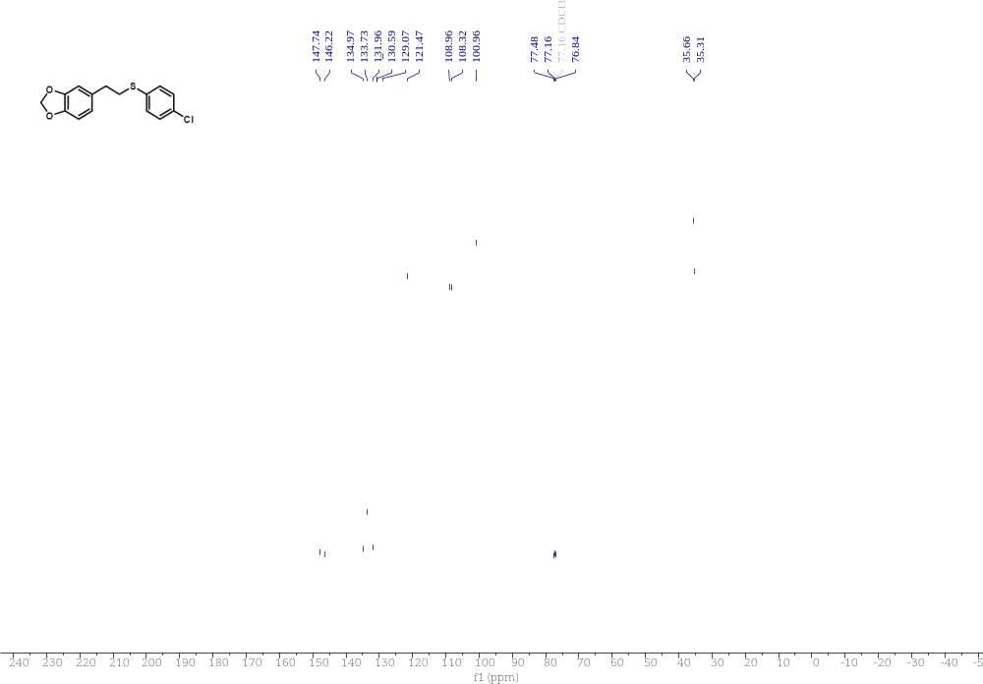

Compound 44 ¹H NMR 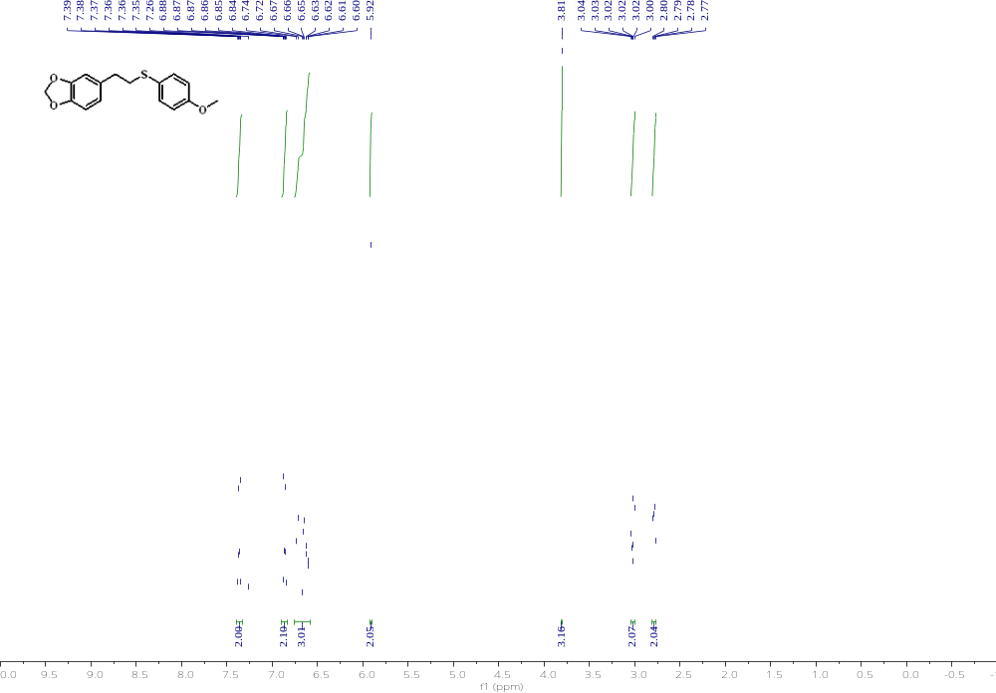

Compound 44 ¹³C NMR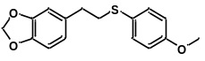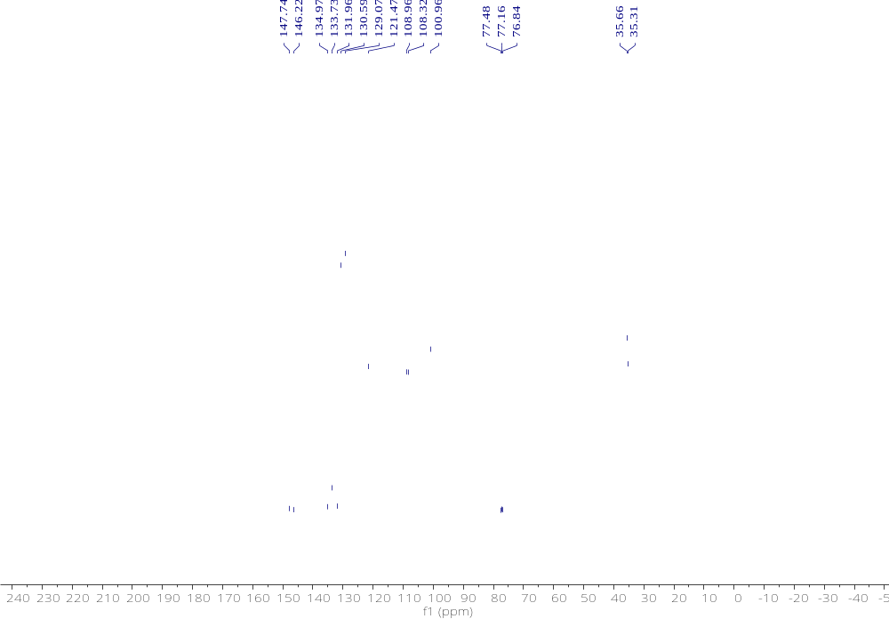

Compound 46 ¹H NMR 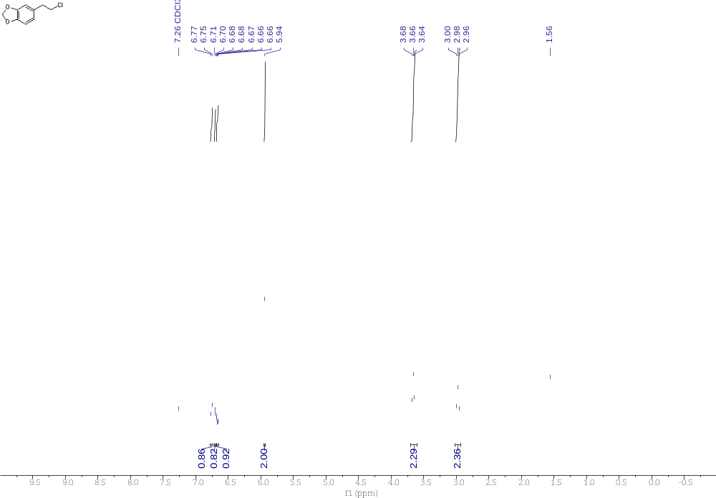 Compound 46 ¹³C NMR 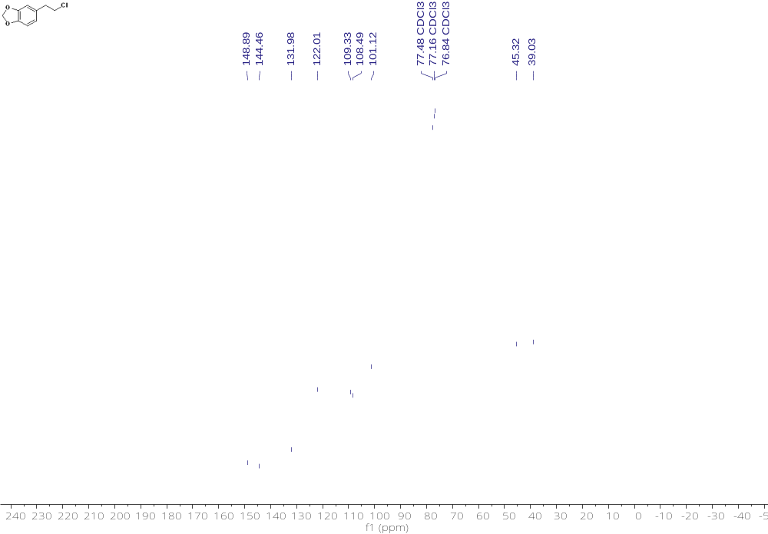

Compound 47 ¹H NMR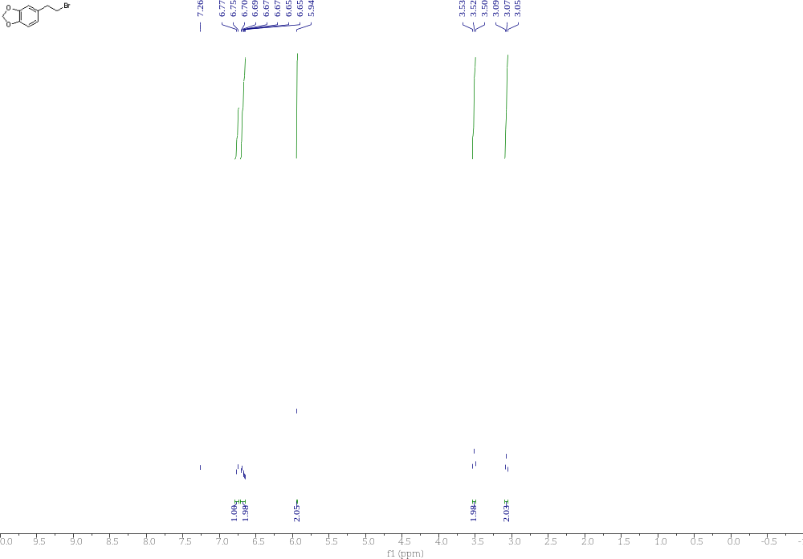

Compound 47 ¹³C NMR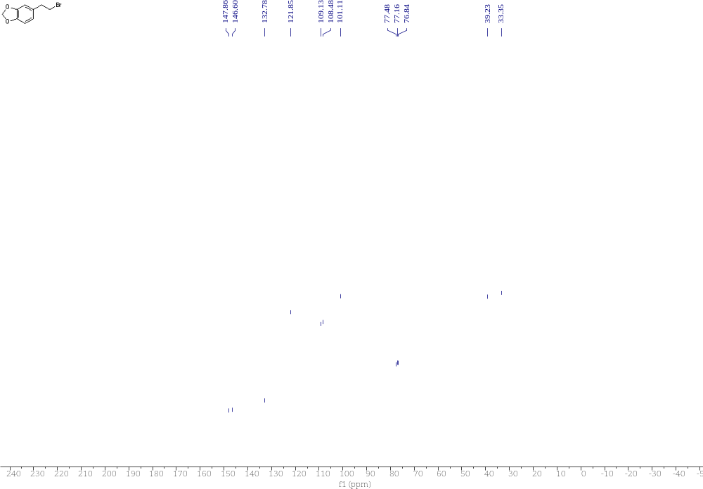

Compound 48 ¹H NMR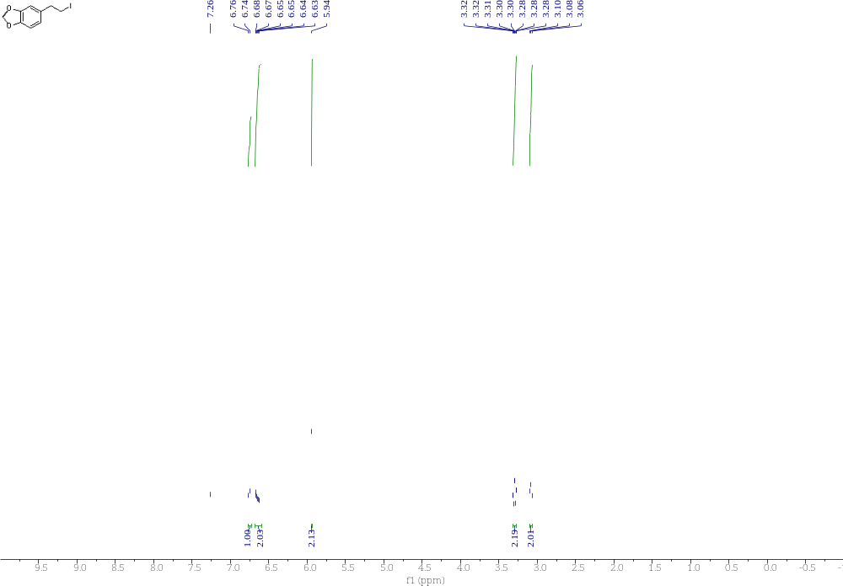

Compound 48 ¹³C NMR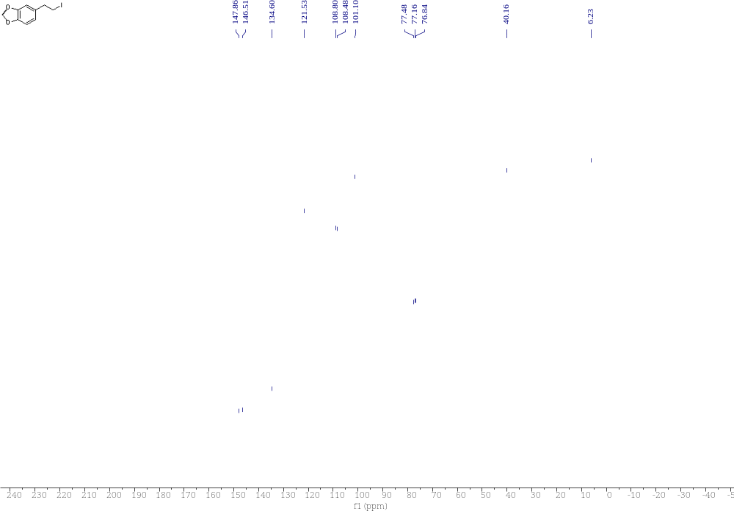

Compound 49 ¹H NMR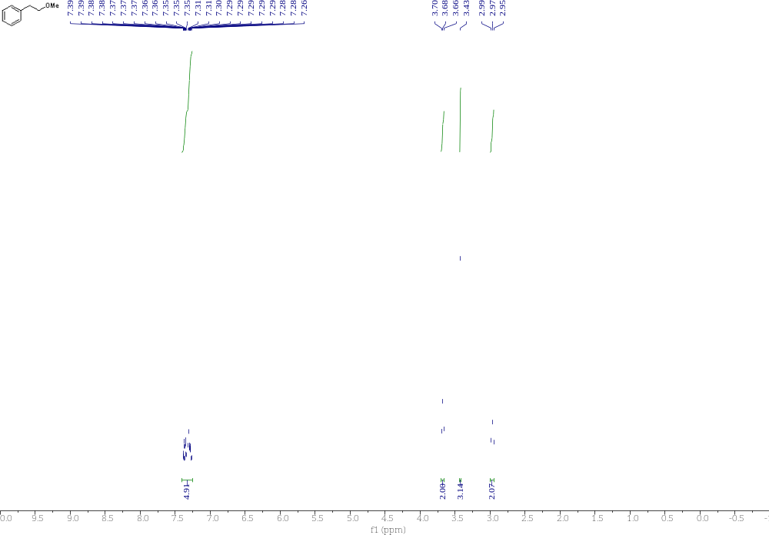

Compound 49 ¹³C NMR 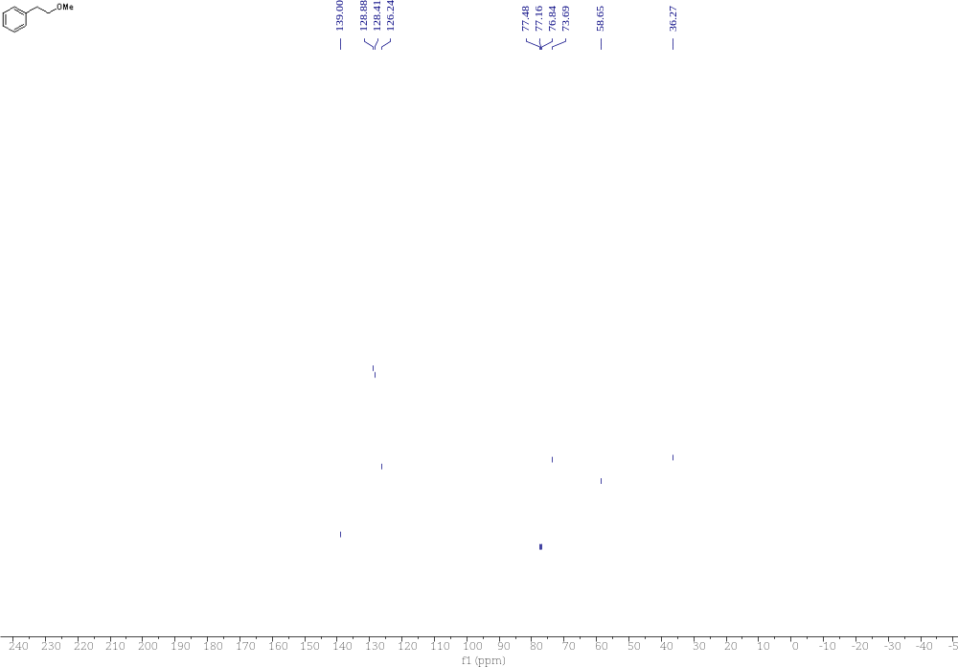

Compound 50 ¹H NMR 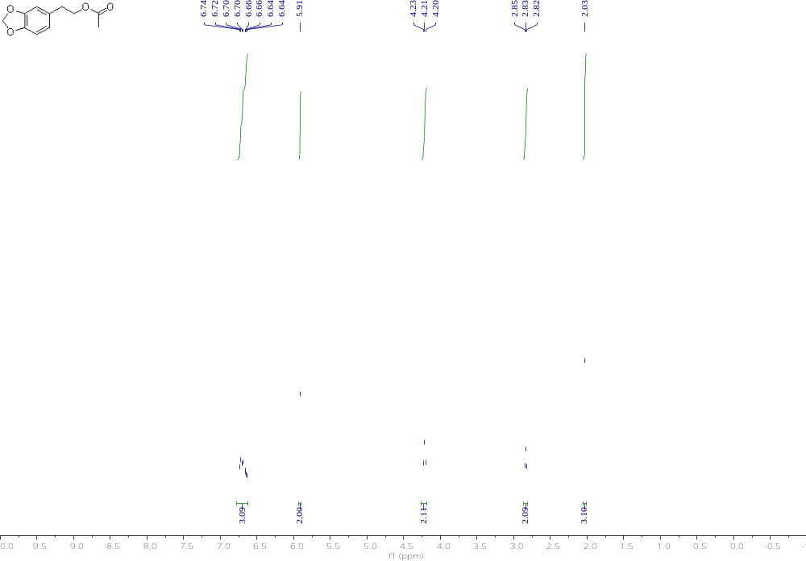

Compound 50 ¹³C NMR 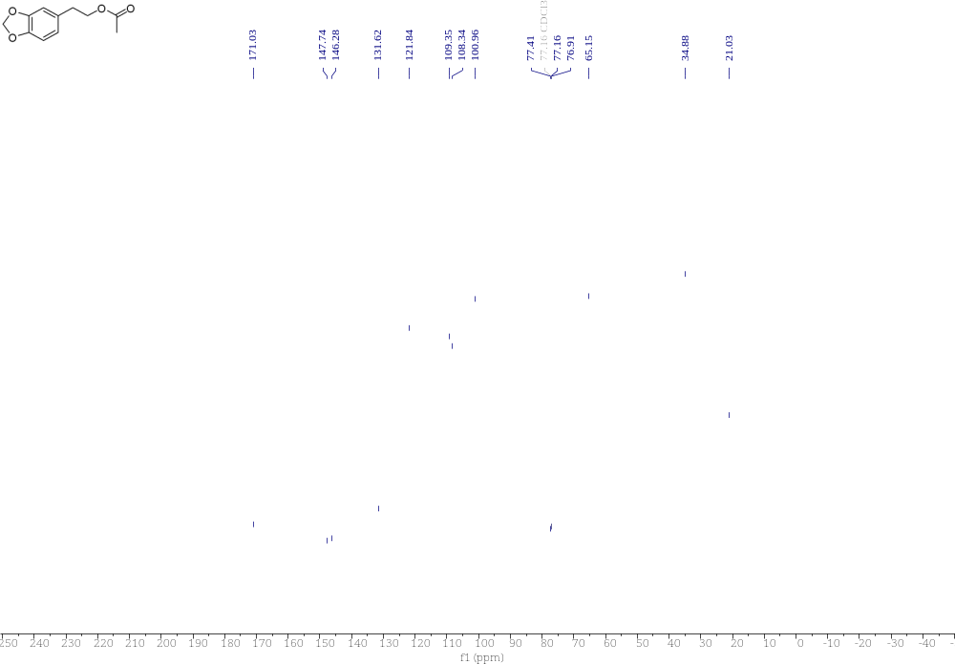

Compound 51 ¹H NMR 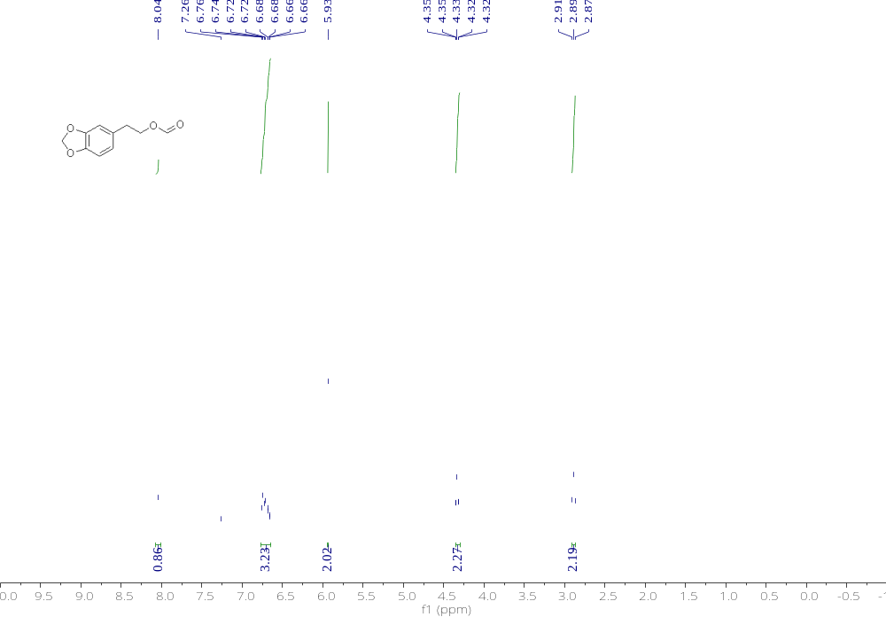

Compound 51 ¹³C NMR 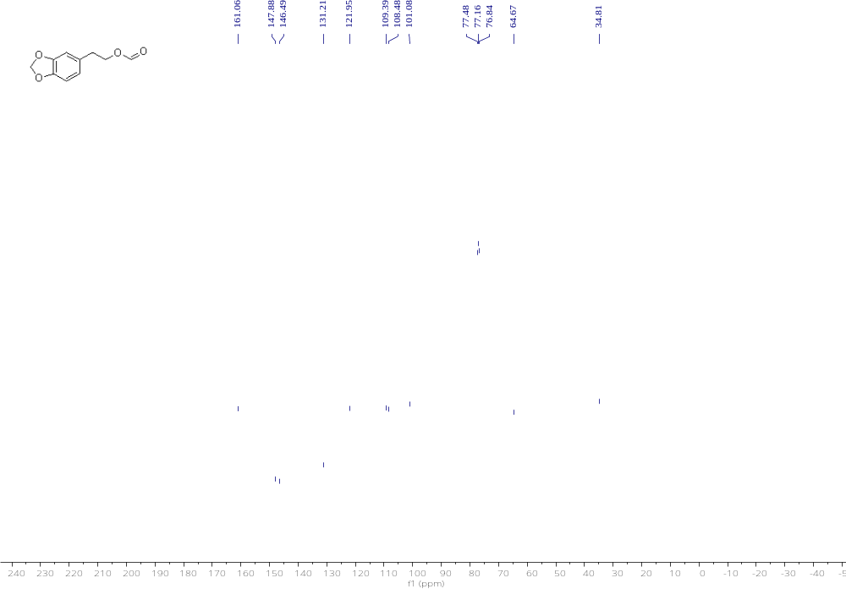

Compound 52 ¹H NMR 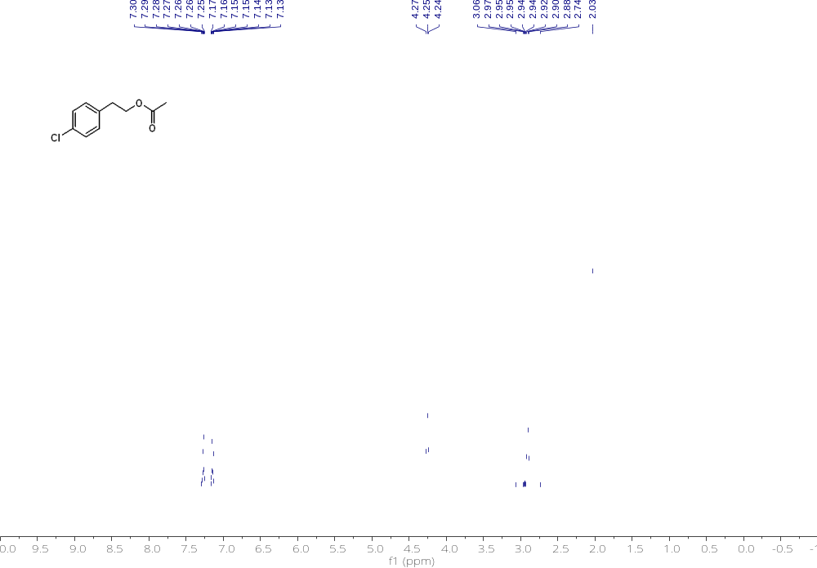

Compound 52 ¹³C NMR 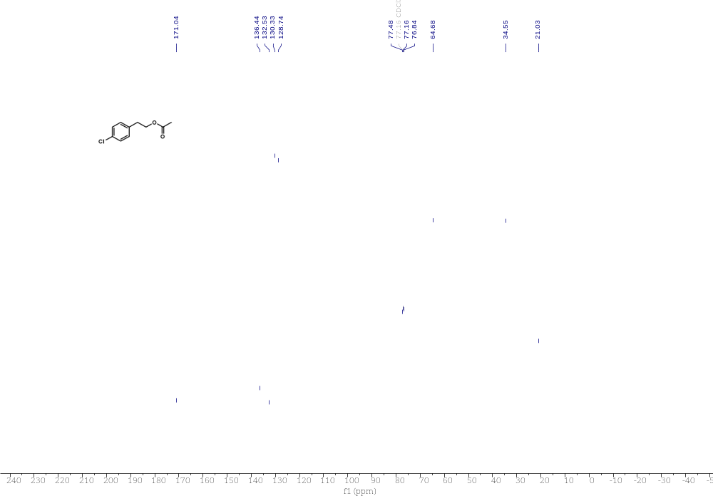

Compound 53 ¹H NMR 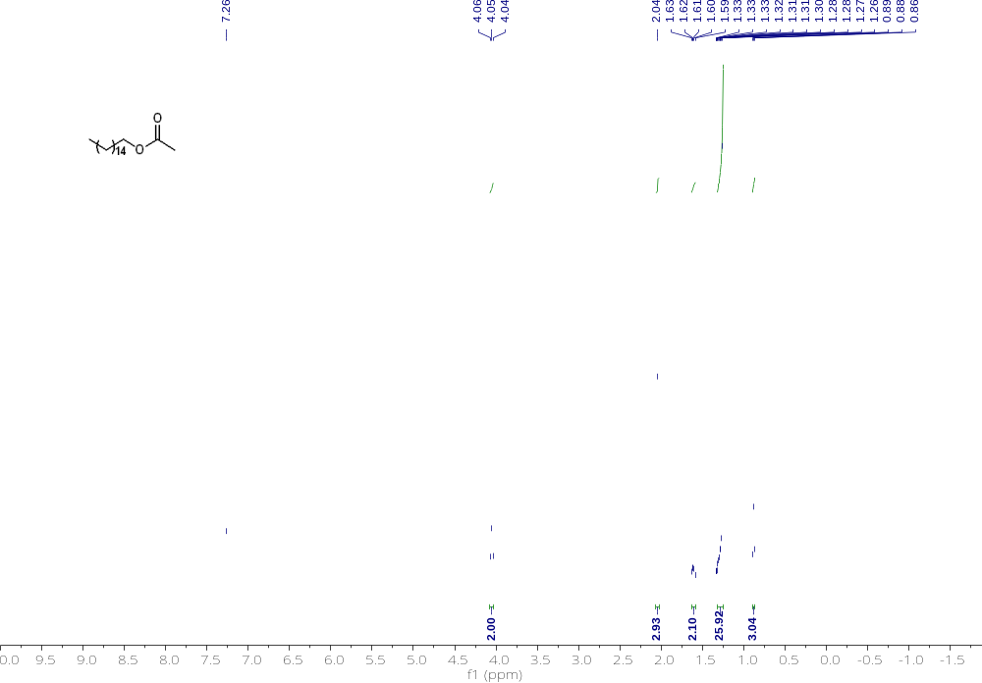

Compound 53 ¹³C NMR 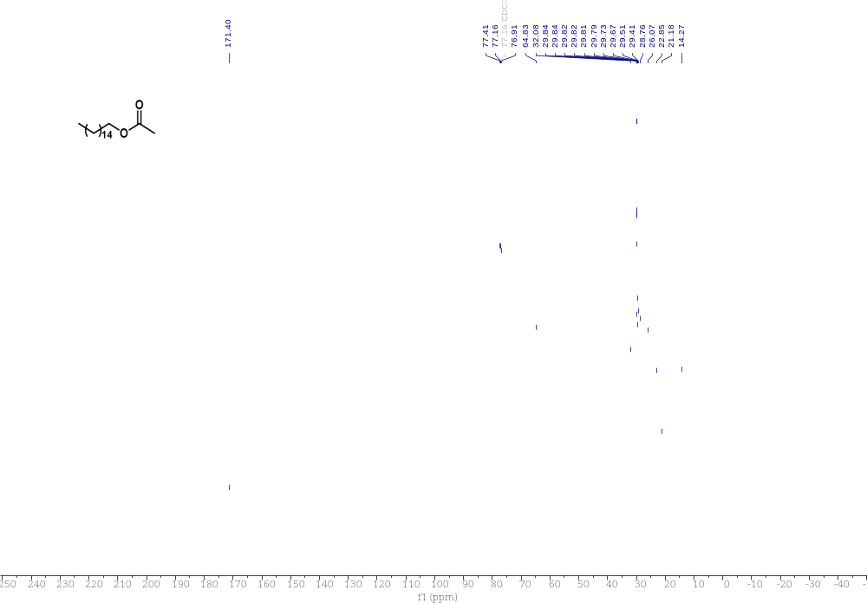

Compound 54 ¹H NMR 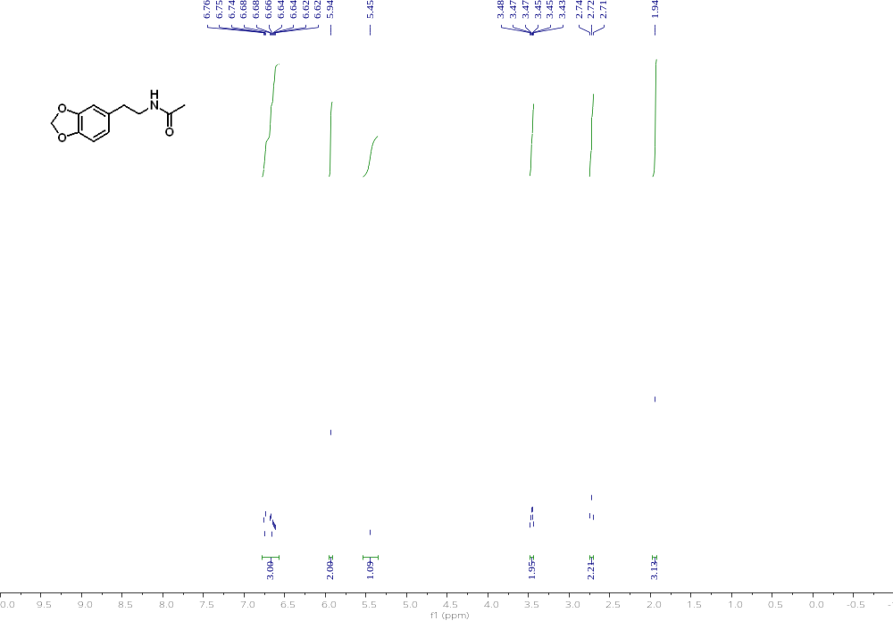

Compound 54 ¹³C NMR 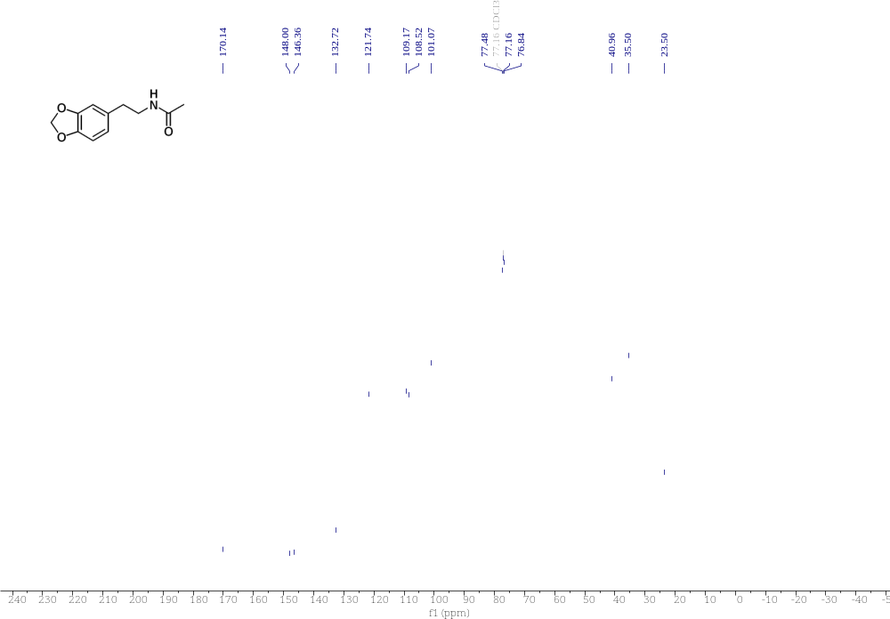

Compound 55 ¹H NMR 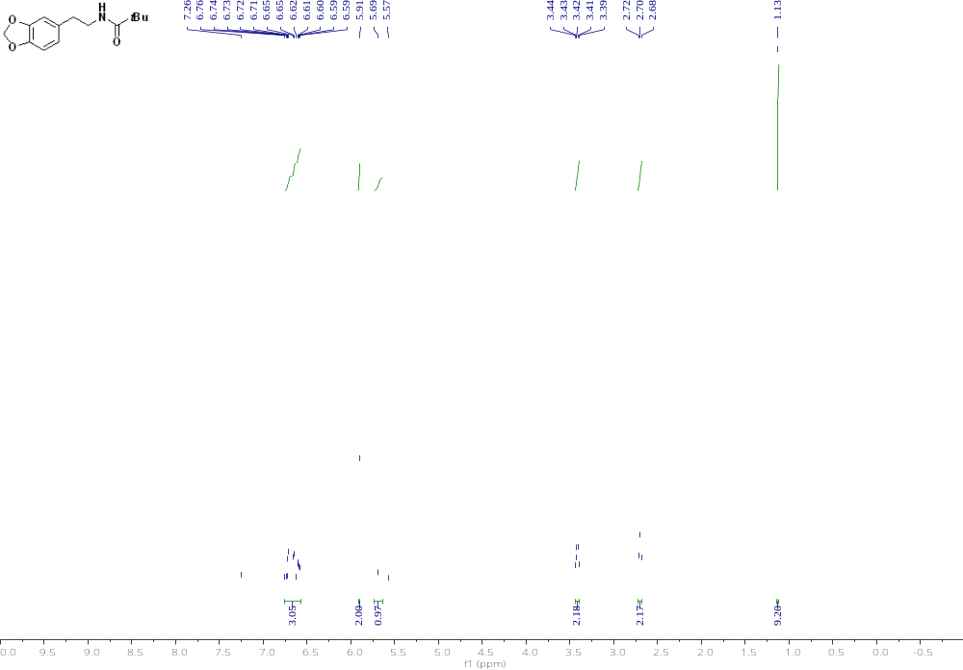

Compound 55 ¹³C NMR 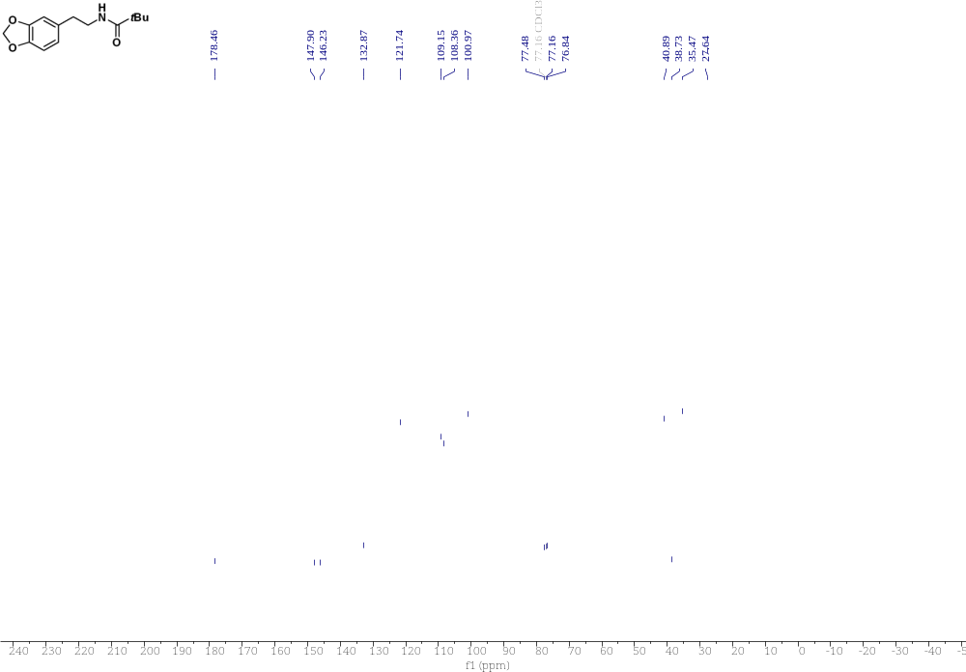

Compound 56 ¹H NMR 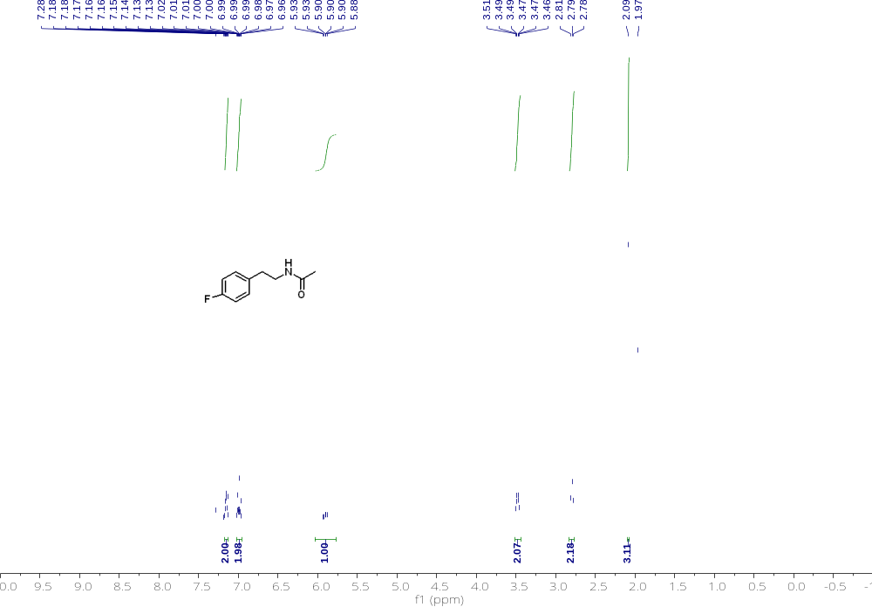

Compound 56 ¹³C NMR 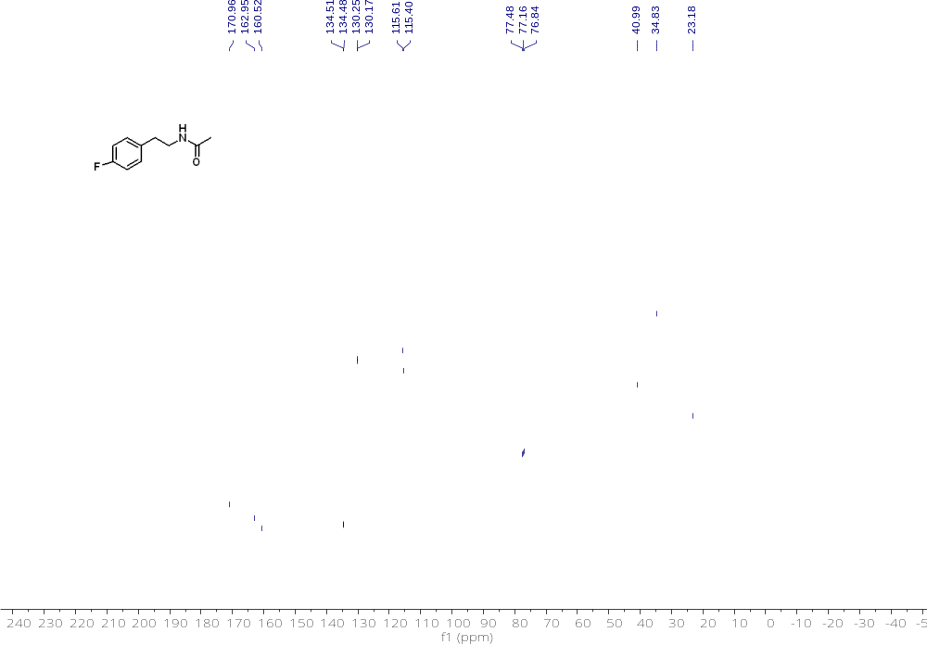

Compound 56 ¹⁹F NMR 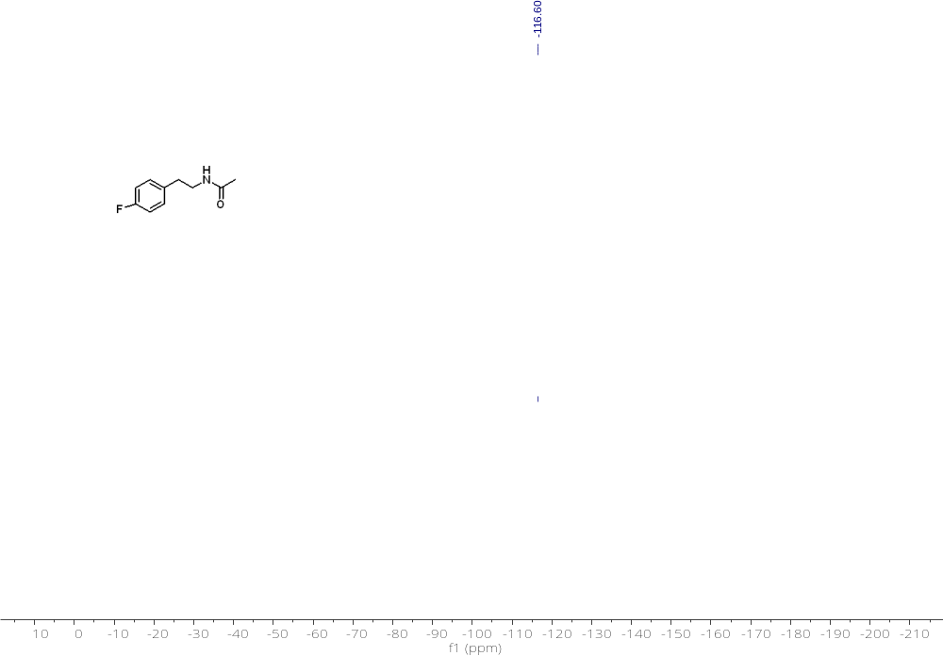

Compound 57 ¹H NMR
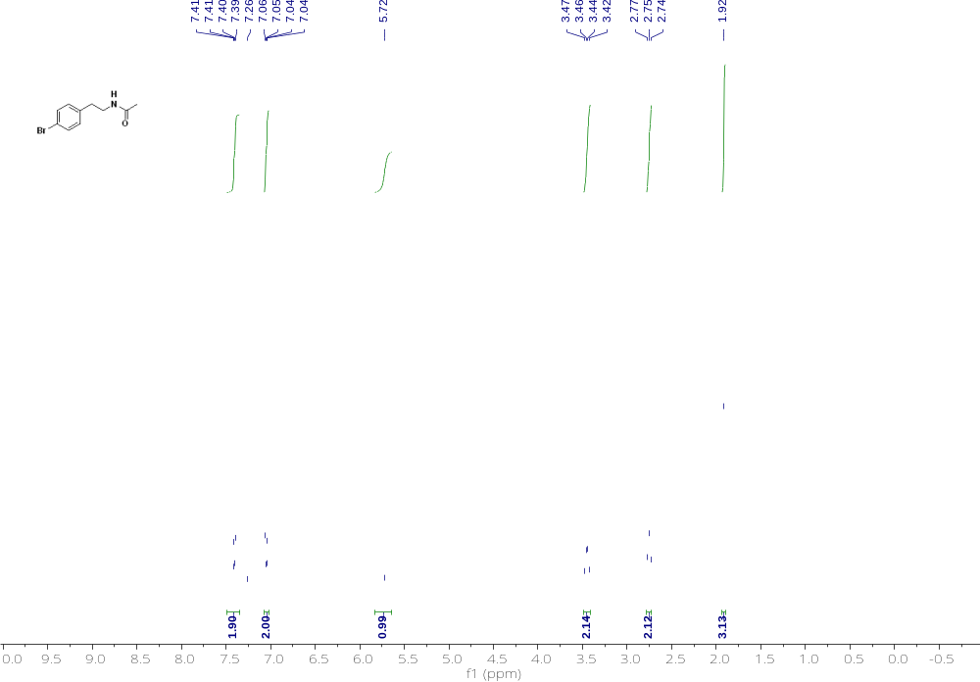

Compound 57 ¹³C NMR
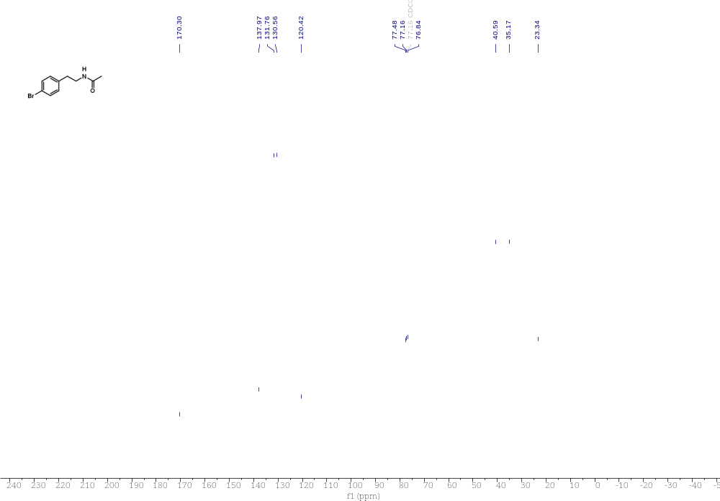

Compound 58 ¹H NMR 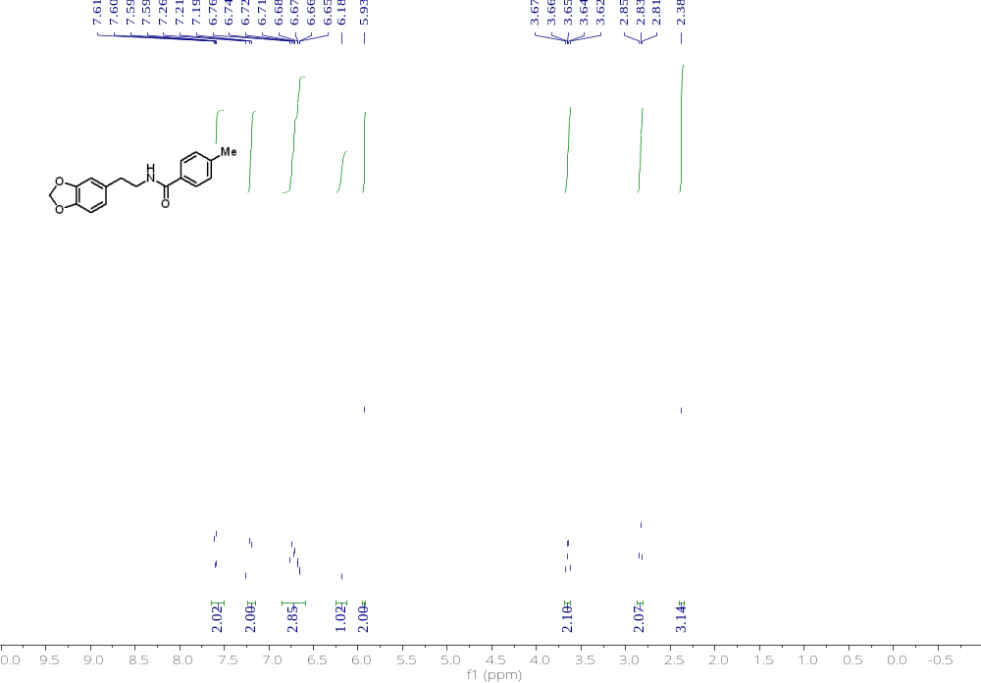

Compound 58 ¹³C NMR
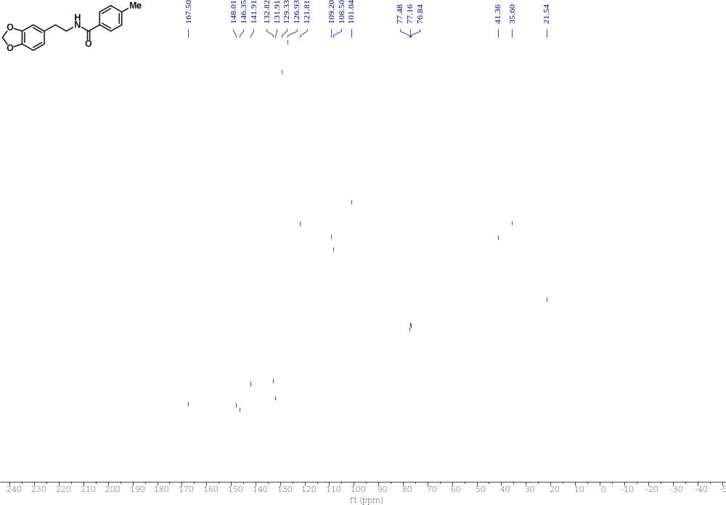

Compound 59 ¹H NMR 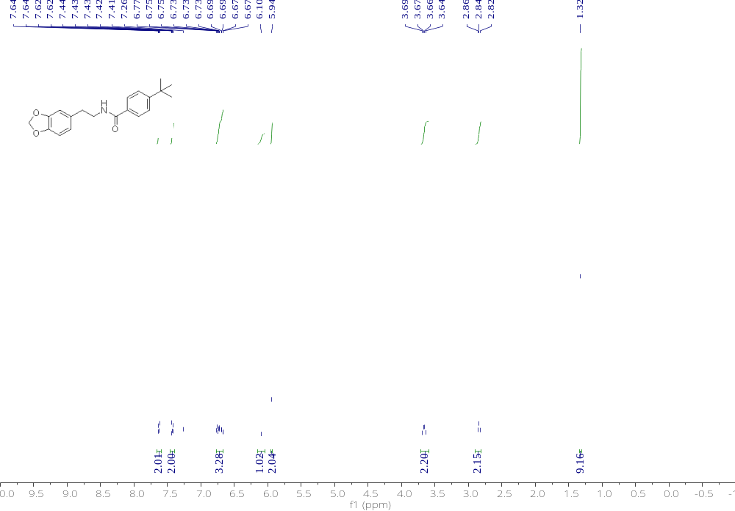

Compound 59 ¹³C NMR 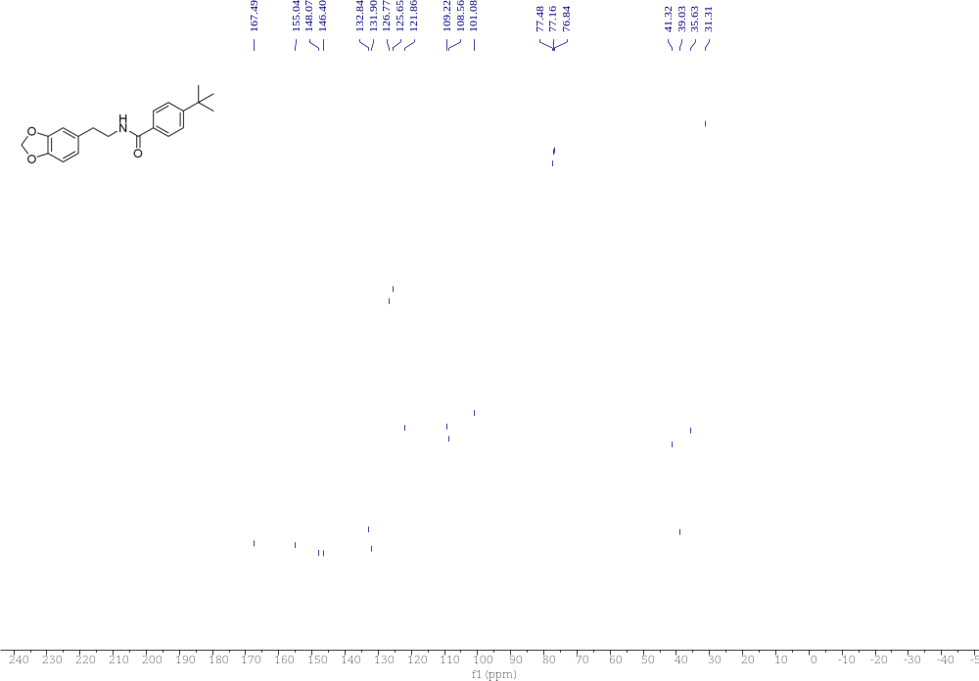

Compound 60 ¹H NMR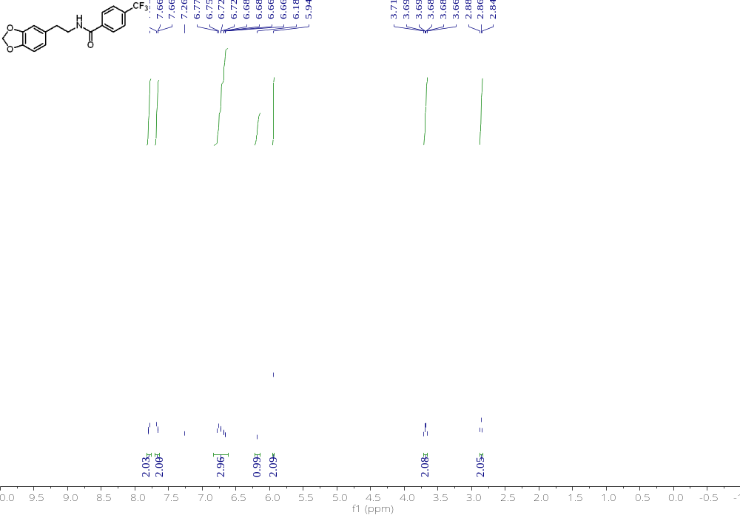

Compound 60 ¹³C NMR 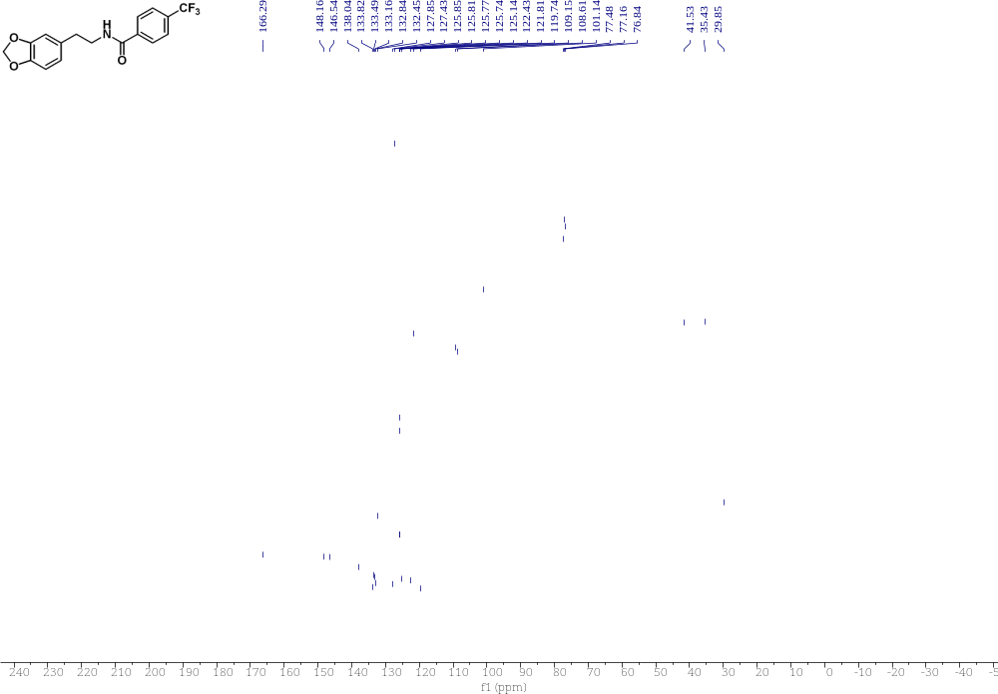

Compound 60 ¹⁹F NMR 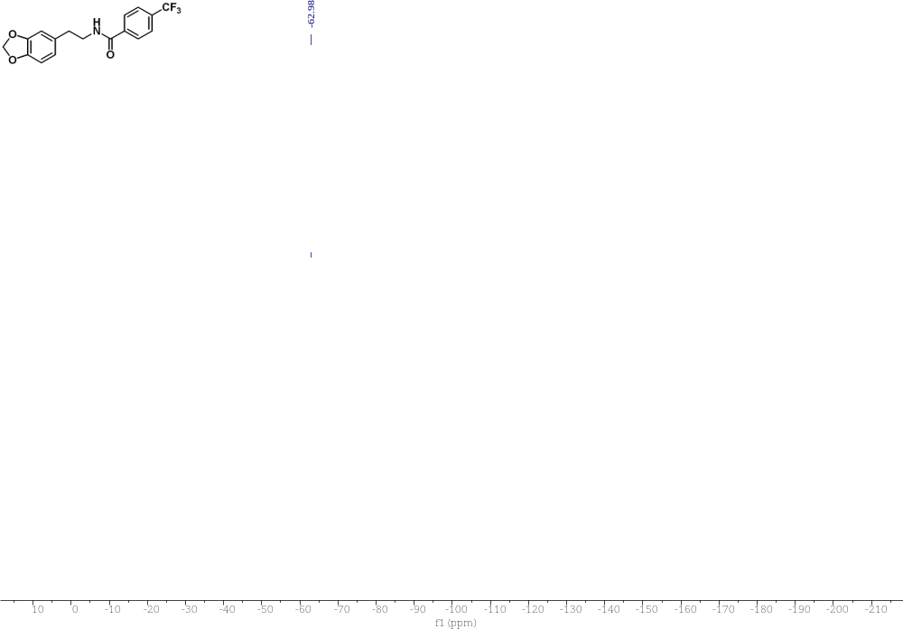

Compound 61 ¹H NMR 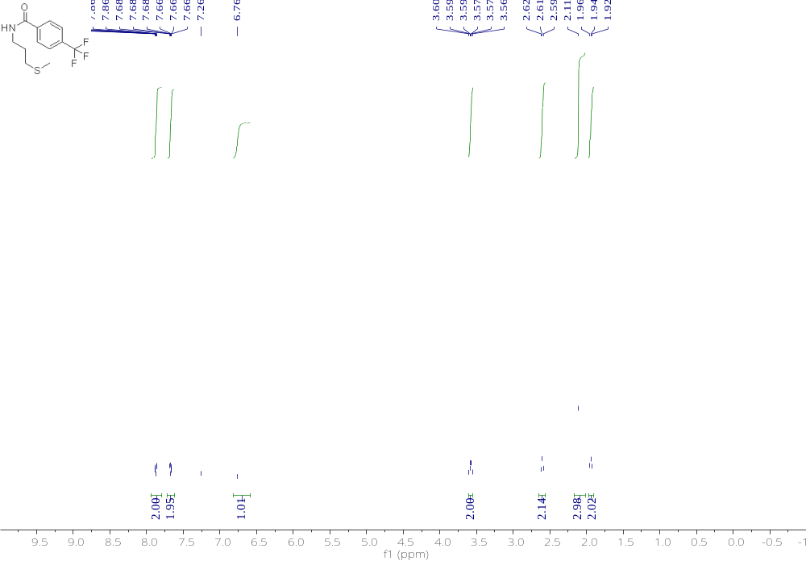

Compound 61 ¹³C NMR 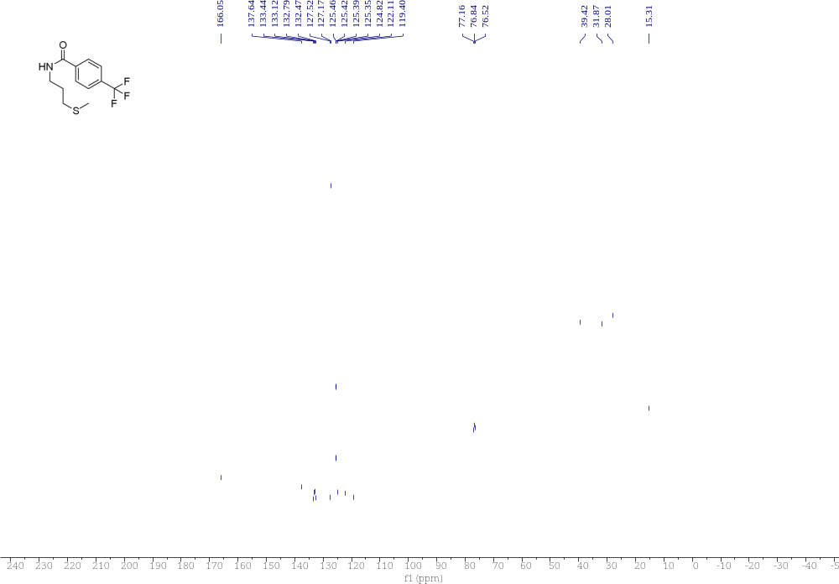

Compound 61 ¹⁹F NMR 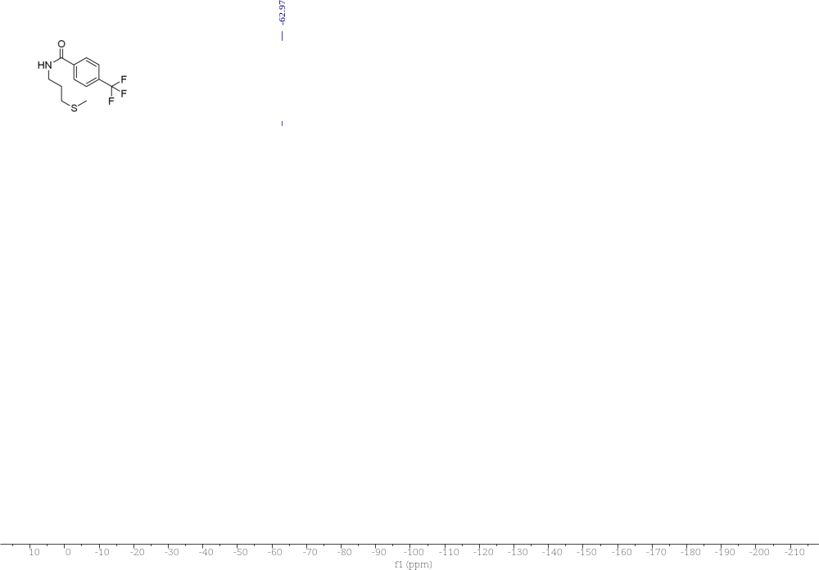

References
1. J.-F. Li, Z.-Z. Wei, Y.-Q. Wang, M. Ye, Green Chem. 2017, 19, 4498-4502.
2. Zhao, C. Li, M. Luo, X. Zeng, Organometallics 2021, 40, 2204-2208.
3. J. Wu, L. He, A. Noble, V. K. Aggarwal, J. Am. Chem.Soc. 2018, 140, 10700-10704.
4. A. Joshi-Pangu, X. Ma, M. Diane, S. Iqbal, R. J. Kribs, R. Huang, C.-Y. Wang, M. R. Biscoe, J. Org. Chem. 2012, 77, 6629-6633.
5. P. K. Verma, K. S. Prasad, D. Varghese, K. Geetharani, Org. Lett. 2020, 22, 1431-1436.
6. P. Guo, H. Jin, J. Han, L. Xu, P. Li, M. Zhan, Org. Lett. 2023, 25, 1268-1273.
7. J. Hu, G. Wang, S. Li, Z. Shi, Angew.Chem.Int.Ed. 2018, 57, 15227-15231.
8. T. Zhang, K. Manna, W. Lin, J. Am. Chem.Soc. 2016, 138, 3241-3249.
9. J. Wang, M. Shang, H. Lundberg, K. S. Feu, S. J. Hecker, T. Qin, D. G. Blackmond, P. S. Baran, ACS Cata. 2018, 8, 9537-9542.
10. S. Li, C. Hu, X. Cui, J. Zhang, L. L. Liu, L. Wu, Angew.Chem.Int.Ed. 2021, 60, 26238-26245.
11. B. C. Ranu, T. Mandal, Synlett 2007, 2007, 0925-0928.
12. R. R. Bhandare and J. D. Canney, Medicinal Chem., 2014, 10, 361-375.
13. A. P. Bashall and J. F. Collins, Tetra. Lett., 1975, 16, 3489-3490.
14. C. Pramthaisong, R. Worayuthakarn, V. Pharikronburee, T. Duangthongyou, R. Rattanakam, S. Ruchirawat, N. Thasana, Org. Lett. 2018, 20, 4015-4019.
15. B. Li, G. Zhou, D. Zhang, L. Yao, M. Li, G. Yang, S. Zhang, H. Nie, Org. Lett. 2024, 26, 2097-2102.
16. M. J. Harper, E. J. Emmett, J. F. Bower, C. A. Russell, J. Am. Chem.Soc. 2017, 139, 12386-12389.
17. N. Goswami, S. K. Sinha, P. Mondal, S. Adhya, A. Datta, D. Maiti, Chem. 2023, 9, 989-1003.
18. H. Liu, L. Wang, Y. Li, J. Liu, M. An, S. Zhu, Y. Cao, Z. Jiang, M. Zhao, Z. Cai, L. Dai, T. Ni, W. Liu, S. Chen, C. Wei, C. Zang, S. Tian, J. Yang, C. Wu, D. Zhang, H. Liu, Y. Jiang, ChemMedChem 2014, 9, 207-216.
19. L. Quteishat, A. Panossian, F. Le Bideau, R. Alsalim, P. Retailleau, C. Troufflard, E. Rose, F. Dumas, J. Organo. Chem. 2015, 776, 35-42.
20. S. Shahane, F. Louafi, J. Moreau, J.-P. Hurvois, J.-L. Renaud, P. van de Weghe, T. Roisnel, Eur.J. Org. Chem. 2008, 2008, 4622-4631.
21.Q. Xie, C. Ni, R. Zhang, L. Li, J. Rong, J. Hu, Angew.Chem.Int.Ed. 2017, 56, 3206-3210.

