Supplementary Material
Improving Therapeutic Decision-Making through Risk-stratification of Severe COVID-19 Patients
Symeon Savvopoulos¹, Anastasia Papadopoulou², Georgios Karavalakis², Ioanna Sakellari², Grigorios Georgolopoulos³, Evangelia Yannaki^{2,3}*, Haralampos Hatzikirou^{1,4}*
- Department of Mathematics, Khalifa University, Abu Dhabi, United Arab Emirates.
- Hematology Department-Hematopoietic Cell Transplantation Unit, Gene and Cell Therapy Center, “George Papanikolaou” Hospital, 57010 Thessaloniki, Greece
- Department of Medicine, University of Washington, Seattle, WA 98195, USA
- Technische Univesität Dresden, Center for Information Services and High Performance Computing, Nöthnitzer Straße 46, P.O. Box: 01062, Dresden, Germany

*These authors participated equally

1. Supplementary tables
Table S1. LDA-identified critical features 60-day patient outcome for each patient cohort.
Arm | Outcome | Important features driving the patient outcome
A | 60-day | PC1: I) CRP, Karnf., CD4, CD56, IL10, IL6, DD, CD8, TNFa, CPK, Ferritin, IFNg, circulating CoV-2-STs, age, II) Con2Abs, gender, IL2, CD3, LDH, WBC, comorb.  PC2: I) CD56, gender, CRP, IL2, TNFa, Ferritin, age, CPK, CD8, CD4,WBC, IFNg, circulating CoV-2-STs, Karnof., DD, II) Con2Abs, IL10, comorb., LDH, CD3, IL6
B | 60-day | PC1: I) IFNg, IL10, CD3, CD56, IL6, DD, Ferritin, CD8, age, circulating CoV-2-STs, gender, II) LDH, CD4, TNFa, IL2, Con2Abs, CPK, , comorb., Karnf., CRP WBC  PC2: I) IFNg, IL10, DD, CD8, circulating CoV-2-STs, LDH, CD4, Karnf., II) CD3, IL6, CPK, CRP, Ferritin, TNFa, Con2Abs, IL2, age, gender, CD56, WBC, comorb.
Underlined elements were significantly different by Kruskal-Wallis test (p-value<0.05) for continuous variables, and chi square (p-value<0.05) for categorical variables among patients of the same cohort classified as i) alive and well, ii) alive with disease and iii) dead. Each principal component (PC) is separated in two groups. Group-I includes the features with higher eigenvalue in the eigenvector (≥0.1), and the set II includes the features with smaller eigenvalue in the same eigenvector (<0.1). Abbreviations: CoV-2NAbs – SARS CoV Antibodies, IFN-γ – Interferon gamma, IL-10 – Interleukin 10, IL-2 – Interleukin 2, IL-6 – Interleukin 6, TNF-a – Tumor Necrosis Factor, CoV-2-STs – SARS CoV Specific T cells, CPK – Creatinine Phosphokinase, CRP – C Reactive Protein, LDH – Lactate Dehydrogenase, WBC – White Blood Cells, IQR – Interquartile range

2. Supplementary figures
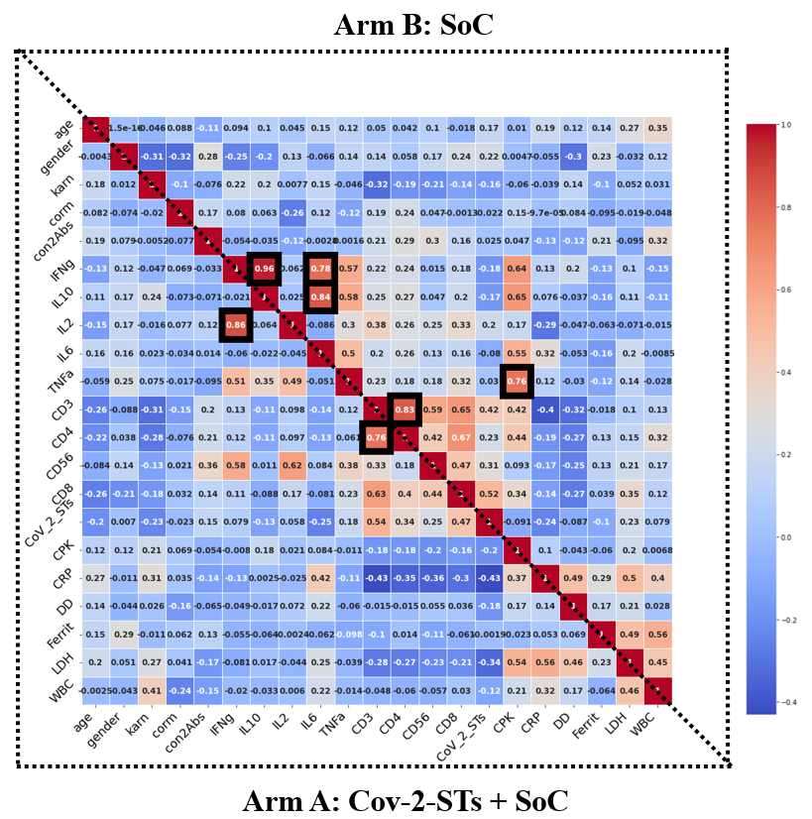
Figure S1: Correlation heatmap of CoV-2-STs+SoC and SoC groups at day 5.

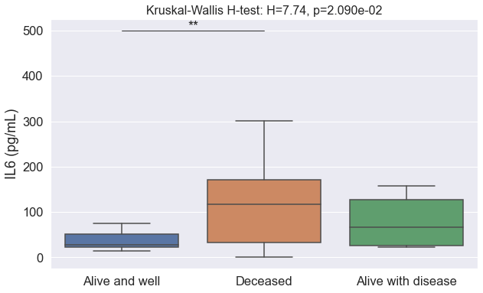 | 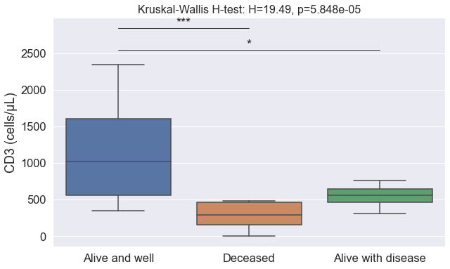
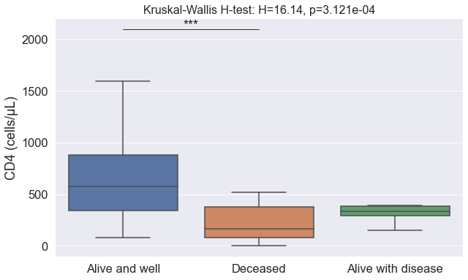 | 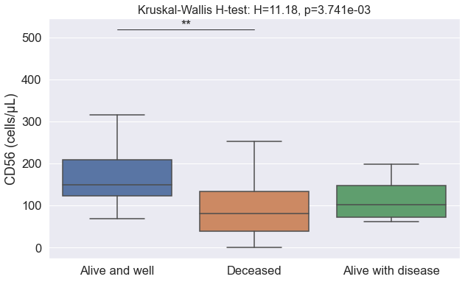
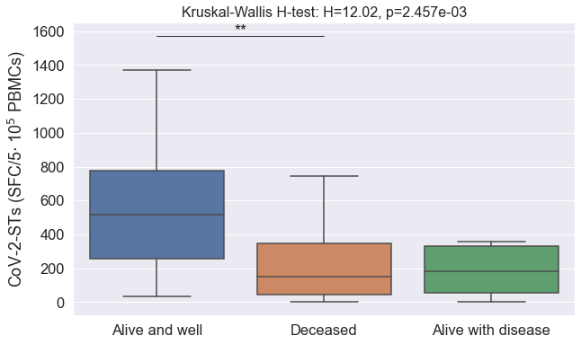 | 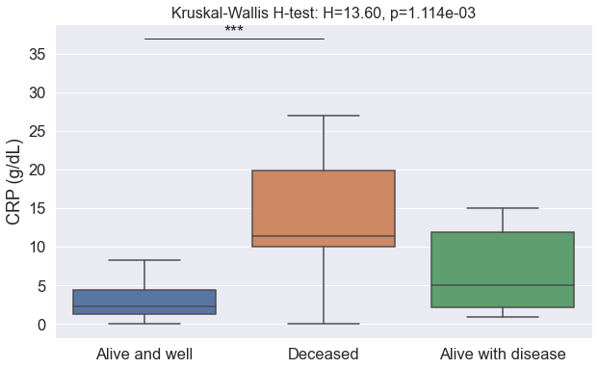
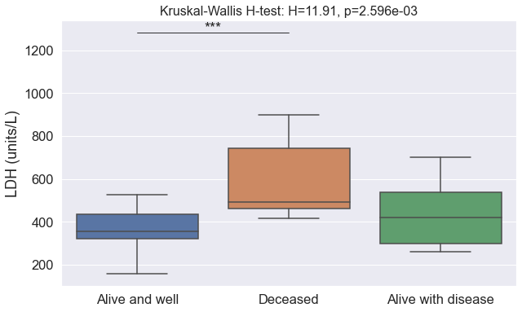 | 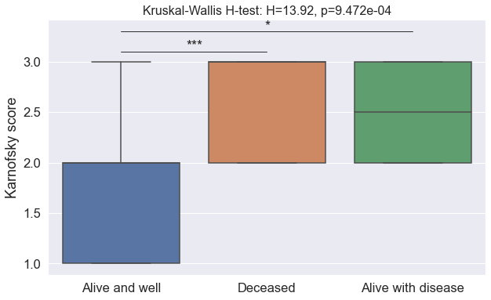
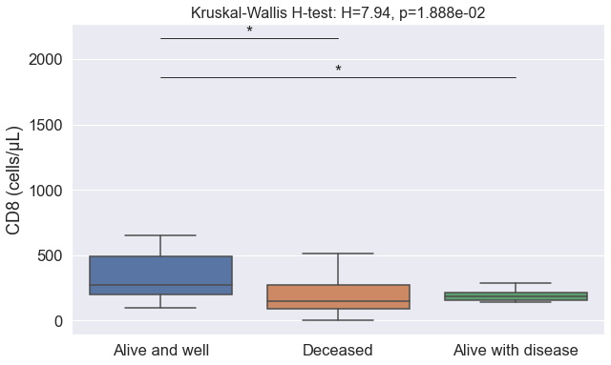

Figure S2: The most critical features driving the 60-day clinical outcome of CoV-2-STs+SoC-treated patients, as identified by LDA. Differences between data sets were analyzed using Kruskal Wallis and Mann-Whitney with p<0.05, (*: p<0.05, **: p<0.01, ***: p<0.001)

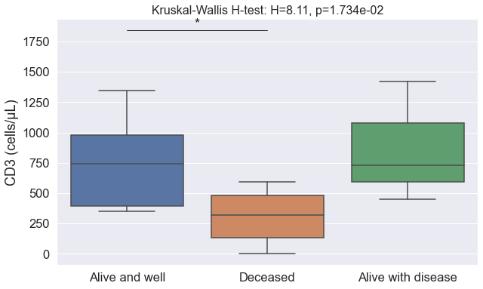 | 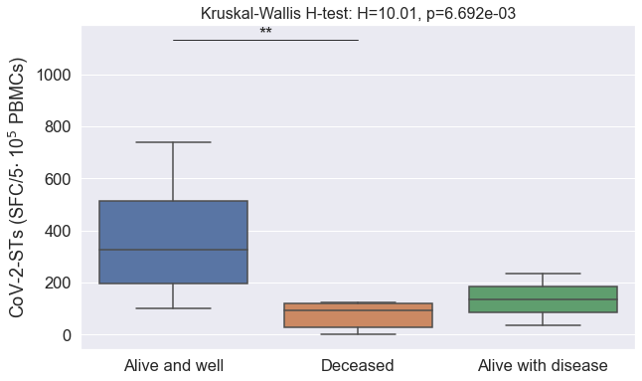
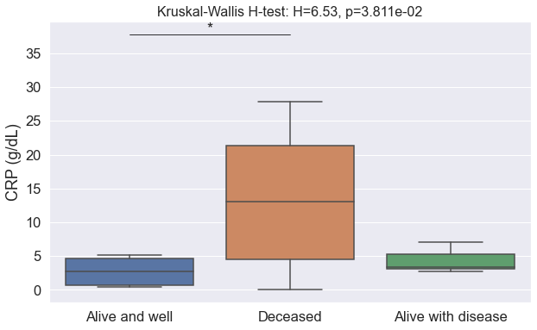 | 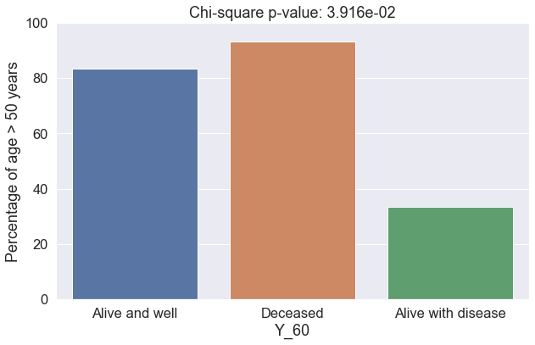

Figure S3: The most critical features driving the 60-day clinical outcome of SoC-treated patients, as identified by LDA. Differences between data sets were analyzed using Kruskal-Wallis and Mann-Whitney with p<0.05, (*: p<0.05, **: p<0.01, ***: p<0.001)

3. A robust tool for outcome prediction
A user-friendly app in Microsoft Excel designed for healthcare professionals managing COVID-19 patients. This innovative tool uses advanced LDA algorithms to predict patient outcomes under different treatment protocols, such as CoV-2-STs+SoC, or SoC only. This app offers personalized, data-driven insights to guide clinical decision-making. Developed with a comprehensive database of COVID-19 treatment outcomes and validated through clinical research, this app is not only user-friendly, but also compliant with healthcare privacy standards. This app aims to enhance treatment strategies, improve patient outcomes, and support healthcare providers in navigating the complexities of COVID-19 treatment.
In the first step (Figure S4), the only factors that need to be considered are individual patient characteristics at the time of diagnosis (day-0). These include age, gender, Karnofsky score, any comorbidities, and specific biomarkers and clinical parameters such as con2Abs, IFNg, IL10, IL2, IL6, TNFa, CD3, CD4, CD56, CD8, CoV-2-STs, CPK, CRP, D-Dimer DD, Ferritin, LDH, and WBC.
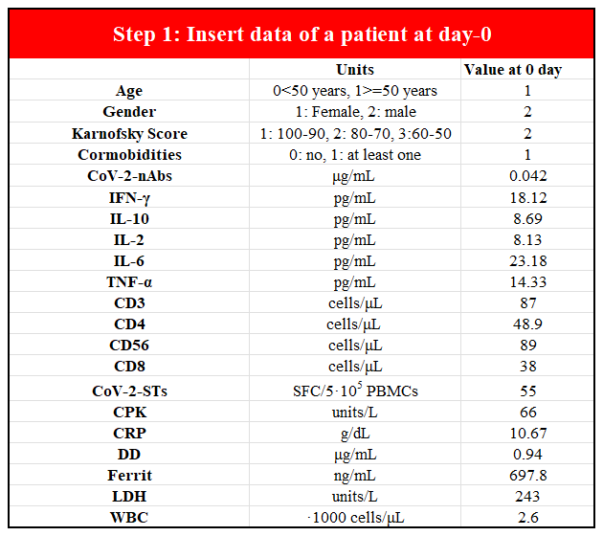

Figure S4: The entry of patient demographic and clinical characteristics at the baseline.

The user can activate the ML model by pressing a button after entering patient-specific measurements on day-0 (Figure S5). The ML algorithm quickly calculates and displays survival probabilities for two treatment options. The application presents these probabilities and performs a Mann-Whitney U test to determine if the two treatments are statistically different in effectiveness. This comprehensive analysis helps medical professionals tailor patient care based on robust statistical evidence by evaluating treatment strategies using data.
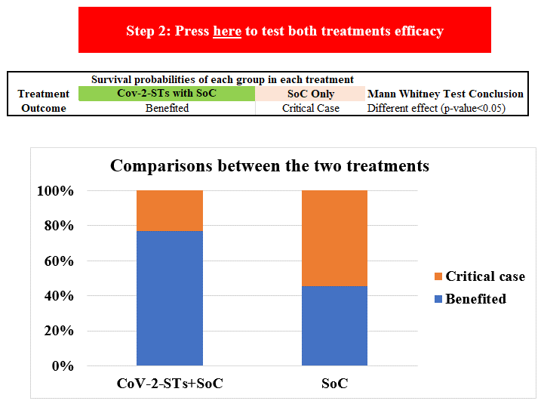
Figure S5: The personalized app conclusions under different treatment options.

The application categorizes patient outcomes into two distinct classes based on the predictions made by our machine learning model. The first class is labeled 'Benefitted,' which identifies patients who are likely to respond positively to the treatment and achieve successful outcomes. This classification aids healthcare professionals in recognizing individuals who are expected to recover with the standard treatment protocols. The second class is termed 'Critical case,' denoting patients who may require additional care and attention during their treatment period. These are individuals predicted to be more susceptible to severe viral symptoms and complications, indicating a need for more intensive or specialized medical intervention. By distinguishing patients in this manner, the application provides valuable insights to healthcare providers, enabling them to tailor treatment strategies according to the predicted needs of each patient.

