Predicting the Impact of Climate Change on Species Distribution and Conservation Strategies of Picea neoveitchii using MaxEnt Modeling
Ninghan Xueª, Kaiyuan Liª, Kexin Chenª, Panpan Liª, Xinmiao Ji^{b}, Zhilin Ma^{c,*}, Wenli Ji^{a,*}
ª College of Landscape Architecture and Art, Northwest A&F University, Yangling 712100, China
^{b} College of Architecture and Engineering, Sichuan Polytechnic University, Deyang 618000, China
^{c} Shaanxi Academy of Forestry, Xi'an 710000, China
*Corresponding authors: Zhilin Ma (540738881@qq.com) and Wenli Ji (jiwenli@nwafu.edu.cn)

Supplementary material
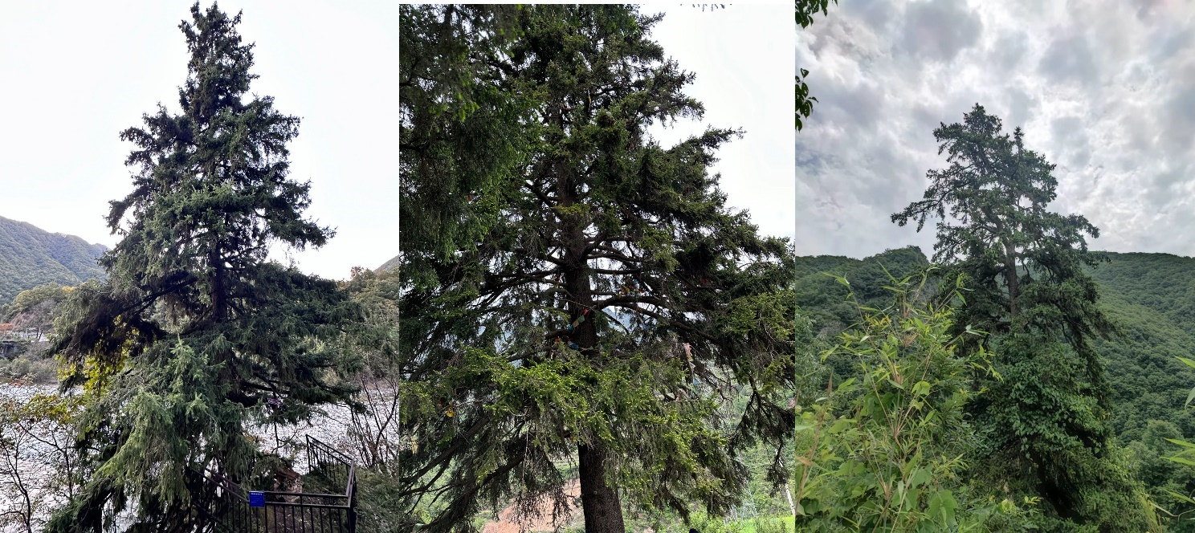
Fig. S1 Taken by authors during field investigation
Table S1Percentage contributions and permutation importance of the bioclimatic variables included in the Maxent models for P. neoveitchii variables without any values
Symbol | Bioclimatic variables | Permutation importance（%） | Percent contribution（%）
BIO6 | Min Temperature of Coldest Month | 29.1 | 16.9
BIO12 | Annual Precipitation | 25.1 | 14.9
BIO4 | Temperature Seasonality | 9 | 11
Altitude | Altitude | 7.7 | 7.1
S_ESP | Subsoil Sodicity (ESP) | 7.5 | 0.2
T_CACO3 | Topsoil Calcium Carbonate | 2.2 | 1.1
S_OC | Subsoil Organic Carbon | 1.8 | 1.4
AWC_CLASS | AWC Range | 1.8 | 0.9
slope | slope | 1.7 | 13.3
T_GRAVEL | Topsoil Gravel Content | 1.7 | 1.1
SU_SYM90 | FAO-90 soil classification | 1.5 | 10.9
Vegetation | Vegetation category | 1.3 | 2.3
Slope | Slope | 1.1 | 1.5
PHASE1 | Soil stage | 1 | 4.2
T_CEC_CLAY | Topsoil CEC (clay) | 0.9 | 1.2
T_CLAY | Topsoil Clay Fraction | 0.8 | 0.2
T_SILT | Topsoil Silt Fraction | 0.7 | 1.2
ADD_PROP | Other properties (gelic, vertic, petric) | 0.6 | 1.9
BIO15 | Precipitation Seasonality | 0.6 | 1.7
T_SAND | Topsoil Sand Fraction | 0.6 | 0.3
BIO3 | Isothermality | 0.5 | 3.6
T_ESP | Topsoil Sodicity (ESP) | 0.4 | 0.5
S_SILT | Subsoil Silt Fraction | 0.4 | 0.2
T_CEC_SOIL | Topsoi CEC (soil) | 0.4 | 0.2
S_USDA_TEX_CLASS | Subsoil USDA Texhire  Classification | 0.4 | 0.1
S_BS | Subsoil Base Saturation | 0.3 | 0.6
T_REF_BULK_DENSITY | Topsoil Reference Bulk Density | 0.3 | 0.2
S_GRAVEL | Subsoil Gravel Content | 0.2 | 0.7
DRAINAGE | Drainage class | 0.2 | 0.1
S_CEC_SOIL | Subsoil CEC (soil) | 0.1 | 0.1
S_TEB | Subsoil TEB | 0 | 0.4
T_PH_H2O | Topsoi pH (H20) | 0 | 0.1

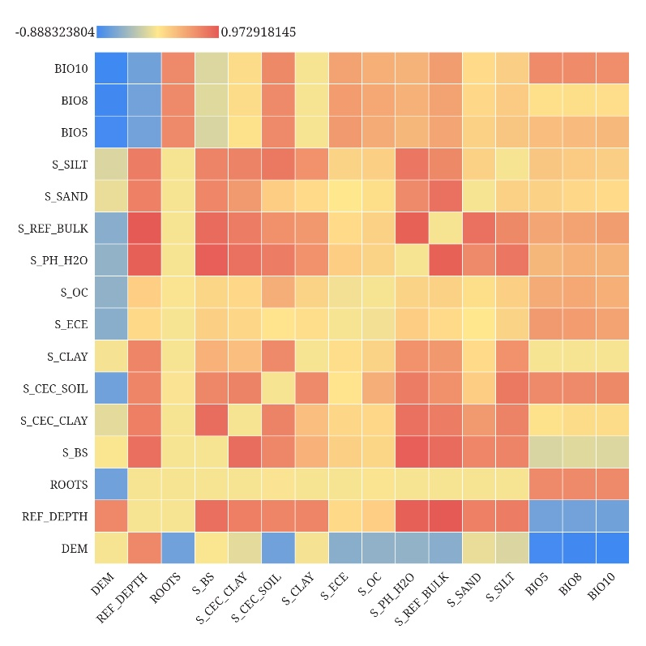
Fig. S2 Cartesian Heatmap for Correlation Analysis Among Environmental Factors (Partial Example).
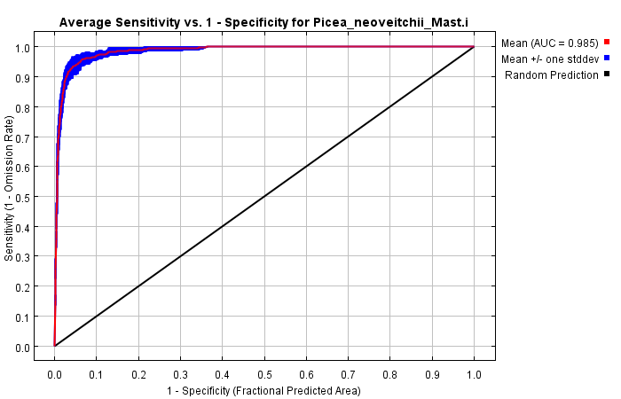
Fig.S3 The receiver operating characteristic (ROC) curve for the data
Table S2The suitable area under various scenarios/periods
climate scenario | area(×10⁵km²)
climate scenario | Suitable | Low suitable | Medium suitable | High suitable | Not suitable
SSP1-2.6_2080-2100s | 42.71 | 25.76 | 9.96 | 6.99 | 899.27
Current | 42.26 | 24.86 | 9.47 | 7.93 | 901.28
SSP2-4.5_2020-2040s | 41.95 | 25.36 | 8.70 | 7.90 | 900.03
SSP2-4.5_2060-2080s | 41.88 | 27.23 | 9.37 | 5.28 | 900.10
SSP5-8.5_2040-2060s | 40.33 | 25.70 | 9.56 | 5.07 | 901.65
SSP1-2.6_2020-2040s | 39.24 | 25.00 | 8.61 | 5.63 | 902.74
SSP1-2.6_2060-2080s | 38.81 | 24.07 | 8.56 | 6.18 | 903.18
SSP5-8.5_2020-2040s | 37.89 | 22.95 | 8.51 | 6.44 | 904.09
SSP2-4.5_2040-2060s | 35.80 | 22.82 | 8.13 | 4.85 | 906.18
SSP1-2.6_2040-2060s | 35.28 | 21.08 | 7.76 | 6.44 | 906.70
SSP5-8.5_2080-2100s | 33.01 | 24.13 | 6.13 | 2.76 | 908.97
SSP2-4.5_2080-2100s | 32.87 | 22.51 | 7.18 | 3.18 | 909.11
SSP5-8.5_2060-2080s | 32.30 | 22.08 | 6.88 | 3.35 | 909.68

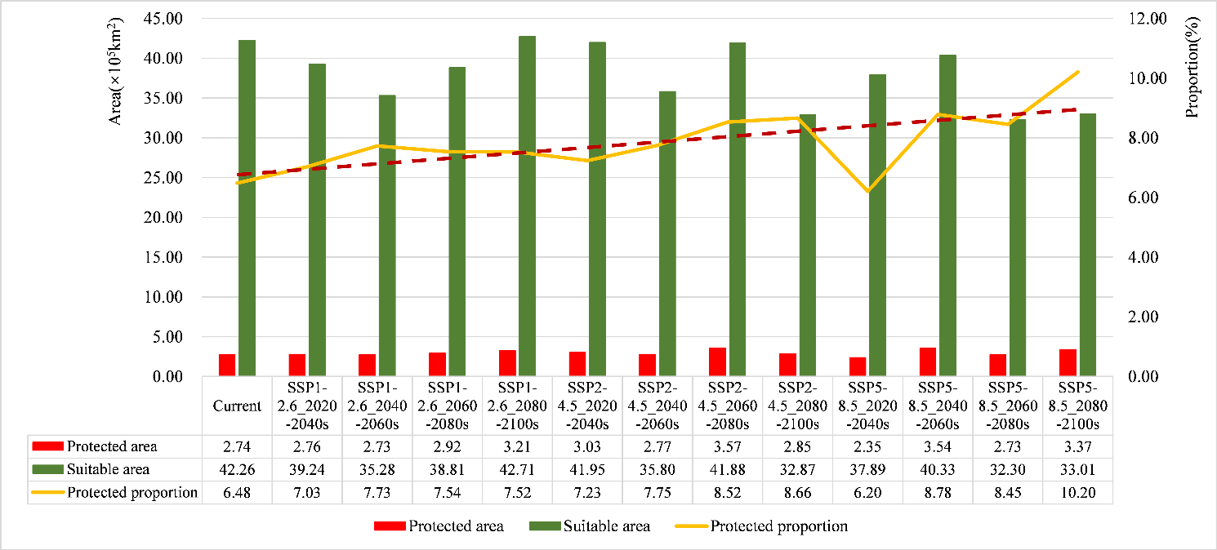
Figure. S 4 The distribution area and proportion of protected areas within the suitable area under various scenarios/periods

