Bioinspired hydrophobic pseudo-hydrogel for programmable shape-morphing
Zhigang Wangª, Zefan Chaiª, Yuhang Huª, Cheng Zhang^{b}, Chunjie Yanª, Wesley Coll^{c}, Tony Jun Huang ^{c, d}, Xianchen Xu ^{d}*, Heng Deng^{a, e}*,
ª Faculty of Materials Science and Chemistry, China University of Geosciences, Wuhan 430074, P. R. China
^{b} College of Engineering, Nanjing Agricultural University, Nanjing, 210031, People’s Republic of China
^{c} Department of Mechanical Engineering and Material Science, Duke University, Durham, NC 27708, USA
^{d} Department of Biomedical Engineering, Duke University, Durham, NC 27708, USA
^{e} Shenzhen Research Institute, China University of Geosciences, Shenzhen 518000, China

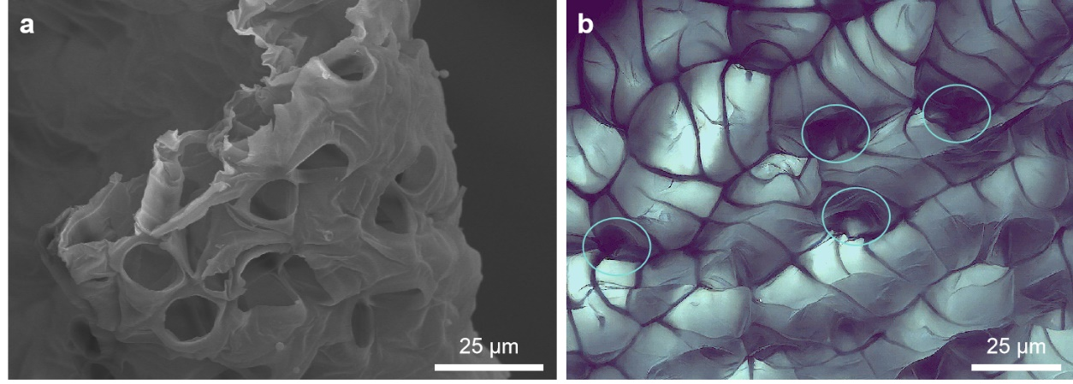
Figure S1. The a) cross-sectional and b) surface SEM image of dried Sphagnum. As can be seen in Fig. S1a, the cross-section of the dried Sphagnum is porous and there are transverse pores present in the pore walls of the longitudinal pores, indicating that the internal pores are interconnected. From the surface SEM plot of the dried Sphagnum (Fig. S1b), it is evident that its surface is porous, enabling capillary forces to facilitate the spontaneous absorption of water by dried peat moss in dry conditions.

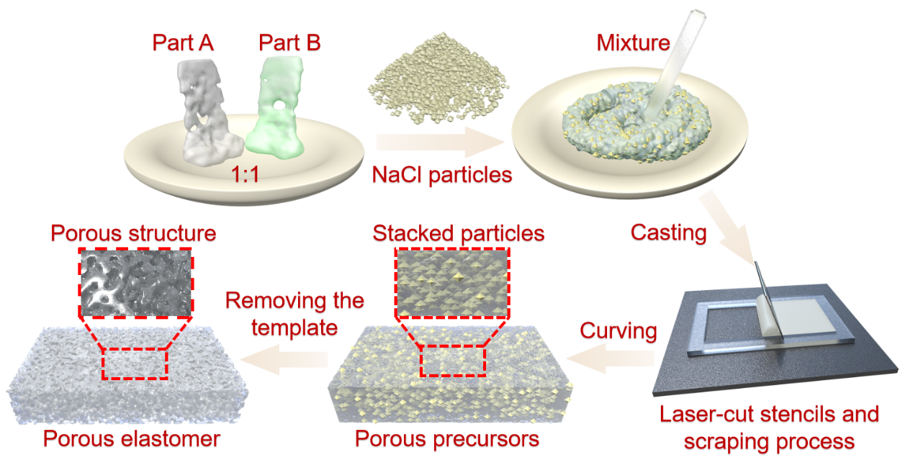
Figure S2. The schematic flowchart for the preparation of porous elastomers using the sacrificial template method. First, component A and component B of ecoflex were mixed 1:1, then NaCl particles of the same mass as the mixture were added, and the mixture was further homogenized and then poured into the molds for molding, and crosslinking was first performed at 60℃. After the crosslinking was completed, the sample was removed and placed in deionized water to remove the templating agent to obtain the porous elastomer.

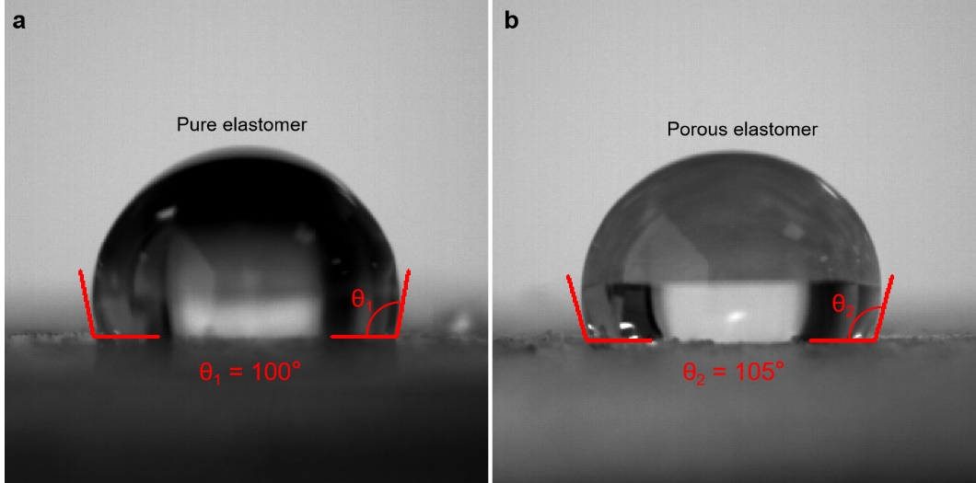
Figure S3. a) The photograph of the contact angle of pure elastomer. b) The photograph of the contact angle of porous elastomer.

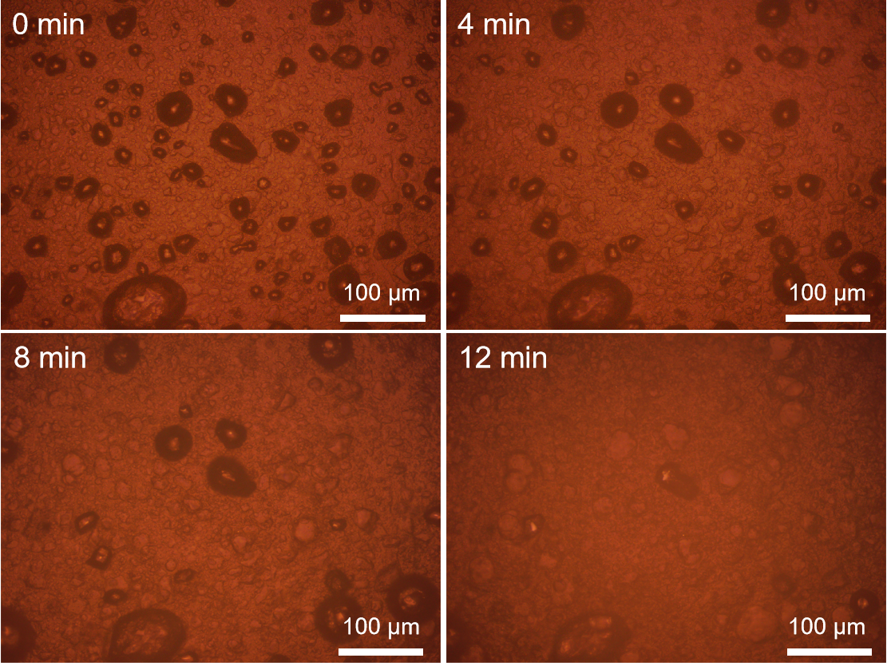
Figure S4. The optical microscope image of the disappearance of surface bubbles with the increase of immersion time after HPH was immersed in water. Upon immersing the HPH in water, the enclosed gas within it became trapped. Under the influence of hydrostatic pressure, water infiltrated the HPH, thus displacing the trapped gas. The gradual dissipation of bubbles observed on the surface of the HPH in the optical microscope image indicated the gradual wetting of the HPH by water.

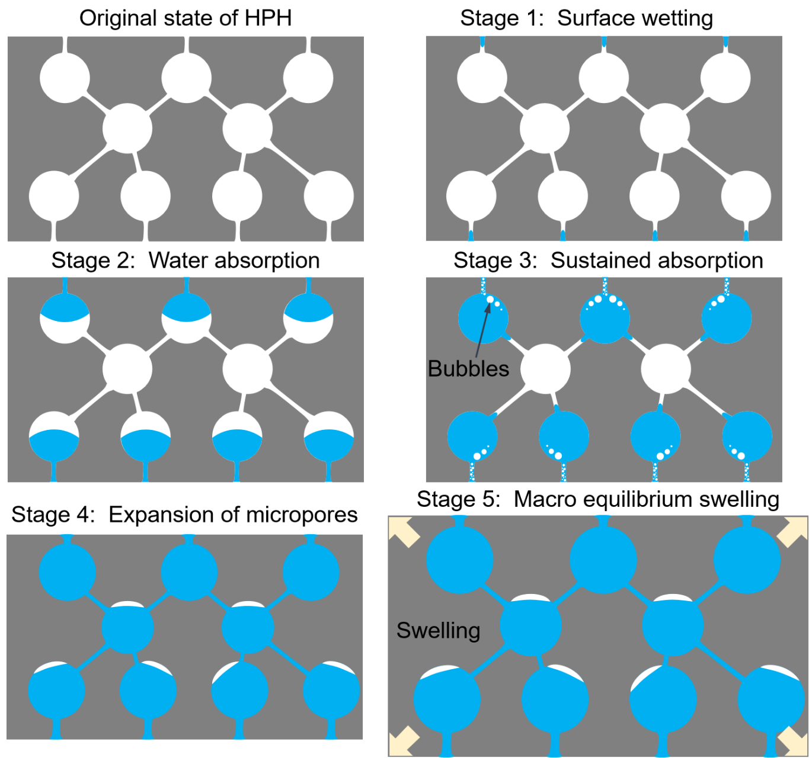
Figure S5. Schematic of the water absorption and swelling process of HPH. In its original state, HPH exhibits a porous nature. When immersed in water, capillary forces drive water into the surface pore channels of HPH (stage 1). Due to its hydrophobic properties, water penetrates the pore, creating an inwardly convex liquid surface against the pore wall. This process persists as water is drawn further into the internal pore through the combined influence of capillary force and surface tension (stage 2). Concurrently, the absorption of water expels some air from within the HPH. As water advances, it converges toward the central pore through the pore channel. The remaining air, not yet discharged during the water absorption, becomes trapped in the central pore of HPH (stage 3). This entrapment concludes when the HPH is fully wetted, and despite the elastomer's binding force, the external force on the water continues to exceed it. This results in the expansion of the microscopic pore structure of HPH (stage 4). Continuing water influx causes the pore diameter to enlarge gradually, reducing the external force until it equals the elastomer binding force. This marks the equilibrium point where HPH achieves dissolution and swelling, exhibiting noticeable macro-scale swelling (stage 5).

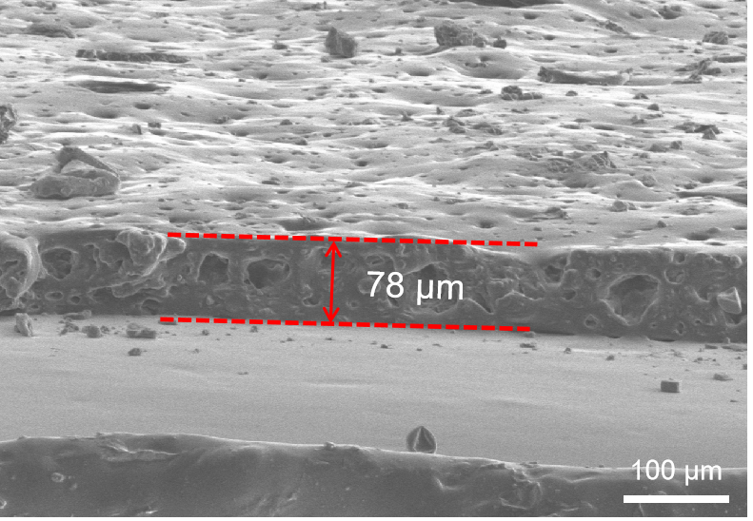
Figure S6. The SEM image of the cross section of HPH thin film. The thickness of the elastomer film is only 78 μm, so the NaCl template can be easily removed to obtain a porous elastomer.

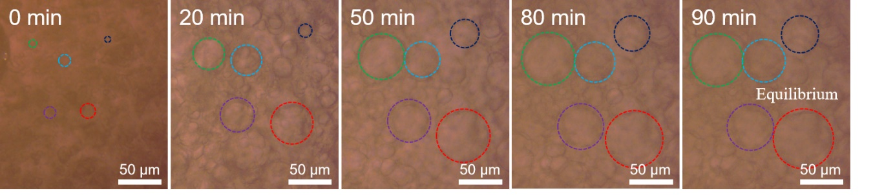
Figure S7. Sequence of optical microscope images of surface pore sizes in time after immersion of porous elastomer in water.

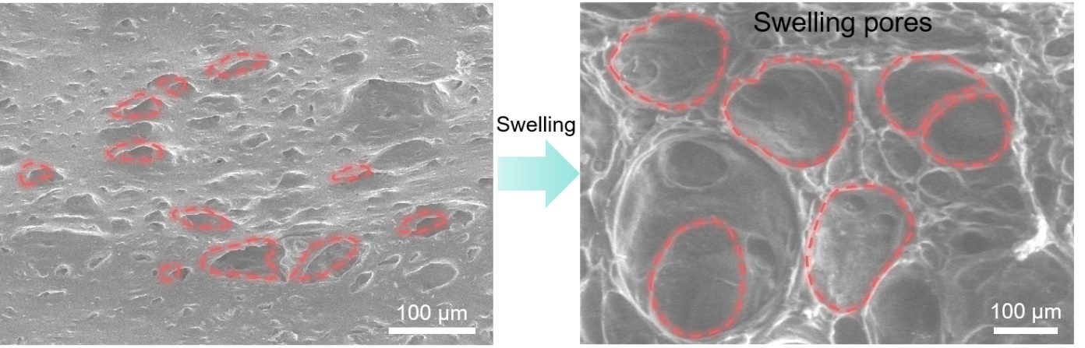
Figure S8. The SEM image of original HPH and the ESEM image of expanded pores of HPH.

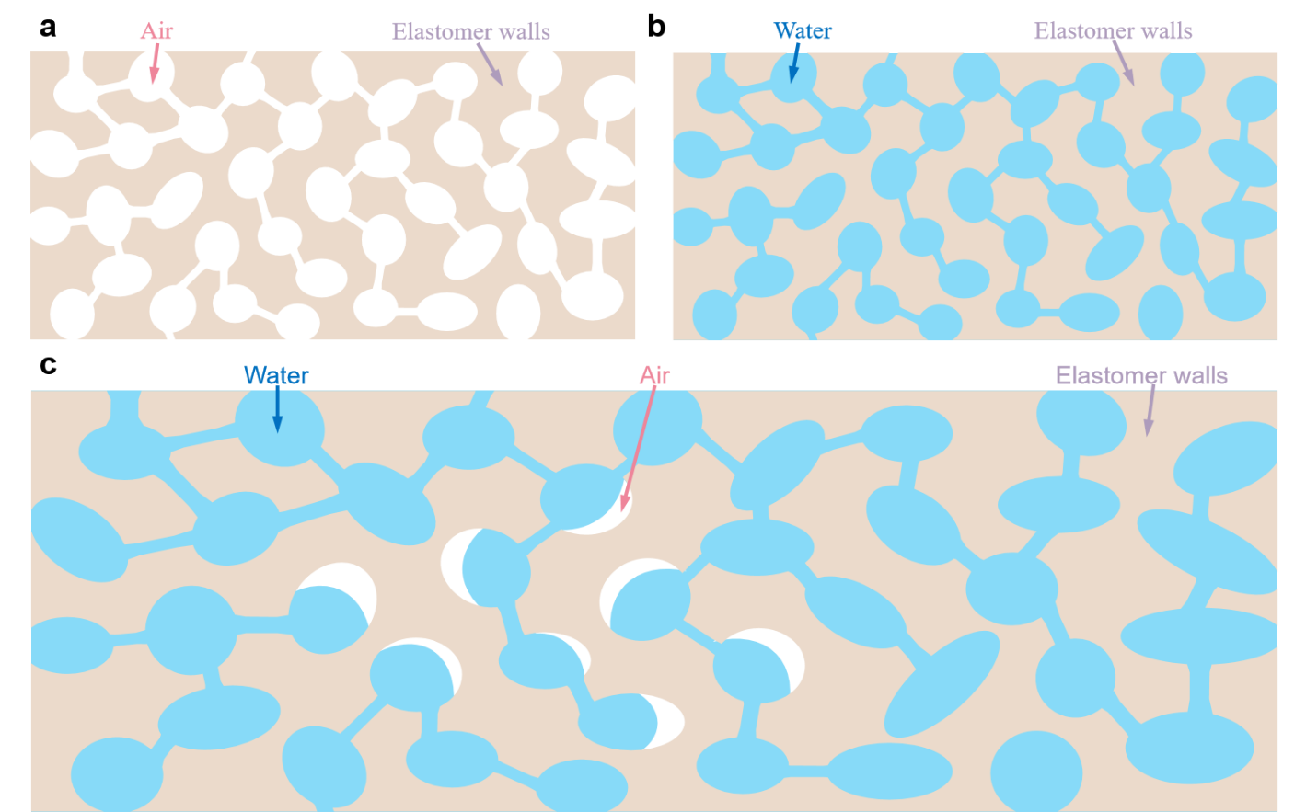
Figure S9. a) The schematic of pure HPH consisting of air and elastomer parts. b) The schematic illustration depicting the assumption that HPH is fully infiltrated by water, leading to the complete expulsion of internal air from the material. c) The schematic representation of HPH undergoing wetting by water with partial displacement of internal air by water. The density of pure ecoflex 00-30 is 1.070 g-cm⁻³. And the density of HPH was calculated as 0.669 g-cm⁻³, the porosity (α) of porous materials is calculated as shown in Equation 1. Utilizing data derived from experimental tests, the porosity of HPH was calculated to be α = 37.48%. This aligns closely with the result obtained by calculating the volumetric percentage of the templating agent NaCl in the sample without template removal (32.99%). This convergence verifies the accuracy of the calculated porosity of HPH. By measuring the volume of HPH and weighing its mass, the density ρ_{dry} of HPH was calculated to be 0.669 g-cm⁻³. Assuming that the air inside the HPH is completely replaced by water, the density ρ_{Tw} (Total water) of the fully wetted HPH is obtained as 1.07*62.52%+1*37.48%=1.0437 g-cm⁻³. From Fig. 2f, it is evident that at the point of volume transition in HPH, its mass is 0.0626 g, and its volume is 0.0675 cm³. Consequently, the calculated density ρ_{Aw} (air and water) is 0.927 g-cm⁻³, positioned midway between ρ_{dry} and ρ_{Tw}. This finding supports the conclusion that water has replaced most of the air within HPH. However, a residual amount of air persists, inducing internal movement of water within the HPH, ultimately resulting in its expansion.
$$\text{α}\text{= (1-}\frac{ρ_{HPH}}{ρ_{ecoflex}})×100\% (S1)$$

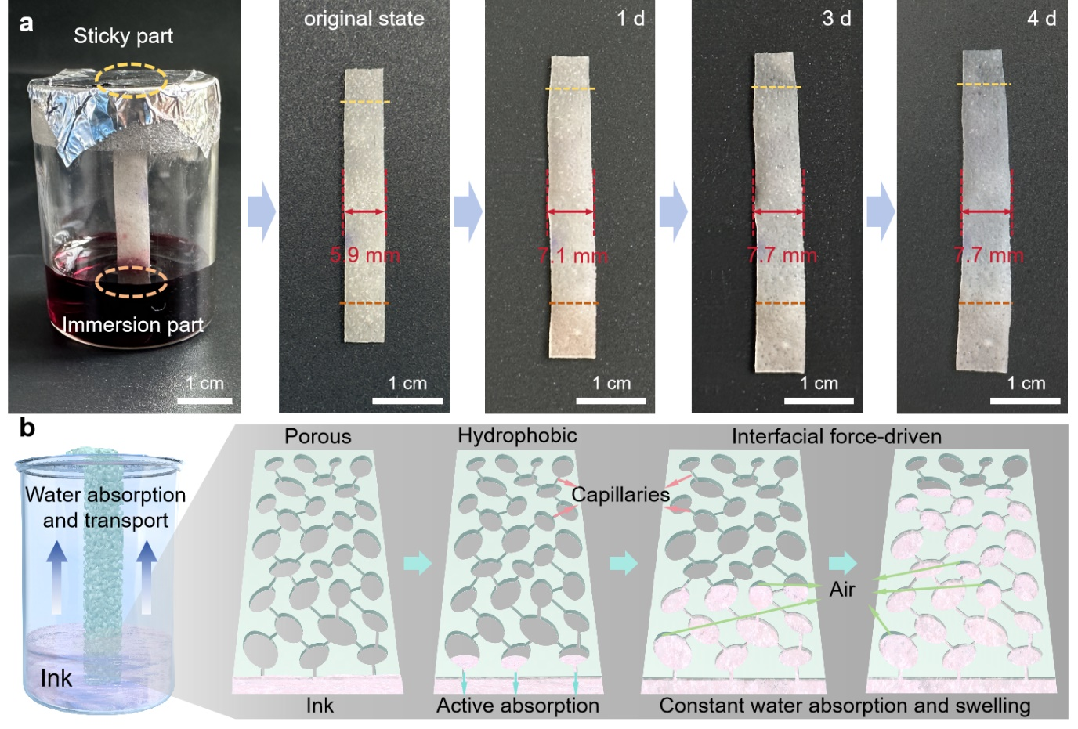
Figure S10. a) The image of the width of the portion of the long HPH bar above the water surface as a function of time. b) The schematic of HPH water absorption from the bottom layer by layer.

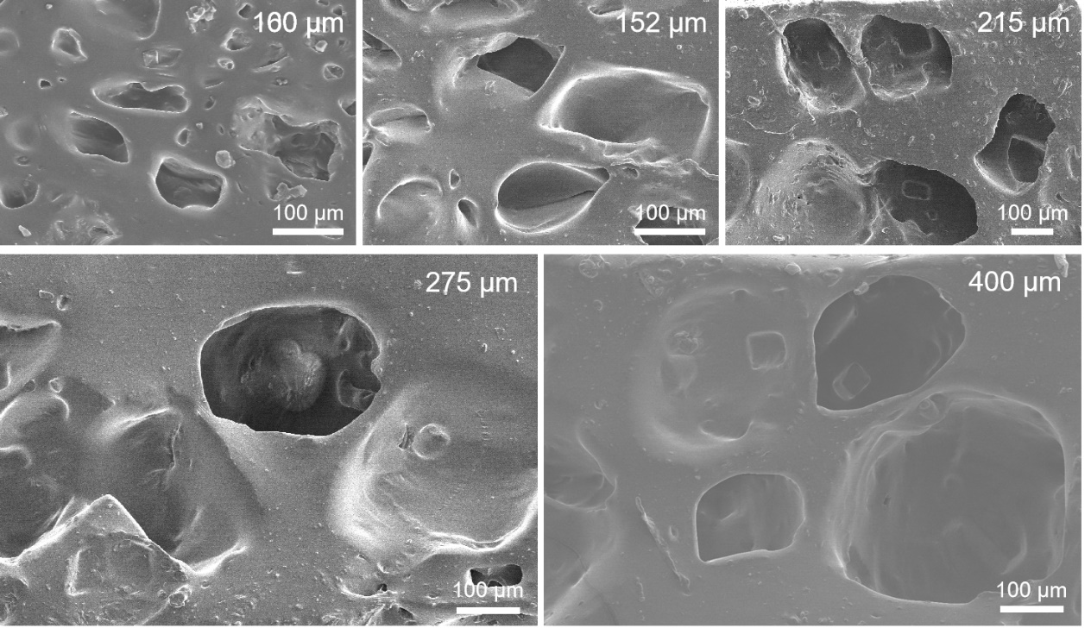
Figure S11. The SEM images of pore structures of porous elastomers that were prepared based on different sizes of NaCl templates.
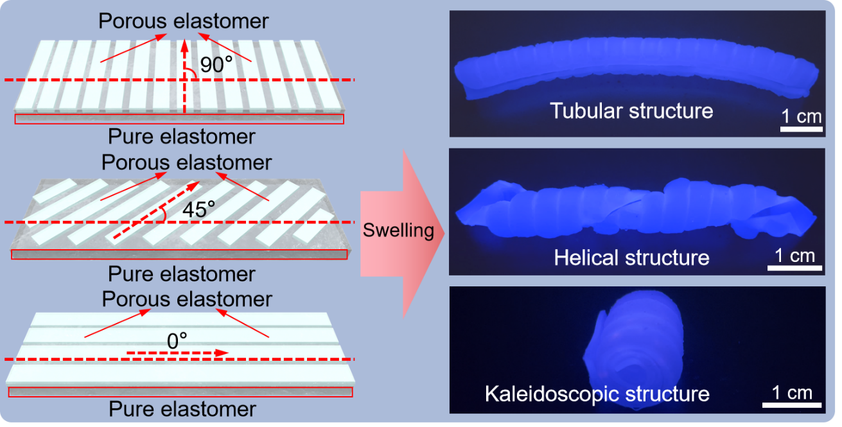
Figure S12. The schematic and optical images of the structural transition from 2D to 3D structures of composites combining HPH and pure elastomers prepared by structural design. In the 2D diagram on the right the white represents the porous elastomer and the grey the pure elastomer.

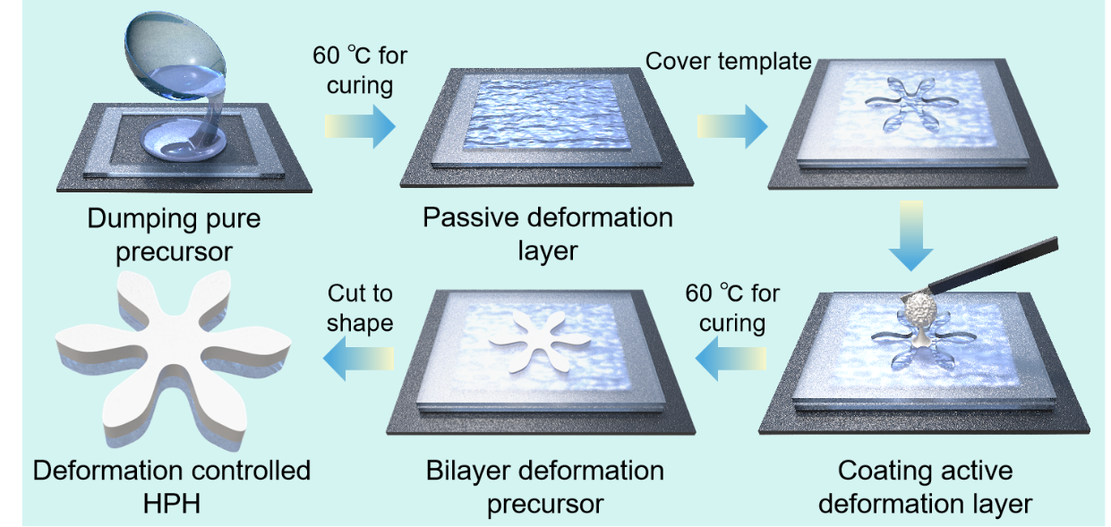
Figure S13. Schematic flowchart for the preparation of HPH with controlled deformation. First, the acrylic sheet undergoes precision cutting using a CO₂ laser, giving rise to templates of diverse shapes. Subsequently, the base template is affixed to a sturdy substrate, and a blend of liquid elastomer precursor is carefully poured into the template. After crosslinking at 60 °C for 15 minutes, the result is a deformation passive layer. Following this, a second template is overlaid onto the initial layer, and a mixture of liquid precursor slurry, combined with a template agent, is poured into the second template. The compound is then coated, smoothed, and subjected to crosslinking in an oven at 60 °C for 15 minutes, resulting in a dual-layer deformed elastomer. The excess portion of the deformation structure is removed to create the final HPH through precise cutting. As the foundational material for both the passive and active deformation layers are ecoflex 00-30 elastomer, a strong adhesive connection ensures that there is no layer separation during subsequent deformations.

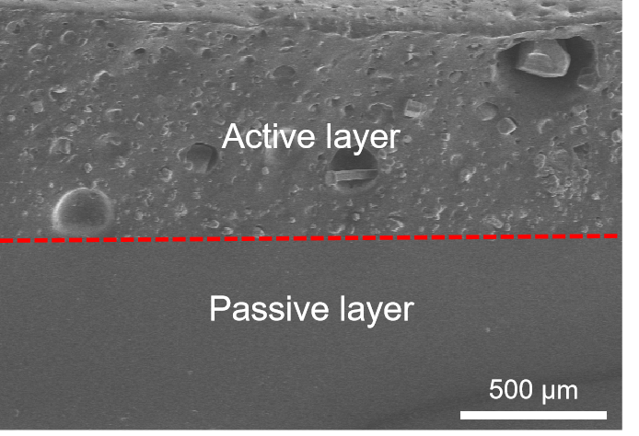
Figure S14. The SEM images of active and passive components perfectly bonded to each other. The stability and recoverability of HPH during deformation is ensured by the tight bond between the passive and active layers.
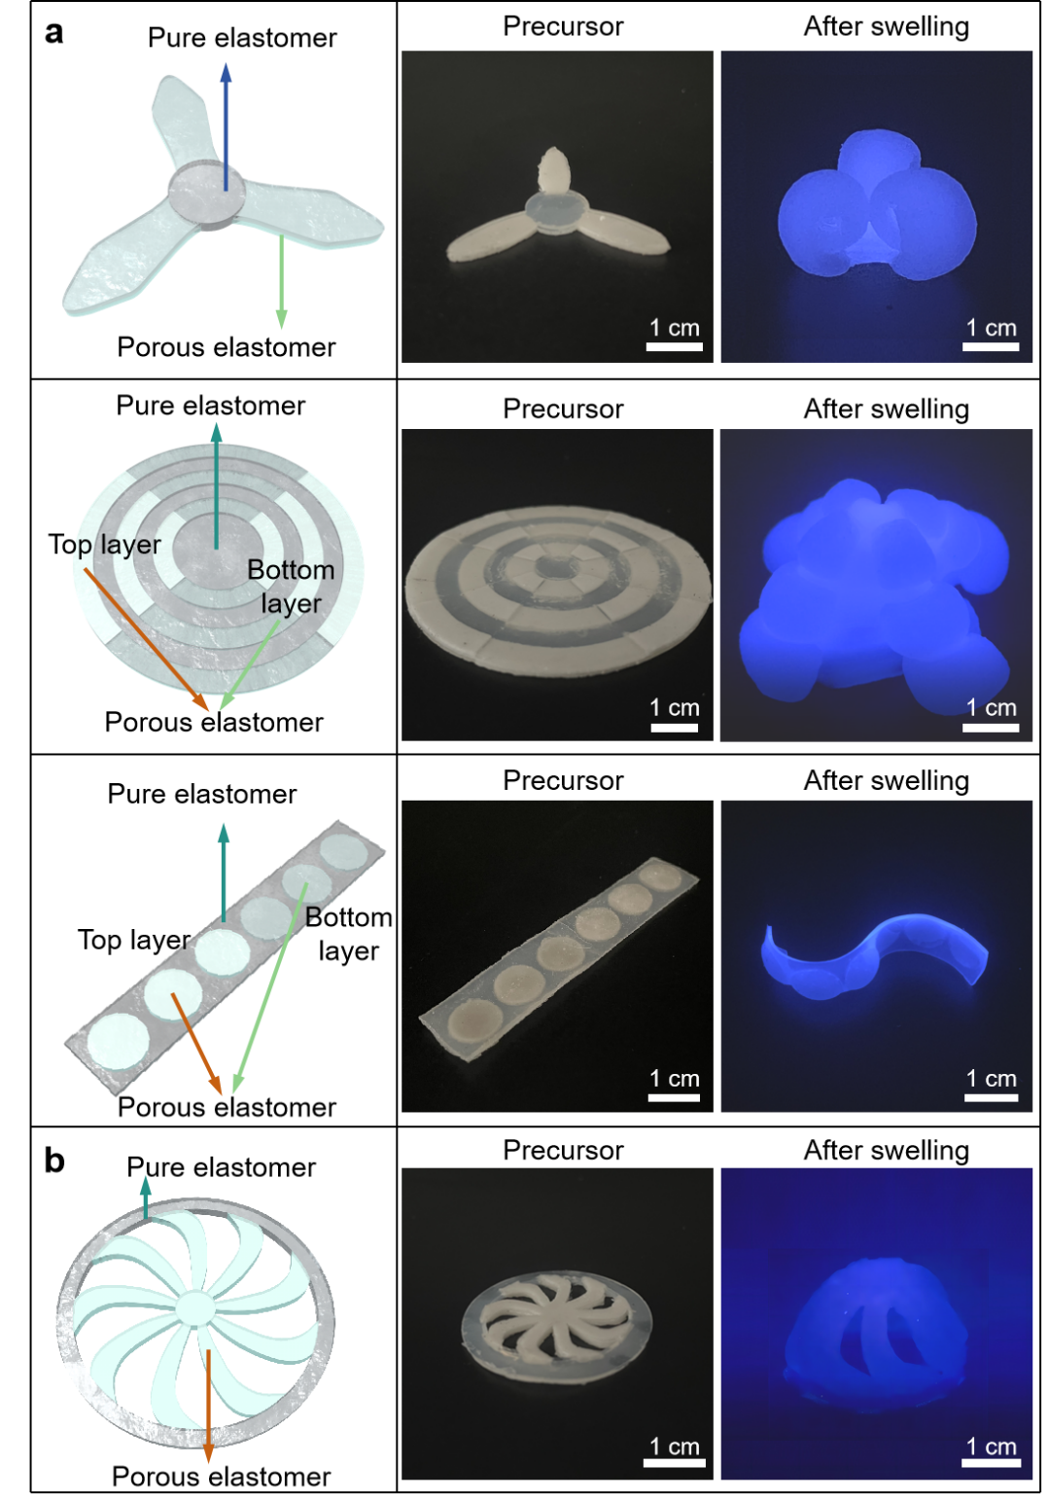
Figure S15. The schematic and optical images of the structural transition from 2D to 3D structures of composites combining HPH and pure elastomers prepared by structural design. In the 2D structure photos the gray is the pure elastomer and the clear is the porous elastomer. (a) folding structures and (b) kirigami structures.

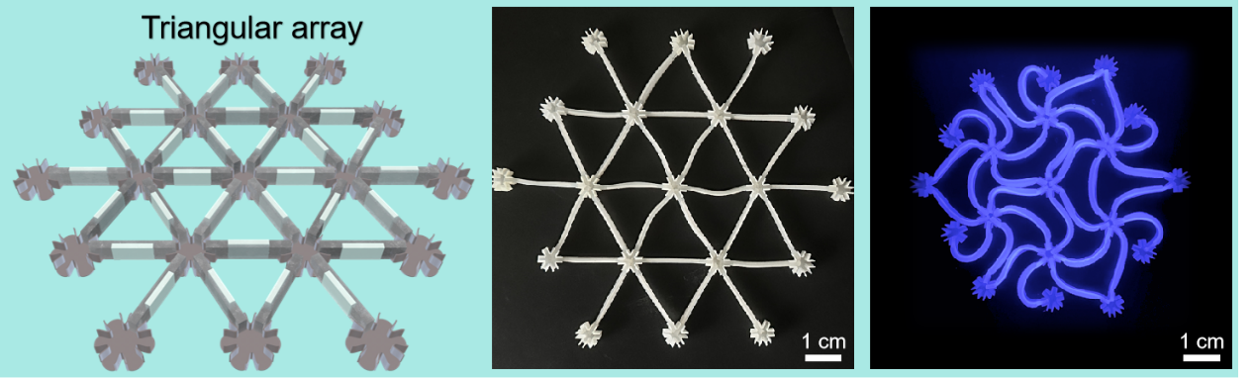
Figure S16. The schematic and optical images of the responsive lattice named triangular array. The lattice achieves negative expansion with a fractional area change rate of 26%.

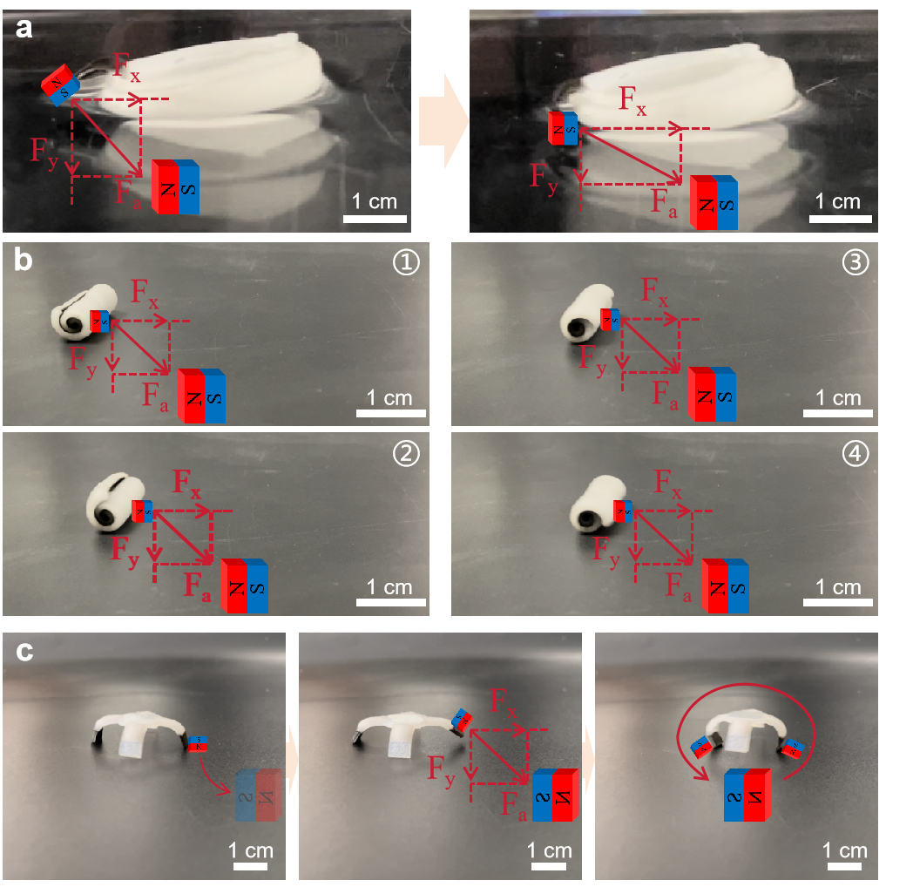
Figure S17. The force analysis schematics for a floating robot (a), a roller robot (b), and a walking robot (c) propelled by magnetic field. The magnetic-driven robots, capable of transitioning from two-dimensional to three-dimensional structures, were created by blending NdFeB magnetic particles with ecoflex and structuring them using HPH. This preparation method seamlessly integrates deformation and magnetic propulsion. In Figure S17a, the floating robot exhibits fish-like forward swimming when subjected to an applied magnetic field, achieved by swaying its “tail”. The magnet, positioned in front of the floating robot on the lower right side with its North pole directed towards the tail, induces an increasing bending amplitude. This occurs as the lower surface of the tail (approximated as the magnet) serves as the South pole, gradually approaching the magnet due to gravitational forces. The tail aligns with the magnetic susceptibility, resulting in two directional forces: a downward force (F_{y}) enhancing stability on the water surface and a rightward force (F_{x}) propelling the robot forward. Repeatedly moving the magnet away and bringing it back causes the tail to swing, akin to pushing the robot forward. In Figure S17b, the rolling robot has its N-pole oriented towards the roller's center after deformation. Placing a magnet at its lower right front, with the N-pole facing the roller, generates a downward force (F_{y}) ensuring stability and a rightward force (F_{x}) propelling the roller forward. The magnetic fields of the wheel's N-pole, pointing toward the center, enable smooth rolling, as the repulsive force at the farthest point is significantly less than the gravitational force at the nearest point. As illustrated in Figure S17c, the walking robot has downward-pointing N-pole. Placing the magnet in front of the lower right side of the robot (with the N-pole pointing right) lifts the robot's right foot due to gravitational force. When the magnet aligns with the center, the right foot gradually descends, securing grip on the ground (via friction between the silicone rubber and the non-smooth interface). As the magnet moves to the center, the left foot is raised by the gravitational force, and when placed in the center, the left foot moves forward due to the magnet's gravitational pull. Upon magnet removal, the robot's feet revert to their initial state, with the left foot fixed in place due to gravitational force, and the right foot moving forward due to elastomer restoration, resulting in continuous walking.

