Supplemental materials
“Long-term HbA1c variability and cardiovascular death: insights from the EMPA-REG OUTCOME trial”

Supplemental Table S1: overview of the timing of the HbA1c-measurements during the trial
Trial Period | Screening | Placebo-run in
Study week | -3 | -2 | * | 12 | 28 | 40 | 52 | Every 14 w after visit 10 to final visit | End of study visit
HbA1c | X |  | X | X | X | X | X | X | X
*Day of randomization

Supplemental Figure S1: Association of HbA1c variability by HbA1c as a continuous time-dependent co-variate and CV death in the treatment groups separately, by landmark analysis starting at week 12

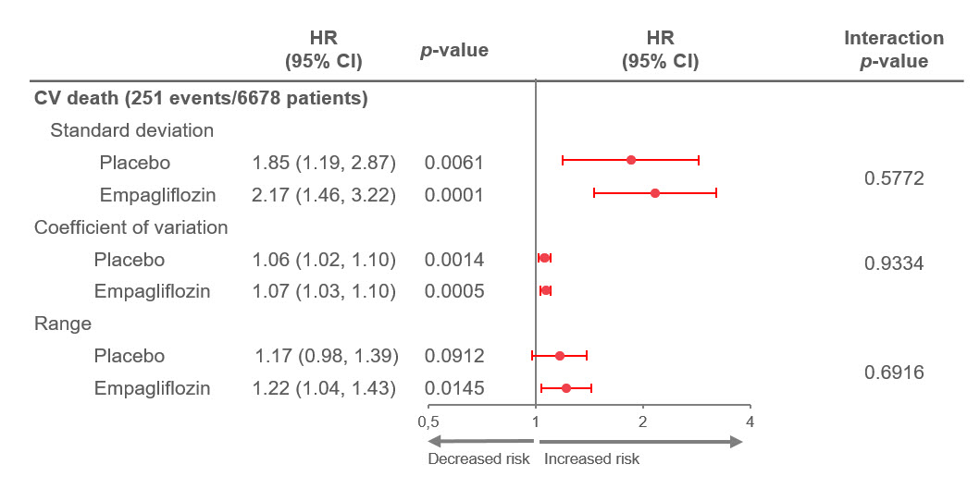
Only patients with least 2 pre-treatment and 2 post-baseline HbA1C measurements included. HRs are for a 1-unit (%) increase in HbA1c variability.
CV, cardiovascular; HbA1c, glycated hemoglobin.
Cox models include: baseline age, sex, baseline Hba1c, baseline BMI, baseline eGFR, geographic region, treatment, change in HbA1c from baseline to week 12, HbA1c variability as time-dependent covariate and its interaction with treatment.
* HbA1c variability*treatment interaction

Supplemental Figure S2 A and B: Association between quintiles of HbA1c variability as a time-dependent co-variate and CV death in the placebo (A) and pooled empagliflozin (B) groups (total n=6678), by landmark analysis starting at week 12. CI; confidence interval
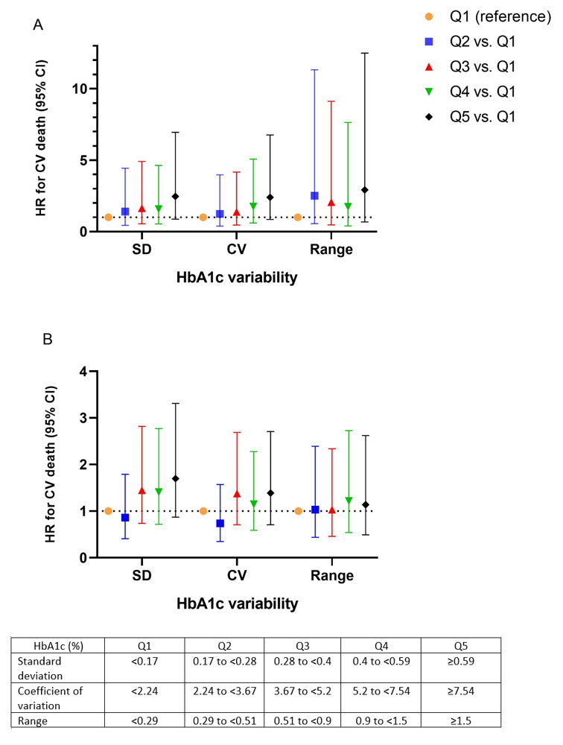
Only patients with least 2 pre-treatment and 2 post-baseline HbA1C measurements included. HRs are compared to Q1. CV, cardiovascular; HbA1c, glycated hemoglobin.
Cox model includes: baseline age, sex, baseline Hba1c, baseline BMI, baseline eGFR, geographic region, treatment, change in HbA1c from baseline to week 12, quintiles of HbA1c variability as time-dependent covariate and its interaction with treatment.

Supplemental Figure S3: Treatment effects of empagliflozin vs placebo on cardiovascular death, landmark analysis starting at week 12. Analyses adjusted for the primary model alone*, and adjusted for the primary model plus quintiles of HbA1c variability as a time-dependent covariate, to explore the mediation effects of HbA1c variability on the reduction in cardiovascular death.
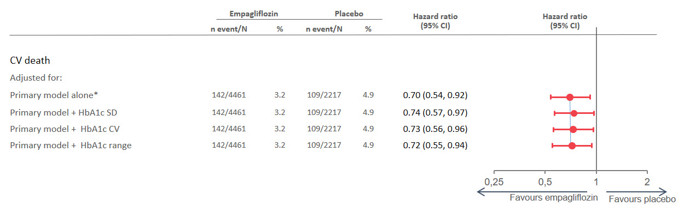
Only patients with least 2 pre-treatment and 2 post-baseline HbA1C measurements included.
* Primary Cox model includes terms for baseline age, sex, baseline eGFR, baseline BMI, baseline HbA1c, region, change in HbA1c from baseline to week 12, treatment.

