Graphical Abstract
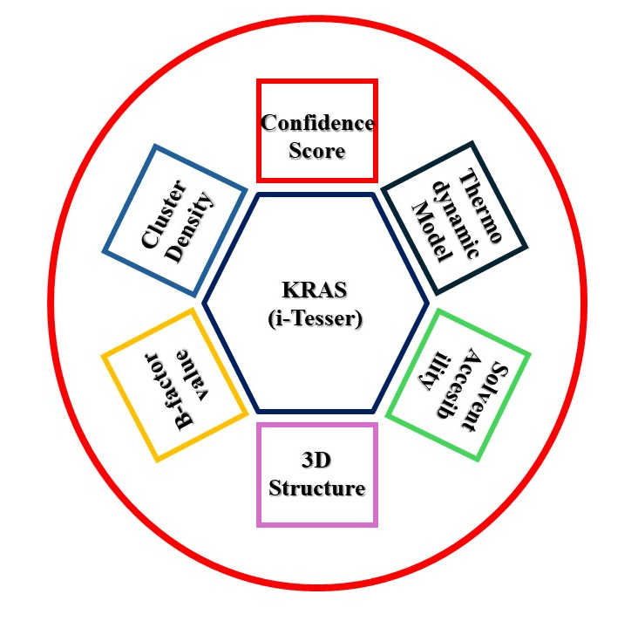
Overall Study Model of our research. This diagram illustrates the various aspects of the KRAS protein analyzed using the i-Tasser bioinformatics tool. The central hexagon represents the KRAS protein, with surrounding circles detailing the specific metrics and models used to understand its structure and function. Central Hexagon KRAS (i-Tasser) The focus of the study is the KRAS protein, with its structure predicted and analyzed using the i-Tasser tool. Surrounding rectangle Confidence Score (Red) A measure of the reliability of the predicted KRAS structures. Thermodynamic Model (Dark Blue) Models describing the thermodynamic properties and states of the KRAS protein. Solvent Accessibility (Green) Scores indicating the exposure of amino acid residues to solvents, relevant for understanding protein interactions and stability. 3D Structure (Purple) The three-dimensional conformation of the KRAS protein as predicted by i-Tasser. B-factor Value (Yellow) Values that represent the thermal motion of atoms within the protein, indicating structural stability. Cluster Density (Light Blue) The density of clusters used in the prediction models reflects the compactness and potential accuracy of the structural predictions.

