Supplementary Information for:

Rate and growth limits and the role of geologic carbon storage in meeting climate targets

Jay Fuhrman¹, Haewon McJeon², Morgan R. Edwards^{3,4}, Zachary H. Thomas⁴, Joe Lane⁵, James Edmonds¹
¹ Joint Global Change Research Institute, University of Maryland and Pacific Northwest National Laboratory, College Park, MD, USA
² KAIST Graduate School of Green Growth & Sustainability, Korea Advanced Institute of Science and Technology, Daejeon, Republic of Korea
³ La Follette School of Public Affairs, University of Wisconsin–Madison, USA

⁴ Nelson Institute Center for Sustainability and the Global Environment, University of Wisconsin–Madison, USA
⁵ Gas & Energy Transition Research Centre, The University of Queensland, Brisbane, Australia

Table of Figures

Figure 1: Conceptual diagram (not-to-scale). 4
Figure 2: Fossil and Industrial CO₂ emissions for all scenarios (excluding land-use change CO₂ emissions). The 1.5 °C scenario with slow CCS growth was infeasible; all other blank subplots were not run as scenarios. 5
Figure 3: CO₂ emissions by sector including land-use change for all scenarios. The 1.5 °C scenario with slow CCS growth was infeasible; all other blank subplots were not run as scenarios. 6
Figure 4: CO₂ price paths to meet below 2 C and below 1.5 °C temperature goals under varying rate and growth limits on CCS. 7
Figure 5: Geologic CO₂ storage by region and scenario through 2100. 8
Figure 6: Geologic CO₂ storage by region and scenario. Results are truncated after 2050 to better highlight the mid-century differences between scenarios. 9
Figure 7: Global geologic CO2 storage by CO₂ source and scenario through 2100. The 1.5 °C scenario with slow CCS growth was infeasible; all other blank subplots were not run as scenarios. 10
Figure 8: Global geologic CO₂ storage by CO₂ source and scenario. Results are truncated after 2050 to better highlight the mid-century differences between scenarios. The 1.5 °C scenario with slow CCS growth was infeasible; all other blank subplots were not run as scenarios. 11
Figure 9: Geologic CO₂ storage by region, scenario, and year for below 2 °C scenarios. 12
Figure 10: Geologic CO₂ storage by region, scenario, and year for below 1.5 °C scenarios. 12
Figure 11: Geologic CO₂ storage by source and region under unrestricted CCS growth rates, 2 °C scenario. 13
Figure 12: Geologic CO₂ storage by source and region under slow CCS growth rates 2 °C scenario. 14
Figure 13: Geologic CO₂ storage by source and region under CCS breakthrough, 2 °C scenario. 15
Figure 14: Global primary energy with CCS (direct equivalent) for all scenarios. The 1.5 °C scenario with slow CCS growth was infeasible; all other blank subplots were not run as scenarios. 16
Figure 15: Global undiscounted (top) and discounted (bottom) policy costs. 17
Figure 16: Global policy costs. 18
Figure 17: Changes in regional policy cost vs. proportion of cumulative CCS used for DACCS. 19
Figure 18: Geologic CO₂ storage by source for below 2⁰ C scenarios (SSP2). The top figure reports results truncated at 2050, to better highlight near-term differences between scenarios. 20

Table 1: Representation of CO₂ storage in leading integrated assessment models. Source: Grant et. al, (2022)¹
Variable | REMIND | GCAM | WITCH | AIM/CGE | IMAGE | MESSAGE
Storage potential | Global storage potential of around 3700 GtCO2 is assumed and regional constraints are also placed | Global storage potential of 7178 GtCO₂ is assumed | Default global storage potential of 11000 GtCO₂ is assumed | No explicit constraint on the storage potential is applied, but ex-ante comparison is performed with global storage potential estimates to ensure consistency | Global storage potential of 5500 GtCO₂ is assumed | No explicit constraint on the storage potential is applied
Injection rate | The yearly injection rate of CO₂ is limited to 0.5% of total storage capacity due to technical and geological constraints | Injection rate constraints are not modelled | Injection rate constraints are not modelled | Injection rate constraints are not modelled | Injection rate constraints are not modelled | Injection rate constraints are not modelled
Injection rate | This corresponds to a maximum injection rate of 21.9 GtCO₂/y
Source | 2,3 | 4,5 | 6,7 | 8 | 9–11 | 12–14

Supplementary Figure 1 is a conceptual diagram for the dynamic (rate-constrained) supply curves for CCS developed for this work. The dynamic supply curves (orange lines) are consumed along with the cumulative storage curves (brown lines) and serve to limit the amount of carbon capture and storage (CCS) that can take place in any given year. These dynamic curves can be scaled along the abscissa (storage quantity) axis using an efficiency parameter to further constrict or relax the rate constraint over time.

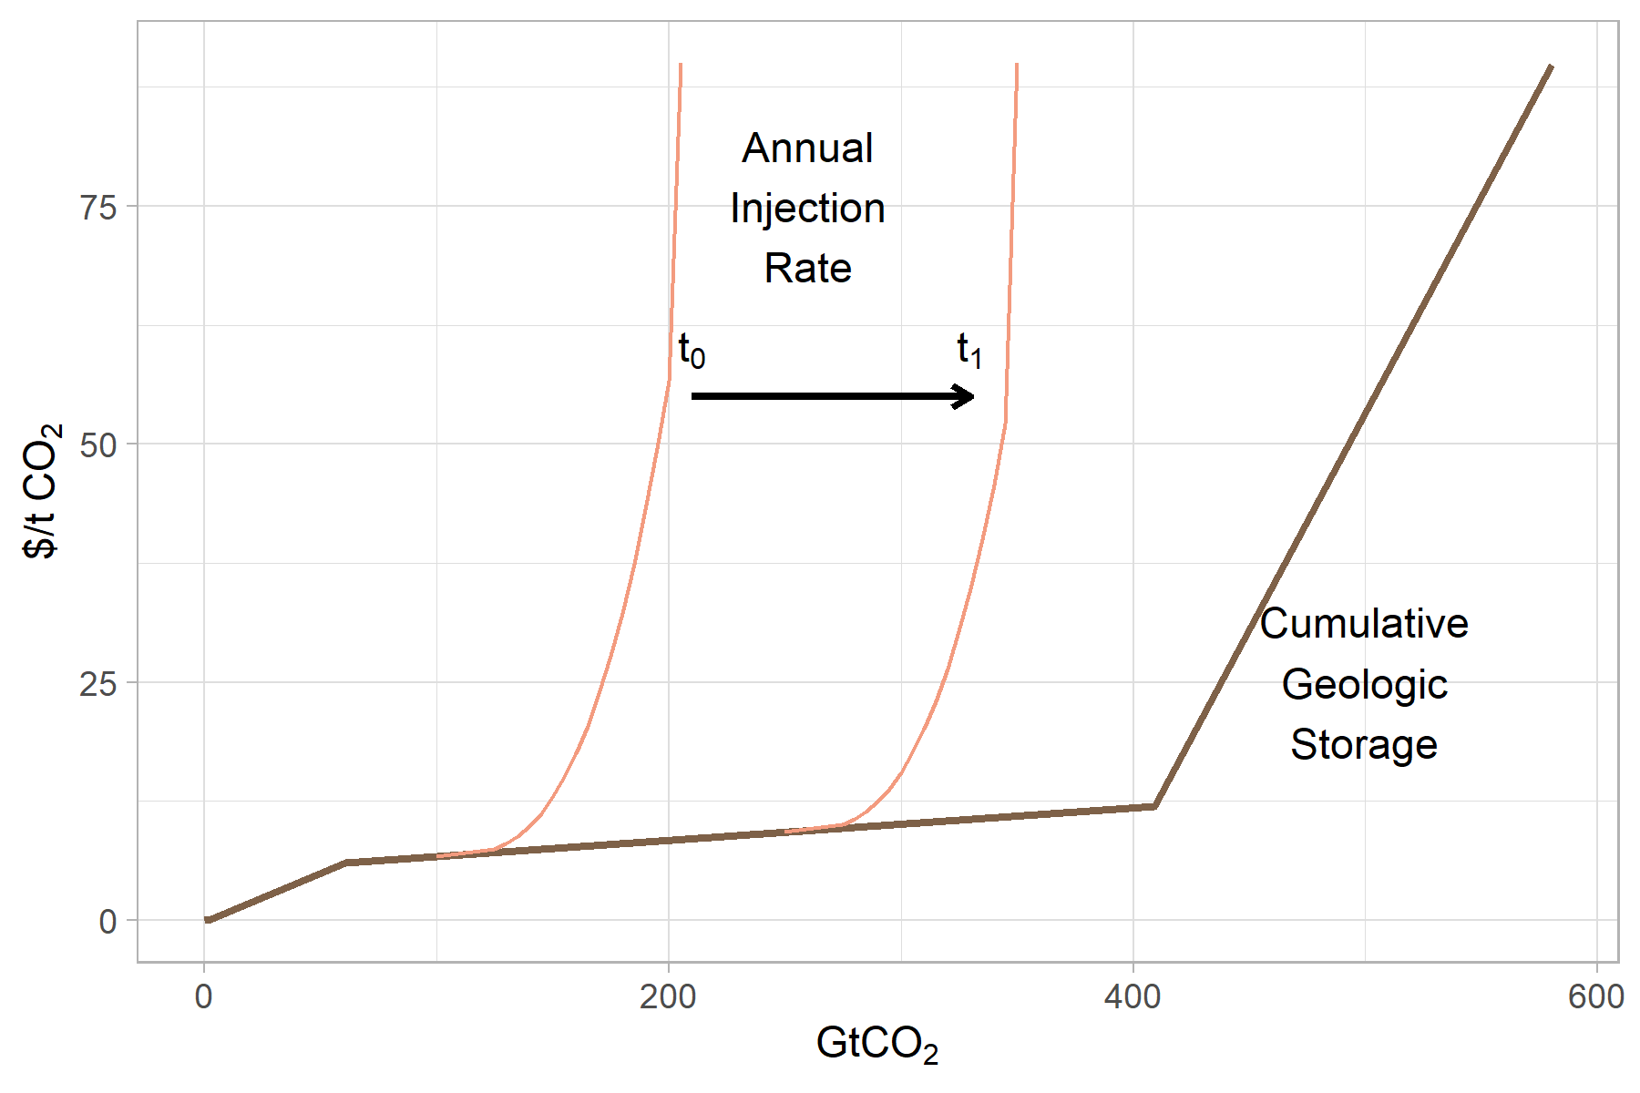
Figure 1: Conceptual diagram (not-to-scale).

Supplementary Figures 2 and 3 report CO₂ emissions with and without land-use change emissions included for all scenarios in this study.
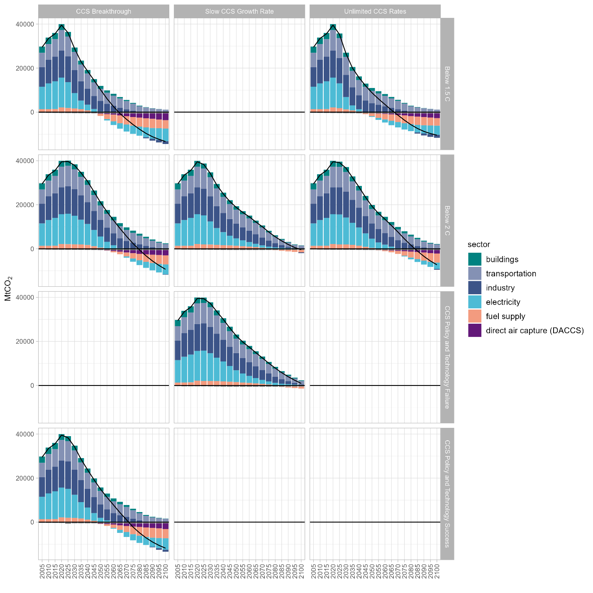
Figure 2: Fossil and Industrial CO₂ emissions for all scenarios (excluding land-use change CO₂ emissions). The 1.5 °C scenario with slow CCS growth was infeasible; all other blank subplots were not run as scenarios.
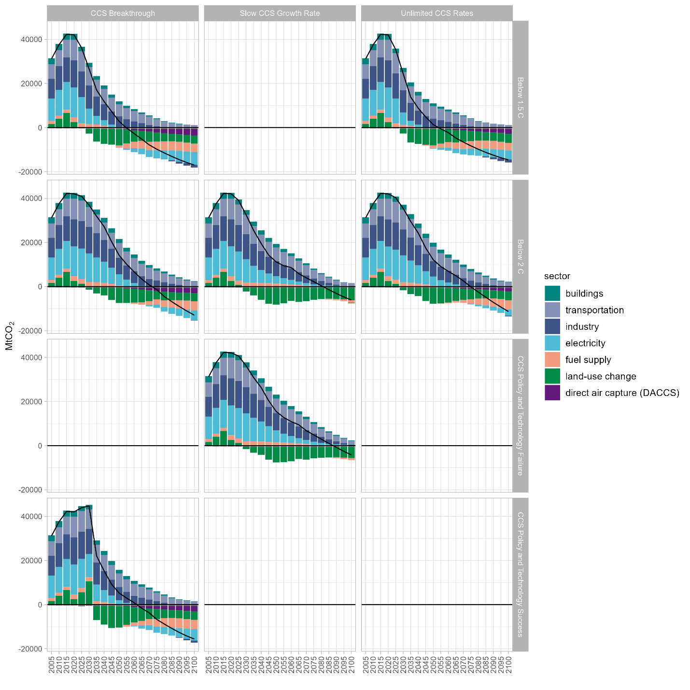

Figure 3: CO₂ emissions by sector including land-use change for all scenarios. The 1.5 °C scenario with slow CCS growth was infeasible; all other blank subplots were not run as scenarios.

Supplementary Figure 4 reports CO₂ price paths for each of the below 1.5 and 2 ⁰C scenarios with feasible solutions. The below 2 ⁰C CO₂ price path under the slow CCS growth rate was also applied to a scenario which allowed more rapid CCS growth and thus additional mitigation (CCS Policy and Technology Success). Conversely, the CO₂ price path from the unlimited CCS rates scenario was also applied to a scenario with a slow CCS growth constraint, which allowed for less mitigation.
The relationship between CCS rate and growth constraints, CO₂ prices required to meet a below 2 ⁰C goal, and peak and long-term temperatures is shown in Supplementary Figure 5. Scenarios with constraints on near-term CCS scale-up (even allowing for rapid growth) have higher peak temperatures. However, more aggressive emissions policy consistent with the expectation of more limited CCS, results in lower peak temperatures. For the same CO₂ price path, CCS scale-ups that differ from expectations when the policy is initiated could increase global mean temperature in 2100 by up to 0.15 ⁰C for slower-than-expected scale-ups, or reduce the 2100 temperature by 0.2 ⁰C for more rapid than expected scale-up.

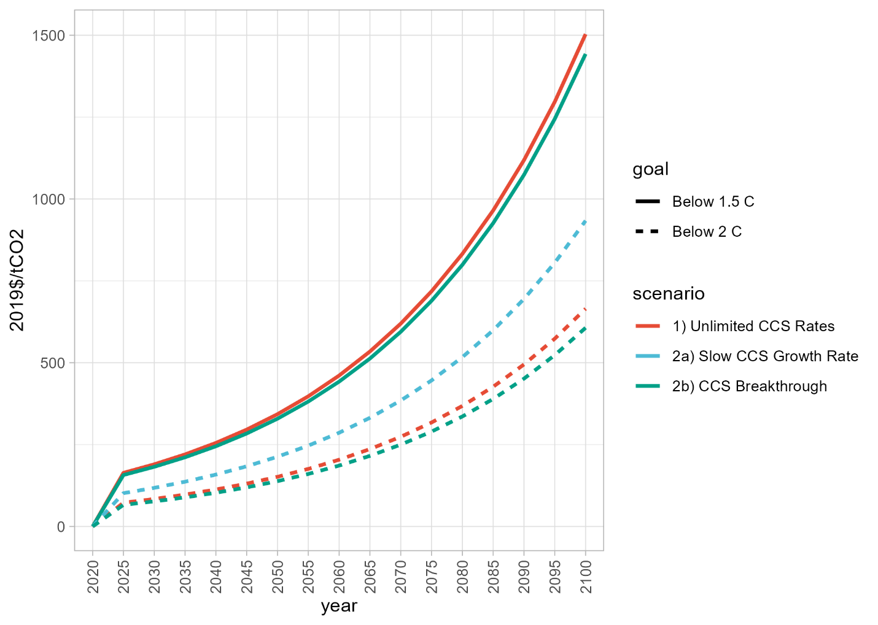
Figure 4: CO₂ price paths to meet below 2 C and below 1.5 °C temperature goals under varying rate and growth limits on CCS.

Supplementary Figures 6 and 7 report CCS by region and scenario to illustrate the locational impacts of rate constraints, which are particularly pronounced in China. Figure 7 truncates presentation of the same results as in Figure 6 to better highlight the mid-century differences between scenarios.
Supplementary Figures 8 and 9 report global CCS by CO₂ source and scenario. As with the regional results, Figure 9 truncates presentation of results to better highlight the mid-century differences between scenarios.
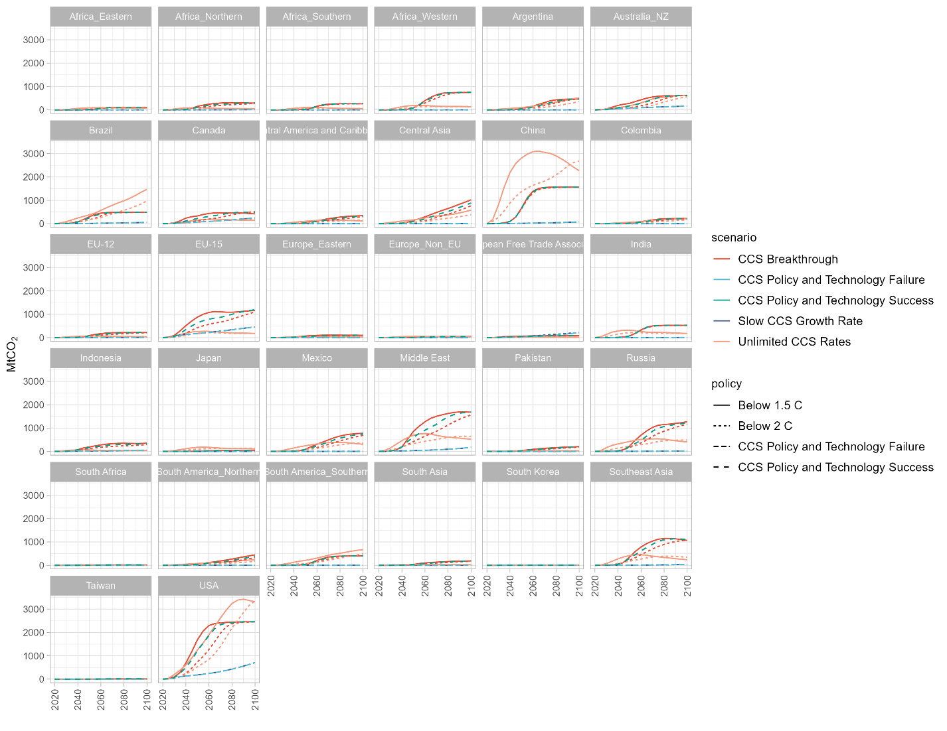
Figure 5: Geologic CO₂ storage by region and scenario through 2100.

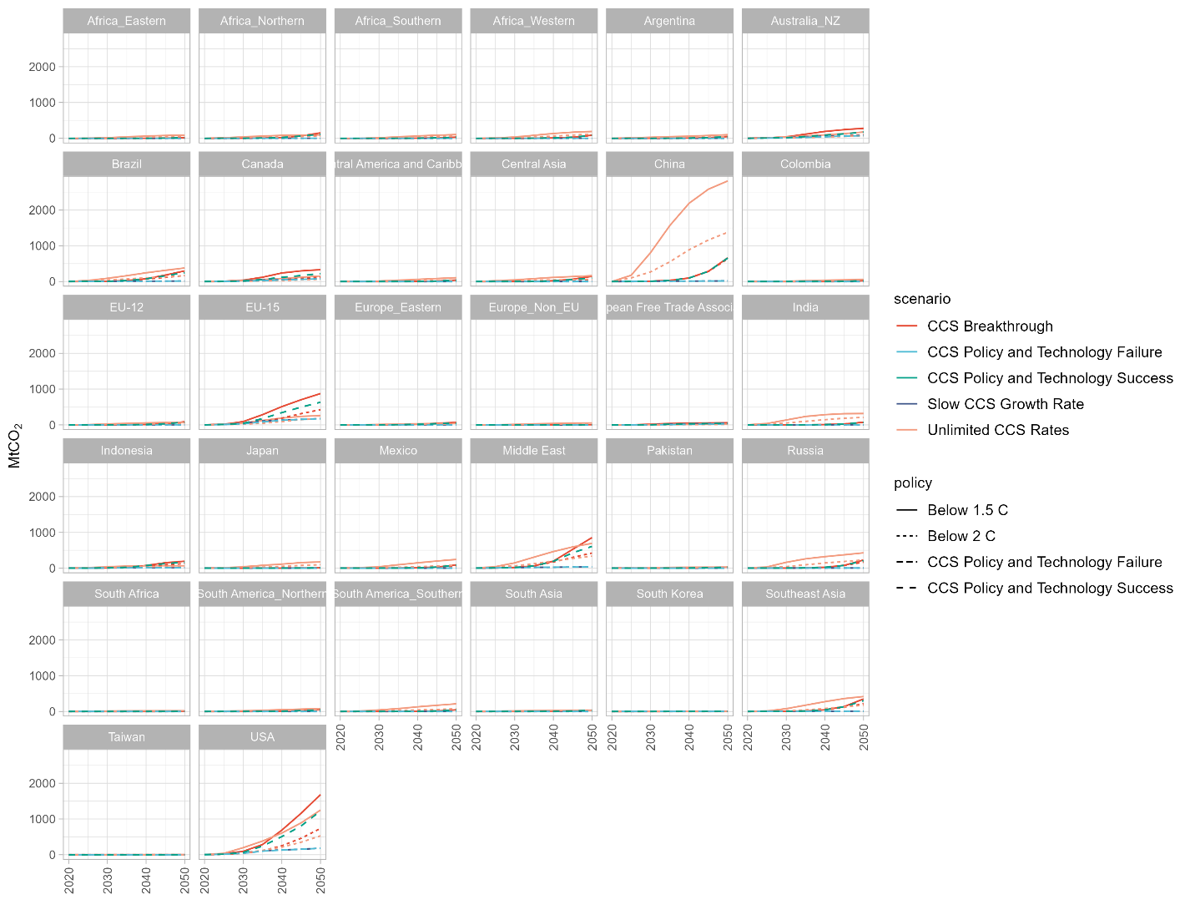
Figure 6: Geologic CO₂ storage by region and scenario. Results are truncated after 2050 to better highlight the mid-century differences between scenarios.

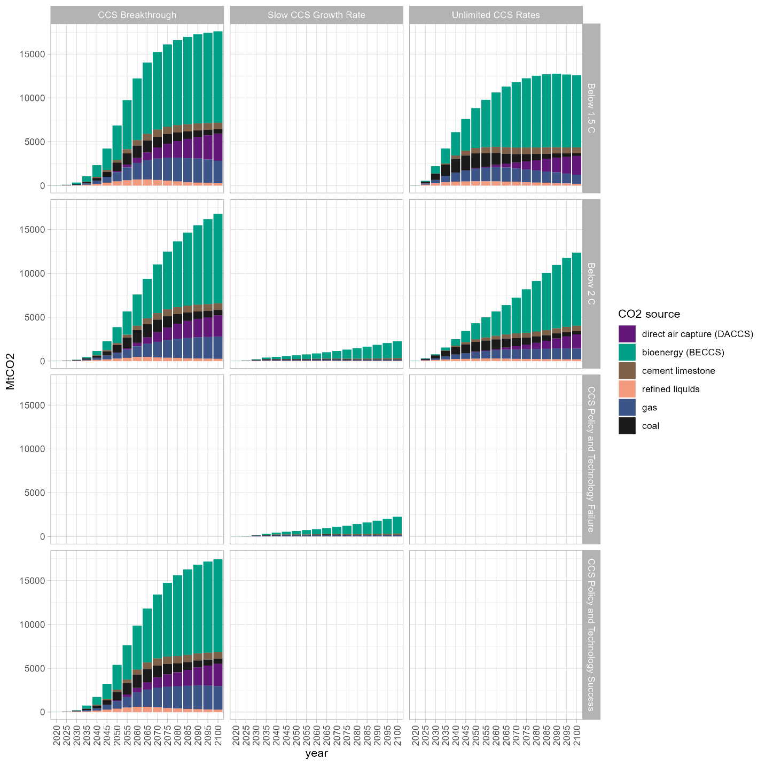
Figure 7: Global geologic CO2 storage by CO₂ source and scenario through 2100. The 1.5 °C scenario with slow CCS growth was infeasible; all other blank subplots were not run as scenarios.
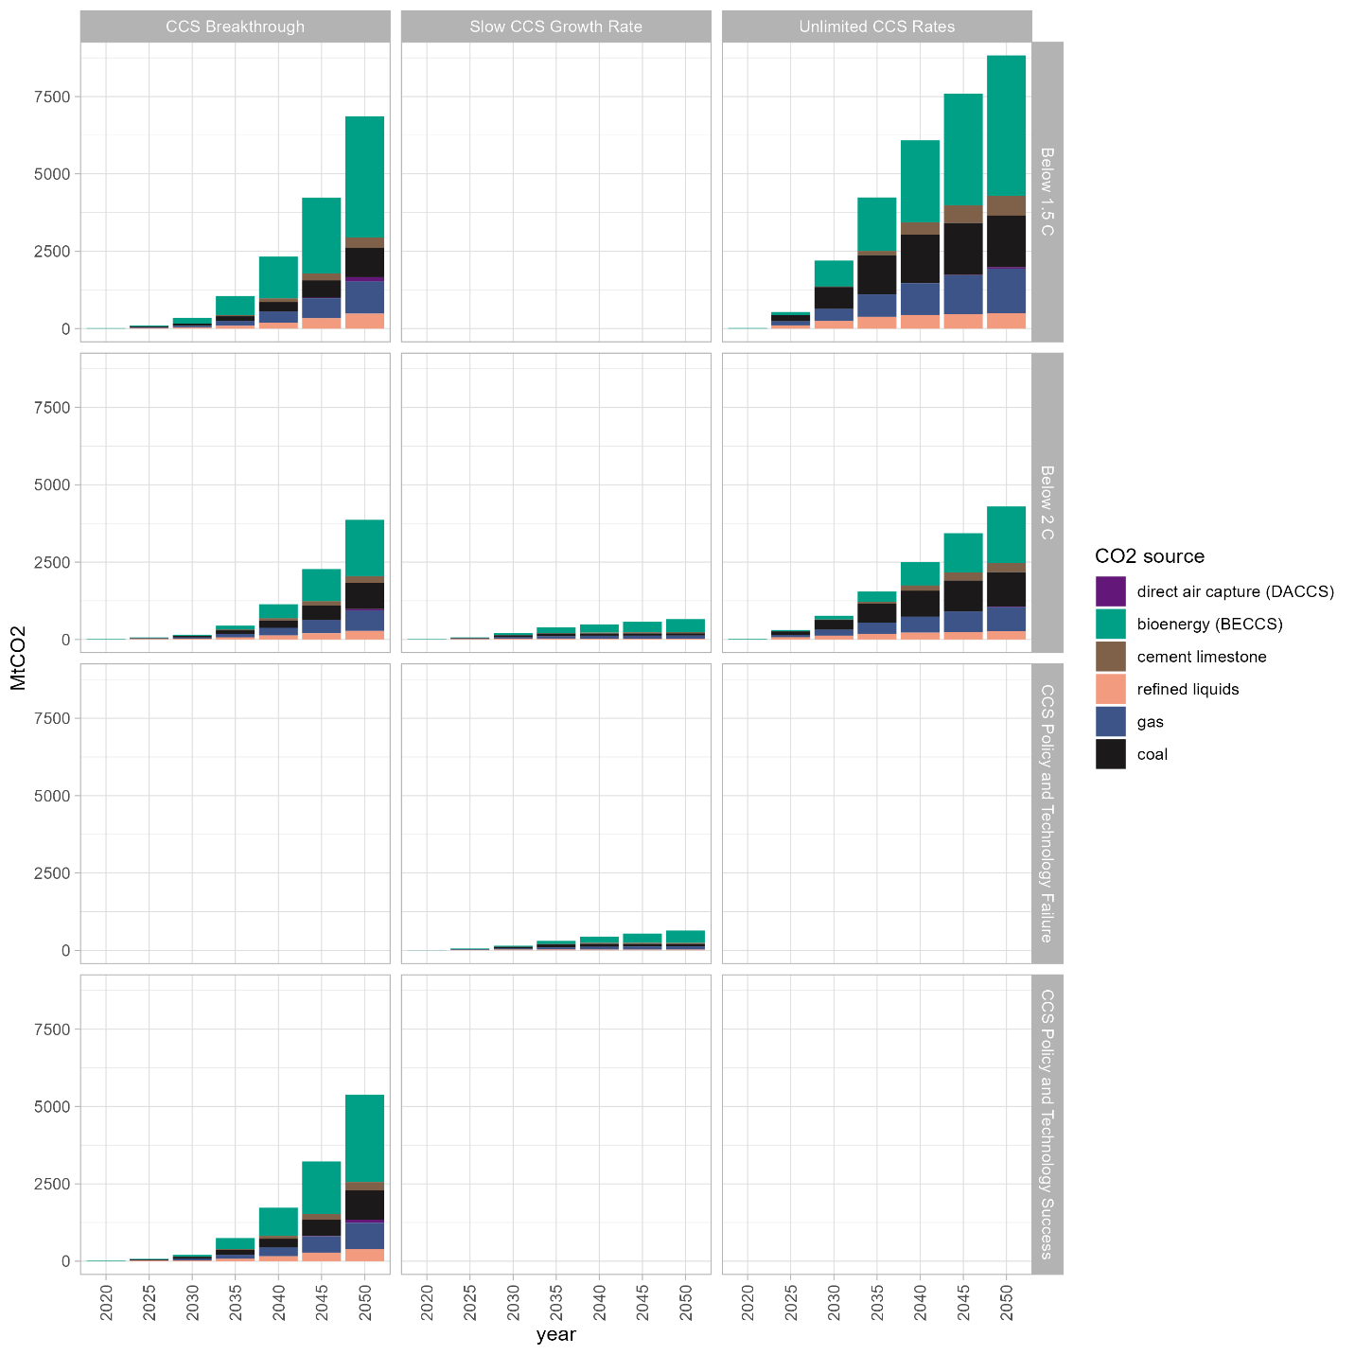
Figure 8: Global geologic CO₂ storage by CO₂ source and scenario. Results are truncated after 2050 to better highlight the mid-century differences between scenarios. The 1.5 °C scenario with slow CCS growth was infeasible; all other blank subplots were not run as scenarios.

Supplementary Figures 10 and 11 report regional CCS deployment rates in 2050 and 2100 for all feasible below 2 ⁰C (Figure 10) and below 1.5 ⁰C scenarios (Figure 11).
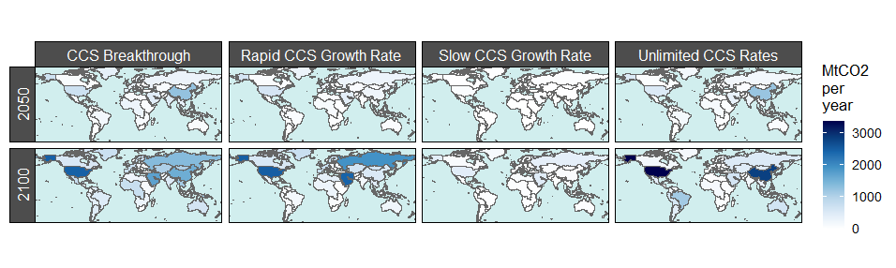
Figure 9: Geologic CO₂ storage by region, scenario, and year for below 2 °C scenarios.

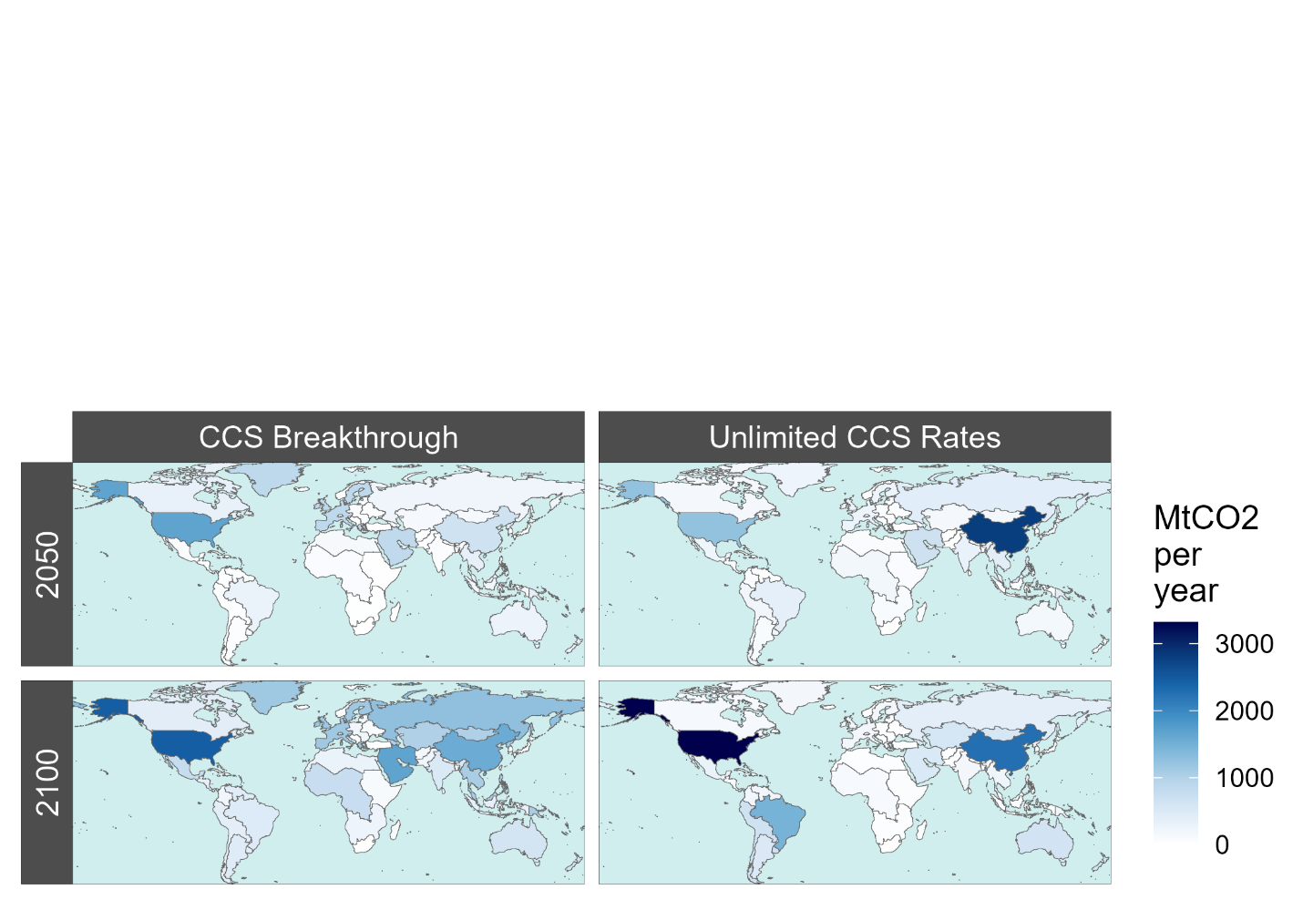
Figure 10: Geologic CO₂ storage by region, scenario, and year for below 1.5 °C scenarios.

Supplementary Figures 12-14 report CCS by region and CO₂ source for below 2 ⁰C scenarios with unlimited (12), slow (13) and rapid (14) CCS rate and growth limits.
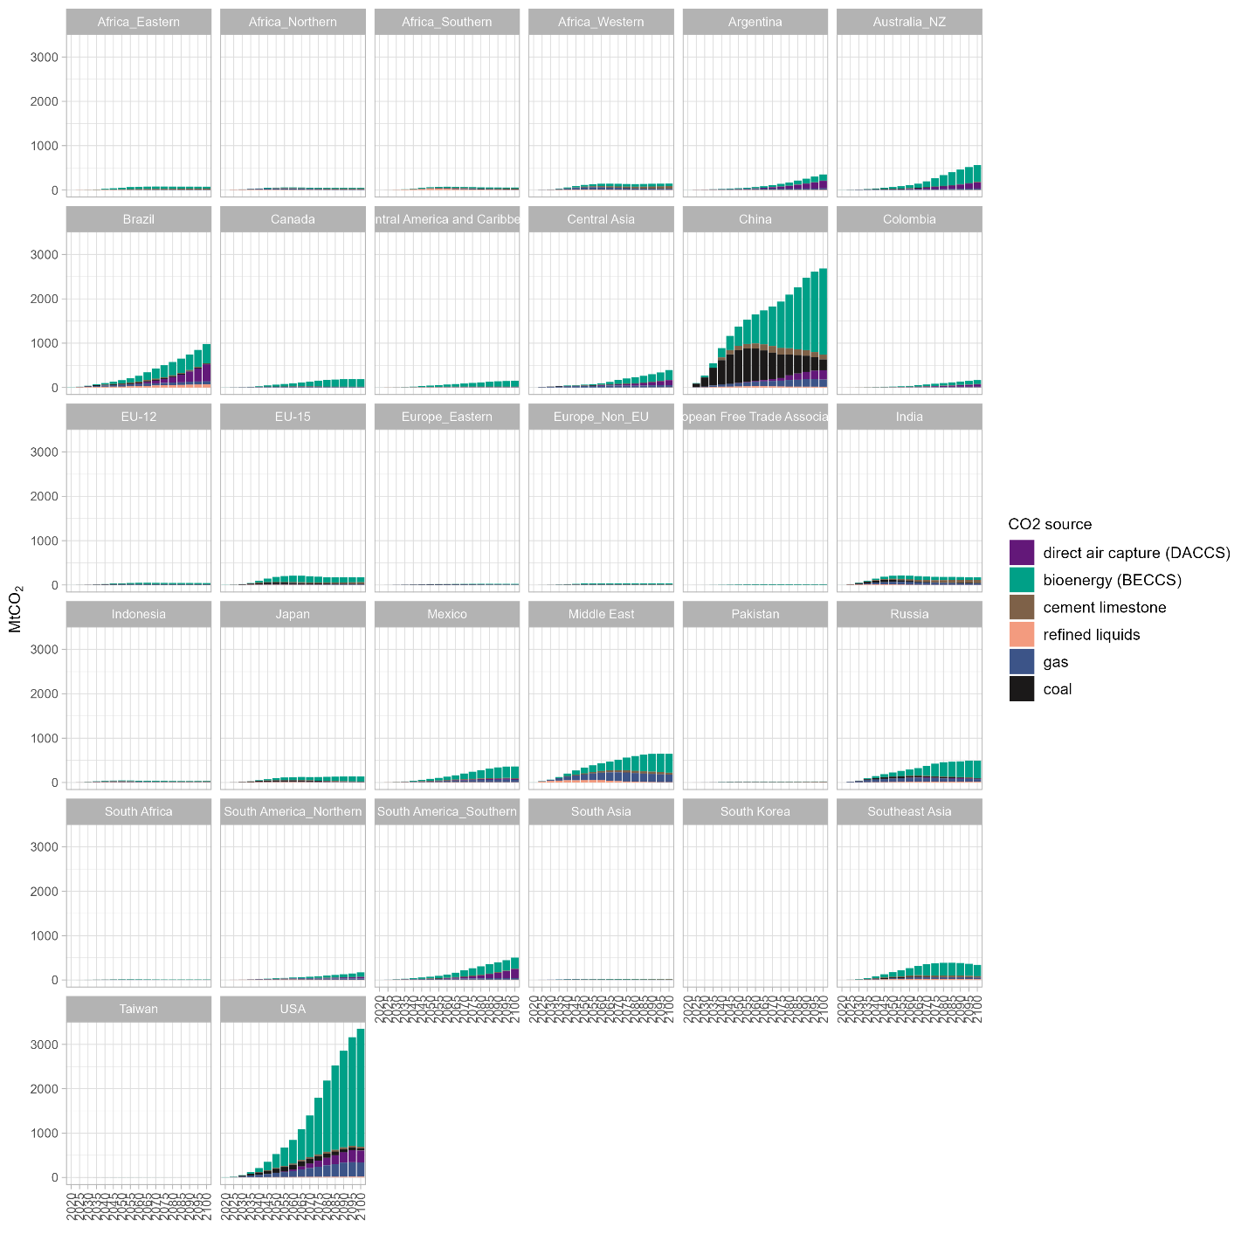
Figure 11: Geologic CO₂ storage by source and region under unrestricted CCS growth rates, 2 °C scenario.
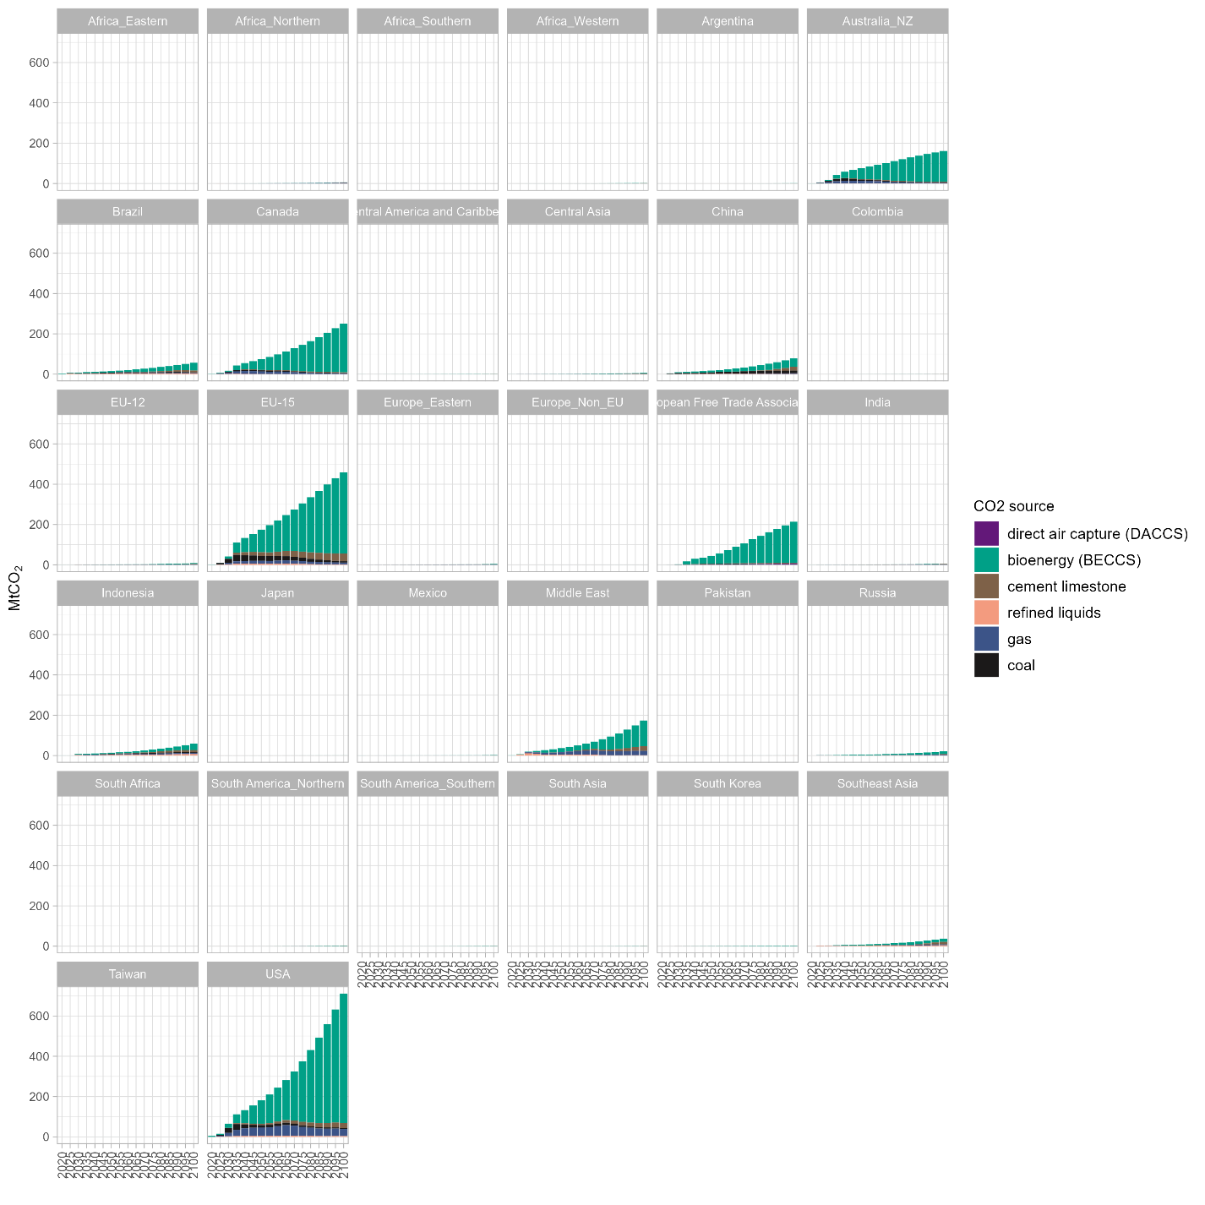
Figure 12: Geologic CO₂ storage by source and region under slow CCS growth rates 2 °C scenario.

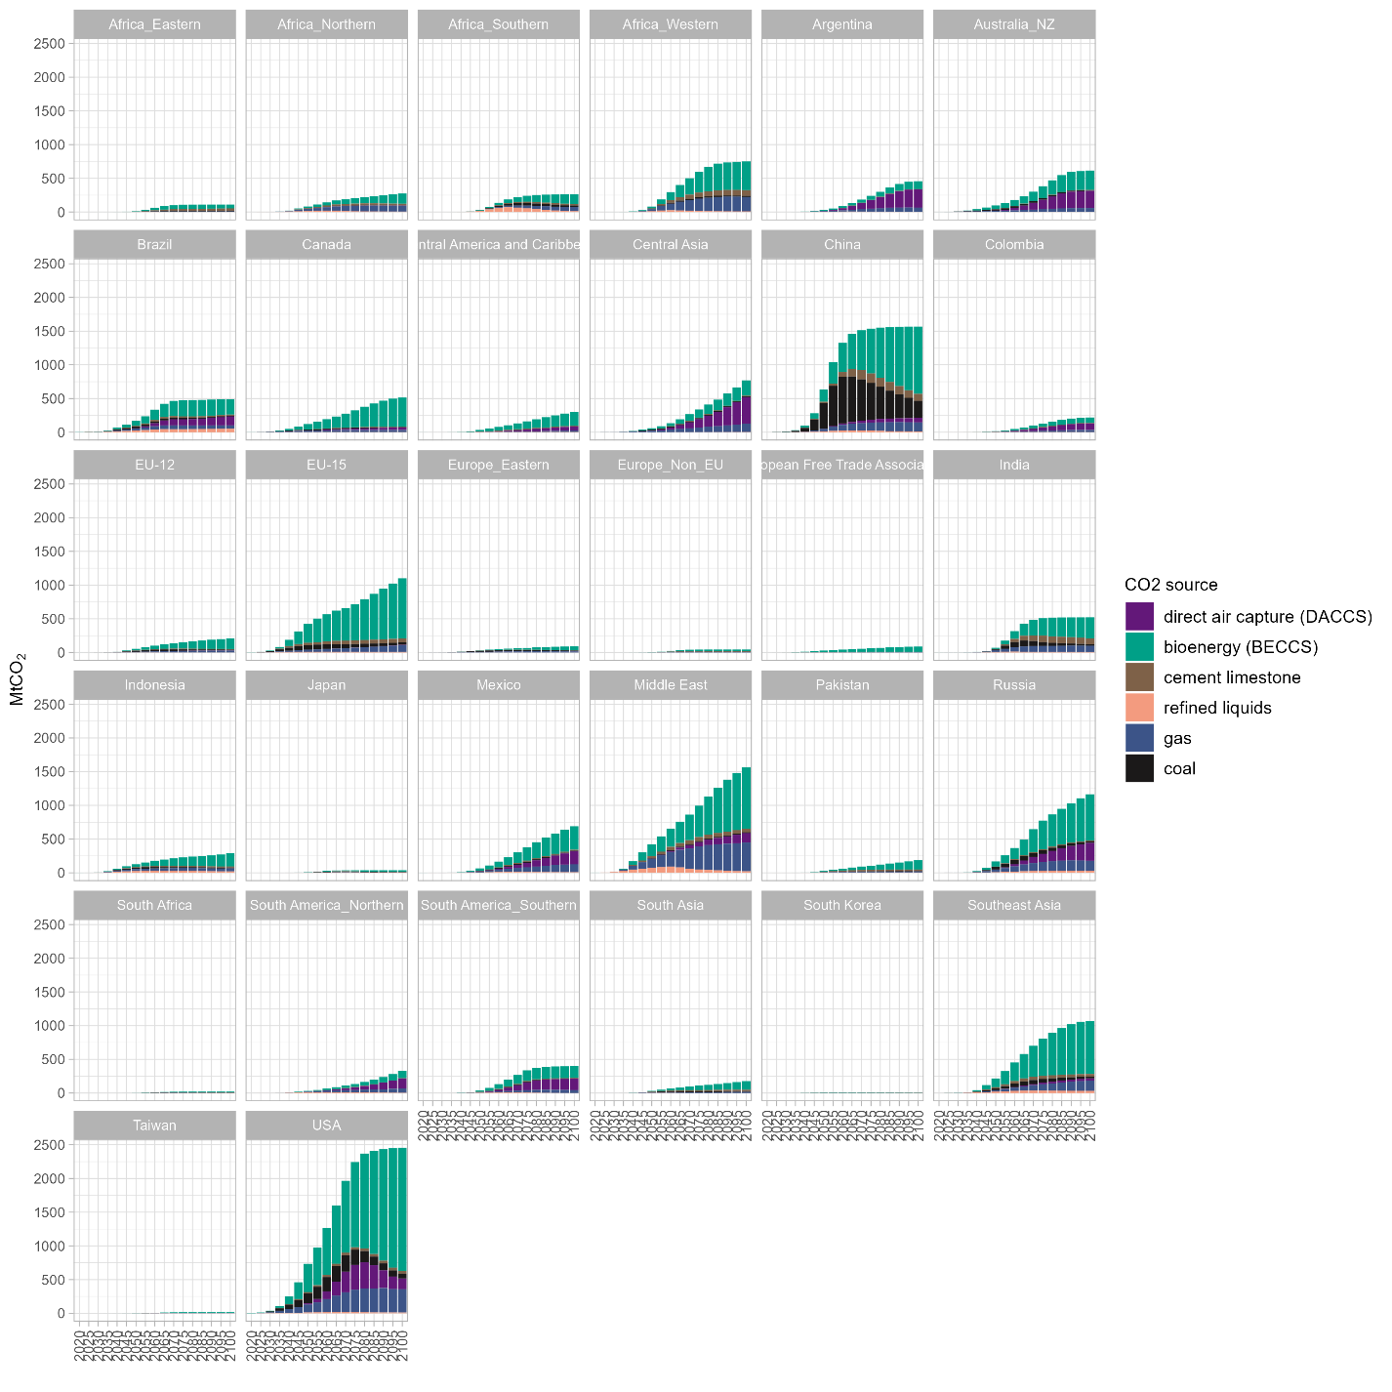
Figure 13: Geologic CO₂ storage by source and region under CCS breakthrough, 2 °C scenario.

Supplementary Figure 15 reports primary energy demand (direct equivalent) for all feasible below 2 ⁰C and below 1.5 ⁰C scenarios. Substantial fossil fuel use linked to CCS only occurs in those scenarios that allow rapid CCS growth.
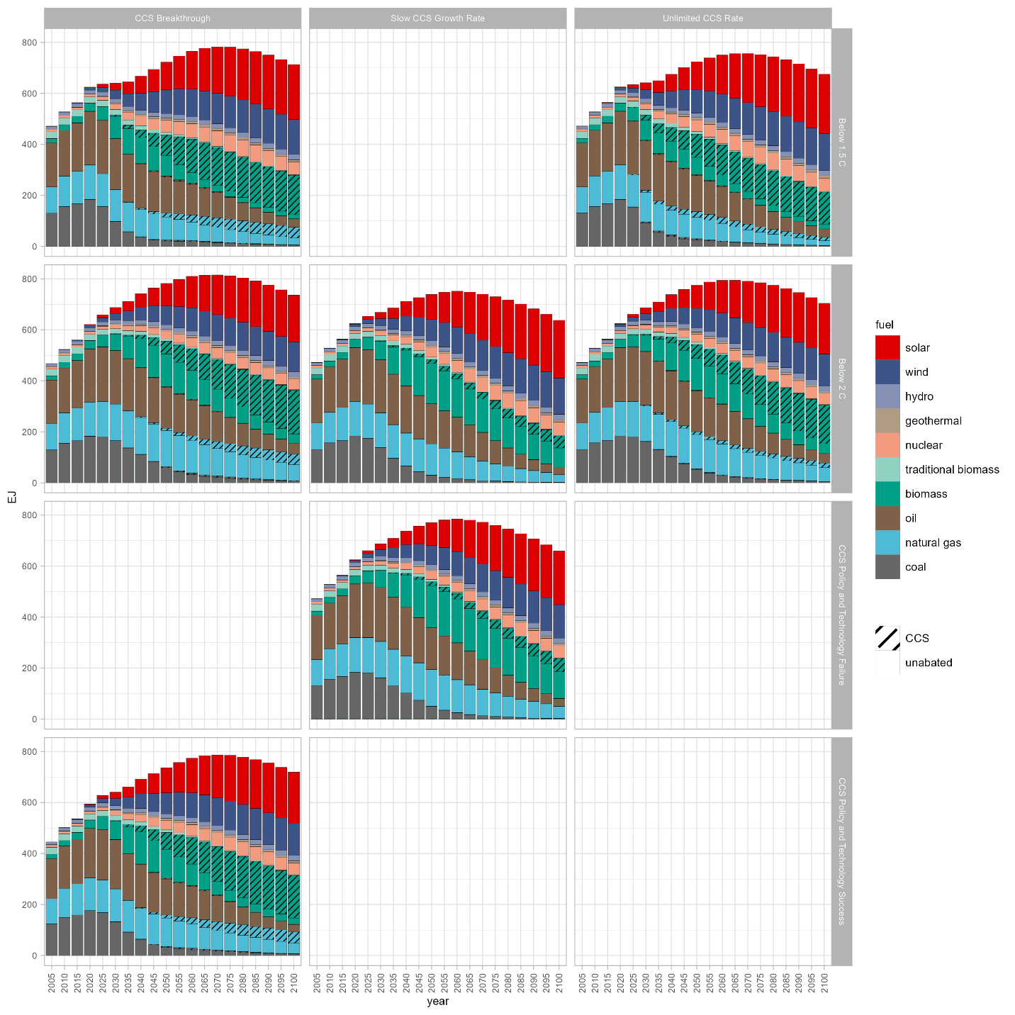
Figure 14: Global primary energy with CCS (direct equivalent) for all scenarios. The 1.5 °C scenario with slow CCS growth was infeasible; all other blank subplots were not run as scenarios.

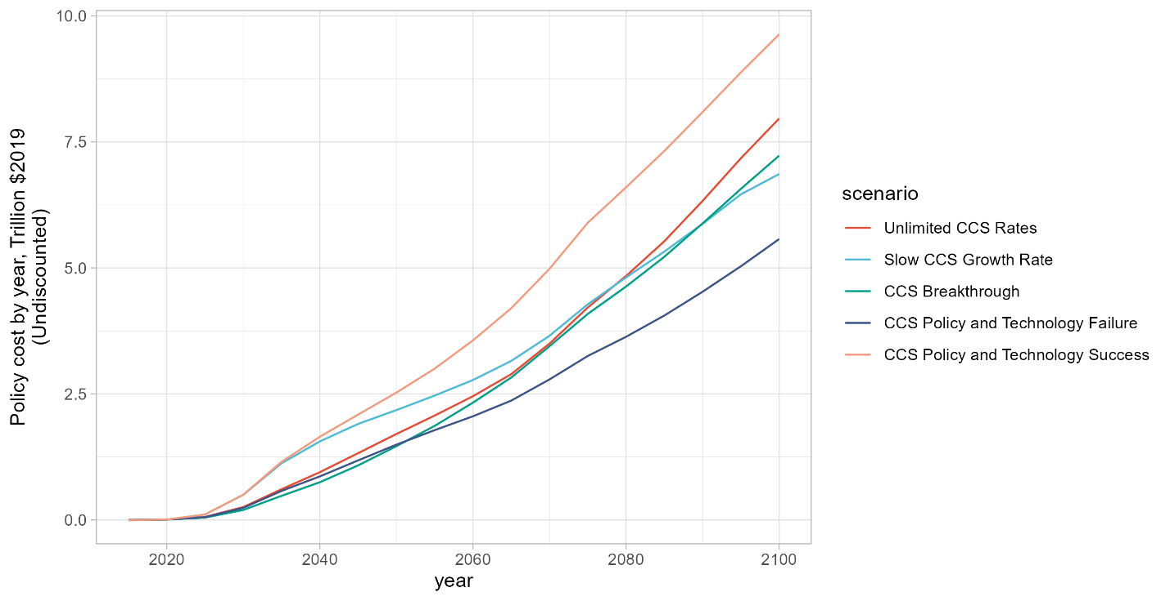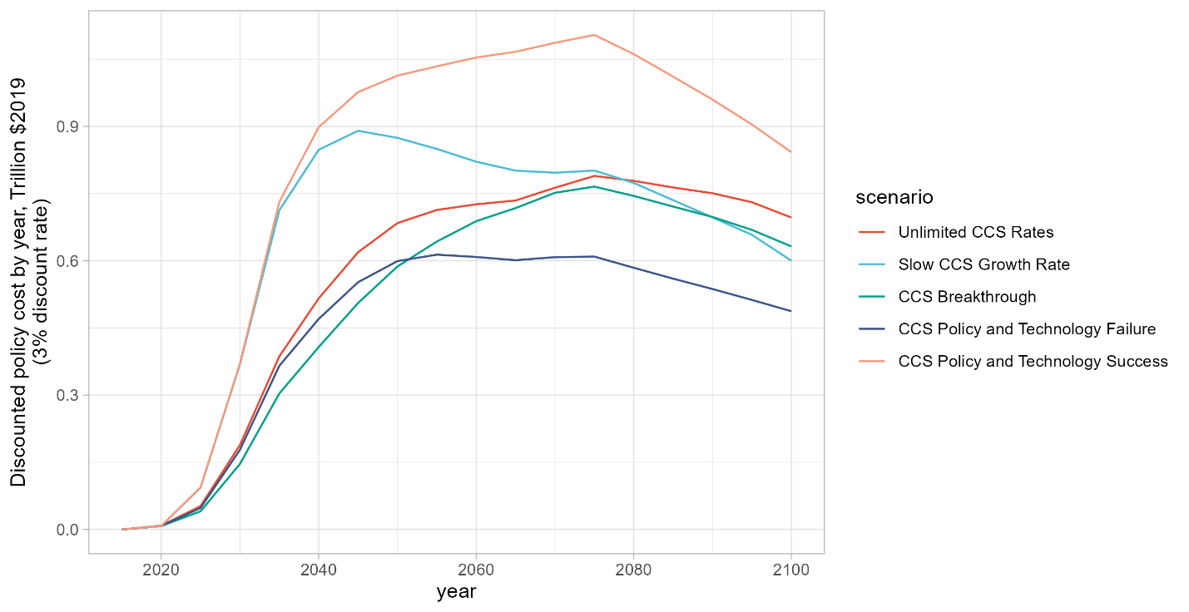
Figure 15: Global undiscounted (top) and discounted (bottom) policy costs.

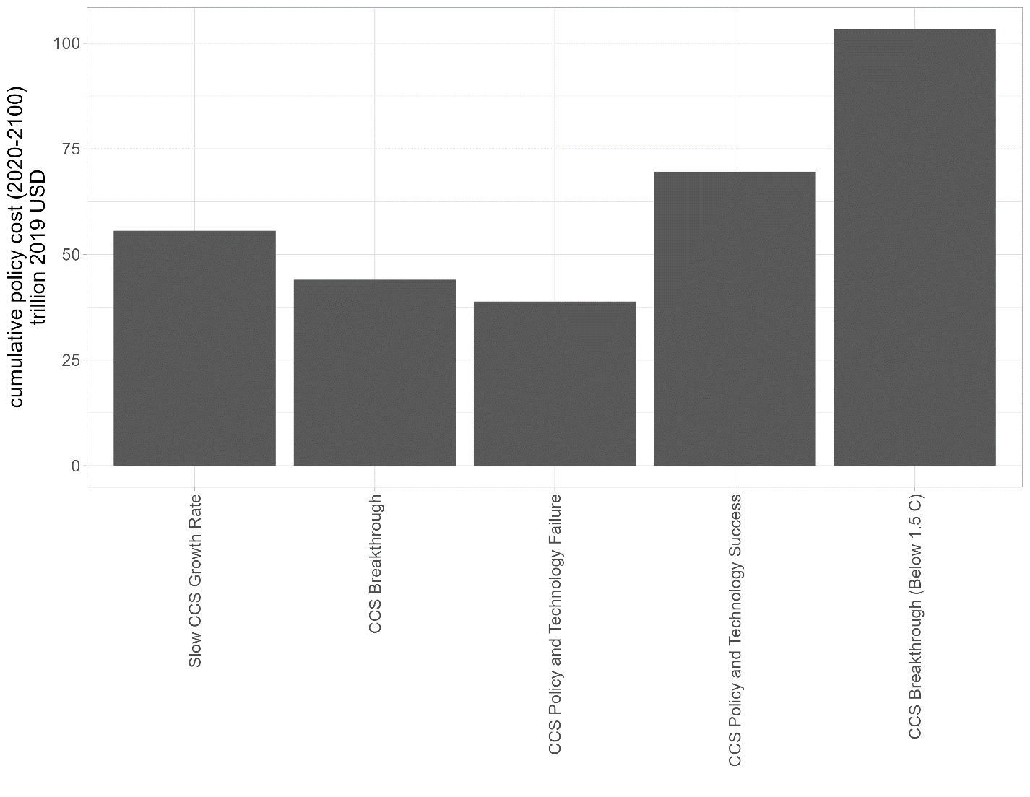
Figure 16: Global policy costs.

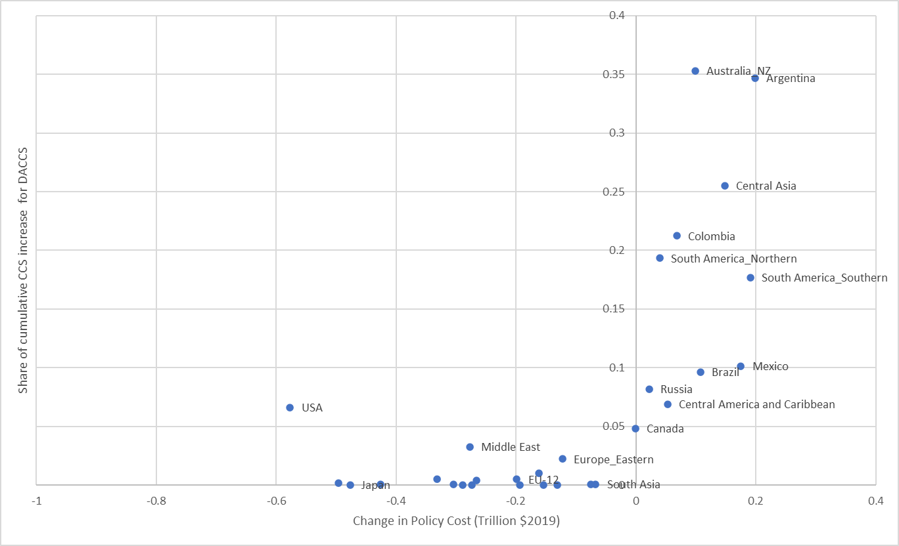
Figure 17: Changes in regional policy cost vs. proportion of cumulative CCS used for DACCS.

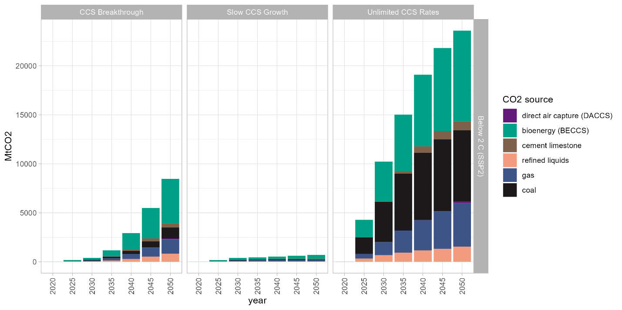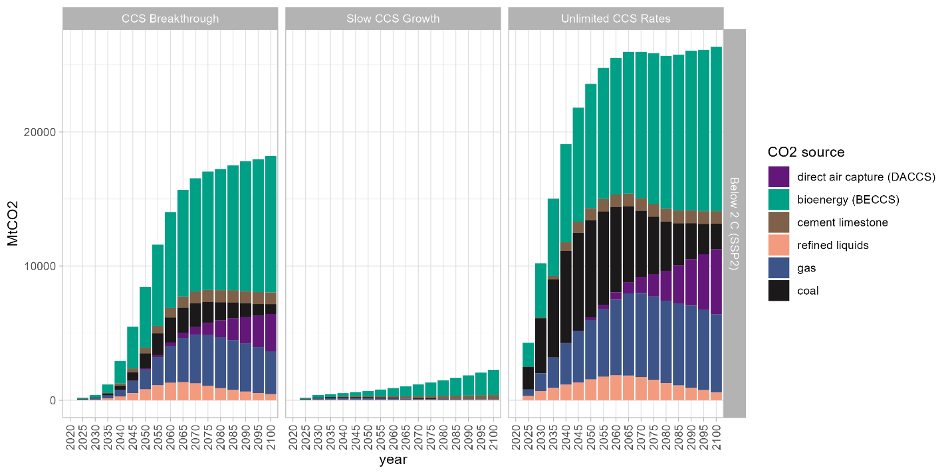
Figure 18: Geologic CO₂ storage by source for below 2⁰ C scenarios (SSP2). The top figure reports results truncated at 2050, to better highlight near-term differences between scenarios.

