Supplementary materials

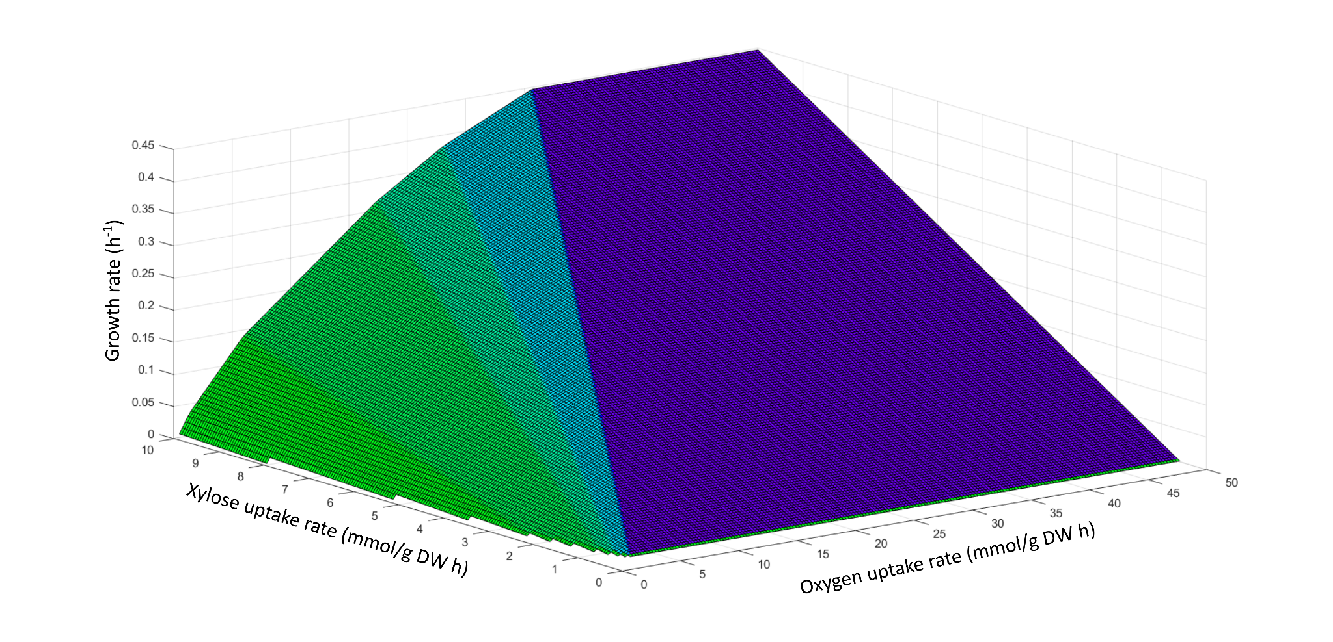
Figure S1 - Effects of varying the xylose and oxygen uptake rates on growth.

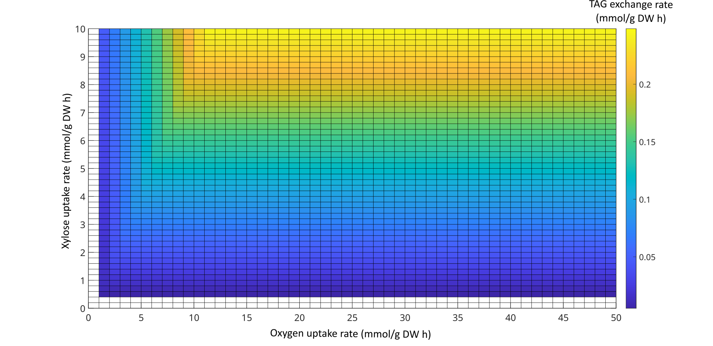
Figure S2 - Effects of varying the xylose and oxygen uptake rates on TAG exchange.

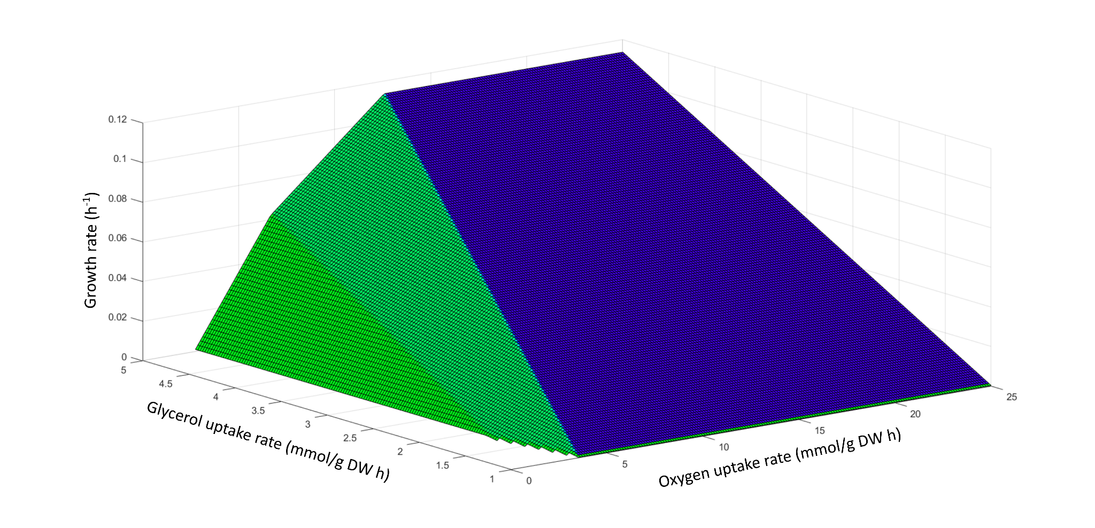
Figure S3 - Effects of varying the glycerol and oxygen uptake rates on growth.

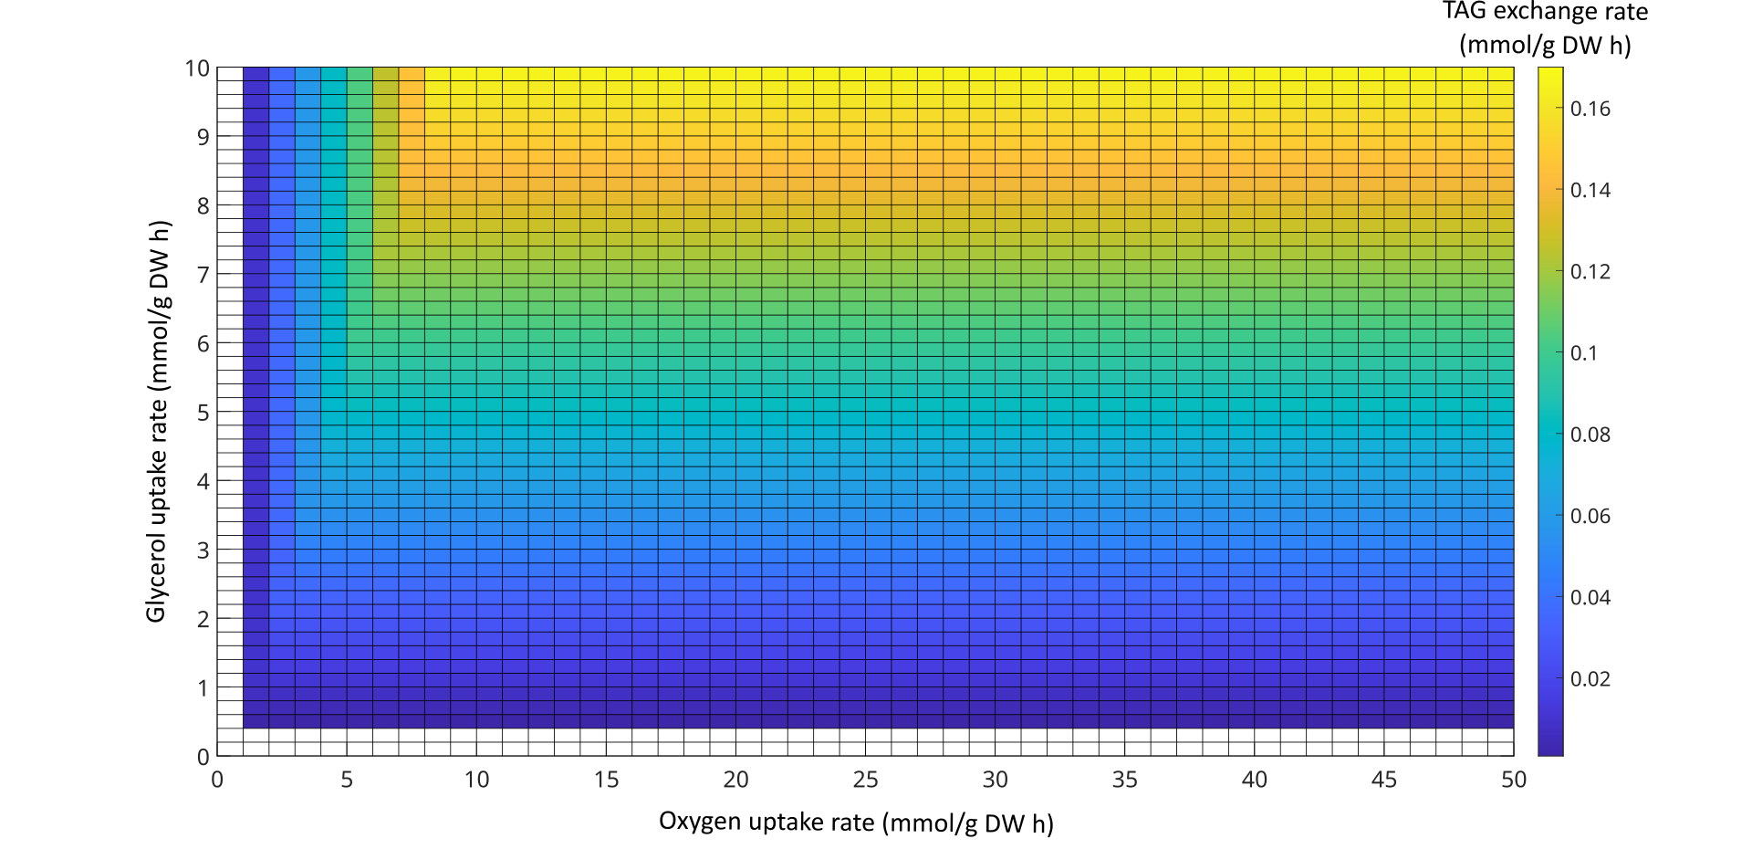
Figure S4 - Effects of varying the glycerol and oxygen uptake rates on TAG exchange.

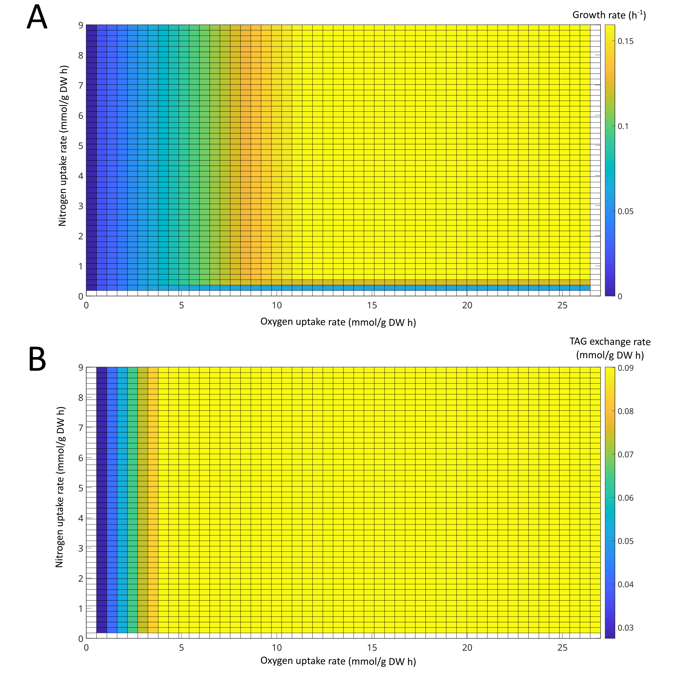
Figure S5 - Effects of varying the nitrogen and oxygen uptake rates on (A) growth and (B) TAG exchange rates fixing glucose as the carbon source.
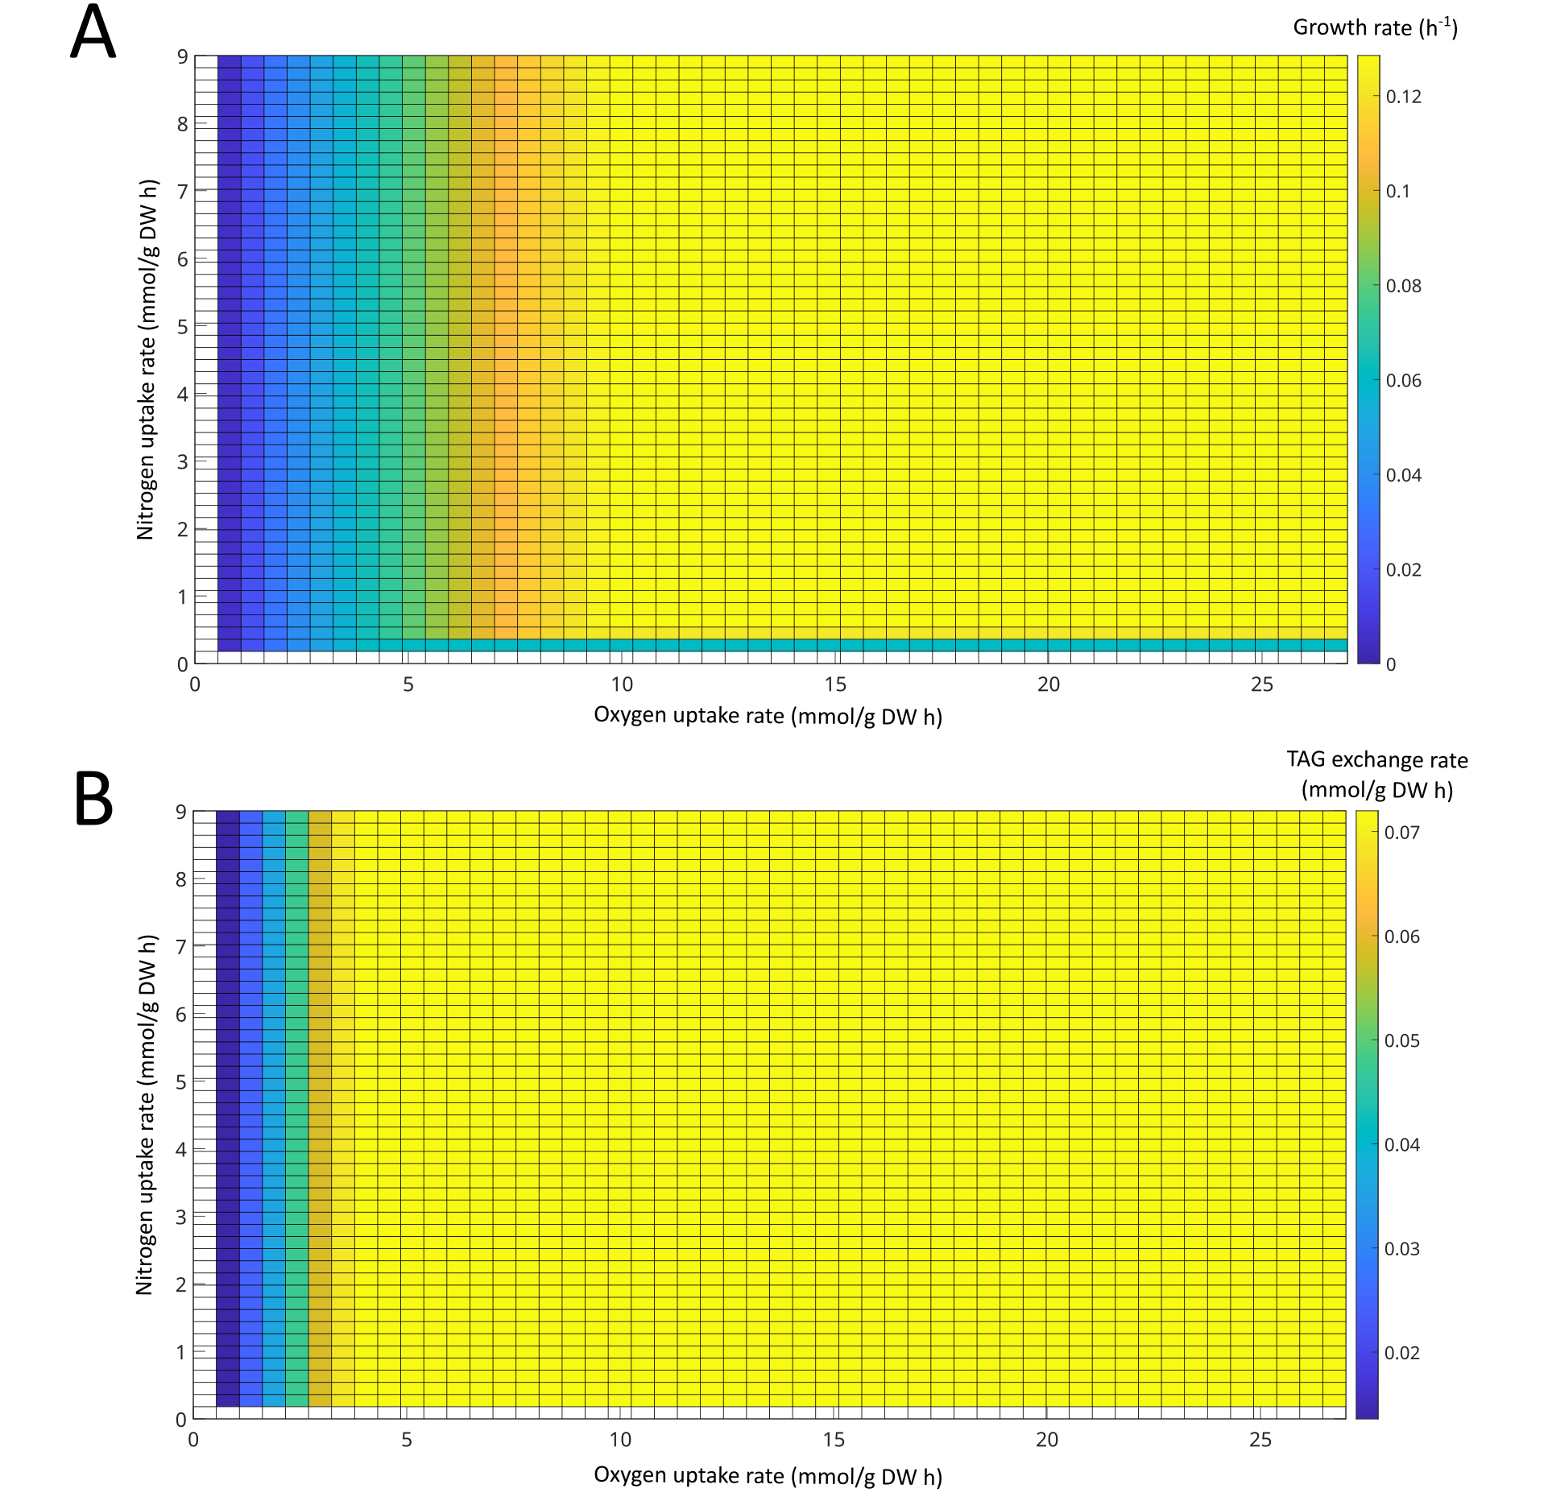
Figure S6 - Effects of varying the nitrogen and oxygen uptake rates on (A) growth and (B) TAG exchange rates fixing xylose as the carbon source

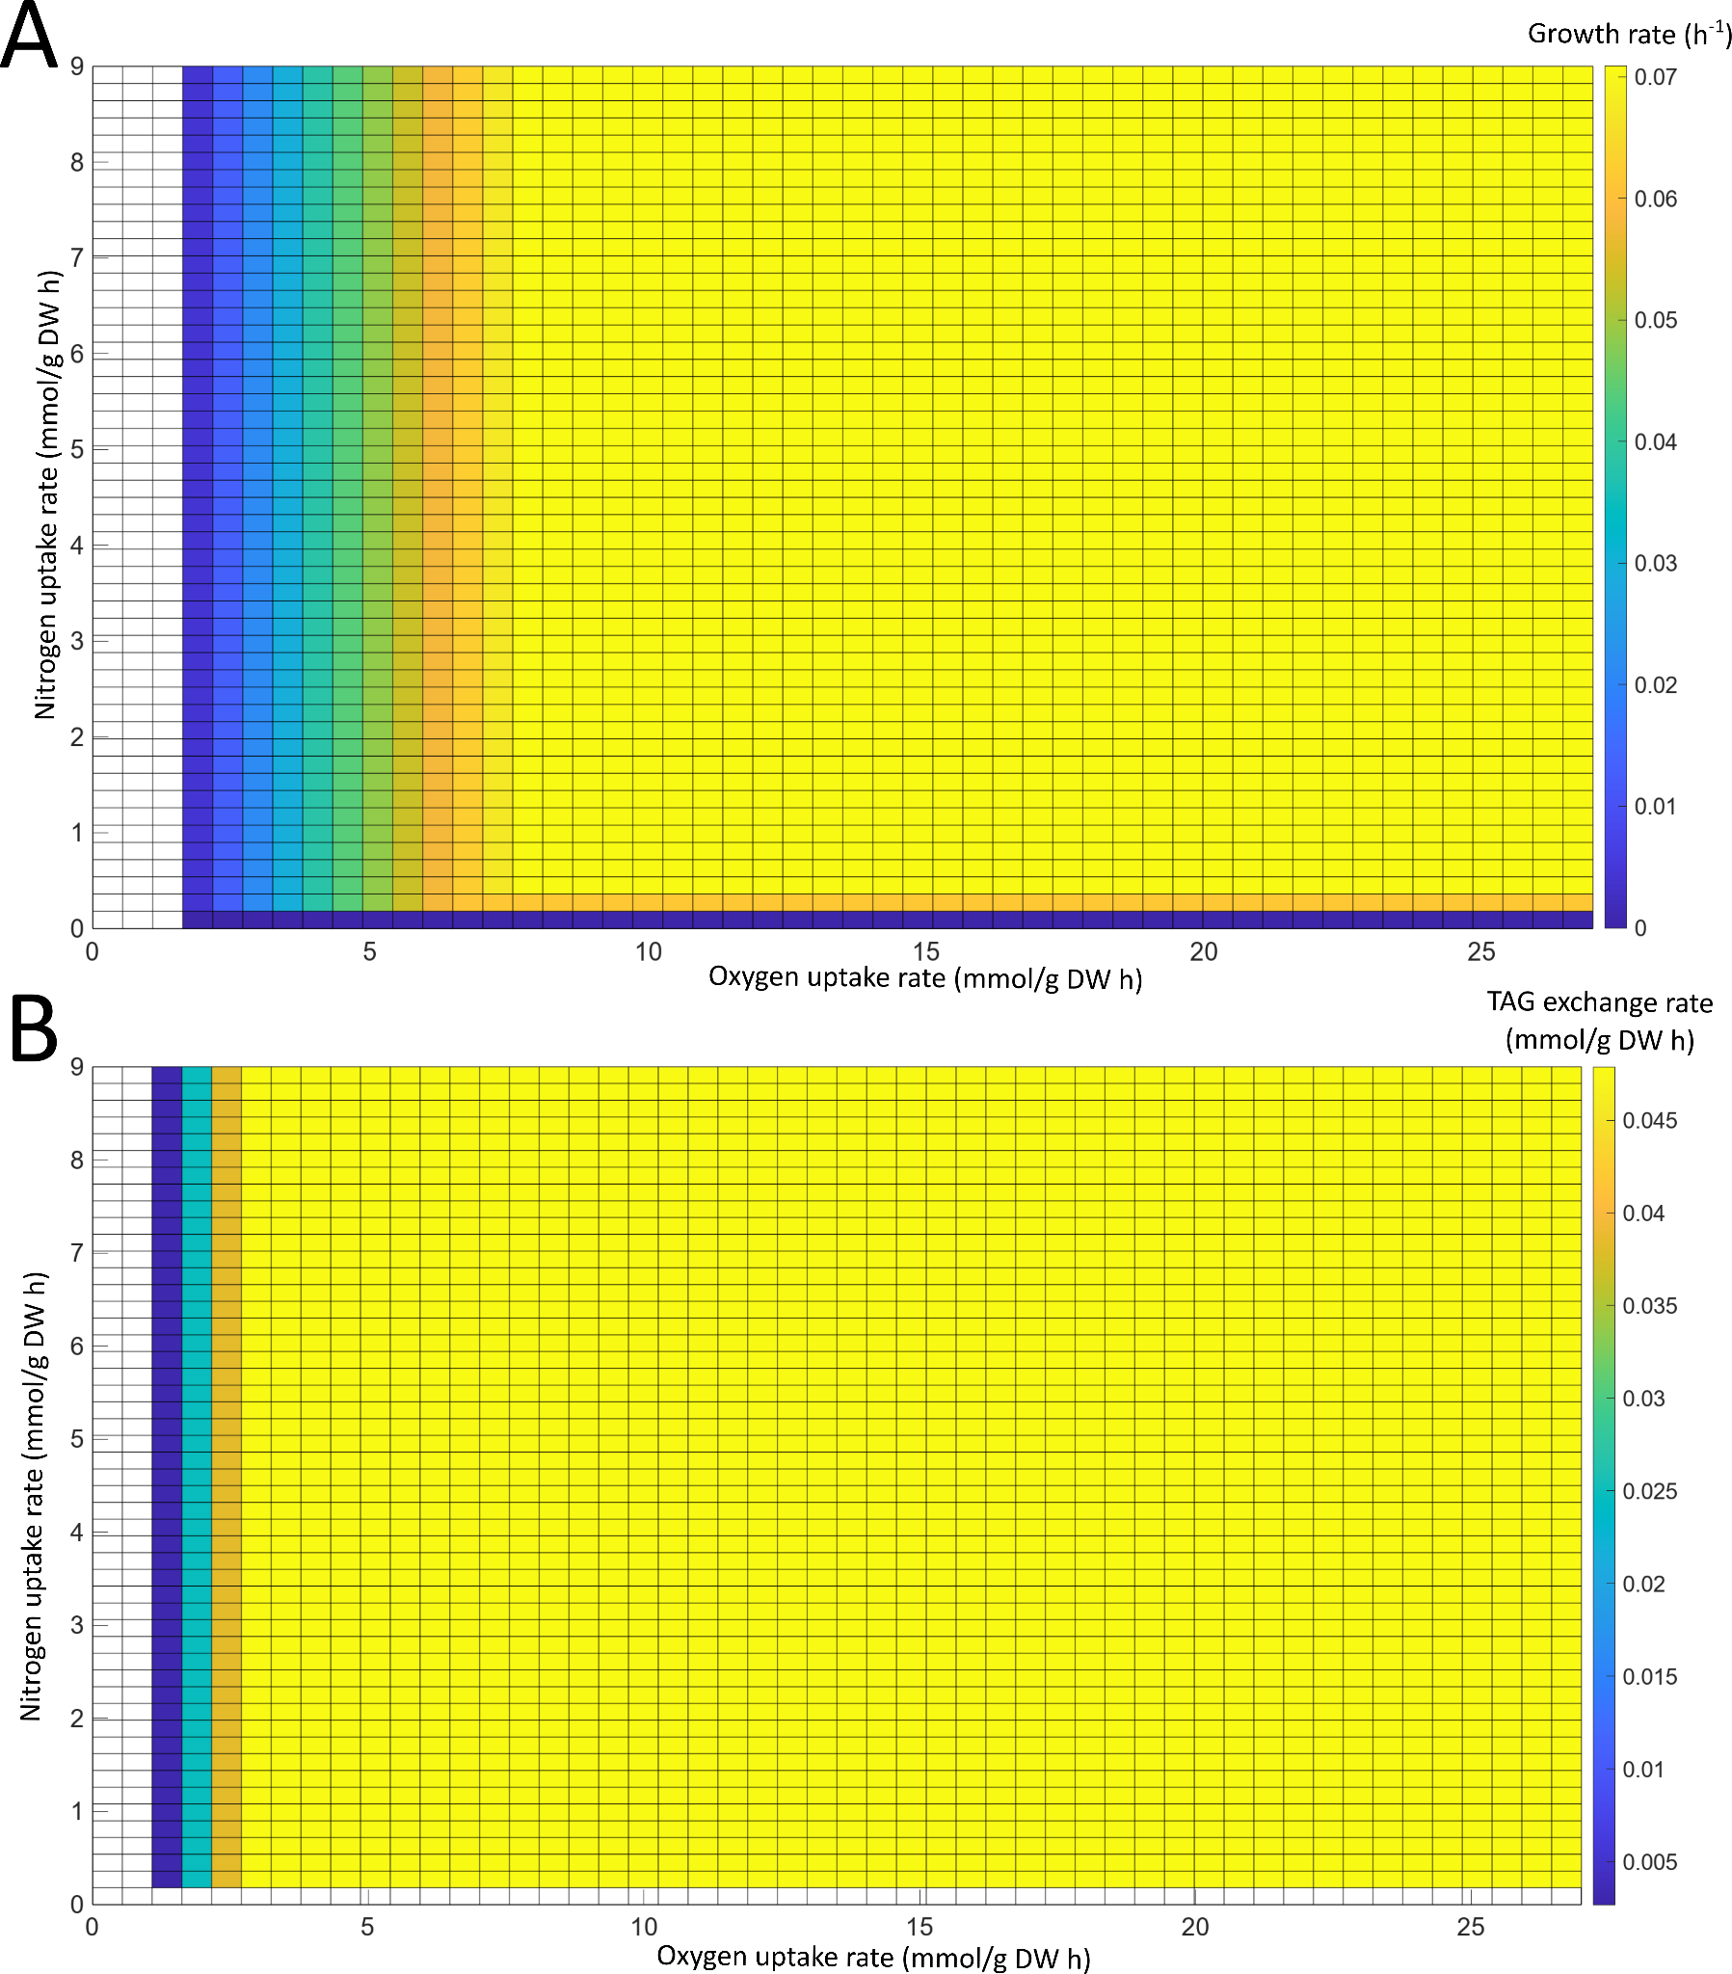
Figure S7 - Effects of varying the nitrogen and oxygen uptake rates on (A) growth and (B) TAG exchange rates fixing glycerol as the carbon source.

