Supplementary Information

Extreme Arctic lakes reveal accelerating ecological shifts linked to 21st century warming

Emma Cameron^{1*}, Marc Oliva², Dermot Antoniades¹

¹ Department of Geography, Centre for Northern Studies (CEN), & Takuvik International Research Laboratory, Université Laval, Québec, Canada

² Department of Geography, Universitat de Barcelona, Catalonia, Spain

Keywords: High Arctic, lakes, climate change, paleolimnology, diatoms, ice cover

Corresponding author: Department of Geography, Centre for Northern Studies & Takuvik International Research Laboratory, Université Laval, G1V 0A6 Quebec, Canada. emma.cameron.1@ulaval.ca.

AGE MODEL DEVELOPMENT

Distinct ¹³⁷Cs peaks recorded the 1963 CE period of maximum atmospheric fallout at 0.0-0.5 cm in lakes CM2 and CM6, and at 1.0-1.5 cm in the CM5 sediment core (Supplementary Fig. S2). This signifies that at least ~60 years of accumulation occurred within the uppermost 0.5 cm of CM2 and CM6, and the uppermost 1.5 cm of CM5. Unsupported ²¹⁰Pb was detected only in the surface samples of CM2 and CM6, precluding age-depth modeling with ²¹⁰Pb. Unsupported ²¹⁰Pb in core CM5 enabled the construction of a ²¹⁰Pb-based age-depth model using the constant rate of supply (CRS) model down to 3 cm core depth (Supplementary Table S3). The position of the ¹³⁷Cs peak within the 1.0-1.5 cm interval in CM5 agreed with the ²¹⁰Pb ages, within error, independently validating the ²¹⁰Pb model in the uppermost part of the core. Age-depth models based on radiocarbon ages (Supplementary Table S4) indicated that the cores from lakes CM2 and CM6 represented ~1950 and ~1900 years of accumulation, respectively, with no age reversals and relatively linear sedimentation rates in both cores (Supplementary Fig. S2). Due to age reversals and suspected carbon reservoir effects, it was not possible to develop a radiocarbon-based age-depth model in lake CM5 and so its basal age remained undetermined. Low sedimentation rates were observed in each lake, averaging 0.20 mm yr⁻¹ in lake CM2, 0.52 mm yr⁻¹ in lake CM5, and 0.18 mm yr⁻¹ in lake CM6, consistent with typically low rates in Arctic freshwaters [58].
Supplementary Table S1. List of taxa present in the CM2, CM5, and CM6 sediment cores, with the number of intervals in which they occurred (n) and their maximum relative abundances (Max. %). Taxa are organized in descending order of the first PCA axis sample scores. Dashes denote the absence of a particular species.
Taxon name | CM2  (n) |  | Max. (%) |  | CM5  (n) |  | Max. (%) |  | CM6  (n) |  | Max. (%)
Staurosira venter (Ehrenberg) Cleve & Möller  Pseudostaurosira brevistriata (Grunow) Williams  Staurosirella pinnata (Ehrenberg)  Pseudostaurosira pseudoconstruens (Marciniak) Williams & Round  Staurosirella sp. 1  Pseudostaurosira parasitica (Smith) Morales  Amphora copulata (Kützing) Shoeman & Archibald  Amphora inariensis Krammer  Amphora pediculus (Kützing) Grunow ex Schmidt  Amphora sp. 1  Cymbopleura incerta var. spitzbergensis Krammer  Cymbopleura incerta (Grunow) Krammer  Achnanthidium rosenstockii Lange-Bertalot  Cymbella designata Krammer  Navicula cari Ehrenberg  Denticula kuetzingii Grunow  Sellaphora stroemii (Hustedt) Kobayasi  Brachysira vitrea (Grunow) Ross  Sellaphora pupula (Kützing) Mereschkovsky  Hippodonta coxiae Lange-Bertalot  Navicula chiarae Lange-Bertalot & Genkal  Cavinula cocconeiformis Gregory ex Greville  Caloneis fasciata (Lagerstedt) Cleve  Navicula cryptocephala Kützing  Nitzschia bryophila Hustedt  Neidium ampliatum (Ehrenberg) Krammer  Aneumastus tusculus Ehrenberg  Placoneis sp. 1  Placoneis gastrum  Sellaphora bacillum (Ehrenberg) Mann  Stephanodiscus medius Håkansson  Navicula radiosa Kützing  Navicula vulpina Kützing  Nitzschia fonticoloides Sovereign & Round  Lindavia antiqua Smith  Lindavia rossii Håkansson  Encyonema ventricosum (Agardh) Grunow  Encyonema elginense (Krammer) Mann  Encyonopsis descripta (Hustedt) Krammer  Caloneis fusus Hamilton & Antoniades  Encyonema silesiacum (Bleisch) Mann  Navicula phyllepta Lange-Bertalot  Encyonema minutum (Hilse) Mann  Caloneis silicula (Ehrenberg) Cleve  Encyonema sp. 1  Pinnularia sp. 1  Encyonema lange-bertalotii Krammer  Diploneis sp. 1  Diploneis sp. 2  Sellaphora laevissima (Kützing) Mann |  | 10  6  10  -  8  4  6  10  10  10  -  -  -  2  10  1  -  3  10  9  5  9  -  2  -  1  -  7  -  1  1  -  5  2  1  3  1  6  2  2  1  5  4  2  -  -  4  2  4  3 |  | 10.5  4.5  56.0  NA  5.8  2.0  2.5  14.5  6.9  14.6  NA  NA  NA  0.5  8.9  2.3  NA  2.3  4.8  4.0  4.0  6.0  NA  2.0  NA  0.5  NA  1.8  NA  0.5  1.0  NA  0.8  0.5  2.5  5.6  2.5  0.8  0.8  0.8  0.8  3.0  2.0  1.3  NA  NA  2.3  3.0  1.0  2.5 |  | 6  -  6  6  -  -  5  5  5  5  -  -  -  -  4  -  3  4  4  5  -  3  3  3  -  -  -  3  3  1  -  -  2  2  -  3  2  2  -  -  -  4  4  3  2  3  1  4  4  2 |  | 6.8  NA  87.5  5.8  NA  NA  2.0  8.7  8.7  1.9  NA  NA  NA  NA  1.1  NA  4.3  1.3  12.8  17.8  NA  1.3  1.0  1.3  NA  NA  NA  2.3  2.0  0.6  NA  NA  1.3  0.5  NA  4.0  1.3  0.8  NA  NA  NA  3.5  1.8  0.8  0.8  0.5  2.8  2.8  1.3  6.3 |  | 5  5  5  3  -  -  5  4  -  -  3  2  5  3  -  5  -  5  4  -  3  -  -  -  2  3  2  3  -  -  -  2  3  1  -  2  1  2  3  -  3  -  -  -  -  -  3  -  -  2 |  | 50.4  13.4  33.8  1.0  NA  NA  1.7  3.4  NA  NA  3.5  2.5  6.5  3.0  NA  4.5  NA  3.0  4.5  NA  1.5  NA  NA  NA  0.8  0.8  2.5  2.3  NA  NA  NA  1.3  1.0  1.0  NA  2.5  1.8  0.5  2.0  NA  0.8  NA  NA  NA  NA  NA  0.8  NA  NA  0.5

Supplementary Table S2. List of additional lakes used to compare diatom assemblage shifts across the Arctic.

Lake | Latitude (°N) | Longitude (°W) | Coring date  (year CE) | Source
Kaffeklubben Sø | 83.617 | 30.783 | 2006 | Perren et al. (2012)
Ward Hunt Lake | 83.083 | 74.167 | 2016 | M-E Adaïmé, unpublished data
Self Pond | 82.265 | 62.016 | 2000 | Antoniades et al. (2005)
Lake Hazen | 81.825 | 70.715 | 2017 | Michelutti et al. (2020)
Birgervatnet | 79.480 | 11.617 | 1993 | Jones & Birks (2004)
Scurvy Pond | 79.733 | 12.300 | 1993 | Jones & Birks (2004)
Arresjøen | 79.667 | 10.850 | 1993 | Jones & Birks (2004)
Stygge Nunatuk | 78.734 | 78.483 | 2004 | Paul et al. (2010)
Pond I-F | 78.475 | 103.262 | 1996 | Antoniades et al. (2005)
Pond I-O | 78.458 | 103.453 | 1996 | Antoniades et al. (2005)
West Lake | 78.450 | 74.378 | 2011 | Griffiths et al. (2017)
High Lake | 78.427 | 74.223 | 2011 | Griffiths et al. (2017)
Proteus Lake | 78.419 | 74.230 | 2011 | Griffiths et al. (2017)
Moraine Lake | 78.367 | 74.500 | 2011 | Griffiths et al. (2017)
Paradise Pond | 78.365 | 74.461 | 2011 | Griffiths et al. (2017)
Plateau Pond 2 | 78.355 | 74.384 | 2011 | Griffiths et al. (2017)
Ytertjørna | 78.217 | 12.933 | 1995 | Jones & Birks (2004)
Vassauga | 77.750 | 13.950 | 1995 | Jones & Birks (2004)
Lake BC01 | 75.429 | 111.967 | 2004 | Peros et al. (2010)
MV-AT Pond | 75.317 | 111.417 | 2002 | Keatley et al. (2006)
Char Lake | 74.700 | 94.833 | 1997 | Michelutti et al. (2003)
Lake PW02 | 74.117 | 99.283 | 1993 | Finkelstein & Gajewski (2008)

Supplementary Table S3. ²¹⁰ Pb activities measured in the CM5 sediment core and the modeled CRS ages.

Sample depth interval (cm) | Excess ²¹⁰ Pb  (Bq kg⁻¹) | Error ²¹⁰ Pb  (Bq kg⁻¹) | CRS Age  (CE) | Error CRS Age (CE)
surface | 56 | 21 | 2022.6 | 0
0.5-1 | 53 | 22 | 2010.1 | 6
1-1.5 | 22 | 18 | 1988.6 | 18
1.5-2 | 3 | 21 | 1972.4 | 31
2-2.5 | 0 | 0 | 1969.3 | 30
2.5-3 | 9 | 19 | 1961.7 | 32
3-3.5 | 15 | 20 | 1944.8 | 40
Note: CE, common era. Bq, becquerel.

Supplementary Table S4. AMS ¹⁴ C dating results of CM2, CM5, and CM6 sediments. Dashes denote samples excluded from age-depth model construction.

 | AMS lab code | Material | Sample depth interval (cm) | ¹⁴ C age (yr BP) | Corrected ¹⁴ C age (yr BP) | Calibrated ¹⁴ C age (cal yr BP) | Calendar Age (CE)
CM2 | UCIAMS-281101 | sediment | surface | 3005 ±15 | -72 | -72 | 2022
 | UCIAMS-281100 | sediment | 8-8.5 | 4235 ±15 | 1230 | 1038 ±15 | 912
 | UCIAMS-281096 | sediment | 16-16.5 | 4325 ±15 | 1320 | 1226 ±15 | 724
 | UCIAMS-272651 | sediment | 22.5-23 | 5025 ±15 | 2020 | 1889 ±15 | 61
CM5 | UCIAMS-281108 | sediment | surface | 4500 ±15 | - | - | -
 | UCIAMS-281109 | sediment | 10-10.5 | 3380 ±15 | - | - | -
 | UCIAMS-281098 | sediment | 20-21.5 | 3785 ±15 | - | - | -
 | UCIAMS-272653 | sediment | 28.5-29 | 3860 ±15 | - | - | -
CM6 | UCIAMS-281099 | sediment | surface | 1355 ±15 | -72 | -72 | 2022
 | UCIAMS-281110 | sediment | 14-15 | 2270 ±15 | 1018
 | UCIAMS-272653 | moss | 14-15 | 1170 ±15 | 1170 | 1097 ±15 | 853
 | UCIAMS-272650 | sediment | 30-31 | 3315 ±15 | 2063
 | UCIAMS-272654 | moss | 30-31 | 1910 ±15 | 1910 | 1815 ±15 | 135
Note: cal yr BP, calibrated years before present. CE, common era.

Supplementary Figure S1, a-e. Normalized first axis scores of the principal component analysis (see methods), extending Fig. 3, illustrating diatom assemblage shifts across study sites in the meta-analysis (n=22) (Supplementary Table S2). (a) Kaffeklubben Sø; (b) Ward Hunt Lake; (c) Self Pond; (d) Lake Hazen; (e) Birgervatnet. This figure was generated with RStudio Version 2023.09.1+494 (https://www.rstudio.com/) using ggplot2 Version 3.4.4.

Supplementary Figure S1, f-j. Normalized first axis scores of the principal component analysis (see methods), extending Fig. 3, illustrating diatom assemblage shifts across study sites in the meta-analysis (n=22) (Supplementary Table S2). (f) Scurvy Pond; (g) Arresjøen; (h) Stygge Nunatuk; (i) Pond IF; (j) Pond IO. This figure was generated with RStudio Version 2023.09.1+494 (https://www.rstudio.com/) using ggplot2 Version 3.4.4.
Supplementary Figure S1, k-o. Normalized first axis scores of the principal component analysis (see methods), extending Fig. 3, illustrating diatom assemblage shifts across study sites in the meta-analysis (n=22) (Supplementary Table S2). (k) West Lake; (l) High Lake; (m) Proteus Lake; (n) Moraine Lake; (o) Paradise Pond. This figure was generated with RStudio Version 2023.09.1+494 (https://www.rstudio.com/) using ggplot2 Version 3.4.4.

Supplementary Figure S1, p-t. Normalized first axis scores of the principal component analysis (see methods), extending Fig. 3, illustrating diatom assemblage shifts across study sites in the meta-analysis (n=22) (Supplementary Table S2). (p) Plateau Pond 2; (q) Ytertjørna; (r) Vassauga; (s) Lake BC01; (t) MV-AT Pond. This figure was generated with RStudio Version 2023.09.1+494 (https://www.rstudio.com/) using ggplot2 Version 3.4.4.

Supplementary Figure S1, u-v. Normalized first axis scores of the principal component analysis (see methods), extending Fig. 3, illustrating diatom assemblage shifts across study sites in the meta-analysis (n=22) (Supplementary Table S2). (u) Char Lake; (v) Lake PW02. This figure was generated with RStudio Version 2023.09.1+494 (https://www.rstudio.com/) using ggplot2 Version 3.4.4.

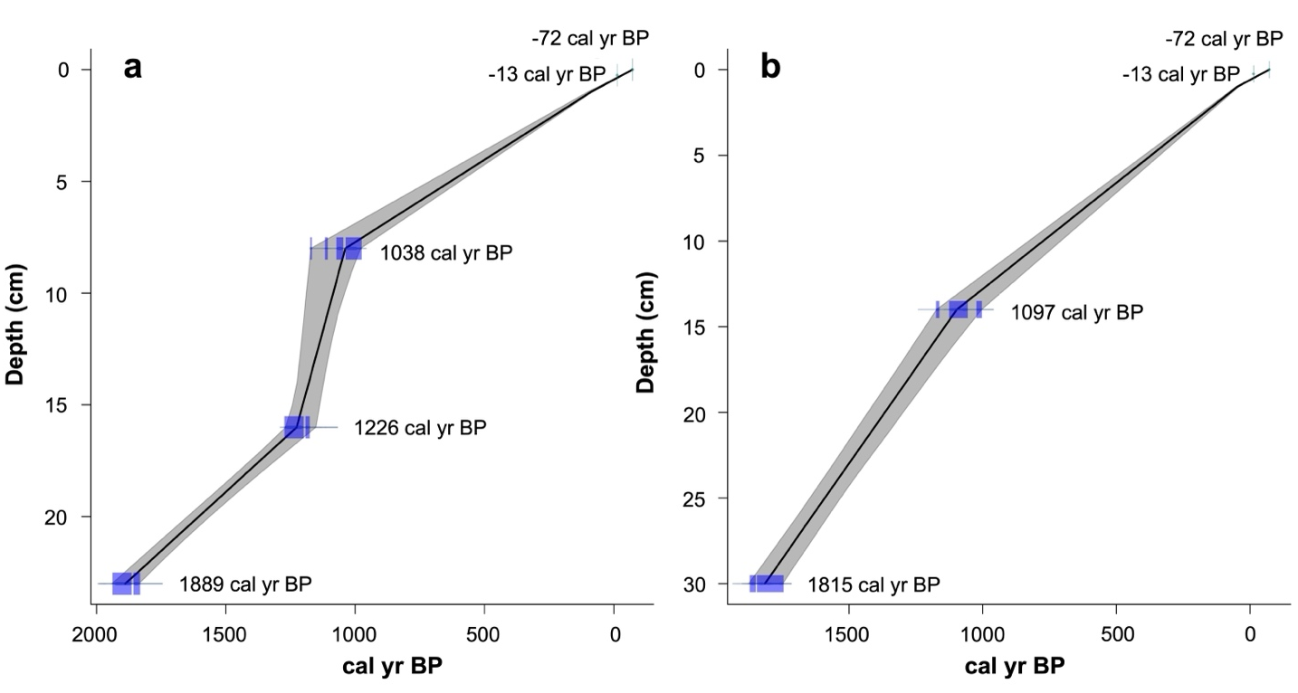

Supplementary Figure S2. Age-depth models for lake (a) CM2 and (b) CM6 constructed based on ¹⁴ C and ¹³⁷ Cs dates (Supplementary Table S4) in CLAM v2.1 (Blaauw, 2010).

