Computational Development of mushroom-6-Glucan/Paclitaxel as a Synergistic Complementary Medicine for Breast Cancer Therapy

Nehal M. EL-Deeb^{1#*}, Omar M. Ibrahim^{2#**}, Ayman M. Kamel ^{3,4}, Ahmed I. Gomaa⁵, Ahmed M. Kenawy⁶

¹Pharmaceutical Bioproducts Research Department, Genetic Engineering and Biotechnology Research Institute (GEBRI), City of Scientific Research and Technological Applications (SRTA-City), New Borg El-Arab City, Alexandria, Egypt.
² Department of Medicine, Washington University School of Medicine, St. Louis, Missouri 63110.
³ Pharmaceutical Sciences Division, Medicinal and Aromatic Plants Dept., National Research Centre, Cairo, Egypt.
⁴ School of Nutrition Sciences, Faculty of Health Sciences, University of Ottawa, Ottawa, Ontario, Canada.
⁵ National Research Center, Nutrition and Food Science Department, Doki, Giza, Egypt.
⁶Nucleic Acids Research Department, Genetic Engineering and Biotechnology Research Institute, City of Scientific Research and Technological Applications (SRTA-City), New Borg El-Arab City, Alexandria, Egypt.

Correspondence: *neldeeb@uottawa.ca ,**oibrahim@buffalo.edu
# Equal contribution

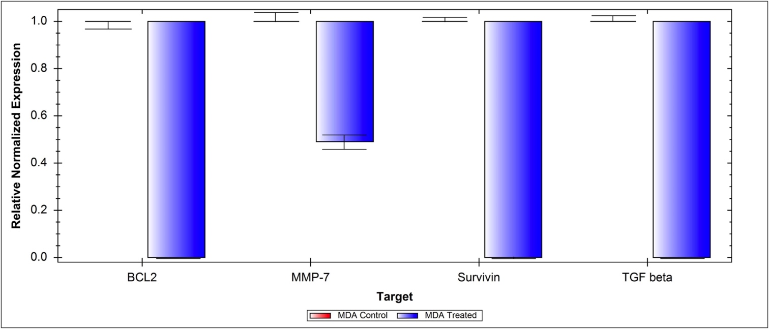
Figure S1. Relative normalized gene expression levels of BCL2, MMP7, Survivin, and TGF-β in PTX/6-glucan treated and untreated control cells. Data normalization was carried out using β-actin reference gene. Error bars are the STD calculated from three replicates.

