SUP TABLE III (please see the full version in supplementary materials)
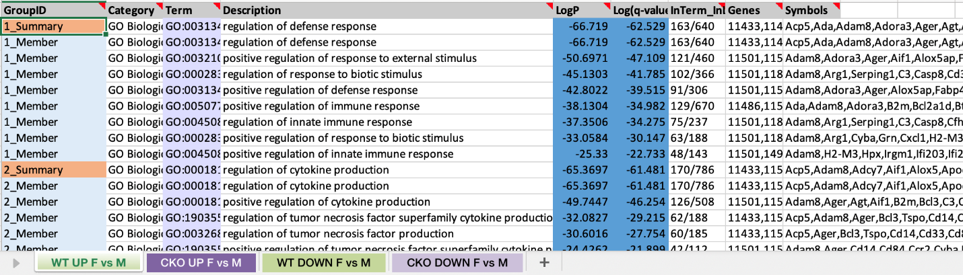

SUP TABLE IV (please see the full version in supplementary materials)
