Supplementary figures and tables for the article Deep learning-based infrastructure detection reveals higher permafrost thaw-related damage costs than previously estimated for Alaska

¹Elias Manos, ¹Chandi Witharana, ²Anna K. Liljedahl
¹ Department of Natural Resources and the Environment, University of Connecticut, 1376 Storrs Road, Unit 4087, Storrs, CT 06269, USA
² Woodwell Climate Research Center, 149 Woods Hole Road, Falmouth, MA 02540, USA
*Correspondence: elias.manos@uconn.edu

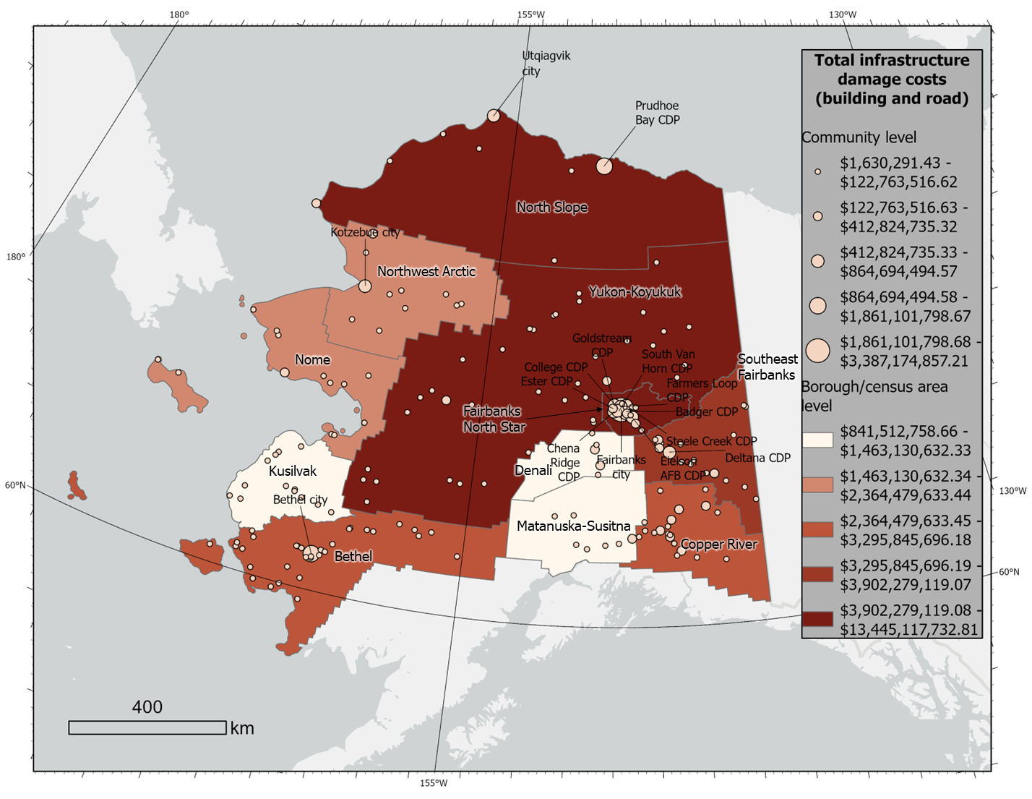
Supplementary Figure S1. Total (not normalized by population) building and road damage costs (USD 2024) in both Alaskan communities and boroughs/census areas caused by bearing capacity loss and ground subsidence projected by 2055-2064 under the SSP585 scenario. Communities with the 15 highest estimated total damage costs (exact costs given in Supplementary Figure 2a) are labelled.

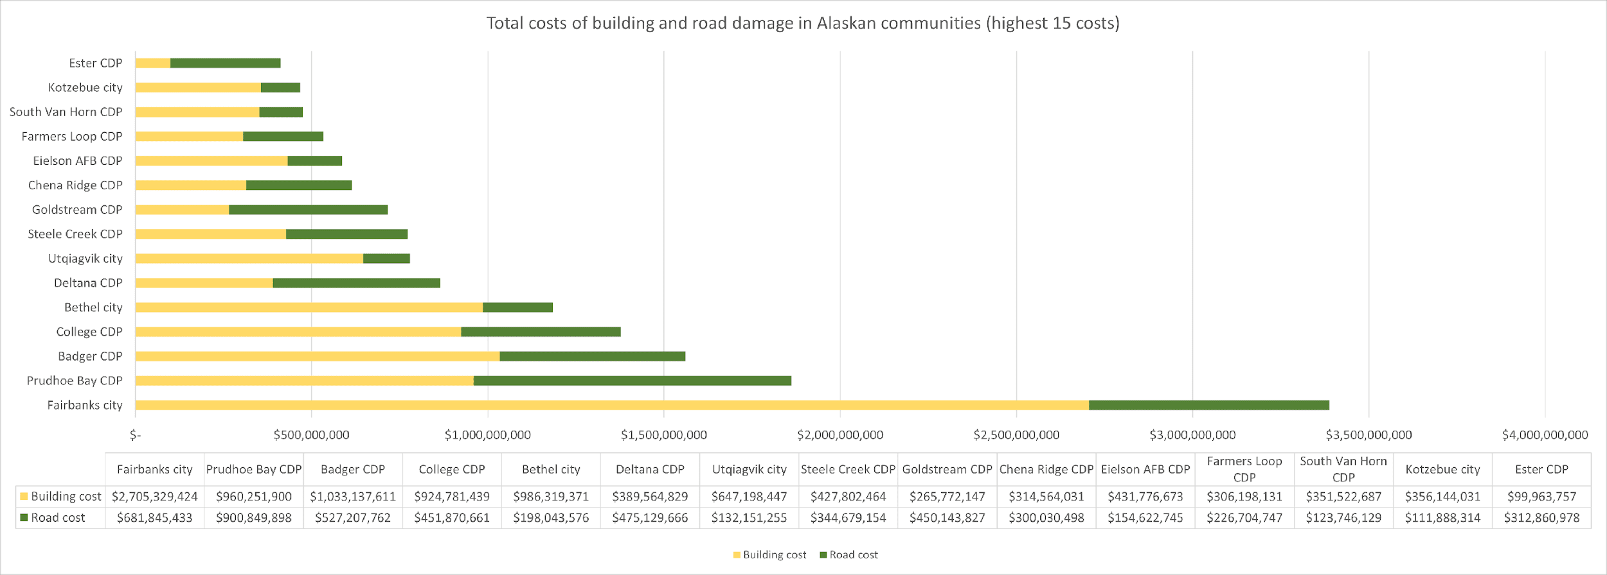
a)

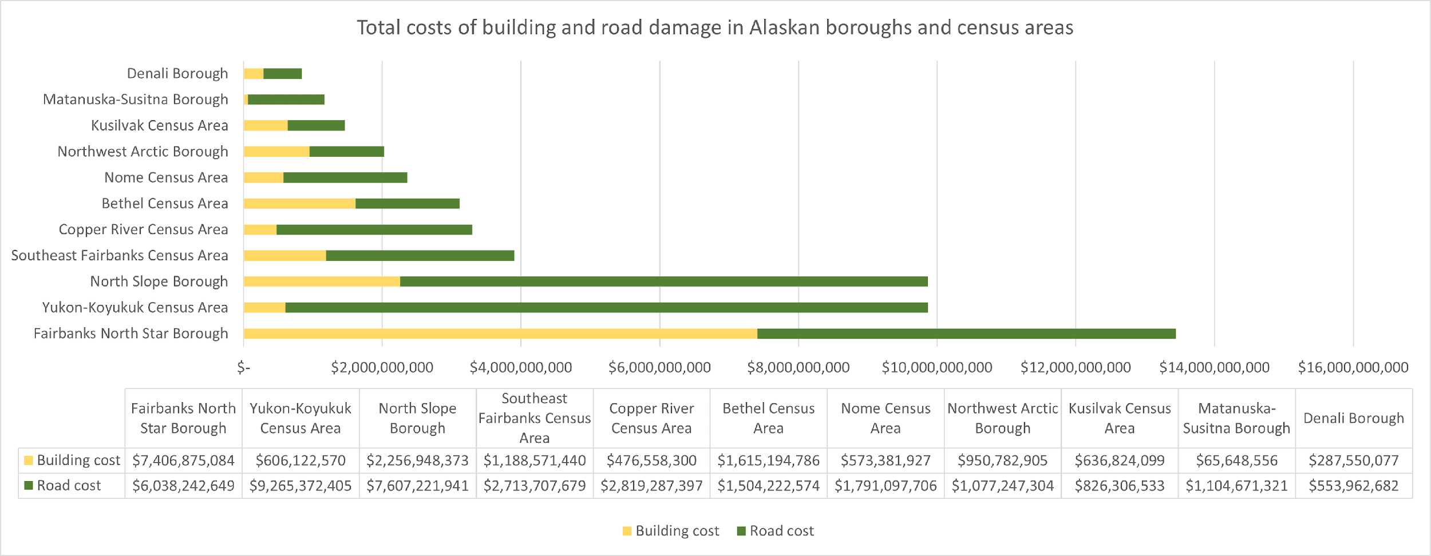
b)

Supplementary Figure S2. Total damage costs (USD 2024) in (a) communities and (b) Alaskan boroughs/census areas caused by bearing capacity loss and ground subsidence projected by 2055-2064 under the SSP585 scenario. Breakdowns of the costs into building and road costs are provided. As shown in (a), the highest total estimated damage costs among Alaskan communities are located in Fairbanks, which amount to ~$3.4B, followed by Prudhoe Bay CDP at ~$1.9B, and Badger CDP at ~$1.6B. As shown in (b), the highest total estimated damage costs among Alaskan borough/census areas are located in the Fairbanks North Star Borough, which amount to ~$13.4B, followed by Yukon-Koyukuk Census Area and North Slope Borough at ~$9.9B.

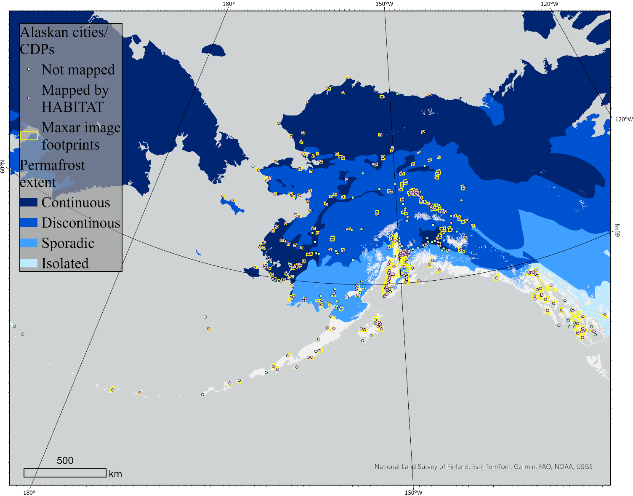
Supplementary Figure S3. Centroids of all 355 Alaskan communities according to the U.S. Census Bureau. Buildings and roads were mapped in 285 of these communities using the HABITAT deep learning pipeline. 70 communities could not be mapped by HABITAT as imagery was not available for them. The footprints of the 387 Maxar images from which communities were mapped are given, overlaid upon the Brown et al. permafrost map.

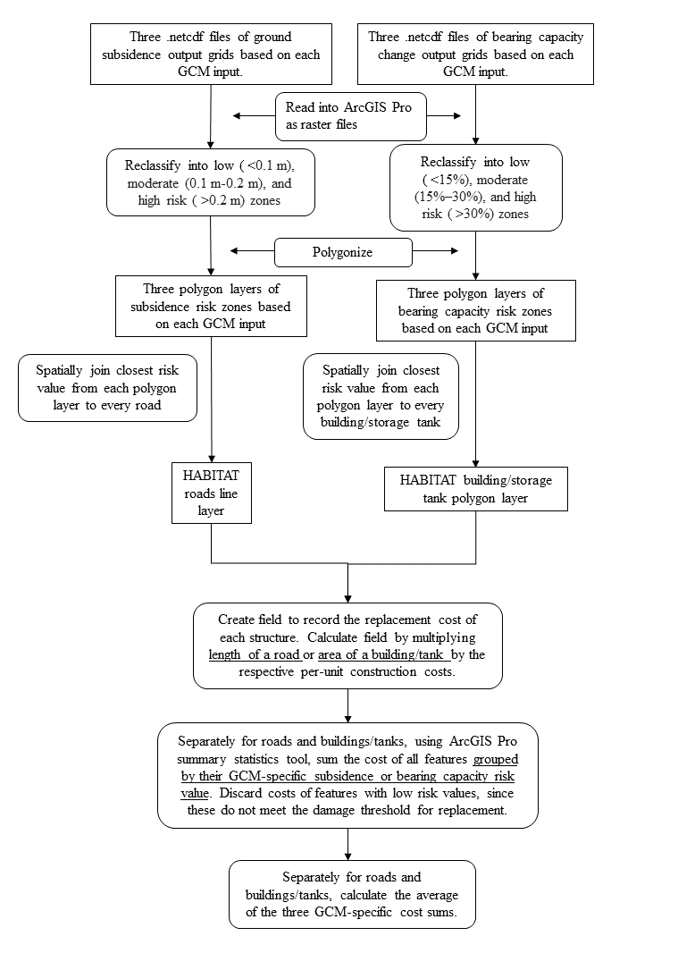
Supplementary Figure S4. Detailed diagram of GIS workflow used to estimate costs associated with building and road damages from ground bearing capacity loss and ground subsidence hazards. Each step is performed in the ArcGIS Pro software.

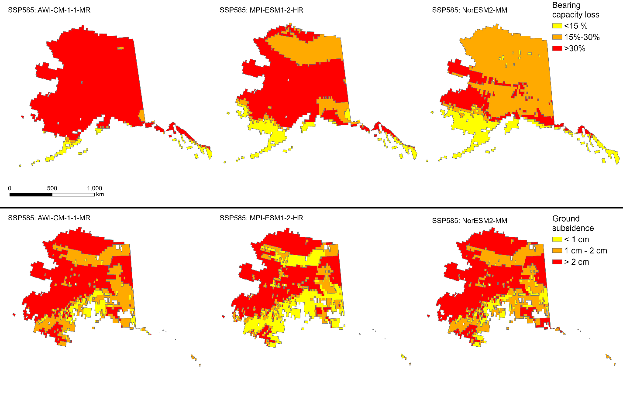
Supplementary Figure S5. Bearing capacity loss and ground subsidence outputs of Streletskiy permafrost geotechnical model clipped to the Alaska state boundary.

Supplementary Table S1. Per unit infrastructure construction costs (USD 2024) averaged from government, public, commercial, and local information across the Arctic from Streletskiy et al.
Infrastructure type (measurement unit) | Cost per unit ($)
Buildings/tanks (m²) | 1,736
Roads (km) | 1,646,986

