Supplemental Information
Figures
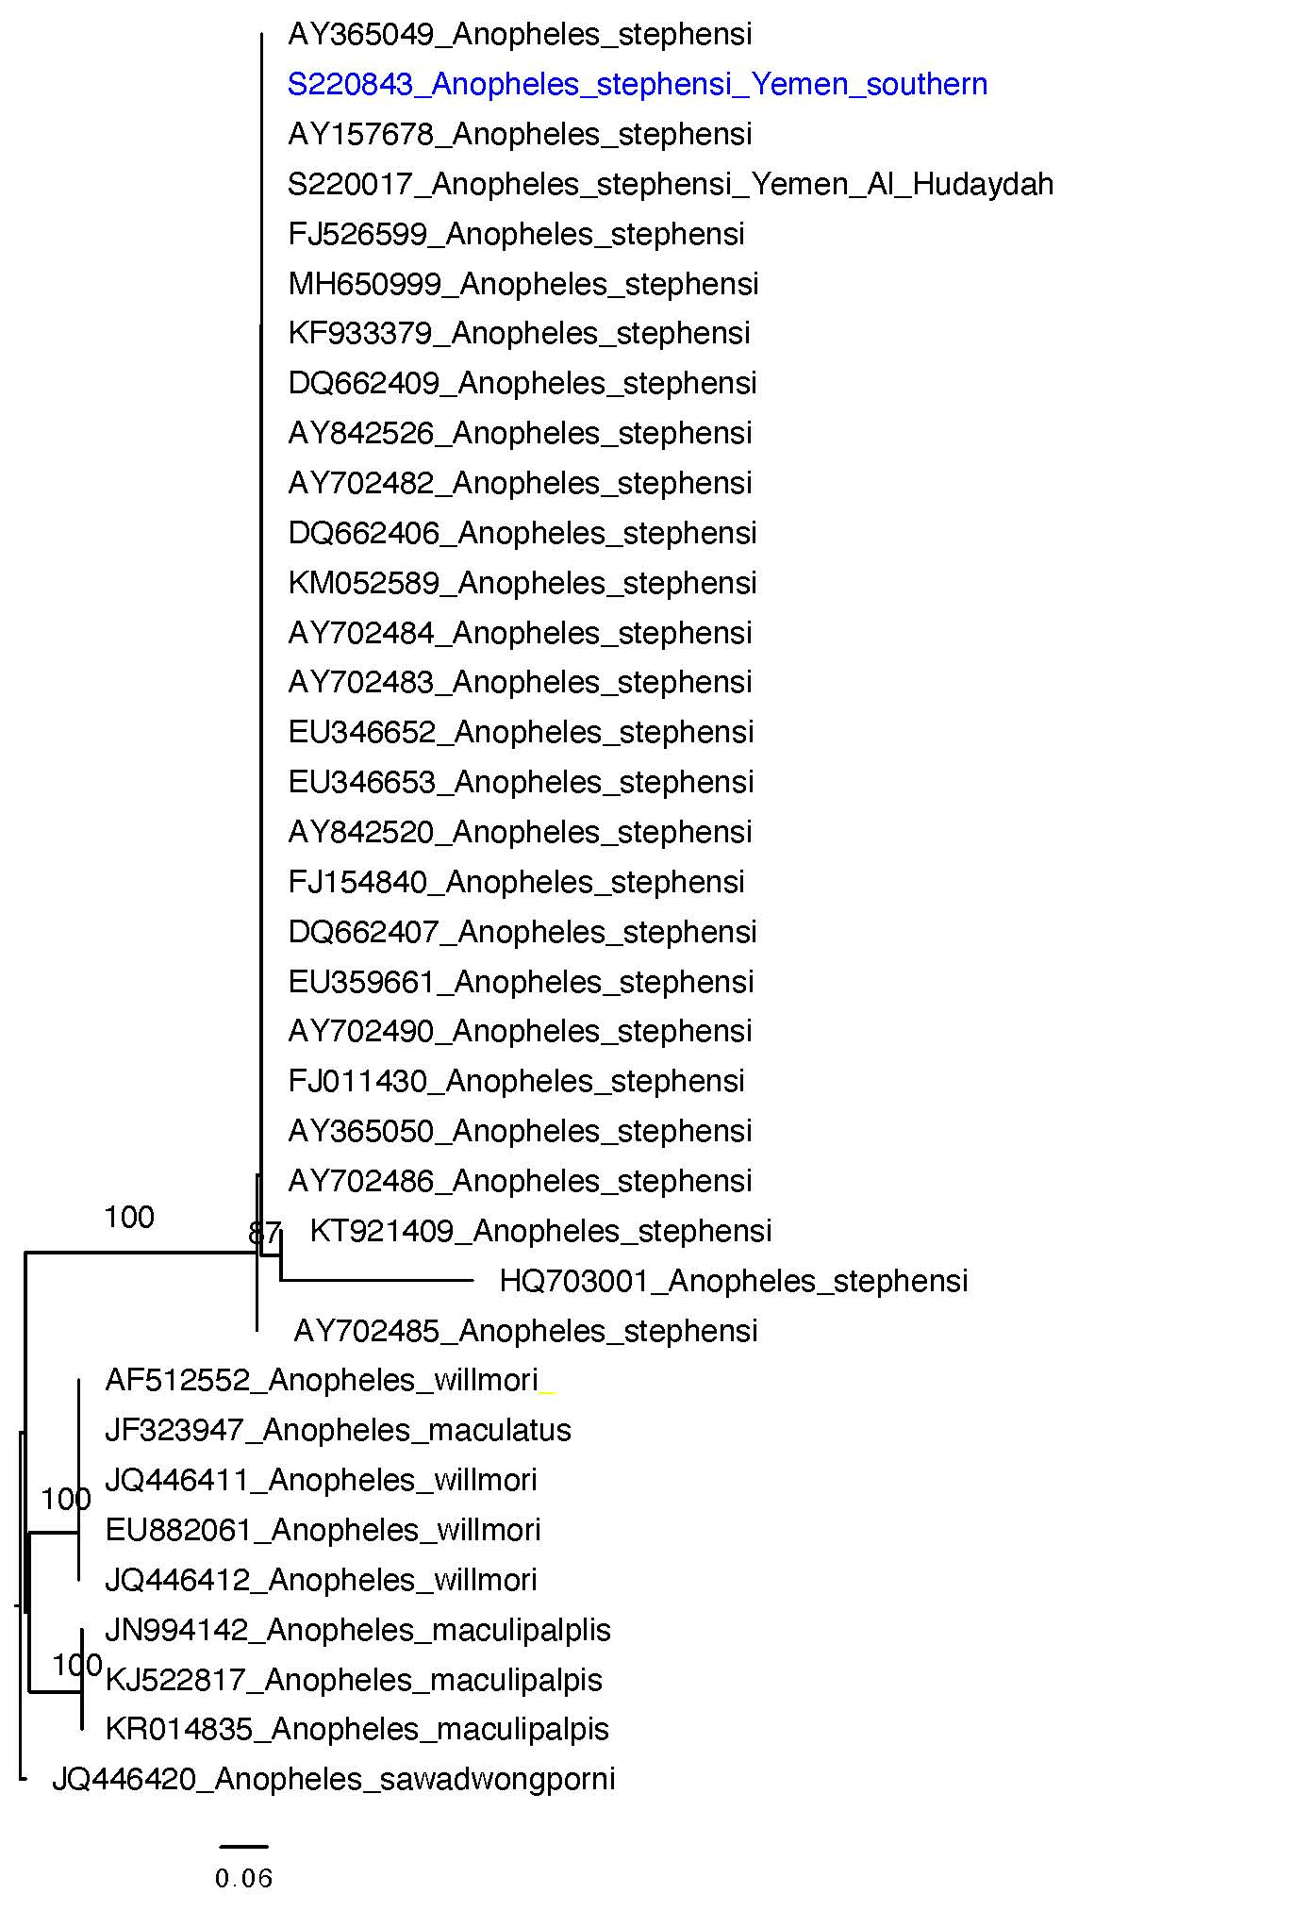
Supplemental Figure. Phylogenetic analysis of An. stephensi ITS2 sequences from southern Yemen using the maximum likelihood approach. The ITS2 sequence observed in southern Yemen is in blue.

