Appendix

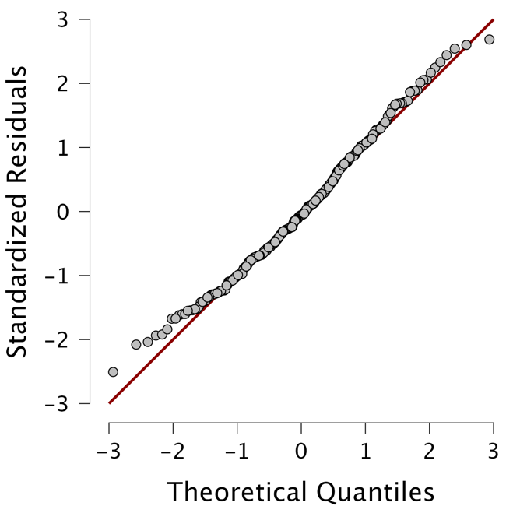
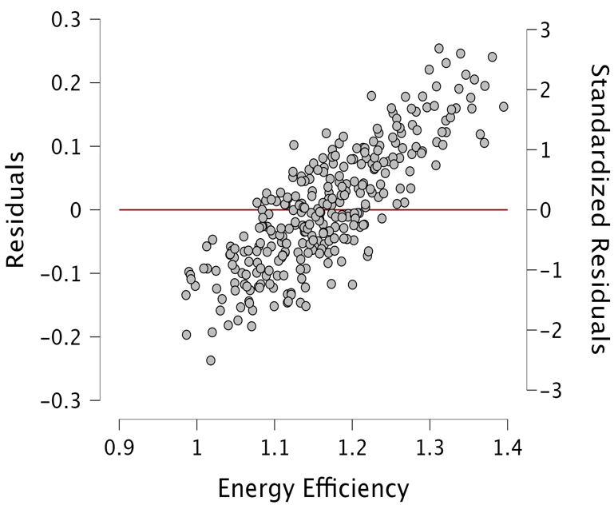
Residuals vs. Dependent Q-Q Plot Standardized Residuals

Correlations Scatter plots

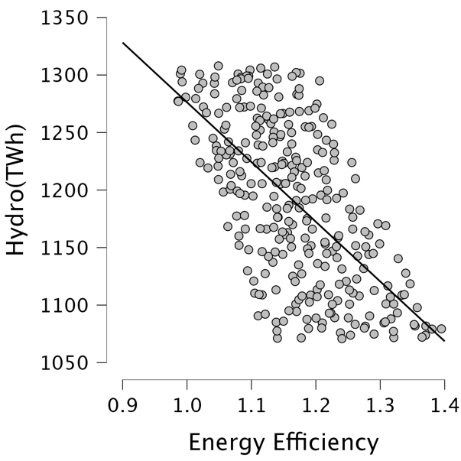
Hydro (TWh) vs. Energy Efficiency Biofuel(TWh) vs. Energy Efficiency
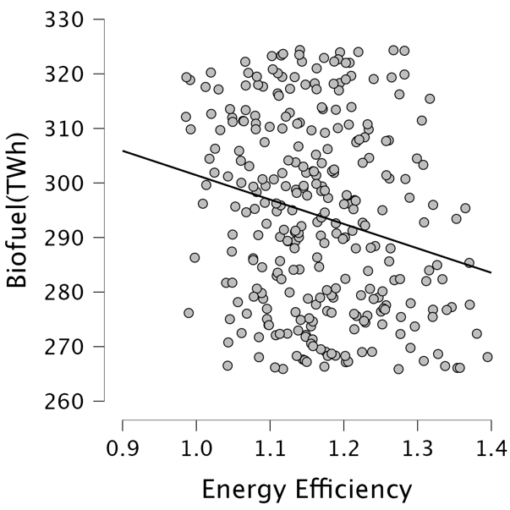

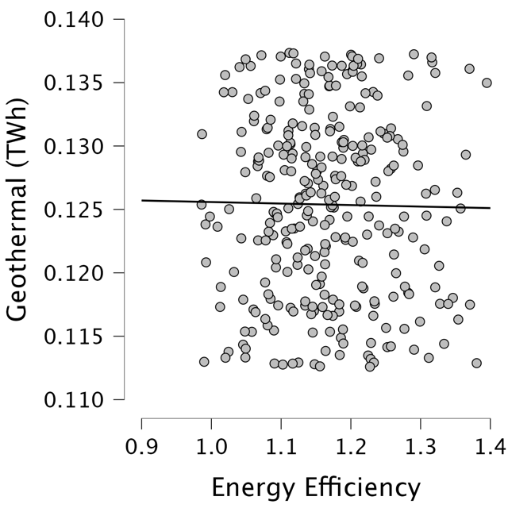
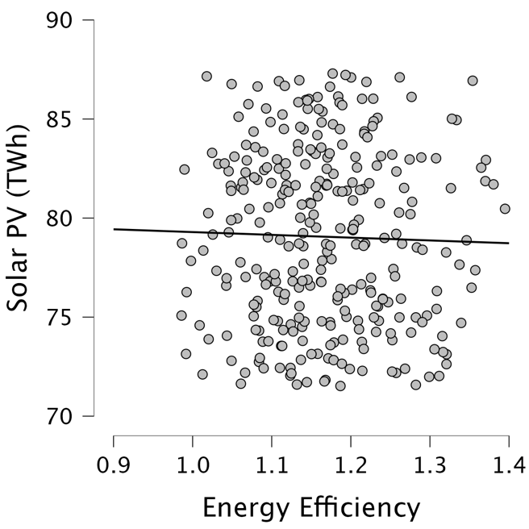
Solar PV (TWh) vs. Energy Efficiency Geothermal (TWh) vs. Energy Efficiency

Hydro (TWh) vs. Biofuel (TWh) Solar PV (TWh) vs. Hydro (TWh)
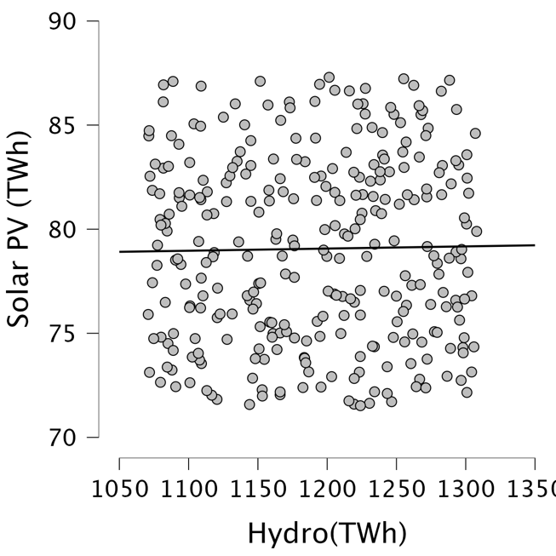
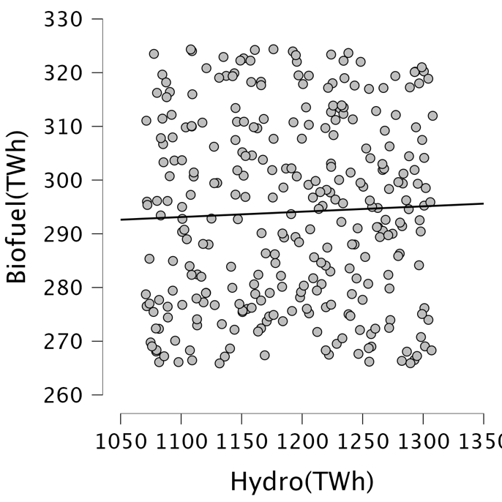

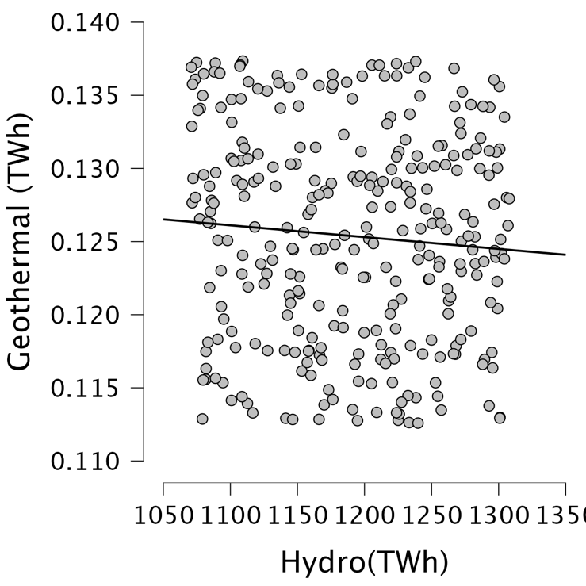
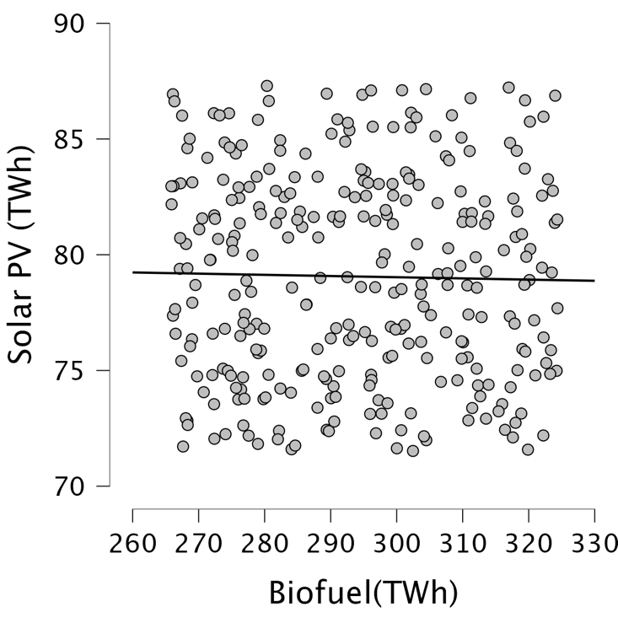
Geothermal (TWh) vs. Hydro (TWh) Solar PV (TWh) vs. Biofuel (TWh)

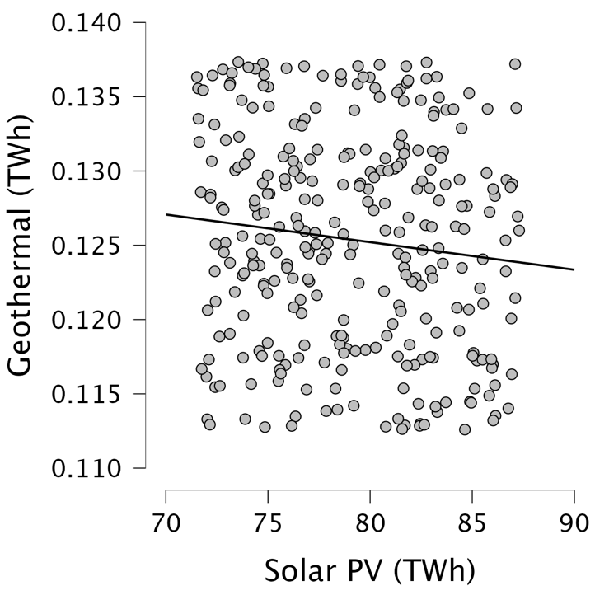
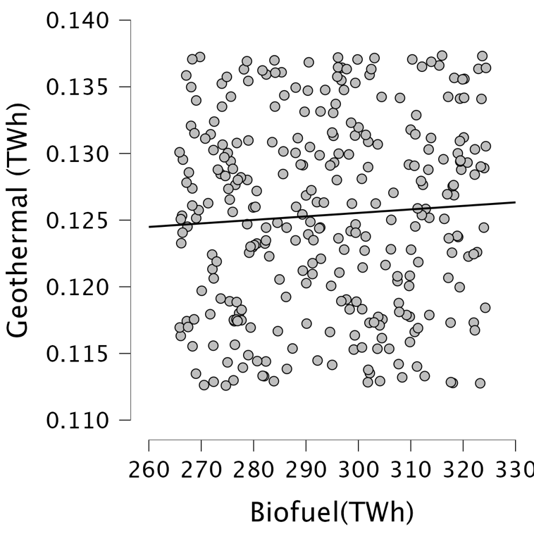
Geothermal (TWh) vs. Biofuel (TWh) Geothermal (TWh) vs. Solar PV (TWh)

