Table 1S: Protox analysis of catechol as a constituent of CAT-PUF/TiO₂
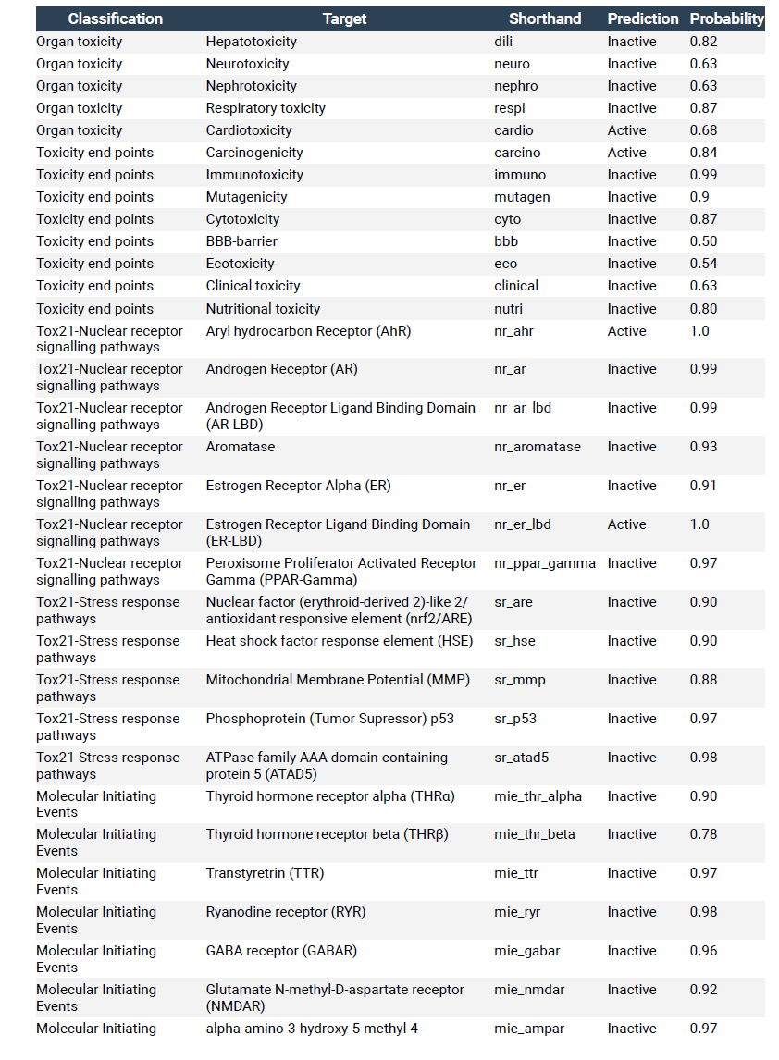

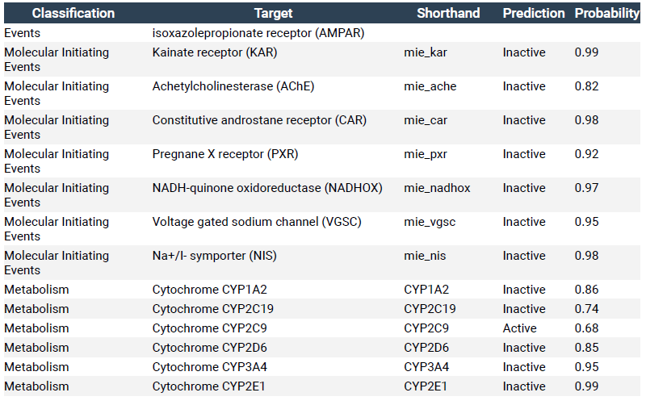

Table 2S: Protox analysis of titanium dioxide as a constituent of the nanocomposite CAT-PUF/TiO₂
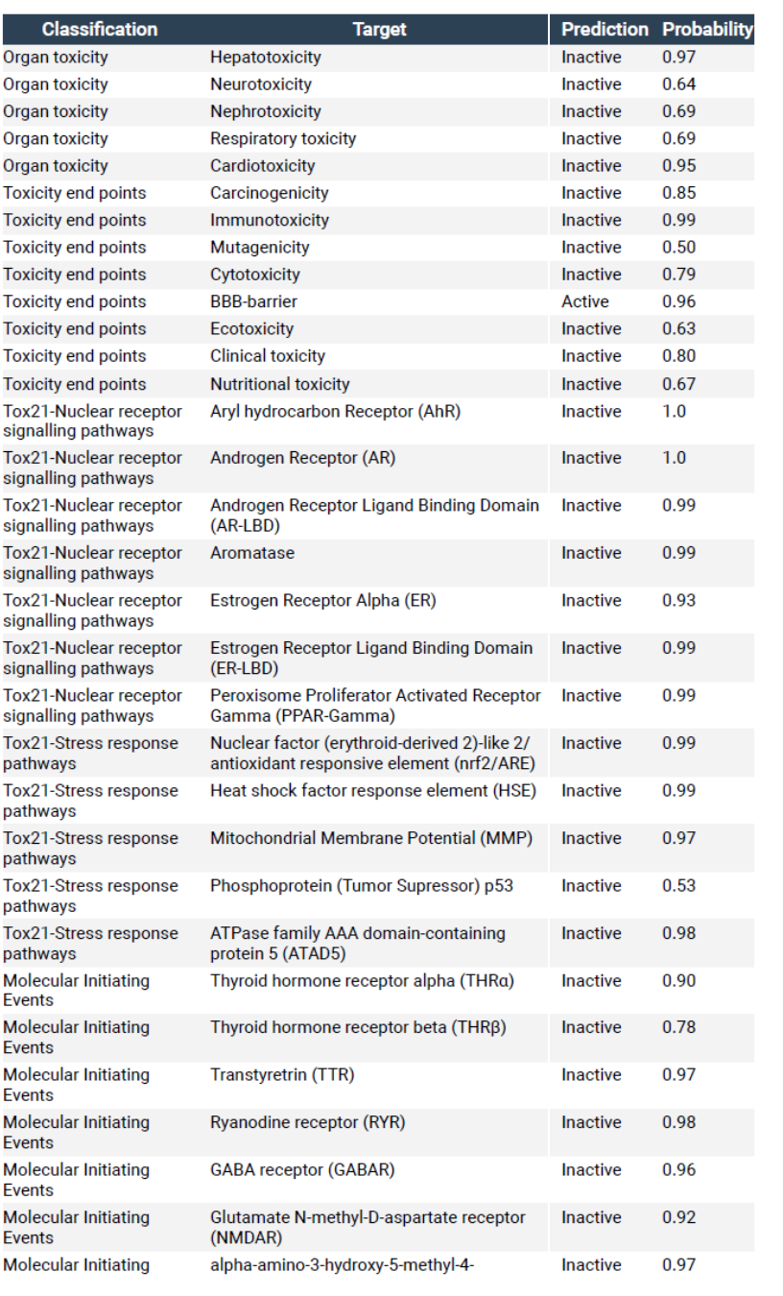

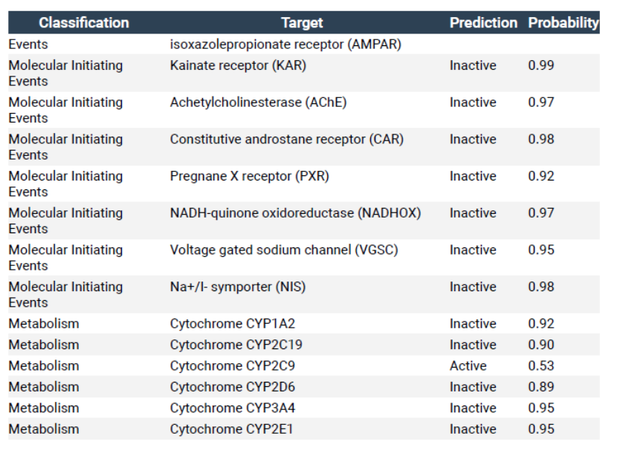

Table 3S: ADME prediction for composite CAT-PUF/TiO2 PUF for absorption, distribution, metabolism and excretion.
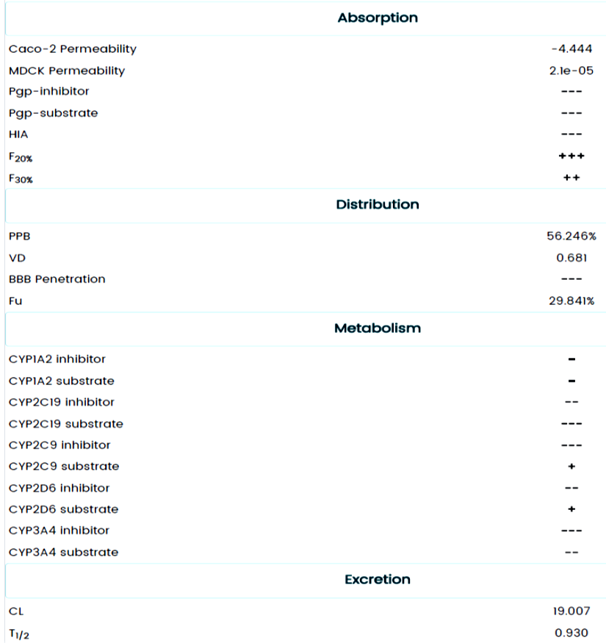

Table 4S: Swiss Target Prediction of the nanocomposite CAT-PUF/TiO2
