Discovering Pesticides and their Transformation Products in Luxembourg Waters using Open Cheminformatics Approaches
Jessy Krierª, Randolph R. Singh^{a,b}, Todor Kondicª, Adelene Lai^{a,c}, Philippe Diderich^{d}, Jian Zhang^{e}, Paul A. Thiessen^{e}, Evan E. Bolton^{e}, Emma L. Schymanskiª*

ª Luxembourg Centre for Systems Biomedicine (LCSB), University of Luxembourg, 6 avenue du Swing, L-4367, Belvaux, Luxembourg
^{b} Current affiliation: IFREMER (Institut Français de Recherche pour l’Exploitation de la Mer), Laboratoire Biogéochimie des Contaminants Organiques, Rue de l’Ile d’Yeu, BP 21105, Nantes Cedex 3, 44311, France
^{c} Institute for Inorganic and Analytical Chemistry, Friedrich-Schiller University, Lessing Strasse 8, 07743, Jena, Germany
^{d} Water Management Agency, Ministry of the Environment, Climate and Sustainable Development, 1 avenue du Rock’n’roll, L-4361, Esch-sur-Alzette, Luxembourg
^{e} National Center for Biotechnology Information, National Library of Medicine, National Institutes of Health, Bethesda, MD, 20894, USA.
* corresponding author ELS (emma.schymanski@uni.lu)

ORCID: JK (0000-0001-6986-5545), RRS (0000-0003-4500-3400), TK (0000-0001-6662-4375), AL (0000-0002-2985-6473), PD (0000-0001-6969-2162), JZ (0000-0002-6192-4632), PAT (0000-0002-1992-2086), EEB (0000-0002-5959-6190), ELS (0000-0001-6868-8145)

Table of Contents

Figure S1: 2
Figure S2:. 3
Figure S3: 3
Figure S4: 4
Figure S5: 4
Figure S6: 5
Figure S7:. 6
Figure S8:. 7

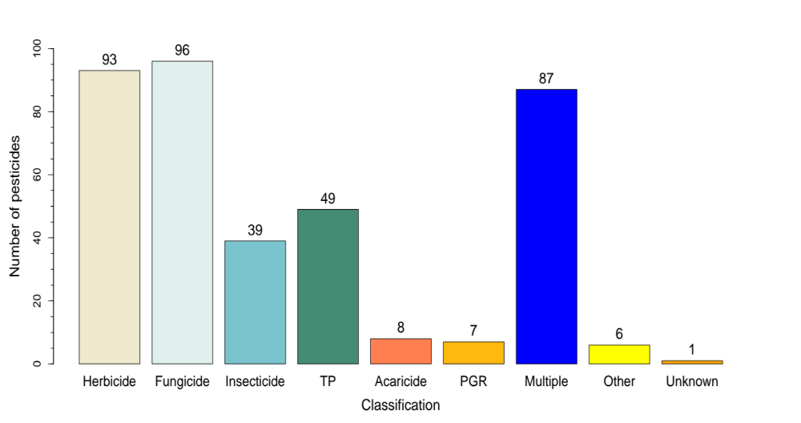
Supplementary Data
Figure S1: The classification information for the pesticides suspect list. This information was retrieved from three different databases:
The European Commission – EU Pesticide database (https://ec.europa.eu/food/plant/pesticides_en);
The Pesticide Properties DataBase Search (https://sitem.herts.ac.uk/aeru/ppdb/en/search.htm); and
The Bio-Pesticide DataBase Search (https://sitem.herts.ac.uk/aeru/bpdb/search.htm).

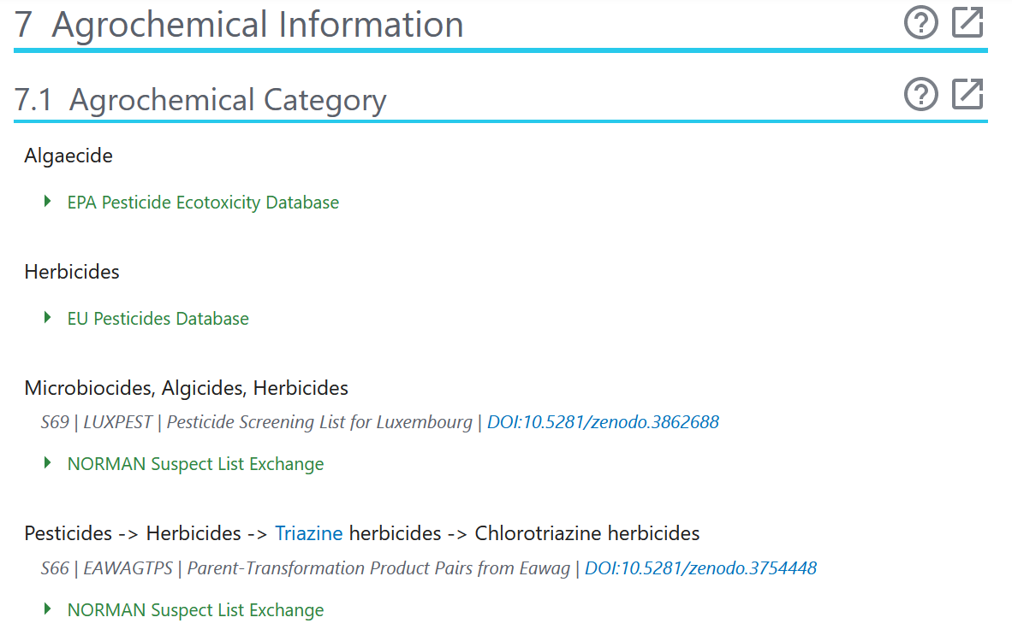
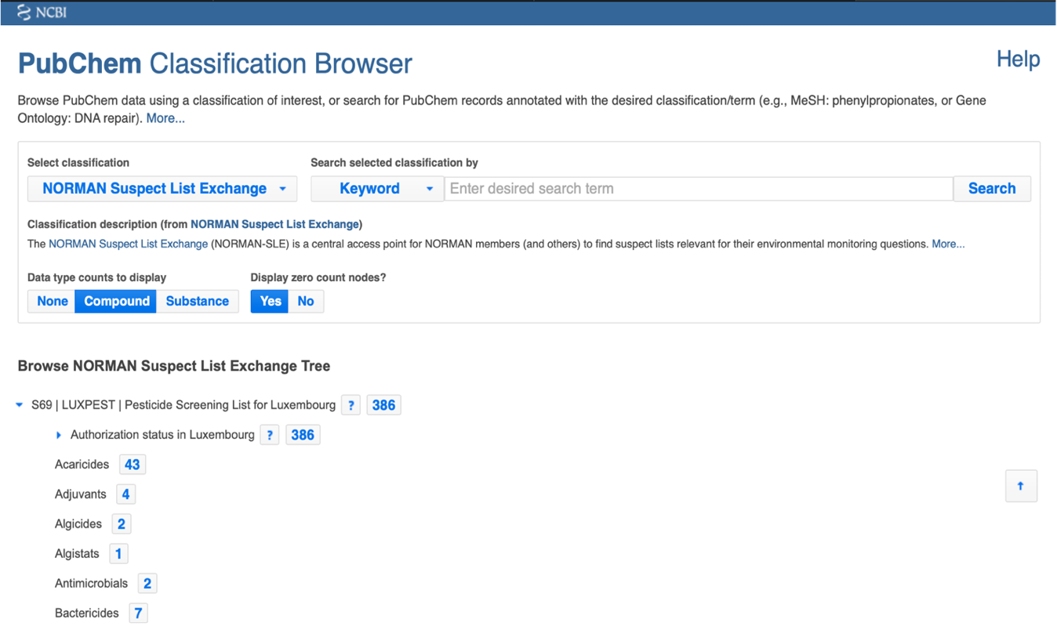
Figure S3: Screenshot from PubChem showing an example (terbutylazine) where newly derived information was uploaded to the agrochemical information section in PubChem (see orange box - S69 | LUXPEST, DOI:10.5281/zenodo.3862688).

Figure S2: Screenshot from PubChem showing the PubChem Classification Browser (available at https://pubchem.ncbi.nlm.nih.gov/classification/#hid=101) with a subset of the classification information about the LUXPEST pesticides suspect list.

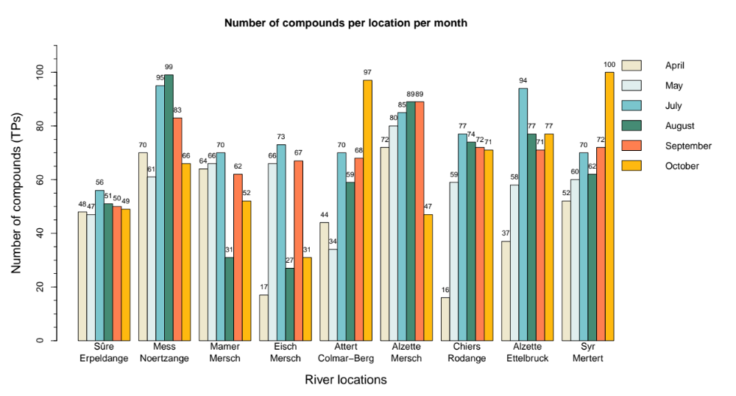
Figure S4: The results of pre-screening with Shinyscreen showing how many transformation products passed the quality check for each sampling location and per month (positive and negative modes are visualized together). See main manuscript Section 3.4 for further details.

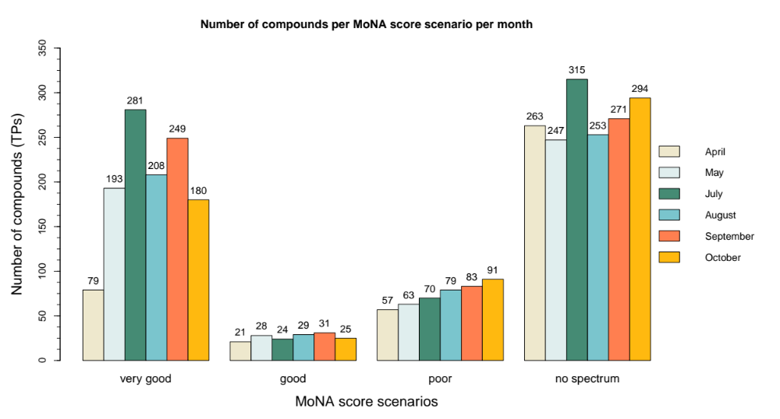
Figure S5: Representation of 3,434 cases (135 transformation products) regrouped according to the four MoNA score scenarios for the six months (positive and negative mode together). See main manuscript Section 3.4 for further details.

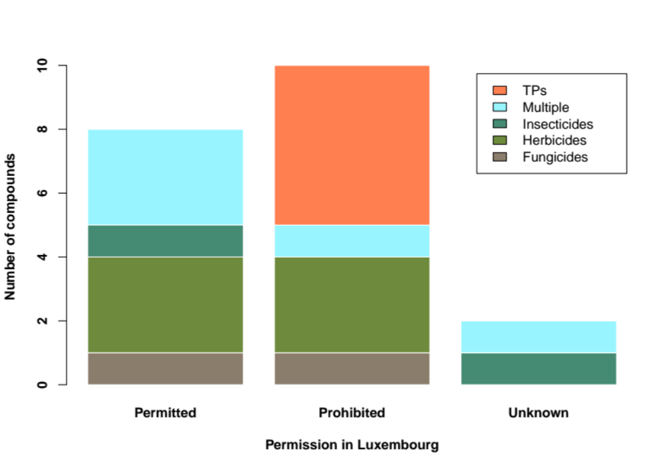
3
1
3
1
1
3
1
5
1
1
Figure S6: The classification of the 21 quantified compounds (pesticides and transformation products together). Each of the three bars shows the number of compounds for the different classes and permission information. (TPs = transformation products)

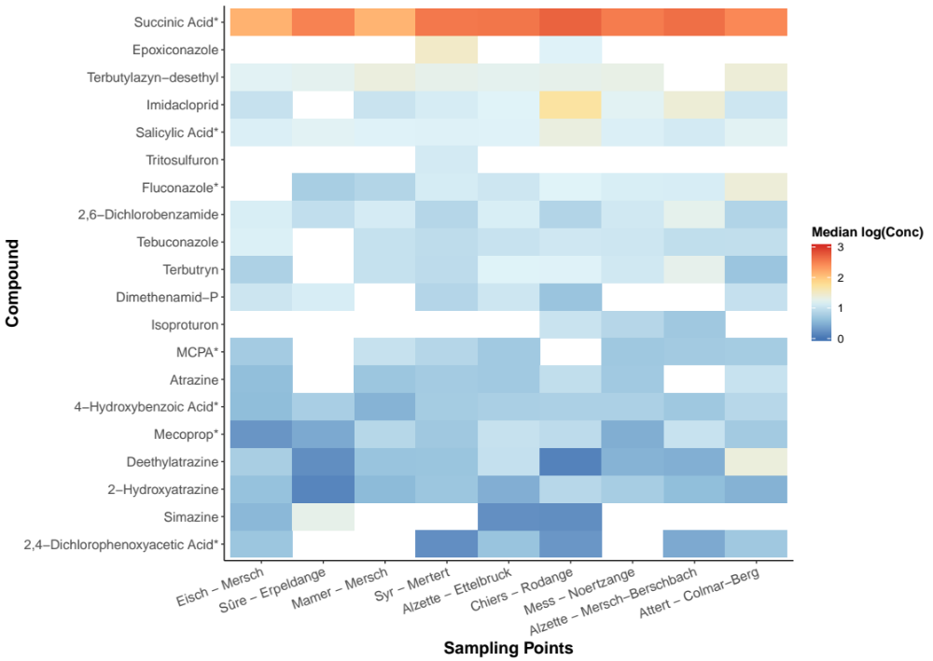
Figure S7: Spatial heat map showing median log (10) concentration values (original concentration units: parts per trillion - ppt) of each compound measured per sampling location in 2019. The median was calculated across all the relevant months of sampling for a given compound per location. Concentration values that were below the respective quantification range were discarded from median calculation and are indicated as white regions. All compounds were measured in positive mode except for those marked with an asterisk, which were measured in negative mode.

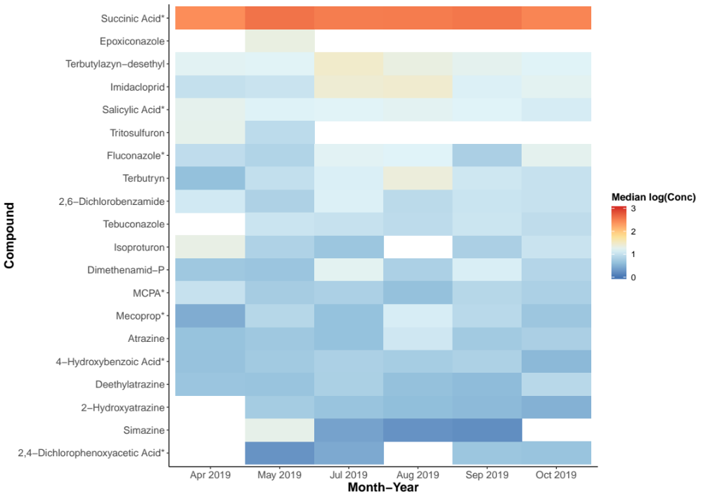
Figure S8: Temporal heat map showing median log (10) concentration values of each compound measured per month (original concentrations in ppt). The median was calculated across all the relevant sampling locations for a given compound per month. Concentration values that were below the respective quantification range were discarded from median calculation and are indicated as white regions. All compounds were measured in positive mode except for those marked with and asterisk, which were measured in negative mode.

