Supplementary Information for
Steady Floquet-Andreev States Probed by Tunnelling Spectroscopy
Sein Park^{1,*}, Wonjun Lee^{1,*}, Seong Jang¹, Yong-Bin Choi¹, Jinho Park¹, Woochan Jung¹, Kenji Watanabe², Takashi Taniguchi³, Gil Young Cho^{1,4,5,†} and Gil-Ho Lee^{1,4,†}

¹ Department of Physics, Pohang University of Science and Technology, Pohang, Republic of Korea
² Research Center for Functional Materials, National Institute for Materials Science, Tsukuba, Japan
³ International Center for Materials Nanoarchitectonics, National Institute for Materials Science, Tsukuba, Japan
⁴ Asia Pacific Center for Theoretical Physics, Pohang, Republic of Korea
⁵ Center for Artificial Low Dimensional Electronic Systems, Institute for Basic Science (IBS), Pohang 37673, Republic of Korea

* These authors contributed equally.
† Correspondence and requests for materials should be addressed to G.Y.C. (gilyoungcho@postech.ac.kr) or G.-H.L. (lghman@postech.ac.kr).

S1. False-coloured SEM image
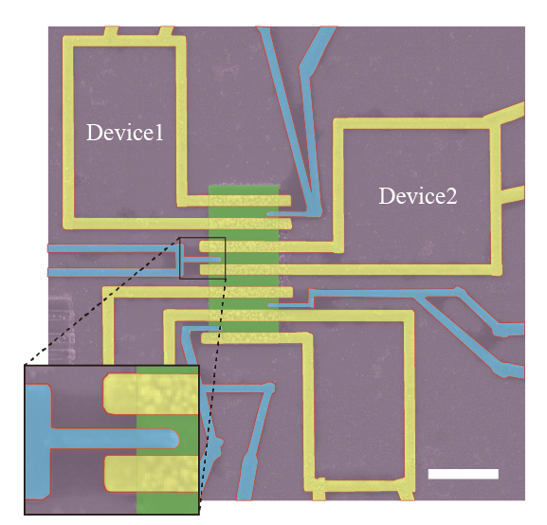
Supplementary Fig. 1 | False-coloured SEM image. False-coloured scanning electron microscope (SEM) image of the device. Aluminium electrodes (blue) are tunnelling contacted and Al electrode (yellow) are ohmic-contacted to graphene (green). The scale bar is 3 µm.

S2. Temperature dependence and magnetic field dependence of the tunnel probe and the Andreev bound states
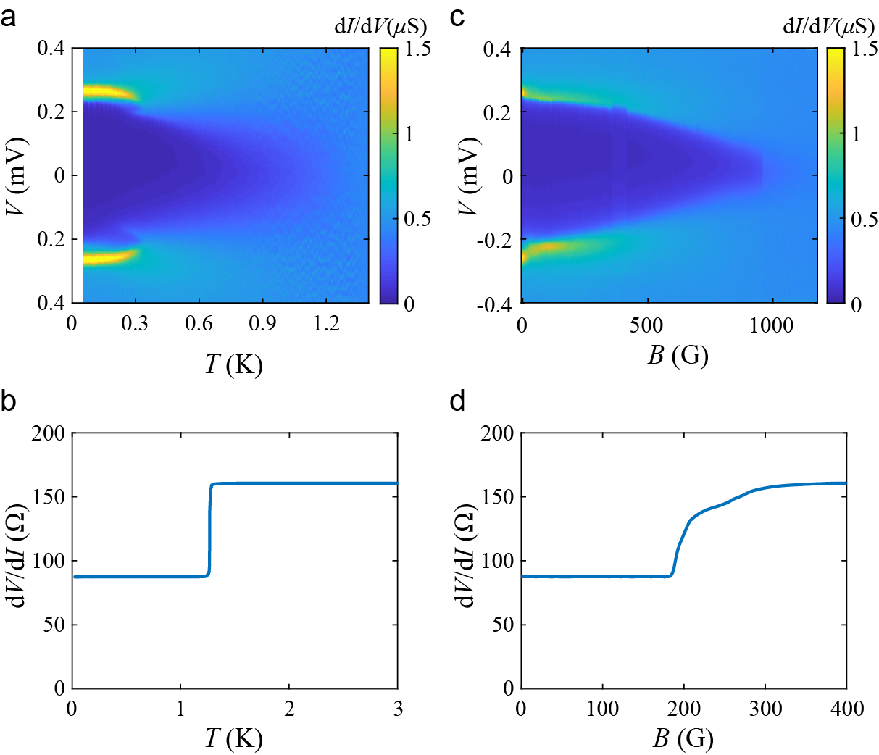
Supplementary Fig. 2 Temperature dependence and magnetic field dependence of the tunnel probe and the Andreev bound states. a, Colour-coded differential conductance dI/dV, at fixed φ = 0 as a function of temperature T and bias voltage V from device 2. b, Temperature dependence of Aluminium (Al) electrode resistance dV/dI. Finite resistance 88 $Ω$ comes from the gold electrode connected to the Al. c, Colour-coded dI/dV at fixed $φ$=0 as a function of magnetic field B and bias voltage V. d, B dependence of Aluminium (Al) electrode resistance dV/dI.
Supplementary Fig. 2a shows the differential conductance dI/dV measured at $φ=0$ as a function of bias voltage V and temperature T. Under the critical temperature ($T_{C,ABS}=$347 mK) of Andreev bound states (ABSs), the convoluted dI/dV peaks position is shifted by the energy of ABSs ($Δ_{ABS}(T)$/e) compared to the Aluminium(Al) superconducting energy gap $Δ_{Al}$. Note that, the bias voltage $V(T)={(±Δ}_{Al}+Δ_{ABS}[T])/e$. The shifted V decreases following the Bardeen-Cooper-Schrieffer (BCS) theory.
In addition, the intensity dI/dV peaks has sharp transition at temperature $T_{C,ABS},$ indicating the distinct dI/dV peaks are originated from the ABSs. The reason is following. Under the $T_{C,ABS}$, dI/dV curve is the convolution of the sharp ABSs and density of states (DOS) of superconductor, whereas dI/dV curve at temperature above $T_{C,ABS}$ is that of relatively blurred graphene DOS and superconductor. Therefore, the intensity of the peaks become blur above the $T_{C,ABS}$. As well as $Δ_{ABS}$ decreases under the $T_{C,ABS}$, $Δ_{Al}$ also decreases to zero under the critical temperature of $T_{c,tip}$. Here, the $T_{c,tip}$ is 1.27 K and is estimated from the temperature dependence of Al electrode’s resistance (see supplementary Fig. 2b). The finite resistance of 88 $Ω$ is comes from the gold electrodes connected to Al.
Similar to the temperature dependence of the superconducting tunnel probe and the ABS, dI/dV peaks also changes depending on the magnetic field (B) in supplementary Fig.2c. As the B increases, the dI/dV peaks dramatically change at the critical field of $H_{C,ABS}=53 G.$ The superconducting gap still survives above the critical field $(H_{c,tip})$ of 186 G. Here, $H_{c,tip}$ is determined by B dependence of Al electrode’s resistance (see supplementary Fig. 2d). This phenomena attribute to the narrow Al superconducting tunnel probe, which make hard for magnetic flux to penetrate the Al leads. Therefore, the superconducting gap remained until the 1000 G.

S3. Estimated full-width at half-maximum (FWHM) of superconducting tunnel probe
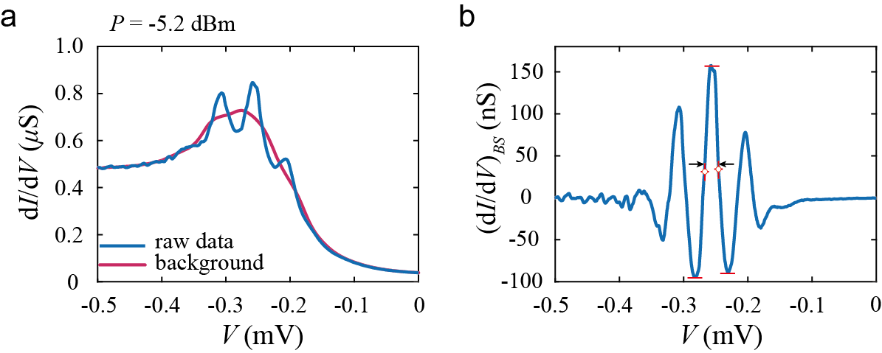
Supplementary Fig. 3 | Estimated resolution of superconducting tunnel probe. a, Differential conductance dI/dV as a function of bias voltage V from device 2. Blue line represents the raw experiment data at microwave power is -5.2 dBm. Background obtained by moving averaged the dI/dV curve is plotted as red lines. b, Background subtracted (dI/dV)_{BS} as a function of V. (dI/dV)_{BS} is obtained by subtracted red line from blue lines in a. Red bar is located at the peak/dip of the (dI/dV)_{BS} curve and black arrows indicates the full width half maximum which is 22.0 $μV$.

S4. Temperature Dependence of Andreev bound states
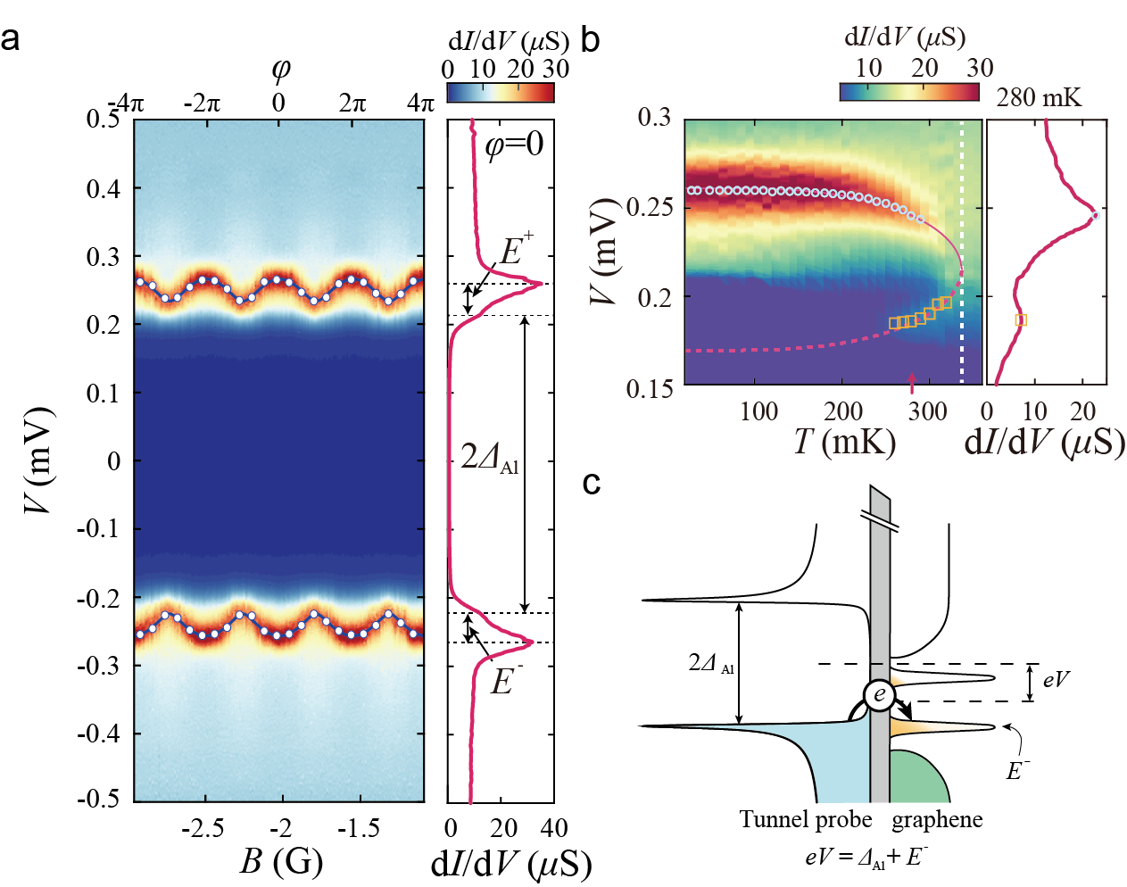
Supplementary Fig. 4 | Phase dependence and temperature dependence of Andreev bound state. a, Colour-coded plot of differential conductance dI/dV as a function of bias voltage V and magnetic field B for device 1. The top horizontal axis shows superconducting phase difference $φ$ calculated from B. Red solid lines represent theoretical fitting in a short junction limit. The line cut at $φ$=0 plotted in the right panel shows dI/dV peaks due to upper ($E^{+}$) and lower ($E^{-}$) bands of Andreev bound state (ABS). b, Left panel shows colour-coded plot of dI/dV as a function of V and temperature T at $φ$=0. Right panel shows a line cut at T=280 mK indicated by a red arrow on the left panel. The voltage value of dI/dV peak (circle) reduces as the temperature increases and is fitted to Bardeen-Cooper-Schrieffer (BCS) theory (solid line). An additional peak (square) appears above 230 mK, and is fitted to BCS theory (dotted line). Critical temperature is indicated by white dotted line. c, Schematics of tunnelling processes from filled state of superconducting tunnel probe to thermally excited empty state of ABS in graphene at a finite temperature.
Supplementary Figure 4a shows the differential conductance (dI/dV) measured at 20 mK as a function of bias voltage V and magnetic field B (already shown in Figure 1e). As the peaks in dI/dV appear at the bias voltage $V(B)={(±Δ}_{Al}+E^{±}[φ(B)])/e$, we fit the oscillations of peak position as a function of B and obtain A=42 µm2, D=0.91 (0.91), and $Δ_{ABS}$= 46.4±0.4 µeV (46.2±0.4 µeV) for the upper (lower) band of ABS. Note that A is the effective area of the superconducting ring and D is the contact transparency, and superconducting gap of Al tunnel probe $Δ_{Al}$ is 215 µeV that we obtained in the temperature dependence later, $E^{±}\left[φ\left(B\right)\right]=Δ_{ABS}\sqrt{(1-D sin^{2}(φ/2))}$, and $φ$ is the superconducting phase difference. D close to unity shows highly transparent superconducting contacts to graphene. Also note that we deposited ohmic-contacted Al electrodes that formed the GJJ in a different condition than that for the superconducting tunnel probe, which reduced $Δ_{ABS}$ about four times smaller than $Δ_{Al}$ and made $ξ$=18 µm much longer than L=0.51 µm so that the GJJ is strictly in a short junction limit. Difference in $Δ_{ABS}$ and $Δ_{Al}$ also make the analysis on temperature dependence simple: at the critical temperature of ohmic-contacted Al electrodes $T_{c,ABS}$ where $Δ_{ABS}$ vanishes, $Δ_{Al}$ changes little by 0.05 % from its zero-temperature value due to insensitive change of Bardeen-Cooper-Schrieffer (BCS) superconducting gap at low temperature. Thus, the temperature dependence of dI/dV peak position at $φ$=0 (circle symbol) shown in supplementary Fig. 4b is simply fitted to ${V(T)=[Δ_{Al}+Δ}_{ABS}(T)]/e$, where $Δ_{ABS}(T)$ follows BCS temperature dependence with $Δ_{ABS}(T=0)$= 43.3 µeV and $T_{c,ABS}$=347 mK (vertical dotted line in supplementary Fig. 4b), and $Δ_{Al}$= 215 µeV stays constant in temperature (see Supplementary Fig. S2 for the behaviour at higher temperature). Note that $E^{±}(φ=0)=±Δ_{ABS}$. Especially, additional peak (yellow symbol) appears at around V=190 µeV for T > 230 mK. At a finite temperature, a thermally excited empty state in the lower band of ABS allows the tunnelling process at $V={[Δ}_{Al}+E^{-}(φ)]/e$ as shown in Fig. 4c, which is not allowed at low temperature. The temperature dependence of the position of additional peak is also fitted to BCS theory as ${V(T)=[Δ_{Al}-Δ}_{ABS}(T)]/e$ with the same fitting parameters used for fitting the original peak (dotted line).

S5. Floquet-Andreev states at microwave frequency of 8.825 GHz
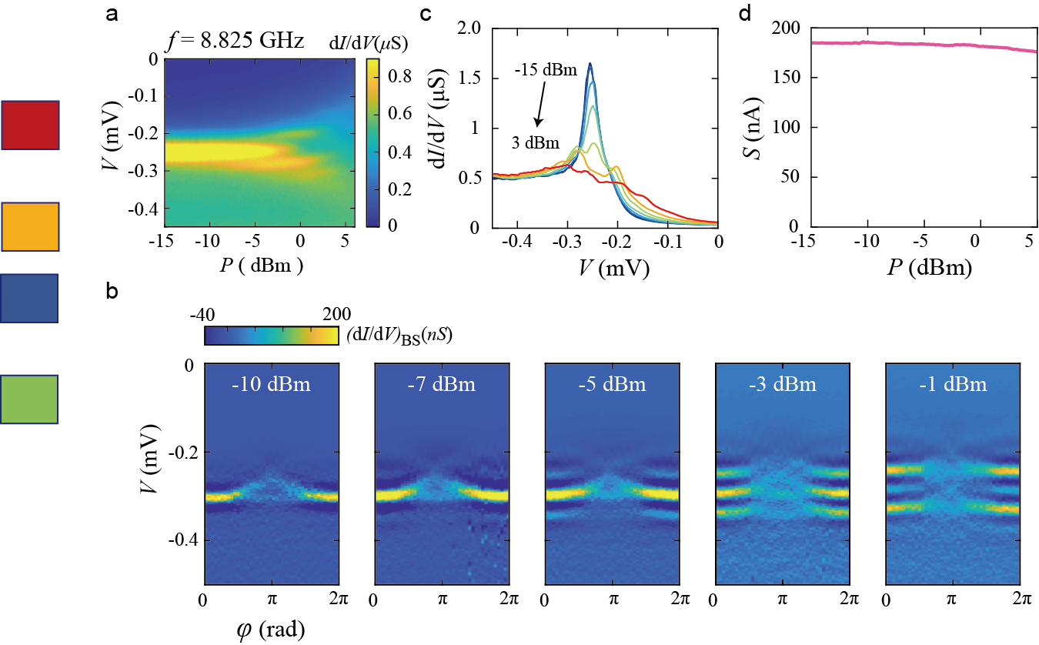
Supplementary Fig. 5 | Floquet-Andreev states at microwave frequency of 8.825 GHz. a, Differential conductance dI/dV as a function of bias voltage V and microwave power P measured from device 2. The microwave frequency f is 8.825 GHz and superconducting phase difference is fixed to $φ=0$. Replicas of Andreev bound state (ABS) peaks emerge as P increases. The duplicated peaks have equal energy spacing of 36.5 µeV, which equals microwave energy quanta. b, Colour-code plot of background subtracted differential conductance (dI/dV)_{BS} as a function of phase difference $φ$ and V at a fixed frequency of 8.825 GHz for various microwave power. c, Line cuts of dI/dV of various P from P = -15 dBm to 3 dBm with 3 dBm intervals. d, The integrated area of dI/dV line cuts at a given P.

S6. Estimation of electron temperature depending on the microwave power
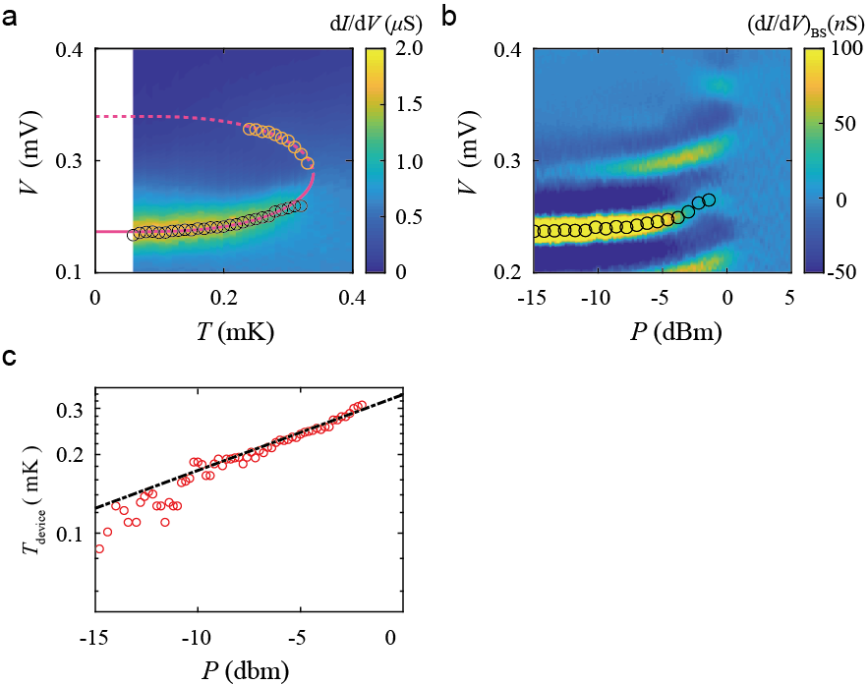
Supplementary Fig. 6 | Estimation of electron temperature depending on the microwave power. a, Temperature Dependence of ABS at $φ=0$ as a function of the V from device 2. The peaks of the ABS are marked with black circles. The pairing gap of ABS is fitted using BCS Theory and is indicated by the red solid line. b, The background subtracted differential conductance as a function of bias voltage V and microwave power P from device 2. The microwave frequency is at 12 GHz. The original ABS peaks are indicated by the black circles. c, Microwave power converted by the device temperature T_{device} by matching the pairing gap size of ABS peak of a and b. Power and temperature is fitted and indicated by black dotted line.
We estimate the electron temperature ($T_{e})$ depending on the microwave power by comparing the differential conductance(dI/dV) peak dependence on temperature and the microwave power$.$ Supplementary Figure. 6a shows the temperature dependence of dI/dV peak at superconducting phase difference, $φ=0$, which is fitted to $V(T)=[-Δ_{Al}+E^{±}(φ)]/e$. Note that, $E^{±}\left(φ=0,T\right)=±Δ_{ABS}(T)$ and $Δ_{ABS}(T)$ follows the of Bardeen-Cooper-Schrieffer (BCS) temperature dependence. The temperature dependence of ABSs is fitted as the same way in supplementary Fig.4b.
Similar to the temperature dependence of ABSs, the peak position (black circles) of original ABSs increases as the microwave power increases in supplementary Fig. 6b. This implies that the irradiation of microwave increases the electron temperature of the ABSs. By matching the bias voltage of dI/dV peaks, we can estimate the microwave power dependence of electron temperature as shown in supplementary Fig. 6c.
At sufficiently low temperature, the heating power and electron temperature follows the following equations^{1, 2},
$$P=A (T_{e}^{δ}-T_{0}^{δ})$$
, note that, A is the electron-phonon coupling coefficient, $T_{0}$ is the base temperature, $δ$ is coefficient depending on the materials. The relation between electron temperature and the microwave power is fitted using above equations and rewritten by,
 | $$\log_{10}{(T/1K)}=0.029×\frac{P}{1 dBm}-0.47$$ | (1)
The electron temperature reaches to critical temperature $T_{c}$ at microwave power of 0.47 dBm.

S7. Fitting Procedure for Differential Conductance
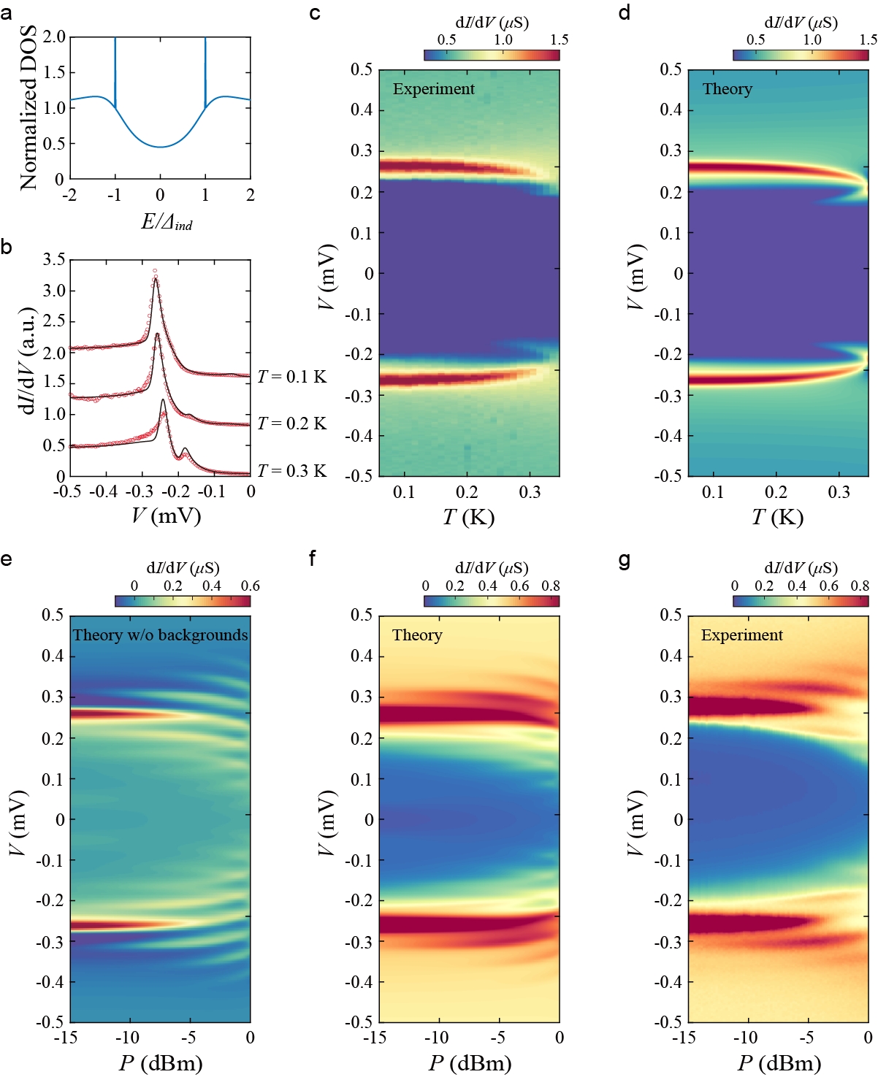
Supplementary Fig. 7 | a, Normalized density of states (DOS) of Andreev bound states (ABSs) and proximity-induced superconductivity. DOS is normalized by DOS at energy is sufficiently larger than the superconducting induced gap, $Δ_{ind}$ Note that DOS for ABSs is delta-function-like b, Differential conductance (dI/dV) as a function of bias voltage V for various temperatures. Note that, each line has offset of 0.8 $μS.$ Red circles and black solid line represents the experiment data and theoretically calculation respectively. c, Measured dI/dV as a function of V and T. d, Theoretically calculated dI/dV as a function of V and temperature T. e,f Numerically calculated dI/dV as a function of V and microwave power P (e) without and (f) with considering into account for the background DOS due to proximity-induced superconductivity. g, Measured dI/dV as a function of V and P up to 0 dBm to compare with theoretical calculation.

We provide more details in our fitting procedure for the differential conductance. In our experiment, we measure the microwave power dependence of the tunnelling differential conductance (dI/dV) from superconducting tunnel probe to graphene of GJJ. This differential conductance contains the contributions not only from the Andreev bound states (ABSs) (without applied microwave) or Floquet-Andreev (F-A) states (with applied microwave) but also from the “background” coming from the proximity effect of ohmic-contacted Al superconductors of the GJJ. As it is difficult to theoretically model the evolution of the background dI/dV in terms of the microwave power, we take a phenomenological approach for the background signals. To state our approach clearly, we note the four following facts. First, Floquet systems subjected under the small, perturbative driving fields should not be too much different from the equilibrium counterparts. Second, the significant portions of the background signals are expected to come from the nearby Al superconductors in the GJJ. The assumed background is schematically shown in supplementary Fig. 7a. Third, the temperature dependence of the pairing gap is approximately given as the interpolating function:
$$Δ\left(T\right)=Δ_{0}\tanh\left(1.74\sqrt{\frac{T_{c}-T}{T}}\right),$$
with the critical temperature $T_{c}$ and the pairing gap at the zero temperature $Δ_{0}$. Finally, we find that the pairing gap of the Al superconductors at power P is the same as the pairing gap at the temperature T without applied microwave as given in Eq. (1). Combining the above, we get the total tunnelling current as
Itot,P=WABS-∞∞dωr​gξr-fFDω+eVℏAprobeω+eVℏBr,β(P)ω+Wind-∞∞dωfFDω-fFDω+eVℏ Aprobeω+eVℏAindω,
where $ω$ is the frequency (or energy interchangeably), $g(ξ_{r})$ is the expectation value of the occupation number of the $r$-th F-A state, $\left\langle {\hat{n}}_{r}(t_{0})\right\rangle$, defined in the below of Eq.(3), $A_{\text{probe}}\left(ω\right)$ is the DOS for the superconducting tunnel probe, $A_{ind}\left(ω\right)$ is the DOS for proximity-induced superconductivity from Al superconductors into graphene, $f_{\text{FD}}\left(ω\right)$ is the Fermi-Dirac distribution, $B_{r,β\left(P\right)}\left(ω\right)$ is the single particle spectral function of the F-A states defined in Eq.(4), $W_{ABS}$ is tunnelling amplitude from superconducting tunnel probe to ABS formed in graphene, $W_{ind}$ is tunnelling amplitude from superconducting tunnel probe to proximity-induced superconducting states in graphene. Here, $A_{\text{probe}}\left(ω\right)$ and $A_{ind}\left(ω\right)$ are defined as³
$$A_{probe}\left(ω\right)=\left|R\frac{ω+iγ_{probe}Δ_{probe}\left(T\right)}{\sqrt{{\left(ω+iγ_{probe}Δ_{probe}\left(T\right)\right)}^{2}-{\left|Δ_{probe}\left(T\right)\right|}^{2}}}\right|$$
and
$$A_{ind}\left(ω\right)=\left|R\frac{ω+iγ_{ind}Δ_{ind}\left(T\right)}{\sqrt{{\left(ω+iγ_{ind}Δ_{ind}\left(T\right)\right)}^{2}-{\left|Δ_{ind}\left(T\right)\right|}^{2}}}\right|,$$
with the Dynes parameters $γ_{probe}$ and $γ_{ind}$, the pairing gaps $Δ_{probe}$ and $Δ_{ind}$, for the superconducting tunnel probe and proximity-induced superconductivity from Al superconductors into graphene, respectively. Differentiating $I_{tot,P}$ with respect to the voltage $V$ gives the differential conductance dI/dV. In summary, we model dI/dV originated from the F-A states as a function of free parameters: $Δ_{probe,0}$, $Δ_{ind,0}$, $T_{c,probe}$, $T_{c,ind}$, $W_{ABS}$, $W_{ind}$, $γ_{probe}$, and $γ_{ind}$. The definitions of these symbols are listed in the Table.S1.
We then confirm our assumptions and determine free parameters by matching the experimentally measured temperature dependence of dI/dV without applied microwave ($σ_{ABS}^{exp}(T,V)$) shown in supplementary Figs. 7c to the theoretically calculated dI/dV ($σ_{ABS}^{fit}(T,V)$) shown in supplementary Figs. 7d. For the fitting, we focus on the experimental data at V < 0, where superconducting tunnel probe works better than in the positive bias voltage regime presumably due to asymmetric tunnelling barrier. The detailed procedures for determining each parameter are as follows: First, the proximity-induced pairing gap $Δ_{ind,0}$ and corresponding $T_{c,ind}$ are determined by matching the peak voltages of $σ_{ABS}^{exp}$ and $σ_{ABS}^{fit}$. Note that $T_{c,probe}$ is significantly (about four times) larger than $T_{c,ind}$, so the temperature dependence of the peak position at the low temperature unambiguously determines $Δ_{probe,0}$ and $T_{c,probe}$. Here, $T_{c,probe }$ is determined from the temperature dependence of Al electrode’s resistance (see supplementary Fig. 2), and $Δ_{probe,0}$ is fitted from the temperature dependence of ABSs using the relations, ${V(T)=[Δ_{probe,0}+Δ}_{ABS}(T)]/e$ (see supplementary Fig. 4).
Second, $W_{ind}$ and $γ_{probe}$ are determined to match $σ_{ABS}^{fit}$ with $σ_{ABS}^{exp}$ in the limit of large $V$, and $W_{ABS}$ and $γ_{probe}$ are determined to match them near peaks. Since $W_{ind}$ and $W_{ABS}$ depend on $γ_{probe}$, they cannot be determined separately in principle, so fixing them requires huge computations. However, we find that if we can bound the value of $γ_{probe}$ in a small range, then we can also bound $W_{ind}$ to be in a smaller range, so we can treat $W_{ind}$ as a constant for a sufficiently small $δ$. To make this idea more clearly, we compute $σ_{ABS}^{fit}$ in the large $V$ limit:
ℏeσABSfit(T,V)=WABS-∞∞dωr​gξr-Θ-ω∂ωAprobeωBr,β0ω-eVℏ+Wind0eVℏdω∂ωAprobeωAPω-eVℏ-WABSAprobe0r​Br,β0-eVℏ-Wind Aprobe0AP-eVℏ≈Wind0∞dω∂ωAprobeω- Aprobe0≈Wind1-γprobe
which depends only on $W_{ind}$ and $γ_{probe}$. Here, we assume $f_{FD}\left(ω\right)≈Θ\left(-ω\right)$ and use the facts that $B_{r,β\left(P\right)}\left(ω\right)$ and $A_{P}\left(ω\right)$ converge to zero and one, respectively, in the limit of $ω→∞$. Thus, if $γ_{probe}$ is bounded in a small range, say $γ_{probe}∈(γ_{probe,0}(1-δ),γ_{probe,0}\left(1+δ\right))$ for some $γ_{probe,0}$ and $δ$, then $W_{ind}$ should be bounded in the smaller range
$$W_{ind}∈\left(W_{ind,0}\left(1-γ_{probe,0}δ\right),W_{ind,0}\left(1+γ_{probe,0}δ\right)\right),$$
where $W_{ind,0}$ is the value of $W_{ind}$ when $γ_{probe}=γ_{probe,0}$, to match $σ_{ABS}^{fit}$ with $σ_{ABS}^{exp}$ in the limit of large $V$. In addition, we find that in order to match $σ_{ABS}^{fit}$ with $σ_{ABS}^{exp}$ near peak, $γ_{probe}$ should be in the small range, $(0.06, 0.09)$. We choose $γ_{probe,0}$ as the mean value of the bounds (0.075) and $δ$ as (0.015). We then obtain the range for $W_{ind}$ as $\left(\left(0.99\right)W_{ind,0},\left(1.01\right)W_{ind,0}\right)$. Thus, we can approximate $W_{ind}$ as $W_{ind,0}$. We determine $W_{ind}$ that gives $σ_{ABS}^{fit}\left(T_{min},V_{max}\right)≈σ_{ABS}^{exp}(T_{min},V_{max})$, where $T_{min}$and $V_{max}$ are the minimum temperature and the maximum voltage of the experimental data, respectively. Note that the temporal value for $γ_{probe}$ is not used for the computation of $σ_{ABS}^{fit}$, instead, it will be replaced by the fine-tuned value. Remarkably, even though we determine $W_{ind}$ at $T=T_{min}$ and $V=V_{max}$, $σ_{ABS}^{fit}(T,V)$ matches with $σ_{ABS}^{exp}(T,V)$ for any temperature $T<T_{c,ind}$ in the limit of large $V$. Next, we search the precise values of $W_{ABS}$ and $γ_{probe}$ that give optimal fit of $σ_{ABS}^{fit}(T,V)$ with $σ_{ABS}^{exp}(T,V)$ near the peaks for all temperature $T<T_{c,ind}$.
Next, Dynes parameter $γ_{ind}$ is determined for matching the overall shape of $σ_{ABS}^{fit}(T,V)$ to that of $σ_{ABS}^{exp}(T,V)$. Since $γ_{ind}$ determines the overall shape, its value is determined less precisely compared to other parameters.
Finally, we numerically compute the microwave power dependence of dI/dV originated from the formation of F-A states ($σ_{F-A}^{fit}(β,V)$). To do so, we assume the relation between the temperature and the power as given in Eq. (1). In addition, we introduce the scaling factor $β_{0}$ for the microwave power. The field strength $β$ at the microwave power P is given by
$$β\left(P\right)=β_{0}×{10}^{\frac{1}{20}\left[P/(1 dBm)+12\right]},$$
where $β_{0}$ is to be determined. Note that $β_{0}$ corresponds to $α$ of the main text as $β_{0}={10}^{-3/5}\frac{ev_{F}}{ℏω^{2}} α$. We determine $β_{0}≈0.9$ that gives the best matching between $σ_{F-A}^{fit}(β,V)$ and experimental data $σ_{F-A}^{exp}(β,V)$ with all the other parameters fixed as the same for calculating $σ_{ABS}^{fit}(T,V)$ above. The values for parameters and which experimental data used for determining each parameter are summarized in Table.S1.
Supplementary Fig. 7e shows the numerically computed dI/dV without considering the background from proximity effect. Without backgrounds, the F-A state peaks evolving with P are clearly shown, and the intensity of dI/dV peaks follow the polarization-averaged Bessel function. The numerically computed $σ_{F-A}^{fit}(P,V)$ with considering the background is plotted in supplementary Fig. 7f, which describes the overall features and peak intensity of the experimental data in Fig. 2a. The deviations from the experiment data for P >-7 dBm is attributed to the fact that our theory does not hold for strong perturbations which leads to non-equilibrium states.
Symbol | Parameter | Fitted experimental data to determine parameter | Value
$$Δ_{probe,0}$$ | Pairing gap of probe at T=0 | Peak position of $σ_{ABS}^{exp}(T,V)$ | 0.215 meV
$$Δ_{ind,0}$$ | Proximity-induced gap at T=0 | Peak position of $σ_{ABS}^{exp}(T,V)$ | 0.051 meV
$$T_{c,probe}$$ | Critical temperature of probe | Peak position of $σ_{ABS}^{exp}(T,V)$  (Supplementary Fig.3a) | 1.27 K
$$T_{c,ind}$$ | Critical temperature of proximity-induced gap | Peak position of $σ_{ABS}^{exp}(T,V)$  (Supplementary Fig.4) | 0.347 K
$$W_{ABS}$$ | Tunnelling amplitude between probe and ABS state | $σ_{ABS}^{exp}(T,V)$ near the peaks | $1.2×{10}^{-8}$ $(ℏ/e) ⋅S$
$$W_{ind}$$ | Tunnelling amplitude between probe and proximity-induced gap | $σ_{ABS}^{exp}(T,V)$ in the limit of large $V$ | $4×{10}^{-7}$ ($ℏ/e) ⋅S$
$$γ_{probe}$$ | Dynes parameter of probe | $σ_{ABS}^{exp}(T,V)$ near the peaks | 0.08
$$γ_{ind}$$ | Dynes parameter of proximity-induced gap | $$σ_{ABS}^{exp}(T,V)$$ | $$0.5±0.2$$
$$β_{0}$$ | Power scaling factor | $$σ_{F-A}^{exp}(β,V)$$ | 0.9
Table S1 Parameters used for the numerical simulations of the differential conductance.

8. Background subtraction method
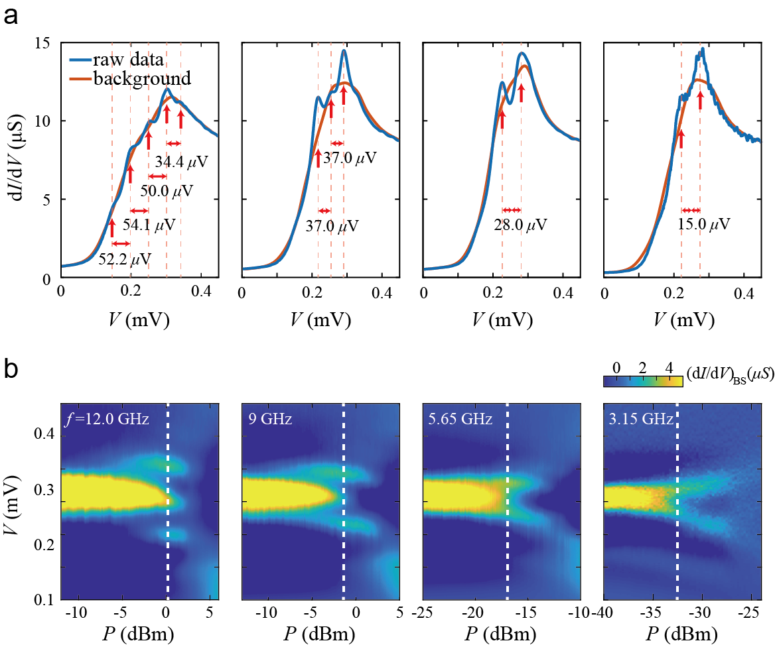
Supplementary Fig. 8 | Background subtraction method. a, Line cuts of dI/dV peaks(blue) without background subtraction at certain microwave power (indicated by white dotted line at each frequency). Voltage difference between adjacent peaks is also denoted in the plot. Background data determined by averaging over several dI/dV peaks is plotted by orange line. The voltage difference between adjacent dI/dV peaks is also denoted in the plot. b, Background subtracted differential conductance ${(dI/dV)}_{BS}$ as function of bias voltage V and microwave power P for various frequencies f.
In supplementary Fig.8a, blue lines show raw data of differential conductance dI/dV as a function of the bias voltage V at certain microwave power (indicated by white dotted line in supplementary Fig. 8b for each frequency). We can clearly distinguish the dI/dV peaks at equal distance of microwave energy quanta $hf$, where h is the Planck constant and f is the frequency of the microwave. The voltage difference between adjacent peaks is also denoted for various frequencies. The average value of the voltage differences as function of the f is plotted in Fig. 8b in the main text.
The dI/dV peaks of supplementary Fig. 8a is convolution of F-A states and density of states (DOS) of the superconductors. Therefore, background data which is DOS of the superconductor should be subtracted to clearly visualized the F-A states. We determine background data by averaging over several dI/dV peaks in supplementary Fig. 8a. By averaging over several point, peaks of F-A states are smoothed out and global features of superconducting DOS are remained. The background data is plotted as an orange line in supplementary Fig. 8a for each frequency. By subtracting background data, F-A states are clearly visible in supplementary Fig. 8b.

9. Theoretical calculations of Floquet-Andreev states

9-1. DBdG Equation & Andreev Bound States
Here we will show some details of calculating the wavefunctions of the ABS in GJJ by mostly following^{4, 5}. The ABS in GJJ is obtained by solving so-called the Dirac-Bogoliubov-De Gennes (DBdG) equation with a certain configuration in the pairing. The equation describes electron and hole excitations in a superconducting electrode on graphene⁵ and is given as
$$\left[\begin{matrix}H_{G}-μ & Δ \\ Δ^{*} & μ-TH_{G}T^{-1}\end{matrix}\right]\left[\begin{matrix}u \\ v\end{matrix}\right]=ϵ\left[\begin{matrix}u \\ v\end{matrix}\right],$$
where $u=(ψ_{K,A},ψ_{K,B},ψ_{K',A},ψ_{K',B})^{t}$, $v=(ψ_{K',A}^{*},-ψ_{K',B}^{*},ψ_{K,A}^{*},-ψ_{K,B}^{*})^{t}$, $μ$ is the chemical potential, and $T$ is the time-reversal operator given as $T=τ_{x}σ_{z}C$. The Hamiltonian for the graphene region $H_{G}$ is the Dirac Hamiltonian,
$$H_{G}=\left[\begin{matrix}H_{G,+} & 0 \\ 0 & H_{G,-}\end{matrix}\right], H_{G,±}=v(p_{x}σ_{x}±p_{y}σ_{y}).$$
We can block-diagonalize this as
$$H_{G}\left[\begin{matrix}\tilde{u} \\ \tilde{v}\end{matrix}\right]=\left[\begin{matrix}H_{+} & 0 \\ 0 & H_{-}\end{matrix}\right]\left[\begin{matrix}\tilde{u} \\ \tilde{v}\end{matrix}\right]=ϵ\left[\begin{matrix}\tilde{u} \\ \tilde{v}\end{matrix}\right],$$
where $\tilde{u}=(ψ_{K,A},ψ_{K,B},ψ_{K',A}^{*},-ψ_{K',B}^{*})^{t}$, $\tilde{v}=(ψ_{K',A},ψ_{K',B},ψ_{K,A}^{*},-ψ_{K,B}^{*})^{t}$, and
$$H_{±}=\left[\begin{matrix}H_{G,±}-μ & Δ \\ Δ^{*} & μ-H_{G,±}\end{matrix}\right].$$
From here and on, we will assume that $Δ\left(x\right)=|Δ|e^{iϕ_{1}}$for $x<-d$ and $Δ\left(x\right)=|Δ|e^{iϕ_{2}}$for $x>0$, while $Δ(x)=0$ in $x∈(-d, 0)$. Following^{4, 5}, we can write out the ABS for $H_{+}$
$$\begin{matrix}{\tilde{u}}_{L} & =a_{1}{\tilde{u}}_{a_{1}}e^{λ_{a_{1}}x+iqy}+b_{1}{\tilde{u}}_{b_{1}}e^{λ_{b_{1}}x+iqy} \\ {\tilde{u}}_{G} & =p{\tilde{u}}_{p}e^{i(kx+qy)}+q{\tilde{u}}_{q}e^{i(-kx+qy)}+r{\tilde{u}}_{r}e^{i(k'x+qy)}+s{\tilde{u}}_{s}e^{i(-k'x+qy)} \\ {\tilde{u}}_{R} & =a_{2}{\tilde{u}}_{a_{2}}e^{λ_{a_{2}}x+iqy}+b_{2}{\tilde{u}}_{b_{2}}e^{λ_{b_{2}}x+iqy}\end{matrix},$$
where $\sqrt{k^{2}+q^{2}}=(μ+ϵ)/ℏv$ and $\sqrt{k'^{2}+q^{2}}=(μ-ϵ)/ℏv$, and
$$\begin{matrix}{\tilde{u}}_{a_{1}} & =\left[\begin{matrix}1 \\ e^{iγ} \\ e^{-i(ϕ_{1}-β)} \\ e^{-i(ϕ_{1}-β-γ)}\end{matrix}\right],{\tilde{u}}_{b_{1}}=\left[\begin{matrix}1 \\ -e^{-iγ} \\ e^{-i(ϕ_{1}+β)} \\ -e^{-i(ϕ_{1}+β+γ)}\end{matrix}\right],{\tilde{u}}_{a_{2}}=\left[\begin{matrix}1 \\ e^{iγ} \\ e^{-i(ϕ_{2}+β)} \\ e^{-i(ϕ_{2}+β-γ)}\end{matrix}\right],{\tilde{u}}_{b_{2}}=\left[\begin{matrix}1 \\ -e^{-iγ} \\ e^{-i(ϕ_{2}-β)} \\ -e^{-i(ϕ_{2}-β+γ)}\end{matrix}\right] \\ {\tilde{u}}_{p} & =\left[\begin{matrix}1 \\ e^{iθ} \\ 0 \\ 0\end{matrix}\right], {\tilde{u}}_{q}=\left[\begin{matrix}1 \\ -e^{-iθ} \\ 0 \\ 0\end{matrix}\right], {\tilde{u}}_{r}=\left[\begin{matrix}0 \\ 0 \\ 1 \\ e^{-iθ'}\end{matrix}\right], {\tilde{u}}_{s}=\left[\begin{matrix}0 \\ 0 \\ 1 \\ -e^{iθ'}\end{matrix}\right]\end{matrix}$$
In the above, $Δ_{L}=\left|Δ\right|e^{iϕ_{1}}$, $Δ_{R}=\left|Δ\right|e^{iϕ_{2}}$, $sin⁡(γ)=ℏvq/μ$, $e^{iθ}=(k+iq)/\sqrt{k^{2}+q^{2}}$, $e^{iθ'}=(k'-iq)/\sqrt{k'^{2}+q^{2}}$, and $e^{iβ}=(ϵ+iℏvκ)/\left|Δ\right|$ with $ℏvκ=\sqrt{{\left|Δ\right|}^{2}-ϵ^{2}}$ ^{4, 5}. In addition, when $\left|Δ\right|≪ℏv/L$, i.e. the so-called short junction limit, the energy spectrum is given as
$$ϵ=\left|Δ\right|\sqrt{1-τ{\text{sin}}^{2}(Δϕ/2)} \text{and} τ=\frac{k^{2}}{k^{2}{\text{cos}}^{2}(kL)+(μ/ℏv)^{2}{\text{sin}}^{2}(kL)},$$
where $Δϕ=ϕ_{2}-ϕ_{1}$, which agree with the previous literature ⁶. Similarly, we can solve for $H_{-}$ and write the corresponding ABS.

9-2. F-A states in GJJ & Differential Conductance dI/dV
Here we show how we obtained the spectral weight of the Floquet-Andreev(F-A) states and how the spectral weight is related with the differential conductance. This requires the calculation of the appropriate Green functions and spectral functions for the F-A states, which can be obtained from the time-evolution of the states.
Below we will first calculate the time evolution of the F-A states, from which we obtain the Green functions. Next, we will show how these quantities manifest in the differential conductance between a superconducting tunnel probe and graphene.
9-2A. F-A states in GJJ: In general, to find the Floquet states, one resorts to diagonalize the so-called Floquet Hamiltonian, which is an infinite-dimensional Hamiltonian defined in frequency domain⁷. However, in our case the Floquet states and their quasi-energy spectrum can be more efficiently calculated by explicitly solving the time-dependent Schrodinger’s equation.
Our starting point is a normal graphene subject under the periodically oscillating electromagnetic field. First, we consider a monochromatic electromagnetic wave $\vec{A}(t)$ as
 | $$\vec{A}=\left(A_{x0}\text{cos}\left(Ωt\right),A_{y0}\text{cos}\left(Ωt+ϕ\right)\right) \\ =\frac{1}{2}\left(A_{x0},A_{y0}e^{iϕ}\right)e^{iΩt}+\frac{1}{2}\left(A_{x0},A_{y0}e^{-iϕ}\right)e^{-iΩt}$$ | (2)

The phase factor $ϕ$ and the ratio of $A_{x0}$, $A_{y0}$ determine the polarization of the light. At the last step of the calculation, we will perform the average over the polarization to model the experimental situation, where the microwave is unpolarized.
With this gauge field, the Hamiltonian in the graphene region of our GJJ becomes
$$H_{G}\left(\vec{A}\right)=\left[\begin{matrix}vτ_{3}⊗\left(\vec{π}⋅\vec{σ}-μσ_{0}\right) & 0 \\ 0 & vτ_{3}⊗\left(\vec{π}⋅{\vec{σ}}^{t}-μσ_{0}\right)\end{matrix}\right],$$
where $\vec{π}=ℏ\vec{k}+e\vec{A}$. We will focus only on the time evolution of the ABS whose y-directional momentum is nearly zero, i.e., $q=0$, which are observed in our experiment. Then, we can show that the ABS are approximately the eigenstates of $H_{G}(\vec{A})$ for the field $\vec{A}$ much smaller than the kinetic energy, $κ≡\frac{eA}{ℏk}≪1$. In fact, $κ$ is roughly $0.01$ for our experimental parameters. Hence, we can immediately find the solutions of the Schrodinger’s equation with the periodic driving
$$ψ_{l}\left(t\right)=e^{-\frac{i}{ℏ}\int_{t_{0}}^{t}{(ξ_{l}+veA_{x}\left(t\right))dt}}ψ_{l}^{e}+e^{-\frac{i}{ℏ}\int_{t_{0}}^{t}{(ξ_{l}-veA_{x}\left(t\right))dt}}ψ_{l}^{h}$$
where $ψ_{l}^{e}$ and $ψ_{l}^{h}$ are spatial electron wave function and hole wave function of the ABS, respectively, and $ξ_{l}$ is the energy of the ABS. Finally, from $ψ_{l}\left(t+T\right)=e^{-\frac{iϵ_{l}T}{ℏ}}ψ_{l}\left(t\right)$, we can find the corresponding quasi-energy of the state as $ϵ_{r}≡ξ_{r} \left(\text{mod }ℏΩ\right)$.

Next, we use the Jacobi-Anger expansion to slightly rewrite the Floquet states as
$$\text{exp}\left(iα-i\frac{ξ_{l}}{ℏ}t-iz\text{sin}\left(Ωt+Ω_{0}\right)\right)=e^{i\left(α-\frac{ξ_{l}t}{ℏ}\right)}\sum_{m=-∞}^{∞}{J_{m}}(β)e^{-im(Ωt+Ω_{0})},$$
where $α$ and $Ω_{0}$ are some constants that depend on the light polarization. Also $J_{m}(β)$ is the Bessel function of the first kind, and $β$ is the dimensionless parameter $β≡\frac{evA_{x0}}{ℏΩ}$. This is the expression that we will use below.

9-2B. Green functions & Spectral Functions of F-A states: Next we calculate several Green functions and use them to obtain the spectral functions of the F-A states. Here we use the second quantized operators $\left\{c_{l}\left(t\right),c_{l}^{†}\left(t\right)\right\}$, which allow creation/annihilations of the corresponding Floquet states. Our first step is to obtain the diagonal greater Green function $G_{ll}^{>}(t_{1},t_{2})$.
$$\begin{matrix}G_{ll}^{>}(t_{1},t_{2}) & =-i\left\langle c_{l}(t_{1})c_{l}^{†}(t_{2})\right\rangle \\ & =-i\left\langle c_{l}\left(t_{0}\right)c_{l}^{†}\left(t_{0}\right)\right\rangle e^{-iξ_{l}\left(t_{1}-t_{2}\right)}\sum_{m,n=-∞}^{∞}{J_{m}}(β)J_{n}(β)e^{-iΩ(mt_{1}-nt_{2})}e^{-i\left(m-n\right)Ω_{0}} \\ & =-i(1-\left\langle {\hat{n}}_{l}\left(t_{0}\right)\right\rangle )e^{-iξ_{l}t_{\text{rel}}}\sum_{m,n=-∞}^{∞}{J_{m}}(β)J_{n}(β)e^{-iΩ(m-n)t_{\text{ave}}}e^{-iΩ(m+n)t_{\text{rel}}/2}e^{-i\left(m-n\right)Ω_{0}}\end{matrix}$$
with $t_{\text{rel}}=t_{1}-t_{2}$ and $t_{\text{ave}}=(t_{1}+t_{2})/2$. Here, the expectation value is defined as
$$\left\langle \hat{O}(t)\right\rangle =Tr[\hat{ρ} \hat{O}(t)],$$
where $\hat{ρ}$ is a distribution function of the stationary system defined in⁷. We assume that $\hat{ρ}$ is diagonal in the F-A states,
 | ρ =l​[gξl/ℏcl†tclt+1-gξl/ℏcltcl†t], | (3)
so that $\left\langle {\hat{n}}_{l}(t_{0})\right\rangle$ is given as $g(ξ_{l}/ℏ)$.
To obtain the spectral function, we next average $G_{ll}^{>}(t_{\text{rel}},t_{\text{ave}})$ over $t_{\text{ave}}$ and then transform $t_{\text{rel}}$ to frequency space,
$$G_{ll}^{>}(0,ω)=\left(1-g\left(ξ_{l}/ℏ\right)\right)\sum_{m=-∞}^{∞}{{\left|J_{m}\left(β\right)\right|}^{2}}\left(\frac{P}{Δξ_{l}/ℏ}-iπδ\left(Δξ_{l}/ℏ\right)\right)$$
where $P$ is the principal value of the pole⁸, and $Δξ_{l}=ω-(ξ_{l}/ℏ+mΩ)$. In the same fashion, we calculate the time-averaged lesser Green function in frequency domain,
$$G_{ll}^{<}(0,ω)=-g\left(ξ_{l}\right)\sum_{m=-∞}^{∞}{{\left|J_{m}\left(β\right)\right|}^{2}}\left(\frac{P}{Δξ_{l}/ℏ}-iπδ\left(Δξ_{l}/ℏ\right)\right).$$
In addition, since the diagonal retarded Green function is given as,
$$G_{ll}^{R}(t_{1},t_{2})=\left(G_{ll}^{>}\left(t_{1},t_{2}\right)-G_{ll}^{<}\left(t_{1},t_{2}\right)\right)Θ(t_{1}-t_{2}).$$
so averaging $G_{ll}^{R}(t_{1},t_{2})$ over $t_{\text{ave}}$ and transforming $t_{\text{rel}}$ to frequency space give
$$G_{ll}^{R}(0,ω)=\sum_{m=-∞}^{∞}{{\left|J_{m}\left(β\right)\right|}^{2}}\left(\frac{P}{Δξ_{l}/ℏ}-iπδ\left(Δξ_{l}/ℏ\right)\right).$$
Thus, the time-averaged spectral function is given as
A0,ω=m=-∞∞Jmβ2l​δω-ξl/ℏ+mΩ.
Since the microwave in our experiment is unpolarized, we need to average this spectral function over the polarizations to compare with the experimental data. This gives
A0,ω =m=-∞∞Jmβl​δω-ξl/ℏ+mΩ,
where ${\overline{J}}_{m}\left(β\right)$ is the average of squared Bessel functions over the polarization,
$${\overline{J}}_{m}\left(β\right)≡\frac{2}{π}\int_{0}^{\frac{π}{2}}{{\left|J_{m}\left(β cos\left(θ\right)\right)\right|}^{2}dθ},$$
where $θ$ is the polar angle of the field in xy-plane, $θ=\tan^{-1}{(\left|A_{y0}\right|/\left|A_{x0}\right|) }$. Note that the phase difference $ϕ$ between the x- and y-components of the gauge field, which is defined in Eq. (2), does not appear in the expression of $\overline{A}\left(0,ω\right)$, since $A\left(0,ω\right)$ only depends on the amplitude.

9-2C. Tunnelling Conductance of F-A states: Our final step is to compute the current induced by small voltage applied to the superconducting tunnel probe. We will closely follow Ref.⁹. However, instead of using the equilibrium Kubo formula, we will use the Floquet-Kubo formula given in⁷. We will assume that electronic tunnelling between the graphene and superconducting tunnel probe are a constant $t_{probe}$ over time and energy^{9, 10}. Then, the tunnelling current is
I=-W R-∞∞dt'Θ(t-t')e-ieVℏt-t'l,r​[Gll>(t',t)Grr<(t,t')-Gll<t',tGrr>t,t'].
Here $W=\frac{2e}{ℏ}{\left|t_{\text{probe}}\right|}^{2}$, and subscripts $l$ and $r$ refer to states in the tunnel probe and the sample respectively. From the definition of retarded and advanced Green functions, we can rewrite this as
I=W R-∞∞dt'e-ieVℏt-t'l,r​[GllA(t',t)Grr<(t,t')+Gll<t',tGrrRt,t'].
We then change variables from $t'$ to $t_{\text{rel}}=t-t'$ as before and then transform $t_{\text{rel}}$ to frequency space to find
I=-W R-∞∞dtrele-ieVℏtrel-∞∞dω'2πeiω'trell,r​[GllA(ω')Grr<(t,t')+Gll<ω'GrrRt,t' ].
Defining $ω$ as $ω'-eV/ℏ$ gives
I=-W R-∞∞dtrel-∞∞dω2πeiωtrell,r​[GllAω+eVℏGrr<(t,t')+Gll<ω+eVℏGrrRt,t'].
Averaging $I\left(t,V\right)$ over $t_{\text{ave}}$ gives
Iτ=-W R-∞∞dtrel-∞∞dω2πeiωtrell,r​[GllAω+eVℏGrr<0,trel+Gll<ω+eVℏGrrR(0,trel)].
Integrating over $t_{\text{rel}}$ gives
$$\begin{matrix}\int_{-∞}^{∞}{d}t_{\text{rel}}e^{iωt_{\text{rel}}}G_{rr}^{<}(0,t_{\text{rel}}) & =g\left(ξ_{r}\right)\sum_{m=-∞}^{∞}{{\overline{J}}_{m}(β)}2πiδ\left(ω-\left(ξ_{r}+mΩ\right)\right) \\ \int_{-∞}^{∞}{d}t_{\text{rel}}e^{iωt_{\text{rel}}}G_{rr}^{R}(0,t_{\text{rel}}) & =\sum_{m=-∞}^{∞}{{\overline{J}}_{m}(β)}\left(\frac{P}{Δξ_{r}}-iπδ\left(ω-\left(ξ_{r}+mΩ\right)\right)\right)\end{matrix}$$
where we used the fact that $G_{rr}^{R}(0,t_{\text{rel}})$ is zero if $t_{\text{rel}}$ is negative. We will assume that the electrons in tunnel probe follows the Fermi-Dirac distribution,
$$f_{\text{FD}}\left(ω\right)=\frac{1}{e^{ℏω/k_{B}T}+1},$$
so
l​Gll<(ω)=2iπfFD(ω)Aprobe(ω) and l​GllA(ω)=iπAprobe(ω).
Thus, considering altogether,
Iτ=Wπ-∞∞dωr​[g(ξr)-fFD(ω+eVℏ)] Aprobe(ω+eVℏ) ×m=-∞∞Jm(β)δω-ξr+mΩ
For a cleaner representation, we define $B_{r,β}(ω)$ as
 | $$B_{r,β}\left(ω\right)≡\sum_{m=-∞}^{∞}{{\overline{J}}_{m}\left(β\right)}δ\left(ω-\left(ξ_{r}+mΩ\right)\right).$$ | (4)
This is essentially the contribution of a single F-A state to the full spectral function. With this, we can rewrite the tunnelling current as
Iτ=Wπ-∞∞dωr​[g(ξr)-fFDω+eVℏ] Aprobe(ω+eVℏ) Br,β(ω).
For the sufficiently low temperature $k_{B}T≪Δ$, we can treat $f_{\text{FD}}(ω)$ as the Heaviside step function $Θ(-ω)$. In this approximation, we find
 | Iτ=Wπ-∞∞dωr​[g(ξr)-Θ-ω-eVℏ]Aprobe(ω+eVℏ) Br,β(ω). | (5)
Thus, the differential conductance is given as
dIdVτ=eπℏW-∞∞dωr​[g(ξr)-Θ(-ω)]∂ωAprobe(ω)Br,β(ω-eVℏ),
Here, we have used $A_{\text{probe}}\left(0\right)≈0$, which comes from the BCS density of states (DOS) with the Dynes parameter $γ$^{9, 10},
$$A_{\text{probe}}\left(ω\right)=\left|R\frac{ω+iγΔ}{\sqrt{(ω+iγΔ)^{2}-Δ^{2}}}\right|,$$
with the superconducting gap $Δ$. The derivative of the DOS of the tunnel probe, $∂_{ω}A_{\text{probe}}(ω)$, diverges at $ω=Δ$ when $γ=0$ and becomes large for small $γ$. Since the Dynes parameter is typically expected to be much smaller than 1⁹, $∂_{ω}A_{\text{probe}}(ω)$ is peaked at $ω=±Δ$. Hence, we approximate the integral by the sum of the contributions at $ω≈±Δ$ to find
dIdVτ∝r​[Br,βΔ-eVℏgξr+Br,β-Δ-eVℏ1-gξr].
Note that in the presence of a periodic driving, quasi-energy spectrum and distribution functions can be very different from those of the systems without the driving. However, in our experiment the electric field is weak compared to the other energy scales. Hence, we expect that the distribution function of the F-A state is not much different from that of the corresponding equilibrium state, i.e. $g\left(ξ_{r}\right)=Θ\left(-ξ_{r}\right)$. Taking this distribution function as an ansatz distribution for our experiments, the differential conductance finally becomes
 | dIdVτ∝ξr<0​Br,β(Δ-eVℏ)+ξr>0​Br,β(-Δ-eVℏ). | (6)
One can easily confirm that Eq. (6) well reproduces the overall shapes of the experimental differential conductance.

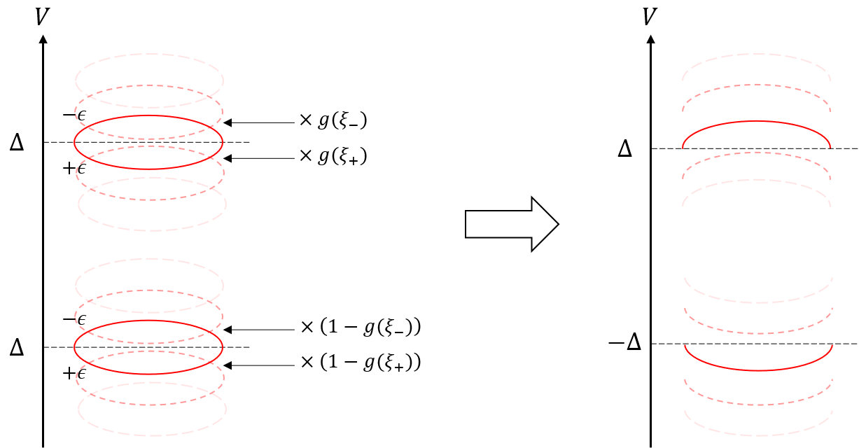
Supplementary Figure 9 | The left (right) figure shows the differential conductance of ABS with the periodic driving before (after) multiplying the distribution function to $g\left(ξ_{r}\right)=Θ\left(-ξ_{r}\right)$.

9-3. Floquet Sum Rule
Here we explicitly show that the time-averaged spectral function $A(0,ω)$ and the differential conductance satisfy sum rules.
Our starting point is the demonstration of the sum rule of $A(0,ω)$.
-∞∞dωA(0,ω)=-∞∞dωm=-∞∞Jmβ2l​δω-ξl+mΩ=Nm=-∞∞Jm(β)2=Nτ0τdtm,n=-∞∞Jm(β)Jn(β)ei(m-n)ωt=Nτ0τdteizsinωte-izsinωt=N
where $N$ is the number of states in the system. Since this holds independently of the value of $z$, the same holds for the polarization-averaged spectral function $\overline{A}(0,ω)$. These are examples of the general Floquet sum rule^{6, 7}. Using this sum rule and Eq. (5), we derive the sum rule for the differential conductance.
S≡-∞∞dVdIdVτ=limV→∞[I(t,V)τ-I(t,-V)τ]=limV→∞2eπℏtprobe2-∞∞dωr​Br,β(ω)[[Aprobeω+eVℏ-Aprobeω-eVℏ]g(ξr) +fFDω-eVℏAprobeω-eVℏ-fFDω+eVℏAprobeω+eVℏ]=2eπℏtprobe2-∞∞dωr​Br,β(ω)limV→∞[[Aprobeω+eVℏ-Aprobeω-eVℏ]g(ξr) +fFDω-eVℏAprobeω-eVℏ-fFDω+eVℏAprobeω+eVℏ]=2eπℏtprobe2-∞∞dωr​Br,βω=2eπℏtprobe2-∞∞dωA0,ω=2eπℏtprobe2N
where we have used$\underset{V→∞}{\text{lim}}A_{\text{probe}}\left(ω±\frac{eV}{ℏ}\right)=1$.

Reference

1. Chen, W. and Clerk, A. A. Electron-phonon mediated heat flow in disordered graphene. Phys. Rev. B 86, (2012).
2. Viljas, J. K. and Heikkila, T. T. Electron-phonon heat transfer in monolayer and bilayer graphene. Phys. Rev. B 81, (2010).
3. Dynes, R. C., Narayanamurti, V. and Garno, J. P. Direct measurement of quasiparticle-lifetime broadening in a strong-coupled superconductor. Phys. Rev. Lett. 41, 1509-1512 (1978).
4. Maiti, M. and Sengupta, K. Josephson effect in graphene superconductor/barrier/superconductor junctions: Oscillatory behavior of the Josephson current. Phys. Rev. B 76, (2007).
5. Beenakker, C. W. Specular Andreev reflection in graphene. Phys. Rev. Lett. 97, 067007 (2006).
6. Titov, M. and Beenakker, C. W. J. Josephson effect in ballistic graphene. Phys. Rev. B 74, 041401(R) (2006).
7. Rudner, M. S. and Lindner, N. H. Band structure engineering and non-equilibrium dynamics in Floquet topological insulators. Nat Rev Phys 2, 229-244 (2020).
8. Uhrig, G. S., Kalthoff, M. H. and Freericks, J. K. Positivity of the spectral densities of retarded Floquet Green functions. Phys. Rev. Lett. 122, 130604 (2019).
9. Pillet, J. D., et al. Andreev bound states in supercurrent-carrying carbon nanotubes revealed. Nature Physics 6, 965-969 (2010).
10. Bardeen, J. Tunnelling from a Many-Particle Point of View. Phys. Rev. Lett. 6, 57-59 (1961).

