Supplementary Materials for

Improve the projection of East China summer precipitation with emergent constraints
Huanhuan Zhu¹, Zhihong Jiang^{2*}, Laurent Li³, Wei Li², Sheng Jiang ²
¹ School of Atmospheric Science and Remote Sensing, Wuxi University, Wuxi 214105, China
² Key Laboratory of Meteorological Disaster of Ministry of Education, Collaborative Innovation Center on Forecast and Evaluation of Meteorological Disaster, Nanjing University of Information Science and Technology, Nanjing 210044, China.
³ Laboratoire de Météorologie Dynamique, CNRS, Sorbonne Université, Ecole Normale Supérieure, Ecole Polytechnique, Paris 75005, France.

*Corresponding author. E-mail: zhjiang@nuist.edu.cn

Table S1. Model numbers, model names, modeling centers and countries, as well as the atmospheric resolutions, of 34 CMIP6 global climate models.
Model  number | Model name | Modeling centers and countries | Atmospheric resolution  (lat×lon)
1  2 | ACCESS-CM2  ACCESS-ESM1-5 | Commonwealth Scientific and Industrial Research Organization and Bureau of Meteorology (Australia) | 1.25°×1.875°  1.25°×1.875°
3 | BCC-CSM2-MR | Beijing Climate Center, China Meteorological Administration (China) | 1.125°×1.125°
4 | CanESM5 | Canadian Centre for Climate Modelling and Analysis (Canada) | 2.8°×2.8°
5 | CESM2-WACCM | National Center for Atmospheric Research (USA) | 0.9375°×1.25°
6  7 | CMCC-CM2-SR5  CMCC-ESM2 | Fondazione Centro Euro-Mediterraneo sui Cambiamenti Climatici (Italy) | 0.9375°×1.25°  0.9375°×1.25°
8  9 | CNRM-CM6-1  CNRM-ESM2-1 | Centre National de Recherches Météorologiques–Centre Européen de Recherche et de Formation Avancée en Calcul Scientifique (France) | 1.4°×1.4°  1.4°×1.4°
10  11  12  13 | EC-Earth3  EC-Earth3-CC  EC-Earth3-Veg  EC-Earth3-Veg-LR | EC-EARTH consortium | 0.7°×0.7°  0.7°×0.7°  0.7°×0.7°  1.125°×1.125°
14 | FGOALS-g3 | LASG, Institute of Atmospheric Physics, Chinese Academy of Sciences and Center for Earth System Science, Tsinghua University (China) | 2.25°×2°
15  16 | GFDL-CM4  GFDL-ESM4 | NOAA Geophysical Fluid Dynamics Laboratory (USA) | 1°×1.25°  1°×1.25°
17  18 | HadGEM3-GC31-LL  HadGEM3-GC31-MM | Met Office Hadley Centre (UK) | 1.25°×1.875°  0.56°×0.83°
19 | IITM-ESM | Centre for Climate Change Research, Indian Institute of Tropical Meteorology Pune (India) | 1.9°×1.875°
20  21 | INM-CM4-8  INM-CM5-0 | Institute for Numerical Mathematics, Russian Academy of Science (Russia) | 1.5°×2°  1.5°×2°
22 | IPSL-CM6A-LR | L’Institut Pierre-Simon Laplace (France) | 1.26°×2.5°
23 | KACE-1-0-G | National Institute of Meteorological Sciences/Korea Meteorological Administration (Korea) | 1.25°×1.875°
24 | KIOST-ESM | Korea Institute of Ocean Science & Technology (Korea) | 1.875°×1.875°
25  26 | MIROC6  MIROC-ES2L | National Institute for Environmental Studies, The University of Tokyo (Japan) | 1.4°×1.4°  2.8°×2.8°
27  28 | MPI-ESM-1-2-HR  MPI-ESM-1-2-LR | Max Planck Institute for Meteorology (Germany) | 0.9375°×0.9375°  1.875°×1.875°
29 | MRI-ESM2-0 | Meteorological Research Institute (Japan) | 1.125°×1.125°
30 | NESM3 | Nanjing University of Information Science and Technology (China) | 1.875°×1.875°
31  32 | NorESM2-LM  NorESM2-MM | Norwegian Climate Centre (Norway) | 1.875°×2.5°  0.94°×1.25°
33 | TaiESM1 | Research Center for Environmental Changes, Academia Sinica (Taiwan) | 0.9375°×1.25°
34 | UKESM1-0-LL | Met Office Hadley Centre (UK) | 1.25°×1.875°
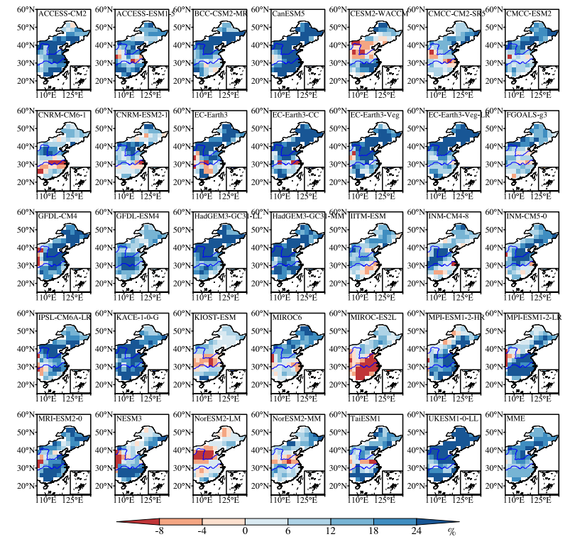
Fig. S1. Spatial distributions of projected changes for East China summer precipitation during 2070-2099 relative to 1985-2014 (unit: %).

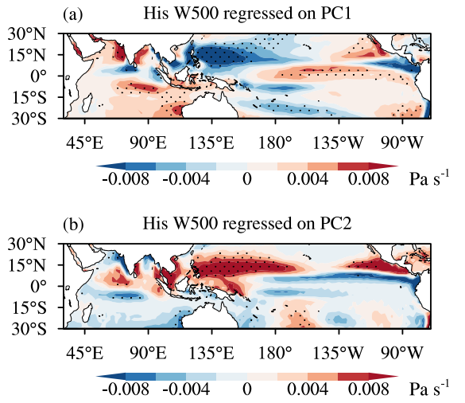
Fig. S2. As in Fig. 2., but for vertical velocity at 500 hPa.

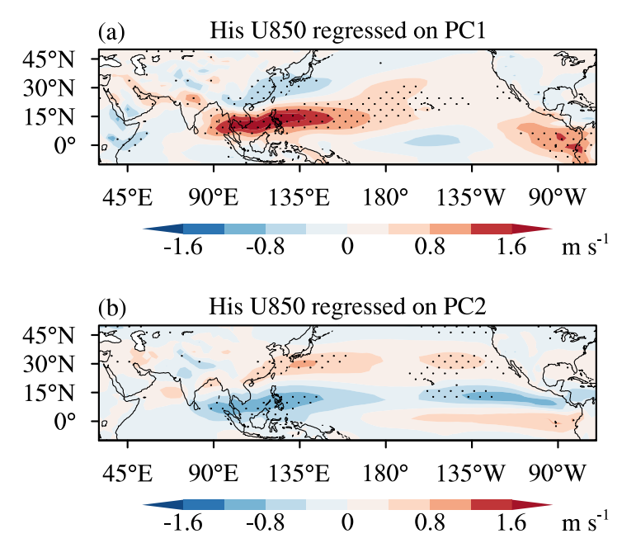
Fig. S3. As in Fig. 2., but for zonal wind at 850 hPa.

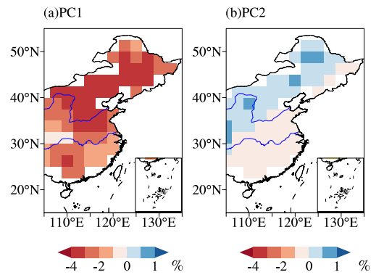
Fig. S4 Constrained leading modes of the inter-model spread. Panels a and b are the two constrained leading EOF modes of the inter-model ECSP changes, based on the optimal first and second Principal Components (PC1 and PC2).
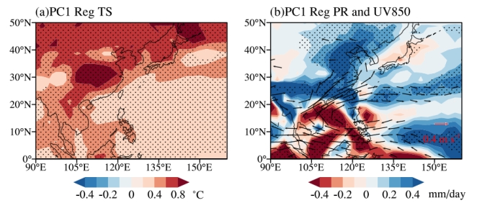
Fig. S5 Inter-model regressions of future changes onto the first principal component (PC1). Changes in summer-mean (a) surface temperature, (b) precipitation (shadings) and 850 hPa winds (vectors). Dotted shadings are statistically significant at the 5% level under Student t-test.

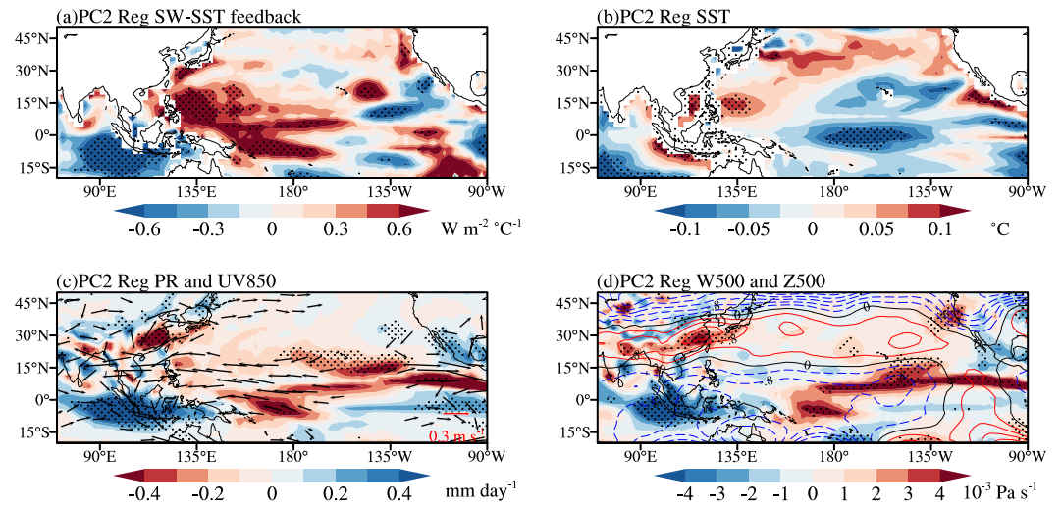
Fig. S6 Inter-model regressions of (a) SW-SST feedback in the historical experiment and future changes in summer-mean (b) sea surface temperature, (c) precipitation (shadings) and 850 hPa winds (vectors), (d) 500hPa vertical velocity (shadings) and geopotential height (contours) onto the second principal component (PC2). Dotted shadings are statistically significant at the 10% level under Student t-test.
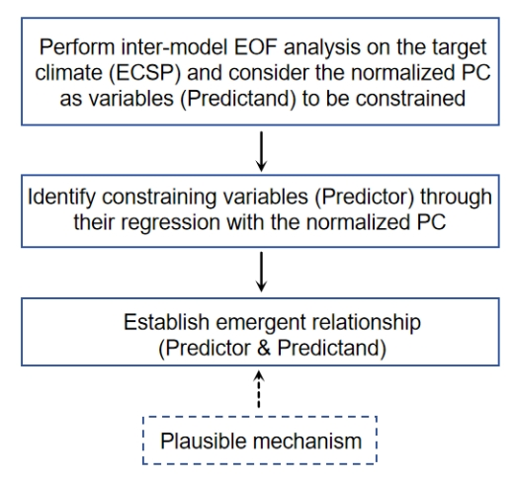
Fig. S7 A flowchart of the emergent constraint procedure.

