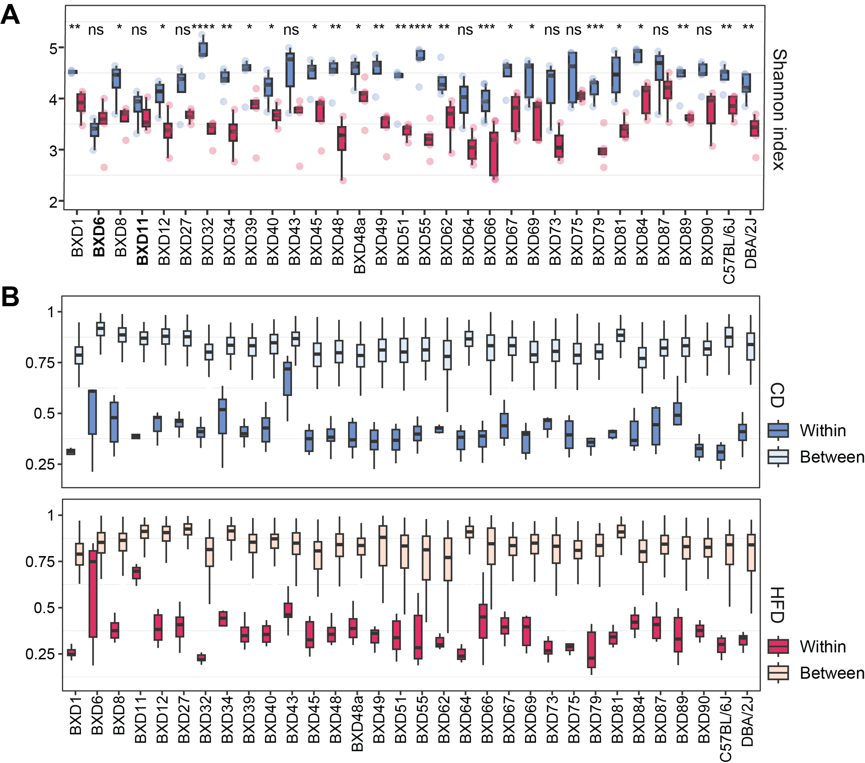
Figure S1: Alpha and beta diversity analyses of the BXD gut microbiome. (A) Cecal bacterial community diversity in terms of Shannon index in each BXD strain under CD (colored in blue) and HFD (colored in red). Most BXD strains (23/32) showed significantly decreased SI upon HFD. P values were calculated by two-tailed Student’s t-test and indicated as follows: *P value <0.05; **P value < 0.01; ***P value < 0.001; ****P value < 0.0001 (B) Box plots showing Bray–Curtis distances of cecal microbial communities within each BXD strain (individual differences) and between strains (genetic differences) under CD (colored in blue) and HFD (colored in red).

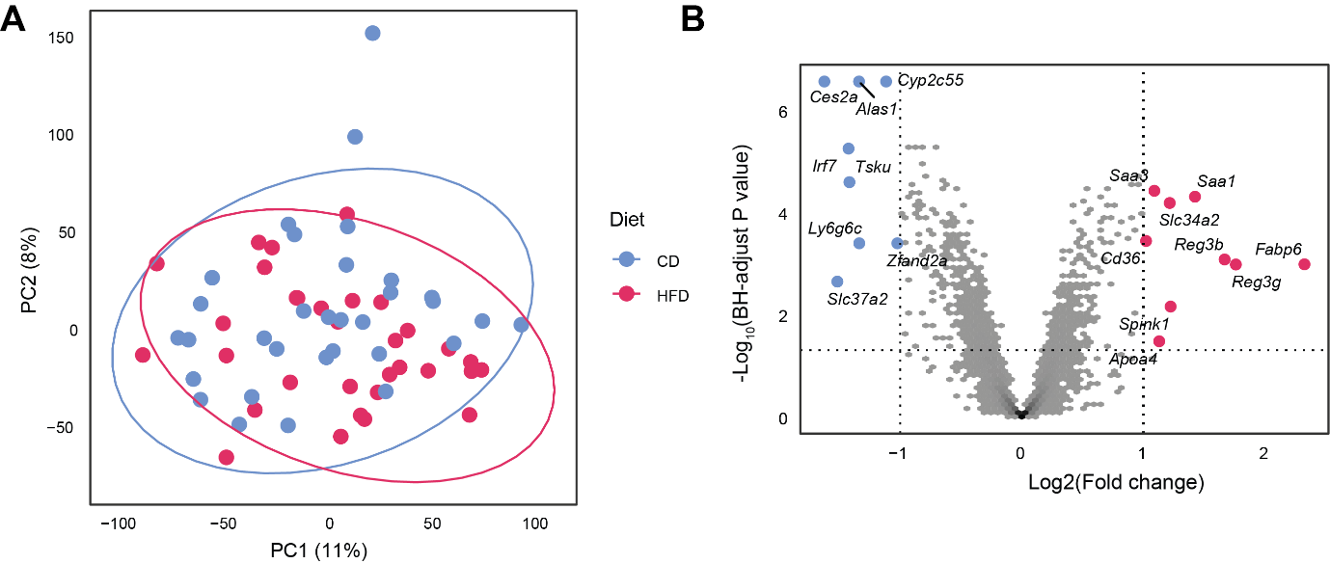
Figure S2: HFD effect on the host gene expression in BXD colons. (A) Principal component analysis (PCA) of the microarray profiles of BXD colons under HFD (indicated in red) or CD (represented in blue). (B) Volcano plot showing the HFD effect on BXD colon transcriptomes and the up- (indicated in red) and down-regulated (represented in blue) differentially expressed genes (DEGs, absolute Log2(Fold change) > 1 and BH-adjusted P value < 0.05).

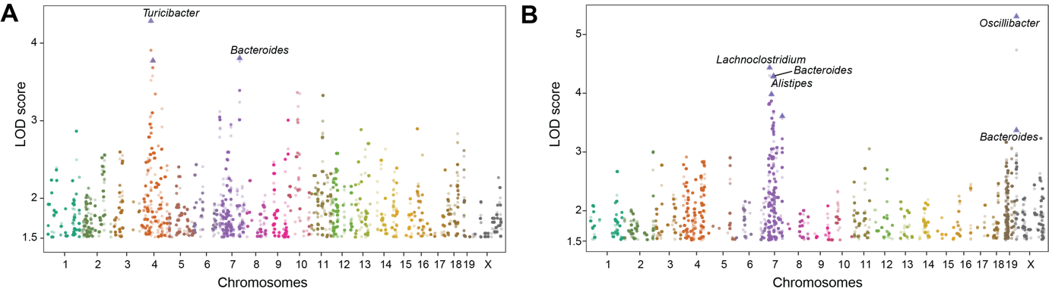
Figure S3: QTL mapping analyses of gut bacteria genera in the BXDs. (A, B) Manhattan plots showing the associations between genetic loci and bacteria under CD (A) and HFD (B). The genetic locus-bacterium associations with LOD > 1.5 are shown. Each chromosome is indicated by color and the significant genetic locus-bacterium associations are represented by triangle
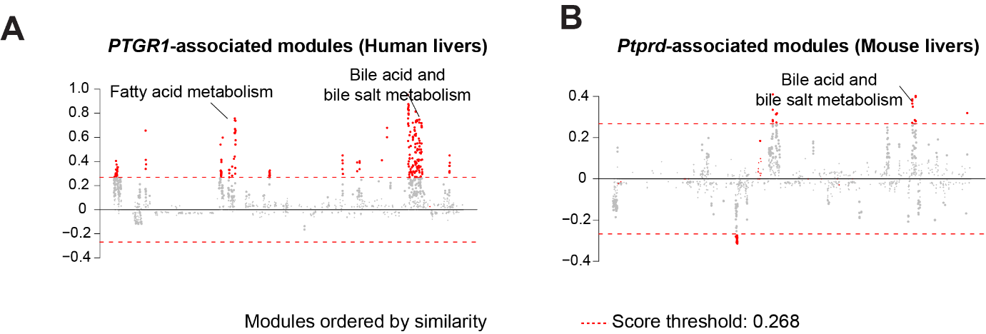
Figure S4: Candidate gene-BA metabolism module associations. (A, B) Manhattan plots showing the associated gene expression modules of Prostaglandin Reductase 1 (PTGR1) in human livers (I) and that of Protein Tyrosine Phosphatase Receptor Type D (Ptprd) in mouse livers (J). Data were retrieved from https://systems-genetics.org/gmad⁹⁸. The threshold is represented by the red dashed line (absolute gene-module association score ≥ 0.268). Terms above the threshold are identified as the significant associated terms. GO terms or gene modules are ranked by similarity

Table S1. List of the BAs measured, their abbreviations, accurate m/z ratio, corresponding internal standards (used for quantification) and retention times (RT). Chromatographic resolution was essential for the separation of isobaric species.
Bile Acid | Abbreviation | H⁻ (m/z) | Internal Standard | RT min
Lithocholic acid | LCA | 375.29047 | d₄-LCA | 20.6
7-Ketolithocholic acid | 7Keto-LCA | 389.26973 | d₄-GDCA | 15.5
Murocholic acid | MDCA | 391.28538 | d₄-CA | 12.4
Ursodeoxycholic acid | UDCA | 391.28538 | d₄-GDCA | 13.3
Chenodeoxycholic acid | CDCA | 391.28538 | d₄-CDCA | 18.3
Deoxycholic acid | DCA | 391.28538 | d₄-DCA | 18.5
Isodeoxycholic acid | isoDCA | 391.28538 | d₄-GDCA | 19.7
3-Oxocholic acid | 3Oxo-CA | 405.26465 | d₄-TCDCA | 12.6
7-Ketodeoxycholic acid | 7Keto-DCA | 405.26465 | d₄-GCA | 11.0
α-Muricholic acid | α-MCA | 407.28030 | d₄-GCA | 10.8
β-Muricholic acid | β-MCA | 407.28030 | d₄-GCA | 11.2
ω-Muricholic acid | ω-MCA | 407.28030 | d₄-GCA | 10.4
γ-Muricholic acid | MCA | 407.28030 | d₄-GCA | 11.8
Cholic acid | CA | 407.28030 | d₄-CA | 12.6
Glycolithocholic acid | GLCA | 432.31193 | d₄-GDCA | 13.5
Glycoursodeoxycholic acid | GUDCA | 448.30685 | d₄-GCA | 10.2
Glycohyodeoxycholic acid | GHDCA | 448.30685 | d₄-CA | 10.6
Glycochenodeoxycholic acid | GCDCA | 448.30685 | d₄-GCDCA | 12.9
Glycocholic acid | GCA | 464.30176 | d₄-GCA | 10.3
Taurolithocholic acid | TLCA | 482.29457 | d₅-TLCA | 13.0
Tauroursodeoxycholic acid | TUDCA | 498.28948 | d₄-TCA | 5.1
Taurohyodeoxycholic acid | THDCA | 498.28948 | d₄-TCDCA | 5.5
Taurochenodeoxycholic acid | TCDCA | 498.28948 | d₄-TCDCA | 10.6
Taurodeoxycholic acid | TDCA | 498.28948 | d₅-TDCA | 10.9
Tauro-α-muricholic acid | TαMCA | 514.28440 | d₄-TαMCA | 2.1
Tauro-β-muricholic acid | TβMCA | 514.28440 | d₄-TβMCA | 2.3
Taurocholic acid | TCA | 514.28440 | d₄-TCA | 5.8

Supplemental information
Supplemental information 1. QTL peaks of both bacterial abundance and BA profiles within identified gMxBs under CD and HFD, related to Fig.5A-E and Table 1.

