Appendix

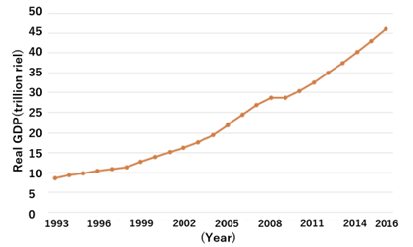
Figure A1 Real GDP trends in Cambodia (MLIT, accessed in July 2024, https://www.mlit.go.jp/totikensangyo/kokusai/kensetsu_database/cambodia/index.html)

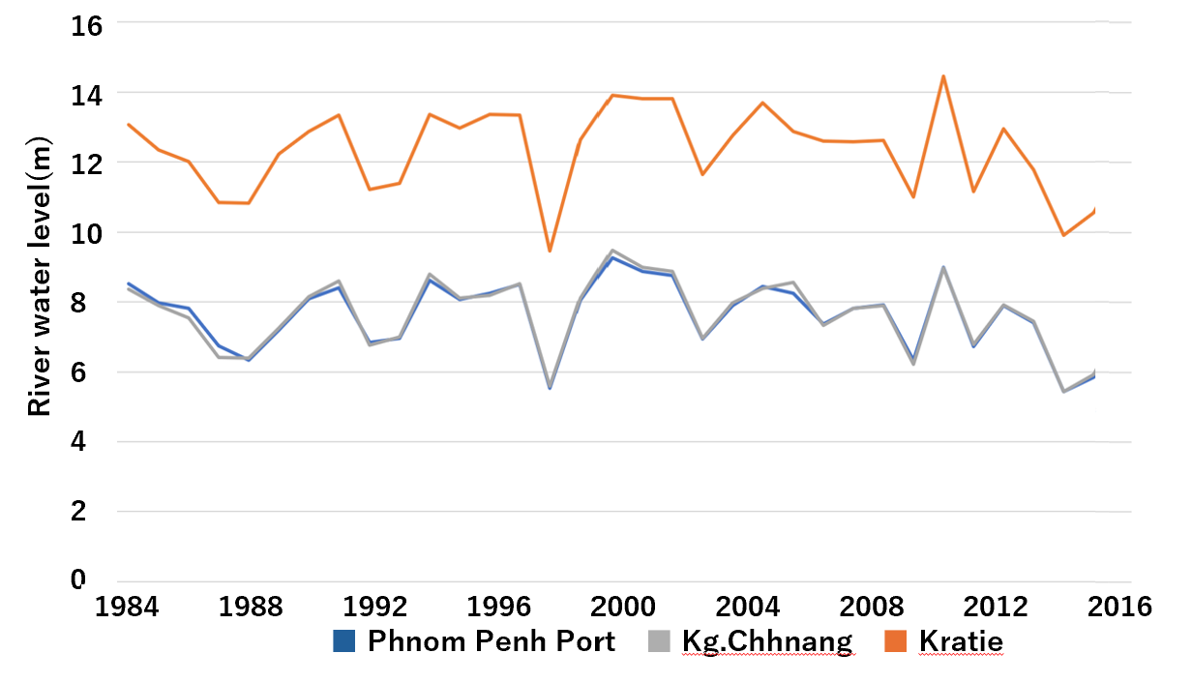
Figure A2 River water level trends at the selected points in the study area (MRC Data and Information Services, accessed in July 2024, http://portal.mrcmekong.org/index)

