Title:
Unveiling the mechanism of amelioration of adjuvant-induced Rheumatoid Arthritis by Drynaria quercifolia rhizome extract using network pharmacology and gene expression-based studies.
Authors:
Debabrata Modak^{1,2}, Subhajit Ghosh², Sourav Sarkar¹, Sudipta K. Roy¹, Ayan Chakraborty³, Arpita Ray⁴, Chirag N. Patel⁵, John J. Georrge², Subarna Thakur²* and Soumen Bhattacharjee¹*
¹Cell and Molecular Biology Laboratory, Department of Zoology, University of North Bengal, Darjeeling, 734013, West Bengal, India.
²Department of Bioinformatics, University of North Bengal, Darjeeling, 734013, West Bengal, India.
³Virus Research and Diagnostic Laboratory, North Bengal Medical College and Hospital, Darjeeling, 734012, West Bengal, India.
⁴Genetics and Molecular Biology Laboratory, Department of Zoology, University of North Bengal, Darjeeling, 734013, West Bengal, India.
⁵Translational Gerontology Branch, National Institute on Aging, National Institutes of Health, Baltimore, MD, USA.
E. mail address of all the co-authors:
Debabrata Modak: debabratacmbl@nbu.ac.in
Subhajit Ghosh: rs_subhajitg@nbu.ac.in
Sourav Sarkar: rs_sourav@nbu.ac.in
Sudipta K. Roy: roysudipto16@nbu.ac.in
Ayan Chakraborty: ayanchakraborty.vrdl@gmail.com
Arpita Ray: rs_arpita@nbu.ac.in
Chirag N. Patel: chiragpatel269@gmail.com
John J. Georrge: georrge@nbu.ac.in
Subarna Thakur: subarna.thakur@nbu.ac.in
Soumen Bhattacharjee: soumenb@nbu.ac.in

*Joint corresponding authors
Prof. (Dr.) Soumen Bhattacharjee,
Department of Zoology,
University of North Bengal,
Raja Rammohunpur,
Darjeeling 734013
West Bengal, India.
Phone: +91-9474674013 (M)
E. Mail: soumenb@nbu.ac.in

Dr. Subarna Thakur,
Department of Bioinformatics,
University of North Bengal,
Raja Rammohunpur,
Darjeeling 734013
West Bengal, India.
Phone: 0353-2699117 (O)/+91-9434106590 (M)
E. Mail: subarna.thakur@nbu.ac.in

Additional Table S1. GC-MS identified phytocomponents name and their respective Pubchem id, Canonical SMILE, Molecular weight, Rule of Three, and Rule of Five.
Sl No | Phytocomponent Names | PubChem ID | Canonical SMILE | Molecular weight | Rule of Three | Rule of Five
1 | Catechol | 289 | C1=CC=C(C(=C1)O)O | 110.112 | 0 | 0
2 | n-Hexadecanoic acid | 985 | CCCCCCCCCCCCCCCC(=O)O | 256.428 | 0 | 1
3 | Benzeneacetic acid | 999 | C1=CC=C(C=C1)CC(=O)O | 136.15 | 0 | 0
4 | 1,3,4,5-Tetrahydroxycyclohexanecarboxylic acid | 1064 | C1C(C(C(CC1(C(=O)O)O)O)O)O | 192.168 | 1 | 0
5 | Dibutyl phthalate | 3026 | CCCCOC(=O)C1=CC=CC=C1C(=O)OCCCC | 278.347 | 0 | 0
6 | Dodecanoic Acid | 3893 | CCCCCCCCCCCC(=O)O | 200.32 | 0 | 0
7 | Octadecanoic acid | 5281 | CCCCCCCCCCCCCCCCCC(=O)O | 284.481 | 1 | 1
8 | 1,2-Benzenedicarboxylic acid, bis(2-methylpropyl) ester | 6782 | CC(C)COC(=O)C1=CC=CC=C1C(=O)OCC(C)C | 278.347 | 0 | 0
9 | Hexadecanoic Acid, Methyl Ester | 8181 | CCCCCCCCCCCCCCCC(=O)OC | 270.454 | 1 | 1
10 | Bis(2-ethylhexyl) phthalate | 8343 | CCCCC(CC)COC(=O)C1=CC=CC=C1C(=O)OCC(CC)CCCC | 390.562 | 1 | 1
11 | Tetradecanoic acid | 11005 | CCCCCCCCCCCCCC(=O)O | 228.374 | 0 | 0
12 | n-Pentadecanol | 12397 | CCCCCCCCCCCCCCCO | 228.417 | 0 | 0
13 | Vitamin E | 14985 | CC1=C(C2=C(CCC(O2)(C)CCCC(C)CCCC(C)CCCC(C)C)C(=C1O)C)C | 430.713 | 1 | 1
14 | Ergosta-8,24(28)-dien-3- ol, 4,14-dimethyl-, (3.beta.,4.alpha.,5.alpha.) | 65252 | CC1C2CCC3=C(C2(CCC1O)C)CCC4(C3(CCC4C(C)CCC(=C)C(C)C)C)C | 426.724 | 1 | 1
15 | 1-Heptacosanol | 74822 | CCCCCCCCCCCCCCCCCCCCCCCCCCCO | 396.739 | 1 | 1
16 | Silane, ethenylethoxydimethyl- | 79315 | CCO[Si](C)(C)C=C | 130.261 | 0 | 0
17 | Benzenepropanoic acid, 4-hydroxy-, methyl ester | 79706 | COC(=O)CCC1=CC=C(C=C1)O | 180.203 | 0 | 0
18 | n-Nonadecanol-1 | 80281 | CCCCCCCCCCCCCCCCCCCO | 284.524 | 1 | 1
19 | A'-neogammacer-22(29)- ene | 92155 | CC(=C)C1CCC2(C1CCC3(C2CCC4C3(CCC5C4(CCCC5(C)C)C)C)C)C | 410.725 | 1 | 1
20 | Gamma.-Tocopherol | 92729 | CC1=C(C=C2CCC(OC2=C1C)(C)CCCC(C)CCCC(C)CCCC(C)C)O | 416.686 | 1 | 1
21 | 4H-Pyran-4-one, 2,3-dihydro-3,5-dihydroxy-6-methyl- | 119838 | CC1=C(C(=O)C(CO1)O)O | 144.127 | 0 | 0
22 | Hexadecanoic acid, 2-hydroxy-1-(hydroxymethyl)ethyl ester | 123409 | CCCCCCCCCCCCCCCC(=O)OC(CO)CO | 330.507 | 1 | 0
23 | 5 Hydroxy methylfurfural | 237332 | C1=C(OC(=C1)C=O)CO | 126.112 | 0 | 0
24 | Cholest-5-en-3-ol, 4,4-dimethyl-, (3.beta.) | 280427 | CC(C)CCCC(C)C1CCC2C1(CCC3C2CC=C4C3(CCC(C4(C)C)O)C)C | 414.713 | 1 | 1
25 | 2 hydroxy cyclopentadecan one | 543400 | C1CCCCCCC(C(=O)CCCCCC1)O | 240.385 | 0 | 0
26 | 9,19-Cyclolanostan-3-ol,24-methylene-, (3.beta.) | 544165 | CC(C)C(=C)CCC(C)C1CCC2(C1(CCC34C2CCC5C3(C4)CCC(C5(C)C)O)C)C | 440.751 | 1 | 1
27 | 9,19-Cyclolanost-24-en-3-ol, (3.beta.) | 550074 | CC(CCC=C(C)C)C1CCC2(C1(CCC34C2CCC5C3(C4)CCC(C5(C)C)O[Si](C)(C)C)C)C | 498.906 | 1 | 1
28 | 9,19-Cyclolanost-25-en-3-ol, 24-methyl-, (3.beta.,24S) | 550205 | CC(CCC(C)C(=C)C)C1CCC2(C1(CCC34C2CCC5C3(C4)CCC(C5(C)C)O)C)C | 440.751 | 1 | 1
29 | Cyclopropa[5,6]-33- norgorgostan-3-ol, 3',6- dihydro-, (3.beta.,5.beta.,6.alpha.,22.xi.,23.xi.) | 557802 | CC(C)C(C)C1CC1C(C)C2CCC3C2(CCC4C3CC5CC56C4(CCC(C6)O)C)C | 426.724 | 1 | 1
30 | 4,8,12,16-Tetramethylheptadecan-4-olide | 567149 | CC(C)CCCC(C)CCCC(C)CCCC1(CCC(=O)O1)C | 324.546 | 1 | 1
31 | 1-phenanthrenecarboxylic acid, 7-ethyl- 1,2,3,4,4a,4b,5,6,7,9,10,10a-dodecahydro-1,4a,7- trimethyl-, methyl Ester | 578750 | CCC1(CCC2C(=C1)CCC3C2(CCCC3(C)C(=O)OC)C)C | 318.498 | 1 | 1
32 | Squalene | 638072 | CC(=CCCC(=CCCC(=CCCC=C(C)CCC=C(C)CCC=C(C)C)C)C)C | 410.725 | 2 | 1
33 | 9,12-Octadecadienoic acid (Z,Z)-, methyl ester | 5284421 | CCCCCC=CCC=CCCCCCCCC(=O)OC | 294.476 | 0 | 1
34 | 6-Octadecenoic acid, methyl ester, (Z) | 5362717 | CCCCCCCCCCCC=CCCCCC(=O)OC | 296.492 | 0 | 1
35 | cis-9-Hexadecenal | 5364643 | CCCCCCC=CCCCCCCCC=O | 238.412 | 0 | 0
36 | 9,12-Octadecadienoic acid (Z,Z)-, 2-hydroxy-1-(hydroxymethyl)ethyl ester | 5365676 | CCCCCC=CCC=CCCCCCCCC(=O)OC(CO)CO | 354.529 | 1 | 0
37 | 5-(7a-Isopropenyl-4,5-dimethyl-octahydroinden-4-yl)-3-methyl-pent-2-en-1-ol | 5375222 | CC1CCC2(CCCC2C1(C)CCC(=CCO)C)C(=C)C | 290.488 | 0 | 0
38 | Ergost-5-en-3-ol, (3.beta.,24r) | 6428659 | CC(C)C(C)CCC(C)C1CCC2C1(CCC3C2CC=C4C3(CCC(C4)O)C)C | 400.687 | 1 | 1
39 | Stigmast-5-en-3-ol, (3.beta.) | 6432744 | CCC(CCC(C)C1CCC2C1(CCC3C2CC=C4C3(CCC(C4)O)C)C)C(C)C | 414.713 | 1 | 1
40 | Alpha.-D-Glucopyranoside, methyl | 11047886 | COC1C(C(C(C(O1)CO)O[Si](C)(C)C)O[Si](C)(C)C)O[Si](C)(C)C | 410.729 | 0 | 0
41 | Beta.-d-Ribopyranoside, methyl, 3-acetate | 11680050 | CC(=O)OC1C(COC(C1O)OC)O | 206.195 | 0 | 0

Additional Table S2. Details of gene names and their respective proteins’ PDB Ids and their chain name along with co-ordinates for Molecular docking study.
SL NO | GENE NAME | PDB ID | Chain name | CO-ORDINATES OF ACTIVE SITES
 |  |  |  | X | Y | Z
1 | PTGS2/ COX-2 | 5IKQ | A | 32.854535 | 32.944359 | 22.980354
2 | TLR4 | 3FXI | A | 17.551596 | -4.483199 | 19.321258
3 | VEGFA | 1CZ8 | V | 31.148625 | -40.563000 | -18.648375
4 | AKT1 | 1H10 | A | 15.265286 | 24.585286 | 15.779250
5 | MMP9 | 1GKC | A | 64.545074 | 24.688565 | 117.527629
6 | CXCL8/  IL-8 | No PDB id has been found
7 | PPARG | 1FM9 | D | 13.462787 | -7.000473 | 10.761273
8 | ACE | 1O86 | A | 38.603327 | 35.889895 | 41.899247
9 | PPARA | 1I7G | A | 37.354929 | 34.871893 | 39.222250
10 | CASP3 | 1CP3 | B | 9.985173 | 3.164101 | 1.988432
11 | ESR1 | 1A52 | A | 105.69834 | 15.266478 | 96.011826
12 | TNF-α | 2AZ5 | A | -21.97351 | 70.223093 | 37.347500
13 | IL-6 | 1ALU | A | -1.625656 | -22.247728 | 2.009775

Additional Table S3. Details of the different primers used for the RT‑PCR obtained from existing literatures.
SL No | Gene Name | Primer sequence (5' to 3') | Reference
1 | COX-2-F | TGTATGCTACCATCTGGCTTCGG | (Albertini et al., 2007)
1 | COX-2-R | GTTTGGAACAGTCGCTCGTCATC | (Albertini et al., 2007)
2 | IL-6-F | CCCACCAGGAACGAAAGTCA | (Saleem et al., 2020)
2 | IL-6-R | ACTGGCTGGAAGTCTCTTGC | (Saleem et al., 2020)
3 | IKβ-F | TGAGTACCTGGACTTGCAGAACG | (Saleem et al., 2020)
3 | IKβ-R | TGTAGATGCCTCTCCAAGGATGG | (Saleem et al., 2020)
4 | TNF-F | AGCCCTGGTATGAGCCCATGTA | (Paquet et al., 2012)
4 | TNF-R | CCGGACTCCGTGATGTCTAAGT | (Paquet et al., 2012)
5 | GAPDH-F | ATGACTCTACCCACGGCAAG | (Kunst et al., 2013)
5 | GAPDH-R | CTGGAAGATGGTGATGGGTT | (Kunst et al., 2013)
6 | AKT-F | TAGGCATCCCTTCCTTACAGC | (Zhang et al., 2022)
6 | AKT-R | CGCTCACGAGACAGGTGGA | (Zhang et al., 2022)
7 | PPARG-F | CTGGCCTCCCTGATGAATAAG | (Y & Valsala Gopalakrishnan, 2020)
7 | PPARG-R | AGGCTCCATAAAGTCACCAAAG | (Y & Valsala Gopalakrishnan, 2020)

References:
Albertini, R., Aimbire, F., Villaverde, A. B., Silva, J. A., & Costa, M. S. (2007). COX-2 mRNA expression decreases in the subplantar muscle of rat paw subjected to carrageenan-induced inflammation after low level laser therapy. Inflammation Research, 56(6), 228-229. https://doi.org/10.1007/s00011-007-6211-6
Kunst, S., Wolloscheck, T., Hölter, P., Wengert, A., Grether, M., Sticht, C., Weyer, V., Wolfrum, U., & Spessert, R. (2013). Transcriptional analysis of rat photoreceptor cells reveals daily regulation of genes important for visual signaling and light damage susceptibility. Journal of Neurochemistry, 124(6), 757-769. https://doi.org/https://doi.org/10.1111/jnc.12089
Paquet, J., Goebel, J.-C., Delaunay, C., Pinzano, A., Grossin, L., Cournil-Henrionnet, C., Gillet, P., Netter, P., Jouzeau, J.-Y., & Moulin, D. (2012). Cytokines profiling by multiplex analysis in experimental arthritis: which pathophysiological relevance for articular versus systemic mediators? Arthritis Research & Therapy, 14(2), R60. https://doi.org/10.1186/ar3774
Saleem, A., Saleem, M., Akhtar, M. F., Shahzad, M., & Jahan, S. (2020). Moringa rivae leaf extracts attenuate Complete Freund’s adjuvant-induced arthritis in Wistar rats via modulation of inflammatory and oxidative stress biomarkers. Inflammopharmacology, 28(1), 139-151.
Y, D. P., & Valsala Gopalakrishnan, A. (2020). γ-Linolenic acid ameliorates DHEA induced pro-inflammatory response in polycystic ovary syndrome via PPAR-γ signaling in rats. Reprod Biol, 20(3), 348-356. https://doi.org/10.1016/j.repbio.2020.05.004
Zhang, L., Jia, B., Velu, P., & Wu, H. (2022). Corilagin induces apoptosis and inhibits HMBG1/PI3K/AKT signaling pathways in a rat model of gastric carcinogenesis induced by methylnitronitrosoguanidine. Environmental Toxicology, 37(5), 1222-1230. https://doi.org/https://doi.org/10.1002/tox.23478
Additional Table S4. Name of potential target identification of phytocomponents of Drynaria quercifolia rhizome methanolic extract through Swiss Target Prediction (STP) and Similarity Ensemble Approach (SEA) databases.
Target from STP | Target from SEA
NPC1L1, PTGER2, PTGFR, FNTA, NR1H4, G6PD, GPBAR1, HSD11B1, ACLY, AR, VDR, CYP19A1, POLB, CDC25A, AKR1B10, FABP4, PPARA, FABP3, FABP5, PPARD, FFAR1, FABP2, HSD11B2, HAO1, UGT2B7, SERPINA6, SHBG, HSD17B3, GABBR1, SLC22A6, GABRA2, EGLN1, HMGCR, CPT1A, PLG, PTPN1, FOLH1, PTGES, CDC45, PTPRC, NR1H3, KDM2A, PHF8, KDM5C, CACNA2D1, GRM3, GRM6, GRM2, MMP2, MMP8, PGD, GRM8, GRM4, GSTK1, LTA4H, MMP9, CA12, CA9, SAE1, GRM5, GRIK1, GRIK2, GAA, SLC1A2, KDM4E, KDM6B, GRM1, AHCY, SCN9A, SLC6A12, PEPD, OPRK1, POLA1, PREP, PRKCA, PTPN6, PTPN2, SIRT2, SHH, IL1B, PPM1B, PPP1CC, ACE, CES2, ANPEP, PTGS2, ENPEP, FAAH, PPARG, TERT, FABP1, SLC1A1, CA1, TRPM8, CA4, OPRM1, NR3C1, TOP2A, CA2, ESR1, ESR2, CDC25B, NR1I3, DPP4, SPHK1, SELP, CNR1, CNR2, PLA2G2C, EPHX2, CYP51A1, AURKB, AURKA, BCHE, ACHE, ENPP2, FNTA FNTB, PTGS1, FUCA1, SQLE, TRPV1, GPR119, DNM1, NPC1, AVPR2, AVPR1A, CHRM4, CHRM5, CHRM2, CHRM1, CHRM3, ITGAL, PRKCG, PRKCD, PRKCB, PRKCE, HSP90AA1, ACACB, FASN, BACE2, CTSD, BACE1, PRKCH, PRKCQ, PLA2G2A, S1PR1, PLA2G1B, RORC, DRD2, HTR2A, DRD3, S1PR3, ACACA, HTR4, KCNH2, CYP24A1, CSF1R, CTSL, EZH2, MET, PFKFB3, APP, ALOX5AP, MAOA, P2RY12, CDC25C, MAPK14, MCHR1, CCKBR, F10, IKBKE, TBK1, SMO, SLC6A3, CETP, OPRL1, EP300, KAT2B, ICMT, NR1H2, RORA, SLC6A2, RBP4, EPHX1, IL6ST, NOS2, MGLL, DHCR7, SCD, AKR1C3, GLRA1, TNF, MTNR1A, MTNR1B, PIM1, PIM3, CXCR3, MAP2K1, DGAT1, BRD4, BRD2, BRD3, GPR55, GPR18, CYP17A1, MDM2, PYGL, GCK, ABL1, F2, ALK, TBXAS1, PSEN2, EGFR, CA7, GSK3B, SIGMAR1, PTPRF, ACP1, ALOX5, SRD5A2, PDE4D, CD81, PTPN11, LTB4R, MAPK3, TOP1, CYP2C19, SLC6A4, PTGER1, PTGES2, CES1, PGR, TP53, ADORA3, PTGDR2, PTGIR, SLC22A12, IDO1, PTGDR, SREBF2, PTGER4, NR1I2, AGTR1, MME, DAGLA, CMA1, CTSG, HSD17B2, NR3C2, DAGLB, AKR1B1, TRPA1, PER2, JAK1, JAK2, TRPV3, GCGR, NOS1, EIF2AK1, PARP1, RASGRP1, SCN5A, KCNA5, PABPC1, NPY5R, HMOX1, PGGT1B, OPRD1, SLC10A2, JAK3, TYK2, ADRA2C, ADA, HRH3, PTK2B, LRRK2, LIPA, KCNA3, PRKDC, HIF1A, QPCT, PRSS1, CTRC, ITK, HRH1, TNKS, CASR, AKT1, C5AR1, F2R, IMPDH2, CYP11B2, SLC9A1, P2RY1, FLT1, KDR, PDGFRB, MCL1, BCL2, PPP5C, CCR2, FKBP1A, TYMS, CYP11B1, KIF11, GRIN2B, PNPLA2, YES1, LCK, SRC, EPHB4, CDC7, ADAMTS5, KCNK3, KCNK9, HRH4, KIT, MAPK9, LIMK2, PAM, MTTP, APOB, METAP2, ECE1, NAMPT, FLT4, PDGFRA, RET, MAP3K20, FRK, PDE10A, PTK6, DDR1, CIT, CDK8, CDK19, TYR, DAO, TYMP, GSR, EDNRA, HPRT1, MAOB, CA6, CA14, CA13, CA5B, CA5A, CASP3, ADORA2A, CDA, TK1, PTPRB, ADK, UPP1, HEXA, HEXB, OGA, PNP, P4HTM, CDK9, CSNK2A1, FBP1, PRKACA, GDA, GBA, HDAC1, ABCB1, KDM4A, KDM4D, KDM4C, PYGM, LIG1, HCAR2, HDAC6, HDAC4, ERCC5, FEN1, TLR4, DDO, CAD, GPR17, TDP1, AKR1C2, AKR1C1, NLRP3, CCNE1 CDK2, GABRB3, ROCK2, ROCK1, LIMK1, MGAT2, DGAT2, GNRHR, NTRK3, MAPK8, UNG, NPY1R, HRH2, RPS6KA5, STS, PIK3CG, PIK3CA, SLC6A9, ESRRA, ESRRB, SPHK2, THRA, ABHD6, NPY2R, CCR1, PDE2A, CYP2D6, CYP2C9, CYP3A4, IGF1R, LYPLA2, OXTR, ATP12A, HCRTR2, HCRTR1, TGFBR1, CDK5R1, DYRK1A, NTRK1, CDK2, MAPK1, CTSS, ADRA1D, ADRA1A, ADRA1B, INSR, FGFR2, MKNK2, SLC5A1, SYK, ZAP70, CDK1, IDH1, MTOR, GRIN2A GRIN1, GRIA2, PRF1, PDE4B, PDE7A, SMG1, PLK1, PRKD1, HPGD, CCNB3, SLC8A1, CTSB, AGPAT2, VCP, PIK3CB, GHSR, BTK, SRD5A1, CCND1, CDK7, CCND3, PLA2G7, HTR6, HTR2C, ASAH1, CRHR1, GRIN1, CALCRL, RARA, CD38, LYPLA1, BRPF1, CTSK, CHRNA4, CYP26A1, ADRA2A, CSNK1D, P2RX7, TBXA2R, TACR1, HTR2B, MDM4, MAP3K14, CCR5, GC, GPR88, HDAC3, CCNE2, PTAFR, SAE1 UBA2, EBP, CDK6, CDK4, TTK, METAP1, F11, INCENP, LSS, SLC18A3, VEGFA, FGF1, FGF2, HPSE, LGALS4, LGALS3, LGALS8, PYGB, ADRA2B, DRD1, HTR1B, STAT3, IL2, GGH, NAALAD2, SSTR5, SSTR2, SSTR4, SSTR1, SSTR3, CPA1, CASP6, CASP7, CASP8, CASP2, KDM5A, JMJD1C, IGF2R, BCL2L1, GLRA2, PPM1A, P4HA1, ADORA1, ELANE, MGAM, SI, MLNR, LGALS9, HSPA5, GSTP1, GSTM2, GAPDH, CCNE1, TSPO, PDE5A, MAPK11, GABRG2, ELOVL6, TNFRSF1A, SCN10A, CPB1, MEN1, TRPC6, TRPC3, TRPV4, MAP3K8, SLC2A1, ADAM17, SLC2A3, SLC2A2, ADORA2B, MMP7, CAPN1, SCN2A, CTSV, KCNN4, PDE4A, ALOX15, PDE4C, BAD, BCL2L2, BCL2L10, BCL2A1, SCARB1, TDO2, NMBR, TACR3, CA3, PTPN22, FYN, NQO2, HDAC8, XDH, MIF, MPI, MAP2, TLR9, CYP1A2, PSMB5, TTR, NQO1, GPR84, PTK2, NEK2, AXL, PSMB8, RNASEH1, TNNC1, DBH, PTGER3, MC5R, HDAC2, SOAT1, DUT, PDE3A, PDE3B, HSD3B1, EIF2AK3, MAP2K2, GRPR, HDAC10, NOD1, NOD2, PLAU, RGS4, ALDH1A1, ALDH3A1, PPP1CA, TNKS2, CXCR2, RGS8, RPS6KA2, GABRA1, GABRA3, TACR2, ADRB3, GABRA5, GALR3, DYRK1B, MAPK10, ALDH2, HTR7, CLK3, TMIGD3, NCEH1, BRD9, CTRB1, CACNA1C, C1R, RAF1, LIPE, DHODH, MAPT, SNCA, HSD17B1, KCNJ5, KCNJ6, CTSH, CTSC, CTSZ, PSMB1, ABCG2, SLC18A2, NR5A2, NR5A1, CHRNA3, RELA, HTR1D, PHLPP1, ILK, PSEN1, CCKAR, ITGA2B, GLI1, PDK1, HTR1A, OGT, PI4KB, MMP16, PORCN, LDLR, SLC5A4, ERG, CCR3, TGM2, MPEG1, ALOX12, BMP1, FPR2, MOGAT2, ADRB2, ADRB1, S1PR5, S1PR2, S1PR4, DUSP3, RPS6KB1, BRAF, SCNN1A, LPAR6, LPAR5, CHEK1, GBA3, FLT3, CSNK2A2, CDK5R1 CDK5, GABBR2, FADS1, CBFB, MB, PDPK1, CTBP2, NAT1, FTO, HDAC5, HDAC7, HDAC9, ALPG, PLAA, KDM1A, QDPR, KCNMA1, PNMT, PLK4, ERN1, ALPL, ALB, MKNK1, RPS6KA3, COMT, GSTA1, DHFR, SLC7A5, NOX4, CLK1, DCTPP1, MAPKAPK2, FGFR1, HTT, DCK, PLA2G4A, SOAT2, NR0B2, RXRA, RARG, RARB, CYP26B1, RXRG, FFAR4, RXRB, SLC16A1, ABCC1, RORB, HNF4A, GCG, PRKAG1, THRB, USP1, LPAR3, LPAR1, CXCL8, RNPEP, EGLN3, KMO, CAPN2, AHR, SLC7A11, YWHAG, CPN1, REN, FDPS, NOTUM, BBOX1, DRD4, TAAR1, AOC3, CASP1, P2RX3, MALT1, UTS2R, ABCC9, KCNJ11, PARP3, NFKBIA, IRAK4, LDHA, NPSR1, GLI2, PRMT1, C3AR1, PDE6D, CHKA, ERBB2, MC4R, KEAP1, MMP13, MMP3, OXER1, SLC6A5, CCR8, CACNA1G, BDKRB2 | GRM3, GRM6, ADH1A, ADH1C, ADH1B, ADH7, PAM, LAP3, ATG4B, GLB1, HSD17B3, DNM1, CES1, CES2, FAAH, FABP3, FDPS, GBA2, GGPS1, GBA, GNAI1, GNAI3, GNAO1, EPHX1, LPAR2, LPAR3, NAAA, PLA2G1B, PLA2G5, PLA2G2A, RAD52, RARB, S1PR2, S1PR4, SLC22A2, SLC22A1, SLC22A6, SLC22A8, SPHK1, TLR2, BCL9, POLA1, NR1H2, NR1H3, KARS1, TTL, GSTO1, CDC25A, CDC25B, PHLPP1, TTPA, ACER2, NDUFAB1, APEX1, CERT1, NDUFAF1, CNR1, CNR2, DAGLA, POLB, POLL, POLM, ENPP2, GPR174, GPR18, GPR34, HMGCR, EPHX2, KAT2B, KDM5A, PRKCA, PRKCE, ALOX5, LPAR1, LPAR4, LPAR5, LPAR6, LY96, SELP, SLC25A20, MGLL, MPEG1, NDUFA1, NDUFA2, NDUFA3, NDUFA4, NDUFA5, NDUFA6, NDUFA7, NDUFA8, NDUFA9, NDUFA10, NDUFA11, NDUFA12, NDUFB1, NDUFB2, NDUFA13, NDUFB3, NDUFB4, NDUFB5, NDUFB6, NDUFB7, NDUFB8, NDUFB9, NDUFB10, NDUFB11, NDUFC1, NDUFC2, NDUFAF2, NDUFAF3, NDUFAF4, NDUFS2, NDUFS1, NDUFS3, NDUFS4, NDUFS5, NDUFS6, NDUFS7, NDUFS8, NDUFV1, NDUFV2, NDUFV3, NOD1, SMPD2, MT-ND1, MT-ND2, MT-ND4L, MT-ND3, MT-ND4, MT-ND5, MT-ND6, NDUFA4L2, OXER1, P2RY10, PAFAH1B2, PLA2G2C, PLA2G10, PDCD4, POLH, POLK, ACP1, PPARA, PPARG, PTPN13, SLCO2A1, SPTLC2, IARS1, TLR4, TOP2A, TRPV1, PLCG2, VEGFA, KAT5, PLA2G4B, SPTLC1, CRYAB, EBP, FGF1, LGALS3, LGALS9, MGAM, SI, ADA, ALDH1A2, ALDH1B1, AMY1A, AMY2A, B4GALT1, HSPA5, CA13, CA14, CA1, CA12, CA2, CA9, CD69, CDA, GJB2, ERAP1, FGF2, HEXA, HEXB, HPSE, IL2, IL6, LGALS4, LGALS8, LGALS7, GAA, SELL, IGF2R, OGA, P2RY4, P2RY6, P2RY14, P4HB, PYGB, PYGM, SLC28A3, SLC5A1, SLC5A2, SLC5A4, SLC5A11, TYR, ABCB11, AR, SERPINA6, CD4, CDC45, CYP17A1, CYP19A1, CYP24A1, CYP27B1, DHCR24, EPHA1, EPHA2, EPHA4, EPHA3, EPHA5, EPHA6, EPHA7, EPHA8, EPHB1, EPHB2, EPHB3, EPHB6, ESR1, ESR2, G6PD, GLI1, GPBAR1, ABCC4, NPC1, NPC1L1, NR1H4, SLC10A2, SLC10A1, RORA, RORC, SLC22A3, SRD5A1, SRD5A2, SHBG, SHH, ST3GAL1, SREBF2, F2, VDR, GC, ACE2, CHRM1, CHRM2, CHRM4, CHRM5, CHRM3, CAPN1, CAPN2, CTSG, CTSH, CTSK, CPA1, CTRB1, GABRB1, GPR88, PRTN3, STAT1, STS, TAS1R1, UBLCP1, CA3, CA5B, CA6, COMT, QDPR, DBH, EP300, GSTA1, IDO1, KAT8, MYOC, NFE2L2, DDO, MPO, PLCG1, UQCRB, ST6GAL1, ADCY10, UGCG, GPER1, ATIC, HTR4, NT5E, ACR, AKR1C1, AKR1C2, ASAH1, ATF1, CACNA1D, CA7, CYP1A2, CYP2C9, CYP2D6, CYP2C19, ELANE, GABRA6, GABRB2, GABRG2, GRK6, RASGRP1, GSTM1, HRH1, HRH2, ICMT, KAT2A, KYNU, LTA4H, LOXL2, MDH1, MDH2, MIF, MMP16, CDC25C, MTNR1A, NCEH1, NCOA1, NFKB1, NLRP1, NR1D1, PLA2G2D, PARP10, PHLPP2, PHOSPHO1, PIN4, PTGES, PTPN6, RARA, S1PR3, S1PR5, SLC6A5, SCN3A, SCN8A, SENP7, TAOK3, THRA, THRB, TLR1, TRPM2, UBE2I, XDH, XPA, RNPEP, ANPEP, CELA1, CAPNS1, DNPEP, SLC1A2, SLC1A1, RCE1, GPR139, HMGB1, KCNA5, KCNK9, KIF11, MAP3K7, MAN2B1, MAX, ABCB1, P2RX1, P2RX4, NPEPPS, SLC15A1, SCN4A, SMAD3, SPPL2A, LARS1, TAB1, TAS1R3, PLAUR, RELA, UGT2B7, ENPEP, BHMT, BBOX1, CYP4F2, CPT2, FABP4, FFAR4, FOLH1, GABBR1, GABBR2, GABRR1, GABRQ, GPR35, GPR84, GSR, GSTK1, HAO1, KDM2A, KDM4A, KDM4C, KDM4E, KDM5C, KDM7A, LTB4R, NAALAD2, PAOX, PTGER2, PTGER3, PTGER4, PTGFR, PHF8, PTGIR, PPARD, S1PR1, SLC6A11, TBXA2R, TBXAS1, AKT1, ILK, YWHAG, SFN, ACE, CHRND, ADRB1, ADRB2, ADRB3, AKR1B10, AKR1C3, AKR1C4, AKR1B1, GFER, CA5A, CALM1, CASP7, CBS, CBR1, CCR9, CMA1, CYP26B1, CTBP2, ERAP2, ERCC1, ESRRB, ESRRG, EZR, FFAR1, ABAT, GRIA1, HCAR2, PRKCH, RPS6KB2, LNPEP, ALOX15, MDM4, MMP12, MB, NMUR2, PCNA, PPID, PPIB, PTPRB, PTPRC, SLC13A5, SCNN1A, SPR, ALDH5A1, STAT6, YARS1, TAS2R14, TAAR1, TAAR5, USP4, USP5, ERCC4, FUT7, PGA5, PRKCZ, PIN1, APOBEC3A, AOC2, AOC3, CACNA1H, CACNA1G, CACNA1I, CASP1, CASP3, CPA3, AGBL2, CDC42, CTDSP1, MLYCD, EGLN1, EGLN3, ERCC5, FABP5, FEN1, FTO, FUCA1, G6PC, GGH, GLS, GPR183, GPR17, HCAR3, HDAC10, HDAC11, HDAC2, HDAC1, HDAC4, HDAC5, HDAC7, HDAC6, HDAC9, HDAC8, HMOX1, IL6ST, CXCL8, KCNQ2, KDM4D, KDM6B, KLK6, SLC7A5, LDHB, LPL, SELE, MEP1B, MMEL1, MMP2, MMP8, MMP9, SLC16A3, MME, GRIN2B, NR0B1, DAO, P4HTM, PLA2G4A, PTGDR2, PDE4B, PDE4D, PTGER1, PTGS1, PTGS2, ACP3, AGER, RCOR3, RGS8, RNASEH1, RPS27, SLC22A12, SIGMAR1, TMEM97, TTR, SLC18A2, BTN3A1, SQLE, FDFT1, FNTA, FNTB, LSS, BCHE

Additional Table S5. Name of target protein associated with Rheumatoid Arthritis from Online Mendelian Inheritance in Man database (OMIM) and Gene-Disease Association database (DisGeNet) databases.
Target proteins from OMIM and DisGeNet databases
IL6, MEFV, MATN1, MAPT, LTA, LGALS3, AFF3, ITPR3, ITGB2, IRF5, IL18, IL17A, TNFRSF9, IL12A, IL10, IL6ST, CIITA, IL3, IL2RG, IL2RB, IL1RN, IL1B, IL1A, IGKC, IGES, IFNGR1, IFNG, SP110, TNC, HRG, HLA-G, SERPINA1, ATXN2, SAA1, S100A9, RPL23A, REL, RARRES2, PSMB8, HTRA1, PRKCQ, PLAU, PLA2G4A, PLA2G2A, PIK3R1, PIK3CG, HLA-DRB1, PGM3, PDGFRA, PDGFB, PDCD1, NR4A2, NT5E, NOS3, NFKBIL1, MYH3, MS, MPO, MMP14, MMP2, MIF, C5, COL2A1, CCR6, CCR5, CISH, CHRNA7, CHI3L1, CHD4, CDKN1A, CDH11, CD44, CD6, SERPINH1, CAST, C8B, COL3A1, C2, BTK, BST2, BST1, BMP6, BMP2, BLK, AXL, ASAH1, APP, ALCAM, ACAN, ADH1C, ACP5, FN1, HLA-DQB1, HLA-DQA1, HLA-C, HLA-B, HFE, HTT, GUSB, GPI, GP5, GOLGB1, GLUD2, GFI1, GBA, FOS, ATXN8OS, FLT3, FLT1, FOXO3, FCGR3B, FCGR3A, FCGR2B, FCGR2A, F8, EEF1A1, DNASE2, DNASE1, DGCR, CYP2C9, CTLA4, PTPN22, LMBRD1, DGCR8, SIAE, TLR9, CD244, PADI3, GP6, TRNT1, ASCC1, TRAT1, DEF6, CD209, TBX21, PADI1, FGF21, SELENOS, CLEC5A, PADI4, TNFRSF13B, MAN2B2, DKK1, NLRP1, TREX1, PADI2, FSTL1, IGAD1, LILRB1, MAP3K2, TNFSF13B, SEMA3C, FCRL3, SLEB13, CELIAC6, KIR2DS2, CCR2, MUC5B, NCF1, GOLGA8B, ILDR2, IRGM, CLEC4D, HEXD, NCR3, LACC1, HT, MERTK, C1QTNF6, TIRAP, NLRP3, IL33, MACIR, SYVN1, CARD14, CDCP1, NOD2, BACH2, RFH1, CIP2A, ANKH, MYDGF, TBP, TRPC1, TRAF1, TP53, TNXB, TNNI2, TNFRSF1B, TNFRSF1A, TNFAIP6, TNFAIP3, TNF, TSPAN8, TLR2, TCF12, HNF1A, TRPC5, TBX1, ADAM17, STAT6, STAT4, STAT3, STAT1, SPP1, SLC22A4, SLC11A1, SLAMF1, SFSWAP, TRAPPC2, CXCL12, CCL2, TNFSF13, PRG4, EBI3, DGCR2, MAFB, SH3PXD2A, SNCAIP, PTGES, MAPKAPK2, IL32, IL1RL1, SOCS3, MAP3K14, CCN6, SIGLEC5, FL1, TNFRSF25, ESS2, DGCR6, HMGA2, LST1, DEK, ZFP36, ZAP70, WAS, VIP, VEGFA, TYRO3, TWIST1, TTR, CRP, HLA-DPB1, IL2RA, IL6R, TRAF6, CD28, CD40, PTPN2, TYK2, RUNX1, PTPRC, AGER, CDK6, MMEL1, ANKRD55, GATA3, NFKBIE, PLD4, DNASE1L3, KIF5A, ARID5B, RASGRP1, CSF2, RCAN1, AHR, SPRED2, ENO1, ANXA3, HLA-DQA2, CCN1, CXCL8, MTHFR, NCF2, TNFRSF11B, FOXP3, IL23A, ABCB1, PON1, PTGS2, CCL21, CXCR4, CAT, ADIPOQ, CCN2, TNFSF14, DHFR, TNFRSF14, TAGAP, IRAK1, ALOX5, GC, HOXD13, TXNDC5, GRK2, FPGS, IGFBP3, FASLG, ATIC, PTGS1, CCL8, SOD2, GGH, B3GNT2, CP, PLB1, MMP12, ACKR3, PRDM1, CD83, ADORA2A, CLEC12A, IKZF3, FKBP5, CXCL2, HSD11B1, RBPJ, STS, MMP10, BGN, BMP4, SMS, ABCC5, ABCC4, CTSD, DDX6, GRK6, HCLS1, HOXD10, PXK, BCL2A1, NR4A3, GDF5, CAV2, ABCC3, GPRC5A, CD2, LHX2, MAB21L2, TXNIP, ABCC2, HAPLN1, GSDME, F2, LY96, GART, RGMB, NR3C1, HOXD11, IRF8, ITGA6, LCN2, MARCKS, RAB8A, PLEK, POU3F1, DDIT4, GIN1, BAIAP2L1, PSG5, NDUFA4L2, PTK2, RAP2A, BDKRB2, CXCL6, TLE3, TMPO, TNFAIP2, TFPI2, CALD1, ST6GALNAC5, MGARP, B3GNT9, RUNX2, SLC25A12, CD3E, CD5, ABCG2, HNRNPA2B1, CD226, HLA-A, ISG20, TAP2, DPP4, AIRE, MICA, HLA-DMB, ATG5, AIF1, MECP2, NOTCH4, TNIP1, CCR3, HLA-DOA, HLA-DPA1, PTPN11, CFB, SFTPD, TSBP1, CCL27, PSORS1C1, MICB, APOM, RAD51B, PRRC2A, DDX39B, CDSN, RPP14, ICOSLG, PHF19, UBASH3A, PRKCH, GSDMB, BTNL2, COG6, UBE2L3, NELFE, KIAA1109, CASP10, SYNGR1, CD247, COL4A1, COL11A2, DAXX, ETFA, RTKN2, HSPA1L, ICAM3, SMTNL2, IL12RB2, FADS1, MBP, EMCN, ATP6V1G2, SUPT20H, PSMB9, WDFY4, RARB, GPSM3, CARD9, TPD52, MPIG6B, TMEM187, MYO18B, NTN1, ELMO1, NAT2, ZDHHC20P2, TMPOP1, WAKMAR2, HNRNPA1P2, NONOP2, UBDP1, AP4B1-AS1, CYP4F23P, PSMB8-AS1, MUC22, MSH5-SAPCD1, ATP6V1G2-DDX39B, PPT2-EGFL8, TSPAN5, TRIM10, LINC01934, LNCPRESS1, LINC00824, TSBP1-AS1, C3orf67-AS1, C2-AS1, HCG9, LOC102723407, ASB15-AS1, LOC102724971, STAG1, NEBL, LINC02356, LINC02357, LINC02571, ETV7-AS1, LINC01748, AGPAT1, CXCL13, AHSA1, CDC42EP3, EHMT2-AS1, MDC1-AS1, CELF2, MTCO2P12, PHTF1, LINC02196, HCP5, PAPOLA, EHMT2, OS9, HTD2, TRIM31, FAM107A, NRM, IL17F, SMIM40, CSMD3, PHACTR3, RPL3P2, IP6K3, CLIC1, ZPBP2, RAVER1, CNTFR, RBM45, FLACC1, TRIM40, MUCL3, SGCZ, ATF6B, CRH, CRK, CRYGD, ASB15, MAPK14, DRAIC, CSNK2B, IL34, CSTF3, IL23R, LINC01104, ZNF595, ERICH1, CYP21A2, DGKQ, MDGA2, ZNF679, CLYBL, DLG2, EGFR, C3orf67, TRIM39-RPP21, EPHB2, AKT1, ESR1, ALB, JAZF1, NKAPL, FGF2, GPC5, ABCF1, PLCL2, PDS5A, SIRT1, TNPO3, SDF2L1, IL27, HCG27, WDR27, GABBR1, ASF1A, RNF19A, RCHY1, LY6G6F, MAGI3, POLDIP2, FBXW8, GCH1, GEM, HLA-S, GFRA1, DKK3, IL37, IL17B, HPGDS, GNL1, LINC00294, CXCR3, HECTD4, TMEM235, HCG22, GSTM1, GSTT1, GUCY1B2, HIF1A, HLA-DOB, HLA-DPB2, HLA-DQB2, HLA-DQB3, HLA-DRA, HLA-DRB4, HLA-DRB9, HMGB1, HSPA4, HSPD1, ICAM1, IFNA1, IFNA13, IGF1, FAS, IL2, IL4, IL7, IL9, IL13, IL15, ILF3, CXCL10, AR, JAK1, JAK2, JAK3, GALNT18, KDR, KIR3DL1, ZKSCAN4, TMEM179, SFTA2, COL11A2P1, LEP, LINC02649, LINC02656, GATA3-AS1, LMNA, LINC01185, LINC00243, MCCD1, TRIM26BP, MTCO3P1, MIR146A, MIR155, MIR223, DDR1-DT, HCG18, HCG17, MBL2, MAP3K4, MMP1, MMP3, MMP9, MMP13, BCL2L15, MYL8P, MSH5, MSI1, COX2, MTF1, MTX1, LRRC18, NFKB1, NM, ACR, NUP88, IL20, IL22, SNHG32, PBX2, CPA4, PDE2A, WNT16, RAB14, CYRIB, PIK3CA, PIK3CB, PIK3CD, PLCL1, IL17D, PLG, GDAP1, KRT20, CCHCR1, NECAB2, POU5F1, RSBN1, RBFOX1, PPIAP9, VPS37C, ENOX1, KIF26B, PPP1R10, ACOXL, TCP11L1, CDK5RAP2, ZNF302, MAPK1, MAPK8, PRL, PRTN3, TRIM39, RETN, PSMA4, PRDM10, VARS2, MIR499A, PRR12, DENND1A, ANO8, NCOA5, C6orf47, LY6G5B, LY6G6D, IL21, RARA, BCL2, RELA, ACTB, RIT2, RNF5, RPL37A, RPS18, RPS19, S100A8, VPS52, CCL5, CCL20, PRDM16, SELE, CLSTN2, LINC00452, HLA-DPA2, GORASP1, SKIV2L, WNK1, PCDH15, CASTOR1, SLC6A11, SLC19A1, SOAT1, SNORA38, BSG, SUOX, SYT1, TAPBP, BTF3P11, TCF19, TRBV20OR9-2, TEC, TGFB1, TIMP1, TLR3, TLR4, TRPS1, DCDC2C, TYMS, VARS1, VCAM1, VDR, VIM, TRIM26, ZNF175, ZSCAN26, DDR1, DDA1, FTO, BAG6, GPANK1, HSD17B8, OR2H2, RNASEH2B, AIMP2, AGBL2, RPP21, ATAT1, SPSB1, ALPK1, CUL5, SLC44A4, VWA7, LY6G6C, LY6G5C, ZNRD1ASP, PRRT1, EGFL8, CDR3, OR5V1, OR12D3, CASP3, UQCC2, DHX16, PGBD1, HAVCR2, AIFM2, CEP89, PPIL4, TNFSF11, TNFRSF11A, SYNGAP1, STK19, NAV2, TRIM15, CCNG2, RABEP1, CD14, MS4A1, PPT2, GRAP2, FADS2, GABBR2, CLOCK, CD40LG, MDC1, CD68, N4BP1, PRORP, RIPOR2, CTIF, SMG7, TNFSF15, CDKN2A, CNTRL, CDC42EP1, COMP, PARP1, CX3CR1, ACE, HAVCR1, HLA-DMA, JUN, CX3CL1, THBS1, LRPPRC, LINC02605, CSF1, CARD8, IL4R, IL7R, MMP8, WG, PRKN, SOST, TREM1, MAPK3, PTX3, RFC1, CXCR5, TPO, C3, ARHGEF5, TNFRSF6B, IL18R1, TIMELESS, SEMA3A, ANP32B, CDAN1, CTSK, CBLL2, ETS1, F2RL1, IFNL1, ANGPT2, CD274, ICOS, CFH, IL12B, KIR2DS1, LPA, MIR21, NFE2L2, NOS2, OSM, P2RX7, SERPINE1, MBL3P, PML, PPARG, SAA2, CCL3, TRIM21, TAC1, TLR5, C4B, MUL1, CALR, CASP1, CD19, CD34, CD69, C4B_2, KLRC4-KLRK1, ADM, DMD, ESR2, KLRK1, TBC1D9, FOLR2, IL17RA, GABPA, GCG, GLP1R, ANGPT1, IGHV3-69-1, GZMB, HP, AGBL3, IL16, IRF4, ITGAV, KIR3DL2, LAIR1, LGALS9, LIF, MDK, MYD88, NOTCH1, IL21R, CLEC4A, TLR7, GDE1, BANK1, MAP2K7, HAMP, BDNF, CCL7, BRAF, TEK, C4A, SUMO1, BEST1, WNT5A, XRCC1, ZBTB16, CASP8, ADAM15, NR1I2, CD86, ADA, NFAT5, BTG3, TNFRSF13C, CCR7, CNR2, SLCO6A1, CREB1, CTSL, ADRB2, CYP1A2, OLIG3, DHODH, DNMT1, EGR1, FCGR1A, FOSB, MTOR, ACAD8, B3GAT1, GSTM2, GSTP1, APOE, IGF1R, LINC01193, IGHG3, ITGAM, ITGB1, JUNB, JUND, GSTK1, KLRB1, RPSA, LGALS1, MIR126, MIR22, MIR221, MIR34A, MCL1, MDM2, CXCL9, NFATC1, HSPA14, PLA2G1B, PTEN, PTH, CXCL16, RAC1, TNFRSF17, ROS1, S100A4, S100A12, SP1, MAP3K7, TRB, TSPO, TM7SF2, VPS51, VEGFC, DHX40, TSLP, SOCS1, TNFSF10, TNFRSF10A, CFLAR, SQSTM1, CD80, ADAMTS4, GDF15, CD38, HOTAIR, ZGLP1, IL18BP, NAMPT, RABEPK, LANCL1, CDKN2D, NXF1, LOC105379528, KHDRBS1, CXCR6, MALT1, EBNA1BP2, H3P13, H3P28, LRG1, CLU, SERPINA3, CCR4, CR2, CRABP2, CSF1R, CTNNB1, CYBB, DECR1, ATN1, S1PR1, LPAR1, EDNRA, EGF, F3, F9, MMRN1, FOXC1, FLNB, SEC14L2, FPR2, BBC3, GLB1, IGHV3OR16-7, IGHV3-52, TRBV16, TRBV7-9, TRBC1, GPT, GRN, RMC1, IL19, ANXA1, ACACA, HLA-DRB3, HOXD9, APC, HTR2A, ARMH1, IFNB1, IGFBP5, LCE3B, LCE3C, IKBKB, IL5, CXCR2, IL10RA, ITGA1, KIR2DL2, KLRC1, SUMO4, LOC390714, LBP, LOX, MIR10A, MIR145, CD46, MIP, MMP19, PAEP, ANGPTL4, PECAM1, PGF, PRKCA, IL26, PSMD7, MIR451A, CCND1, REG1A, REN, S100A1, S100B, CCL3L1, CXCL5, SELL, SELP, MAP2K4, SFRP1, SHBG, SLC22A5, FSCN1, SOX5, TAP1, TBX5, TPMT, C5AR1, TXN, VWF, STEAP4, EHMT1, CD276, IL1F10, USO1, TP63, CD1C, ARHGEF2, TIMD4, MSC, CD27, ADAM10, DDX39A, SPRY2, SIK1B, KLF2, NOD1, PDPN, TRAF3IP2, HPSE, LILRA3, ADRM1, ADAMTS5, CD160, SLC7A9, POLG2, PRRT2, ACOT7, CTHRC1, H4-16, CCR1, OSCAR, SIK1, CD55, DBP, GADD45A, DNMT3B, DPEP1, E2F2, TYMP, ELAVL2, PRSS55, EPHB1, ERBB2, ERG, EZH2, FCGR1B, FCN1, FHL1, FLG, ACSBG1, FLT3LG, CLEC16A, DICER1, SMUG1, NUP62, SH3BP4, ALOX15, FRZB, AOC1, COPD, MSTN, GDNF, SGSM3, GLS, PYCARD, CXCL1, GTF2H1, GTF2I, GZMA, HLA-DRB5, HMOX1, HOXC6, HSP90AA1, APOB, IDDM8, ACTBL2, H3P44, IGF2, IL1R1, CXCR1, AQP1, IRF1, IRS1, ITGA4, ABCC6, ITGAL, KIR2DL1, KLRC2, KLRD1, NPSR1, LRP5, LTB, ARNTL, MIR140, MIR143, MIR20A, MIR23B, MIR27A, MIR17HG, SMAD3, MAP3K5, FOXO4, MPG, MPP1, POTEKP, MIR323A, MIR338, MSRA, MTR, MTRR, MUC1, MYC, GADD45B, NCAM1, NFKBIA, DDR2, OGG1, OLR1, P4HB, PCSK6, PAK3, DCTN4, TLR8, PDE3A, NCKIPSD, SIRT6, SERPINF1, PF4, PFKFB3, PIK3R2, SLCO1C1, PPIA, ASPN, SLC52A1, ADI1, MEG3, H4C15, PRKCB, PROC, PSMD12, PTCH1, PTHLH, SEMA6A, SIGIRR, HRH4, RHO, BCR, RPS6KA3, BGLAP, CCL13, CCL18, CXCL11, SDC1, IFIH1, POTEM, ST6GAL1, RAPH1, SLC22A1, SLPI, SST, STAT5B, SULT2A1, ABCC8, TACR1, TRA, TFF3, TIE1, TIMP2, TIMP3, ACTG1, TPI1, CRISP2, ACTG2, TNFSF4, TXNRD1, VIL1, VTN, YY1, VTCN1, SCD5, PDCD1LG2, SLC7A5, ADAMTS12, TLR10, CAMP, H4C9, H4C1, H4C4, H4C6, H4C12, H4C11, H4C3, H4C8, H4C2, H4C5, H4C13, H4C14, PRAM1, SPZ1, FCRLA, ORAI1, PIK3R3, ABCC11, BECN1, FADD, CD84, HDAC3, CCK, APLN, PER2, CCRL2, FCGR2C, LPAR2, XPR1, ASIC3, CD163, KL, FHL5, ENTPD1, BMS1, CDC42, SCO2, MIR760, SH2B3, LINC01672, RPL17-C18orf32, LINC-ROR, ADAM8, CDK2, CALCRL, SPRY1, RAMP2, CCL26, WARS2, LINC02210-CRHR1, SEMA4D, CEBPD, KAT5, IVNS1ABP, EBP, CTSC, CFTR, CCR9, CHAT, PSIP1, IRAK3, KLF12, SAAL1, MIR155HG, CHUK, C1QTNF3, TADA1, LTB4R, CNR1, PPARGC1B, COX8A, CPB1, CR1, ATF2, CREBBP, CRHR1, CSF3, CSK, CST3, ADRA1A, CTSB, ADRA2B, BTLA, CYP2D6, CYP3A5, CYP17A1, CYP19A1, CYP26A1, DNAJB1P1, NLRP6, DHCR7, AFP, DNTT, DR1, DRD2, JAG1, TSC22D3, DUSP1, EDN1, EFNB1, EIF4EBP1, ELAVL1, ELF3, ELK3, EPAS1, FBL, ETS2, F2R, ALDH1A1, PTK2B, FCER2, FCN2, FGB, FGF1, FGF13, CASC3, COG2, FOXO1, KDM6B, FLT4, BRD4, ALPP, TMEM158, ASPM, GAPDH, ATRNL1, GAS6, HSPB8, GH1, CBLIF, LAMP3, HPLH1, PDLIM3, ABO, CCR10, GPR15, VSTM1, DLL1, TRAV29DV5, GPR42, TRAJ60, TRAC, GPX1, ANPEP, SETD2, GRP, GSK3B, MSH6, SENP1, A1CF, SLC40A1, HDAC1, HDGF, ADGRE2, HGF, ANXA6, HIP1, NR4A1, HRAS, HSD11B2, HSPA8, BIRC5, DNAJB1, ICA1, ID1, IGFBP1, IGHA1, APRT, KLK3, IL1RAP, IL5RA, IL9R, IL10RB, IL11, IDO1, INHBA, INSR, INSRR, AQP9, ITGA2, ITGAE, ITGAX, AREG, KCNMA1, MALAT1, KIR2DL3, KIR2DS5, KLK1, KNG1, ARG1, KPNA1, CCL4L1, LDLR, LGALS2, LGALS3BP, LGALS8, LIG4, LRPAP1, SH2D1A, MIR132, MIR152, MIR17, MIR192, MIR210, MIR214, MIR222, MIR29A, MIR30A, MIR98, SMAD7, MCAM, MET, MFAP1, MFAP4, MKI67, ASIP, MOG, MRC1, MRE11, ZFAS1, MIR346, ASPA, MST1, COX1, MUTYH, MYO9B, ATHS, ATM, NGF, NHS, NME1, NOS1, NOTCH3, NPPA, ODC1, OXA1L, G0S2, NOX4, PAK1, PAM, PAX5, ADIPOR1, PCNA, PLEKHO1, PDC, TNFRSF12A, TRPV2, PDE4A, PDE7A, ENPP2, ADA2, PGR, PITX2, TREM2, POU2AF1, ARL15, AHI1, ATG16L1, NAT10, PRELP, CHD7, WDR11, MAP2K1, CCL28, SLC12A9, CEMIP, AICDA, MIR410, KIDINS220, MIB1, PTN, PHRF1, BAK1, RAC2, MOK, RAF1, BCHE, PLAAT4, RB1, UBL5, RBP2, RDX, RNASE2, BCL6, RNF2, IGAN1, RORC, RPL17, SAA3P, SAT1, CCL4, CCL17, CCL19, CCL22, CCL25, SDC2, TINAGL1, SEMA4A, CLEC7A, AGXT2, SLC2A3, SLC6A2, SUMO3, SUMO2, SNCA, SOD1, SOD3, SPARC, SSRP1, SSTR4, STAT5A, BRS3, CNTN2, TBCA, GCFC2, TG, TGFA, TGM2, THBD, THOP1, THY1, TIA1, TLR1, POTEF, TNFRSF4, TYROBP, UQCRFS1, VPREB1, WARS1, WNT3, WNT10B, YWHAZ, CA1, IL1R2, IRX1, ADIPOR2, RHBDF2, ASRGL1, TAM, CAPG, FCRL4, JAM3, LOH19CR1, CASP5, ROPN1L, CASP7, NLRC5, MINDY4, CUL1, IL17RC, SEMA7A, UBASH3B, CAV1, TNFSF12, TNFRSF10B, IL18RAP, NRP1, SPHK1, MBD4, MBD2, PGLYRP1, PSTPIP1, CD1D, PDCD5, INTS4, CD8A, DNER, KLF4, CD22, TNFRSF8, ADAMTS3, TBPL1, CCL4L2, CD48, IKBKE, SDC3, FAM53B, CD70, HDAC9, ADGRE5, PIEZO1, KEAP1, SPATA2, CDKN2B-AS1, MIR708, MIR887, C20orf181, HDAC6, HDAC5, BCL2L11, TRAP, MIR1246, MIR1908, TMED7-TICAM2, MIR762, AAA1, PARP2, DNAJB6, SLC17A4, GAPLINC, LOC100505909, LOC100506023, CNNM3-DT, OCLN, CASP12, H3P43, P2RX5-TAX1BP3, DNM1L, MIR4701, MIR4764, PSC, PTPRU, MIR5571, MIR5100, G3BP1, CHST4, CDK4, CDK7, GDF11, RASGRP2, SLC17A2, MIR6089, MIR6716, MIR6785, CDK2AP2, IRX5, THRIL, CDKN1B, FSTL3, LOC102724334, LOC102725035, LILRB2, DNAJA2, ADAR, CDKN2C, CRISP3, CDKN3, CDR1-AS, CPQ, SPAG11B, YAP1, PRMT5, CFDP1, TMEM147, CLEC10A, FST, CREB3, SEMA6B, CEBPB, MYBBP1A, CIB1, ZNRD2, UPK3B, CERNA3, BATF, CECR, ARPC1A, IFI44, NPC2, LOC106007493, TRIM3, CENPE, POSTN, DCTN6, YME1L1, MASP2, LOC107987462, CYSLTR1, NEU3, CEACAM8, LYVE1, JTB, SUB1, TMED2, IFI44L, RAB40B, ERVK-32, IL24, LILRA1, LILRB3, LILRA2, PIM2, C5-OT1, TPPP, DNAJB4, RCAN3, CHGA, IL1RAPL1, KAT7, ADAMTS7, TREH, WIF1, CHEK2, CHN2, CHP1, B4GALT7, CHRM3, CDCA5, SLC46A1, VSIG4, GLCCI1, DBA2, UCN3, CIRBP, H3P8, H3P23, H3P19, H3P40, ADCYAP1R1, PRAP1, TPP1, CYP2R1, CLTA, TPH2, CMKLR1, GGT6, PLK3, CNN2, COL1A1, OSCP1, COL1A2, COL4A5, COL9A2, COL12A1, KLF6, ADAD1, ZFP42, CD109, CPA1, CPB2, CLDN7, CPOX, CRABP1, CRHR2, CRKL, ADORA3, MUC17, NRSN1, SIRPA, CSE1L, PIWIL4, CSF2RA, CSF3R, OR2AG1, CSNK1E, PWAR1, B3GNTL1, PTPRVP, CTH, CTRB1, COMMD1, GPBAR1, RMDN2, CTSS, CUX1, CYB5A, CREBRF, CYBA, CYLD, CYP1A1, AMOT, ADRB3, CYP2B6, CYP2C19, CYP2E1, CYP3A4, DCC, DCK, IFNLR1, KANK4, DEFA1, DEFA3, IDO2, AAVS1, NQO1, SARDH, DNAH8, DOCK2, AGT, DSPP, DUSP2, AGTR1, DUSP8, DVL2, DYRK1A, AGTR2, S1PR3, EDNRB, EFNB2, EGR2, AHSG, NLRC3, EIF4E, EIF4G1, ELANE, A2M, ELN, EMD, MARK2, TIGIT, ENG, C9orf72, EPHA1, EPHA3, CLN8, EPO, LVRN, ERBB3, ERCC2, EREG, AKT2, ERV3-1, ESRRB, MECOM, EXT1, F10, ALDH2, FABP5, FAP, FAT1, UNC5B, ALDH1A3, DLEU7, EFEMP1, FCGRT, FGD1, FGF4, FGF7, FGF9, FGFR1, FGFR3, FHL2, VEGFD, IKZF2, NR1I4, PUF60, FOXJ3, SACM1L, CD93, SNW1, P2RX2, FOXJ1, MAST3, ZNF292, MON2, SMG1, ZNF423, TAB2, CIC, FLNA, PHLDB1, ARC, SATB2, SYNM, COTL1, HARS2, FOLR1, CABIN1, SNAPIN, DDAH2, LPAR3, FPR1, DDAH1, FAM215A, AMACR, CD2AP, HSPBP1, PPP1R15A, PLD3, BRD1, ALOX12, ABCA4, ALOX5AP, SPESP1, FTL, FUT4, ZBTB38, EBF3, TAC4, PCSK9, CIZ1, QPCT, PRDX5, PART1, POT1, IL4I1, IBTK, LRIG1, PYDC1, LRIT1, KIFBP, GARS1, AMD1, GATA1, FBXO2, GATA2, CLEC4E, GATA4, AMD1P2, GCHFR, GCK, KAT2A, SLC17A5, GCY, GDF2, GREM1, AMH, B4GALT1, RNU1-1, GHSR, SMR3A, GJA1, AMPD1, SIGLEC7, LAT, PELP1, DKK2, IL36B, SIGLEC9, GCLC, BMP10, RABGEF1, GLI1, APOBEC3C, GNA12, GNAQ, GNB3, GNS, GPC1, GPLD1, IFNL2, GPR3, ANG, H19, NEAT1, UTS2R, IGHV5-78, IGHV1-69, MIF-AS1, GPER1, CYP4V2, TRBV28, TRBV27, TRBV20-1, TRBV14, TRBV6-7, TRBV3-1, TRBV2, GPR39, TRBC2, TRAV5, GRK5, GRB2, IGKV3D-15, GRIA1, IGKV1D-8, IGKV3-20, IGKV2-29, REM1, LAMTOR2, RGCC, HIPK2, GRIK4, STXBP6, UHRF1, CXCL3, PDIA3, GRPR, GSN, GTS, GYS1, EFEMP2, GZMM, ANXA2, HAGH, HARS1, HAS1, HAS3, HCRTR1, HDC, ANXA4, HEXA, HEXB, ANXA5, KCNIP3, TAX1BP3, HK1, HK2, HLA-DRB2, HLA-DRB6, HLA-E, HMGCR, HMMR, APAF1, HNRNPC, HOXB2, HOXD4, APCS, HPRT1, PRMT1, HES1, BIRC2, BIRC3, HSPA1A, HSPA1B, HSPA5, XIAP, HSPB1, HSPB2, NDST1, APOA1, APOA2, IAPP, RSPO2, IDDM7, IDDM13, IFI16, IFI27, IFI35, CYCSP51, IFIT2, IFIT1, IFNGR2, ZNF391, IGFBP4, IGFBP6, IGFBP7, IGH, NMNAT3, HLA-P, PADI6, TICAM2, IL11RA, IL12RB1, IL15RA, CYCSP52, INS, INPP5D, IRAK2, IRF3, ISL1, ITGA2B, ITGA5, ITGA9, ITIH1, ITIH4, ITPR2, CD82, KCNA4, MIA3, ENHO, KCNQ1, PICSAR, KIR2DS3, KIR2DS4, KIR3DS1, KIT, KPNA2, ARG2, KRTAP5-9, KRT5, KRT7, KRT8, KRT13, KRT16, THEMIS, RTL1, LAG3, LAIR2, LAMA3, RPS12P4, LBR, LCAT, LCK, LECT2, LIFR, LNPEP, SAPCD1, CRIP3, LOXL2, LERFS, LRP1, LRP2, LRP6, LSP1, LTBR, MIRLET7B, MIR106A, LYZ, MIR125A, MIR137, MIR141, MIR142, MIR147A, MIR150, MIR16-1, MIR18A, MIR182, MIR183, MIR188, MIR193A, MIR196A2, MIR199A1, MIR199A2, MIR19A, MIR19B1, MIR200C, MIR203A, MIR204, MIR212, MIR219A2, MIR23A, MIR26B, MIR27B, MIR29B1, MIR29B2, MIR301A, MIR320A, MIR33A, MIR34B, MIR34C, MIR7-1, MIR7-2, MIR7-3, MIR99B, CAPRIN1, TNFSF12-TNFSF13, ARRB1, MAA, SMAD1, ARRB2, ASIC1, MAL, MARK1, MBNL1, ADAM11, MDM4, MAP3K3, MGAT5, KITLG, MITF, MAP3K11, KMT2A, AFF1, MMP7, MMP15, MMP16, MMP17, MNAT1, MOBP, MOS, CCDC88C, CALHM6, MIR135B, MIR148B, MSD, MSH2, MSH3, TARP, MSMB, PLF, ND1, MTNR1B, MUC2, MUC3A, MUC4, MUC5AC, MX1, MYCN, SERPINC1, ATF3, NBN, NCF4, NDUFA7, NDUFS3, NEDD9, ATOH1, NELL1, NEU1, ATP1A1, NFATC2, NFIA, NFIL3, NFKBIB, NFYA, NNAT, NMT1, NONO, NPAS2, NPPB, NTRK1, NUCB2, OAP, MIR382, OAZ1, ODF1, OPRK1, P2RX1, P2RX3, P2RX4, P2RX5, P2RY1, P2RY2, P2RY11, PEBP1, FURIN, SERPINB2, PARD6A, PCBP1, IBD5, EXOSC1, TMED7, NDUFA13, RMDN1, IRAK4, DBR1, ZDHHC2, PCSK1, CLEC1B, RASL12, PCYT1A, ZBTB7A, HOOK1, PDE4D, ISYNA1, NELFCD, ZC3HC1, SCLY, ATP6V1H, PDK1, SF3B6, ENPP1, PDPK1, GHRL, ACP1, PGK1, PGM1, PHEX, PI3, PIGR, PIM1, PIN1, PKD1, PLAT, PLAUR, SPA17, PLCG2, PLD1, SERPINF2, PLK1, PLTP, IL20RA, IL20RB, H2BS1, CYCS, POLD1, TERF2IP, POMC, PON2, SMOX, ATR, POU2F1, POU2F2, UGT1A10, UGT1A8, UGT1A7, UGT1A6, EGLN1, PPARA, UGT1A4, UGT1A1, PPBP, IL17RD, SAMD9, QPCTL, ZCCHC2, UHRF1BP1, CDKAL1, PPM1A, BANP, MARCHF1, PPP1R1A, TTC38, AKIRIN2, PIWIL2, RMDN3, NADSYN1, THNSL2, KIR2DL5B, IMPACT, MIR448, PRCP, PRF1, SYBU, NLRP2, ZNF334, ATF7IP, DHX32, PAG1, CENPJ, PKN1, PRKCZ, MAPK9, MAPK10, MAPK13, EIF2AK2, PROP1, AZGP1, METTL3, PPAN, LTB4R2, PRSS2, MASP1, CYP26B1, PSEN1, SAR1A, SPHK2, PSMB5, ARNTL2, PSMB6, DUSP22, PRDM8, ADAMTS9, PCBP4, PCNP, PNPLA2, CD248, PSMD9, SLURP1, PTBP1, KIR2DL5A, PTGER2, PTGER4, MIR363, ABHD6, MIR432, MIR181D, MIR498, MIR522, MIR506, REXO1, SRGAP1, PTMA, PTMAP4, EPB41L5, MAGEE1, GRHL3, PTPN14, MUC3B, PTPRJ, PTPRK, BAX, RBPJP4, JAM2, RAG1, RAG2, IL22RA1, ACTA2, RAP1A, RARG, HIVEP3, TRPV4, PBOV1, RBP4, OPN1LW, RET, BCL2L1, REV3L, RGS1, RGS12, RHCE, GRK1, BCL3, RMRP, RNASE1, RNASE3, EXOC4, BRD2, SLC5A7, PPCDC, GAS5, ROBO1, RORA, BCS1L, RPS4X, MIR486-1, RRAS, RRM2, RXRA, RYR1, S100A10, S100A11, SAA4, SCD, SRL, CCL1, CCL11, CCL14, CCL23, CCL24, XCL1, SDC4, MRPL17, ERVK-6, ERAP2, SETMAR, STRA6, ROBO3, SFRP2, SFRP4, SFRP5, MMP25, SGCA, DCLRE1C, CIAO3, SGCG, SH3BP2, ITSN1, SHH, ENGASE, P2RY12, IL25, LINC00273, SLC2A1, SLC3A2, SLC5A5, UCA1, BMP5, SPAG11A, SLC7A4, SLC8A3, SLC22A2, SLIT3, SNAI2, BMX, CHID1, SMO, SMPD1, SIGLEC1, SNAI1, MIR539, SOX4, DST, SPR, BPI, SRC, AKR1D1, SRF, SRP54, SRY, RO60, SSB, ST2, STATH, STIM1, AURKA, TACR2, TACR3, TAGLN, TAL1, TAT, TCEA1, PPAN-P2RY11, TBX3, TCF3, MIR421, MIR551B, MIR573, MIR590, MIR613, MIR633, MIR642A, TCF7L2, TCN2, TRAV6, BTN1A1, TRD, TRG, TRGC1, PPP1R11, TDGF1, TDGF1P3, PRDX2, TEF, TEP1, TERF2, TERT, TF, NR2F1, TFDP1, TFF1, TFF2, TGFB2, TGFB3, TGFBI, TGFBR1, TGIF1, THAS, NKX2-1, TNNC1, TNNI3, TP73, TPSAB1, TPT1, NR2C2, HSP90B1, TRAF3, TRAF5, C3AR1, HSP90B2P, CCT3, TRPM2, MIR650, MIR663A, TTN, SFTPA2, TYRP1, UBE2N, UBTF, UCN, UCP2, UGCG, UNG, UTRN, KDM6A, VAV1, VDAC1, VIPR1, TRPV1, WNT1, XBP1, XBP1P1, XRCC4, CA2, CA3, MIR671, MIR766, CACNA1S, PSS, SCG2, MANF, GGCT, AHNAK, ASPSCR1, TSL, OPLL, BHLHE41, TFEB, NTT, NKAP, SLC52A2, SPAG16, TNFAIP8L2, NLRX1, LRRC31, SHCBP1, CAMKMT, CCDC134, TNIP3, NAA25, TRPM3, CALM1, ZC3H12A, BRD3, WDR26, EFHC2, FER1L4, PDGFD, TET1, PPP1R2C, CEP70, CSRP3, CALM2, FOSL1, FGF23, COL18A1, CALM3, APOL6, AAAS, SLC38A1, GDPD5, LBH, FIP1L1, MAP1LC3B, SLC14A2, MIA, NCOA3, COLQ, EOMES, ARHGAP24, BCL2L12, FAM167A, PARP9, SESN2, ITCH, PLA2G10, TMPRSS13, ZNF644, RECK, CAVIN2, DOT1L, MAP1LC3A, CASR, ZNF469, GPR65, CILP, MAP4K3, PPM1D, TMEM60, DNAJC14, PIR, DCLK3, KHSRP, STC2, PSMG1, HSD17B6, UNC5C, NCOA1, NUMB, MARCO, HYAL2, ACTN1, URI1, RIPK1, TNFSF9, TNFRSF18, CREG1, HESX1, SOCS2, CCN5, CCN4, PROM1, CDK5R1, ALDH1A2, PER3, IER3, ARHGEF7, KRIT1, MTMR3, CCNB1, KYNU, LMLN, RPS6KA4, HSPB3, UCN2, PKD2L1, GADD45GIP1, CCT, CLDN1, MTA1, SLC16A4, SLC16A3, P2RX6, SLC28A2, EBAG9, MFSD4B, OSMR, DEDD, CD4, MTDH, LRAT, NAF1, RPS6KA5, AIMP1, PDLIM7, PIWIL1, CD9, ADGRG1, S1PR2, SRSF11, MMP20, PPIG, LONP1, ZFYVE9, COX5A, CIAO1, CLEC6A, ORMDL3, CYP7B1, AIM2, IL27RA, CHST3, CD36, ATP6V1G1, GTF2IRD1, PRDX6, AKAP12, CD47, NCOR1, ISG15, CD58, CD59, BMS1P20, LPIN2, MARF1, CD63, RIMS2, CD74, CD79A, HDAC4, PCLAF, CDA, GIT2, CDK1, TESPA1, GAB2, NR1I3, HNRNPDL

Additional Table S6. Details of the 117 final target proteins and their node degree (interactions) based on network analysis.
Node | Node Degree | Full names
AKT1 | 62 | AKT Serine/Threonine Kinase 1
VEGFA | 46 | Vascular Endothelial Growth Factor A
PTGS2 | 43 | Prostaglandin-Endoperoxide Synthase 2
CASP3 | 41 | Caspase 3
ESR1 | 41 | Estrogen Receptor 1
CXCL8 | 40 | C-X-C Motif Chemokine Ligand 8
PPARG | 40 | Peroxisome Proliferator Activated Receptor Gamma
MMP9 | 35 | Matrix Metallopeptidase 9
TLR4 | 35 | Toll Like Receptor 4
FGF2 | 29 | Fibroblast Growth Factor 2
ACE | 27 | Angiotensin I Converting Enzyme
PPARA | 27 | Peroxisome Proliferator Activated Receptor Alpha
IL2 | 24 | Interleukin 2
PTPRC | 23 | Protein Tyrosine Phosphatase Receptor Type C
ALOX5 | 22 | Arachidonate 5-Lipoxygenase
PLA2G4A | 21 | Phospholipase A2 Group IVA
RELA | 21 | RELA Proto-Oncogene, NF-KB Subunit
CASP1 | 20 | Caspase 1
HDAC1 | 20 | Histone Deacetylase 1
MMP2 | 20 | Matrix Metallopeptidase 2
PTGS1 | 20 | Prostaglandin-Endoperoxide Synthase 1
SELP | 20 | Selectin P
AR | 19 | Androgen Receptor
F2 | 19 | Coagulation Factor II, Thrombin
PLA2G1B | 19 | Phospholipase A2 Group IB
CYP2C9 | 18 | Cytochrome P450 Family 2 Subfamily C Member 9
HMOX1 | 18 | Heme Oxygenase 1
CYP19A1 | 16 | Cytochrome P450 Family 19 Subfamily A Member 1
PTGER4 | 16 | Prostaglandin E Receptor 4
CYP2C19 | 15 | Cytochrome P450 Family 2 Subfamily C Member 19
HSPA5 | 15 | Heat Shock Protein Family A (Hsp70) Member 5
LGALS3 | 15 | Galectin 3
PRKCA | 15 | Protein Kinase C Alpha
ALOX15 | 14 | Arachidonate 15-Lipoxygenase
CYP1A2 | 14 | Cytochrome P450 Family 1 Subfamily A Member 2
PTGES | 14 | Prostaglandin E Synthase
VDR | 14 | Vitamin D Receptor
TRPV1 | 13 | Transient Receptor Potential Cation Channel Subfamily V Member 1
ABCB1 | 12 | ATP Binding Cassette Subfamily B Member 1
ELANE | 12 | Elastase, Neutrophil Expressed
SPHK1 | 12 | Sphingosine Kinase 1
ADRB2 | 11 | Adrenoceptor Beta 2
CNR1 | 11 | Cannabinoid Receptor 1
ESR2 | 11 | Estrogen Receptor 2
HDAC6 | 11 | Histone Deacetylase 6
LPAR1 | 11 | Lysophosphatidic Acid Receptor 1
MMP8 | 11 | Matrix Metallopeptidase 8
PLA2G2A | 11 | Phospholipase A2 Group IIA
CYP17A1 | 10 | Cytochrome P450 Family 17 Subfamily A Member 1
HDAC4 | 10 | Histone Deacetylase 4
RARA | 10 | Retinoic Acid Receptor Alpha
GLI1 | 9 | GLI Family Zinc Finger 1
HMGCR | 9 | 3-Hydroxy-3-Methylglutaryl-CoA Reductase
LPAR3 | 9 | Lysophosphatidic Acid Receptor 3
SHH | 9 | Sonic Hedgehog Signaling Molecule
TTR | 9 | Transthyretin
ENPP2 | 8 | Ectonucleotide Pyrophosphatase/Phosphodiesterase 2
IDO1 | 8 | Indoleamine 2,3-Dioxygenase 1
S1PR1 | 8 | Sphingosine-1-Phosphate Receptor 1
ANPEP | 7 | Alanyl Aminopeptidase
CTSK | 7 | Cathepsin K
CYP2D6 | 7 | Cytochrome P450 Family 2 Subfamily D Member 6
FGF1 | 7 | Fibroblast Growth Factor 1
KDM6B | 7 | Lysine Demethylase 6B
LGALS9 | 7 | Galectin 9
MIF | 7 | Macrophage Migration Inhibitory Factor
SHBG | 7 | Sex Hormone Binding Globulin
CA2 | 6 | Carbonic Anhydrase 2
HDAC5 | 6 | Histone Deacetylase 5
LTB4R | 6 | Leukotriene B4 Receptor
STS | 6 | Steroid Sulfatase
BCHE | 5 | Butyrylcholinesterase
CYP26B1 | 5 | Cytochrome P450 Family 26 Subfamily B Member 1
GC | 5 | GC Vitamin D Binding Protein
MMP16 | 5 | Matrix Metallopeptidase 16
PTGER2 | 5 | Prostaglandin E Receptor 2
RARB | 5 | Retinoic Acid Receptor Beta
S1PR2 | 5 | Sphingosine-1-Phosphate Receptor 2
ADA | 4 | Adenosine Deaminase
ADRB3 | 4 | Adrenoceptor Beta 3
CASP7 | 4 | Caspase 7
EGLN1 | 4 | Egl-9 Family Hypoxia Inducible Factor 1
GABBR1 | 4 | Gamma-Aminobutyric Acid Type B Receptor Subunit 1
GABBR2 | 4 | Gamma-Aminobutyric Acid Type B Receptor Subunit 2
GBA | 4 | Glucosylceramidase Beta 1
GPBAR1 | 4 | G Protein-Coupled Bile Acid Receptor 1
HDAC9 | 4 | Histone Deacetylase 9
ASAH1 | 3 | N-Acylsphingosine Amidohydrolase 1
CA1 | 3 | Carbonic Anhydrase 1
CNR2 | 3 | Cannabinoid Receptor 2
CTRB1 | 3 | Chymotrypsinogen B1
ESRRB | 3 | Estrogen Related Receptor Beta
FABP5 | 3 | Fatty Acid Binding Protein 5
MDM4 | 3 | MDM4 Regulator Of P53
NOD1 | 3 | Nucleotide Binding Oligomerization Domain Containing 1
RORC | 3 | RAR Related Orphan Receptor C
S1PR3 | 3 | Sphingosine-1-Phosphate Receptor 3
CA3 | 2 | Carbonic Anhydrase 3
CDA | 2 | Cytidine Deaminase
CHRM3 | 2 | Cholinergic Receptor Muscarinic 3
CPA1 | 2 | Carboxypeptidase A1
FTO | 2 | FTO Alpha-Ketoglutarate Dependent Dioxygenase
HEXA | 2 | Hexosaminidase Subunit Alpha
PDE4D | 2 | Phosphodiesterase 4D
ACP1 | 1 | Acid Phosphatase 1
EBP | 1 | EBP Cholestenol Delta-Isomerase
GGH | 1 | Gamma-Glutamyl Hydrolase
HEXB | 1 | Hexosaminidase Subunit Beta
IL6ST | 1 | Interleukin 6 Cytokine Family Signal Transducer
LGALS8 | 1 | Galectin 8
PRKCH | 1 | Protein Kinase C Eta
RASGRP1 | 1 | RAS Guanyl Releasing Protein 1
RORA | 1 | RAR Related Orphan Receptor A
SLC7A5 | 1 | Solute Carrier Family 7 Member 5
GSTK1 | 0 | Glutathione S-Transferase Kappa 1
HPSE | 0 | Heparanase
PAM | 0 | Peptidylglycine Alpha-Amidating Monooxygenase

Additional Table S7. Details and function of core target protein identified according to the highest degree of centrality and betweenness values.
Protein Names | Function details | Degree | Betweenness
CXCL8 | The protein encoded by this gene is a member of the CXC chemokine family and is a major mediator of the inflammatory response. | 43 | 72.32295322
AKT1 | AKT1 is one of 3 closely related serine/threonine-protein kinases (AKT1, AKT2 and AKT3) called the AKT kinase, and which regulate many processes including metabolism, proliferation, cell survival, growth and angiogenesis | 62 | 60.19872456
ACE | Angiotensin-converting enzyme (ACE) which is important component of renin-angiotensin system (RAS). In recent years, a key role of ACE and ACE2 and their peptides has been recognized in the inflammatory process. | 46 | 59.43979838
ESR1 | Estrogen receptor 1 proteins regulate the transcription of many estrogen-inducible genes that play a role in growth, metabolism, etc. | 40 | 52.12084459
PPARA | Peroxisome proliferator-activated receptor alpha protein affects the expression of target genes involved in cell proliferation, cell differentiation and in immune and inflammation responses. | 41 | 43.79157095
PPARG | Peroxisome proliferator-activated receptor -gamma has been implicated in the pathology of numerous diseases including obesity, diabetes, atherosclerosis and cancer. | 40 | 38.65665264
VEGFA | Vascular endothelial growth factor A induces proliferation and migration of vascular endothelial cells, and is essential for both physiological and pathological angiogenesis. | 27 | 32.73768395
MMP9 | Matrix metallopeptidase 9 is involved in the breakdown of extracellular matrix in normal physiological processes, as well as in disease processes, such as arthritis and metastasis. | 27 | 30.44677731
TLR4 | Toll like receptor 4 plays a fundamental role in pathogen recognition and activation of innate immunity. | 41 | 30.22567506
CASP3 | Caspase 3 plays a central role in the execution-phase of cell apoptosis. | 35 | 29.85649965
PTGS2 | Prostaglandin-endoperoxide synthase 2, also known as cyclooxygenase 2 (COX-2) is regulated by specific stimulatory events, and is responsible for the inflammation and mitogenesis. | 35 | 27.33385622

Additional Table S8. The frequency counts of interacting phytocomponents with each of the target proteins and their respective name.
Name of target proteins | Frequency counts of interacting phytocomponents | Full protein name
AR | 24 | Androgen Receptor
CYP19A1 | 24 | Cytochrome P450 Family 19 Subfamily A Member 1
PPARA | 23 | Peroxisome Proliferator Activated Receptor Alpha
CA2 | 21 | Carbonic Anhydrase 2
ESR2 | 21 | Estrogen Receptor 2
PTGES | 21 | Prostaglandin E Synthase
PTGS2 | 21 | Prostaglandin-Endoperoxide Synthase 2
CA1 | 20 | Carbonic Anhydrase 1
HMGCR | 20 | 3-Hydroxy-3-Methylglutaryl-CoA Reductase
SHBG | 20 | Sex Hormone Binding Globulin
RORC | 19 | RAR Related Orphan Receptor C
CNR1 | 18 | Cannabinoid Receptor 1
CNR2 | 18 | Cannabinoid Receptor 2
FABP5 | 18 | Fatty Acid Binding Protein 5
VDR | 18 | Vitamin D Receptor
ESR1 | 17 | Estrogen Receptor 1
PTGS1 | 17 | Prostaglandin-Endoperoxide Synthase 1
CYP17A1 | 15 | Cytochrome P450 Family 17 Subfamily A Member 1
TRPV1 | 15 | Transient Receptor Potential Cation Channel Subfamily V Member 1
PPARG | 13 | Peroxisome Proliferator Activated Receptor Gamma
BCHE | 12 | Butyrylcholinesterase
IDO1 | 12 | Indoleamine 2,3-Dioxygenase 1
PRKCA | 12 | Protein Kinase C Alpha
PTGER2 | 12 | Prostaglandin E Receptor 2
GPBAR1 | 11 | G Protein-Coupled Bile Acid Receptor 1
RORA | 11 | RAR Related Orphan Receptor A
CYP2C19 | 10 | Cytochrome P450 Family 2 Subfamily C Member 19
ALOX5 | 9 | Arachidonate 5-Lipoxygenase
GABBR1 | 9 | Gamma-Aminobutyric Acid Type B Receptor Subunit 1
PRKCH | 9 | Protein Kinase C Eta
PTGER4 | 9 | Prostaglandin E Receptor 4
ACP1 | 8 | Acid Phosphatase 1
CHRM3 | 8 | Cholinergic Receptor Muscarinic 3
CTSK | 8 | Cathepsin K
IL6ST | 8 | Interleukin 6 Cytokine Family Signal Transducer
PLA2G1B | 8 | Phospholipase A2 Group IB
SREBF2 | 8 | Sterol Regulatory Element Binding Transcription Factor 2
STS | 8 | Steroid Sulfatase
ALOX15 | 7 | Arachidonate 15-Lipoxygenase
F2 | 7 | Coagulation Factor II, Thrombin
MDM4 | 7 | MDM4 Regulator Of P53
ACE | 6 | Angiotensin I Converting Enzyme
AKT1 | 6 | AKT Serine/Threonine Kinase 1
CASP3 | 6 | Caspase 3
FUCA1 | 6 | Alpha-L-Fucosidase 1
GSTK1 | 6 | Glutathione S-Transferase Kappa 1
HDAC1 | 6 | Histone Deacetylase 1
HDAC6 | 6 | Histone Deacetylase 6
MMP2 | 6 | Matrix Metallopeptidase 2
SHH | 6 | Sonic Hedgehog Signaling Molecule
ADA | 5 | Adenosine Deaminase
ENPP2 | 5 | Ectonucleotide Pyrophosphatase/Phosphodiesterase 2
PTPRC | 5 | Protein Tyrosine Phosphatase Receptor Type C
S1PR3 | 5 | Sphingosine-1-Phosphate Receptor 3
ABCB1 | 4 | ATP Binding Cassette Subfamily B Member 1
CDA | 4 | Cytidine Deaminase
CYP2D6 | 4 | Cytochrome P450 Family 2 Subfamily D Member 6
EBP | 4 | EBP Cholestenol Delta-Isomerase
ELANE | 4 | Elastase, Neutrophil Expressed
HEXA | 4 | Hexosaminidase Subunit Alpha
HEXB | 4 | Hexosaminidase Subunit Beta
HPSE | 4 | Heparanase
MMP9 | 4 | Matrix Metallopeptidase 9
PAM | 4 | Peptidylglycine Alpha-Amidating Monooxygenase
PDE4D | 4 | Phosphodiesterase 4D
PLA2G4A | 4 | Phospholipase A2 Group IVA
RARA | 4 | Retinoic Acid Receptor Alpha
S1PR1 | 4 | Sphingosine-1-Phosphate Receptor 1
SPHK1 | 4 | Sphingosine Kinase 1
ASAH1 | 3 | N-Acylsphingosine Amidohydrolase 1
CASP7 | 3 | Caspase 7
CCKAR | 3 | Cholecystokinin A Receptor
CTRB1 | 3 | Chymotrypsinogen B1
CYP26B1 | 3 | Cytochrome P450 Family 26 Subfamily B Member 1
ESRRB | 3 | Estrogen Related Receptor Beta
GBA | 3 | Glucosylceramidase Beta 1
GLI1 | 3 | GLI Family Zinc Finger 1
HDAC4 | 3 | Histone Deacetylase 4
LTB4R | 3 | Leukotriene B4 Receptor
MIF | 3 | Macrophage Migration Inhibitory Factor
PLA2G2A | 3 | Phospholipase A2 Group IIA
RARB | 3 | Retinoic Acid Receptor Beta
TLR4 | 3 | Toll Like Receptor 4
VEGFA | 3 | Vascular Endothelial Growth Factor A
ADRB3 | 2 | Adrenoceptor Beta 3
ANPEP | 2 | Alanyl Aminopeptidase, Membrane
CA3 | 2 | Carbonic Anhydrase 3
CYP1A2 | 2 | Cytochrome P450 Family 1 Subfamily A Member 2
CYP2C9 | 2 | Cytochrome P450 Family 2 Subfamily C Member 9
DHCR7 | 2 | 7-Dehydrocholesterol Reductase
EGLN1 | 2 | Egl-9 Family Hypoxia Inducible Factor 1
FGF1 | 2 | Fibroblast Growth Factor 1
FGF2 | 2 | Fibroblast Growth Factor 2
GC | 2 | GC Vitamin D Binding Protein
GGH | 2 | Gamma-Glutamyl Hydrolase
HDAC5 | 2 | Histone Deacetylase 5
HDAC9 | 2 | Histone Deacetylase 9
IL2 | 2 | Interleukin 2
KDM6B | 2 | Lysine Demethylase 6B
LGALS3 | 2 | Galectin 3
LGALS8 | 2 | Galectin 8
MMP16 | 2 | Matrix Metallopeptidase 16
MMP8 | 2 | Matrix Metallopeptidase 8
NOD1 | 2 | Nucleotide Binding Oligomerization Domain Containing 1
RASGRP1 | 2 | RAS Guanyl Releasing Protein 1
RELA | 2 | RELA Proto-Oncogene, NF-KB Subunit
TTR | 2 | Transthyretin
ADRB2 | 1 | Adrenoceptor Beta 2
CASP1 | 1 | Caspase 1
CPA1 | 1 | Carboxypeptidase A1
CXCL8 | 1 | C-X-C Motif Chemokine Ligand 8
FTO | 1 | FTO Alpha-Ketoglutarate Dependent Dioxygenase
GABBR2 | 1 | Gamma-Aminobutyric Acid Type B Receptor Subunit 2
HMOX1 | 1 | Heme Oxygenase 1
HSPA5 | 1 | Heat Shock Protein Family A (Hsp70) Member 5
LGALS9 | 1 | Galectin 9
LPAR1 | 1 | Lysophosphatidic Acid Receptor 1
LPAR3 | 1 | Lysophosphatidic Acid Receptor 3
S1PR2 | 1 | Sphingosine-1-Phosphate Receptor 2
SELP | 1 | Selectin P
SLC7A5 | 1 | Solute Carrier Family 7 Member 5

Additional Table S9. List of phytocomponents that modulated the major target proteins.
SL No | PubChem ID | Phytocomponent Name | Total number of target proteins | Target protein names
1 | 1064 | 1,3,4,5-Tetrahydroxycyclo-hexanecarboxylic acid | 25 | MMP2, SHBG, FABP5, PTGES, GABBR1, CYP19A1, SHH, PTGS2, KDM6B, PTPRC, HMGCR, PTGER2, MMP8, GPBAR1, PPARG, EGLN1, VDR, ACE, PPARA, GSTK1, ANPEP, CA1, AKT1, PRKCA, MMP9
2 | 74822 | 1-Heptacosanol | 23 | SHBG, FABP5, BCHE, GABBR1, CYP19A1, SELP, SHH, ESR1, ENPP2, PTGER2, GPBAR1, ESR2, CNR1, SPHK1, VDR, PPARA, CNR2, GSTK1, CA2, PTGS1, CA1, FUCA1, AR
3 | 80281 | n-Nonadecanol-1 | 24 | SHBG, FABP5, GABBR1, CYP19A1, SHH, ESR1, TRPV1, PLA2G1B, GPBAR1, PRKCH, RORC, CHRM3, ESR2, S1PR3, PLA2G2A, CNR1, SPHK1, PPARA, CNR2, S1PR1, CA2, CA1, AR, PRKCA
4 | 12397 | n-Pentadecanol | 23 | SHBG, FABP5, SHH, PTGS2, ESR1, TRPV1, HMGCR, GPBAR1, CYP17A1, PRKCH, RORC, CHRM3, ESR2, S1PR3, CNR1, CNR2, RORA, S1PR1, CA2, IL6ST, CA1, AR, PRKCA
5 | 578750 | 1-phenanthrenecarboxylic acid, 7-ethyl- 1,2,3,4,4a,4b,5,6,7,9,10,10a-dodecahydro-1,4a,7- trimethyl-, methyl Ester | 29 | CYP2C19, SHBG, FABP5, BCHE, PTGES, CYP19A1, SREBF2, PTGS2, ESR1, PDE4D, PTGER4, TRPV1, HMGCR, IDO1, PTGER2, PLA2G1B, CYP17A1, ACP1, PRKCH, RORC, ESR2, ALOX5, PPARG, CNR1, LTB4R, PPARA, RORA, TGS1, AR
6 | 543400 | 2-hydroxy cyclopentadecan one | 23 | SHBG, FABP5, BCHE, GABBR1, CYP19A1, TRPV1, IDO1, HMOX1, PTGER2, GPBAR1, PRKCH, ALOX5, ADA, VDR, PPARA, CNR2, RASGRP1, GSTK1, CA2, IL6ST, CA1, AR, PRKCA
7 | 567149 | 4,8,12,16-Tetramethylheptadecan-4-olide | 10 | CYP19A1, PTGS2, TRPV1, HMGCR, PAM, VDR, CA2, AKT1, CA1, PRKCA
8 | 119838 | 4H-Pyran-4-one, 2,3-dihydro-3,5-dihydroxy-6-methyl- | 16 | PTGS2, IDO1, HDAC1, CDA, HEXA, ESR2, ABCB1, HEXB, GBA, ADA, CASP3, CA2, AKT1, PTGS1, FUCA1, CA1
9 | 237332 | 5-Hydroxymethylfurfural | 15 | PTGES, PTGS2, HDAC4, CDA, HEXA, ESR2, HEXB, GBA, ADA, CA2, TLR4, PTGS1, FUCA1, CA1, HDAC6
10 | 5362717 | 6-Octadecenoic acid, methyl ester, (Z) | 25 | FABP5, PTGES, CYP19A1, PTGS2, PDE4D, PTGER4, TRPV1, HMGCR, PTGER2, PLA2G1B, CYP17A1, ACP1, PRKCH, RORC, HDAC1, ALOX5, PPARG, CNR1, LTB4R, PPARA, CNR2, CA2, PTGS1, CA1, AR
11 | 5375222 | 5-(7a-Isopropenyl-4,5-dimethyl-octahydroinden-4-yl)-3-methyl-pent-2-en-1-ol | 29 | CYP2D6, CYP2C19, SHBG, BCHE, GABBR1, CYP19A1, SREBF2, CYP2C9, ESR1, ESRRB, HMGCR, IDO1, CYP17A1, STS, PRKCH, RORC, CHRM3, ESR2, ALOX5, CNR1, SPHK1, LTB4R, PPARA, CNR2, RORA, RASGRP1, IL6ST, AR, PRKCA
12 | 5284421 | 9,12-Octadecadienoic acid (Z, Z)-, methyl ester | 17 | FABP5, PTGES, ASAH1, CYP19A1, PTGS2, CTSK, TRPV1, CYP17A1, RORC, ALOX5, PPARG, CNR1, RARA, PPARA, CNR2, PTGS1  AR
13 | 5365676 | 9,12-Octadecadienoic acid (Z, Z)-, 2-hydroxy-1-(hydroxymethyl) ethyl ester | 13 | PTGES, PTGS2, HMGCR, CYP17A1, S1PR3, PPARG, CNR1, PPARA, CNR2, S1PR1, TLR4, PTGS1, PRKCA
14 | 550074 | 9,19-Cyclolanost-24-en-3-ol, (3. beta) | 26 | CYP2C19, SHBG, FABP5, BCHE, CYP19A1, SREBF2, PTGS2, ESR1, PDE4D, ESRRB, HMGCR, PLA2G1B, CYP17A1, STS, ACP1, RORC, ESR2, PPARG, CNR1, VDR, PPARA, RORA, IL6ST, PTGS1, AR, MDM4
15 | 550205 | 9,19-Cyclolanost-25-en-3-ol, 24-methyl-, (3 beta,24S) | 21 | CYP2C19, SHBG, BCHE, CYP19A1, ESR1, ESRRB, EBP, TRPV1, HMGCR, CYP17A1, STS, RORC, ESR2, VDR, CNR2, CA2, IL6ST, PTGS1, CA1, PRKCA, MDM4
16 | 11047886 | Alpha-D-Glucopyranoside, methyl | 27 | CYP2D6, ELANE, PTGES, FGF1, FGF2, VEGFA, TRPV1, GGH, LGALS3, RORC, HPSE, CDA, HEXA, HEXB, GBA, CASP7, ADA, CASP3, VDR, ACE, CPA1, IL2, CA2, TLR4, LGALS8, FUCA1, CA1
17 | 11680050 | Beta-d-Ribopyranoside, methyl, 3-acetate | 29 | CYP2D6, ELANE, PTGES, FGF1, FGF2, PTGS2, VEGFA, GGH, IDO1, LGALS3, RORC, HDAC1, HPSE, CDA, HEXA, ESR2, ABCB1, HEXB, CASP7, ADA, CASP3, VDR, HSPA5, LGALS9, CA2, LGALS8, PTGS1, FUCA1, CA1
18 | 6432744 | Stigmast-5-en-3-ol, (3 beta) | 26 | CYP2C19, SHBG, FABP5, BCHE, PTGES, CYP19A1, SHH, SREBF2, ESR1, PTGER4, DHCR7, EBP, HMGCR, IDO1, PTGER2, PLA2G1B, CYP17A1, ACP1, PRKCH, RORC, ESR2, VDR, PPARA, RORA, IL6ST AR, MDM4
19 | 8343 | Bis(2-ethylhexyl) phthalate | 14 | MMP2, ELANE, PTGES, CTSK, TRPV1, IDO1, GPBAR1, RORC, ALOX15, CASP3, ACE, AR, PRKCA, MMP9
20 | 289 | Catechol | 12 | ESR1, IDO1, CA3, ESR2, ALOX15, TTR, CYP1A2, CA2, MIF, PTGS1, CA1, HDAC6
21 | 280427 | Cholest-5-en-3-ol, 4,4-dimethyl-, (3 beta) | 28 | CYP2C19, SHBG, FABP5, BCHE, PTGES, CYP19A1, GC, SHH, SREBF2, PTGS2, ESR1, PTGER4, EBP, HMGCR, IDO1, PTGER2, CYP17A1, STS, ACP1, RORC, CHRM3, ESR2, PPARG, VDR, PPARA, RORA, AR, MDM4
22 | 5364643 | Cis-9-Hexadecenal | 22 | SHBG, FABP5, PTGES, ASAH1, CYP19A1, F2, CTSK, TRPV1, PLA2G1B, CYP17A1, STS, ACP1, RORC, HDAC1, PPARG, CNR1, PPARA, CNR2, NOD1, PTGS1, AR, HDAC6
23 | 3026 | Dibutyl phthalate | 14 | CYP2D6, CYP2C19, F2, PTGS2, CYP2C9, CTSK, CYP17A1, ADRB3, S1PR3, CASP7, CASP3, MIF, PTGS1, PRKCA
24 | 6782 | 1,2-Benzenedicarboxylic acid, bis(2-methylpropyl) ester | 14 | MMP2, F2, PTGS2, CTSK, PDE4D, IDO1, GPBAR1, CHRM3, CTRB1, PLA2G2A, CASP3, TTR, PRKCA, MMP9
25 | 92155 | A-neogammacer- 22(29)- ene | 17 | CYP2C19, SHBG, PTGES, CYP19A1, SREBF2, ESR1, TRPV1, HMGCR, CYP17A1, RORC, ESR2, CNR1, PPARA, CNR2, RELA, PTGS1, AR
26 | 6428659 | Ergost-5-en-3-ol, (3 beta 24r) | 27 | CYP2C19, SHBG, FABP5, BCHE, PTGES, CYP19A1, SREBF2, PTGS2, ESR1, PTGER4, DHCR7, EBP, HMGCR, IDO1, PTGER2, PLA2G1B, CYP17A1, ACP1, PRKCH, RORC, ESR2, CNR1, VDR, PPARA, RORA, IL6ST, AR, MDM4
27 | 92729 | Gamma-Tocopherol | 24 | MMP16, PTGES, GLI1, PTGS2, CTSK, ESR1, TRPV1, HMGCR, HDAC4, STS, HPSE, CTRB1, ESR2, ALOX5, PPARG, ALOX15, CNR1, CNR2, NOD1, AKT1, PTGS1, CCKAR, AR, MDM4
28 | 123409 | Hexadecanoic acid, 2-hydroxy-1-(hydroxymethyl) ethyl ester | 23 | S1PR2, CYP19A1, ENPP2, HMGCR, PAM, PRKCH, ADRB3, HDAC1, S1PR3, PLA2G2A, CNR1, SPHK1, ADRB2, VDR, CNR2, S1PR1, IL2, CA2, AKT1, CA1, FUCA1, PRKCA, HDAC6
29 | 79706 | Benzenepropanoic acid, 4-hydroxy-, methyl ester | 18 | SHBG, GABBR2, CYP19A1, PTGS2, ESR1, VEGFA, IDO1, FTO, ESR2, HDAC5, HDAC9, EGLN1, PPARA, CYP1A2, SLC7A5, CA2, AKT1, MIF
30 | 8181 | Hexadecanoic Acid, Methyl Ester | 24 | SHBG, FABP5, ASAH1, GABBR1, CYP19A1, TRPV1, HMGCR, PAM, GPBAR1, STS, RORC, HDAC1, ALOX5, ALOX15, CNR1, PLA2G4A, VDR, PPARA, CNR2, CA2, CA1, AR, HDAC6
31 | 985 | n-Hexadecanoic acid | 28 | MMP2, SHBG, FABP5, PTGES, RARB, GABBR1, CYP19A1, ENPP2, PTGER4, PTPRC, HMGCR, PTGER2, GPBAR1, STS, PPARG, ALOX15, ABCB1, PLA2G4A, VDR, RARA, PPARA, RORA, GSTK1, CA2, CYP26B1, CA1, AR
32 | 65252 | Ergosta-8,24(28)-dien-3- ol, 4,14-dimethyl-, (3 beta ,4 alpha, 5 alpha) | 23 | CYP2C19, SHBG, FABP5, BCHE, PTGES, CYP19A1, SREBF2, ESR1, HMGCR, PTGER2, PLA2G1B, CYP17A1, ACP1, RORC, ESR2, ALOX5, CNR1, VDR, CNR2, RORA, IL6ST, AR, MDM4
33 | 5281 | Octadecanoic acid | 28 | MMP2, SHBG, FABP5, PTGES, RARB, GABBR1, CYP19A1, ENPP2, PTGER4, PTPRC, HMGCR, LPAR3, PTGER2, GPBAR1, PPARG, ALOX15, ABCB1, PLA2G4A, VDR, ACE, RARA, PPARA, GSTK1, CA2, CYP26B1, LPAR1, CA1, AR
34 | 999 | Benzeneacetic acid | 23 | BCHE, F2, PTGS2, KDM6B, ESR1, PTPRC, PAM, HDAC4, CA3, CHRM3, ESR2, HDAC5, CXCL8, HDAC9, CNR1, ACE, PPARA, CNR2, CA2, ANPEP, PTGS1, CA1, HDAC6
35 | 79315 | Silane, ethenylethoxydimethyl- | 13 | ELANE, BCHE, CYP19A1, CASP1, PTGS2, CTSK, CHRM3, ESR2, CA2, RELA, CA1, AR, MMP9
36 | 638072 | Squalene | 11 | PTGES, GLI1, PTGS2, ENPP2, CHRM3, VDR, PPARA, CNR2, RORA, CA2, CCKAR
37 | 11005 | Tetradecanoic acid | 26 | MMP2, SHBG, FABP5, MMP16, PTGES, RARB, GABBR1, CYP19A1, PTGER4, PTPRC, HMGCR, PTGER2, MMP8, GPBAR1, PPARG, ALOX15, PLA2G4A, VDR, RARA, PPARA, RORA, GSTK1, CA2, CYP26B1, CA1, AR
38 | 14985 | Vitamin E | 20 | PTGES, GLI1, PTGS2, CTSK, ESR1, PTGER4, TRPV1, RORC, HPSE, CTRB1, ESR2, ALOX5, PPARG, CNR1, ACE, PPARA, CNR2, AKT1, PTGS1, CCKAR

Additional Table S10. Results of GO enrichment analysis with respective subgroup and their respective gene counts.
GO term | Subgroup | Gene Count
positive regulation of transcription | Biological process | 28
inflammatory response | Biological process | 24
negative regulation of transcription | Biological process | 20
signal transduction | Biological process | 20
positive regulation of cell proliferation | Biological process | 19
positive regulation of gene expression | Biological process | 16
positive regulation of transcription | Biological process | 16
response to lipopolysaccharide | Biological process | 15
Proteolysis | Biological process | 15
positive regulation of ERK1 and ERK2 | Biological process | 14
negative regulation of gene expression | Biological process | 14
negative regulation of cell proliferation | Biological process | 13
negative regulation of apoptotic process | Biological process | 13
response to drug | Biological process | 12
positive regulation of apoptotic process | Biological process | 12
cell differentiation | Biological process | 12
positive regulation of smooth muscle cell proliferation | Biological process | 11
adenylate cyclase-activating G-protein signaling pathway | Biological process | 11
negative regulation of inflammatory response | Biological process | 10
response to hypoxia | Biological process | 10
Cytoplasm | Cellular Component | 60
plasma membrane | Cellular Component | 51
Cytosol | Cellular Component | 49
extracellular space | Cellular Component | 38
extracellular region | Cellular Component | 36
extracellular exosome | Cellular Component | 30
Membrane | Cellular Component | 27
endoplasmic reticulum membrane | Cellular Component | 21
integral component of plasma membrane | Cellular Component | 19
intracellular membrane-bounded organelle | Cellular Component | 16
cell surface | Cellular Component | 15
endoplasmic reticulum | Cellular Component | 15
Chromatin | Cellular Component | 14
perinuclear region of cytoplasm | Cellular Component | 12
external side of plasma membrane | Cellular Component | 11
Lysosome | Cellular Component | 10
membrane raft | Cellular Component | 9
neuronal cell body | Cellular Component | 9
lysosomal lumen | Cellular Component | 7
receptor complex | Cellular Component | 7
zinc ion binding | Molecular Function | 31
enzyme binding | Molecular Function | 21
RNA polymerase II core promoter | Molecular Function | 18
sequence-specific DNA binding | Molecular Function | 13
transcription factor binding | Molecular Function | 12
RNA polymerase II transcription factor activity | Molecular Function | 11
heme binding | Molecular Function | 11
transcription factor activity | Molecular Function | 11
iron ion binding | Molecular Function | 10
monooxygenase activity | Molecular Function | 8
heparin binding | Molecular Function | 8
RNA polymerase II sequence-specific DNA binding | Molecular Function | 8
oxidoreductase activity | Molecular Function | 7
endopeptidase activity | Molecular Function | 7
histone deacetylase binding | Molecular Function | 7
lipid binding | Molecular Function | 7
serine-type endopeptidase activity | Molecular Function | 7
dioxygenase activity | Molecular Function | 6
transcription coactivator binding | Molecular Function | 6
peptidase activity | Molecular Function | 6

Additional Table S11. Result of KEGG pathway analysis along with pathway names and their respective gene ratios, p value, and gene count.
KEGG pathway | Gene ratio | p value | Gene count | Gene ratio %
hsa05200: Pathways in cancer | 0.264957265 | 1.97887E-12 | 31 | 26.4957265
hsa04080: Neuroactive ligand-receptor interaction | 0.145299145 | 1.40093E-05 | 17 | 14.52991453
hsa05207: Chemical carcinogenesis - receptor activation | 0.111111111 | 1.64981E-05 | 13 | 11.11111111
hsa05417: Lipid and atherosclerosis | 0.111111111 | 1.8997E-05 | 13 | 11.11111111
hsa04613: Neutrophil extracellular trap formation | 0.102564103 | 3.08378E-05 | 12 | 10.25641026
hsa05206: MicroRNAs in cancer | 0.102564103 | 0.002089804 | 12 | 10.25641026
hsa05205: Proteoglycans in cancer | 0.094017094 | 0.000295605 | 11 | 9.401709402
hsa00590: Arachidonic acid metabolism | 0.085470085 | 6.93198E-08 | 10 | 8.547008547
hsa04726: Serotonergic synapse | 0.085470085 | 1.57942E-05 | 10 | 8.547008547
hsa05171: Coronavirus disease - COVID-19 | 0.085470085 | 0.002963039 | 10 | 8.547008547
hsa04014: Ras signaling pathway | 0.085470085 | 0.002963039 | 10 | 8.547008547
hsa04071: Sphingolipid signaling pathway | 0.068376068 | 0.000833034 | 8 | 6.837606838
hsa04915: Estrogen signaling pathway | 0.068376068 | 0.001974154 | 8 | 6.837606838
hsa04072: Phospholipase D signaling pathway | 0.068376068 | 0.002932252 | 8 | 6.837606838
hsa00591: Linoleic acid metabolism | 0.05982906 | 1.48769E-06 | 7 | 5.982905983
hsa05133: Pertussis | 0.05982906 | 0.000419492 | 7 | 5.982905983
hsa04933: AGE-RAGE signaling pathway in diabetic complications | 0.05982906 | 0.001783445 | 7 | 5.982905983
hsa04972: Pancreatic secretion | 0.05982906 | 0.00197333 | 7 | 5.982905983
hsa04066: HIF-1 signaling pathway | 0.05982906 | 0.002760445 | 7 | 5.982905983
hsa05134: Legionellosis | 0.051282051 | 0.000797096 | 6 | 5.128205128
hsa04370: VEGF signaling pathway | 0.051282051 | 0.000933854 | 6 | 5.128205128
hsa04913: Ovarian steroidogenesis | 0.042735043 | 0.004099308 | 5 | 4.273504274
hsa00600: Sphingolipid metabolism | 0.042735043 | 0.004710064 | 5 | 4.273504274

Additional Table S12. List of upregulated (red in color) and downregulated (blue in color) differentially expressed genes.
 | Probe ID | GB ACC No | Gene Symbol | Gene Title | Log FC | Ave Expr | t | P Value | adj.P. Value | B
UP-regulated genes | 201525_at | NM_001647 | APOD | apolipoprotein D | 4.416504779 | 10.61698 | 8.663081 | 3.23E-08 | 3.73E-06 | 9.067043
UP-regulated genes | 209613_s_at | M21692 | ADH1B | alcohol dehydrogenase 1B (class I), beta polypeptide | 4.014240181 | 7.222478 | 10.9327 | 6.62E-10 | 1.72E-07 | 12.9363
UP-regulated genes | 36711_at | AL021977 | MAFF | v-maf avian musculoaponeurotic fibrosarcoma oncogene homolog F | 3.8838847 | 8.857355 | 10.77086 | 8.57E-10 | 2.06E-07 | 12.68131
UP-regulated genes | 205883_at | NM_006006 | ZBTB16 | zinc finger and BTB domain containing 16 | 3.881049906 | 8.939853 | 9.679199 | 5.26E-09 | 8.88E-07 | 10.87971
UP-regulated genes | 210096_at | J02871 | CYP4B1 | cytochrome P450, family 4, subfamily B, polypeptide 1 | 3.837794832 | 7.190877 | 5.194216 | 4.35E-05 | 0.000957 | 1.839918
UP-regulated genes | 202768_at | NM_006732 | FOSB | FBJ murine osteosarcoma viral oncogene homolog B | 3.83065064 | 10.57402 | 9.321999 | 9.81E-09 | 1.39E-06 | 10.25794
UP-regulated genes | 209612_s_at | M24317 | ADH1B | alcohol dehydrogenase 1B (class I), beta polypeptide | 3.815291823 | 8.121995 | 13.23852 | 2.22E-11 | 1.10E-08 | 16.26338
UP-regulated genes | 203574_at | NM_005384 | NFIL3 | nuclear factor, interleukin 3 regulated | 3.68673039 | 9.79101 | 17.52548 | 1.23E-13 | 1.24E-10 | 21.21245
UP-regulated genes | 202672_s_at | NM_001674 | ATF3 | activating transcription factor 3 | 3.389322629 | 9.500132 | 12.76389 | 4.30E-11 | 1.95E-08 | 15.6224
UP-regulated genes | 212741_at | AA923354 | MAOA | monoamine oxidase A | 3.141530075 | 9.181253 | 8.725536 | 2.88E-08 | 3.38E-06 | 9.182412
UP-regulated genes | 209681_at | AF153330 | SLC19A2 | solute carrier family 19 (thiamine transporter), member 2 | 3.058670106 | 7.801987 | 12.48732 | 6.37E-11 | 2.78E-08 | 15.23892
UP-regulated genes | 203543_s_at | NM_001206 | KLF9 | Kruppel-like factor 9 | 3.04622087 | 8.794532 | 12.18252 | 9.90E-11 | 3.87E-08 | 14.80751
UP-regulated genes | 203542_s_at | AI690205 | KLF9 | Kruppel-like factor 9 | 2.976016581 | 10.005 | 10.9948 | 6.00E-10 | 1.57E-07 | 13.03333
UP-regulated genes | 205225_at | NM_000125 | ESR1 | estrogen receptor 1 | 2.93106268 | 10.19238 | 8.535413 | 4.10E-08 | 4.41E-06 | 8.829564
UP-regulated genes | 213006_at | AV655640 | CEBPD | CCAAT/enhancer binding protein (C/EBP), delta | 2.910282638 | 6.945129 | 11.72781 | 1.94E-10 | 6.55E-08 | 14.14619
UP-regulated genes | 203980_at | NM_001442 | FABP4 | fatty acid binding protein 4, adipocyte | 2.82323672 | 9.600568 | 8.710685 | 2.96E-08 | 3.45E-06 | 9.155026
UP-regulated genes | 210764_s_at | AF003114 | CYR61 | cysteine-rich, angiogenic inducer, 61 | 2.822361377 | 9.912242 | 10.24856 | 2.01E-09 | 4.14E-07 | 11.83744
UP-regulated genes | 209305_s_at | AF078077 | GADD45B | growth arrest and DNA-damage-inducible, beta | 2.794147667 | 9.658215 | 9.648328 | 5.55E-09 | 9.19E-07 | 10.82662
UP-regulated genes | 202581_at | NM_005346 | HSPA1A | heat shock 70kDa protein 1A /// heat shock 70kDa protein 1B | 2.788779427 | 9.697038 | 8.500105 | 4.38E-08 | 4.62E-06 | 8.763496
UP-regulated genes | 207574_s_at | NM_015675 | GADD45B | growth arrest and DNA-damage-inducible, beta | 2.781098885 | 11.01577 | 10.40962 | 1.54E-09 | 3.36E-07 | 12.10113
UP-regulated genes | 202912_at | NM_001124 | ADM | adrenomedullin | 2.754509864 | 10.31258 | 7.909136 | 1.35E-07 | 1.06E-05 | 7.632252
UP-regulated genes | 205357_s_at | NM_000685 | AGTR1 | angiotensin II receptor, type 1 | 2.716755969 | 8.836829 | 7.463385 | 3.27E-07 | 2.10E-05 | 6.747014
UP-regulated genes | 203725_at | NM_001924 | GADD45A | growth arrest and DNA-damage-inducible, alpha | 2.709313394 | 10.32922 | 14.22196 | 6.03E-12 | 3.95E-09 | 17.52631
UP-regulated genes | 216248_s_at | S77154 | NR4A2 | nuclear receptor subfamily 4, group A, member 2 | 2.701759238 | 7.582688 | 6.984817 | 8.68E-07 | 4.32E-05 | 5.766064
UP-regulated genes | 201465_s_at | BC002646 | JUN | jun proto-oncogene | 2.694937141 | 9.300271 | 5.734981 | 1.28E-05 | 0.000364 | 3.063166
UP-regulated genes | 201289_at | NM_001554 | CYR61 | cysteine-rich, angiogenic inducer, 61 | 2.680995532 | 10.31233 | 11.89725 | 1.51E-10 | 5.19E-08 | 14.39515
UP-regulated genes | 209182_s_at | AI302100 | C10orf10 | chromosome 10 open reading frame 10 | 2.663553071 | 10.02971 | 7.128031 | 6.46E-07 | 3.47E-05 | 6.062907
UP-regulated genes | 210665_at | AF021834 | TFPI | tissue factor pathway inhibitor (lipoprotein-associated coagulation inhibitor) | 2.631881417 | 7.73585 | 8.331022 | 6.01E-08 | 5.96E-06 | 8.444742
UP-regulated genes | 217546_at | R06655 | MT1M | metallothionein 1M | 2.62183408 | 10.78048 | 6.725136 | 1.49E-06 | 6.60E-05 | 5.220767
UP-regulated genes | 214091_s_at | AW149846 | GPX3 | glutathione peroxidase 3 (plasma) | 2.562578173 | 12.14227 | 14.38238 | 4.90E-12 | 3.41E-09 | 17.7244
UP-regulated genes | 205000_at | NM_004660 | DDX3Y | DEAD (Asp-Glu-Ala-Asp) box helicase 3, Y-linked | 2.555339896 | 6.928048 | 3.322916 | 0.00338 | 0.026923 | -2.45437
UP-regulated genes | 204731_at | NM_003243 | TGFBR3 | transforming growth factor, beta receptor III | 2.537689186 | 10.05523 | 8.146296 | 8.55E-08 | 7.44E-06 | 8.092011
UP-regulated genes | 206157_at | NM_002852 | PTX3 | pentraxin 3, long | 2.528368802 | 6.91928 | 3.935797 | 0.000812 | 0.009268 | -1.06407
UP-regulated genes | 200800_s_at | NM_005345 | HSPA1A | heat shock 70kDa protein 1A /// heat shock 70kDa protein 1B /// heat shock 70kDa protein 1-like | 2.523667012 | 10.66382 | 11.02727 | 5.70E-10 | 1.53E-07 | 13.0839
UP-regulated genes | 221031_s_at | NM_030817 | APOLD1 | apolipoprotein L domain containing 1 | 2.500538293 | 9.065199 | 11.38606 | 3.26E-10 | 1.01E-07 | 13.63471
UP-regulated genes | 209183_s_at | AL136653 | C10orf10 | chromosome 10 open reading frame 10 | 2.470069717 | 11.21208 | 9.508723 | 7.07E-09 | 1.10E-06 | 10.58502
UP-regulated genes | 209355_s_at | AB000889 | PPAP2B | phosphatidic acid phosphatase type 2B | 2.455636224 | 10.66769 | 9.70181 | 5.06E-09 | 8.74E-07 | 10.91852
UP-regulated genes | 206423_at | NM_021146 | ANGPTL7 | angiopoietin-like 7 | 2.434657391 | 7.588778 | 5.838965 | 1.02E-05 | 0.000303 | 3.295143
UP-regulated genes | 204154_at | NM_001801 | CDO1 | cysteine dioxygenase type 1 | 2.429675428 | 10.71623 | 5.867399 | 9.55E-06 | 0.000288 | 3.358374
UP-regulated genes | 211998_at | AW138159 | H3F3A | H3 histone, family 3A /// H3 histone, family 3B (H3.3B) /// microRNA 4738 | 2.417501705 | 9.940616 | 9.888215 | 3.68E-09 | 6.77E-07 | 11.236
UP-regulated genes | 209304_x_at | AF087853 | GADD45B | growth arrest and DNA-damage-inducible, beta | 2.399269396 | 10.90911 | 10.05427 | 2.78E-09 | 5.29E-07 | 11.51516
UP-regulated genes | 37028_at | U83981 | PPP1R15A | protein phosphatase 1, regulatory subunit 15A | 2.394254509 | 10.0694 | 10.17563 | 2.27E-09 | 4.51E-07 | 11.71701
UP-regulated genes | 202431_s_at | NM_002467 | MYC | v-myc avian myelocytomatosis viral oncogene homolog | 2.370606842 | 9.789566 | 8.560411 | 3.91E-08 | 4.23E-06 | 8.876237
UP-regulated genes | 204622_x_at | NM_006186 | NR4A2 | nuclear receptor subfamily 4, group A, member 2 | 2.368192865 | 7.964722 | 7.297938 | 4.57E-07 | 2.66E-05 | 6.411444
UP-regulated genes | 204748_at | NM_000963 | PTGS2 | prostaglandin-endoperoxide synthase 2 (prostaglandin G/H synthase and cyclooxygenase) | 2.365581195 | 6.54382 | 5.662357 | 1.51E-05 | 0.000414 | 2.90048
UP-regulated genes | 206243_at | NM_003256 | TIMP4 | TIMP metallopeptidase inhibitor 4 | 2.335060551 | 8.776176 | 8.249578 | 7.02E-08 | 6.57E-06 | 8.289805
UP-regulated genes | 213519_s_at | AI078169 | LAMA2 | laminin, alpha 2 | 2.330221179 | 7.965216 | 5.915742 | 8.58E-06 | 0.000266 | 3.465677
UP-regulated genes | 205794_s_at | NM_002515 | NOVA1 | neuro-oncological ventral antigen 1 | 2.327206874 | 8.806177 | 10.16265 | 2.32E-09 | 4.52E-07 | 11.69551
UP-regulated genes | 202014_at | NM_014330 | PPP1R15A | protein phosphatase 1, regulatory subunit 15A | 2.294644959 | 9.5922 | 10.07648 | 2.68E-09 | 5.14E-07 | 11.55222
UP-regulated genes | 204621_s_at | AI935096 | NR4A2 | nuclear receptor subfamily 4, group A, member 2 | 2.292771243 | 7.744001 | 6.773018 | 1.35E-06 | 6.13E-05 | 5.321988
UP-regulated genes | 205960_at | NM_002612 | PDK4 | pyruvate dehydrogenase kinase, isozyme 4 | 2.290200007 | 8.208721 | 3.893387 | 0.000897 | 0.010021 | -1.16158
UP-regulated genes | 201348_at | NM_002084 | GPX3 | glutathione peroxidase 3 (plasma) | 2.271044112 | 12.74039 | 13.27775 | 2.11E-11 | 1.07E-08 | 16.31541
UP-regulated genes | 218880_at | N36408 | FOSL2 | FOS-like antigen 2 | 2.26571806 | 8.015009 | 10.72436 | 9.23E-10 | 2.17E-07 | 12.6075
UP-regulated genes | 202992_at | NM_000587 | C7 | complement component 7 | 2.252957072 | 8.812279 | 7.976976 | 1.19E-07 | 9.54E-06 | 7.764562
UP-regulated genes | 212444_at | AA156240 | GPRC5A | G protein-coupled receptor, class C, group 5, member A | 2.249933074 | 9.588473 | 6.860251 | 1.12E-06 | 5.37E-05 | 5.505617
UP-regulated genes | 222162_s_at | AK023795 | ADAMTS1 | ADAM metallopeptidase with thrombospondin type 1 motif, 1 | 2.225841283 | 9.748522 | 12.04872 | 1.20E-10 | 4.34E-08 | 14.61515
UP-regulated genes | 203140_at | NM_001706 | BCL6 | B-cell CLL/lymphoma 6 | 2.216766719 | 11.09822 | 13.20355 | 2.33E-11 | 1.13E-08 | 16.21687
UP-regulated genes | 201909_at | NM_001008 | RPS4Y1 | ribosomal protein S4, Y-linked 1 | 2.216584651 | 9.781477 | 2.688493 | 0.014098 | 0.075573 | -3.81684
UP-regulated genes | 209189_at | BC004490 | FOS | FBJ murine osteosarcoma viral oncogene homolog | 2.185191583 | 12.24224 | 4.75985 | 0.000118 | 0.002123 | 0.841489
UP-regulated genes | 217741_s_at | AW471220 | ZFAND5 | zinc finger, AN1-type domain 5 | 2.152408586 | 10.87935 | 6.591093 | 1.98E-06 | 8.28E-05 | 4.935795
UP-regulated genes | 204760_s_at | NM_021724 | NR1D1 | nuclear receptor subfamily 1, group D, member 1 /// thyroid hormone receptor, alpha | 2.149121402 | 8.010496 | 5.445829 | 2.46E-05 | 0.000611 | 2.412353
UP-regulated genes | 221577_x_at | AF003934 | GDF15 | growth differentiation factor 15 | 2.141847195 | 6.928643 | 4.571987 | 0.000183 | 0.002948 | 0.407051
UP-regulated genes | 201466_s_at | NM_002228 | JUN | jun proto-oncogene | 2.130370983 | 8.239456 | 7.373533 | 3.92E-07 | 2.38E-05 | 6.565239
UP-regulated genes | 201473_at | NM_002229 | JUNB | jun B proto-oncogene | 2.126807871 | 10.94299 | 7.967439 | 1.21E-07 | 9.62E-06 | 7.746
UP-regulated genes | 210664_s_at | AF021834 | TFPI | tissue factor pathway inhibitor (lipoprotein-associated coagulation inhibitor) | 2.120829556 | 8.917957 | 6.739476 | 1.45E-06 | 6.45E-05 | 5.251113
UP-regulated genes | 216840_s_at | AK026829 | LAMA2 | laminin, alpha 2 | 2.120197168 | 7.729927 | 6.054661 | 6.32E-06 | 0.00021 | 3.772551
UP-regulated genes | 218087_s_at | NM_015385 | SORBS1 | sorbin and SH3 domain containing 1 | 2.111341858 | 7.337783 | 7.886524 | 1.41E-07 | 1.09E-05 | 7.58801
UP-regulated genes | 210512_s_at | AF022375 | VEGFA | vascular endothelial growth factor A | 2.108274332 | 9.167411 | 5.078429 | 5.68E-05 | 0.001184 | 1.574869
UP-regulated genes | 209774_x_at | M57731 | CXCL2 | chemokine (C-X-C motif) ligand 2 | 2.107565195 | 9.533321 | 3.537693 | 0.002057 | 0.01887 | -1.97274
UP-regulated genes | 201983_s_at | AW157070 | EGFR | epidermal growth factor receptor | 2.107072483 | 9.799428 | 9.110627 | 1.43E-08 | 1.92E-06 | 9.882195
UP-regulated genes | 205116_at | NM_000426 | LAMA2 | laminin, alpha 2 | 2.0894861 | 7.135773 | 5.582635 | 1.80E-05 | 0.000477 | 2.721283
UP-regulated genes | 202284_s_at | NM_000389 | CDKN1A | cyclin-dependent kinase inhibitor 1A (p21, Cip1) | 2.085137051 | 10.71226 | 12.19742 | 9.68E-11 | 3.85E-08 | 14.82881
UP-regulated genes | 202068_s_at | NM_000527 | LDLR | low density lipoprotein receptor | 2.081470185 | 8.210085 | 5.360595 | 2.98E-05 | 0.00071 | 2.219028
UP-regulated genes | 219230_at | NM_018286 | TMEM100 | transmembrane protein 100 | 2.062870751 | 9.289317 | 3.558693 | 0.001959 | 0.018201 | -1.92526
UP-regulated genes | 203766_s_at | NM_012134 | LMOD1 | leiomodin 1 (smooth muscle) | 2.052167457 | 9.015687 | 6.815468 | 1.24E-06 | 5.68E-05 | 5.411475
UP-regulated genes | 221841_s_at | BF514079 | KLF4 | Kruppel-like factor 4 (gut) | 2.047135249 | 12.04479 | 9.45799 | 7.72E-09 | 1.18E-06 | 10.4966
UP-regulated genes | 202935_s_at | AI382146 | SOX9 | SRY (sex determining region Y)-box 9 | 2.045553875 | 7.268378 | 6.016763 | 6.87E-06 | 0.000225 | 3.689054
UP-regulated genes | 204042_at | AB020707 | WASF3 | WAS protein family, member 3 | 2.042370061 | 8.630009 | 7.090813 | 6.97E-07 | 3.69E-05 | 5.986032
UP-regulated genes | 206359_at | BG035761 | SOCS3 | suppressor of cytokine signaling 3 | 2.040607636 | 8.32808 | 7.938655 | 1.28E-07 | 1.01E-05 | 7.689901
UP-regulated genes | 221060_s_at | NM_003266 | TLR4 | toll-like receptor 4 | 2.033487069 | 9.70512 | 5.886781 | 9.15E-06 | 0.00028 | 3.401427
UP-regulated genes | 216511_s_at | AJ270770 | TCF7L2 | transcription factor 7-like 2 (T-cell specific, HMG-box) | 2.026624033 | 7.978205 | 7.643314 | 2.28E-07 | 1.59E-05 | 7.10766
UP-regulated genes | 204011_at | NM_005842 | SPRY2 | sprouty homolog 2 (Drosophila) | 2.020642736 | 8.228427 | 10.46116 | 1.41E-09 | 3.15E-07 | 12.18486
UP-regulated genes | 203973_s_at | NM_005195 | CEBPD | CCAAT/enhancer binding protein (C/EBP), delta | 2.01269536 | 12.66905 | 9.853695 | 3.90E-09 | 7.12E-07 | 11.17753
UP-regulated genes | 203936_s_at | NM_004994 | MMP9 | matrix metallopeptidase 9 (gelatinase B, 92kDa gelatinase, 92kDa type IV collagenase) | 2.01269536 | 12.66905 | 9.853695 | 3.90E-09 | 7.12E-07 | 11.17753
Down-regulated genes | 209670_at | M12959 | TRAC | T cell receptor alpha constant | -2.003227383 | 8.54739 | -7.7358 | 1.90E-07 | 1.38E-05 | 7.2913
Down-regulated genes | 221286_s_at | NM_016459 | MZB1 | marginal zone B and B1 cell-specific protein | -2.0263709 | 8.573623 | -12.5045 | 6.21E-11 | 2.77E-08 | 15.26295
Down-regulated genes | 211640_x_at | L23519 | IGHG1 | immunoglobulin heavy constant gamma 1 (G1m marker) /// immunoglobulin heavy constant mu | -2.028822778 | 7.345068 | -8.20296 | 7.67E-08 | 6.95E-06 | 8.200717
Down-regulated genes | 201137_s_at | NM_002121 | HLA-DPB1 | major histocompatibility complex, class II, DP beta 1 | -2.040695212 | 11.89528 | -10.3087 | 1.82E-09 | 3.86E-07 | 11.93623
Down-regulated genes | 212488_at | N30339 | COL5A1 | collagen, type V, alpha 1 | -2.060183692 | 9.517656 | -6.56968 | 2.08E-06 | 8.60E-05 | 4.890063
Down-regulated genes | 205798_at | NM_002185 | IL7R | interleukin 7 receptor | -2.066943411 | 8.404493 | -8.01345 | 1.10E-07 | 9.05E-06 | 7.835445
Down-regulated genes | 201852_x_at | AI813758 | COL3A1 | collagen, type III, alpha 1 | -2.071074315 | 12.69001 | -7.36844 | 3.96E-07 | 2.40E-05 | 6.554897
Down-regulated genes | 213193_x_at | AL559122 | TRBC1 | T cell receptor beta constant 1 | -2.077717556 | 9.179796 | -9.39456 | 8.63E-09 | 1.28E-06 | 10.38558
Down-regulated genes | 201669_s_at | NM_002356 | MARCKS | myristoylated alanine-rich protein kinase C substrate | -2.079346187 | 9.644047 | -9.54691 | 6.61E-09 | 1.05E-06 | 10.65135
Down-regulated genes | 208894_at | M60334 | HLA-DRA | major histocompatibility complex, class II, DR alpha | -2.083251956 | 12.26503 | -7.50461 | 3.01E-07 | 1.96E-05 | 6.830042
Down-regulated genes | 216829_at | X72475 | IGK | immunoglobulin kappa locus /// immunoglobulin kappa constant | -2.083328916 | 7.0867 | -7.96673 | 1.21E-07 | 9.62E-06 | 7.744625
Down-regulated genes | 211654_x_at | M17565 | HLA-DQB1 | major histocompatibility complex, class II, DQ beta 1 | -2.086375452 | 10.78129 | -6.29326 | 3.76E-06 | 0.000139 | 4.294338
Down-regulated genes | 211161_s_at | AF130082 | COL3A1 | collagen, type III, alpha 1 | -2.086677901 | 10.99891 | -6.99741 | 8.46E-07 | 4.23E-05 | 5.792276
Down-regulated genes | 203932_at | NM_002118 | HLA-DMB | major histocompatibility complex, class II, DM beta | -2.09577532 | 10.87374 | -12.0914 | 1.13E-10 | 4.27E-08 | 14.67669
Down-regulated genes | 209606_at | L06633 | CYTIP | cytohesin 1 interacting protein | -2.100349639 | 7.849931 | -6.87721 | 1.09E-06 | 5.21E-05 | 5.541197
Down-regulated genes | 204359_at | NM_013231 | FLRT2 | fibronectin leucine rich transmembrane protein 2 /// uncharacterized LOC100506718 | -2.128269606 | 8.042287 | -10.8753 | 7.25E-10 | 1.82E-07 | 12.84621
Down-regulated genes | 219117_s_at | NM_016594 | FKBP11 | FK506 binding protein 11, 19 kDa | -2.131210877 | 9.542338 | -8.41479 | 5.14E-08 | 5.25E-06 | 8.603156
Down-regulated genes | 216412_x_at | AF043584 | CKAP2 | cytoskeleton associated protein 2 /// immunoglobulin lambda constant 1 (Mcg marker) /// /// immunoglobulin lambda variable 1-40 /// /// immunoglobulin lambda variable 1-50 (non-functional) | -2.131530748 | 8.427166 | -8.60871 | 3.57E-08 | 3.95E-06 | 8.966175
Down-regulated genes | 207655_s_at | NM_013314 | BLNK | B-cell linker | -2.150985031 | 7.113721 | -9.68096 | 5.24E-09 | 8.88E-07 | 10.88274
Down-regulated genes | 205081_at | NM_001311 | CRIP1 | cysteine-rich protein 1 (intestinal) | -2.156119586 | 10.56098 | -7.30117 | 4.54E-07 | 2.65E-05 | 6.418036
Down-regulated genes | 210982_s_at | M60333 | HLA-DRA | major histocompatibility complex, class II, DR alpha | -2.158972861 | 12.30533 | -8.27236 | 6.72E-08 | 6.32E-06 | 8.333237
Down-regulated genes | 217478_s_at | X76775 | HLA-DMA | major histocompatibility complex, class II, DM alpha | -2.161312078 | 10.80378 | -9.6286 | 5.74E-09 | 9.40E-07 | 10.79264
Down-regulated genes | 203923_s_at | NM_000397 | CYBB | cytochrome b-245, beta polypeptide | -2.187248592 | 8.909568 | -7.65842 | 2.21E-07 | 1.56E-05 | 7.137733
Down-regulated genes | 212489_at | AI983428 | COL5A1 | collagen, type V, alpha 1 | -2.20572471 | 8.185457 | -6.73486 | 1.46E-06 | 6.50E-05 | 5.241355
Down-regulated genes | 201310_s_at | NM_004772 | NREP | neuronal regeneration related protein | -2.210444912 | 8.701901 | -9.10971 | 1.43E-08 | 1.92E-06 | 9.88055
Down-regulated genes | 208850_s_at | AL558479 | THY1 | Thy-1 cell surface antigen | -2.219348442 | 8.970106 | -8.1891 | 7.88E-08 | 7.07E-06 | 8.17416
Down-regulated genes | 202763_at | NM_004346 | CASP3 | caspase 3, apoptosis-related cysteine peptidase | -2.235325709 | 7.915877 | -7.20298 | 5.54E-07 | 3.10E-05 | 6.217149
Down-regulated genes | 216541_x_at | AJ275397 | IGHG1 | immunoglobulin heavy constant gamma 1 (G1m marker) /// immunoglobulin heavy constant mu | -2.284976414 | 7.523492 | -7.21469 | 5.41E-07 | 3.06E-05 | 6.241165
Down-regulated genes | 203290_at | NM_002122 | HLA-DQA1 | major histocompatibility complex, class II, DQ alpha 1 | -2.289984649 | 8.041073 | -2.68013 | 0.014359 | 0.076391 | -3.83401
Down-regulated genes | 205890_s_at | NM_006398 | GABBR1 | gamma-aminobutyric acid (GABA) B receptor, 1 /// ubiquitin D | -2.301364364 | 8.270789 | -5.74476 | 1.25E-05 | 0.000357 | 3.085036
Down-regulated genes | 208998_at | U94592 | UCP2 | uncoupling protein 2 (mitochondrial, proton carrier) | -2.327675961 | 10.42362 | -10.222 | 2.10E-09 | 4.29E-07 | 11.79367
Down-regulated genes | 214511_x_at | L03419 | FCGR1B | Fc fragment of IgG, high affinity Ib, receptor (CD64) | -2.333978789 | 8.512635 | -8.42581 | 5.03E-08 | 5.16E-06 | 8.623924
Down-regulated genes | 206134_at | NM_014479 | ADAMDEC1 | ADAM-like, decysin 1 | -2.344940373 | 7.17161 | -6.40747 | 2.94E-06 | 0.000114 | 4.541655
Down-regulated genes | 204006_s_at | NM_000570 | FCGR3A | Fc fragment of IgG, low affinity IIIa, receptor (CD16a) /// Fc fragment of IgG, low affinity IIIb, receptor (CD16b) | -2.3689052 | 9.849911 | -5.39109 | 2.78E-05 | 0.000673 | 2.288275
Down-regulated genes | 202404_s_at | NM_000089 | COL1A2 | collagen, type I, alpha 2 | -2.39396591 | 11.43616 | -7.20215 | 5.55E-07 | 3.10E-05 | 6.215441
Down-regulated genes | 214084_x_at | AW072388 | NCF1 | neutrophil cytosolic factor 1 | -2.40543005 | 8.546953 | -10.3921 | 1.58E-09 | 3.43E-07 | 12.07268
Down-regulated genes | 34210_at | N90866 | CD52 | CD52 molecule | -2.413177489 | 7.323874 | -7.23974 | 5.14E-07 | 2.94E-05 | 6.292503
Down-regulated genes | 205828_at | NM_002422 | MMP3 | matrix metallopeptidase 3 (stromelysin 1, progelatinase) | -2.413668379 | 11.59752 | -3.25023 | 0.003994 | 0.030561 | -2.61551
Down-regulated genes | 204446_s_at | NM_000698 | ALOX5 | arachidonate 5-lipoxygenase | -2.418850928 | 9.498719 | -7.59569 | 2.51E-07 | 1.68E-05 | 7.012639
Down-regulated genes | 219386_s_at | NM_020125 | SLAMF8 | SLAM family member 8 | -2.477253551 | 8.008396 | -7.32776 | 4.30E-07 | 2.54E-05 | 6.472211
Down-regulated genes | 211656_x_at | M32577 | HLA-DQB1 | major histocompatibility complex, class II, DQ beta 1 /// HLA class II histocompatibility antigen, DQ beta 1 chain-like | -2.477267335 | 11.25373 | -9.74899 | 4.66E-09 | 8.25E-07 | 10.99929
Down-regulated genes | 202311_s_at | AI743621 | COL1A1 | collagen, type I, alpha 1 | -2.477988229 | 7.820506 | -4.84134 | 9.81E-05 | 0.00183 | 1.029553
Down-regulated genes | 212314_at | AB018289 | SEL1L3 | sel-1 suppressor of lin-12-like 3 (C. elegans) | -2.528107214 | 9.101241 | -16.9326 | 2.35E-13 | 2.28E-10 | 20.60719
Down-regulated genes | 212587_s_at | AI809341 | PTPRC | protein tyrosine phosphatase, receptor type, C | -2.528211688 | 8.809397 | -9.12134 | 1.40E-08 | 1.91E-06 | 9.901385
Down-regulated genes | 211991_s_at | M27487 | HLA-DPA1 | major histocompatibility complex, class II, DP alpha 1 | -2.552497047 | 11.51067 | -9.36278 | 9.13E-09 | 1.33E-06 | 10.32976
Down-regulated genes | 203915_at | NM_002416 | CXCL9 | chemokine (C-X-C motif) ligand 9 | -2.581531764 | 8.933517 | -5.8233 | 1.05E-05 | 0.000309 | 3.260272
Down-regulated genes | 211639_x_at | L23518 | IGH | immunoglobulin heavy locus /// immunoglobulin heavy constant alpha 1 /// immunoglobulin heavy constant alpha 2 (A2m marker) /// immunoglobulin heavy constant delta /// immunoglobulin heavy constant gamma 1 (G1m marker) /// immunoglobulin heavy constant gamma 3 (G3m marker) /// immunoglobulin heavy constant gamma 4 (G4m marker) /// immunoglobulin heavy constant mu /// immunoglobulin heavy variable 4-31 | -2.603866455 | 8.483596 | -9.40636 | 8.46E-09 | 1.26E-06 | 10.40627
Down-regulated genes | 211796_s_at | AF043179 | TRBC1 | T cell receptor beta constant 1 | -2.606237504 | 8.344293 | -8.2259 | 7.34E-08 | 6.79E-06 | 8.244582
Down-regulated genes | 213502_x_at | AA398569 | GUSBP11 | glucuronidase, beta pseudogene 11 | -2.629927317 | 9.6538 | -11.8938 | 1.51E-10 | 5.19E-08 | 14.39005
Down-regulated genes | 213537_at | AI128225 | HLA-DPA1 | major histocompatibility complex, class II, DP alpha 1 | -2.631010725 | 8.821256 | -10.3012 | 1.84E-09 | 3.87E-07 | 11.92396
Down-regulated genes | 204961_s_at | NM_000265 | NCF1 | neutrophil cytosolic factor 1 /// neutrophil cytosolic factor 1B pseudogene /// neutrophil cytosolic factor 1C pseudogene | -2.654055699 | 8.701949 | -9.79409 | 4.32E-09 | 7.70E-07 | 11.07624
Down-regulated genes | 215949_x_at | BF002659 | IGHM | immunoglobulin heavy constant mu | -2.671004342 | 8.559312 | -8.83226 | 2.37E-08 | 2.90E-06 | 9.378339
Down-regulated genes | 213909_at | AU147799 | LRRC15 | leucine rich repeat containing 15 | -2.708726928 | 9.240126 | -13.8468 | 9.83E-12 | 5.92E-09 | 17.0546
Down-regulated genes | 215214_at | H53689 | IGLC1 | immunoglobulin lambda constant 1 (Mcg marker) /// immunoglobulin lambda variable 3-25 /// | -2.729985697 | 7.082403 | -7.20261 | 5.54E-07 | 3.10E-05 | 6.216382
Down-regulated genes | 210915_x_at | M15564 | TRBC1 | T cell receptor beta constant 1 | -2.737900227 | 8.864726 | -11.2342 | 4.13E-10 | 1.18E-07 | 13.40334
Down-regulated genes | 211641_x_at | L06101 | IGHA1 | immunoglobulin heavy constant alpha 1 /// immunoglobulin heavy constant alpha 2 (A2m marker) /// immunoglobulin heavy constant delta /// immunoglobulin heavy constant gamma 1 (G1m marker) /// immunoglobulin heavy constant gamma 3 (G3m marker) /// immunoglobulin heavy constant mu /// immunoglobulin heavy variable 4-31 | -2.767061554 | 8.579461 | -10.7674 | 8.62E-10 | 2.06E-07 | 12.6759
Down-regulated genes | 211650_x_at | L34164 | IGH | immunoglobulin heavy locus /// immunoglobulin heavy constant alpha 1 /// immunoglobulin heavy constant delta /// immunoglobulin heavy constant gamma 1 (G1m marker) /// immunoglobulin heavy constant gamma 3 (G3m marker) /// immunoglobulin heavy constant mu /// immunoglobulin heavy variable 3-23 /// immunoglobulin heavy variable 4-31 | -2.796717976 | 8.346649 | -9.47382 | 7.51E-09 | 1.15E-06 | 10.52422
Down-regulated genes | 211868_x_at | AJ225092 | IGH | immunoglobulin heavy locus /// immunoglobulin heavy constant alpha 1 /// immunoglobulin heavy constant alpha 2 (A2m marker) /// immunoglobulin heavy constant delta /// immunoglobulin heavy constant gamma 1 (G1m marker) /// immunoglobulin heavy constant gamma 2 (G2m marker) /// immunoglobulin heavy constant gamma 3 (G3m marker) /// immunoglobulin heavy constant mu /// immunoglobulin heavy variable 4-31 | -2.798434433 | 8.753659 | -10.8901 | 7.09E-10 | 1.81E-07 | 12.86944
Down-regulated genes | 215946_x_at | AL022324 | IGLL3P | immunoglobulin lambda-like polypeptide 3, pseudogene | -2.809902978 | 9.442614 | -13.461 | 1.64E-11 | 8.94E-09 | 16.55664
Down-regulated genes | 209924_at | AB000221 | CCL18 | chemokine (C-C motif) ligand 18 (pulmonary and activation-regulated) | -2.860790552 | 11.00237 | -6.60659 | 1.92E-06 | 8.09E-05 | 4.96886
Down-regulated genes | 209823_x_at | M17955 | HLA-DQB1 | major histocompatibility complex, class II, DQ beta 1 /// HLA class II histocompatibility antigen, DQ beta 1 chain-like | -2.868569299 | 10.73781 | -9.43592 | 8.03E-09 | 1.22E-06 | 10.45802
Down-regulated genes | 216560_x_at | D87021 | IGLC1 | immunoglobulin lambda constant 1 (Mcg marker) /// immunoglobulin lambda variable 3-10 /// | -2.952087174 | 9.153294 | -8.93338 | 1.97E-08 | 2.52E-06 | 9.562573
Down-regulated genes | 212588_at | Y00062 | PTPRC | protein tyrosine phosphatase, receptor type, C | -3.00423026 | 8.811426 | -13.0214 | 3.00E-11 | 1.42E-08 | 15.97286
Down-regulated genes | 216853_x_at | AF234255 | IGLJ3 | immunoglobulin lambda joining 3 /// immunoglobulin lambda variable 3-19 /// | -3.017473583 | 8.880563 | -9.61936 | 5.83E-09 | 9.49E-07 | 10.77669
Down-regulated genes | 212998_x_at | AI583173 | HLA-DQB1 | major histocompatibility complex, class II, DQ beta 1 /// HLA class II histocompatibility antigen, DQ beta 1 chain-like | -3.112070188 | 10.3802 | -7.83691 | 1.56E-07 | 1.17E-05 | 7.490681
Down-regulated genes | 202310_s_at | K01228 | COL1A1 | collagen, type I, alpha 1 | -3.120775425 | 11.29404 | -6.75407 | 1.41E-06 | 6.34E-05 | 5.281979
Down-regulated genes | 217227_x_at | X93006 | IGLV1-44 | immunoglobulin lambda variable 1-44 | -3.263427858 | 8.333797 | -13.4244 | 1.73E-11 | 9.17E-09 | 16.50866
Down-regulated genes | 205242_at | NM_006419 | CXCL13 | chemokine (C-X-C motif) ligand 13 | -3.274367144 | 7.901473 | -7.01981 | 8.07E-07 | 4.12E-05 | 5.838858
Down-regulated genes | 217258_x_at | AF043583 | IGLV1-44 | immunoglobulin lambda variable 1-44 | -3.295173971 | 7.909423 | -12.4677 | 6.55E-11 | 2.81E-08 | 15.21139
Down-regulated genes | 213241_at | AF035307 | PLXNC1 | plexin C1 | -3.369987193 | 7.952924 | -15.5692 | 1.13E-12 | 9.38E-10 | 19.12569
Down-regulated genes | 217235_x_at | D84140 | IGLL5 | immunoglobulin lambda-like polypeptide 5 | -3.475997953 | 10.0437 | -14.3025 | 5.43E-12 | 3.67E-09 | 17.62608
Down-regulated genes | 211881_x_at | AB014341 | IGLJ3 | immunoglobulin lambda joining 3 | -3.508435188 | 8.23825 | -11.0506 | 5.50E-10 | 1.49E-07 | 13.1201
Down-regulated genes | 217281_x_at | AJ239383 | IGH | immunoglobulin heavy locus /// immunoglobulin heavy constant alpha 1 /// immunoglobulin heavy constant alpha 2 (A2m marker) /// immunoglobulin heavy constant gamma 1 (G1m marker) /// immunoglobulin heavy constant gamma 2 (G2m marker) /// immunoglobulin heavy constant gamma 3 (G3m marker) /// immunoglobulin heavy constant mu /// immunoglobulin heavy variable 4-31 /// uncharacterized LOC102725526 | -3.537387983 | 8.341379 | -15.22 | 1.72E-12 | 1.32E-09 | 18.7248
Down-regulated genes | 216557_x_at | U92706 | IGHA1 | immunoglobulin heavy constant alpha 1 /// immunoglobulin heavy constant delta /// immunoglobulin heavy constant gamma 1 (G1m marker) /// immunoglobulin heavy constant gamma 3 (G3m marker) /// immunoglobulin heavy constant mu /// immunoglobulin heavy variable 4-31 | -3.56809745 | 8.704178 | -12.3892 | 7.33E-11 | 2.97E-08 | 15.10101
Down-regulated genes | 214973_x_at | AJ275469 | IGHD | immunoglobulin heavy constant delta | -3.636144045 | 9.545853 | -15.3455 | 1.48E-12 | 1.18E-09 | 18.86996
Down-regulated genes | 214916_x_at | BG340548 | IGHA1 | immunoglobulin heavy constant alpha 1 /// immunoglobulin heavy constant alpha 2 (A2m marker) /// immunoglobulin heavy constant gamma 1 (G1m marker) /// immunoglobulin heavy constant gamma 3 (G3m marker) /// immunoglobulin heavy constant mu /// immunoglobulin heavy variable 3-23 /// immunoglobulin heavy variable 4-31 | -3.647689409 | 8.63341 | -12.131 | 1.07E-10 | 4.10E-08 | 14.73368
Down-regulated genes | 211637_x_at | L23516 | IGH | immunoglobulin heavy locus /// immunoglobulin heavy constant alpha 1 /// immunoglobulin heavy constant alpha 2 (A2m marker) /// immunoglobulin heavy constant delta /// immunoglobulin heavy constant gamma 1 (G1m marker) /// immunoglobulin heavy constant gamma 3 (G3m marker) /// immunoglobulin heavy constant gamma 4 (G4m marker) /// immunoglobulin heavy constant mu /// immunoglobulin heavy variable 3-23 /// immunoglobulin heavy variable 4-31 | -3.71077596 | 8.771587 | -12.0465 | 1.21E-10 | 4.34E-08 | 14.6119
Down-regulated genes | 216984_x_at | D84143 | CKAP2 | cytoskeleton associated protein 2 /// immunoglobulin lambda constant 1 (Mcg marker) /// /// immunoglobulin lambda joining 2 /// immunoglobulin lambda joining 3 /// immunoglobulin lambda joining 3 /// /// immunoglobulin lambda variable 1-44 /// /// immunoglobulin lambda variable cluster | -3.799291566 | 9.235673 | -13.8228 | 1.01E-11 | 5.95E-09 | 17.02392
Down-regulated genes | 211635_x_at | M24670 | IGHA1 | immunoglobulin heavy constant alpha 1 /// immunoglobulin heavy constant alpha 2 (A2m marker) /// immunoglobulin heavy constant delta /// immunoglobulin heavy constant gamma 1 (G1m marker) /// immunoglobulin heavy constant gamma 3 (G3m marker) /// immunoglobulin heavy constant gamma 4 (G4m marker) /// immunoglobulin heavy constant mu /// immunoglobulin heavy variable 4-31 | -3.81759 | 8.894603 | -10.522 | 1.28E-09 | 2.91E-07 | 12.28333
Down-regulated genes | 212671_s_at | BG397856 | HLA-DQA1 | major histocompatibility complex, class II, DQ alpha 1 /// major histocompatibility complex, class II, DQ alpha 2 /// HLA class II histocompatibility antigen, DQ alpha 1 chain-like | -3.850799626 | 10.91401 | -8.17914 | 8.03E-08 | 7.10E-06 | 8.155063
Down-regulated genes | 32128_at | Y13710 | CCL18 | chemokine (C-C motif) ligand 18 (pulmonary and activation-regulated) | -3.894480608 | 9.920979 | -6.54088 | 2.21E-06 | 8.93E-05 | 4.828451
Down-regulated genes | 205267_at | NM_006235 | LOC101928620 | uncharacterized LOC101928620 /// POU class 2 associating factor 1 | -3.90300417 | 7.821979 | -16.5163 | 3.75E-13 | 3.48E-10 | 20.16847
Down-regulated genes | 217157_x_at | AF103530 | IGK | immunoglobulin kappa locus /// immunoglobulin kappa constant | -3.922879635 | 8.927367 | -15.5654 | 1.14E-12 | 9.38E-10 | 19.12137
Down-regulated genes | 211798_x_at | AB001733 | IGLJ3 | immunoglobulin lambda joining 3 | -3.996549921 | 8.759133 | -14.9379 | 2.44E-12 | 1.75E-09 | 18.39409
 | 209596_at | AF245505 | MXRA5 | matrix-remodelling associated 5 | -4.004914681 | 9.712709 | -9.3446 | 9.43E-09 | 1.35E-06 | 10.29777
 | 217148_x_at | AJ249377 | IGLC1 | immunoglobulin lambda constant 1 (Mcg marker) /// immunoglobulin lambda joining 3 /// /// immunoglobulin lambda variable cluster | -4.118172415 | 10.46672 | -15.0202 | 2.20E-12 | 1.64E-09 | 18.49122
 | 216510_x_at | AB035175 | IGHA1 | immunoglobulin heavy constant alpha 1 /// immunoglobulin heavy constant gamma 1 (G1m marker) /// immunoglobulin heavy constant mu /// immunoglobulin heavy variable 3-23 /// immunoglobulin heavy variable 4-31 | -4.206688141 | 7.576125 | -10.2488 | 2.01E-09 | 4.14E-07 | 11.83783
 | 211634_x_at | M24669 | IGHM | immunoglobulin heavy constant mu | -4.295589527 | 8.851784 | -11.2613 | 3.96E-10 | 1.15E-07 | 13.44487
 | 214836_x_at | BG536224 | IGK | immunoglobulin kappa locus /// immunoglobulin kappa constant | -4.304246753 | 10.99165 | -20.5401 | 5.96E-15 | 8.30E-12 | 23.97358
 | 216491_x_at | U80139 | IGHM | immunoglobulin heavy constant mu | -4.337436315 | 8.407776 | -12.8911 | 3.60E-11 | 1.67E-08 | 15.79634
 | 217480_x_at | M20812 | AC128677.4 | /// /// immunoglobulin kappa variable 1/OR-1 (pseudogene) /// /// immunoglobulin kappa variable 1/OR10-1 (pseudogene) /// /// immunoglobulin kappa variable 1/OR2-2 (pseudogene) | -4.402756897 | 10.14791 | -21.2819 | 3.01E-15 | 4.47E-12 | 24.58109
 | 216207_x_at | AW408194 | IGKC | immunoglobulin kappa constant | -4.419088462 | 10.72138 | -22.1988 | 1.33E-15 | 2.12E-12 | 25.29756
 | 221671_x_at | M63438 | IGK | immunoglobulin kappa locus /// immunoglobulin kappa constant | -4.456981512 | 12.51063 | -17.972 | 7.63E-14 | 8.50E-11 | 21.65378
 | 221651_x_at | BC005332 | IGK | immunoglobulin kappa locus /// immunoglobulin kappa constant | -4.570782494 | 12.44754 | -17.5366 | 1.21E-13 | 1.24E-10 | 21.22362
 | 211643_x_at | L14457 | IGK | immunoglobulin kappa locus /// immunoglobulin kappa constant | -4.667133595 | 9.974545 | -20.3417 | 7.18E-15 | 9.41E-12 | 23.8066
 | 214768_x_at | BG540628 | IGKC | immunoglobulin kappa constant /// immunoglobulin kappa variable 2-28 /// /// immunoglobulin kappa variable 2D-28 /// | -4.867476735 | 9.276854 | -18.7725 | 3.33E-14 | 4.12E-11 | 22.41543
 | 212592_at | AV733266 | IGJ | immunoglobulin J polypeptide, linker protein for immunoglobulin alpha and mu polypeptides | -4.902592074 | 7.961112 | -18.4741 | 4.52E-14 | 5.30E-11 | 22.13581
 | 214777_at | BG482805 | abParts | Parts of antibodies, mostly variable regions. /// immunoglobulin kappa constant /// immunoglobulin kappa variable 4-1 /// | -4.907255305 | 9.077591 | -13.4735 | 1.62E-11 | 8.94E-09 | 16.5729
 | 217378_x_at | X51887 | IGKV1OR2-108 | immunoglobulin kappa variable 1/OR2-108 (non-functional) /// | -5.145712606 | 10.11415 | -28.8378 | 8.14E-18 | 3.02E-14 | 29.54975
 | 204475_at | NM_002421 | MMP1 | matrix metallopeptidase 1 (interstitial collagenase) | -5.221866048 | 8.566677 | -6.54322 | 2.20E-06 | 8.90E-05 | 4.833458
 | 216576_x_at | AF103529 | IGK | immunoglobulin kappa locus /// immunoglobulin kappa constant | -5.240890007 | 10.16376 | -24.7801 | 1.58E-16 | 3.86E-13 | 27.1299
 | 215121_x_at | AA680302 | CYAT1 | immunoglobulin lambda light chain-like /// immunoglobulin lambda constant 1 (Mcg marker) /// immunoglobulin lambda variable 1-44 | -5.292699373 | 11.42271 | -28.0373 | 1.41E-17 | 4.50E-14 | 29.11121
 | 214669_x_at | BG485135 | IGKC | immunoglobulin kappa constant | -5.337338261 | 11.33408 | -24.6615 | 1.73E-16 | 3.86E-13 | 27.05121
 | 216401_x_at | AJ408433 | IGKV1-37 | immunoglobulin kappa variable 1-37 (non-functional) /// /// immunoglobulin kappa variable 1D-37 (non-functional) /// | -5.414609532 | 9.615018 | -29.1252 | 6.70E-18 | 2.99E-14 | 29.70293
 | 215379_x_at | AV698647 | IGLV1-44 | immunoglobulin lambda variable 1-44 | -5.535677331 | 11.00302 | -32.5658 | 7.44E-19 | 4.15E-15 | 31.37927
 | 211644_x_at | L14458 | IGK | immunoglobulin kappa locus /// immunoglobulin kappa constant | -5.65810559 | 10.53605 | -33.1947 | 5.10E-19 | 3.79E-15 | 31.65688
 | 209374_s_at | BC001872 | IGHM | immunoglobulin heavy constant mu | -5.807968973 | 10.02077 | -23.744 | 3.62E-16 | 6.73E-13 | 26.42518
 | 211645_x_at | M85256 | IGKV1-17 | immunoglobulin kappa variable 1-17 /// | -5.995236444 | 9.924671 | -36.5493 | 7.61E-20 | 1.70E-15 | 33.00827
 | 209138_x_at | M87790 | IGLC1 | immunoglobulin lambda constant 1 (Mcg marker) | -6.142915444 | 11.09521 | -24.8279 | 1.52E-16 | 3.86E-13 | 27.16146
 | 217022_s_at | S55735 | IGH | immunoglobulin heavy locus /// immunoglobulin heavy constant alpha 1 /// immunoglobulin heavy constant alpha 2 (A2m marker) | -6.220245855 | 9.771351 | -12.0132 | 1.27E-10 | 4.49E-08 | 14.56381
 | 211430_s_at | M87789 | IGHG1 | immunoglobulin heavy constant gamma 1 (G1m marker) /// immunoglobulin heavy constant gamma 2 (G2m marker) /// immunoglobulin heavy constant mu /// immunoglobulin heavy variable 4-31 /// microRNA 8071-1 /// microRNA 8071-2 | -6.511410633 | 11.23174 | -24.1746 | 2.55E-16 | 5.18E-13 | 26.72284
 | 214677_x_at | X57812 | IGLC1 | immunoglobulin lambda constant 1 (Mcg marker) | -6.715250161 | 10.98974 | -23.2238 | 5.57E-16 | 9.54E-13 | 26.0562
 | 215176_x_at | AW404894 | IGK | immunoglobulin kappa locus /// immunoglobulin kappa constant | -6.776525751 | 10.09495 | -34.0582 | 3.07E-19 | 3.42E-15 | 32.02498

Additional Table S13. Molecular docking scores of bioactive compounds identified in Drynaria quercifolia rhizome methanolic extracts with key target proteins.
SL  No | Protein  Name | Compound | Pub-Chem ID | Binding energy (Kcal/Mol) | No. of H bonds  (Drug-enzyme) | Amino acid involved in the interaction | Other interacting residues
1 | ACE | 1,3,4,5-Tetrahydroxycyclo-hexanecarboxylic acid | 1064 | -7.451 | 1 | TYR 523 | HIE 513, LYN 511, GLN 281, GLY 2000, PHE 527, PHE 457, VAL 380, HIP 383, GLU 384, HIE 387, TYR 520, GLU 411, HIS 353, ALS 354, SER 355
2 | AKT1 | 1,3,4,5-Tetrahydroxycyclo-hexanecarboxylic acid | 1064 | -7.283 | 3 | GLU 17, LYS 14, ARG 86 | TYR 18, GLY 16, ARG 23, PHE 55, ASN 53
3 | CASP3 | 1,3,4,5-Tetrahydroxycyclo-hexanecarboxylic acid | 1064 | -7.096 | 3 | TRP214, ARG207, PHE250 | SER 209, ASN 208, TRP 206, PHE 256, SER 251, SER 249
4 | COX2 | Ergost-5-en-3-ol | 6428659 | -7.178 | 1 | THR 212 | ASN 382, TYR 385, HIE 386, TRP 387, HIE 388, TYR 348, LEU 390, LEU 391, ALA 199, ALA 202, GLN 203, THR 206, HIS 207, PHE 210, LYS 211, ASP 213, HIE 214, GLN 289, VAL 291, VAL 447
5 | ESR1 | 5-(7a-Isopropenyl-4,5-dimethyl-octahydroinden-4-yl)-3-methyl-pent-2-en-1-ol | 5375222 | -10.061 | 2 | GLU 353, ARG 394 | MET 343, LEU 346, THR 347, LEU 349, ALA 350, PHE 404, LEU 391, MET 388, LEU 387, LEU 384, TRP 383, LEU 428, PHE 425, ILE 424, MET 421, LEU 525, HIE 524, GLY 521
6 | IL6 | 1,3,4,5-Tetrahydroxycyclo-hexanecarboxylic acid | 1064 | -5.091 | 2 | LYS 171, GLU 51 | ARG 168, GLU 51, HIE 164, ARG 40
7 | MMP9 | Beta-d-Ribopyranoside, methyl, 3-acetate | 11680050 | -6.228 | 3 | PRO 421, GLH 402, LEU 188 | ALA 191, HIP 190, ALA 189, LEU 187, HIS 405, HIS 401, VAL 398, LEU 397, LEU 418, TYR 420, MET 422, TYR 423, HIS 411
8 | PPARA | 9,12-Octadecadienoic acid (Z, Z)-, 2-hydroxy-1-(hydroxymethyl)ethyl ester | 5365676 | -10.329 | 4 | PHE 273, HIE 440, TYR 464, TYR 314 | LEU 247, ALA 250, GLU 251, LEU 254, ILE 241, ILE 272, CYS 275, CYS 276, GLN 277, THR 279, SER 280, LEU 460, VAL 444, LEU 456, ILE 317, PHE 318, LEU 321, LYS 358, MET 355, LEU 344, ILE 339, MET 330, VAL 332, ALA 333
9 | PPARG | 9,12-Octadecadienoic acid (Z, Z)-, 2-hydroxy-1-(hydroxymethyl)ethyl ester | 5365676 | -9.845 | 3 | HIS 323, SER 289, HIE 449 | LEU 453, ILE 456, PHE 360, PHE 363, MET 364, LYS 367, LEU 353, LEU 356, LEU 330, TYR 327, ILE 326, ARG 288, GLN 286, CYS 285, PHE 282, ILE 281, TYR 473, LEU 469, LEU 465
10 | TLR 4 | 1,3,4,5-Tetrahydroxycyclohexanecarboxylic acid | 1064 | -4.556 | 2 | SER 317, ARG 264 | TYR 292, ARG 234, GLU 262, PHE 263, ASN 265, ASN 339, VAL 316
11 | TNF-α | Catechol | 289 | -4.3 | 1 | TYR 151 | TYR 119, LEU 120, GLY 121, GLN 61, SER 60, TYR 59
12 | VEGFA | Catechol | 289 | -4.159 | 1 | GLN 79 | ILE 80, MET 81, ILE 91, LYS 48, PRO 49

Additional Table S14. Effect of Drynaria quercifolia rhizome methanol extracts (DME) on the mRNA expression level of selected inflammatory biomarkers after the experimental schedule. Analysis was done by One-way ANOVA followed by Dunnett’s post hoc test, where ***indicates p ≤ 0.001, **indicates p ≤ 0.01, *indicates p ≤ 0.05, as compared to arthritic control group.
Experimental groups | Target gene names and their relative expression (in fold change)
Experimental groups | AKT | PPARG | Iĸβ | COX-2 | IL-6 | TNF-α
Arthritic Control group | 3.49 ± 0.51 | 2.25 ± 0.23 | 0.77 ± 0.91 | 1.47 ± 0.14 | 3.48 ± 0.17 | 6.98 ± 0.41
Low Dose group of DME (250 mg/kg b.w.) | 2.38 ± 0.78 | 3.36 ± 1.38 | 2.19 ± 0.65 | 0.99 ± 0.07** | 3.20 ± 0.25 | 3.08 ± 1.99*
High Dose group of DME (500 mg/kg b.w.) | 1.66 ± 0.47* | 10.4 ± 0.02*** | 2.96 ± 0.38* | 0.38 ± 0.05*** | 2.23 ± 0.43** | 0.36 ± 0.66**

Additional Table S15. Effect of Drynaria quercifolia rhizome methanol extracts (DME) on the serum level concentration of selected inflammatory biomarkers after the experimental schedule from different experimental groups. Analysis was done by One-way ANOVA followed by Dunnett’s post hoc test, where ***indicates p ≤ 0.001, as compared to arthritic control group.
Experimental Groups | COX-2 concentration (in ng/ml) | TNF-α concentration (in pg/ml) | IL-6 concentration (in pg/ml)
Arthritic Control group | 11.6 ± 1.04 | 444 ± 28.7 | 97.6 ± 17
Low Dose group of DME (250 mg/kg b.w.) | 8.51 ± 0.49*** | 235 ± 27.2*** | 67.6 ± 5.84***
High Dose group of DME (500 mg/kg b.w.) | 4.17 ± 0.28*** | 163 ± 23.6*** | 45.3 ± 7.89***
Vehicle control | 3.13 ± 0.46*** | 113 ± 14.9*** | 22.6 ± 8.54***

Additional Table S16. Effect of Drynaria quercifolia rhizome methanol extracts (DME) on the liver oxidative stress markers of different experimental groups after the treatment schedule. Analysis was done by One-way ANOVA followed by Dunnett’s post hoc test, where ***indicates p ≤ 0.001, and **indicates p ≤ 0.01, as compared to arthritic control group. SOD: superoxide dismutase; GSH: reduced glutathione; MDA: malondialdehyde; and CAT: catalase.
Experimental Groups | SOD activity (in U/gm tissue) | GSH level (in nmol/gm tissue) | MDA level (in nmol/gm tissue) | CAT activity (in U/min/gm tissue)
Arthritic Control group | 5.90 ± 0.86 | 0.000349 ± 3.60e-005 | 48.8 ± 5.89 | 9.90 ± 0.451
Low Dose group of DME (250 mg/kg b.w.) | 6.71 ± 0.61 | 0.000470 ± 4.00e-005*** | 39.6 ± 2.56*** | 12.9 ± 0.798***
High Dose group of DME (500 mg/kg b.w.) | 8.71 ± 0.55*** | 0.000605 ± 2.54e-005*** | 33.6 ± 2.66*** | 16.4 ± 0.648***
Vehicle control | 10.2 ± 0.30*** | 0.000673 ± 2.36e-005*** | 28.1 ± 2.53*** | 18.6 ± 0.978***

Additional Figure S1. Venn diagram showing overlapping target proteins. A. Venn diagram of the common target of STP and SEA databases. B. Venn diagram shows 117 common targets from RA-specific target proteins and 280 common targets of STP and SEA.
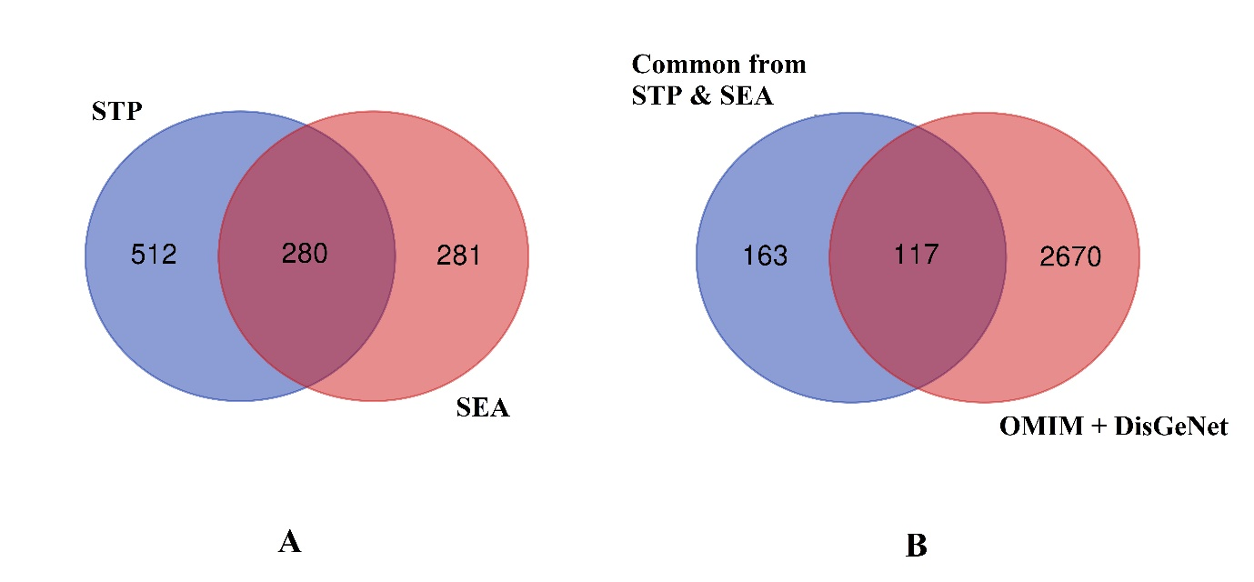

Additional Figure S2. Lollipop chart represents the counts of interacting phytochemicals with each of the targt proteins (A), and the prominent phytochemicals that modulated the major inflammatory markers (B).
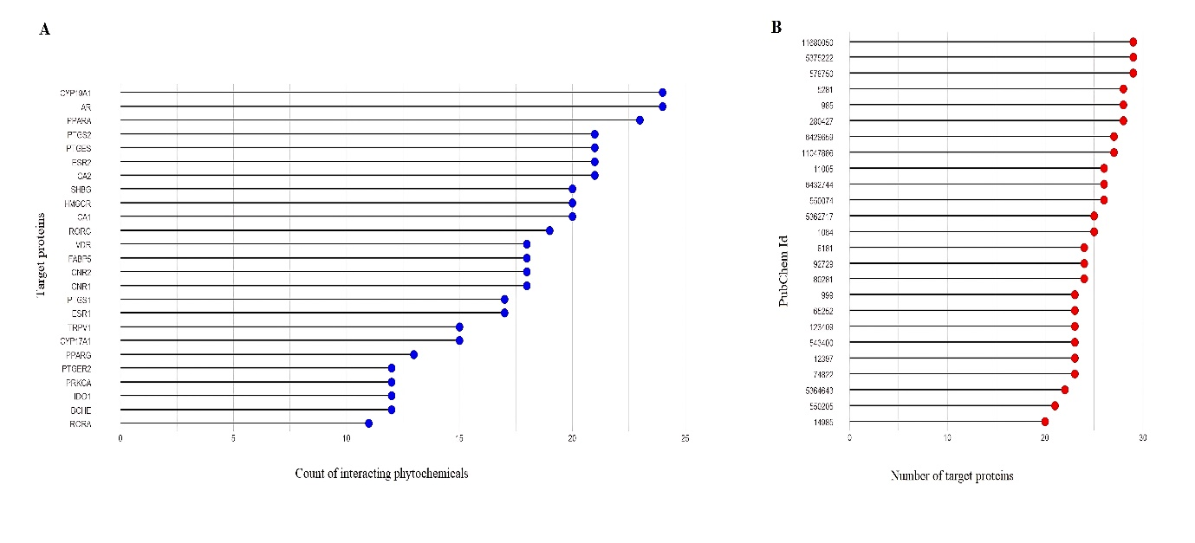

Additional Figure S3. Molecular docking 3D interaction between best docked active compounds and key targets proteins: (A) 1,3,4,5-tetrahydroxycyclohexanecarboxylic acid binds with ACE; (B) 1,3,4,5-tetrahydroxycyclohexanecarboxylic acid binds with AKT1; (C) 1,3,4,5-tetrahydroxycyclohexanecarboxylic acid binds with CASP3; (D) Ergost-5-en-3-ol, (3.beta.,24r) binds with COX-2; (E) 5-(7a-Isopropenyl-4,5-dimethyl-octahydroinden-4-yl)-3-methyl-pent-2-en-1-ol binds with ESR1; (F) 1,3,4,5-tetrahydroxycyclohexanecarboxylic acid binds with IL-6; (G) Beta.-d-Ribopyranoside, methyl, 3-acetate bind with MMP-9; (H) 9,12-Octadecadienoic acid (Z,Z)-, 2-hydroxy-1-(hydroxymethyl)ethyl ester binds with PPARA; (I) 9,12-Octadecadienoic acid (Z,Z)-, 2-hydroxy-1-(hydroxymethyl)ethyl ester binds with PPARG; (J) 1,3,4,5-tetrahydroxycyclohexanecarboxylic acid binds with TLR4; (K) Catechol binds with TNF-α; and (L) Catechol binds with VEGFA.
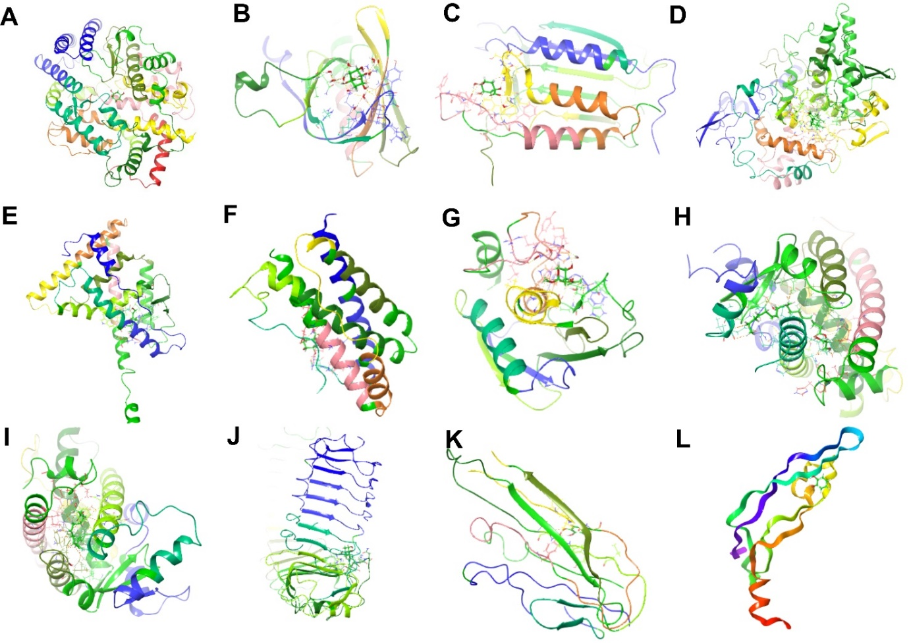

Additional Figure S4. Heat map represents the binding energies between the 41 active components of DME and the target proteins. The red colour represents higher binding interactions, and the yellow represents lower binding energies. The heat map is generated using RStudio 2022.07.1 Build 554.
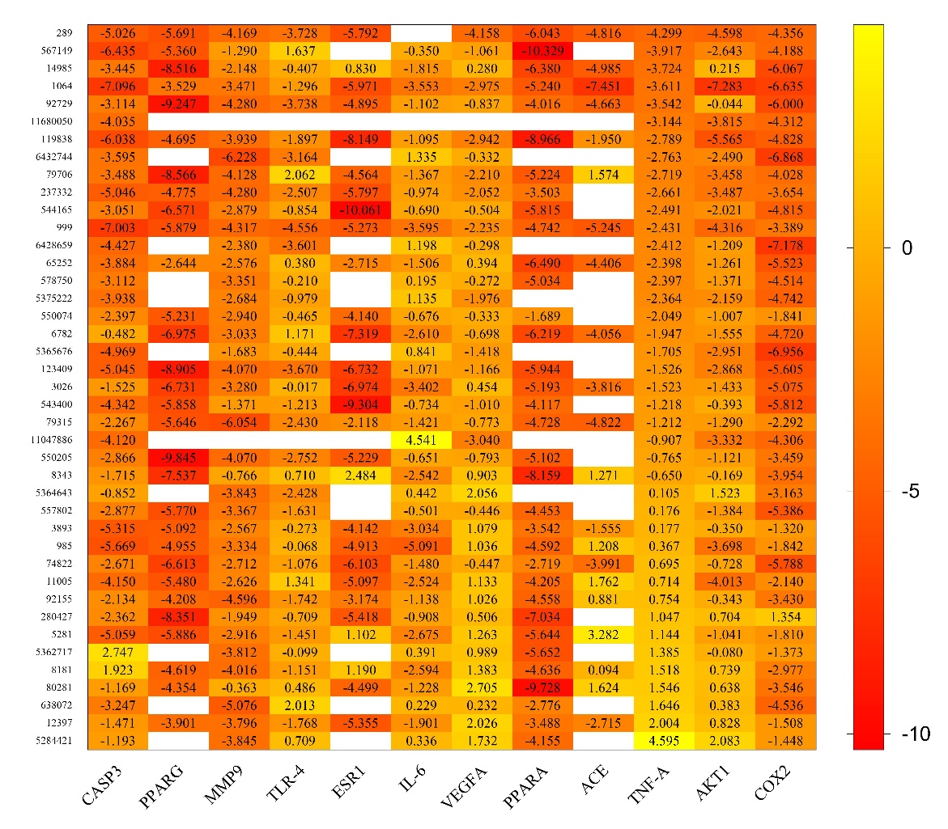

Additional Figure S5. Intermolecular interactions and timeline representation of the interactions and contacts (H-bonds, Hydrophobic, Ionic, Water bridges) made by target proteins with bioactive compounds during molecular dynamics simulations. A, B, and C represent the intermolecular interactions of target proteins AKT1, PPARA, and PPARG, respectively; D, E, and F represent the timeline interactions of AKT1, PPARA, and PPARG, respectively.
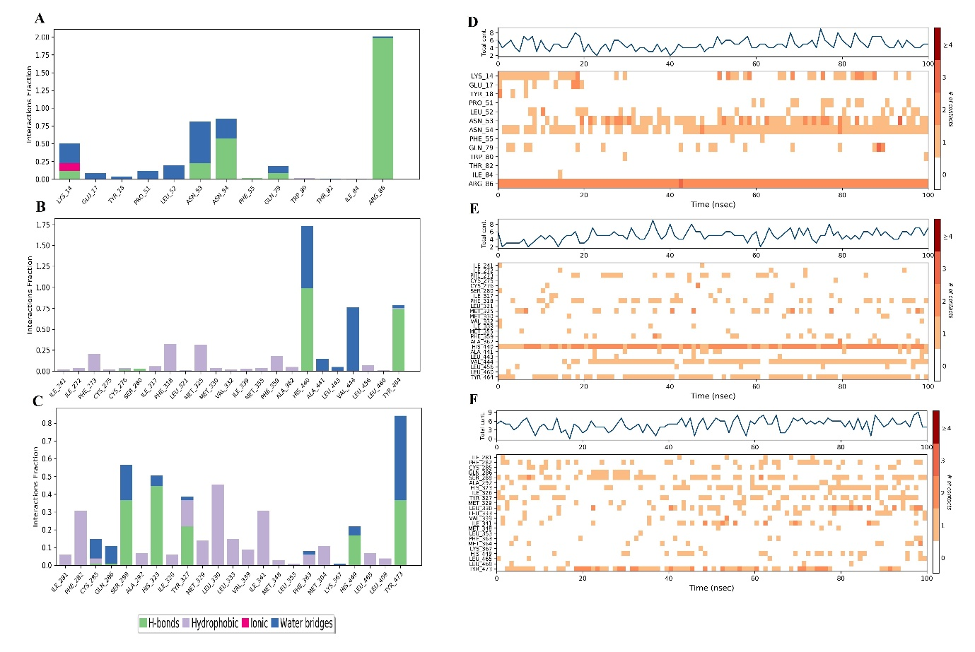

Additional Figure S6. Schematic representation of the interactions between AKT1 with ligand 1,3,4,5-Tetrahydroxycyclohexanecarboxylic acid (PubChem Id: 1064) by ligand interaction diagram: (A) 0 ns, (B) 10 ns, (C) 20 ns, (D) 30 ns, (E) 40 ns, (F) 50 ns, (G) 60 ns, (H) 70 ns, (I) 80 ns, (J) 90 ns, (K) 100 ns.
A)
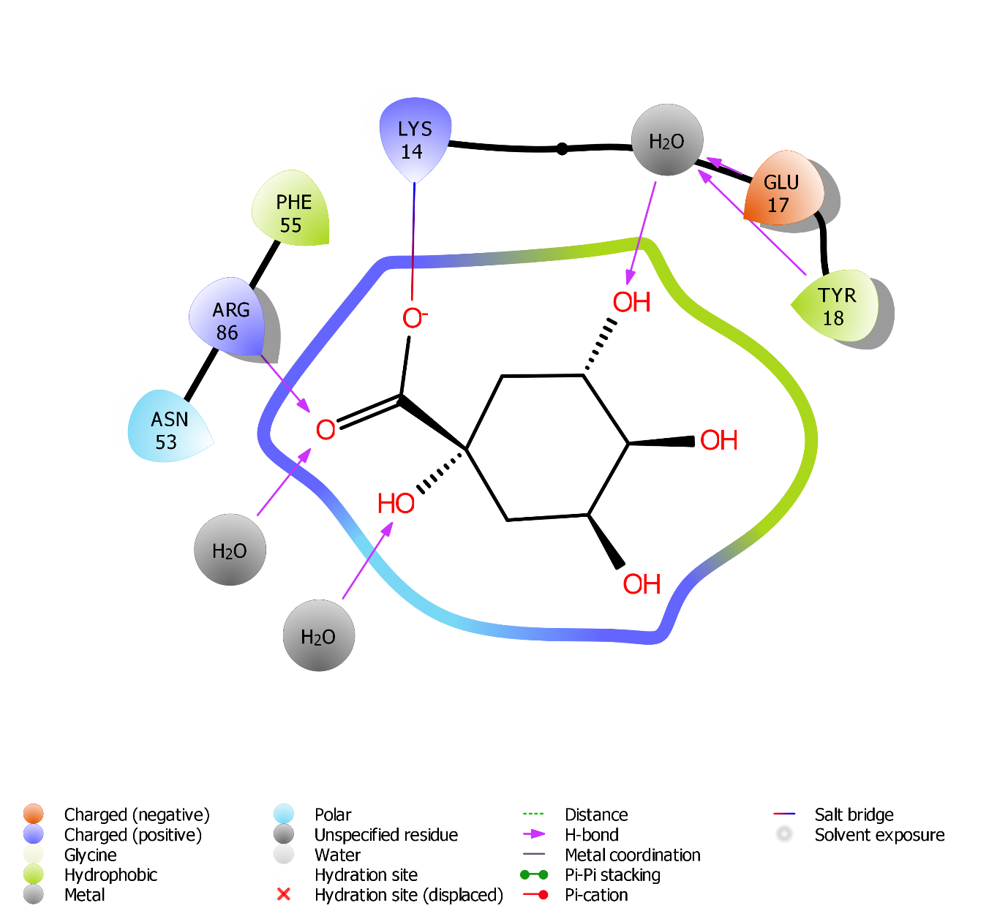

B)
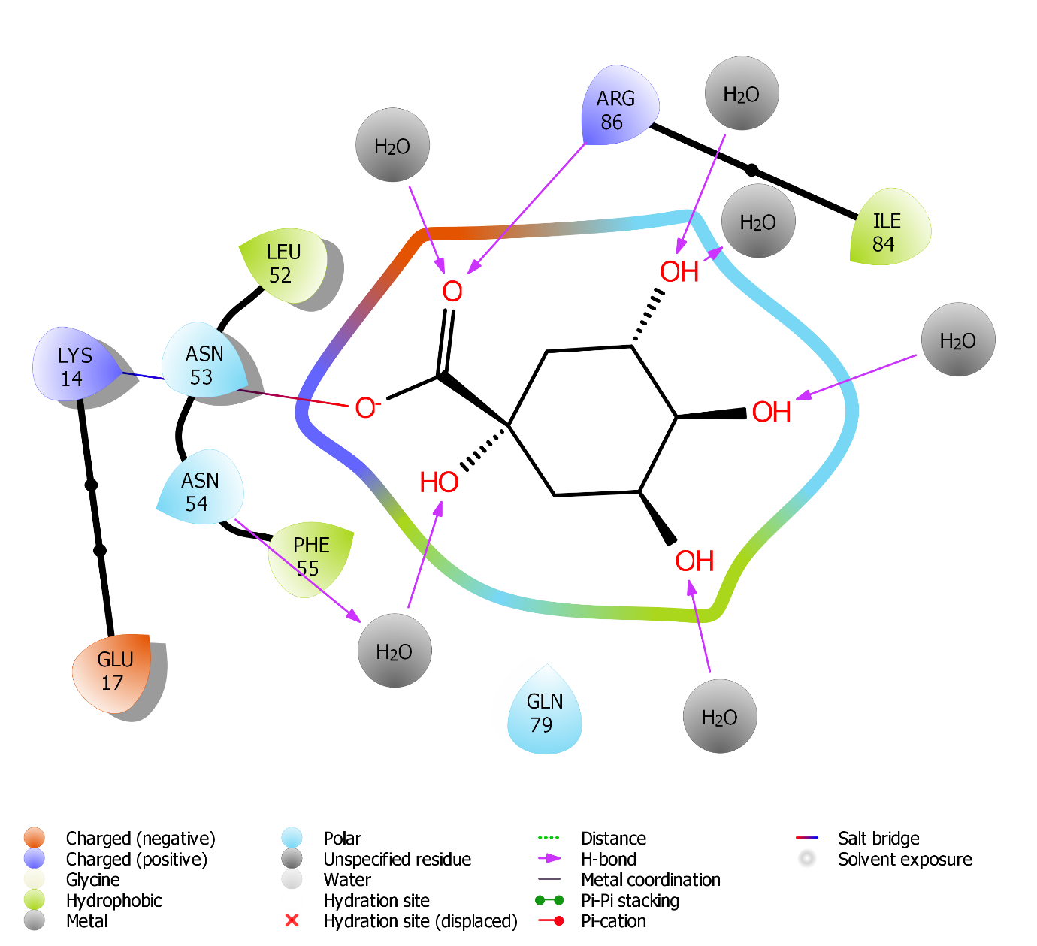

C)
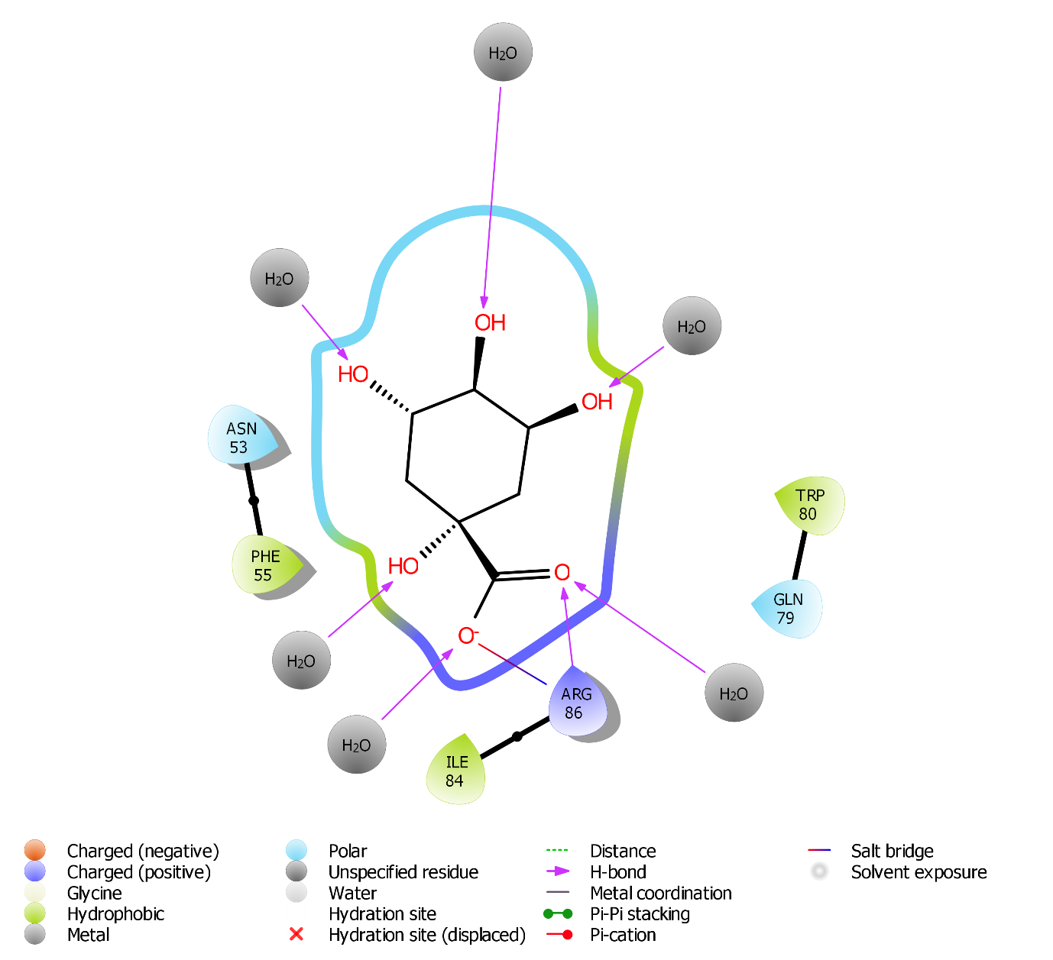

D)
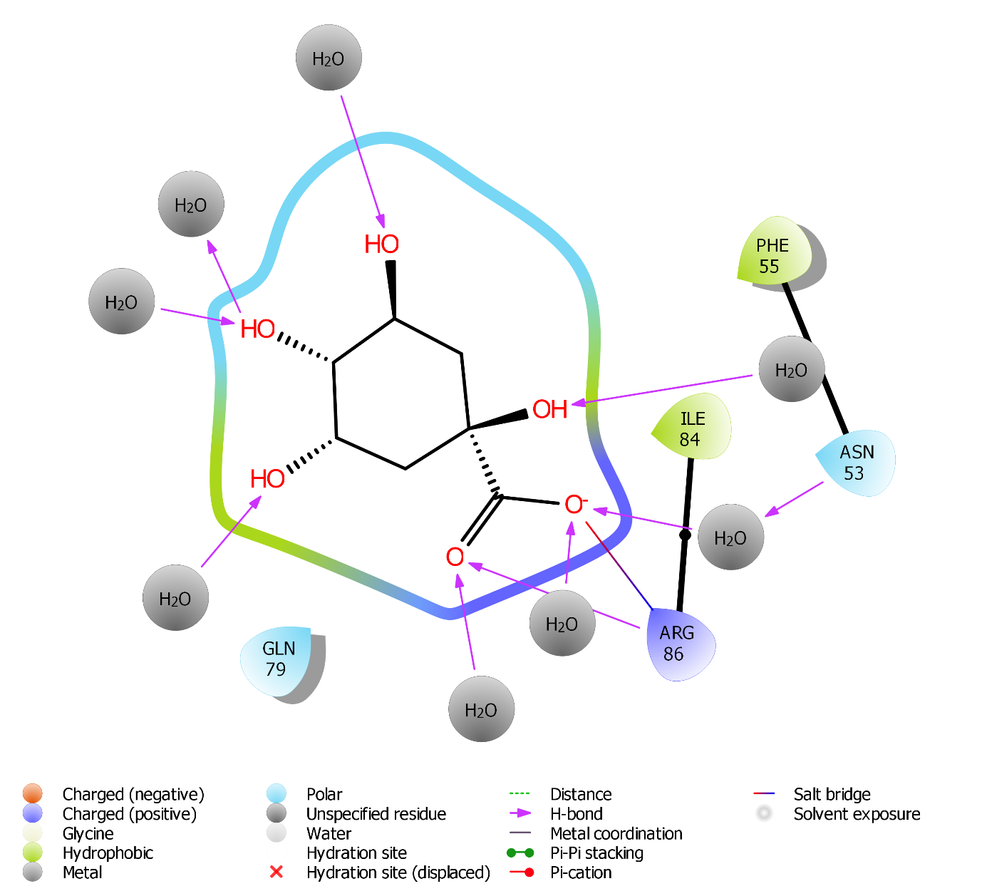
E)
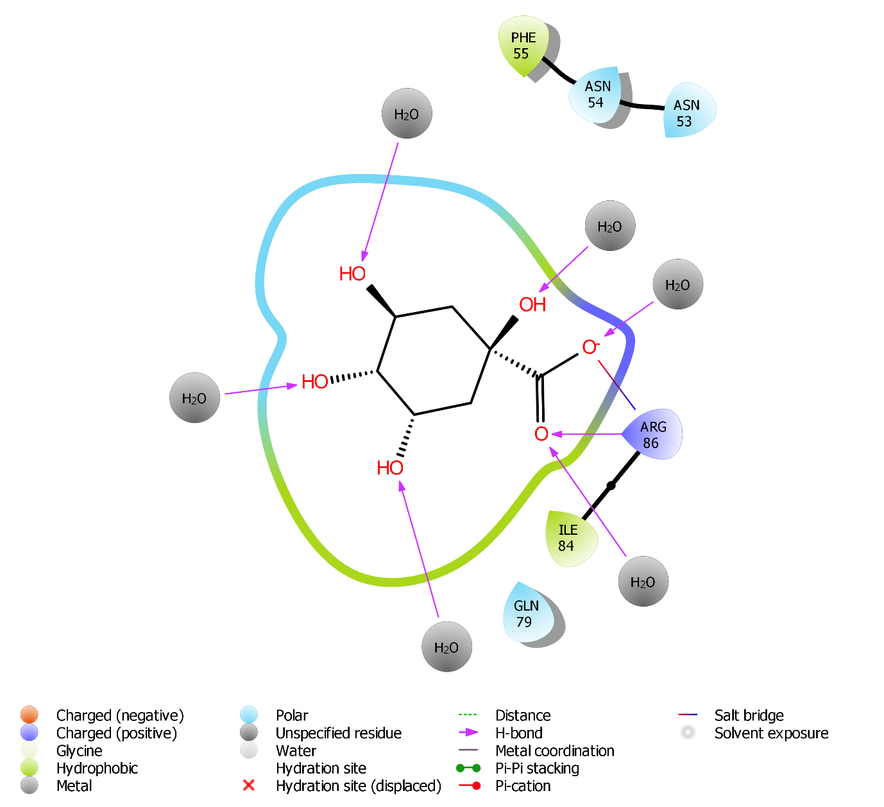

F)
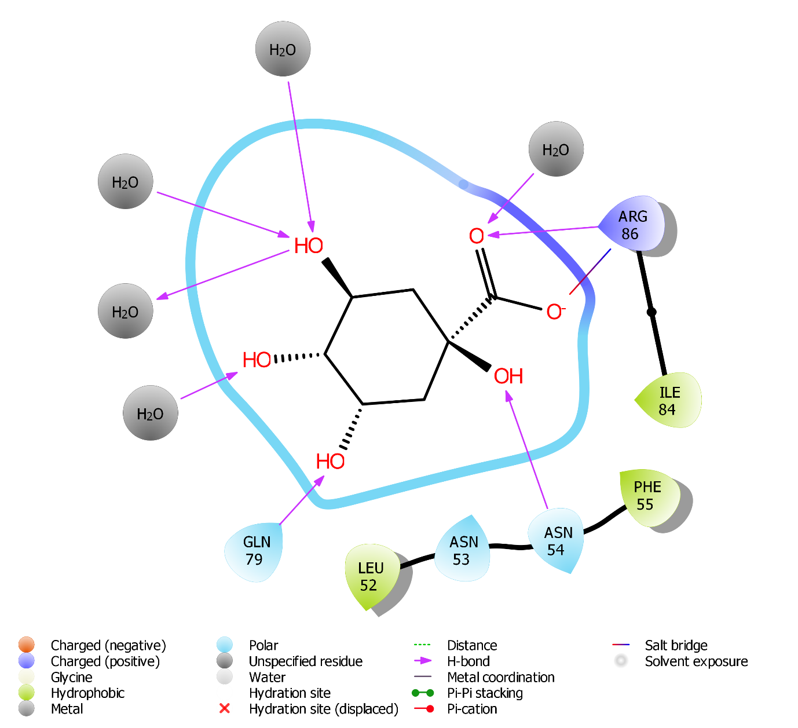

G)
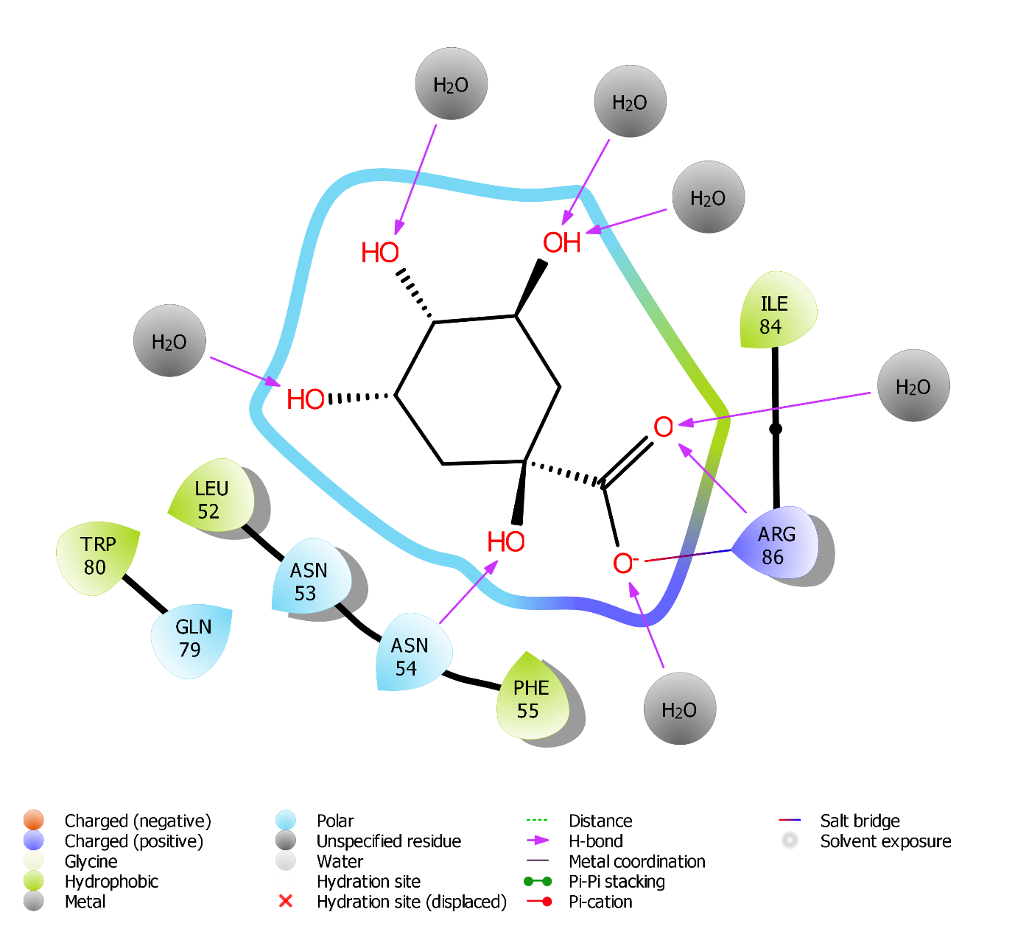

H)
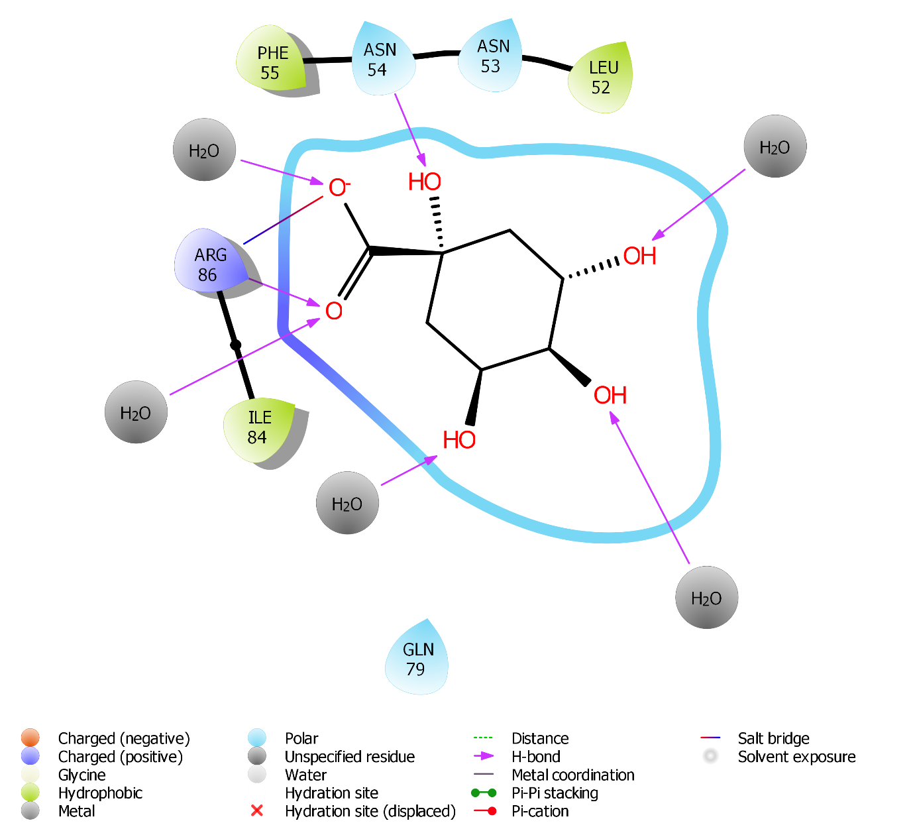

I)
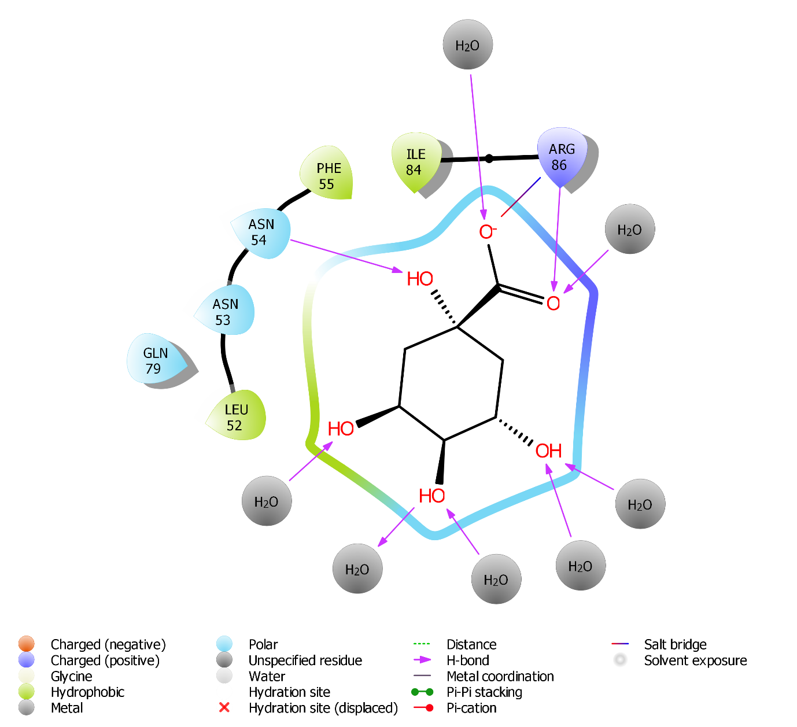

J)
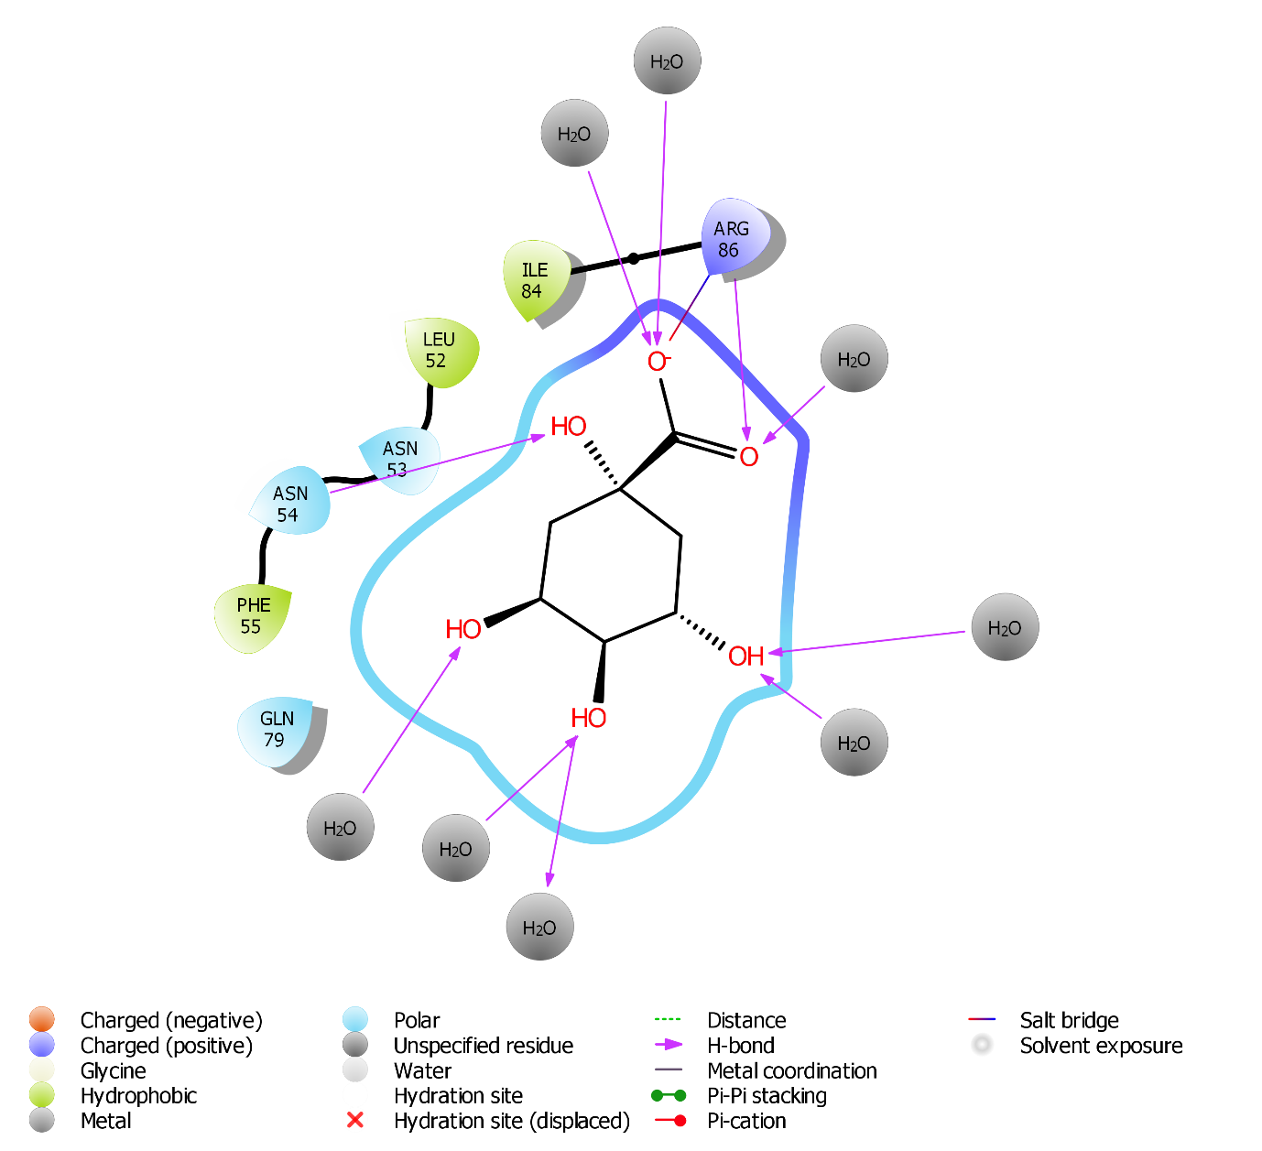

K)
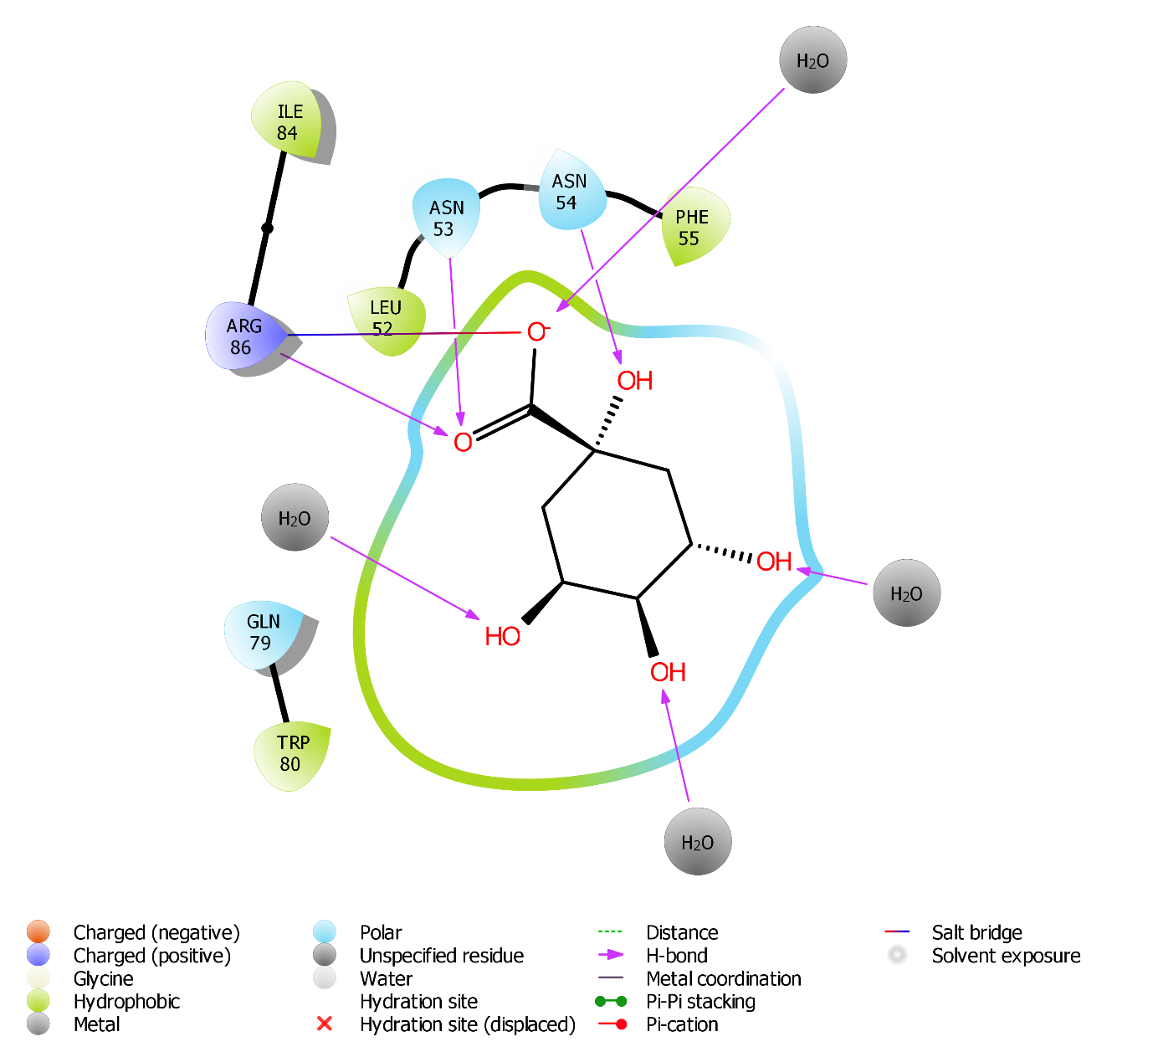

Additional Figure S7. Schematic representation of the interactions between PPARG with ligand 9,12-Octadecadienoic acid (Z, Z)-, 2-hydroxy-1-(hydroxymethyl) ethyl ester (PubChem Id: 5365676) by ligand interaction diagram: (A) 0 ns, (B) 10 ns, (C) 20 ns, (D) 30 ns, (E) 40 ns, (F) 50 ns, (G) 60 ns, (H) 70 ns, (I) 80 ns, (J) 90 ns, (K) 100 ns.
A)
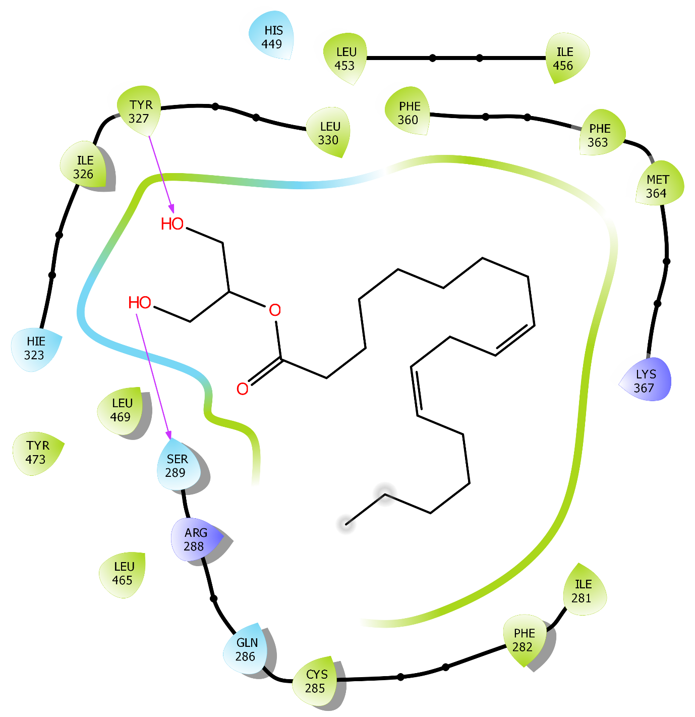

B)
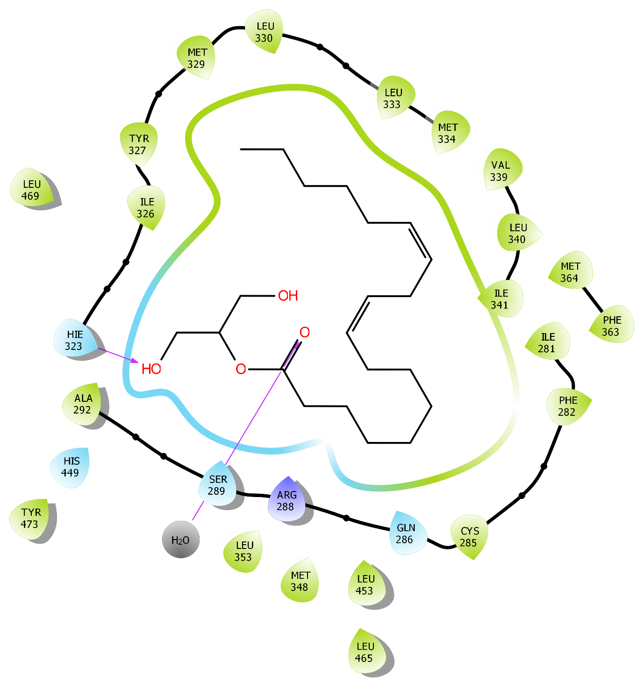

C)
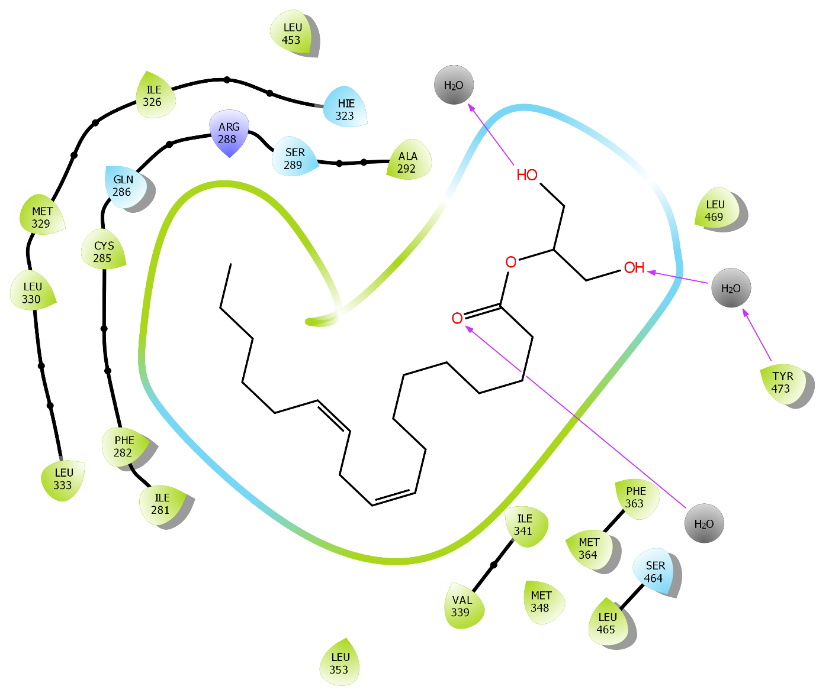

D)
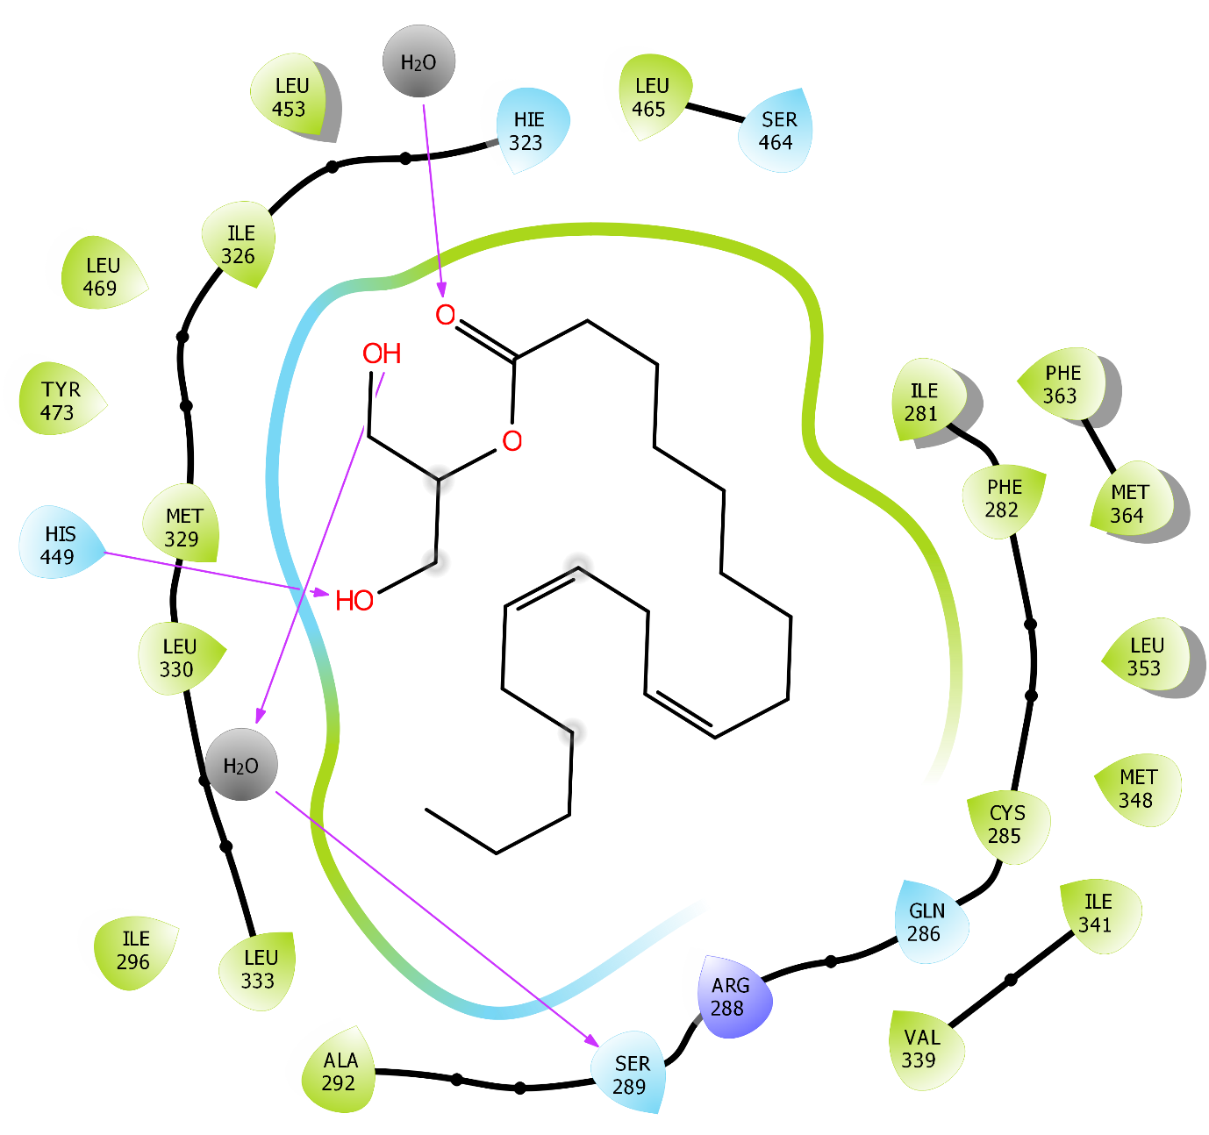

E)
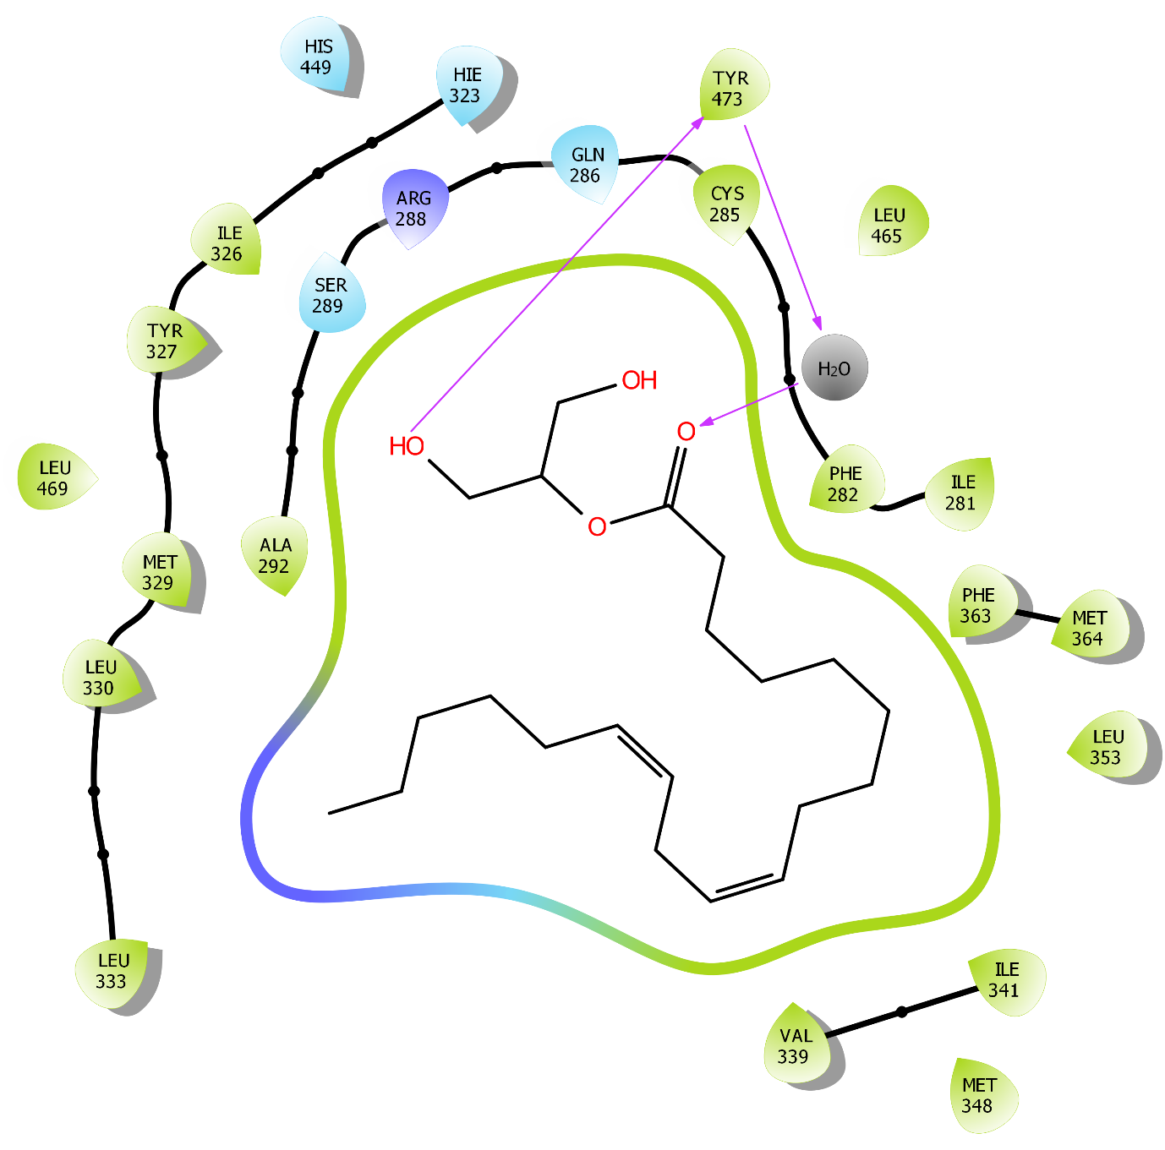

F)
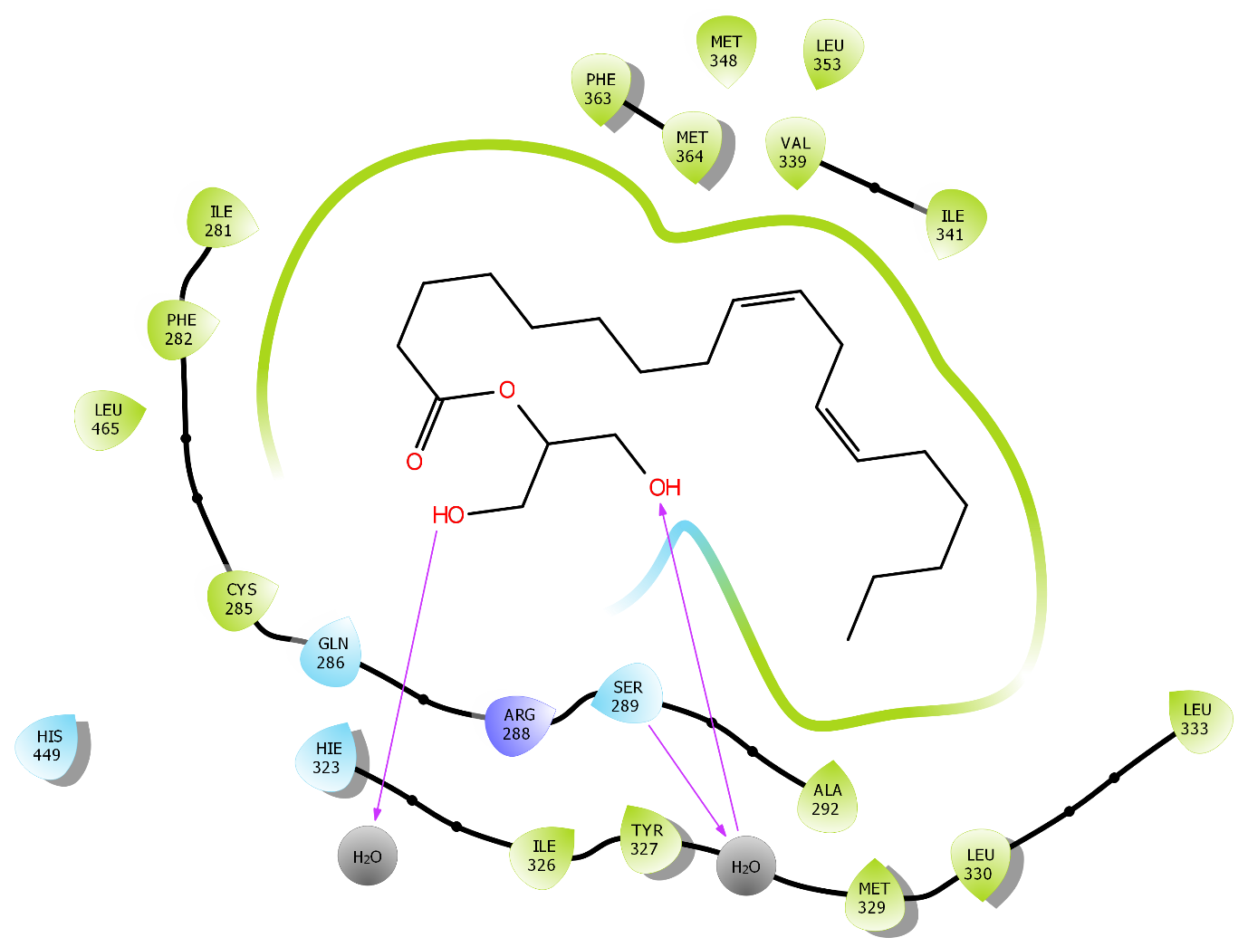

G)
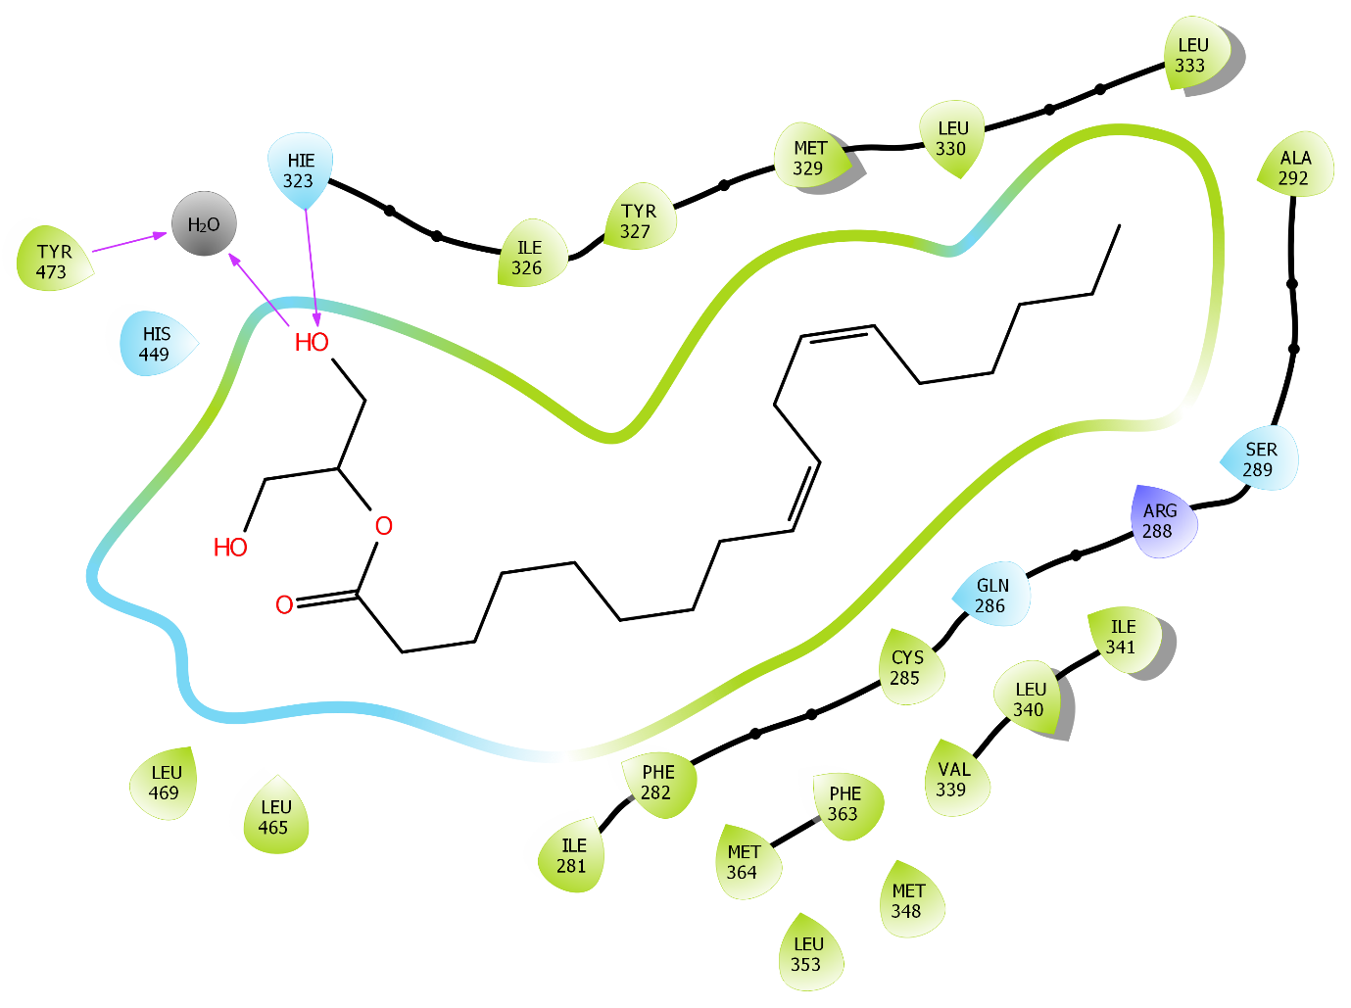

H)
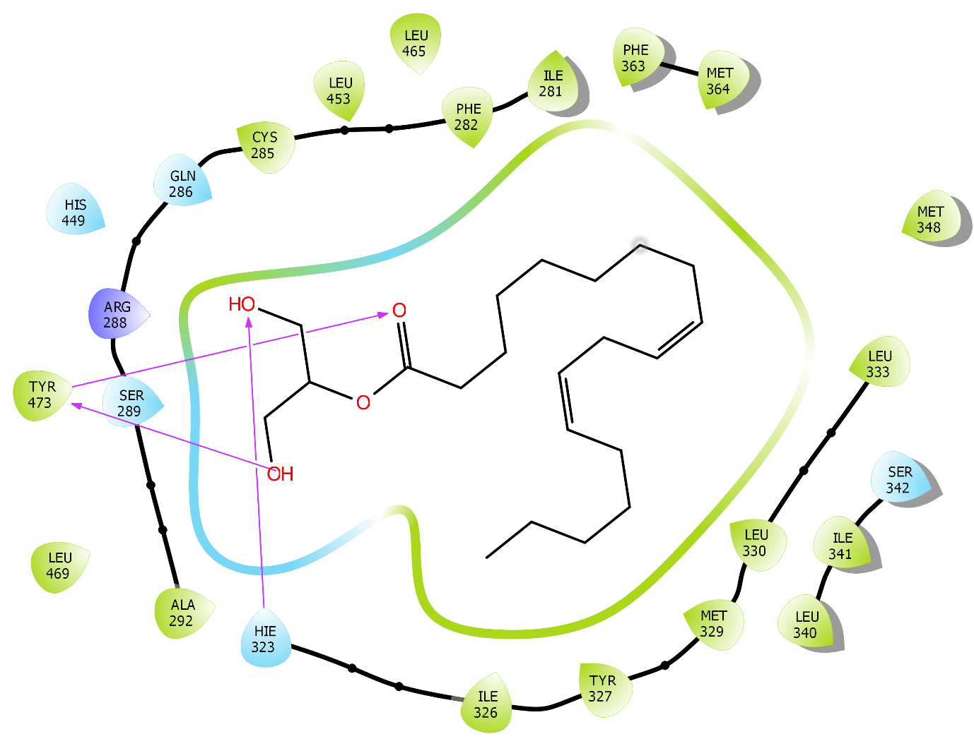

I)
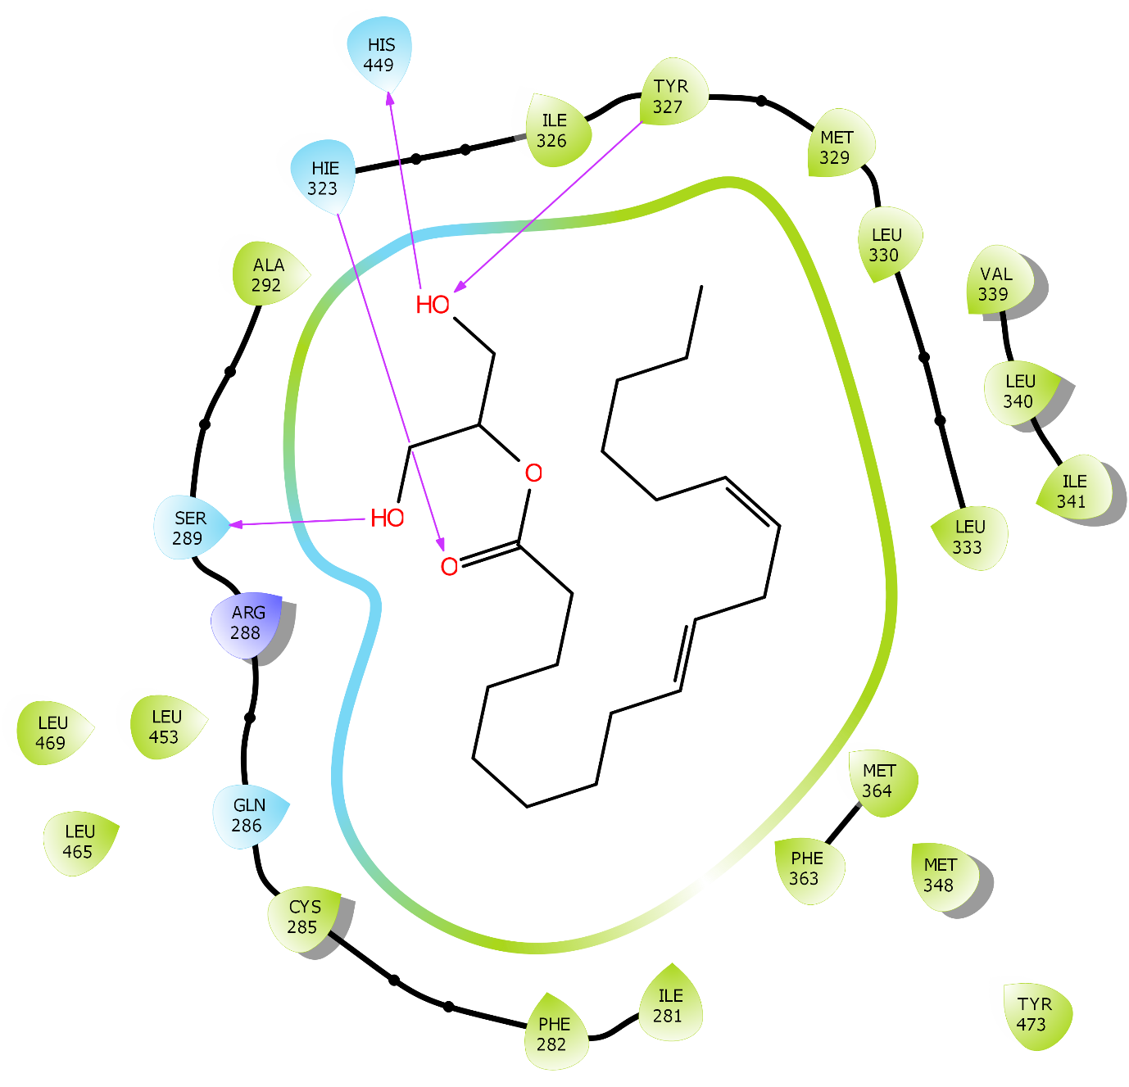

J)

K)
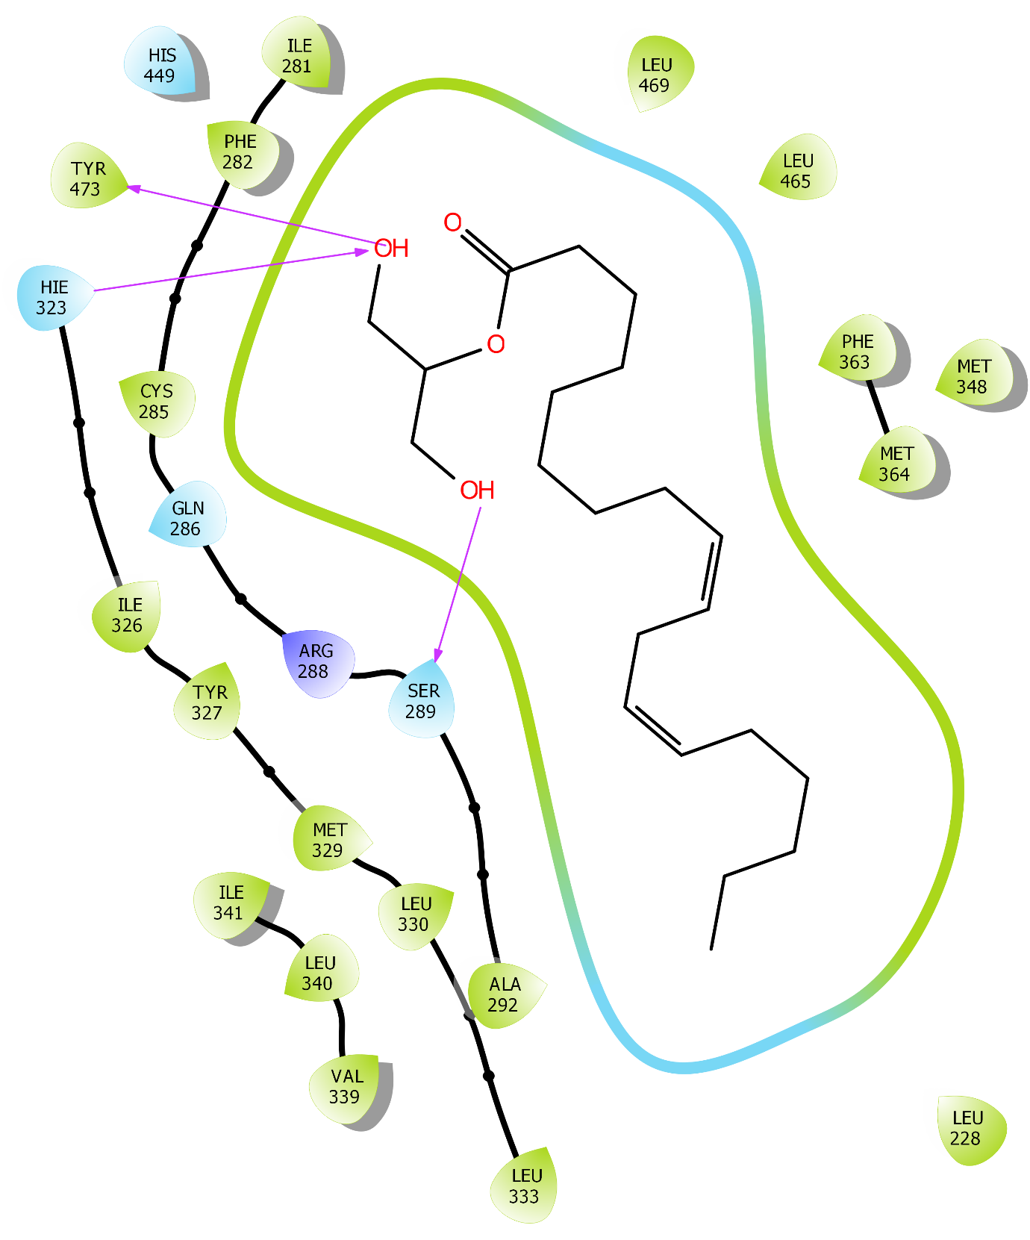

Additional Figure S8. Schematic representation of the interactions between PPARA with ligand 9,12-Octadecadienoic acid (Z, Z)-, 2-hydroxy-1-(hydroxymethyl) ethyl ester (PubChem Id: 5365676) by ligand interaction diagram: (A) 0 ns, (B) 10 ns, (C) 20 ns, (D) 30 ns, (E) 40 ns, (F) 50 ns, (G) 60 ns, (H) 70 ns, (I) 80 ns, (J) 90 ns, (K) 100 ns.
A)
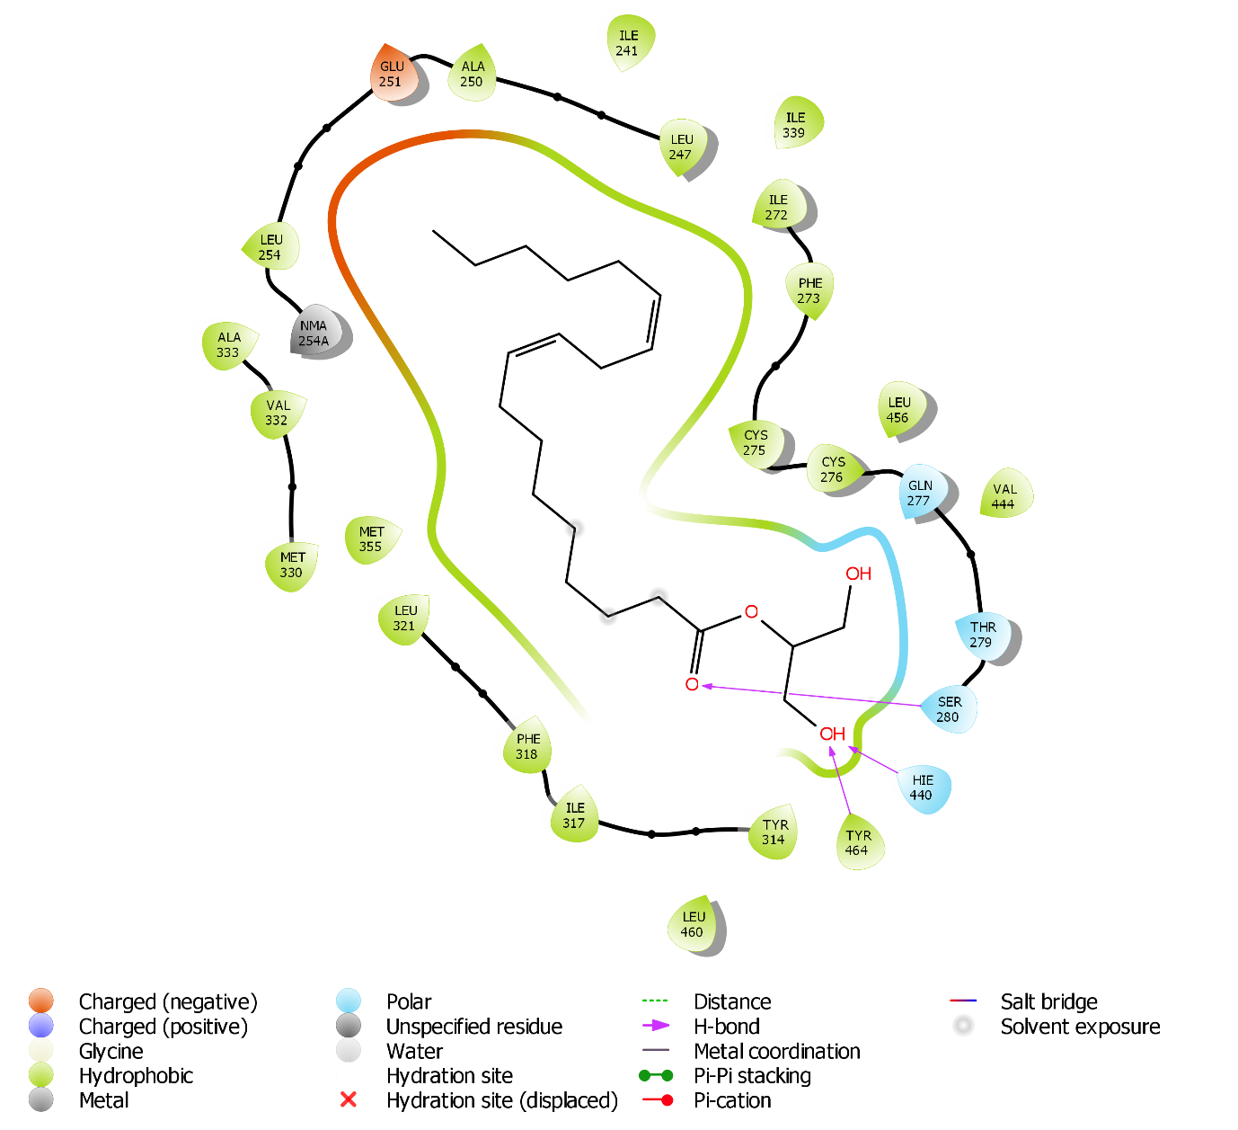

B)
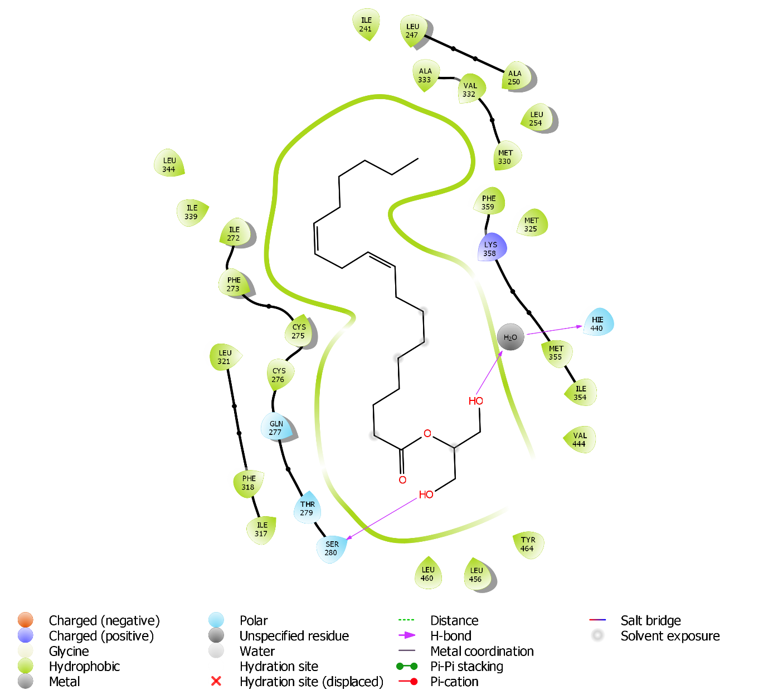

C)
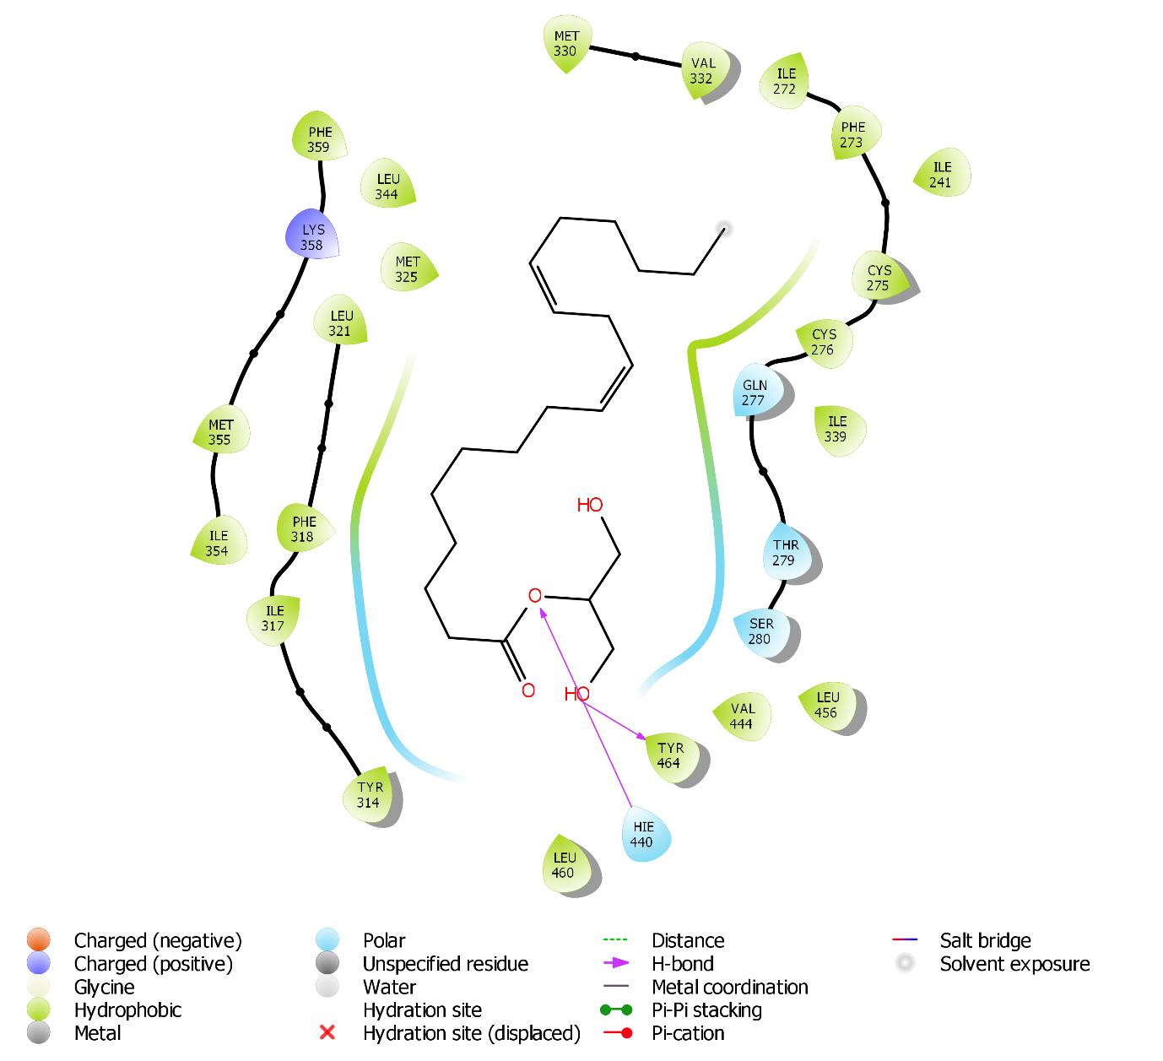

D)
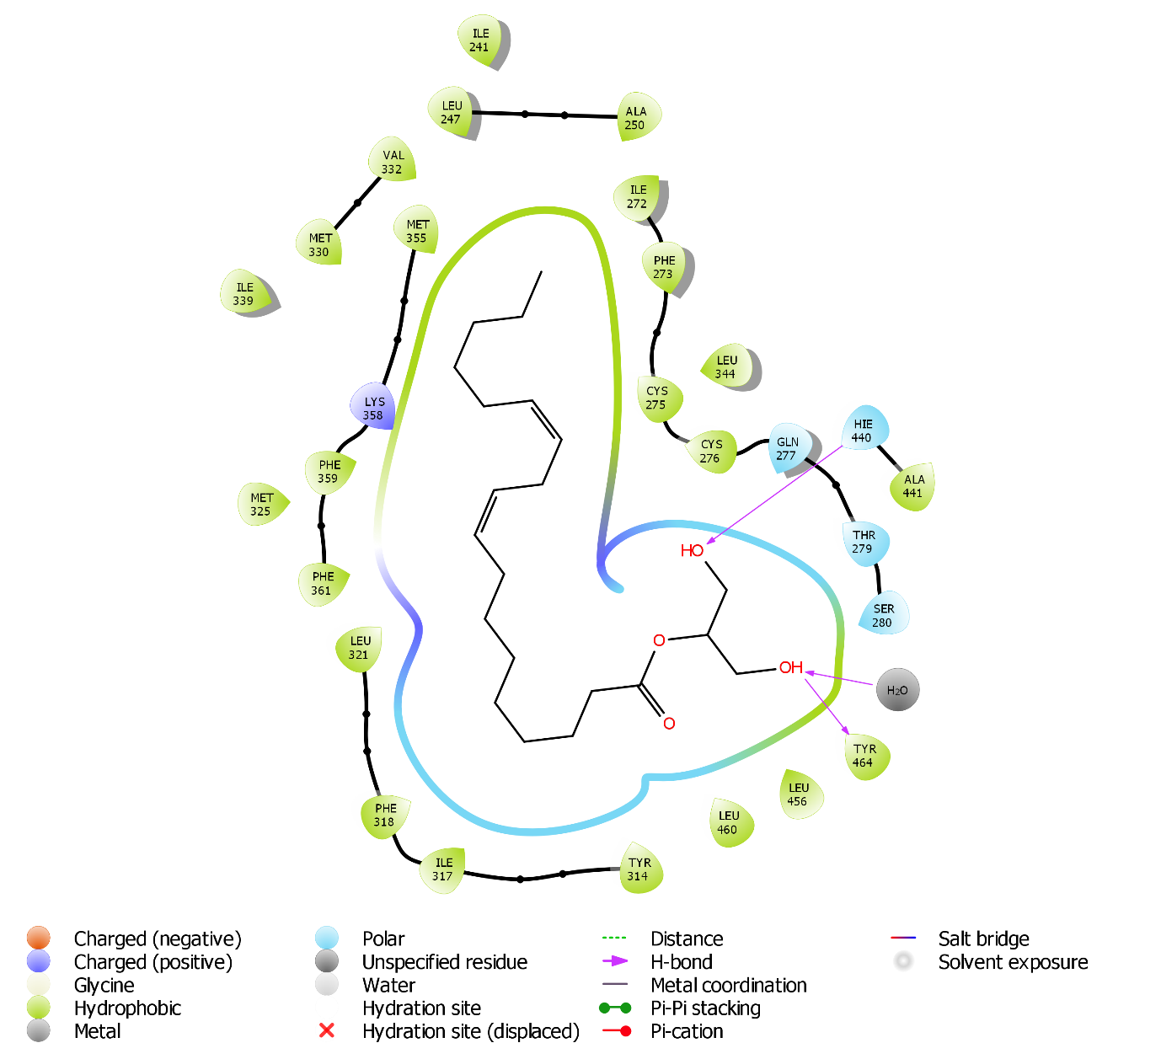

E)
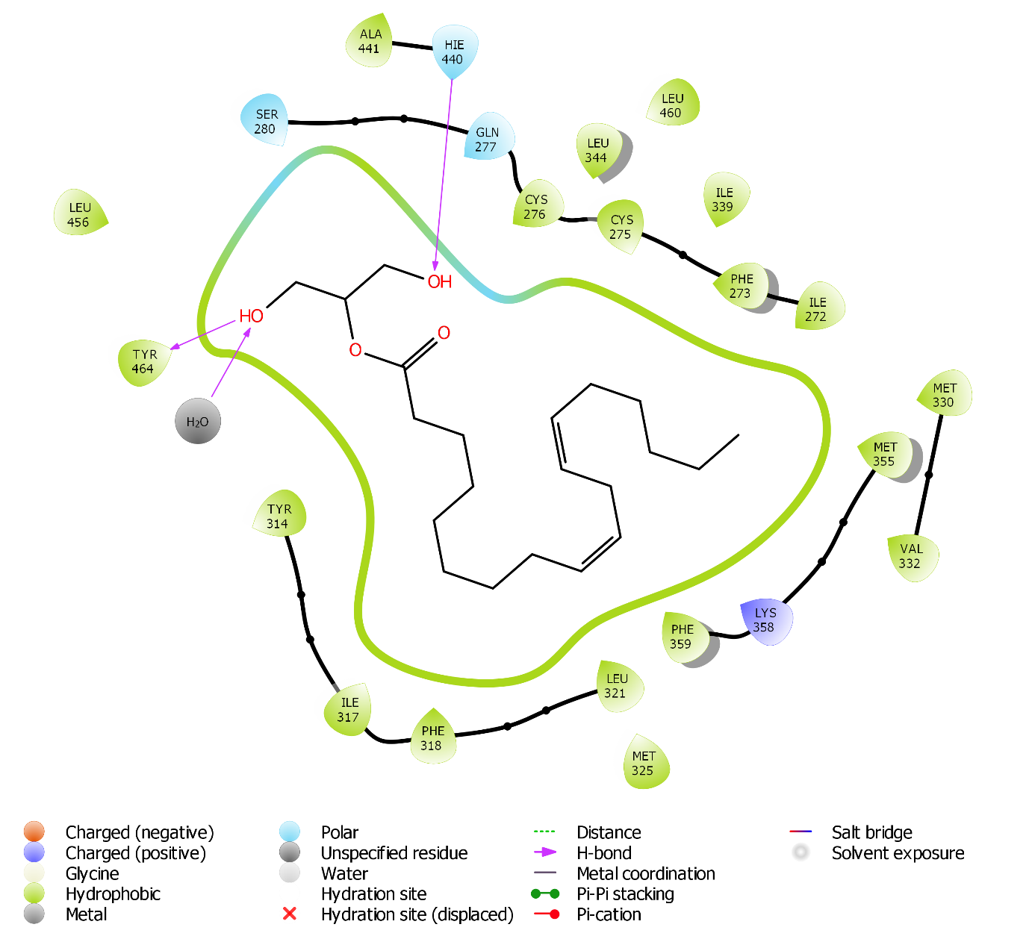

F)
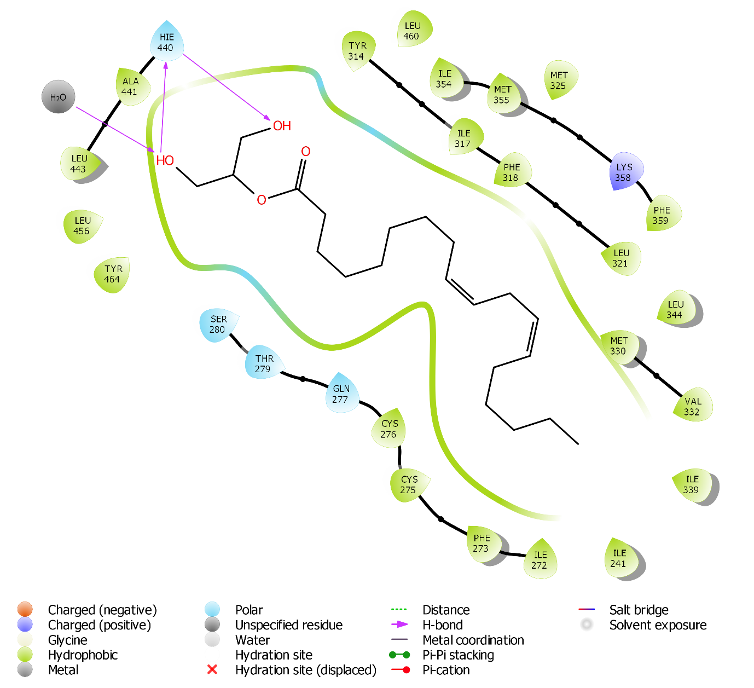

G)
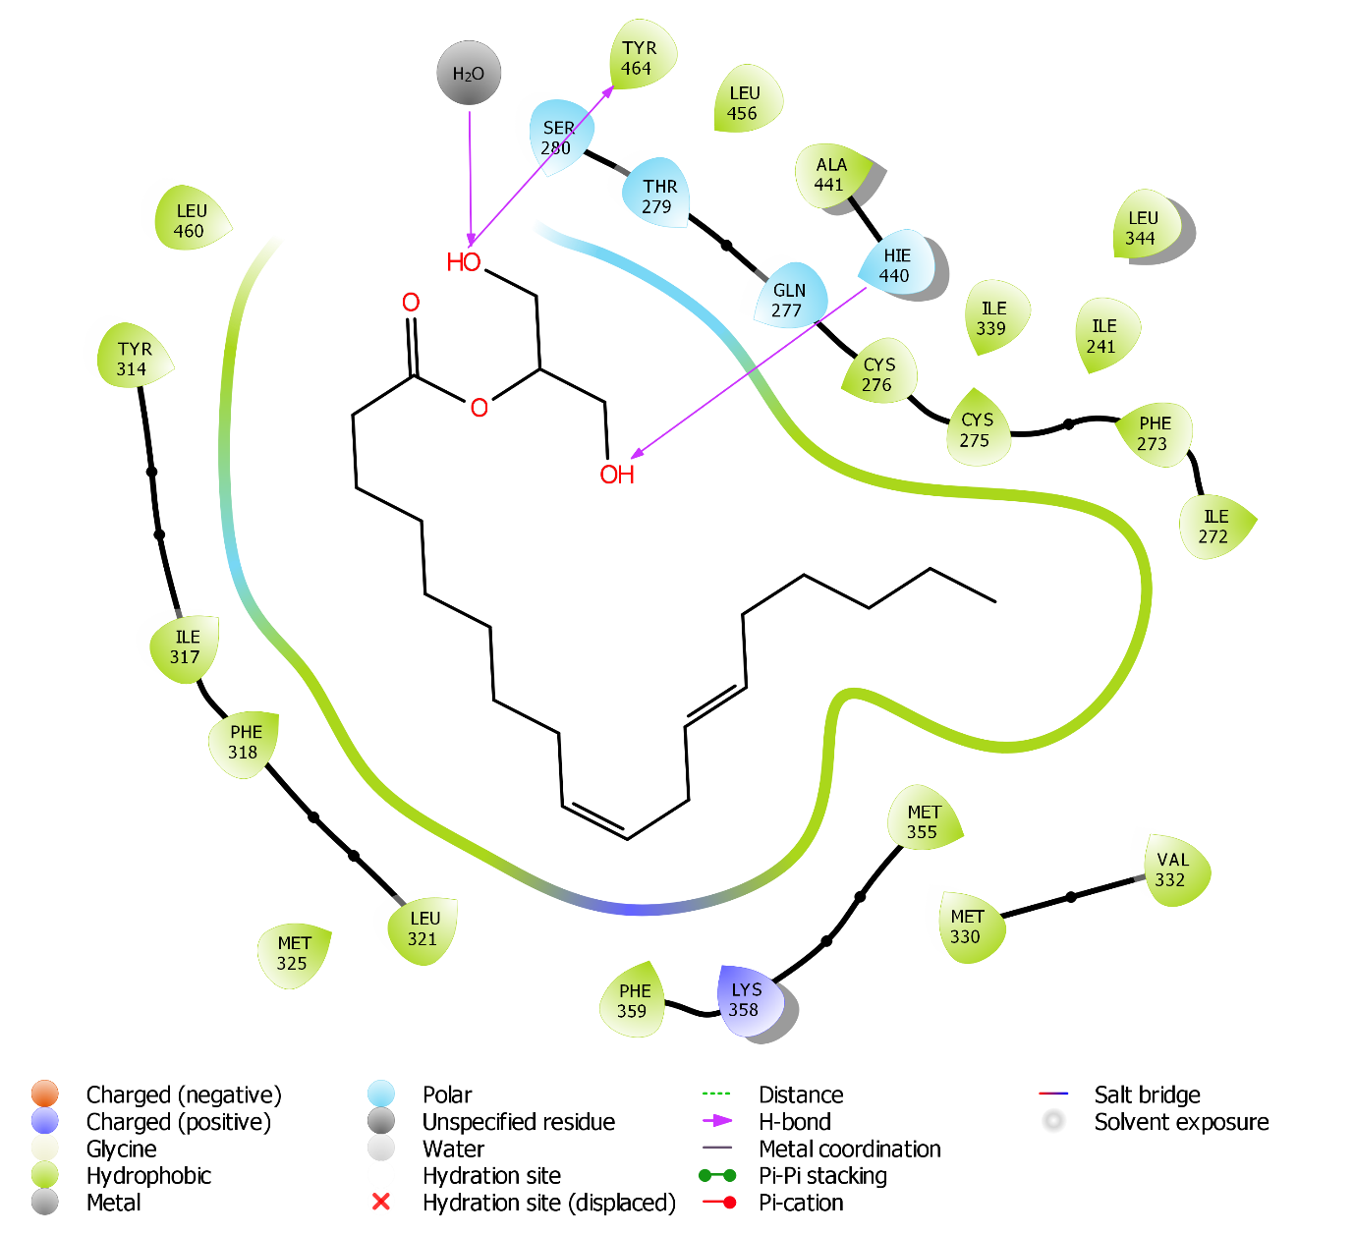

H)
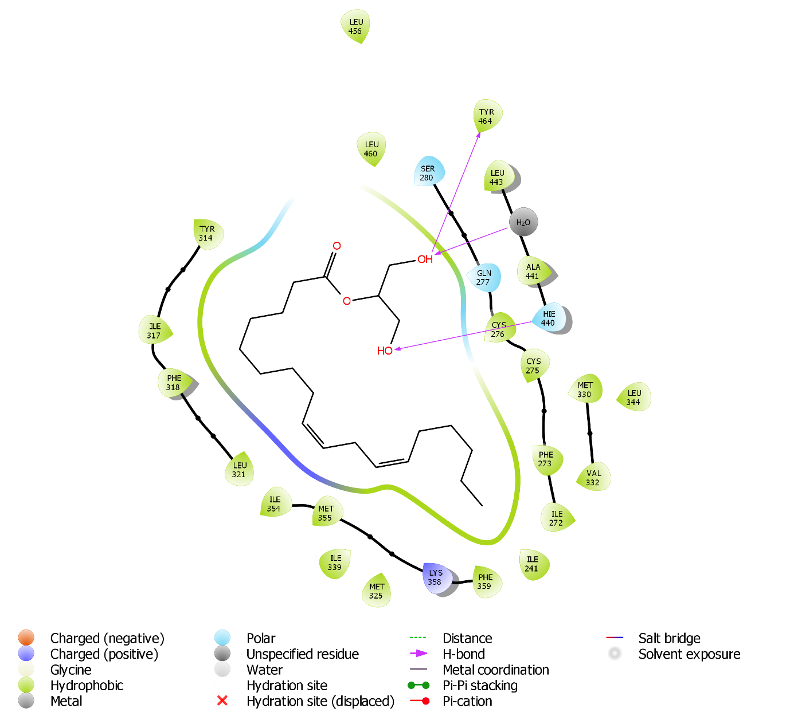

I)
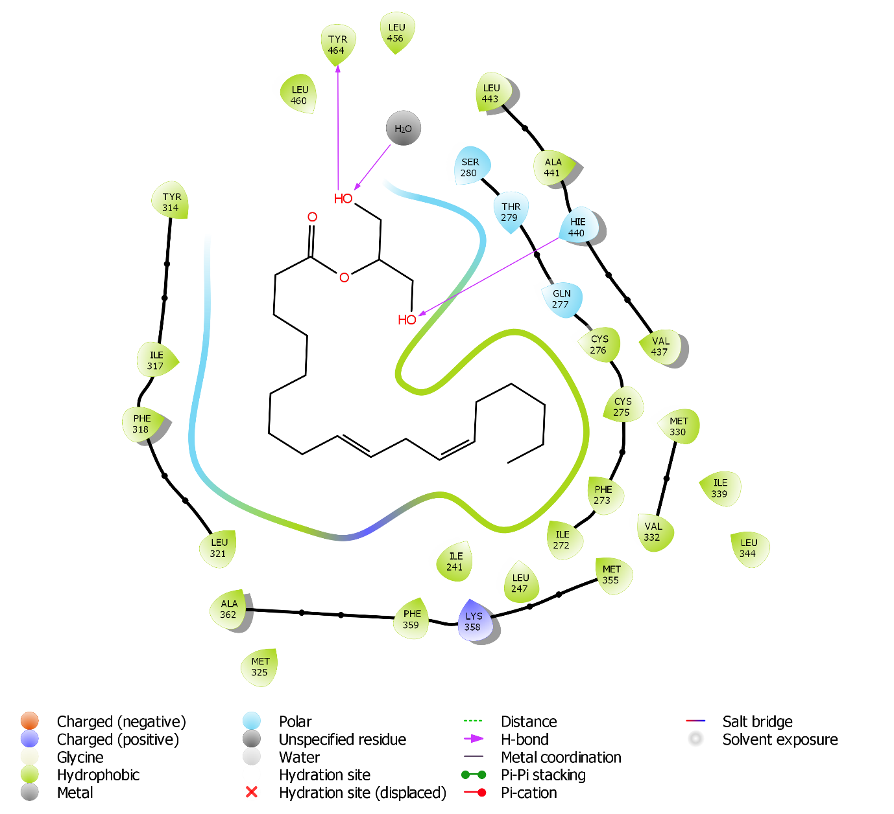

J)
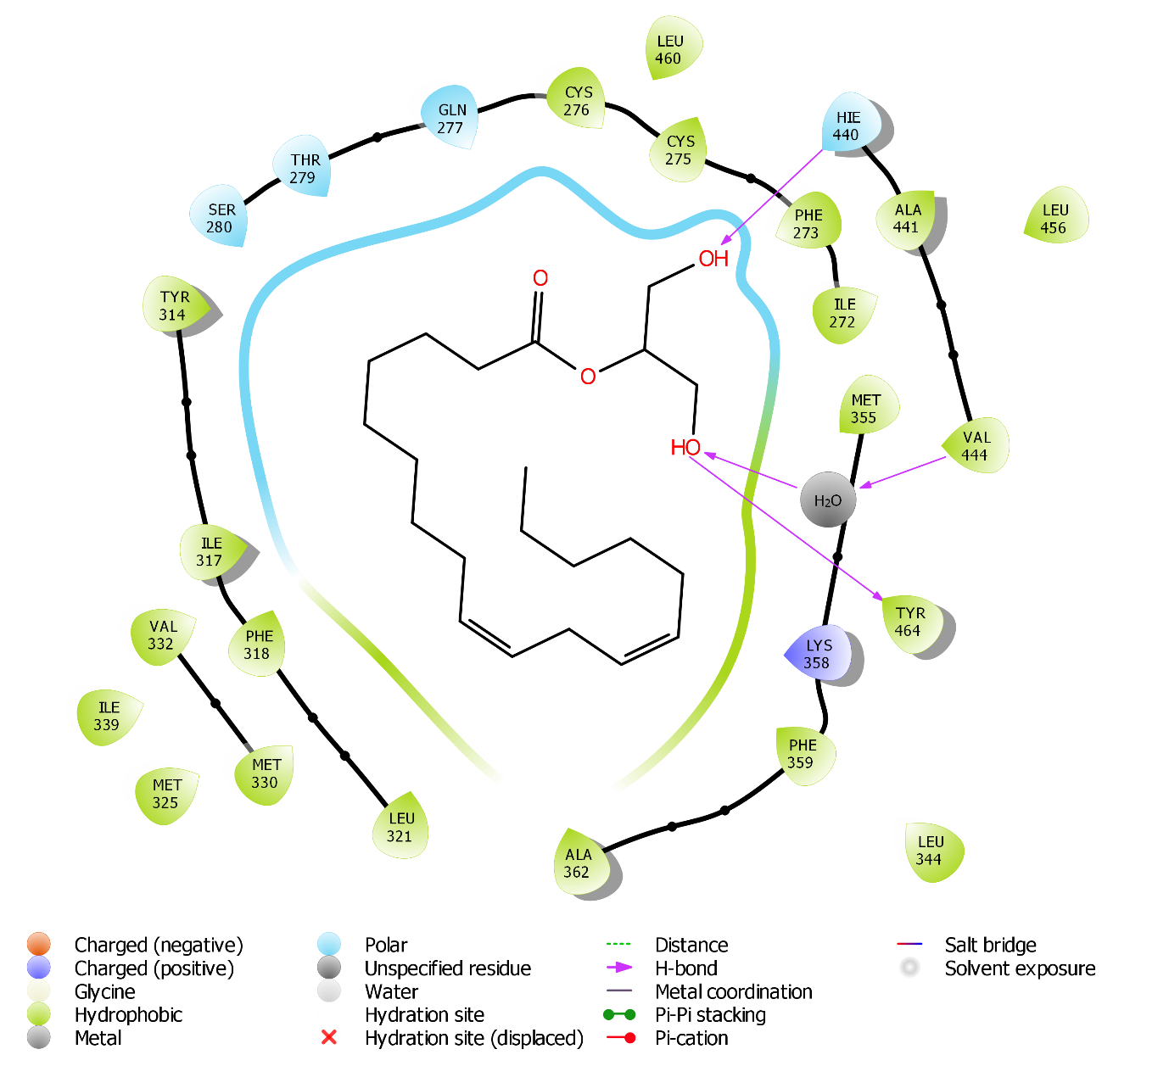

K)
