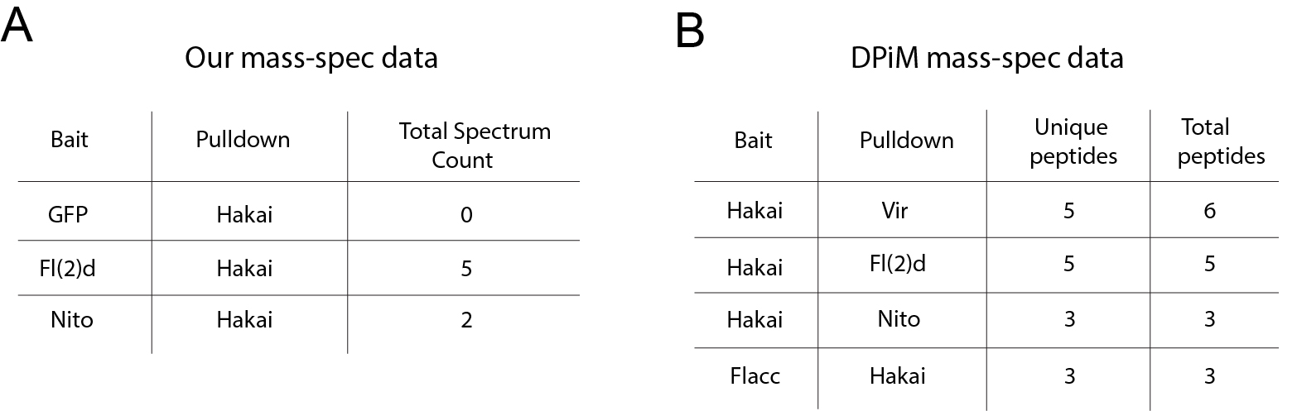

Figure S1. Interactions between Hakai and other m⁶A writer components from Mass-spec data
(A) In our previous mass-spec experiments, using Fl(2)d and Nito, but not GFP, as baits can pull down Hakai. (B) From DPiM mass-spec dataset, Hakai as a bait can pull down Vir, Fl(2)d and Nito, while Flacc as a bait can pull down Hakai. Unique and total peptides pulled were shown.

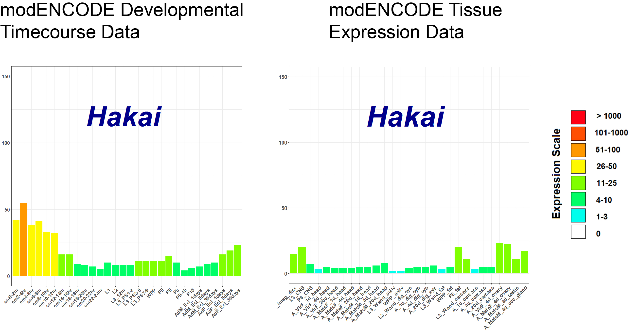

Figure S2. Expression of Hakai transcripts across modENCODE data
RPKM measurements of Hakai from modENCODE developmental timecourse and tissue expression dataset.

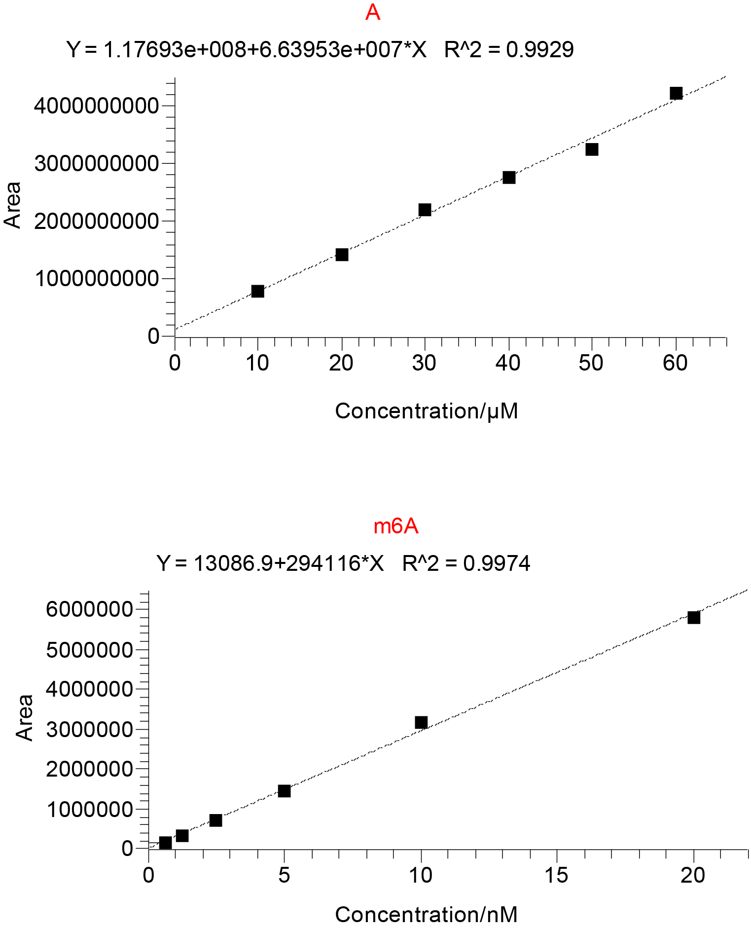
Figure S3. Calibration curves for m⁶A quantification
Standard calibration curves for detection of adenosine (A) and N6-methyladenosine (m⁶A) used for absolute quantifications.

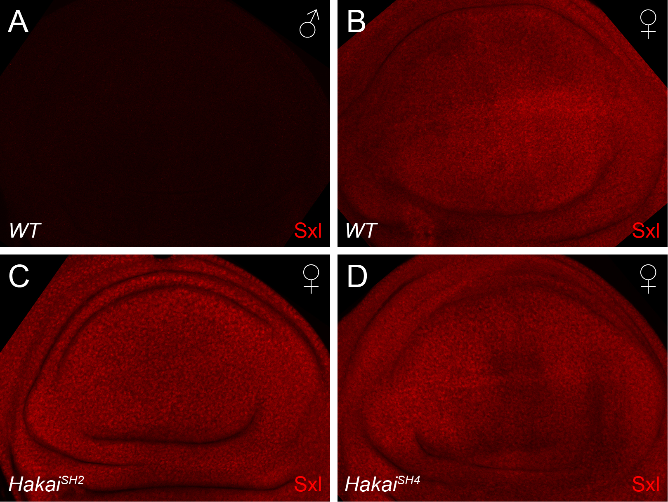

Figure S4. Hakai is not required for Sxl levels in discs
In wild-type, Sxl protein is only expressed in female (B), but not male (A) wing discs, as shown by Sxl antibody staining. (C-D) Sxl protein levels are not reduced in Hakai^{SH2} and Hakai^{SH4} female discs.

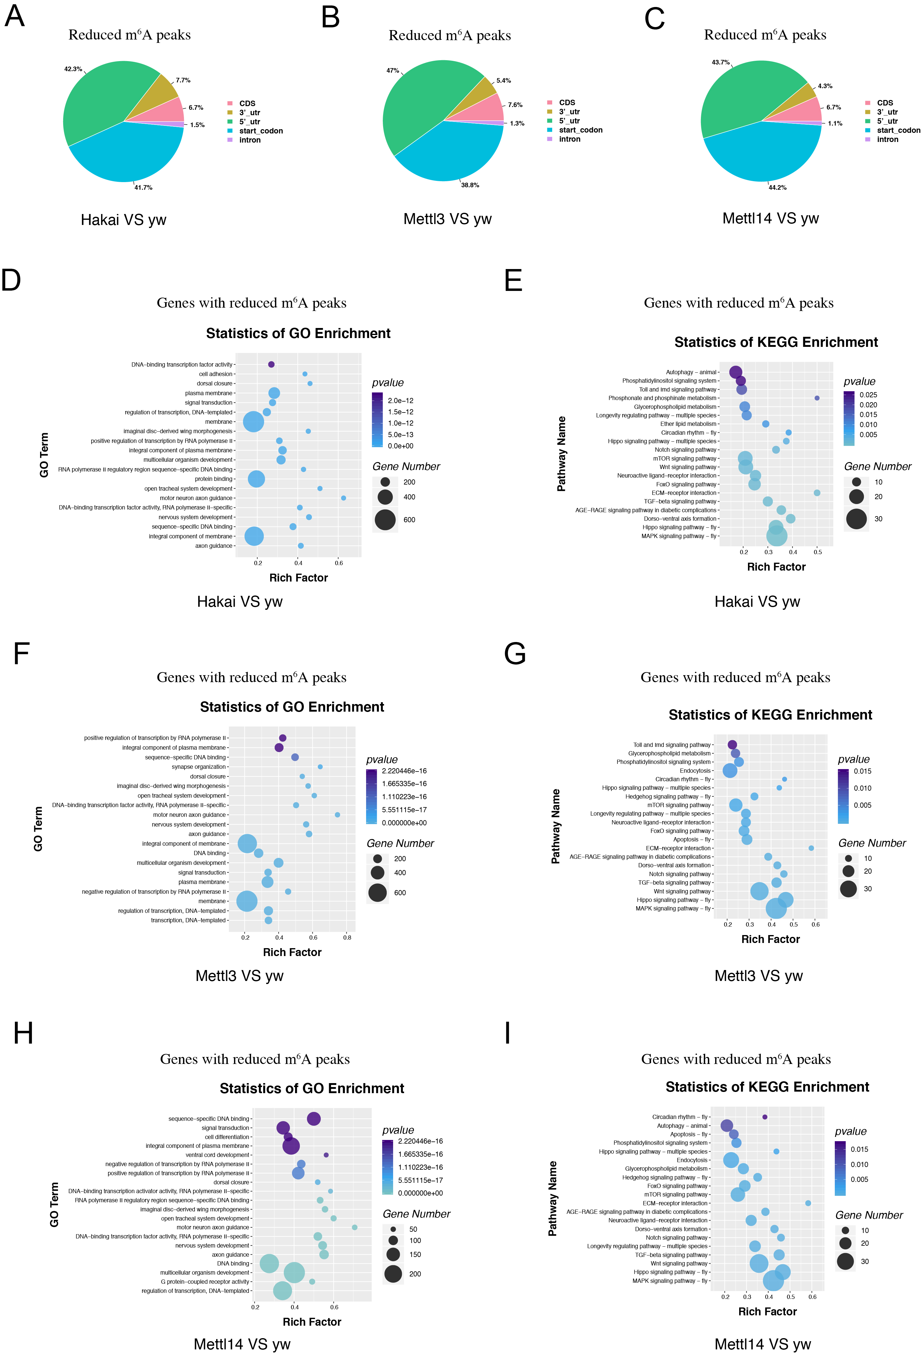
Figure S5. Distribution of reduced m⁶A peaks in Mettl3, Mettl14, and Hakai mutants and their gene enrichment analysis
(A-C) Pie charts depicting the distribution of reduced m⁶A peaks (p<0.05 and fold change ≤0.5) in different transcript segments in Mettl3 (B), Mettl14 (C), and Hakai (A) mutants versus yw control. (D, F, H) GO term and (E, G, I) KEGG pathway analysis of genes with reduced m⁶A peaks in Mettl3 (F, G), Mettl14 (H, I), and Hakai (D, E) mutants against yw flies. The top 20 terms are displayed.

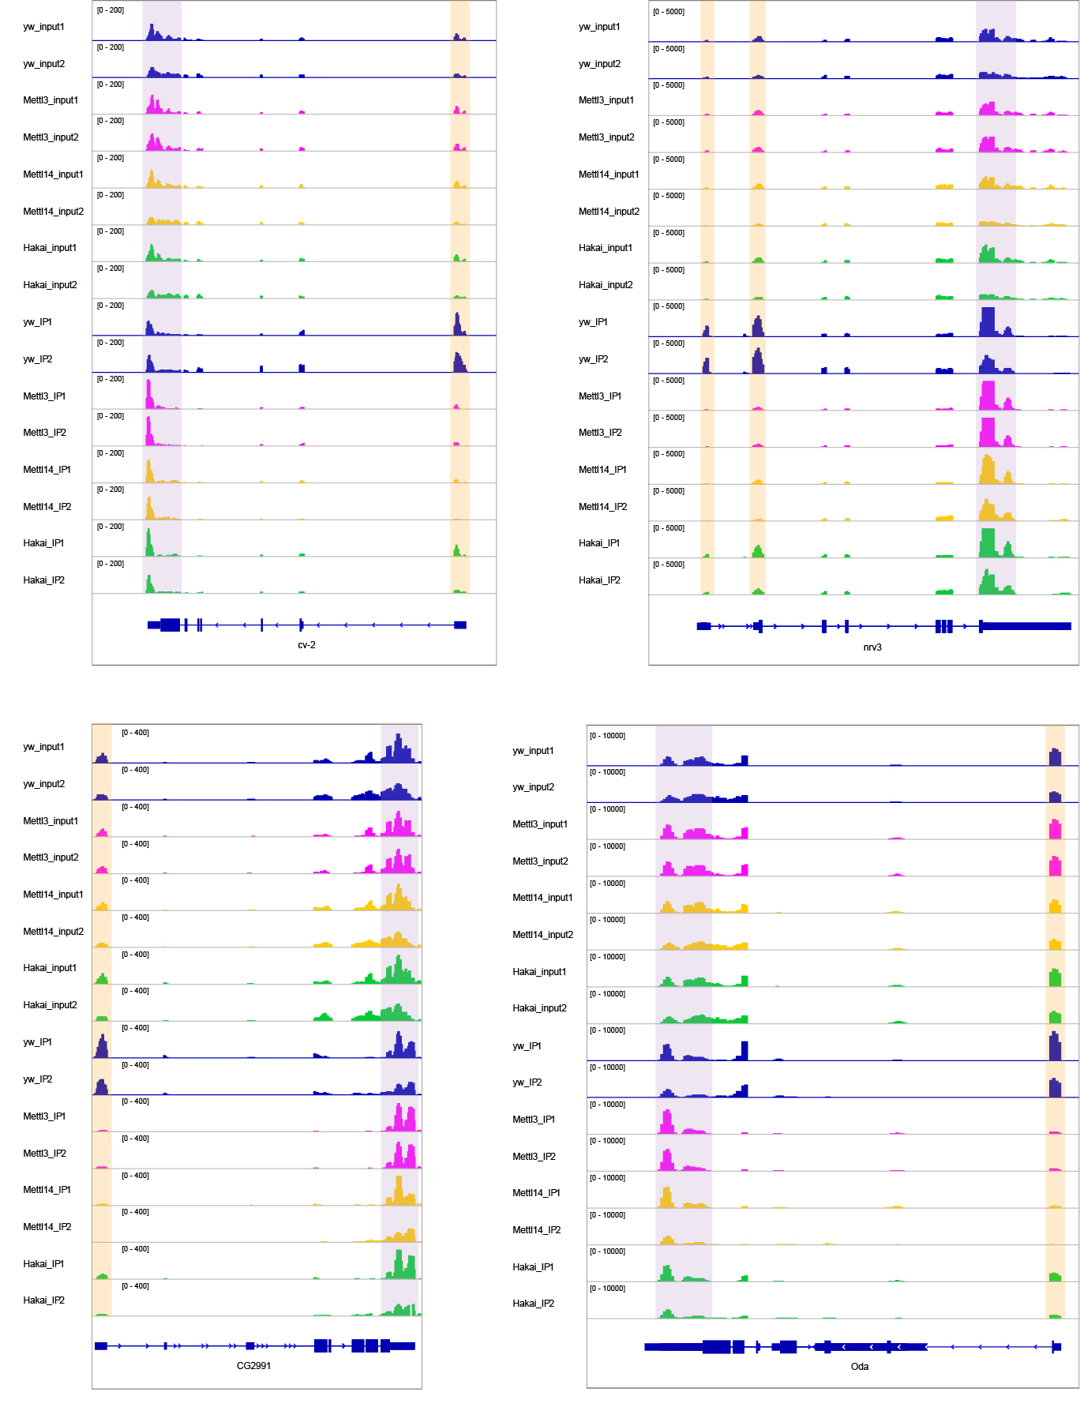
Figure S6. Examples of common reduced m⁶A peaks in Mettl3, Mettl14, and Hakai mutants
Integrative Genomics Viewer (IGV) tracks displaying MeRIP-seq (lower panels, IP) and RNA-seq (upper panels, input) reads along indicated mRNAs in yw, Mettl3, Mettl14, and Hakai flies. Two replicates are shown. Note the reduced peaks in 5’ UTR (shaded in yellow) and peaks in 3’ UTR (shaded in purple) are not changed.

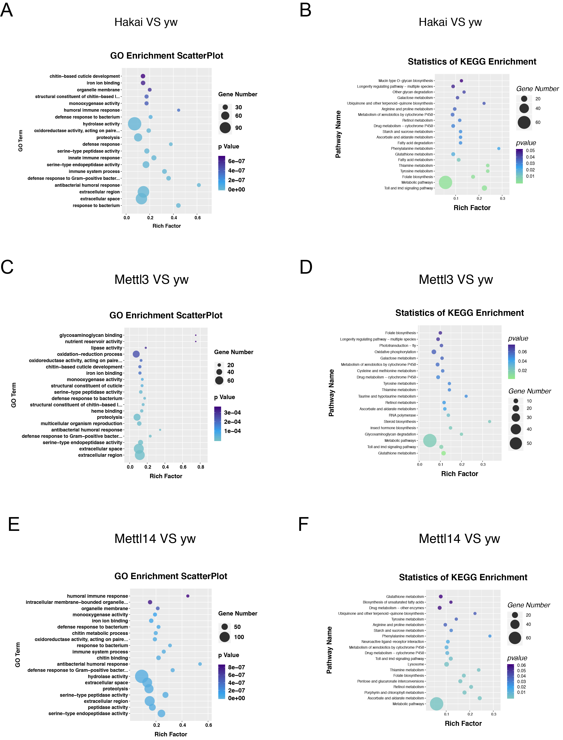
Figure S7. Enrichment analysis of mis-regulated genes in m⁶A writer mutants
(A, C, E) GO term and (B, D, F) KEGG pathway analysis of differentially expressed genes in Mettl3 (C, D), Mettl14 (E, F), and Hakai (A, B) mutants against yw flies. The top 20 terms are displayed.

