SUPPLEMENTARY MATERIAL for ”Trait coordination and trade-offs constrain the diversity of water use strategies in Mediterranean woody plants” by Muñoz-Gálvez et al.

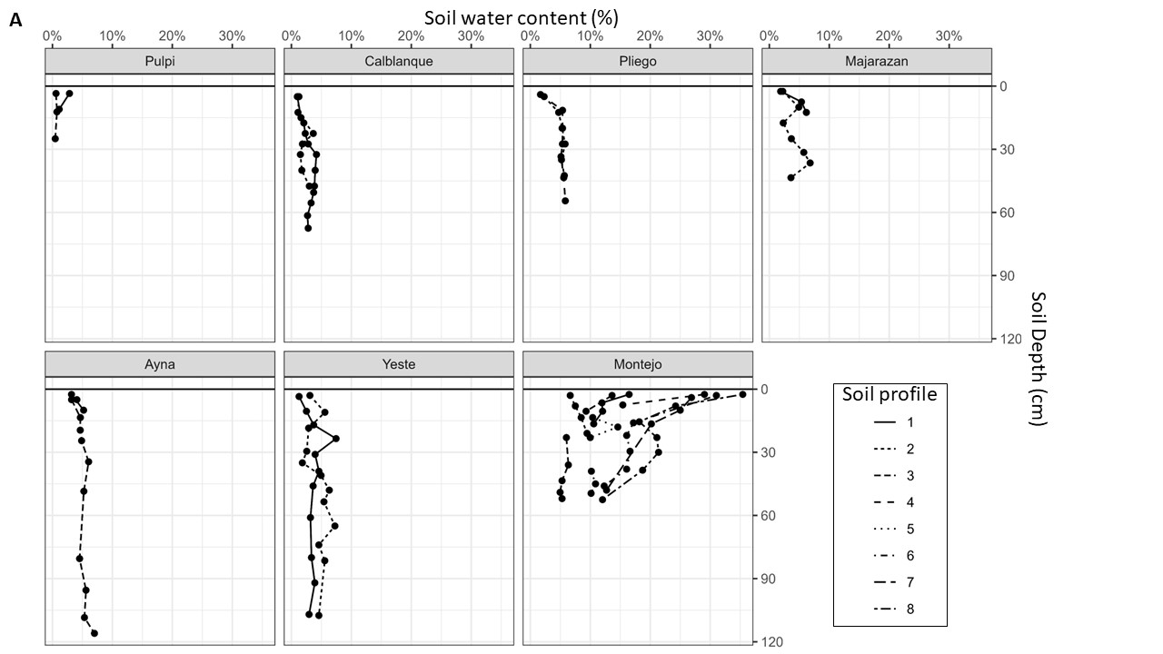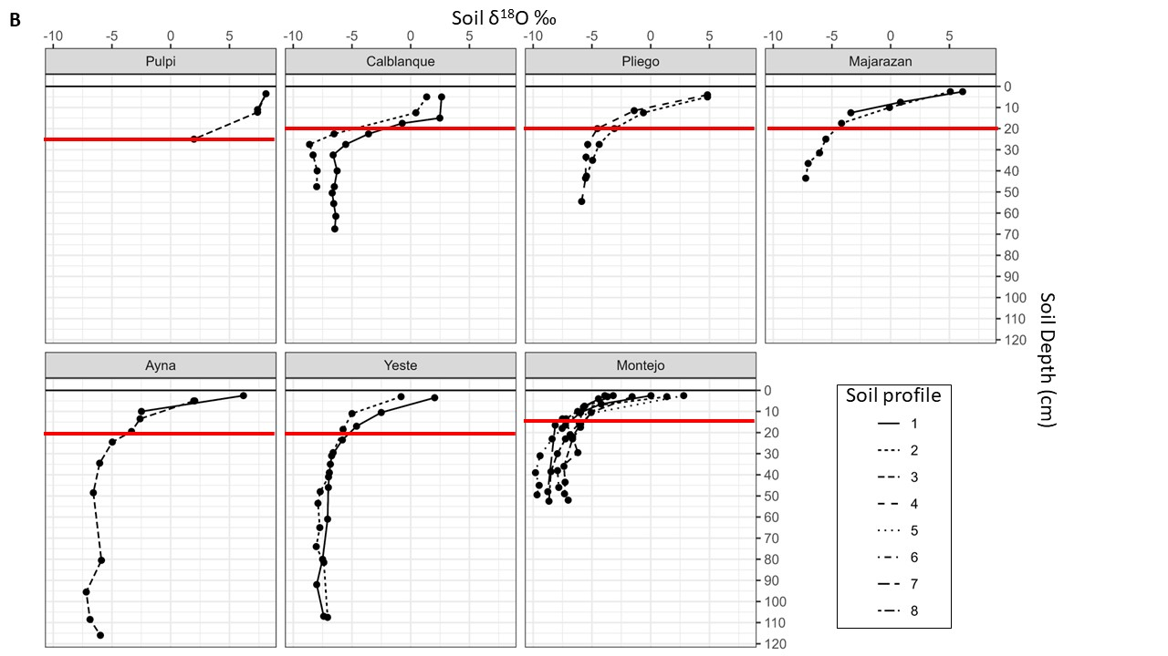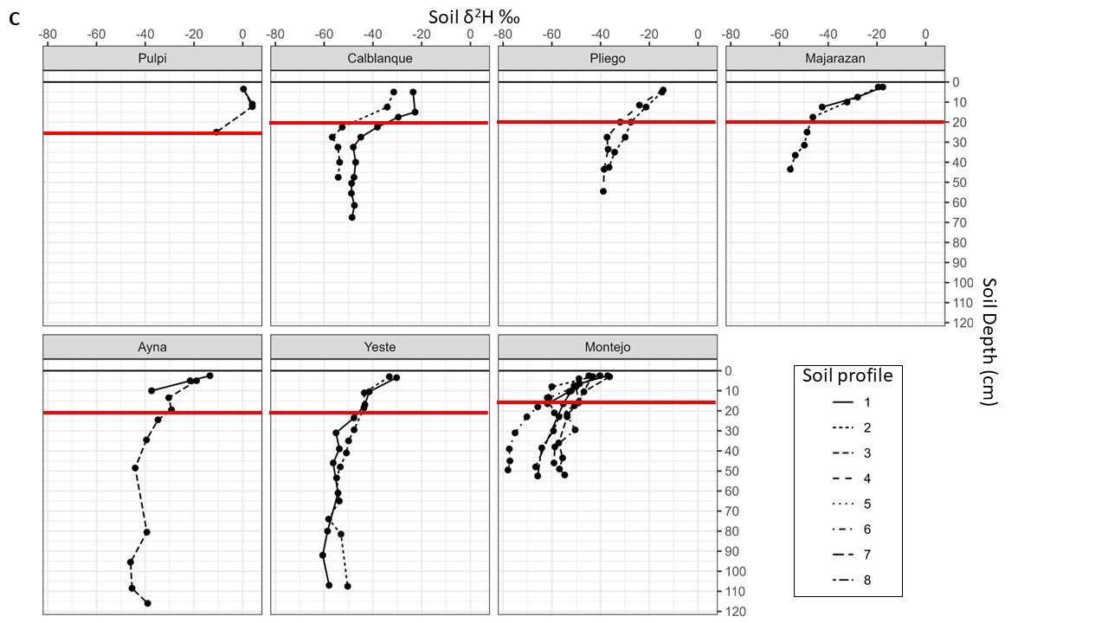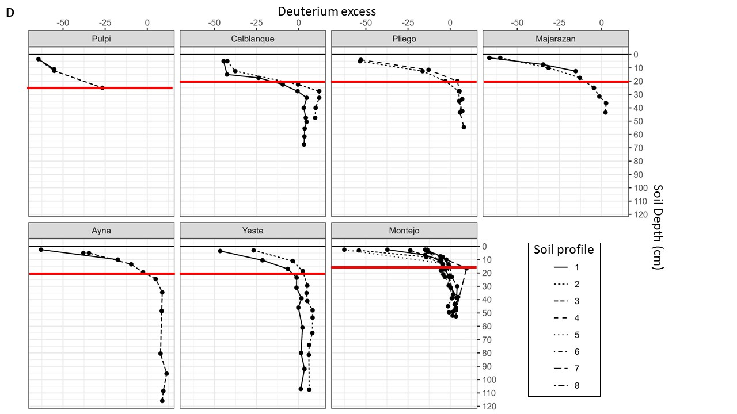

Figure S1. Steep gradients in soil water content % (A), δ¹⁸O ‰ (B) δ²H ‰ (C), and d-excess (D) with soil depth (0 – 110 cm). Dots connected by lines depict the isotopic composition or soil water content of multiple soil profiles at each site. Red lines indicate the threshold between shallow and deep water sources, which was set at 20 cm for Ayna, Calblanque, Majarazán, Pliego and Yeste, at 15 cm in Montejo and at 25 cm in Pulpí based on visual inspection of the data.

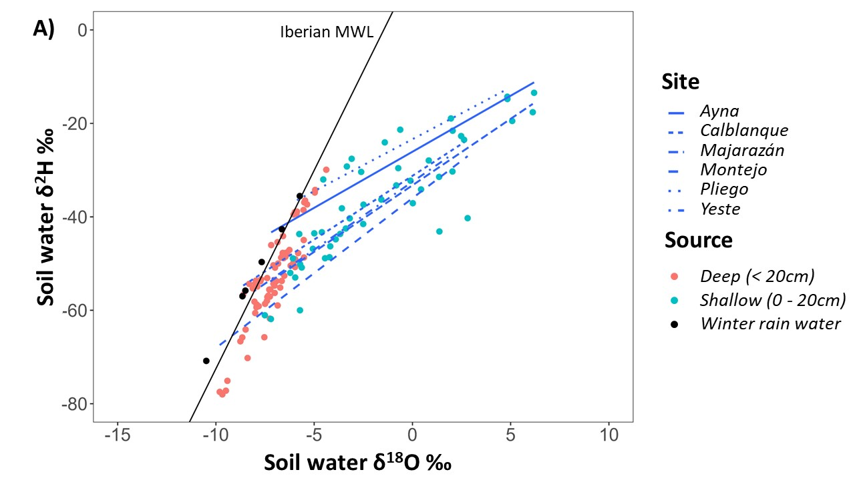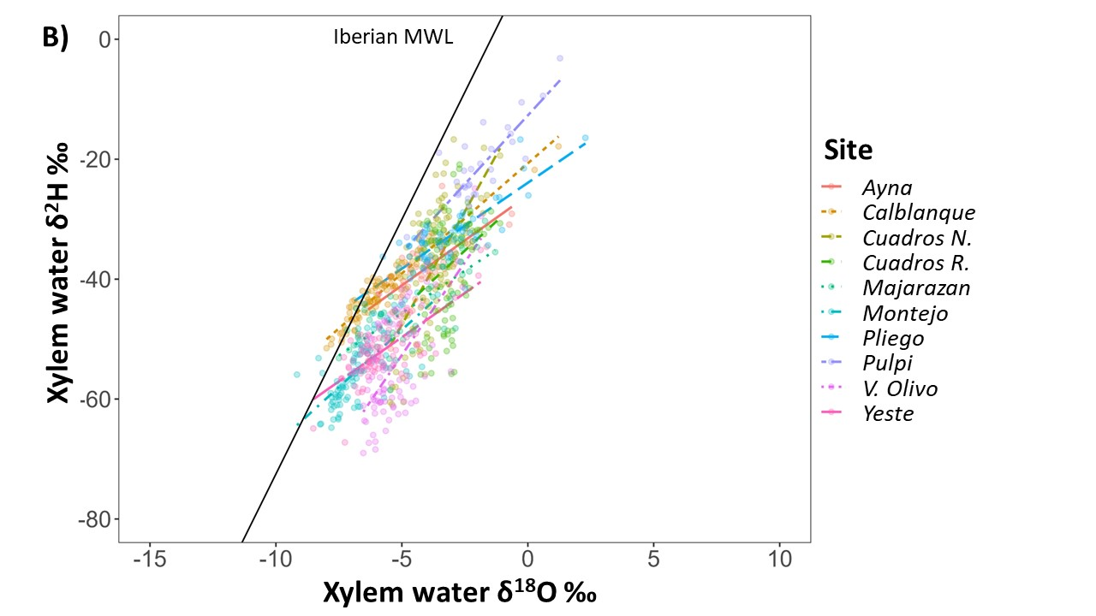
Figure S2. Soil and xylem water isotopic composition for all the soil profiles and plant individuals sampled at each study site. A) Regression lines of soil water isotopic composition (ẟ¹⁸O and ẟ²H) values per site and the Iberian Peninsula Meteoric Water Line (solid black line) are shown. Dots represent the isotopic composition of individual shallow (blue) and deep (red) soil water samples. Black dots represent the average winter rain water isotopic composition at each site ^{69,70}. B) Regression lines of xylem water isotopic composition (ẟ¹⁸O and ẟ²H) per site (color lines) and the Iberian Peninsula Meteoric Water Line ⁶⁴ (black) are shown. Colored dots in panel B represent the isotopic composition of xylem water in one plant individual per site.

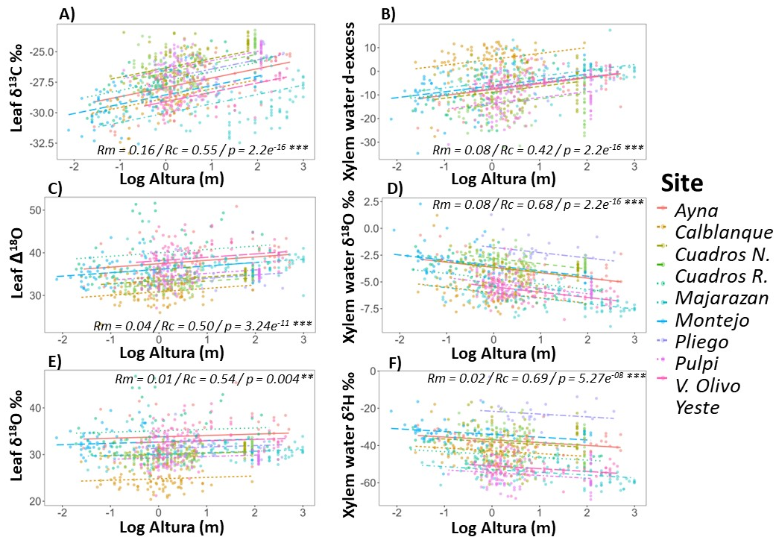

Figure S3. Within site relationships between plant height (m) and the isotopic composition of leaves (ẟ¹³C_{L}, Δ¹⁸O_{L}) and xylem water (δ¹⁸O) across coexisting woody species. Plant height was log-transformed to achieve normality. Regression lines per site from linear mixed regression models are shown. Colored dots represent individual plants for each site. Marginal and conditional r-square values indicate de proportions of variance explained by fixed (Rm) and by fixed and random (Rc) effects in each linear mixed model and P values indicate the degree of significance.

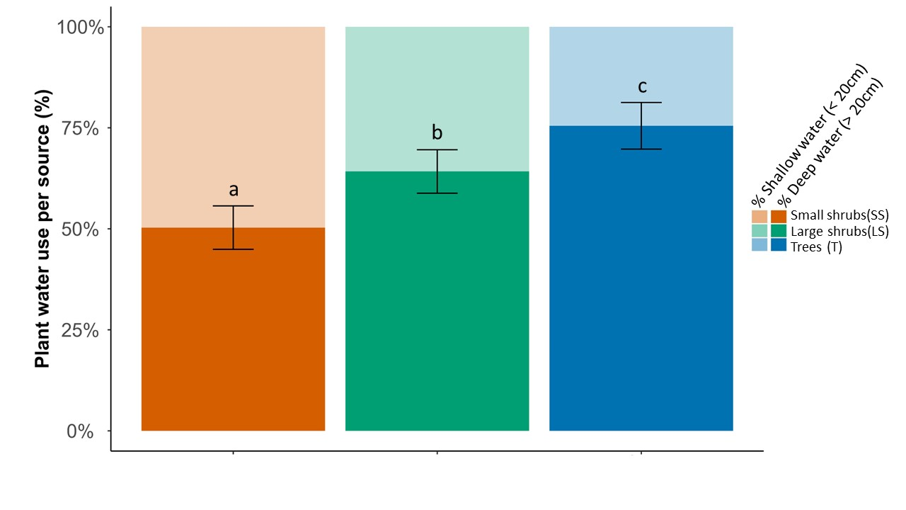
Figure S4. Proportions (% ± Std.error) of shallow (0 – 20 cm; faded colour in upper part of columns) and deep (> 20 cm; dark colour in lower part of columns) water taken up by plants of different life forms; Small shrubs (SS, < 1m height), large shrubs (LS, 1-3 m height) and trees (T, 3-20 m height). Different letters denote significant differences between plant life forms in the proportion of deep and shallow water sources used based on post-hoc tests (LSD) in mixed models (p<0.05).
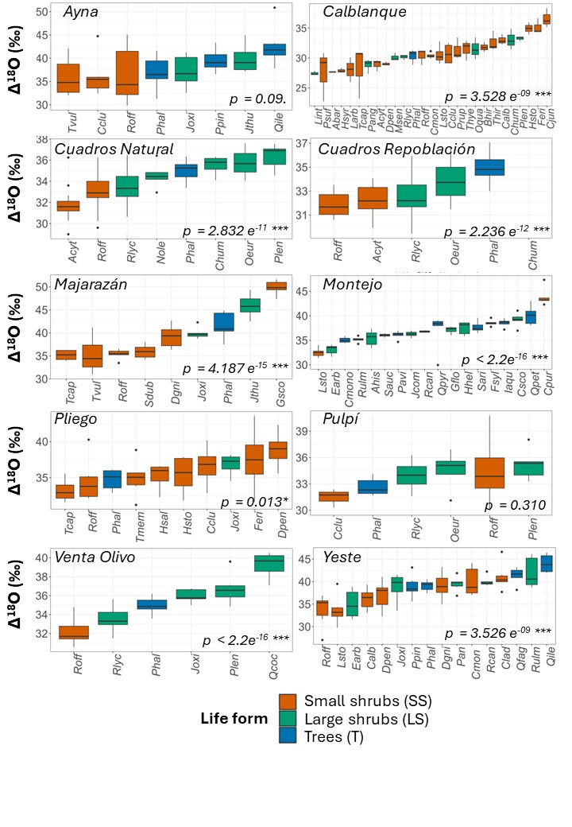
Figure S5. Variation of leaf Δ¹⁸O ‰ (A) across 62 woody species growing at 10 study sites. Bars within the box in boxplots represent mean species values for leaf Δ¹⁸O ‰ from linear models at each site. Different colors were used to represent plant life forms (small shrubs, <1m; large shrubs 1-3 m and trees 3-20 m height). P values indicate significant differences among coexisting woody species within each site. The two shrub species exhibiting the highest mean leaf Δ¹⁸O values in Majarazán and Montejo (Genista scorpius and Cytisus purgans, respectively) are both nitrogen-rich legumes with photosynthetic stems and very small leaves, which may be capable of exhibiting exceptionally stringent stomatal regulation of plant water flux.

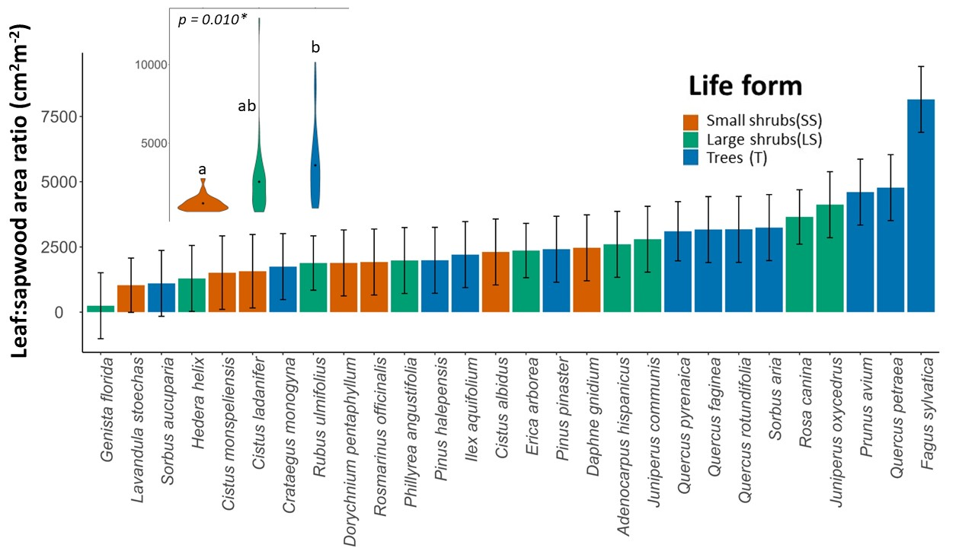
Figure S6. Variation in leaf area to sapwood area ratio across 29 woody species present at two study sites (Yeste and Montejo). Bars represent the mean and whiskers the standard deviation per species. The inset depicts the violin plots of leaf to sapwood are ratio by plant life form. Different letters denote significant differences between life forms (at p<0.05). P-values of the corresponding linear mixed models (LMMs) are shown in the violin plot.

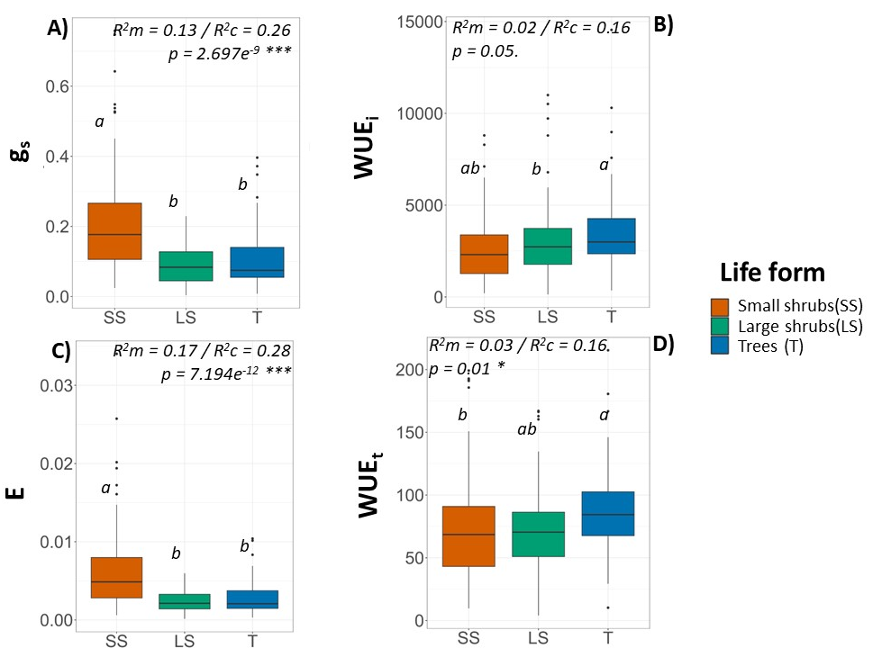
Figure S7.Variation of leaf gas exchange traits (g_{s}, E, WUE_{i} and WUE_{t}) by plant life form across study sites. Different colours were used to represent plant life forms (small shrubs, <1m; large shrubs 1-3 m and trees 3-20 m). Different letters denote significant differences between life forms (at p<0.05). P-values, marginal r-square (R²m) and conditional r-square (R²c) of the corresponding linear mixed models (LMMs) are shown in the violin plot.

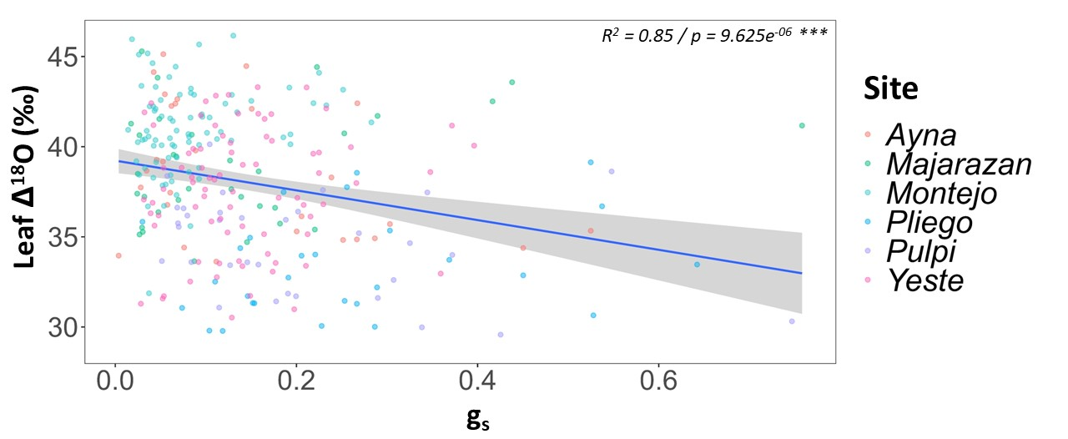
Figure S8. Relationship between leaf Δ¹⁸O and LICOR-measured stomatal conductance (g_{s}) using a linear model approach (LM). A linear model approach was used instead of a linear mixed model approach as Δ¹⁸O is strongly influenced by environmental factors such as temperature, VPD or altitude that differ considerably among study sites. All data were collected during a field campaign performed in 2022, in which leaf isotopic and gas exchange measurements were conducted on the same plant individuals.

Table S9. Location (latitude, longitude), year of field sampling, altitude (m.a.s.l.), mean annual temperature (MAT, ºC), mean annual precipitation (MAP, mm), mean annual potential evapotranspiration (PET, mm), aridity index (AI = 1 – P/PET), and maximum and minimum xylem water oxygen isotopic composition (ẟ¹⁸O ‰) measured in each of the ten study sites.
Site | Location | Year | Altitude (m.a.s.l) | MAT | MAP | PET | Aridity Index | Xylem ẟ¹⁸O  (max/min)
Calblanque | 37.6040,  - 0.7471 | 2017 | 10 | 18.5 | 278 | 1380.30 | 0.80 | 1.28 / -4.8
Pulpí | 37.3601,  - 1.7331 | 2019, 2022 | 195 | 17.6 | 272 | 1323.28 | 0.79 | 1.22 / -7.99
Cuadros Natural | 38.0864,  -1.1044 | 2008 | 130 | 17.9 | 303 | 1340.35 | 0.77 | -1.1 / -5.47
Cuadros Repoblación | 38.0864,  -1.1044 | 2008 | 130 | 17.9 | 303 | 1340.35 | 0.77 | -1.1 / -4.38
Venta del Olivo | 38.372,  -1.4931 | 2008 | 563 | 16.5 | 327 | 1352.90 | 0.76 | 2.29 / -6.89
Pliego | 37.9546,  -1.5013 | 2019, 2022 | 473 | 14.8 | 414 | 1328.71 | 0.69 | -1.29 / -7.50
Ayna | 38.5224,  -2.0874 | 2019, 2022 | 900 | 13.7 | 432 | 1296.31 | 0.67 | -1.85 / -6.53
Majarazán | 38.0997,  -2.0709 | 2019, 2022 | 1235 | 12.7 | 466 | 1238.18 | 0.62 | -0.63 / -6.34
Yeste | 38.3899,  -2.4575 | 2019, 2022 | 1151 | 12.1 | 496 | 1205.84 | 0.59 | -1.87 / -8.52
Montejo | 41.1114,  -3.5011 | 2021, 2022 | 1450 | 8.6 | 726 | 951.34 | 0.24 | -3.58 / -9.2

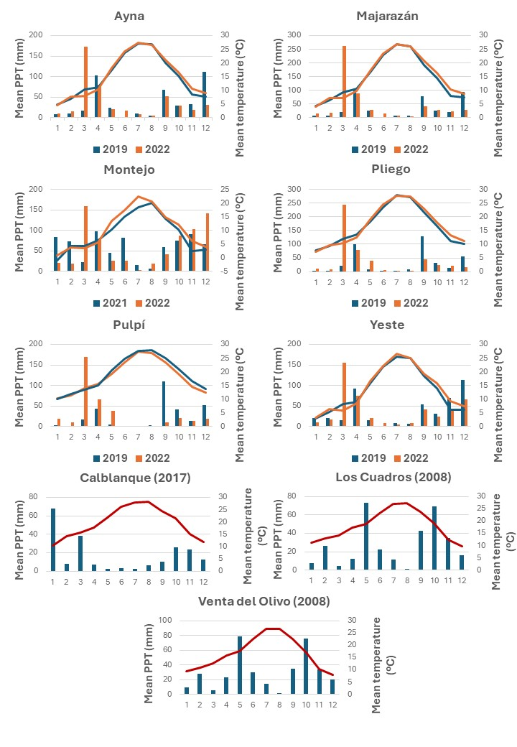
Figure S10. Climographs showing monthly precipitation (PPT, mm, shown in bars) and temperature (ºC, shown with lines) for the years when the field sampling campaigns were performed at each study site. For sites where two field sampling campaigns were conducted in different years, a different colour was set for each year for temperature (lines) and precipitation (bars).

