Supplementary Information
Multiple sliding ferroelectricity of rhombohedral-stacked InSe for reconfigurable photovoltaics and imaging applications
Qingrong Liang¹, Guozhong Zheng², Liu Yang³, Shoujun Zheng^{1,}*

¹Centre for Quantum Physics, Key Laboratory of Advanced Optoelectronic Quantum Architecture and Measurement (MOE), School of Physics, Beijing Institute of Technology, Beijing, 100081 China,
²School of Physics and Information Technology, Shaanxi Normal University, Xi’an, 710062, P. R. China
³Department of Physics, Hubei Engineering Research Center of Weak Magnetic-field Detection, China Three Gorges University, Yichang 443002, China
*E-mail: szheng@bit.edu.cn

This supplementary informations includes:
Supplementary Note 1: Raman characterization of γ-InSe with different layers and Raman mapping of Gr/γ-InSe/Gr
Supplementary Note 2: Verification of the ferroelectricity of InSe through PFM
Supplementary Note 3: Band structure and PL analysis
Supplementary Note 4: Power conversion efficiency estimation of bulk photovoltaic devices
Supplementary Note 5: Preliminary determination of sliding ferroelectricity using BSF theory
Supplementary Note 6: Explanation of photodetector mechanism based on sliding ferroelectricity mechanism
Supplementary Figure 1: Transition from circular to reverse circular stacking order
Supplementary Figure 2: Raman mapping of the device and Raman spectra for different layers
Supplementary Figure 3: Band structure calculation and photoluminescence (PL) of γ-InSe with different layers
Supplementary Figure 4: Fabrication process for PFM, KPFM, and C-AFM test devices
Supplementary Figure 5: Optical and AFM images of γ-InSe
Supplementary Figure 6: PFM ferroelectric polarization reversal of thick flakes
Supplementary Figure 7: Butterfly curves and phase diagrams for different thicknesses
Supplementary Figure 8: Surface potential difference between InSe and Au substrate
Supplementary Figure 9: C-AFM measurements of InSe devices with different thicknesses
Supplementary Figure 10: Fabrication process for bulk photovoltaic and photodetector devices
Supplementary Figure 11: Detection of spontaneous polarization in bulk photovoltaic under dark conditions
Supplementary Figure 12: Polarization-up bulk photovoltaic short-circuit current switching cycles under different light powers
Supplementary Figure 13: Polarization-down bulk photovoltaic short-circuit current switching cycles under different light powers
Supplementary Figure 14: Schematic of 3-5 layer sliding order cycles
Supplementary Figure 15: Change in polarization value of 3-5 layer γ-InSe sliding
Supplementary Figure 16: Differential charge density maps of 2-5 polarization states
Supplementary Figure 17: Band structure changes in ferroelectric and paraelectric states under SOC
Supplementary Figure 18: Band alignment in γ-InSe devices
Supplementary Figure 19: Output characteristic curves under different illuminations
Supplementary Figure 20: Charge transfer distribution at the Gr/InSe interface
Supplementary Figure 21:Image recognition by photodetectors under different illuminations
Supplementary Figure 22: Stability tests of Gr/InSe/Gr after 120 days
Supplementary Table 1: Bilayer materials and their corresponding bulk material symmetries determined by BSF theory

Supplementary Note 1: Raman Characterization of γ-InSe with Varying Layer Numbers and Raman Mapping of Gr/γ-InSe/Gr Devices
To accurately assess the quality of γ-InSe crystals and Gr/γ-InSe/Gr devices, we conducted Raman characterization using a 532 nm laser on γ-InSe with different layer numbers and Raman mapping of Gr/γ-InSe/Gr devices (as shown in Figure S2). In Figure S2(a), three distinct Raman peaks are observed at 119.3 cm⁻¹, 180.3 cm⁻¹, and 232.2 cm⁻¹, consistent with previous studies^{1, 2}. These peaks confirm that γ-InSe belongs to the R3m space group, comprising four atoms per unit cell and exhibiting twelve Raman-active vibrational modes. Figure S2(b) illustrates the vibrational directions of four intrinsic Raman peaks for γ-InSe layers fewer than three. The peak at 119.3 cm⁻¹ corresponds to the A_{11g} mode, 180.3 cm⁻¹ to the E12g mode, and 232.2 cm⁻¹ to the A_{21g} mode. The A_{11g} and A_{21g} modes are out-of-plane vibrations, while the E_{12g} mode is an in-plane vibration. The Raman peak at 203.4 cm⁻¹, associated with the A_{11g}(LO) mode, is less prominent but can be distinctly observed in thin layers, making it useful for estimating the layer number in thin γ-InSe samples.
Figure S2(c) presents the Raman spectral mapping of the Gr/γ-InSe/Gr device, validating the phase structure and thickness of γ-InSe and graphene, consistent with the device structure observed under optical microscopy. The thickness of graphene was confirmed through optical contrast under a microscope and Raman spectroscopy. For few-layer graphene, the thickness can be determined by the intensity ratio of the G and two-dimensional (2D) modes³.
Supplementary Note 2: Verification of Ferroelectricity in InSe Using PFM
Piezoresponse Force Microscopy (PFM) is a powerful technique for characterizing ferroelectric materials by dynamically measuring their piezoelectric response. However, PFM measurements on two-dimensional van der Waals ferroelectric materials are more challenging compared to conventional ferroelectric materials. The difficulties are due to several factors: First, even materials with relatively large polarization values, such as BN (0.68 µC/cm²), exhibit polarization magnitudes that are two orders of magnitude smaller than traditional ferroelectric materials like BaTiO₃ (~26 µC/cm²)^{4, 5}. Theoretically, γ-InSe has an even smaller polarization than BN, making its intrinsic measurement particularly challenging. Second, previous reports indicate numerous defects in intrinsic InSe, which complicate the PFM measurements of γ-InSe sliding ferroelectricity⁶. Third, static charges introduced during sample preparation can interfere with the measurements. Fourth, InSe is prone to oxidation when exposed to air for extended periods, leading to performance degradation. Fifth, as the thickness of InSe decreases, interface contamination and thermal effects induced by the applied voltage during testing can hinder PFM domain writing.
To address these challenges, we first used mechanical exfoliation of γ-InSe with PDMS in a glove box, then transferred it onto gold-coated silicon substrates. After adhering for three hours, we obtained InSe layers of varying thicknesses (as shown in Figure S5). We then utilized the Dual Amplitude Resonance Tracking (DART) SS-PFM mode on a commercial scanning probe microscopy system (Asylum Research Cypher, Oxford, UK) to perform domain writing, butterfly curve, and phase reversal measurements of intrinsic γ-InSe. The testing parameters are detailed in the methods section. As depicted in Figures S7 and S8, we confirmed the ferroelectric behavior of InSe by varying the Vac amplitude (1.5-2V), a necessary step to validate the authenticity of PFM hysteresis measurements. Additionally, using the LithoPFM mode in the Asylum Research software, we applied a reverse DC bias (Vdc = ±8V) to write domains in InSe flakes of different thicknesses, successfully detecting significant out-of-plane (OOP) ferroelectric polarization.
Supplementary Note 3: Band Structure and PL Analysis
Figure S2a records the photoluminescence (PL) spectra of InSe, showing a bandgap range from 1.27 to 1.49 eV. As the thickness of InSe decreases, a significant blue shift in the PL peak is observed, accompanied by a sharp decline in PL intensity. When the thickness is reduced to 5.6 nm, the PL becomes barely detectable, which may be related to a bandgap transition^{7, 8}. To elucidate the evolution of InSe's band structure, we performed density functional theory (DFT) simulations to model the variation of γ-InSe's bandgap with the number of layers (as shown in Figures S20b-f). With increasing layer thickness, the shape of the valence and conduction bands undergoes significant changes, and the bandgap value gradually decreases, indicating that the PL intensity of InSe will further increase. From the figures, it is evident that the valence band maximum (VBM) is located at the Γ point, while the conduction band minimum (CBM) is situated at a low-symmetry point in the Brillouin zone. As the number of layers increases, the CBM remains almost stationary at the Γ point, but the VBM shifts towards the Γ point, leading to the formation of a direct bandgap. Therefore, it can be concluded that the bandgap value can be tuned by the number of layers (N). However, when the number of layers exceeds five, InSe undergoes a transition from an indirect to a direct bandgap, which explains why PL is difficult to observe in few-layer InSe. Interestingly, this bandgap transition is entirely opposite to that observed in MoS₂⁹, and this transition is more favorable for the transition of photo-generated carriers.
Supplementary Note 4: Estimation of Power Conversion Efficiency in Bulk Photovoltaic Devices
We estimated the power conversion efficiency (PCE) using the formula:
η=Jsc×Voc×FF/Pin×α​
where Jsc​ is the short-circuit current density, Voc​ is the open-circuit voltage under illumination, Pin​is the incident light power, α is the absorption coefficient of 2D γ-InSe, and FF is the fill factor, representing the ratio of actual power to the ideal power given by Jsc×Voc¹⁰. Considering that γ-InSe is transparent to visible light at room temperature¹¹, most incident light intensity is not absorbed by the device. The absorption coefficient α of γ-InSe at 520 nm is less than 5%¹². Based on the data in Figure 3c (with an incident light power density of 100 mW/cm², Jsc is approximately 15 mA/cm²), we compared this efficiency with traditional ferroelectric photovoltaic cells. For instance, a 50 nm thick ferroelectric BaTiO₃ film has a PCE of 2.1 × 10⁻⁶⁵. Among all bulk photovoltaic effect (BPVE) materials, our efficiency is highly attractive.
Figure 2d shows the characteristic output I-V curve of the device. Due to the atomic-scale thickness of the 2D ferroelectric material, the bias in DC measurements was set within the range of ±200 mV (much smaller than Voc​) to avoid polarization degradation of the ultra-thin γ-InSe. In traditional photovoltaics, Voc is determined by reading the bias voltage from the I-V measurement over a wide range¹³. However, for 2D materials, the application of low voltage perpendicular to the 2D plane results in a high electric field strength due to their atomic-scale thinness. For example, applying a 1 V DC voltage to a 1 nm thick film generates an electric field strength of 1 × 10⁷ V/cm in the out-of-plane direction, which far exceeds the coercive field strength of 2D materials.
Supplementary Note 5: Preliminary determination of sliding ferroelectricity using BSF theory
In recent years, 2D sliding ferroelectrics have developed rapidly, enabling high-density, multi-conductance, low-energy non-volatile memory. Quickly determining whether 2D materials have sliding ferroelectricity is crucial for industrial applications. In 2023, a group proposed a Bulk Silicene Framework (BSF) theory based on group theory analysis of bilayer stacking ferroelectricity¹⁴, which generates ferroelectricity by stacking two layers of the same 2D material with different rotations and translations, thus determining whether the 2D material has sliding ferroelectricity. According to the systematic group theory analysis by the group, there are possible BSFs in 80 layer groups. These 80 layer groups can be classified into four types based on lattice type: oblique lattice (layer groups 1-7), rectangular lattice (layer groups 8-48), square lattice (layer groups 49-64), and hexagonal lattice (layer groups 65-80). They can also be categorized into four types of polarization based on the polar types of the monolayer and bilayer stack combinations: in-plane polarization, out-of-plane polarization, combined polarization, and non-polar.
The following six steps are used to preliminarily determine whether 2D materials have sliding ferroelectricity based on the BSF theory: Analysis of Monolayer Symmetry: Determine the layer group and point group of the monolayer material and analyze the polar types (in-plane polarization, out-of-plane polarization, combined polarization, non-polar). Construction of Stacking Model: Establish the stacking model of the bilayer material, considering different rotations and translations. Polarization analysis of high symmetry points and lines: analyze the symmetry at different stackings by examining the high symmetry points and lines and predict the possible polar types at these points and lines. Determination of Sliding Ferroelectric Polarization Types: Based on the analysis, determine the types of polarization that can be induced by sliding. First-Principles Calculation Validation: Use first-principles calculation methods to validate the polarization types and their stability. This article summarizes the sliding models of abstract types of hexagonal lattices (see Table S1 for details) and the classifications of sliding based on hexagonal lattices published so far (see Table S2 for details)¹⁵.
Next, we use BSF theory to preliminarily determine whether InSe has sliding ferroelectricity, with the following steps:Analysis of Monolayer Symmetry: First, analyze the symmetry of the InSe monolayer. The layer group of the InSe monolayer is P−6m2 (LG-78), and the corresponding point group is D3h. This symmetry allows for all four types of polarization (in-plane polarization, out-of-plane polarization, combined polarization, non-polar).Construction of Stacking Model: Establish the stacking model of the InSe bilayer. In the simplest stacking case, i.e., without sliding and rotation of the two monolayers (AA stacking), the bilayer is at the high symmetry point G, belonging to the D3h point group, and there is no polarization.Polarization Analysis of High Symmetry Points and Lines:High symmetry points M and N (i.e., sliding from point G along the unit cell lattice vectors a and b by 1/3, 2/3 and 2/3, 1/3, respectively) belong to the C3v point group and exhibit out-of-plane polarization (in the [001] direction).
High symmetry points A, B, and C (i.e., sliding by 1/2, 0; 0, 1/2; 1/2, 1/2, respectively) belong to the C2v point group and exhibit in-plane polarization (in the [1,2,0], [2,1,0], [1,-1,0] directions, respectively).
Determination of Sliding Ferroelectricity: Based on the above analysis, InSe at specific high symmetry points and lines will exhibit ferroelectricity. For example, sliding at points M and N can induce out-of-plane polarization, while sliding at points A, B, and C can induce in-plane polarization.
Practical Application:
For the InSe bilayer system, sliding operations can induce polarization in different directions, thereby achieving sliding ferroelectricity. This phenomenon can be extended to other 2D materials with similar symmetries.
The above steps systematically determine and predict whether 2D materials like InSe have sliding ferroelectricity, providing a theoretical foundation for designing and applying new 2D ferroelectric materials.
Supplementary Note 6: Mechanism of Photodetectors Based on Sliding Ferroelectricity
The ultra-high photocurrent observed in the Gr/γ-InSe/Gr device can be attributed to the effective built-in electric field established by the sliding ferroelectricity of γ-InSe between the top and bottom graphene layers, as previously anticipated. This built-in electric field is hypothesized to significantly enhance the rapid separation of photogenerated carriers, as depicted in the schematic in Figure 5a. To validate the mechanism of carrier separation and transport, which is triggered by the strong built-in electric field in the Gr/γ-InSe/Gr photodetector, we first performed DFT simulations to examine the evolution of γ-InSe's band structure with varying layer thicknesses (as shown in Figure S20). With increasing layer thickness, the bandgap shifts to lower energy levels. In monolayer InSe, the VBM is located in the Γ-K direction with a Mexican hat-like band structure, while the CBM is at the Γ point, resulting in an indirect bandgap. However, as the layer thickness increases (greater than 6 nm), the CBM remains at the Γ point while the VBM shifts towards the Γ point, leading to the formation of a direct bandgap. Interestingly, this bandgap transition is opposite to what is observed in MoS₂, and this transition favors the transition of photogenerated carriers.
Next, by comparing the optoelectronic performance of vertical and lateral devices, it is evident that under the vertical built-in electric field in the Gr/γ-InSe/Gr device, photogenerated electron-hole pairs can be effectively separated and transported in the out-of-plane direction. In contrast, the Au/γ-InSe/Au device, which is laterally symmetric, lacks an in-plane built-in electric field.
Furthermore, we simulated the interfacial effects between γ-InSe and graphene (as shown in Figure S20). Three types of electric fields are generated at the graphene/γ-InSe interface: an externally applied electrostatic field, a built-in electric field, and fields due to charged impurities and substance adsorption. The formation of the built-in electric field is attributed to electron transfer from graphene to γ-InSe upon contact, resulting in positively charged graphene and negatively charged γ-InSe, with the electric field directed from graphene to γ-InSe. This theoretical finding is confirmed by our calculations (Figure S21). The superposition of these three electric fields forms the final effective electric field, which consistently points from graphene to γ-InSe. When γ-InSe is illuminated, electron-hole pairs are generated, and the photogenerated electrons preferentially flow into the graphene under the effective electric field, enhancing the separation efficiency of photogenerated carriers. Besides the separation of electron-hole pairs, the high electron mobility in graphene and the long charge trapping lifetime of holes in γ-InSe contribute to the formation of a photogating effect at the interface (as shown in Figure 5d). Consequently, electrons undergo multiple recirculations in graphene, resulting in increased photocurrent and enhanced responsivity.

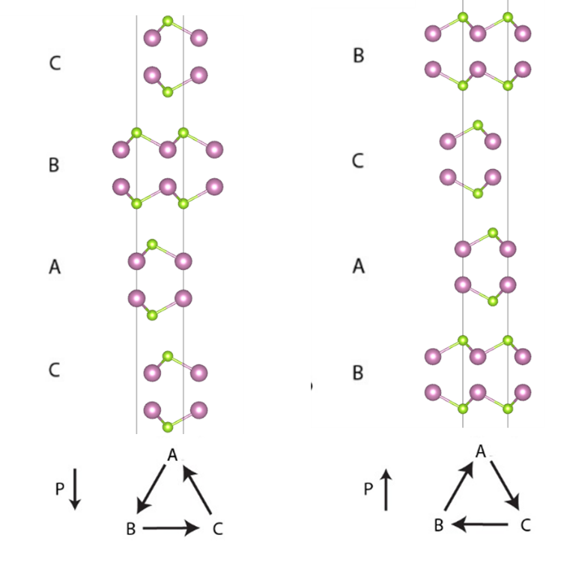
Supplementary Figure 1. Notation for the relative positions of each layer with respect to other layers. The series begins from the bottom layer to the top. Polarization is switched when the layer stacking order is switched from cyclic (a) to anticyclic (b).
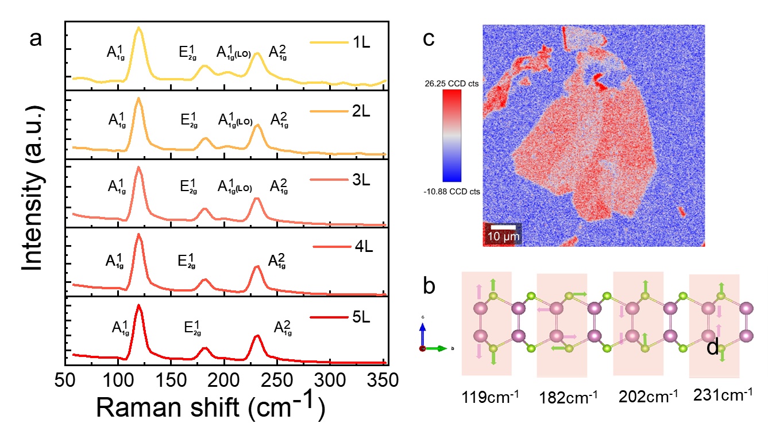
Supplementary Figure 2. a. Raman spectra of 2D γ-InSe with different layer numbers. b. Raman mapping images corresponding mapping of the 2D BPVE device. c.Schematic diagram of various Raman modes present in InSe. Coloured arrows indicate the vibration directions of In (orange) and Se (green) atoms.
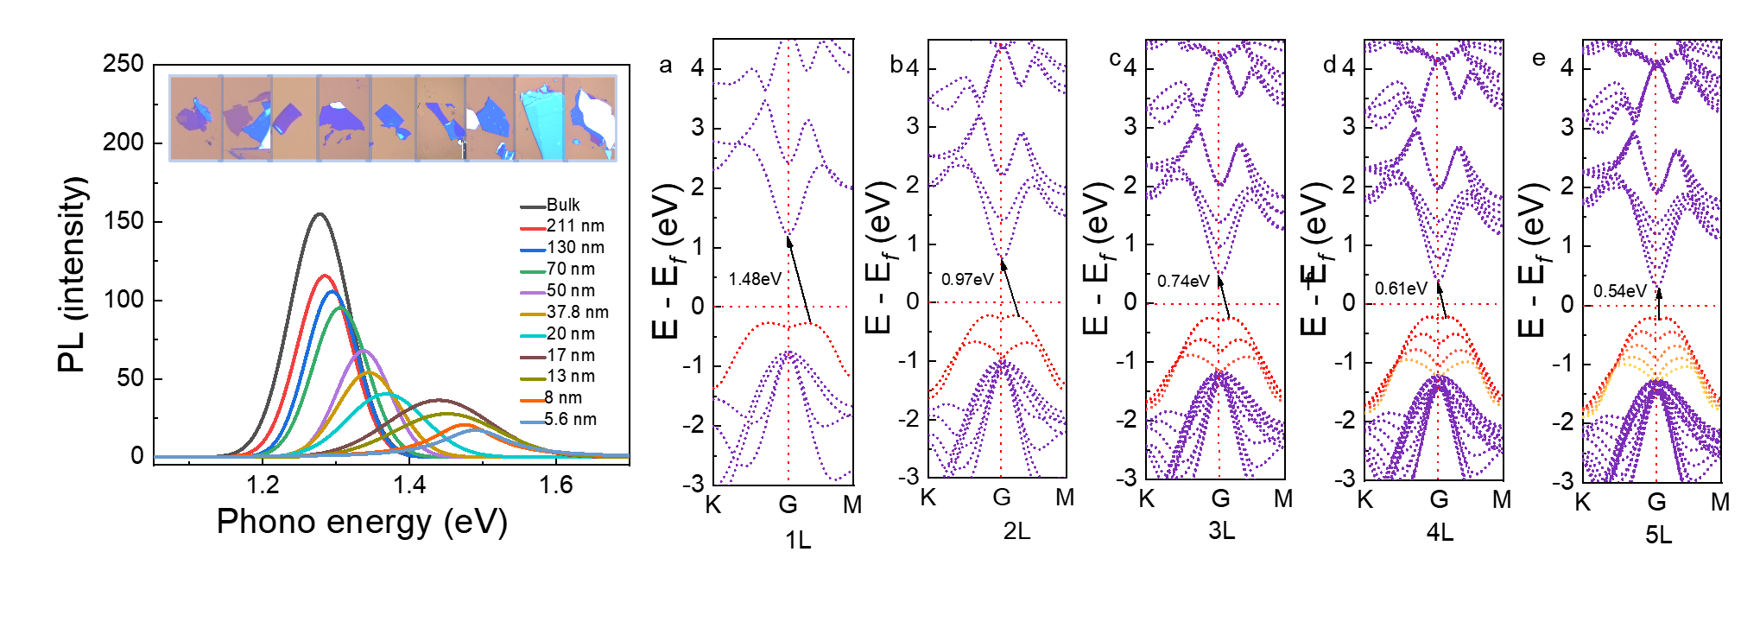

Supplementary Figure 3. a-e The band gap variation of InSe with different layers based on first principles and PL.

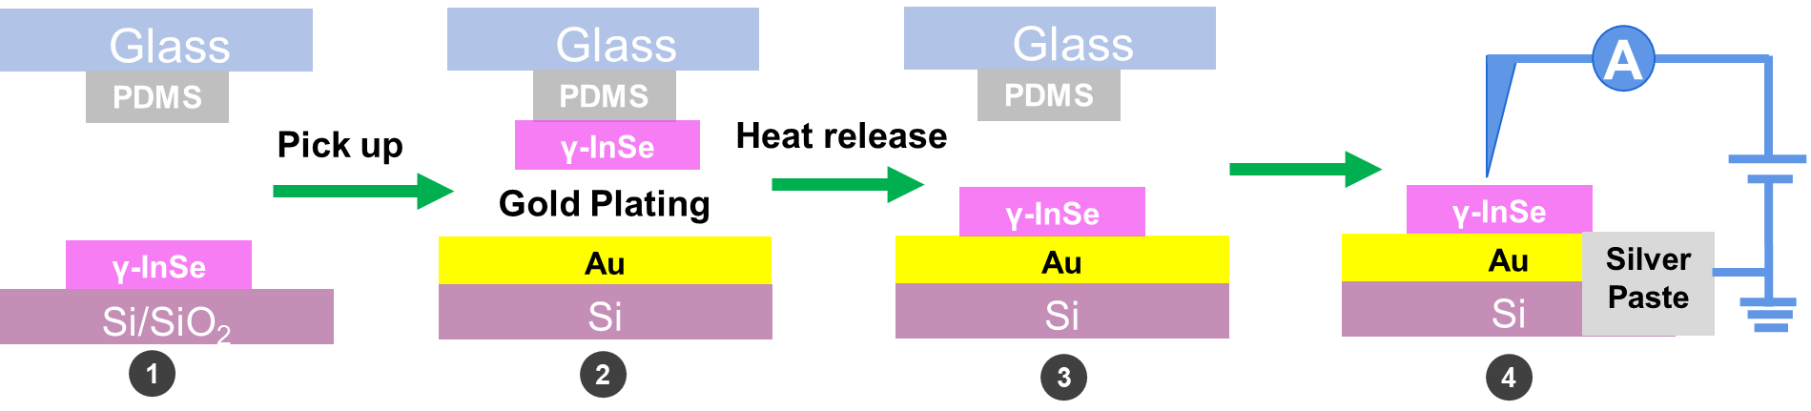

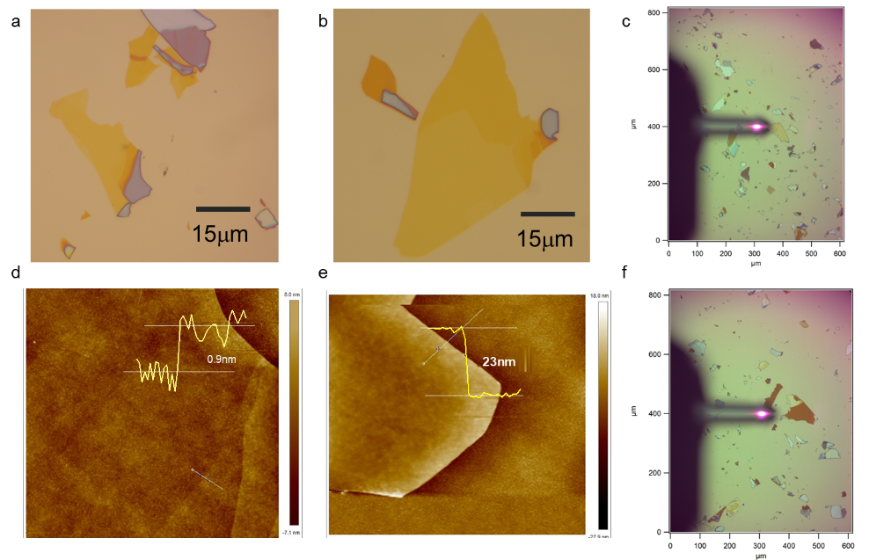
Supplementary Figure 4. Sample preparation for PFM, KPFM and C-AFM measurements.

Supplementary Figure 5. Optical images and AFM images of γ-InSe.

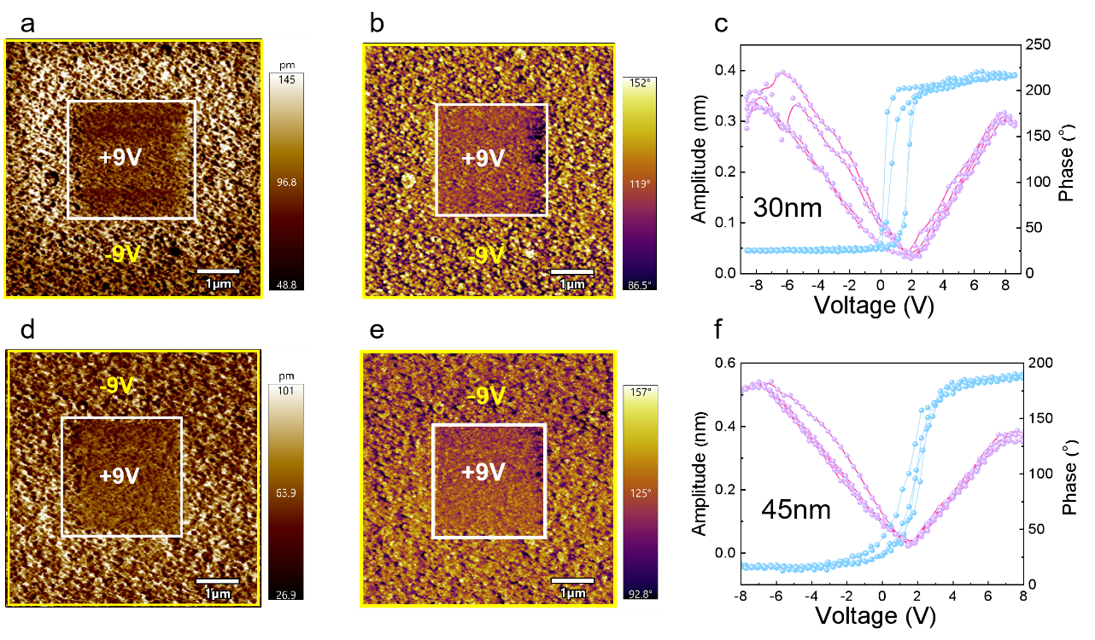

Supplementary Figure 6. Additional PFM results at high frequency. The local PFM amplitude and phase loops (results of tow cycles) during the switching process of InSe flakes with different thicknesses (~20 – 100 nm measured by AFM) under the resonant mode (320-kHz).

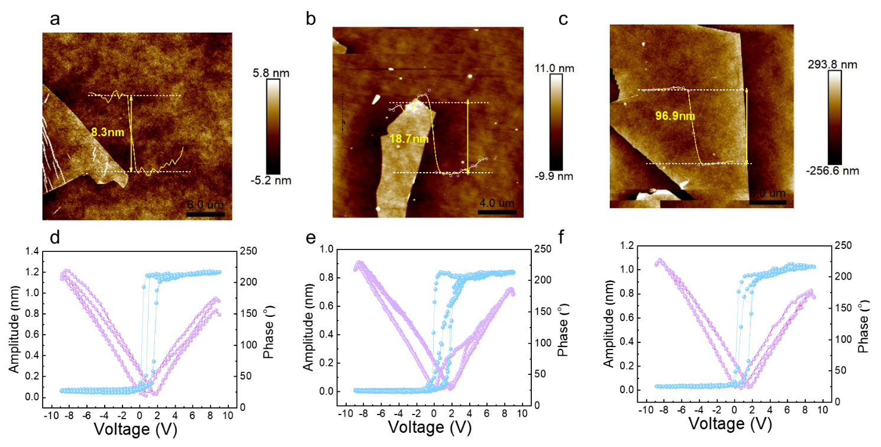
Supplementary Figure 7. Additional PFM results at high frequency. The local PFM amplitude and phase loops (results of tow cycles) during the switching process of InSe flakes with different thicknesses (~20 – 100 nm measured by AFM) under the resonant mode (320-kHz).

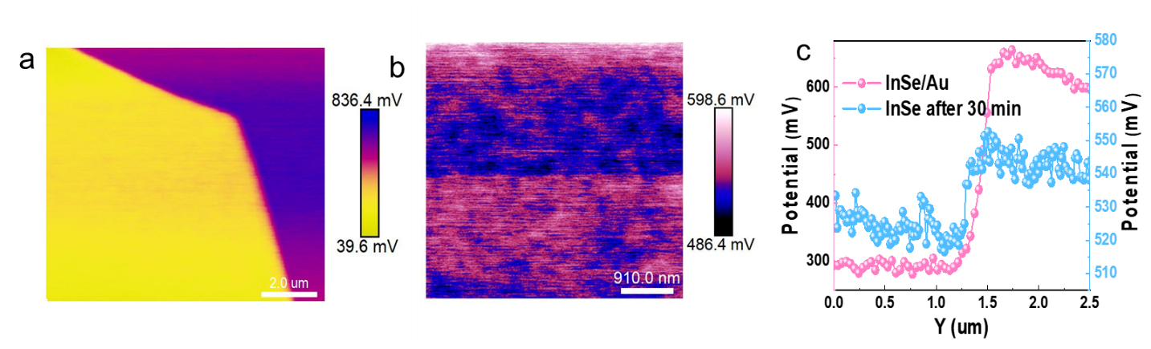
Supplementary Figure 8. a. Surface potential difference mapping between InSe and the Au substrate. b. KPFM amplitude mapping of the γ-InSe device 30 minutes after removing the vertical electric field. c. The purple curve represents the potential variation between InSe and the Au substrate, while the blue curve represents the potential variation along the white line on the surface of the γ-InSe device.

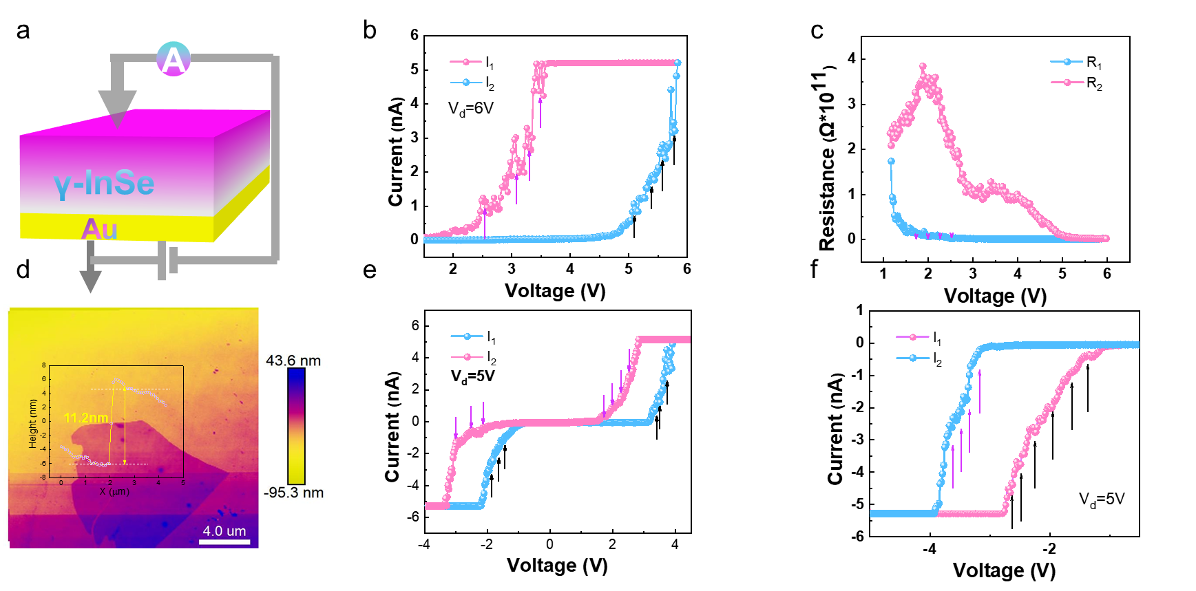

Supplementary Figure 9. a. The AFM image of InSe flake for CAFM measurements . b The I-V loop from CAFM measurements. c The corresponding bias-dependent resistance (R-V) curve from .d The AFM image of 11.2nm InSe flake.eThe I-V loop from CAFM measurements.f corresponding to an enlarged view of Fig. 2e (The pink arrows in (b) indicate current jumps as the voltage increases (the pink line), corresponding to the abrupt resistance shifts in (c).)

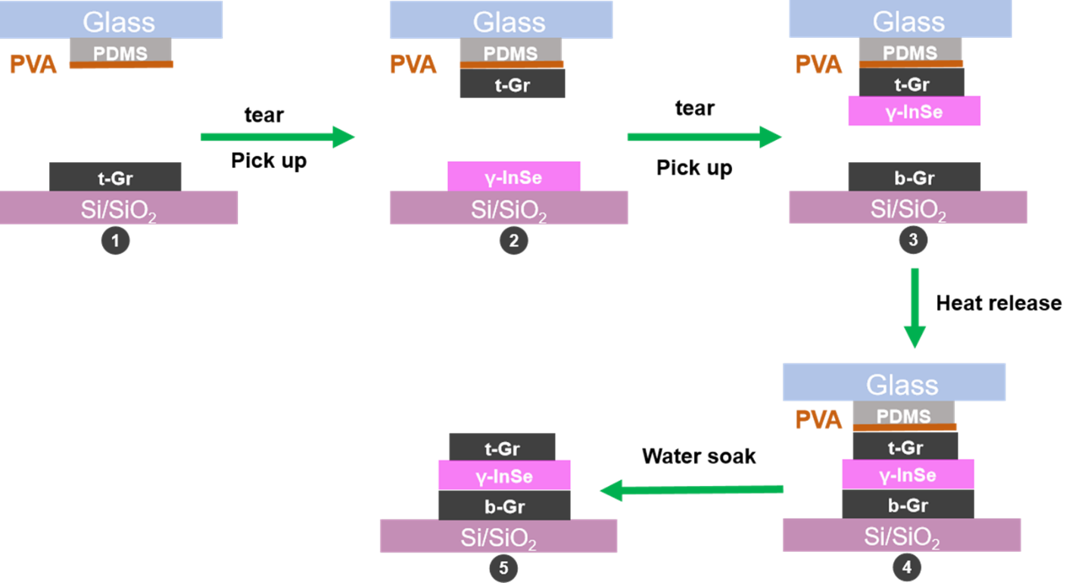

Supplementary Figure 10. Schematic diagram of the detailed procedures of the Gr/γ-InSe/Gr photodetector using dry-transfer technique.

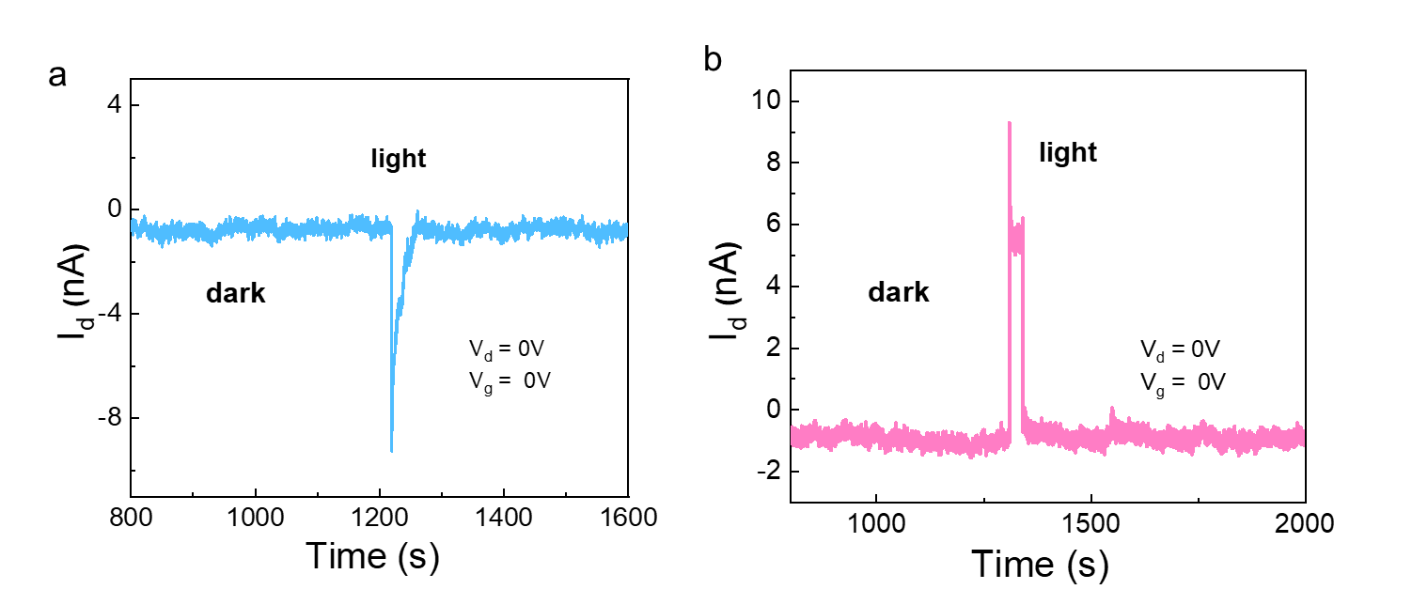
Supplementary Figure 11. a-b. The short-circuit current variation curves over time for downward polarization and upward polarization in the dark state.
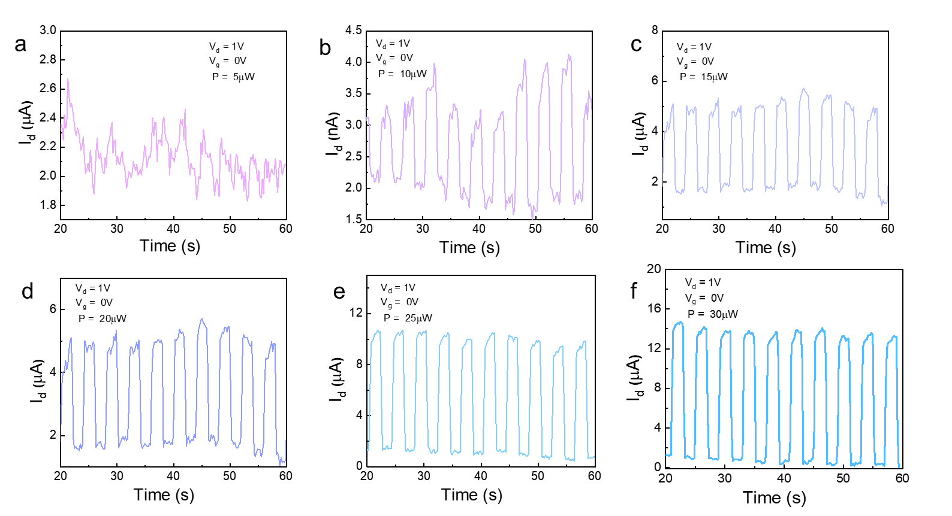

Supplementary Figure 12. a-f. Positive photocurrent switching characteristics under periodic illumination at different power levels of 520 nm light at zero bias.

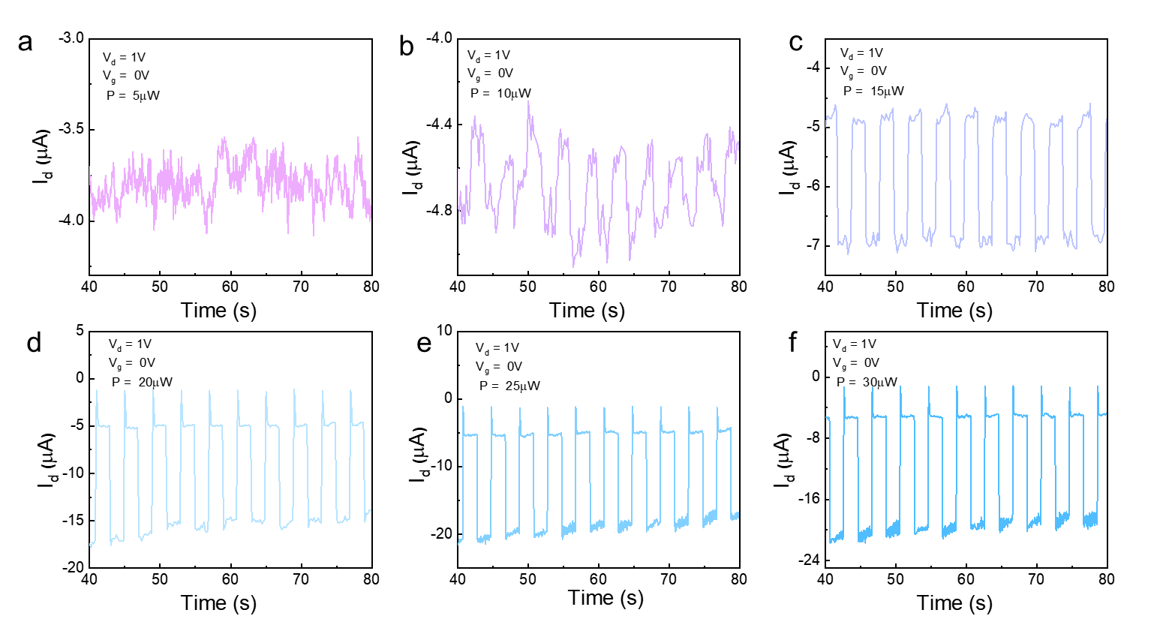

Supplementary Figure 13. a-f. Negative photocurrent switching characteristics under periodic illumination at different power levels of 520 nm light at zero bias.
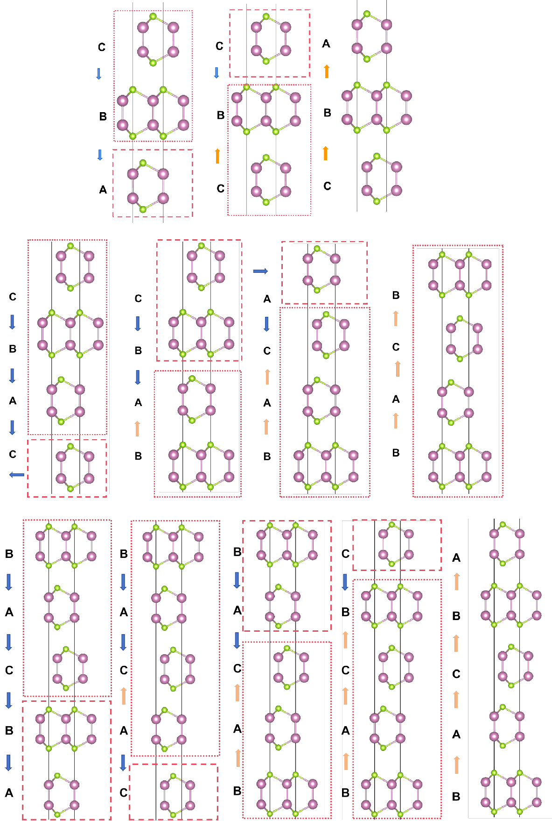
Supplementary Figure 14. Atomic structures of stable intermediate polarization states produced by the generalized model for (a)trilayer, (b) tetralayer and (c) pentalayer γ-InSe. Red dashed boxes mark out the moving blocks. Red horizontalarrows indicate the blocks’ directions of translation immediately after the state shown. Red dotted boxes mark out the stationary blocks. Each black vertical arrow indicates the direction of interface dipole between the layers sandwiching the arrow. Each set of black vertical arrows also illustrates the different polarization configurations in each state.

Supplementary Figure 15. Variation of spontaneous polarization in n-layer γ-InSe following the generalized model. Spontaneouspolarizations of states at 50% of switching process are taken as zero. Negative values denote downward polarization, and vice versa.

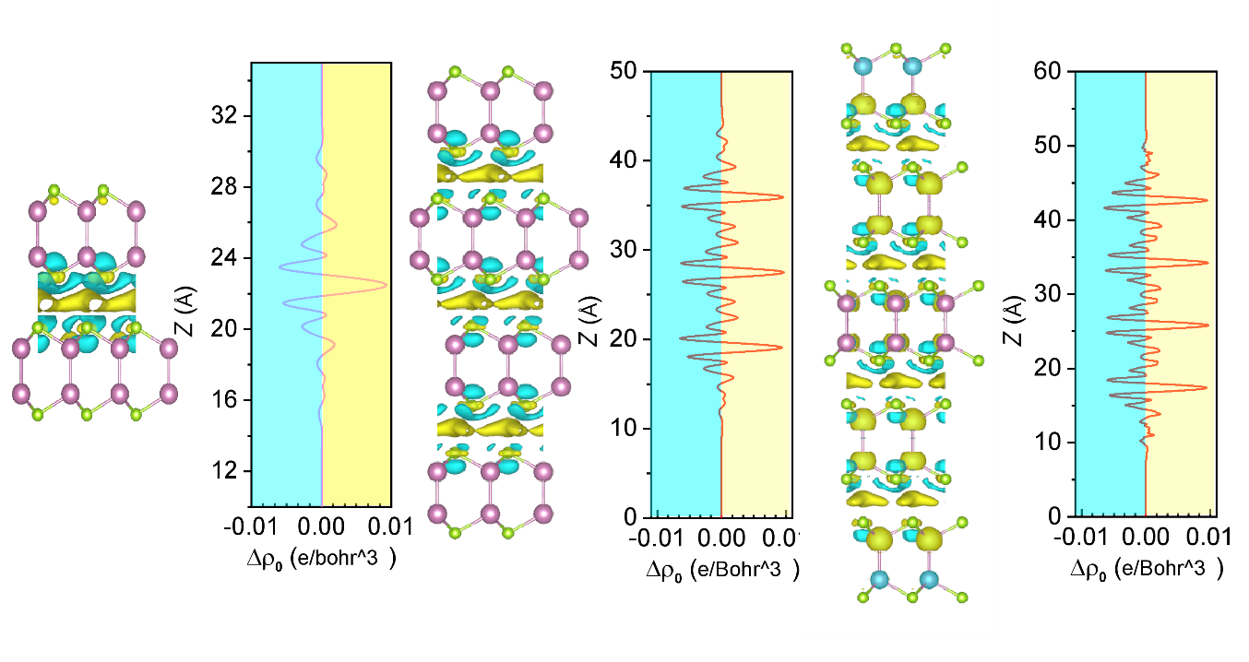
Supplementary Figure 16. Planar-averaged screening charge profiles among γ-InSe multilayers composed of three, four, five, and six γ-InSe monolayers, respectively. After the integration of Δρ from regions marked in Yellowand blue colors, the contributions from interlayer and monolayer regions to total P can be obtained. Green and gray areas indicate the polar surface charges accumulated at the top and bottom surfaces, respectively.

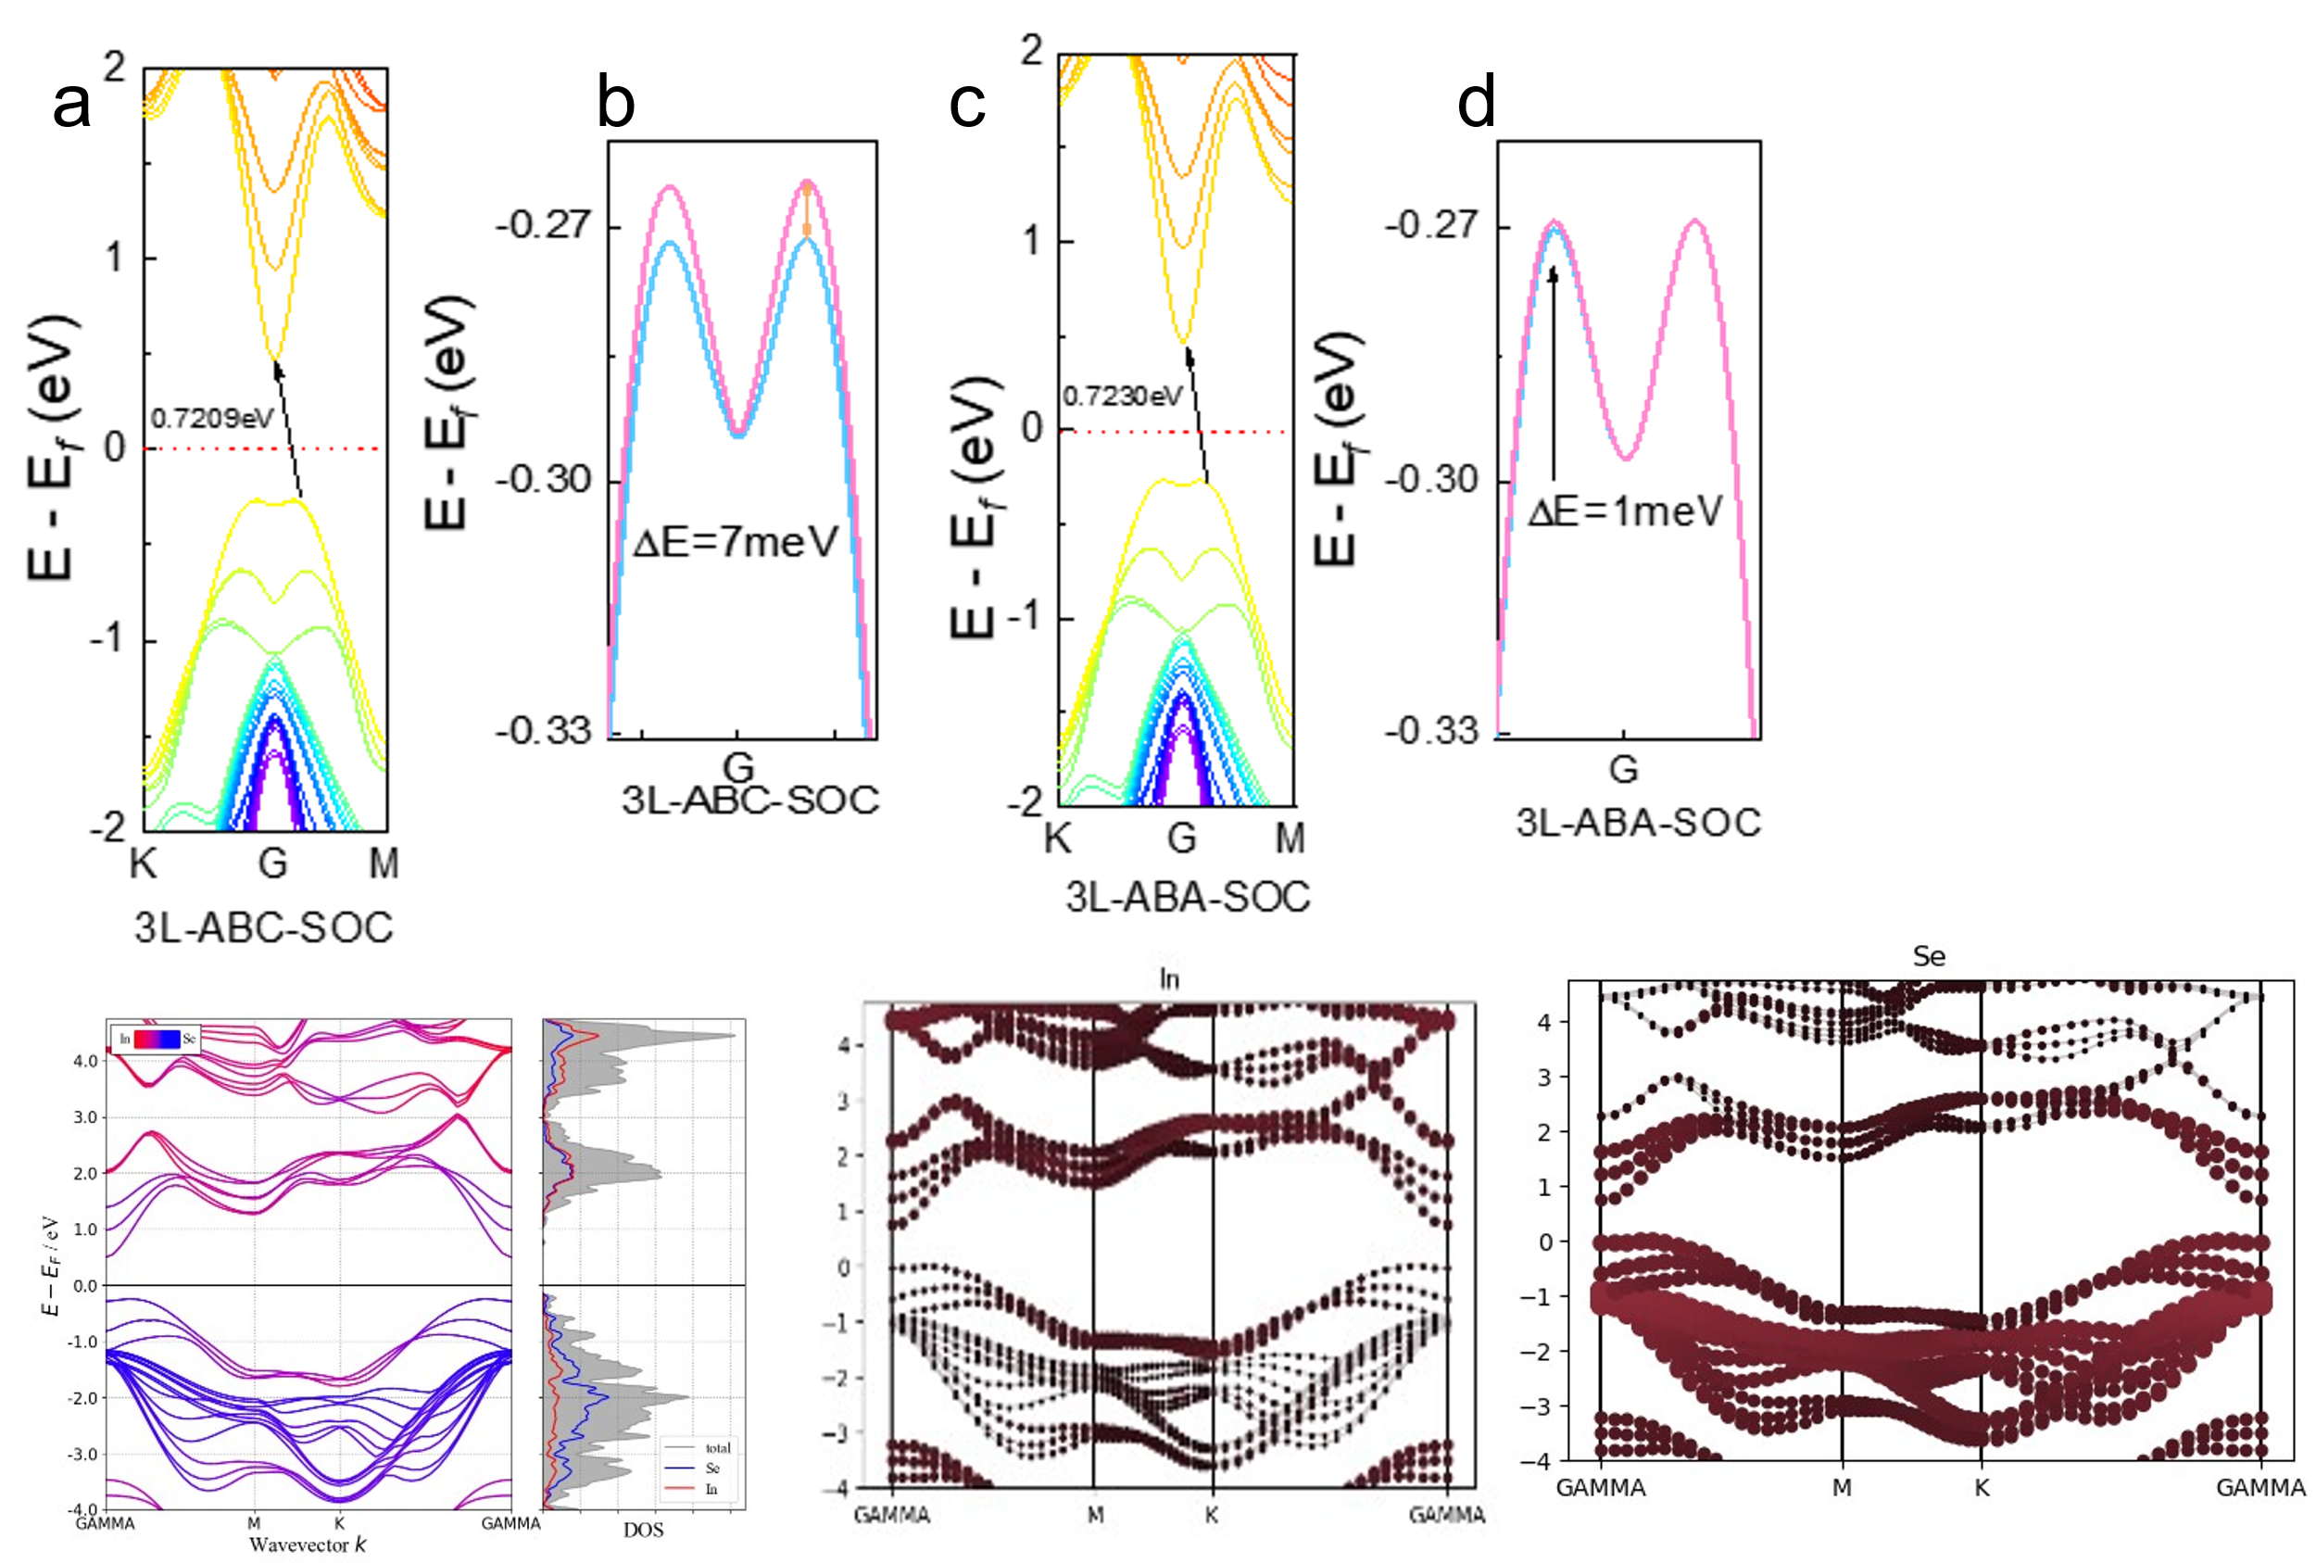
Supplementary Figure 17. a-d. band diagrams considering the spin-orbit coupling effect (SOC) for ABC and ABA stacking, respectively. Figures b and d are local magnifications of the valence band region corresponding to the band diagrams in figures a and c.
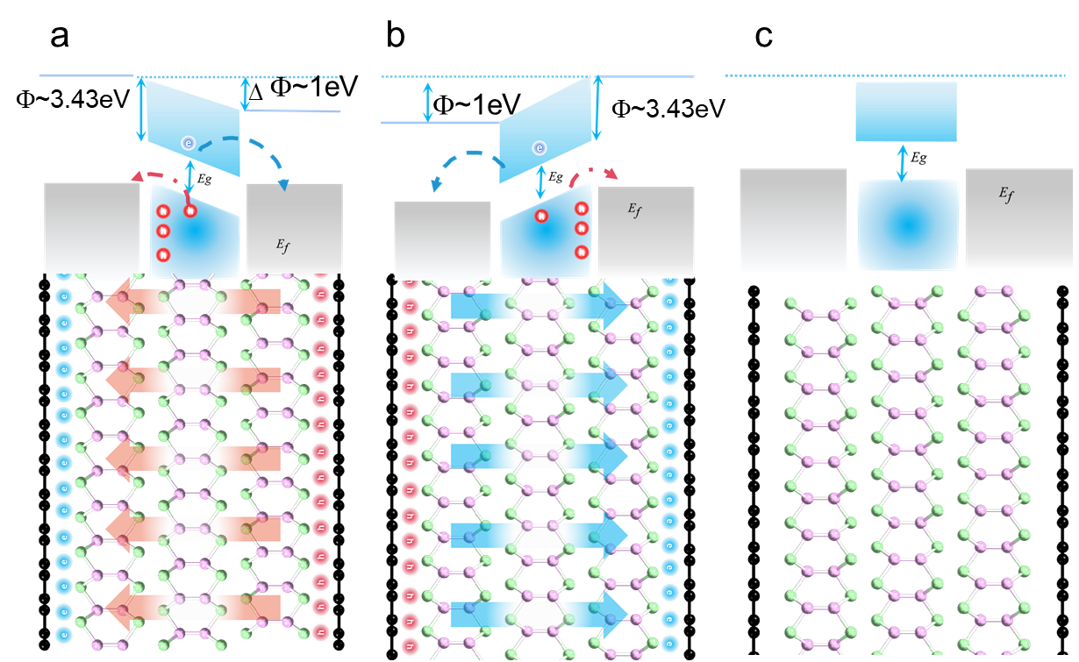

Supplementary Figure 18. a-b.The band diagram for the graphene/γ-InSe/graphene heterostructure at the upward and downward electric polarization state of ferroelectric γ-InSe. The top and bottom graphene electrodes are represented with slabs of atoms in black on the left and right sides of γ-InSe. In the heterostructure, the built-in electric field is indicated by the dashed lined arrows. The cartoon on the top depicts the corresponding energy shift of the conduction band and valence band. c. shows the band diagram of the device with γ-InSe in the paraelectric phase.
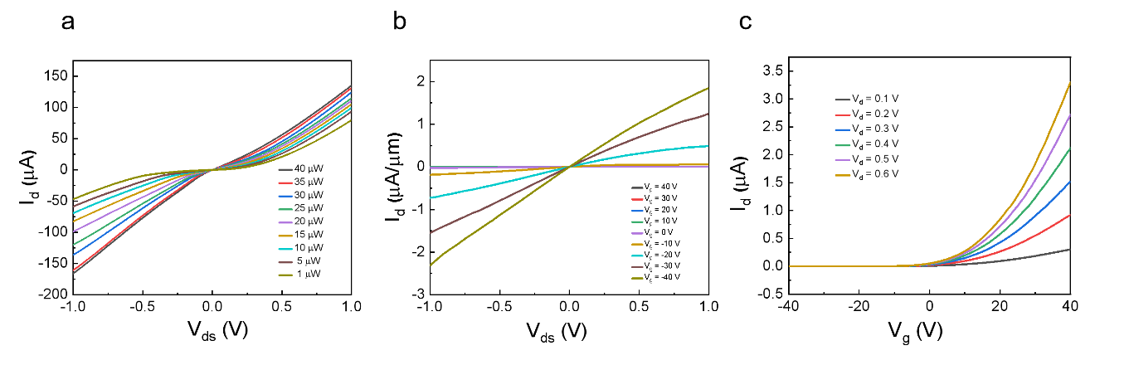
Supplementary Figure 19. a. The output characteristic curves of the Gr/InSe/Gr device under different light powers. b-c. The output characteristic curves and transfer characteristic curves of the Au/InSe/Au device under different gate voltages and bias voltages.

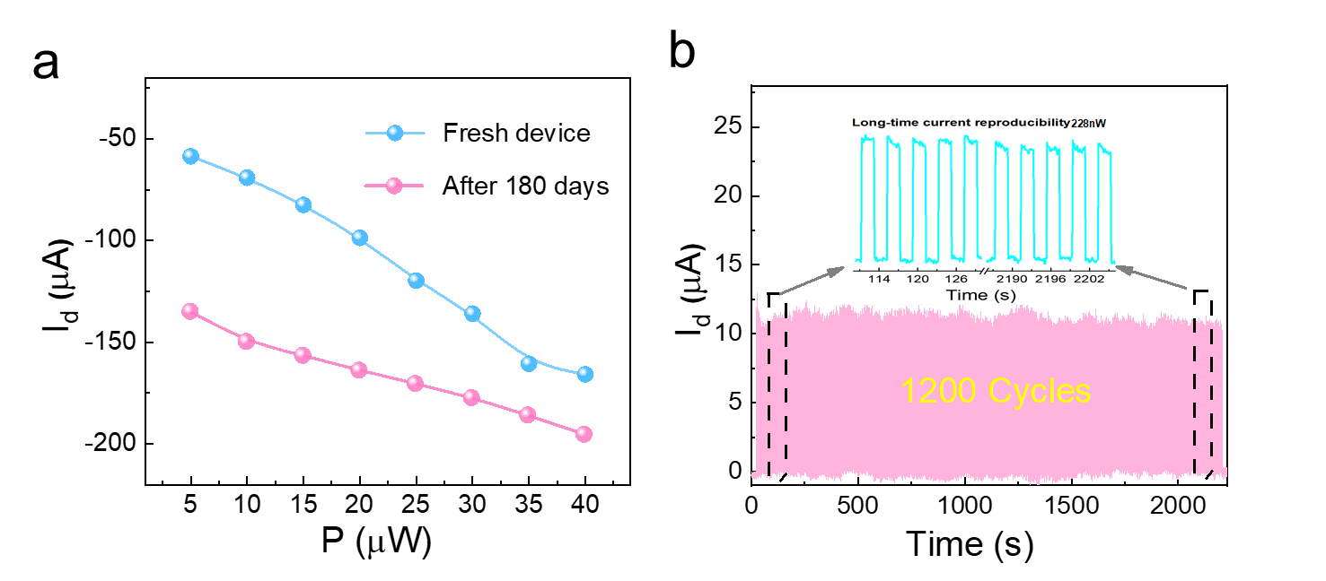

Supplementary Figure 20. a. Periodic switching response of the Gr/γ-InSe/Gr photodetector at different power densities under 520nm illumination. b. Photo-switching response of the Gr/γ-InSe/Gr photodetector under 520 nm periodic illumination with power density of 100 mW/cm². The γ-InSe/Gr photodetector remains a stable output photocurrent without any degradation after 1200 cycles.

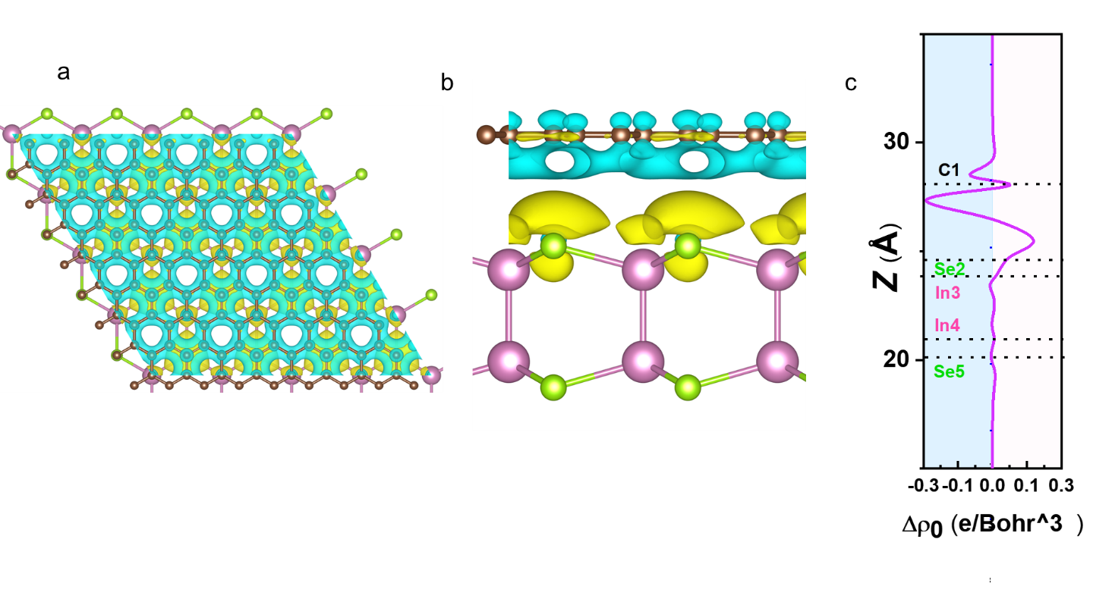
Supplementary Figure 21. Differential Charge Density and Charge Density Difference with Its Planar Averaged Profile

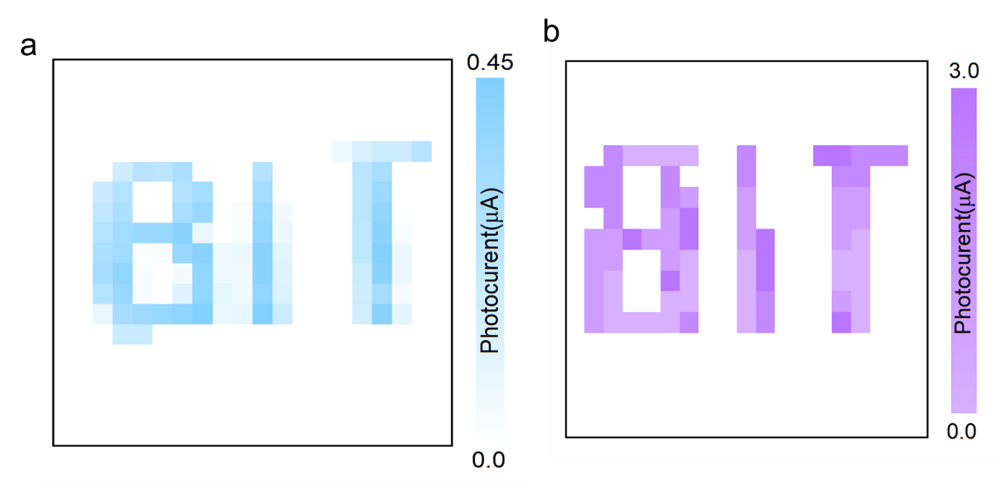

Supplementary Figure 22. The “BIT” images acquired from the single-pixel imaging system based on (a) the γ-InSe/Gr photodetector and (b) the Gr/γ-InSe/Gr photodetector upon 520 nm light irradiation.

Supplementary Table 1: Bilayer materials and their corresponding bulk material symmetries determined by BSF theory. (1) The crystal structures here are abstract bilayers, and the orange quadrilateral indicates the abstract unit cell of monolayer. (2) S+ and S− represent the bilayer with opposite sliding vectors.
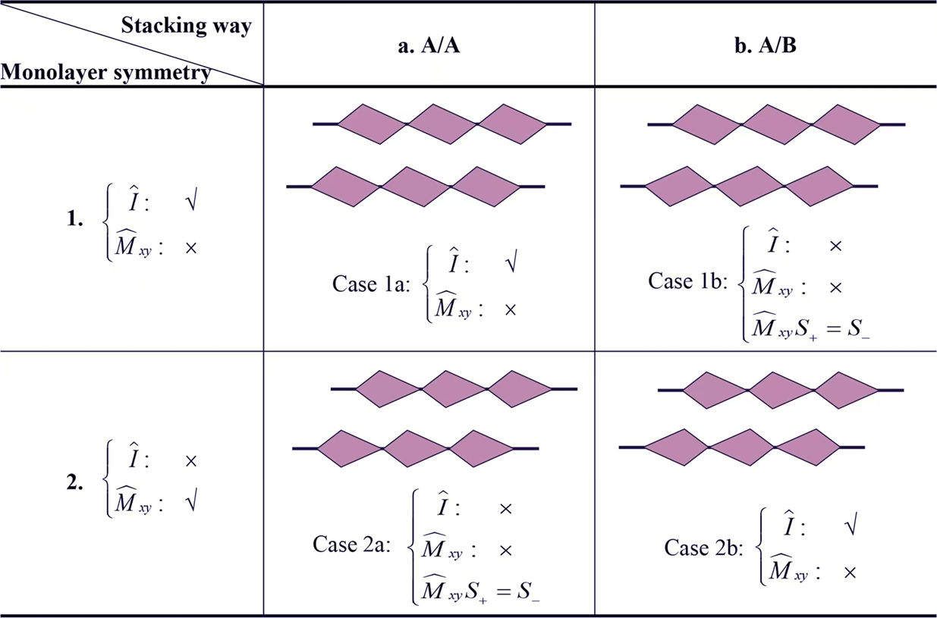
References:
1. Gasanly NM, Yavadov BM, Tagirov VI, Vinogradov EA. Infrared and Raman Spectra of Layer InSe Single Crystals. Phys Stat Sol (b) 89, K43-K48 (1978).

2. Hao Q, et al. Surface-Modified Ultrathin InSe Nanosheets with Enhanced Stability and Photoluminescence for High-Performance Optoelectronics. ACS Nano 14, 11373-11382 (2020).

3. Ferrari AC, et al. Raman spectrum of graphene and graphene layers. Phy Rev Lett 97, 187401 (2006).

4. Li L, Wu M. Binary Compound Bilayer and Multilayer with Vertical Polarizations: Two-Dimensional Ferroelectrics, Multiferroics, and Nanogenerators. ACS Nano 11, 6382-6388 (2017).

5. Ji W, Yao K, Liang YC. Bulk Photovoltaic Effect at Visible Wavelength in Epitaxial Ferroelectric BiFeO₃ Thin Films. Adv Mater 22, 1763 (2010).

6. Sui F, et al. Sliding ferroelectricity in van der Waals layered γ-InSe semiconductor. Nat Commun 14, 36 (2023).

7. Mudd GW, et al. Tuning the Bandgap of Exfoliated InSe Nanosheets by Quantum Confinement. Adv Mater 25, 5714 (2013).

8. Hamer MJ, et al. Indirect to Direct Gap Crossover in Two-Dimensional InSe Revealed by Angle-Resolved Photoemission Spectroscopy. ACS Nano 13, 2136-2142 (2019).

9. Arora H, Erbe A. Recent progress in contact, mobility, and encapsulation engineering of InSe and GaSe. Infomat 3, 662-693 (2021).

10. Liu M, et al. A graphene-based broadband optical modulator. Nature 474, 64-67 (2011).

11. Li Y, et al. Enhanced bulk photovoltaic effect in two-dimensional ferroelectric CuInP₂S₆. Nat Commun 12, 5896 (2021).

12. Lv H, Chu L, Sun X, Chen F. Thickness-Dependent nonlinear optical absorption of InSe/Graphene van der Waals heterostructures. Mater Lett 349, 134839 (2023).

13. Grinberg I, et al. Perovskite oxides for visible-light-absorbing ferroelectric and photovoltaic materials. Nature 503, 509 (2013).

14. Ji J, Yu G, Xu C, Xiang HJ. General Theory for Bilayer Stacking Ferroelectricity. Phy Rev Lett 130, (2023).

15. Xiao R-C, Gao Y, Jiang H, Gan W, Zhang C, Li H. Non-synchronous bulk photovoltaic effect in two-dimensional interlayer-sliding ferroelectrics. npj Comput Mater 8, 138 (2022).

