Supplementary Materials
Table E1. Information of the keloid patients.
No. | Gender | Age | Keloid area | Time with keloid(s)
1 | Female | 25 | Thorax | 7 years
2 | Female | 54 | Anterior | 2 years
3 | Female | 39 | Right knee | 2 years

Table E2. Targeting sequences of siRNAs against endogenous SSBP1.
Name | Targeting sequences
si-NC | 5’-ACGUGACACGUUCGGAGAATT-3’
si-SSBP1-1 | 5’-UCGCCACAUCUCAUUAGUUGCTT-3’
si-SSBP1-2 | 5’-UUUCAAGAACCAAACUGGUAGTT-3’
si-SSBP1-3 | 5’-AUUGUUGUUGCUUGUCGCCUCTT-3’

Table E3. Primer sequences for real-time PCR analysis.
Gene | Forward primer | Reverse primer
Human  IRF1 | 5’- TCACACAGGCCGATACAA-3’ | 5’- TTCCTGCTCTGGTCTTTCA-3’
Human GAPDH | 5’-GCACCGTCAAGGCTGAGAAC-3’ | 5’-GGATCTCGCTCCTGGAAGATG-3’

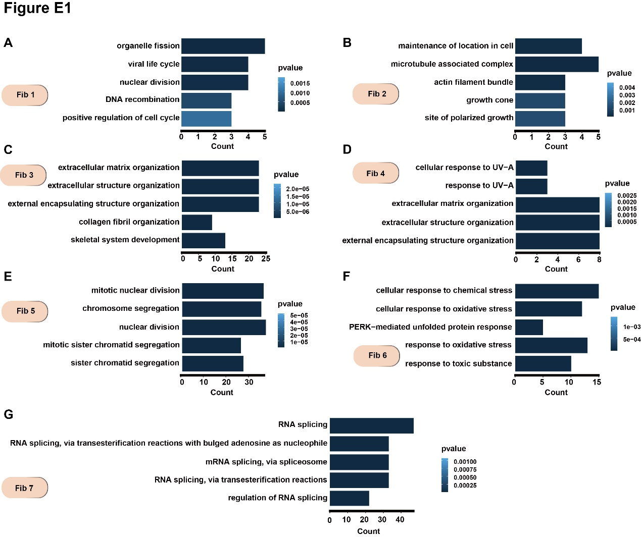

Fig. E1. Functional enrichment of primary keloid fibroblasts.
(A-G) Functional enrichment of upregulated genes in each fibroblast cell cluster with significance threshold set at P < 0.05.
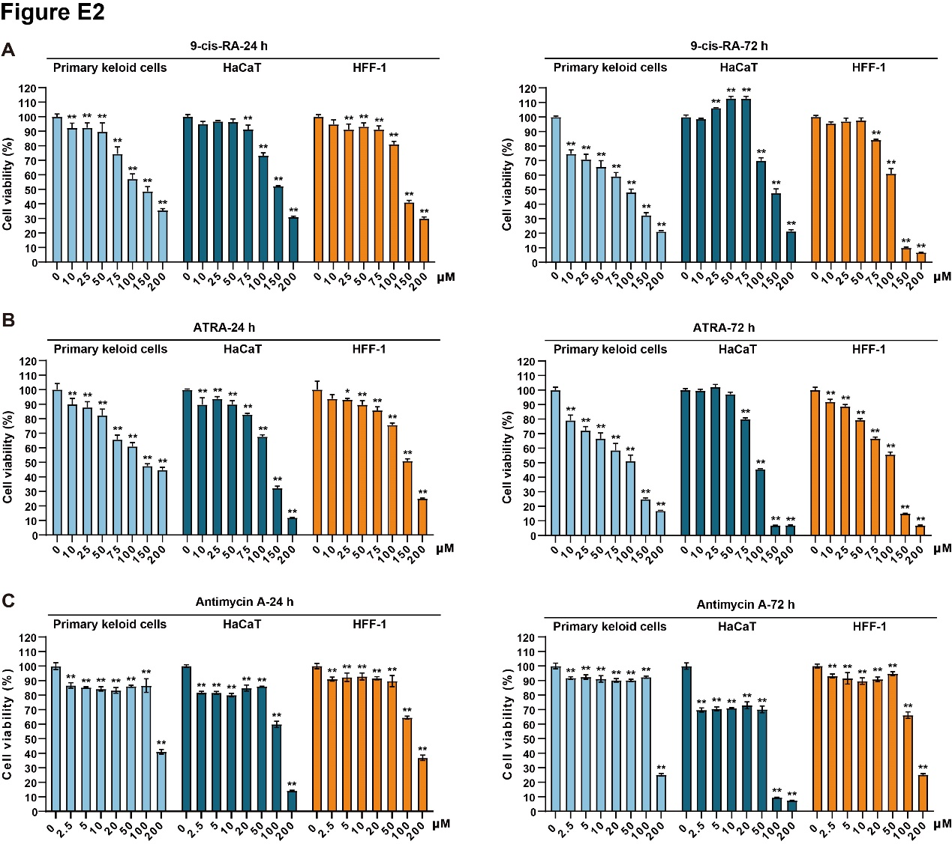

Fig. E2. Related to Fig. 6.
(A)-(C) Primary keloid fibroblasts, HaCaT and HFF-1 cells were treated with 9-cis-RA, ATRA and Antimycin A for 24 h and 72 h, then cell viability was measured by CCK-8 assays. *P < 0.05 and **P < 0.01.

Single-cell RNA sequencing (scRNA-seq)
Primary analysis of raw read data (scRNA-seq)
Raw reads were processed to generate gene expression profiles using CeleScope v1.5.2 (Singleron Biotechnologies) with default parameters. Briefly, Barcodes and UMIs were extracted from R1 reads and corrected. Adapter sequences and poly A tails were trimmed from R2 reads and the trimmed R2 reads were aligned against the GRCh38 (hg38) transcriptome using STAR (v2.6.1b). Uniquely mapped reads were then assigned to exons with FeatureCounts (v2.0.1). Successfully Assigned Reads with the same cell barcode, UMI and gene were grouped together to generate the gene expression matrix for further analysis.
Quality control, dimension-reduction and clustering (Seurat)
Seurat v 3.1.2 was used for quality control, dimensionality reduction and clustering. For each sample dataset, we filtered expression matrix by the following criteria: 1) cells with gene count less than 200 or with top 2% gene count were excluded; 2) cells with top 2% UMI count were excluded; 3) cells with mitochondrial content 20% were excluded; 4) genes expressed in less than 5 cells were excluded. After filtering, 43867 cells were retained for the downstream analyses, with on average 3027 genes and 10366 UMIs per cell. Gene expression matrix was normalized and scaled using functions NormalizeData and ScaleData. Top 2000 variable genes were selected by FindVariableFeatures for PCA analysis. Cells were separated into 7 clusters by FindClusters, using the top 20 principal components and resolution parameter at 0.35. Cell clusters were visualized using Uniform Manifold Approximation and Projection (UMAP) with Seurat functions RunUMAP.
Differentially expressed genes (DEGs) analysis (Seurat)
To identify differentially expressed genes (DEGs), we used the Seurat FindMarkers function based on Wilcoxon rank sum test with default parameters, and selected the genes expressed in more than 10% of the cells in both groups of cells and with an average log (Fold Change) value greater than 0.25 as DEGs. Adjusted p value was calculated by Bonferroni Correction and the value 0.05 was used as the criterion to evaluate the statistical significance.
Pathway enrichment analysis
To investigate the potential functions of DEGs between clusters, Gene Ontology (GO) analysis was used with the “clusterProfiler” R package v 3.16.1.¹ Pathways with p_adj value less than 0.05 were considered as significantly enriched. Selected significant pathways were plotted as bar plots. For GSVA pathway enrichment analysis, the average gene expression of each cell type was used as input data.²
Celltype annotation
Cell-type recognition with Cell-ID
Cell-ID is multivariate approach that extracts gene signatures for each individual cell and perform cell identity recognition using hypergeometric tests (HGT). Dimensionality reduction was performed on normalized gene expression matrix through multiple correspondence analysis, where both cells and genes were projected in the same low dimensional space. Then a gene ranking was calculated for each cell to obtain most featured gene sets of that cell. HGT were performed on these gene sets against brain reference from SynEcoSys database, which contains all cell-type's featured genes. Identity of each cell was determined as the cell-type has the minimal HGT p value. For cluster annotation, Frequency of each cell-type was calculated in each cluster, and cell-type with highest frequency was chosen as cluster’s identity.³
Cell-cell interaction analysis: CellPhoneDB
Cell-cell interaction (CCI) among clusters were predicted based on known ligand–receptor pairs by Cellphone DB (v2.1.0) version.⁴ Permutation number for calculating the null distribution of average ligand-receptor pair expression in randomized cell identities was set to 1000. Individual ligand or receptor expression was thresholded by a cutoff based on the average log gene expression distribution for all genes across each cell type. Predicted interaction pairs with p value <0.05 and of average log expression > 0.1 were considered as significant and visualized by heatmap_plot and dot_plot in CellphoneDB.
Cell differentiation potential evaluation: CytoTRACE
CytoTRACE v0.3.3 (a computational method that predicts the differentiation state of cells from single-cell RNA-sequencing data using gene counts and expression) was used to predict the differentiation potential of cell subpopulations.⁵
Pseudotime trajectory analysis: monocle2
Cell differentiation trajectory of monocyte subtypes was reconstructed with the Monocle2 v 2.10.0.⁶ For constructing the trajectory, top 2000 highly variable genes were selected by Seurat (v3.1.2) FindVairableFeatures, and dimension-reduction was performed by DDRTree. The trajectory was visualized by plot_cell_trajectory function in Monocle2.
Transcription factor regulatory network analysis (pySCENIC)
Transcription factor network was constructed by pyscenic (v0.11.0) using scRNA expression matrix and transcription factors in AnimalTFDB. First, GRNBoost2 predicted a regulatory network based on the co-expression of regulators and targets. CisTarget was then applied to exclude indirect targets and to search transcription factor binding motifs. After that, AUCell was used for regulon activity quantification for every cell. Cluster-specific TF regulons were identified according to Regulon Specificity Scores (RSS) and the activity of these TF regulons were visualized in heatmaps.⁷
Cell transfection
To explore the functions of SSBP1 in primary keloid fibroblasts, we used siRNA to knock down the expression of SSBP1. The targeting sequence of siRNAs against endogenous SSBP1 were listed in Table E2. Primary keloid fibroblasts were seeded in 10.0 cm culture dishes to 50–60% confluence and then transfected with either si-NC or si-SSBP1 using ExFect Transfection Reagent (Vazyme Biotech Co., Ltd., Nanjing, China) at a final concentration of 100 nM according to the manufacturer’s instructions.
Co-immunoprecipitation (Co-IP) assay
Primary keloid fibroblasts were irradiated with 5 Gy × 4 X-rays and 48 h after irradiation cells were washed with pre-chilled phosphate-buffered saline (PBS) and lysed with RIPA buffer containing protease inhibitor com pounds and PMSF (1%). 500 μg cell lysates was subjected to immunoprecipitation with 3 μg anti-IRF1 antibodies for co- immunoprecipitation (Co-IP) using Protein G Magnetic Beads (Med Chem Express, Monmouth Junction, NJ). The protein level was detected using indicated antibodies with Western blotting analysis.
RNA isolation and real-time quantitative PCR
TRIzol (Beijing Solarbio Science & Technology Co., Ltd., Beijing, China) was used to extract RNA from primary keloids fibroblasts at 72 h after the treatment of ATRA, 9-cis-RA and Antimycin A. RNA was then reverse-transcribed into DNA using PrimeScript™ RT reagent Kit with gDNA Eraser (Perfect Real Time) (Takara Biomedical Technology Co., Ltd., Beijing, China). The reverse transcription products were amplified by QuantStudio™ 3 (Applied Biosystems) using SuperReal PreMix Plus (SYBR Green) (TIANGEN BIOTECH (BEIJING) Co., Ltd., Beijing, China) according to the manufacturer’s instructions. The sequences were listed in Supplementary Table 3. All samples were repeated 3 times. GAPDH was used as an internal reference, and the formula was calculated using 2^{−△△Ct} method. The relative RNA concentration was calculated by treating the untreated group as 1.
Infection
Primary keloid fibroblasts were infected with adenovirus-mediated IRF1 overexpression (Ad-IRF1; GenBank accession) and their respective controls, which were obtained from Hanbio Biotechnology (Shanghai, China). Then cells were verified with Western blotting for subsequent experiments.
Potential therapeutic drugs prediction
The Comparative Toxicogenomics Database | CTD (ctdbase.org) was used to predict potential chemicals that interacted with the target gene.
Cell viability assay
Primary keloid fibroblasts, HaCaT and HFF-1 cells were seeded into 96 wells plates at 2000, 10000 and 4000 cells/well, respectively. After 24h, the cells were treated with ATRA, 9-cis-RA and Antimycin A and cultured for another 24, 48 and 72 h at 37˚C in a CO₂ incubator. Then, cell viability was assayed using a Cell Counting Kit-8 (CCK-8; Dojindo Laboratories, Inc., Kumamoto, Japan) and absorbance values were determined at 450 nm using a microplate reader (BioTek, Synergy HTX, Winooski, VT).
Statistical analysis
We performed three independent experiments. The data were expressed as mean ± standard error of the mean (SEM) and analyzed by GraphPad Prism 8.4. One-way analysis of variance (ANOVA) was used to assess significant differences, and statistical differences were considered when P < 0.05.

References
- Yu G, Wang LG, Han Y, He QY. clusterProfiler: an R package for comparing biological themes among gene clusters. OMICS. 2012 May;16(5):284-7.
- Hänzelmann S, Castelo R, Guinney J. GSVA: gene set variation analysis for microarray and RNA-seq data. BMC Bioinformatics. 2013 Jan 16;14:7.
- Cortal A, Martignetti L, Six E, Rausell A. Gene signature extraction and cell identity recognition at the single-cell level with Cell-ID. Nat Biotechnol. 2021 Sep;39(9):1095-1102.
- Efremova M, Vento-Tormo M, Teichmann SA, Vento-Tormo R. CellPhoneDB: inferring cell-cell communication from combined expression of multi-subunit ligand-receptor complexes. Nat Protoc. 2020 Apr;15(4):1484-1506.
- Gulati GS, Sikandar SS, Wesche DJ, Manjunath A, Bharadwaj A, Berger MJ, Ilagan F, Kuo AH, Hsieh RW, Cai S, Zabala M, Scheeren FA, Lobo NA, Qian D, Yu FB, Dirbas FM, Clarke MF, Newman AM. Single-cell transcriptional diversity is a hallmark of developmental potential. Science. 2020 Jan 24;367(6476):405-411.
- Qiu X, Hill A, Packer J, Lin D, Ma YA, Trapnell C. Single-cell mRNA quantification and differential analysis with Census. Nat Methods. 2017 Mar;14(3):309-315.
- Van de Sande B, Flerin C, Davie K, De Waegeneer M, Hulselmans G, Aibar S, Seurinck R, Saelens W, Cannoodt R, Rouchon Q, Verbeiren T, De Maeyer D, Reumers J, Saeys Y, Aerts S. A scalable SCENIC workflow for single-cell gene regulatory network analysis. Nat Protoc. 2020 Jul;15(7):2247-2276.

