Supporting Information

Supplementary figure 1. Immunohistochemical staining results of 92 pairs of tumor tissues and normal tissues adjacent to the cancer in patients with colorectal cancer. (scale bar, 700 μm)

Supplementary figure 2. a. Differential analysis of BCL3 in CRC and adjacent normal tissues in the TCGA database colorectal cancer project. (***, P < 0.001, paired sample t-test) b. Survival prognosis analysis for patients with high and low expression of BCL3 queried in the KM-plotter database. (Kaplan-Meier survival analysis) c. Sequencing data of colon cancer (COAD), rectal cancer (READ), esophageal cancer (ESCA), pancreatic cancer (PAAD), gastric cancer (STAD) and liver cancer (LIHC) tumor tissues and normal tissues were downloaded from TCGA and GTEx databases to compare BCL3 expression differences. (wilcox test, ***, P < 0.001)

Supplementary figure 3. p50 immunoblot (IB) following anti-Flag immunoprecipitation (IP) of protein lysates from 293T cells expressing Flag-tagged BCL3 plasmid, treated with DMSO, JS6 (10, 30, 50 μM) for 48 h.

Supplementary figure 4. a. The synthesis of JS6, refer to the methods section for the synthesis procedure. b. The proton nuclear magnetic resonance spectrum of JS6.

Supplementary figure 5. a. The synthesis process of PJ1799, refer to the methods section for the synthesis procedure. b. The proton nuclear magnetic resonance spectrum of PJ1799.

Supplementary figure 6. a. Concentration-dependent degradation of BCL3 by PJ1799. (duplicated twice, 48 h) (b - c) qPCR analysis of BCL3 after treatment with PJ1799 at concentrations of 0, 200, 250, 300, 350, 400 nM for 48 hours in HCT15 and HCT116 cells, respectively. (n = 4) d. Time-dependent degradation of BCL3 by PJ1799. (duplicated twice, 400 nM) (e - f) Western blotting analysis of BCL3 after treatment with JS6 at concentrations of 0, 0.5, 1, 10, 30, 50 μM for 48 h in HCT15 and HCT116 cells, respectively.

Supplementary figure 7. The CCK-8 assay assesses the cytotoxicity of PJ1799 and JS6 across various cell lines. (triplicate, mean ± SD)

Supplementary figure 8. AM/PI staining results and live/dead cell count statistics for HCT116 cells treated with specified concentrations of DMSO, JS6, PJ1799 for 48 h. (scale bar, 100 μm. ***, P < 0.001, unpaired two-tailed t-test)

Supplementary figure 9. HCT15 and HCT116 cells were treated with specified concentrations of DMSO, JS6, and PJ1799 for 48 h. a. Cell migration was observed using Transwell assays, (b - c) and the number of migrating cells was quantified. (n = 3, scale bar, 200 μm.***, P < 0.001, **, P < 0.005, unpaired two-tailed t-test)

Supplementary figure 10. (a - b) HCT15 and HCT116 cells were treated with specified concentrations of DMSO, JS6, and PJ1799 for 48 h. The cell cycle was detected using flow cytometry.

Supplementary figure 11. (A, B) Knockdown of BCL3 in 293T cells, followed by qPCR and Western blotting analysis of BCL3 24 h post-transfection. (n = 3)

Supplementary figure 12. (a - b) Western blotting results of JNK/p38-MAPK signaling pathway-related proteins in HCT15 and HCT116 cells treated with JS6 at concentrations of 0, 10, 30, 50 μM for 48 h.

Supplementary figure 13. (a - b) Western blotting results of PI3K-AKT signaling pathway-related proteins in HCT15 and HCT116 cells treated with JS6 at concentrations of 0, 10, 30, 50 μM for 48 h.

Supplementary figure 14. Transient overexpression of BCL3 in HCT15 and HCT116 cells, with qPCR (n = 6) (a - c) and Western blotting (b - d) analyses of BCL3 conducted 48 hours post-plasmid transfection.
Supplementary figure 15. Mitochondrial membrane potential in HCT15 a. and HCT116 b. cells treated with DMSO, JS6 (30 μM, 48 h), PJ1799 (400 nM, 48h), and BCL3 overexpression plasmid pre-treated for 24 hours followed by PJ1799 (400 nM, 48 h). (Scale bar, 100 μm)
Supplementary figure 16. a. The synthesis process of PJ1799-fo, refer to the methods section for the synthesis procedure. b. The proton nuclear magnetic resonance spectrum of PJ1799-fo.

Supplementary figure 17. Immunofluorescence assays were conducted to assess the expression of FR in HCT15, HCT116, and HK2 cells. (Scale bar, 20 μm)

Supplementary figure 18. a. Display of subcutaneous tumors in mice prior to dissection. b. Weighting and comparison of subcutaneous tumors in mice after dissection. (n = 5, *, P < 0.05, ***, P < 0.001, unpaired two-tailed t-test)

Supplementary figure 19. a. The cytotoxic effect of PJ1799-abl on CRC cell lines. (triplicate, CCK8 assay, 48 h) b. Western blotting results of BCL3 in HCT15 cells after treated with PJ1799-abl at concentrations of 0, 10, 20, 30, 40, and 50 nM for 48 h.

Supplementary figure 20. Cellular uptake of PJ1799-abl. Following treatment of tumor cells with PJ1799-abl, the process of drug absorption by the tumor cells was observed. The PJ1799-abl nanomedicine, labeled with Dio dye, was indicated by green fluorescence; the actin cytoskeleton was marked by red fluorescence; and the cell nuclei was denoted by blue fluorescence with DAPI. (Scale bar, 50 μm，20 μm)

Supplementary figure 21. Modeling of an abdominal disseminated tumor model in mice. A mice model of intraperitoneal metastatic dissemination tumors was established using HCT15-Luci cells. On the third day after intraperitoneal inoculation, IVIS imaging and abdominal dissection confirmed the successful establishment of the intraperitoneal metastatic dissemination tumor model.

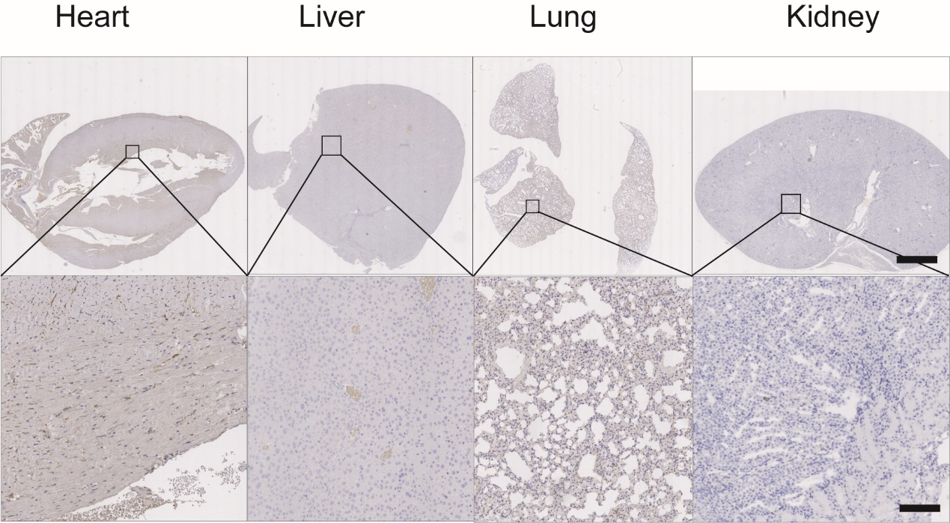
Supplementary figure 22. BCL3 immunohistochemical staining on tissue sections of the heart, lungs, liver, and kidneys of mice. (Scale bar, 2.5 mm, 200 μm)

Supplementary figure 23. Recorded body weight changes in abdominal tumor models in each group of mice. (n = 5)

Supplementary figure 24. Lymphocyte count and hemoglobin content for each group of mice.
a. Lymphocyte count and for each group of mice. (n = 3) b. hemoglobin content for each group of mice. (n = 3)

Supplementary figure 25. Hemolysis of erythrocytes after 4 h of co-incubation with the nanomedicine PJ1799-abl at various concentrations.

