Supplementary information

S1 Higher topological charge STOV driving beams.
HHG allows for the generation of STOVs with extremely high topological charges, as indicated by the harmonic topological charge linear dependence with the driving STOV fundamental topological charge and the harmonic order. In the same way as in longitudinal vortices, where topological charges as high as 100 have been demonstrated [1] extremely high-topological charge EUV-STOVs can be obtained using multiply charged driving IR STOVs. Here, first we present HHG experimental results driven with higher topological charge STOVs with an inhomogeneous distribution and in the out-of-focus scenario.
In Fig. S1 we present experimental and numerical results, for HHG driven by IR STOVs with topological charges of $l_{0}=1$ (first row), $l_{0}=2$ (second row) and $l_{0}=4$ (third row). In this scenario, for all the cases an inhomogeneity parameter $η \sim 2$ is assumed, and the gas jet is located after the focus. As we are dealing with an out-of focus and inhomogeneous scenario, the positively sloped spectral stripes, discussed in the Section 2.3, for each harmonic order are observed. Looking at the experimental spectra [Fig. S1(c)], the increase of the driving topological charge enlarges the spectral distance between the two stripes for each harmonic order, i.e., their harmonic bandwidth is increased. As there is a direct relation between the topological charge content and the spectral bandwidth in STOVs, for a given harmonic order, a larger bandwidth means a higher topological charge, which linearly scales with the harmonic order and the fundamental topological charge.

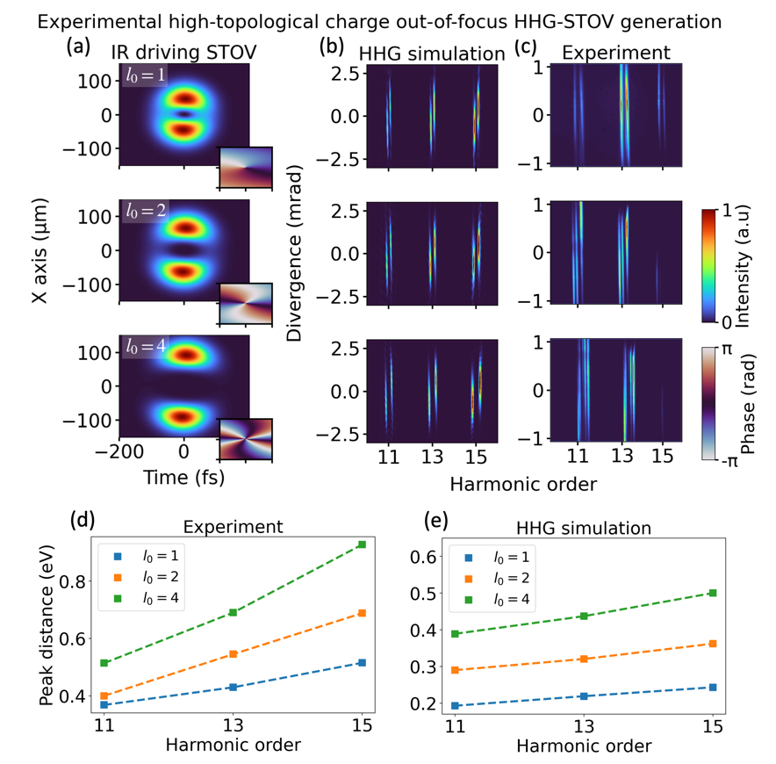
Figure S1: Experimental and theoretical results of HHG driven by elliptical STOVs for different topological charges after-the-focus position. Top: charge $l0=1$, middle: $l0=2$, and bottom: $l0=4$. (a) The driving STOV fields ($η=2$) with the different topological charges used. (b) Simulated HHG-STOV spectra results for the driving STOV fields shown in panel (a). (c) Experimental harmonic STOV spectra driven by an inhomogeneous STOV beam ($η∼1.8$) for the different topological charges. Note the positively slope striped harmonic spectra resulting from the inhomogeneous driving STOV in the after-focus-position. The spectral peak distances of the harmonic stripes are shown in panels (d) and (e) for the experimental and simulated results presented in panels (b) and (c). The predicted harmonic bandwidth increasing with the driving beam topological charge is experimentally confirmed.
The theoretical simulations, shown in Fig. S1(b), are performed feeding the driving spatiotemporal intensities shown in Fig. S1(a) and assuming a gas jet position $z = f + 1.5$ mm to mimic the experimental parameters. The simulation spectra show a very similar trend, predicting the harmonic bandwidth widens as the driving topological charge is also increased. The peak distances between the harmonic stripes in Figs. S1 (b) and S1(c) are shown in Figs. S1(d) and S1(e) as function of the driving STOV topological charge, respectively. It is evident the direct relationship between the driving STOV topological and the increasing harmonic STOV bandwidth. Although a complete spatiotemporal/spatiospectral phase retrieval would be required to determine the exact harmonic STOV/SSOV topological charge—which to the best of our knowledge does not exist in the EUV regime—, this is clear signature of the higher harmonic topological charges. The scale difference between experimental and the simulated results comes from the different driving pulse durations assumed in the numerical simulations due to computational limitations.

S2 Intrinsic dipole phase effect in the high-order harmonic STOV
The intrinsic dipole phase is the accumulated electronic phase during its continuum excursion which is translated into the HHG emission in the recombination step. It is known to be critical on several applications of the HHG emission, as the harmonic beam divergence optimization, the generation of attosecond pulses or the intra-atomic temporal optimization [2–4]. We have observed that the perfect agreement between the HHG numerical simulations and the analytical model (which does not include the dipole phase) shown in the main text hold when the harmonics are well in the plateau. However, we do observe dipole phase effects for the harmonics closer to cut-off energy.
To analyze the effect of the dipole phase, in Fig. S2, SSOV higher harmonic orders are shown (from the 21st to the 25th), closer to the cut-off ($q_{cutoff}=27$). The spectrum is obtained assuming that the gas-jet is placed in the focus position and using a driving STOV inhomogeneity parameter $η=2$. The results shown are obtained using (a) the full numerical simulations, and (b, c) the analytical model shown in Eq. (5) neglecting/including the intrinsic dipole phase $ϕ_{int}$. The intrinsic dipole phase is calculated using the gamma model [2]. In contrast with the straight harmonic stripes obtained in Fig. 3, bottom row, the higher harmonic orders shown in Fig. S2 show their edges warped. The nature of the harmonic warping obtained in the full HHG numerical simulations can only be described when the intrinsic dipole phase term is included in the analytical model.
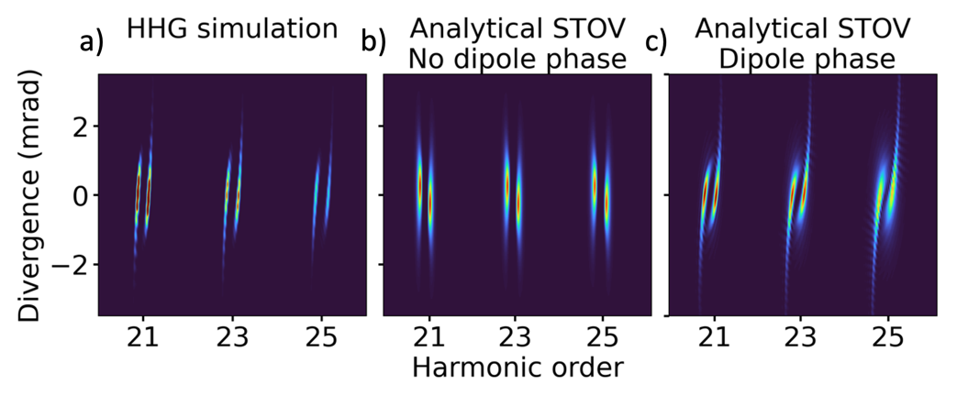
Figure S2: Intrinsic dipole phase effect on the inhomogeneous harmonic SSOV spectrum. (a) High-order harmonics (near to cutoff frequency) driven by an inhomogeneous STOV ($η=2$). The harmonic stripes are bent respect to the lower harmonic orders (see Fig. 3 bottom row in main text). The analytical model harmonic spectrum (see methods) without the intrinsic dipole phase (b) and with the intrinsic dipole phase (c). Only when the dipole phase term is included, the harmonic SSOV bending can be described

S3 Elliptical STOV beam generation from the pulse shaper
The ellipticity of STOV beam is defined by the inhomogeneity parameter $η$, as described in eq. (3). The $η=1$ case represents the canonical STOV beam, where a perfect donut-shaped STOV beam is formed. In many cases, the inhomogeneity parameter can be deviated from unity due to various experimental conditions. In our experiment, such inhomogeneity parameter $η$ is defined by the beam spatial ellipticity at the Fourier plane of the 4-f pulse shaper. The inhomogeneity parameter $η=1.8$ can be calculated by using the following experimental conditions, i.e., beam diameter (10 mm), laser spectral bandwidth (45 nm), grating groove density (600 grooves/mm), cylindrical lens focal length (20cm).
Figure S3 (a) shows the simulation of an elliptical Gaussian beam at the Fourier plane of the pulse shaper. The STOV beam at the gas jet can be estimated with a 2-d Fourier transform, as shown in Figure S3 (b), where spatiotemporal profile of the STOV beam is very similar to our simulation in the paper with inhomogeneity parameter $η=2$.
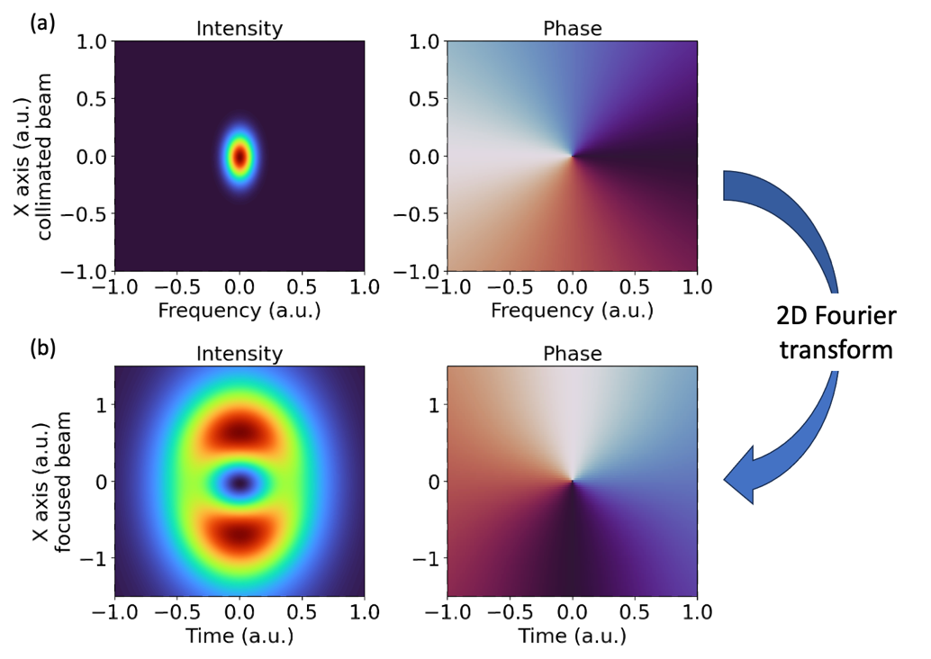
Figure S3: Simulation of STOV beam generation from pulse shaper with inhomogeneity parameter $η=1.8$. (a) An elliptical Gaussian beam is formed at the Fourier plane of the pulse shaper. (b) The Elliptical STOV beam at the gas jet generated from the (a).

Bibliography
1. Pandey, A. K. et al. Characterization of extreme ultraviolet vortex beams with a very high topological charge. ACS Photonics 9, 944–951 (2022).
2. Guo, C. et al. Phase control of attosecond pulses in a train. J. Phys. B: At. Mol. Opt. Phys. 51, 034006 (2018).
3. Wikmark, H. et al. Spatiotemporal coupling of attosecond pulses. Proceedings of the National Academy of Sciences 116, 4779–4787 (2019).
4. Christov, I. P., Bartels, R., Kapteyn, H. C. & Murnane, M. M. Attosecond Time-Scale Intra-atomic Phase Matching of High Harmonic Generation. Phys. Rev. Lett. 86, 5458–5461 (2001).

