Supplementary Information: Solar thermal resonant energy exchange desalination (STREED) for 24-hour, membrane-free, off-grid water treatment

William Schmid^{1,2‡}, Aleida Machorro-Ortiz^{1,2,3‡}, Qian Ye^{2,4}, Peter Nordlander^{1,2,4}, Pratiksha D. Dongare^{1,2,5}, Naomi J. Halas^{1,2,4,6*}, Alessandro Alabastri^{1,2*}
¹Department of Electrical and Computer Engineering, Rice University, Houston, TX, USA; ²Laboratory for Nanophotonics, Rice University, Houston, TX, USA; ³Applied Physics Graduate Program, Rice University, Houston, TX, USA; ⁴Department of Physics and Astronomy, Rice University, Houston, TX, USA; ⁵Currently with SLB, Houston, TX, USA; ⁶Department of Chemistry, Rice University, Houston, TX, USA

*Correspondence to: halas@rice.edu (N.J.H.), alessandro.alabastri@rice.edu (A.A.)

‡Equal contribution

Photos of the experimental STREED apparatus
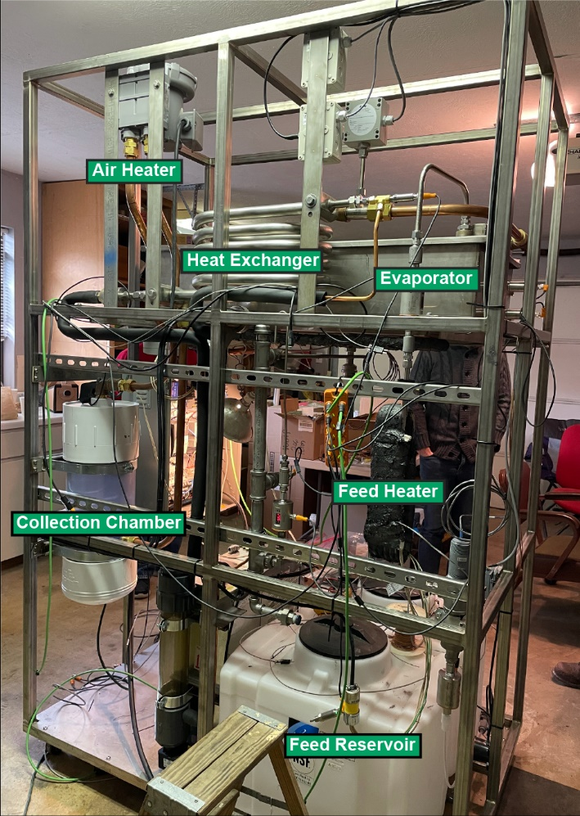
Supplementary Fig. 1 | Photo of experimental STREED prototype. As diagrammed Fig. 1b, the physical STREED prototype consists of a flat plate evaporator coupled with a spiral shell-and-tube heat exchanger. Chilled saline water from the feed reservoir flows into the heat exchanger to interact with the countercurrent flow of air and vapor exiting the evaporator. The feed recovers latent heat from the condensing vapor before being heated by the feed heater. The hot feed evaporates into the air flow and the vapor continues on to the heat exchanger. After exiting the heat exchanger, the air flows into the collection chamber to deposit condensed water. The air then continues onto the air heater before being recirculated into the evaporator.

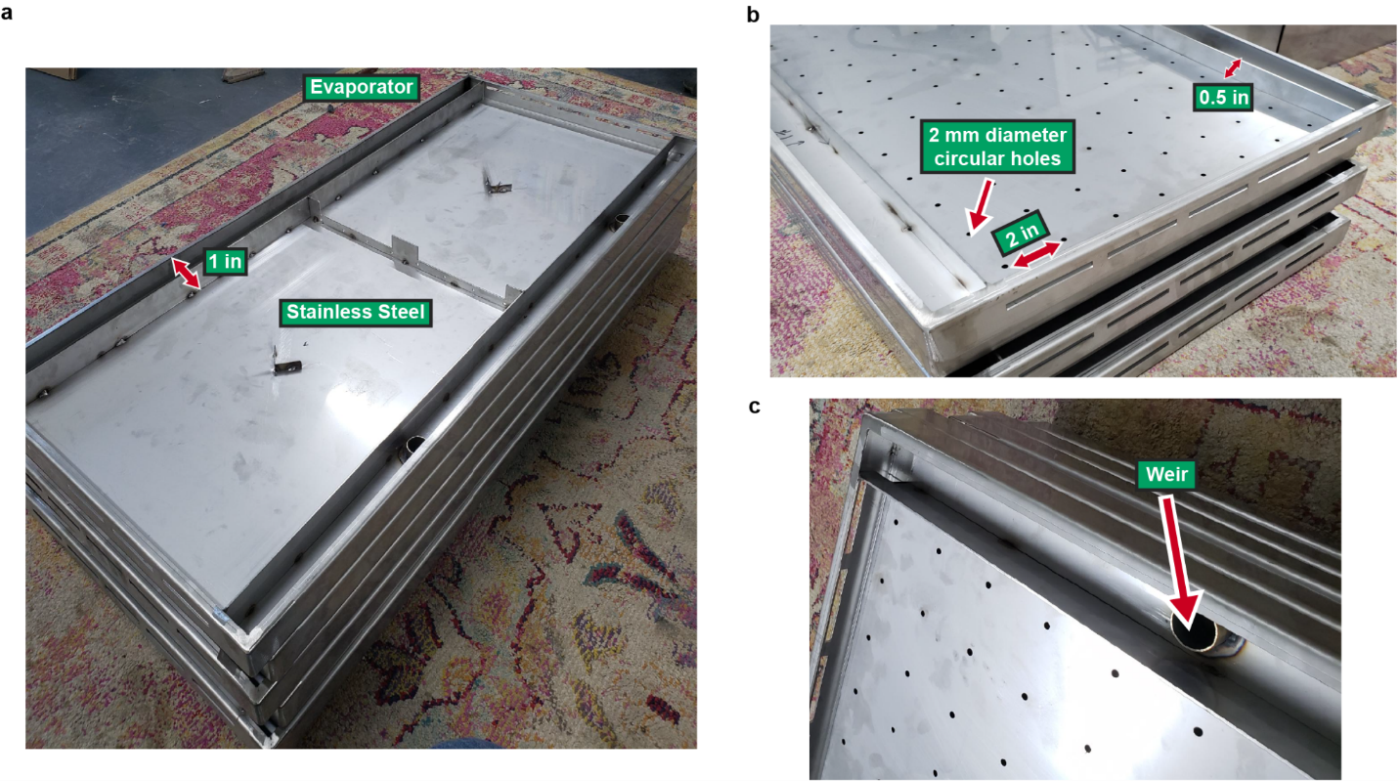
Supplementary Fig. 2 | Close-up photos of the evaporator with dimensions. a, Stainless steel evaporator with a 1-inch depth tray. b, Plate with 2 mm diameter circular holes on the evaporator that are separated 2 inches apart. c, Draining system in the form of a circular overflow weir that prevents overflowing from the edges.

Air and feed flow rates in experimental apparatus

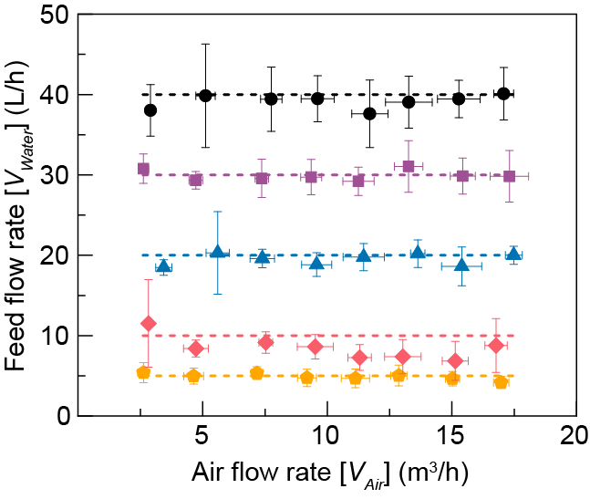
Supplementary Fig. 3 | Analysis of air flow rate versus feed flow rate. Solid symbols represent the experimental values of the feed ($V_{feed}$) and airflow ($V_{air}$) rates. Dashed lines serve as a visual guide for the 5 feed flow rates: 5, 10, 20, 30, and 40 L/h.

Predicted STREED performance with increased feed salinity and temperature
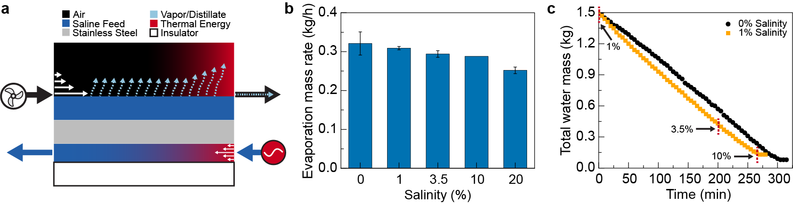
Supplementary Fig. 4 | Evaporation performance at different salinities. a, Schematic of the system for the salinity dependence measurements. The feed channel (bottom stream) gets heated before entering the system. Saline and feed water are in thermal contact with the metal plate. Evaporation is dragged out from the module by the airflow. b, Experimentally measured evaporation rate at 5 different salinities (0, 1, 3.5, 10, 20 wt%). c, Experimentally measured water mass over time at 2 different salinities (0 and 1 wt%).
Supplementary Note 1: Evaporation performance at different salinities. The salinity dependence experiments were performed in a lab-scale evaporator system (20 cm x 50 cm) (Supplementary Fig. 5a) that mimics the evaporator from Fig. 1. The evaporator was made of a 0.25-inch-thick stainless-steel plate 316L. It consisted of a 0.5-inch-deep tray where saline water was deposited for evaporation as shown in Supplementary Fig. 5a. Underneath, there was a 2-mm-thick heated water channel contained by a 0.5-inch-thick polycarbonate plate, the hot water is indirect thermal contact with the saline water on the top. The hot water was heated until it reached ~90 °C using a heating tape (BRISKHEAT, HSTAT101006) that was wrapped around a galvanized steel pipe with a 1-inch radius and 4 feet long. At 14 cm away from the evaporator, a blower fan (Intertek, TF-810S) was placed, which swept the evaporation away using a countercurrent flow from the system. The system was placed over a digital balance (ISHIDA, IPC) that monitored and recorded the variation of mass over time to analyze how the salinity content in saline water can affect the evaporation rate.
For measuring the evaporation performance at different salinity concentrations, 5 different saline solutions with a salinity range from 0 to 20 wt% were prepared, one with only deionized water (produced by Milli-Q Integral; Millipore) and the rest at 4 different salt concentrations (1, 3.5, 10 and 20 wt%, ionized salt (HEB) in deionized water). The salinity values were chosen thinking in the most common water sources of desalination systems, for example, brackish and saline water are 1 and 3.5 wt%, respectively. The higher values (10 and 20 wt%) mimicked hypersaline water sources and 0 wt% was tested as the control value. Evaporation rates for the 5 salinities cases are shown in Supplementary Fig. 5b. The difference between the two extreme cases (0 and 20 wt% simulated saline water) is ~21.5%. The non-significant change in the evaporation rate demonstrates that it is possible to use evaporation-based technologies like STREED to treat water with high salt concentrations. To observe the change in the rate of evaporation over time when the salinity concentration is increasing, the cases of 0 and 1 wt% simulated saline water were studied. For each case, 1.5 liters of the simulated saline water were added to the evaporator, and the mass change was monitored and recorded in real time. For the 1 wt% simulated saline water case (black line, Supplementary Fig. 5c), marks were placed on the graph when the solution reached the concentrations of 3.5 and 10 wt% simulated saline water. The evaporation rate (total water mass per time) is 0.288 kg/h and 0.306 kg/h for 0 and 1 wt% simulated saline water cases, respectively. The percentage change between both evaporation rates is 6.25%, which indicates that there is no significant change between both cases. This shows that STREED is a robust system for saline water evaporation.

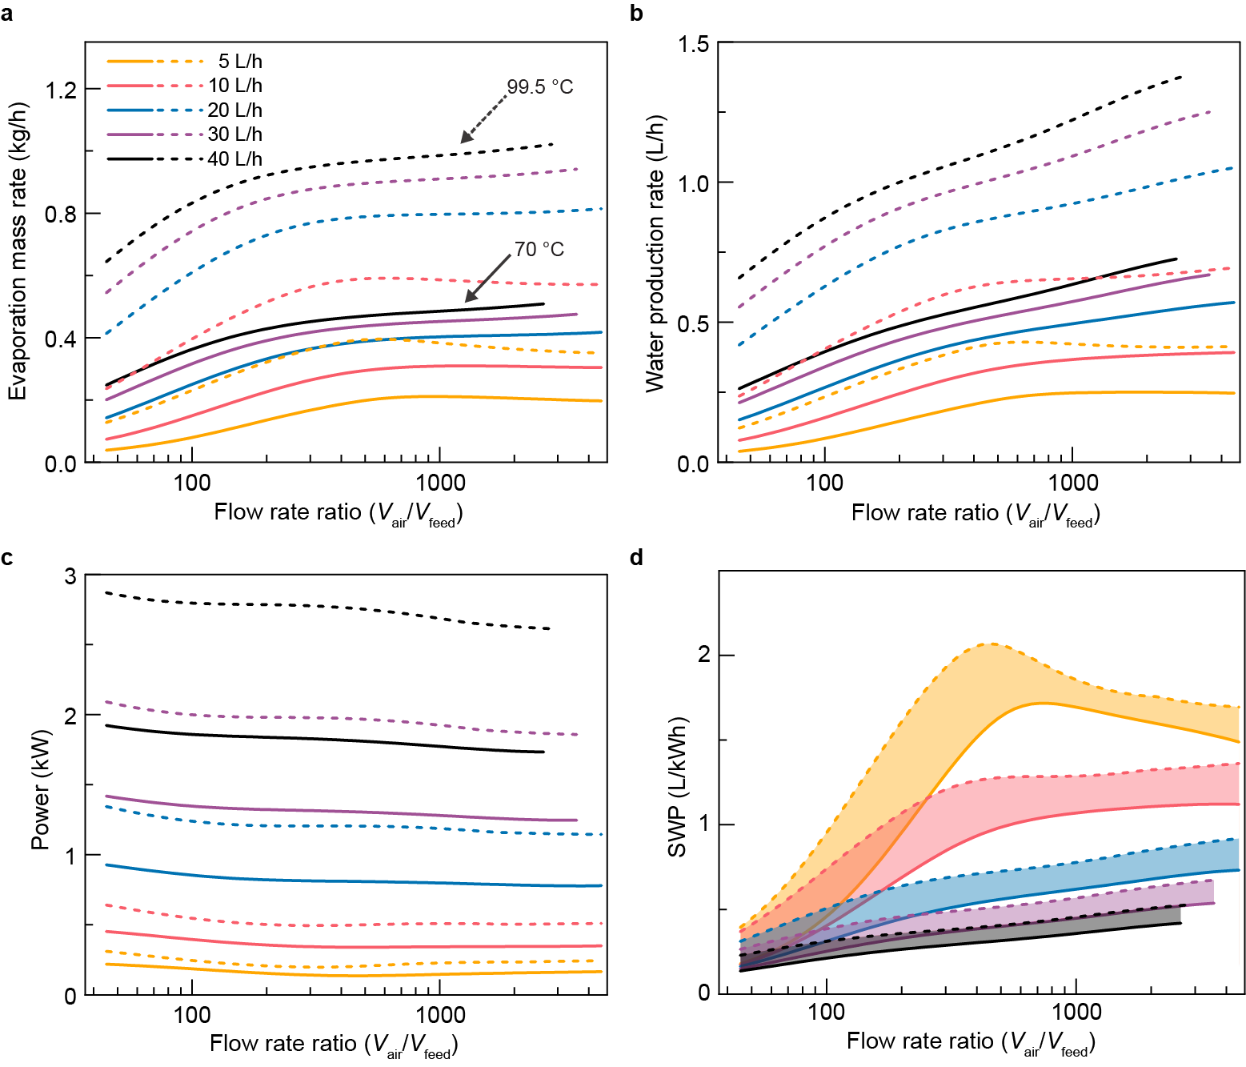
Supplementary Fig. 5 | Simulations of STREED prototype performance at different input temperatures. a, b, c, d, Simulated evaporation mass rate, water production rate, total power, and SWP varied flow rate of saline water at 5, 10, 20, 30, and 40 𝐿/ℎ, air at 2.4, 4.3, 6.3, 8.7, 10.6, 12.5, 14.2, 15.8 𝑚³/h at two different feed input temperatures: 70 (solid line) and 99.5 (dashed line) °C. The shaded area represents the SWP region between the two different temperatures at the same saline water flow rate ratio.

Resonant Energy Transfer (RET): from membrane to airflow systems
Supplementary Note 2: Determining the resonant condition for mixed-fluid and airflow systems. Similar to previous resonant desalination systems^{15,22} the design of our STREED system follows the general principles of flow-driven heat oscillators^{20,21}. In their most basic form, flow-driven oscillators consist of two interacting, countercurrent fluid flows separated by a heat source. In an analogous way to matching component frequencies to achieve maximum amplitude/energy density in traditional resonant systems, e.g., in double pendulums or LRC circuits, flow-driven heat oscillators achieve maximum thermal energy storage when the countercurrent flow rates are matched. At resonance, power transfers continuously between the two flows in a circular, oscillating manner.
This general concept of resonant energy transfer (RET) was directly applied to flat plate, nanophotonics-enhanced membrane desalination systems (NESMD)^{42,43}. These first resonant desalination systems²² consisted of one distilled and one heated saline water channel, separated by a porous membrane on one side of the system and a thin plate thermal conductor on the other. Clean water vapor diffused through the porous membrane in the evaporator from the heated saline flow to the distillate flow, transferring the latent heat of condensation to the distillate flow in the process. The conductor recovers the latent heat back into the saline flow before the flow interacts with the heat source. In NESMD, solar energy was absorbed by a thin layer of carbon black nanoparticles. At the resonance condition predicted by the flow-driven oscillator theory—when the distillate and saline flows have equal magnitude—the planar membrane system exhibited maximum energy to water efficiency. Once the resonance condition is achieved, the best absolute value of the matched flow rates for a given amount of input power can be found, maximizing SWP. Coupling nanophotonics-enhanced membrane desalination to a flat plate heat exchanger and operating at resonance improved energy to water efficiency 12-fold over the original NESMD concept²². The energy efficiency limits of such flat plate resonance systems were characterized in a recent numerical study¹⁵.
Whereas the resonance condition for the water-water membrane system was to match the countercurrent flow rates, the resonance condition for the air-water STREED system is not as straightforward due to multiple factors. For one, air is a relatively poor absorber and carrier of sensible heat; air is a poor thermal conductor, has nearly 1000-times lower density and nearly 4-times lower specific heat capacity than liquid water. It was recently shown in a theoretical study²¹, extending the original flow-driven oscillator concept to mixed fluid systems and multiple coupled channels, that the resonance condition between two different fluids occurs when the flow rates scaled by the thermal capacities (density ρ multiplied by specific heat C) of each fluid are matched, i.e. $ρ_{1}C_{1}V_{1}=ρ_{2}C_{2}V_{2}$for any distinct fluids 1 and 2. This is a good estimate for general flat flow-driven oscillators transferring sensible heat only between multiple flows, so long as losses are small enough to prevent the resonant system from becoming damped. The current experimental STEED system (XS) includes (i) latent heat (ii) features non-flat (e.g., cylindrical) elements and (iii) is lossy. As seen in the simulations and especially experimental data in Fig. 1 the system does not exhibit a clear peak in efficiency at higher feed flow rates.
The major complicating factor in determining the air-water resonance condition is the latent heat carried by the air in the form of evaporating and condensing water vapor. Latent heat recovery was indeed critical to previous resonant desalination systems, though in those membrane systems the transfer of vapor and, thus, the heat of condensation from the saline to the distillate channel was simple to treat as the vapor transfer was only diffusive within a very thin membrane (and behaved as conductive sensible heat from a numerical simulation standpoint). Moreover, the sensible heat transfer between the two thin channels of water was efficient due to the relatively large thermal capacity of water, and this sensible heat transfer drove the bulk of the resonant effect. Here, instead, the air flow acts predominantly as a carrier of the latent heat, transferring the vapor convectively from the evaporator to the heat exchanger. The flowing air encourages evaporation, but it is the latent heat of condensation recovered within the heat exchanger that ultimately fuels the cyclical heat exchange. Evaporation and condensation are the result of a gradient in vapor saturation pressure that depends exponentially on temperature. The temperature gradient due to the flowing air and water is complex and difficult to predict a priori, yet it is this nonlinearity that is at the basis of the shifting resonant condition.

Supplementary Note 3: Calculation of outlet heat fluxes.
The resonance condition for STREED occurs when the outlet heat fluxes of each flow are matched. Eq. S1 gives a mathematical expression for the water heat flux, $Q_{feed}$, and the air heat flux, $Q_{air}$.
$$\begin{aligned}\left\{\begin{aligned}Q_{feed}=\frac{1}{A_{w}}\iint_{outlet}{u_{w}ρ_{w}C_{w}\left(T-T_{amb}\right)dA} \\ Q_{air}=\frac{1}{A_{a}}\iint_{outlet}{u_{a}\left(ρ_{a}C_{a}\left(T-T_{amb}\right)+H_{vap}\left(c-c_{amb}\right)\right)}dA\end{aligned}\right.\#\left(S1\right).\end{aligned}$$
Here $T$ is the temperature and $T_{amb}$ is the ambient temperature, $c$ is the concentration and $c_{amb}$ is the ambient concentration, $H_{vap}$ is the enthalpy of vaporization, and $ρ_{w}C_{w}$ and $ρ_{a}C_{a}$ are the thermal capacities of water and air, respectively. For the simple 2D system in Fig. 2a, the area differential is $dA=dy×$ 1 m using the coordinate system of Fig. 2b. The average water and air flow velocities are denoted by $u_{w}$ and $u_{a}$, respectively, and $A_{w}$ and $A_{a}$ are the water and air channel cross-sectional areas, respectively.
The water heat flux $Q_{feed}$ consists only of sensible heat, and thus only involves terms proportional to changes in temperature ($T-T_{amb}$). The air heat flux $Q_{air}$ consists of both latent and sensible heat, and thus includes a term proportional to changes in concentration ($c-c_{amb}$). Implicitly the thermal capacities of each fluid, as well as the vapor concentrations, depend on temperature.

STREED models: explicit/adjustable vs. implicit heating
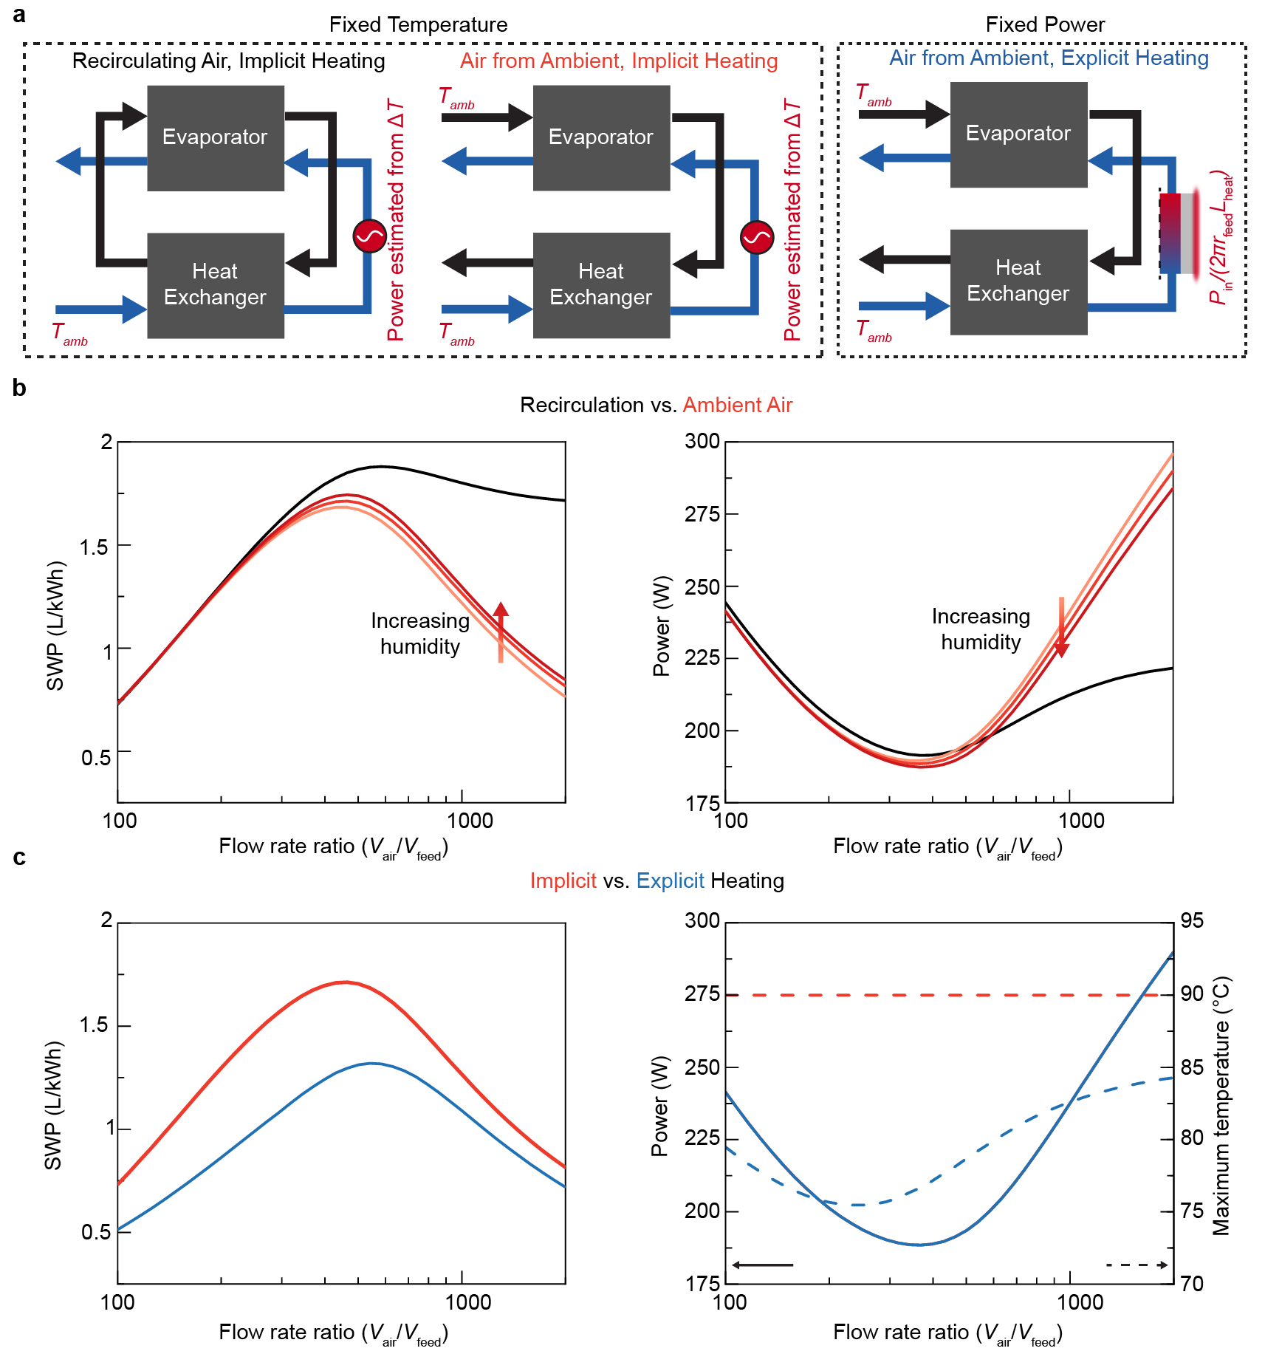
Supplementary Fig. 6 | Performance comparison of three system model configurations: effect of air recirculation and explicit/adjustable vs. implicit heating. Simulations were conducted considering a feed flow of V_{Water} = 5 L/h and a flow rate ratio V_{Air}/V_{Water} in the range 100-2000. Only the feed and not the air is assumed to be heated in all cases. a, Block flow diagrams of the three configurations compared: two fixed temperature models (left group), one with air recirculation (left) and one that takes in air from the environment at ambient temperature and humidity (right); and one fixed-power model (right group), which also takes in air from the environment. The fixed temperature/implicit heating models apply fixed temperature boundary conditions at the evaporator feed inlet and the input power is estimated from the change in temperature from the heat exchanger outlet. The fixed power/explicit heating model applies an explicit boundary heat source condition on a physical length of the feed channel and inputs the resulting temperature into the evaporator. b, Comparison of efficiency and estimated power for fixed temperature models with (black) and without (red) air recirculation. The model without air recirculation is tested with 25%, 50%, and 70% humidity. The input feed temperature is always 90 °C. c, Comparison of efficiency, power, and temperature for implicit (red) and explicit (blue) heating models without air recirculation. The power vs. flow ratio profile inputted into the explicit heating model was the same as the estimated profile for the implicit heating model kept at 90°C heating.

OS model
Supplementary Note 4: Systematic optimization of system parameters. The XS and OS share the same topology: coupled 2D and 2D axisymmetric components with materials and boundary conditions in the same layout as in Supplementary Fig. 12. However, specific geometric and environmental loss parameters were varied systematically to achieve higher SWP at sub-boiling point temperatures. The XS’s geometrical parameters include 1.067 m evaporator length, 16 mm evaporator feed channel thickness, 4 mm evaporating feed layer thickness, 0.9 mm perforated conductor thickness, 17.3 mm evaporator air channel thickness, 2 mm external metal plate thickness, 50 mm aerogel insulation thickness, 5.67 m heat exchanger length, 7.9 mm heat exchanger feed tube radius, 14.2 mm heat exchanger air shell radius, and 1.7 mm metal tubing thickness. The feed heater is 1 m long with the same radius/pipe thickness as the feed tube. The ambient humidity of the incoming air is 50% and the ambient air temperature is 32 °C to mirror the experimental conditions in central Texas in the summer of 2023. The feed enters the heat exchanger cooled to 20 °C. The loss coefficient is m_{loss} is initially set at 1. All models consider 0 g/kg salinity.
In a similar manner to how the membrane system in ³³ was improved via systematic variation of model parameters, the OS is developed by reducing the thickness of flow channels, increasing total evaporation and heat exchange surface area, and mitigating environmental losses of the XS. The geometrical parameters of the OS include 5 m evaporator length, 2 mm evaporator feed channel thickness, 2 mm evaporating feed layer thickness, 5 mm evaporator air channel thickness, and 15 m heat exchanger length. The loss coefficient m_{loss} is reduced to 0.1, reflecting strong insulation and selective radiative loss mitigation.

Flow and water production rates for time-explicit models
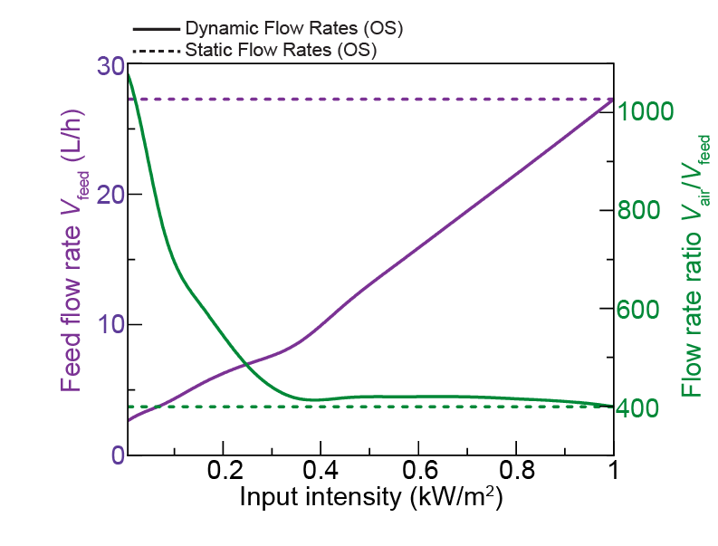
Supplementary Fig. 7 | Optimal flow rates of OS versus solar intensity. Feed flow rates (left, purple) and relative air flow rates (right, green) for OS design in dynamic (solid) and static (dashed) flow configurations. In the dynamic case, the reported flow rates give the largest SWP while keeping the system under boiling-point temperatures for each intensity. In the static case, the flow rates are optimized for 1 kW/m² peak sun intensity. These flow rates are inputted into time-explicit models with time-varying intensity input.

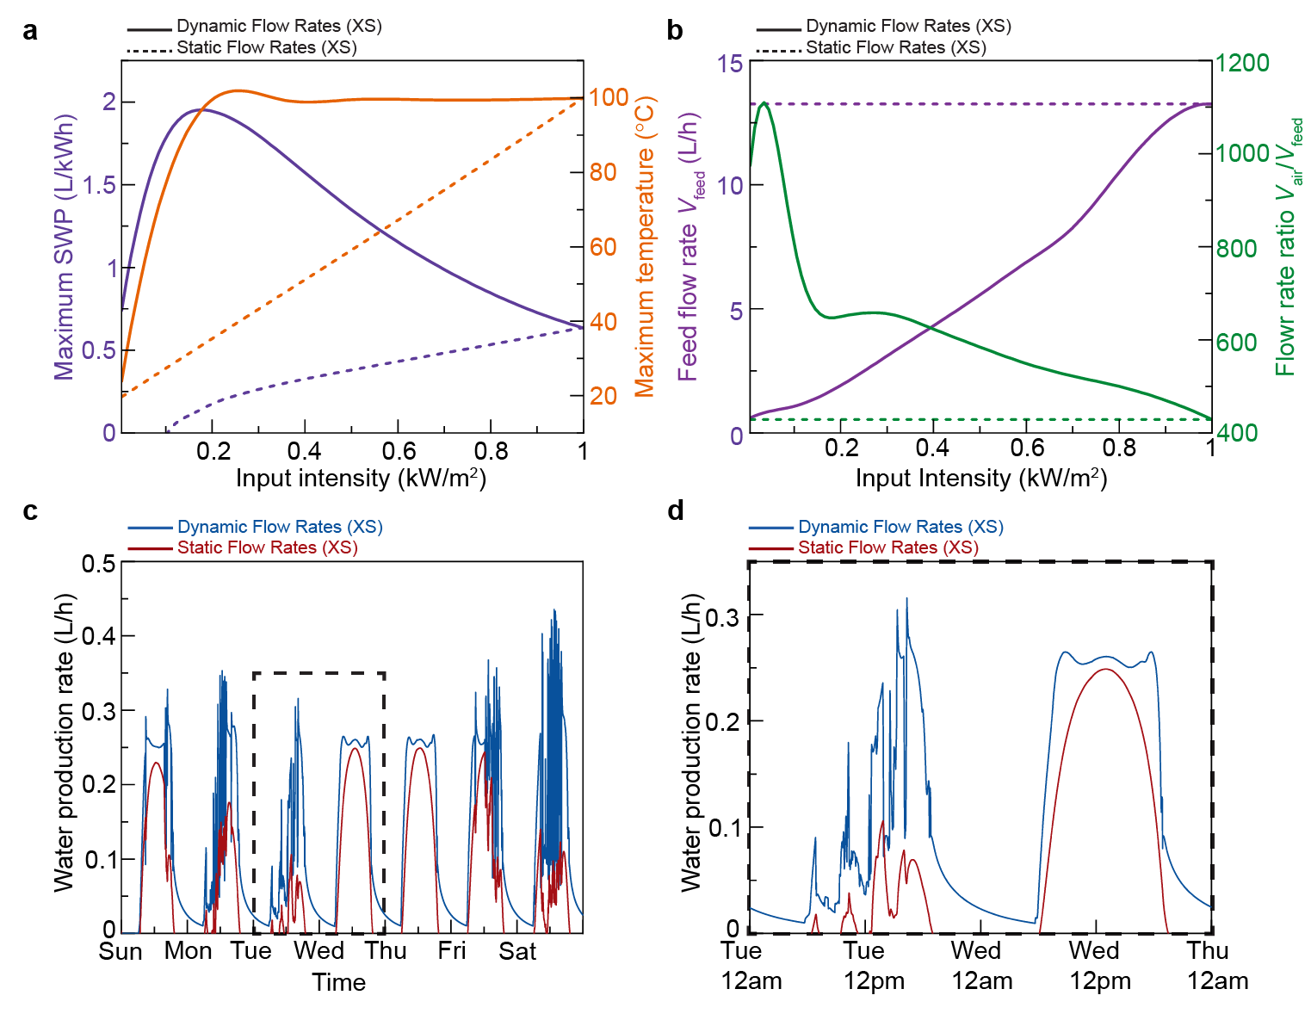
Supplementary Fig. 8 | Optimal flow rates and freshwater production rate versus time for XS. a, Maximum SWP (left, purple) and maximum system temperature (right, orange) for XS in dynamic (solid) and static (dashed) flow configurations. b, Feed flow rates (left, purple) and relative air flow rates (right, green) for the XS. c, Predicted water production rate versus time for the XS in dynamic (blue curve) and static (red curve) modes of operation. d, Panel b zoomed in on two days (Tuesday and Wednesday, the 4th and 5th) for increased detail.

Boundary conditions of Finite Element Method model
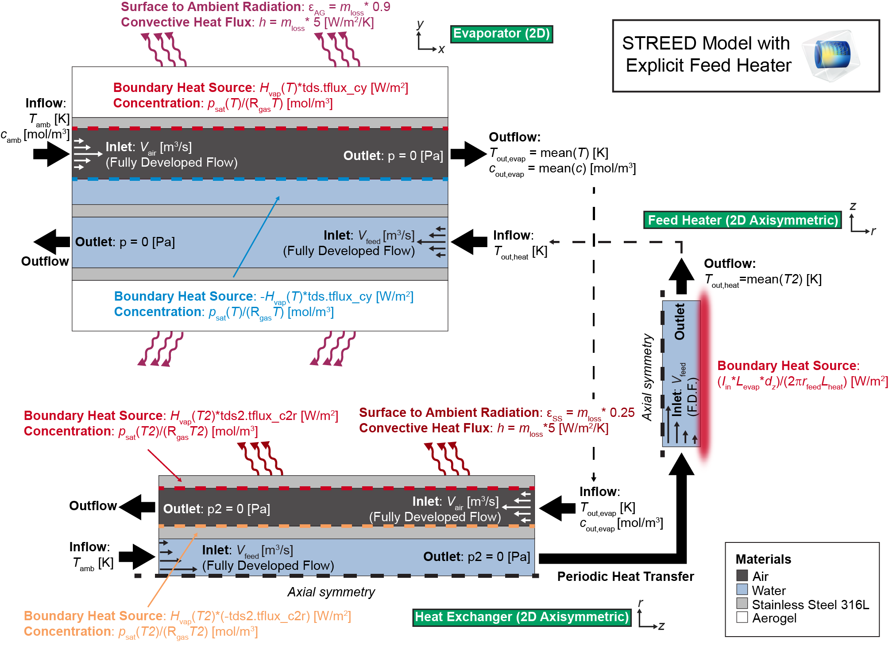
Supplementary Fig. 9 | Complete diagram of Finite Element Method model of STREED system with boundary conditions. Coupled heat transfer, navier-stokes, and diluted species transport equations are solved in two coupled components in COMSOL Multiphysics version 6.2. The rectangular evaporator is modeled in a 2D component, and the cylindrical heat exchanger and feed heater are modeled in a 2D axisymmetric components. Six physics nodes are needed: (1) heat transfer in solids in the evaporator (ht) with dependent variable temperature $T$; (2) laminar flow in the evaporator (spf) with dependent variables pressure $p$ and velocity field $u$; (3) transport of diluted species in the evaporator (tds) with dependent variable concentration $c$; (4) heat transfer in solids in the heat exchanger and heater (ht2) with dependent variable temperature $T2$; (5) laminar flow in the heat exchanger and heater (spf2) with dependent variables pressure $p2$ and velocity field $u2$; (6) transport of diluted species (tds2) in the heat exchanger with dependent variable concentration $c2$. The components are coupled by inputting average temperatures and concentrations (i.e., $T_{out,heat}$, $T_{out,evap},c_{out, evap}$) measured at outlets of one component into inlets of the other. Material properties for water in air, vapor saturation pressure $p_{sat}$, and evaporation enthalpy $H_{vap}$ are temperature dependent functions. The vapor saturation pressure is modeled via the Antoine equation. Species flux (defined in the diagram with COMSOL notation “tds.tflux”) is estimated from the temperature-dependent concentration gradient. Boundary latent heat contributions are defined by scaling the evaporation enthalpy by the magnitude of the species flux in the direction toward the boundary. The environmental losses are characterized by $ε_{SS}$, the average global hemispherical emissivity of stainless steel 316L, $ε_{AG}$, the average global hemispherical emissivity of aerogel, and generalized convective and conductive loss coefficient $h$. To easily explore the effects of reduced losses, these loss parameters are scaled by a multiplicative factor $m_{loss}$.
Supplementary Note 5: Default parameter values used in Finite Element Method model. A list of parameters used to define model material properties and boundary conditions is included below:
- Ambient temperature ($T_{amb})$: 20$°$C
- Relative humidity: 50% (used to define ambient concentration $c_{amb}$)
- Emissivity of stainless steel 316 L ($ε_{SS}$): 0.25
- Emissivity of aerogel ($ε_{AG}$): 0.9
- Generalized convective and conductive loss coefficient ($h$): 5 W/m²/K
- Multiplicative loss factor ($m_{loss}$): 1
- Stainless steel density: 8000 kg/m³
- Stainless steel heat capacity: 500 J/kg/K
- Stainless steel thermal conductivity: 15 W/m/K
- Aerogel density: 50 kg/m³
- Aerogel heat capacity: 2100 J/kg/K
- Aerogel thermal conductivity: 0.017 W/m/K
- Diffusion coefficient of vapor in air: 0.2 cm²/s
Water and air properties are defined by built-in, temperature-dependent material functions in COMSOL.

