Supplementary Figures
Supplementary Figure 1. Statistics of age and gender in healthy people and patients with circulation system disease.
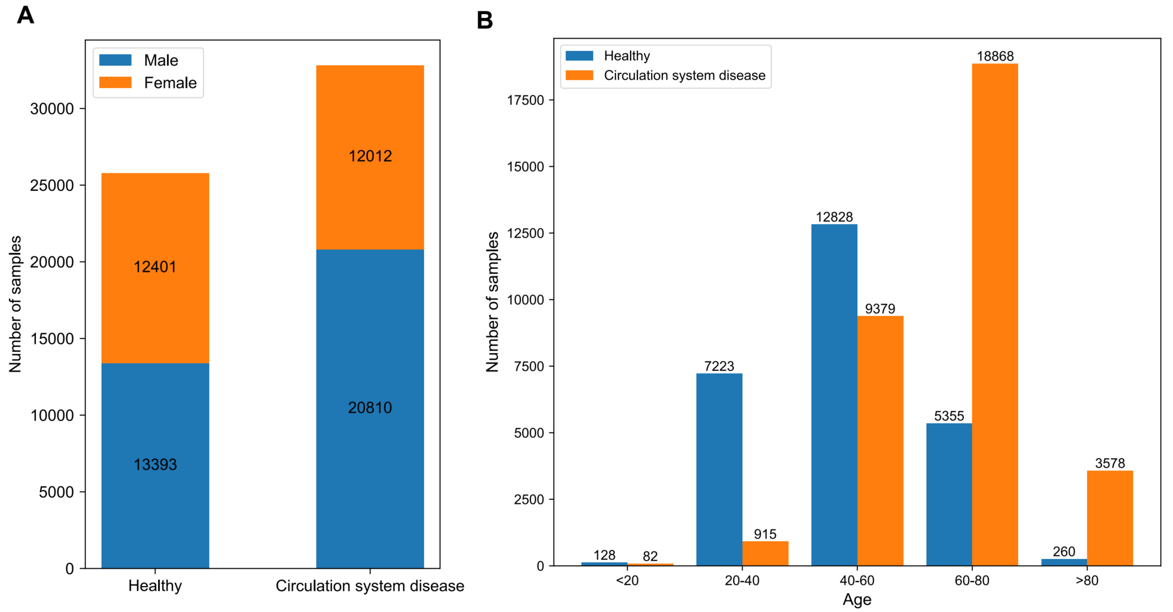
A. Gender distribution of healthy people versus patients with circulation system disease. B. Age distribution of healthy people versus patients with circulation system disease.

Supplementary Figure 2. Classification tree of circulation system diseases.
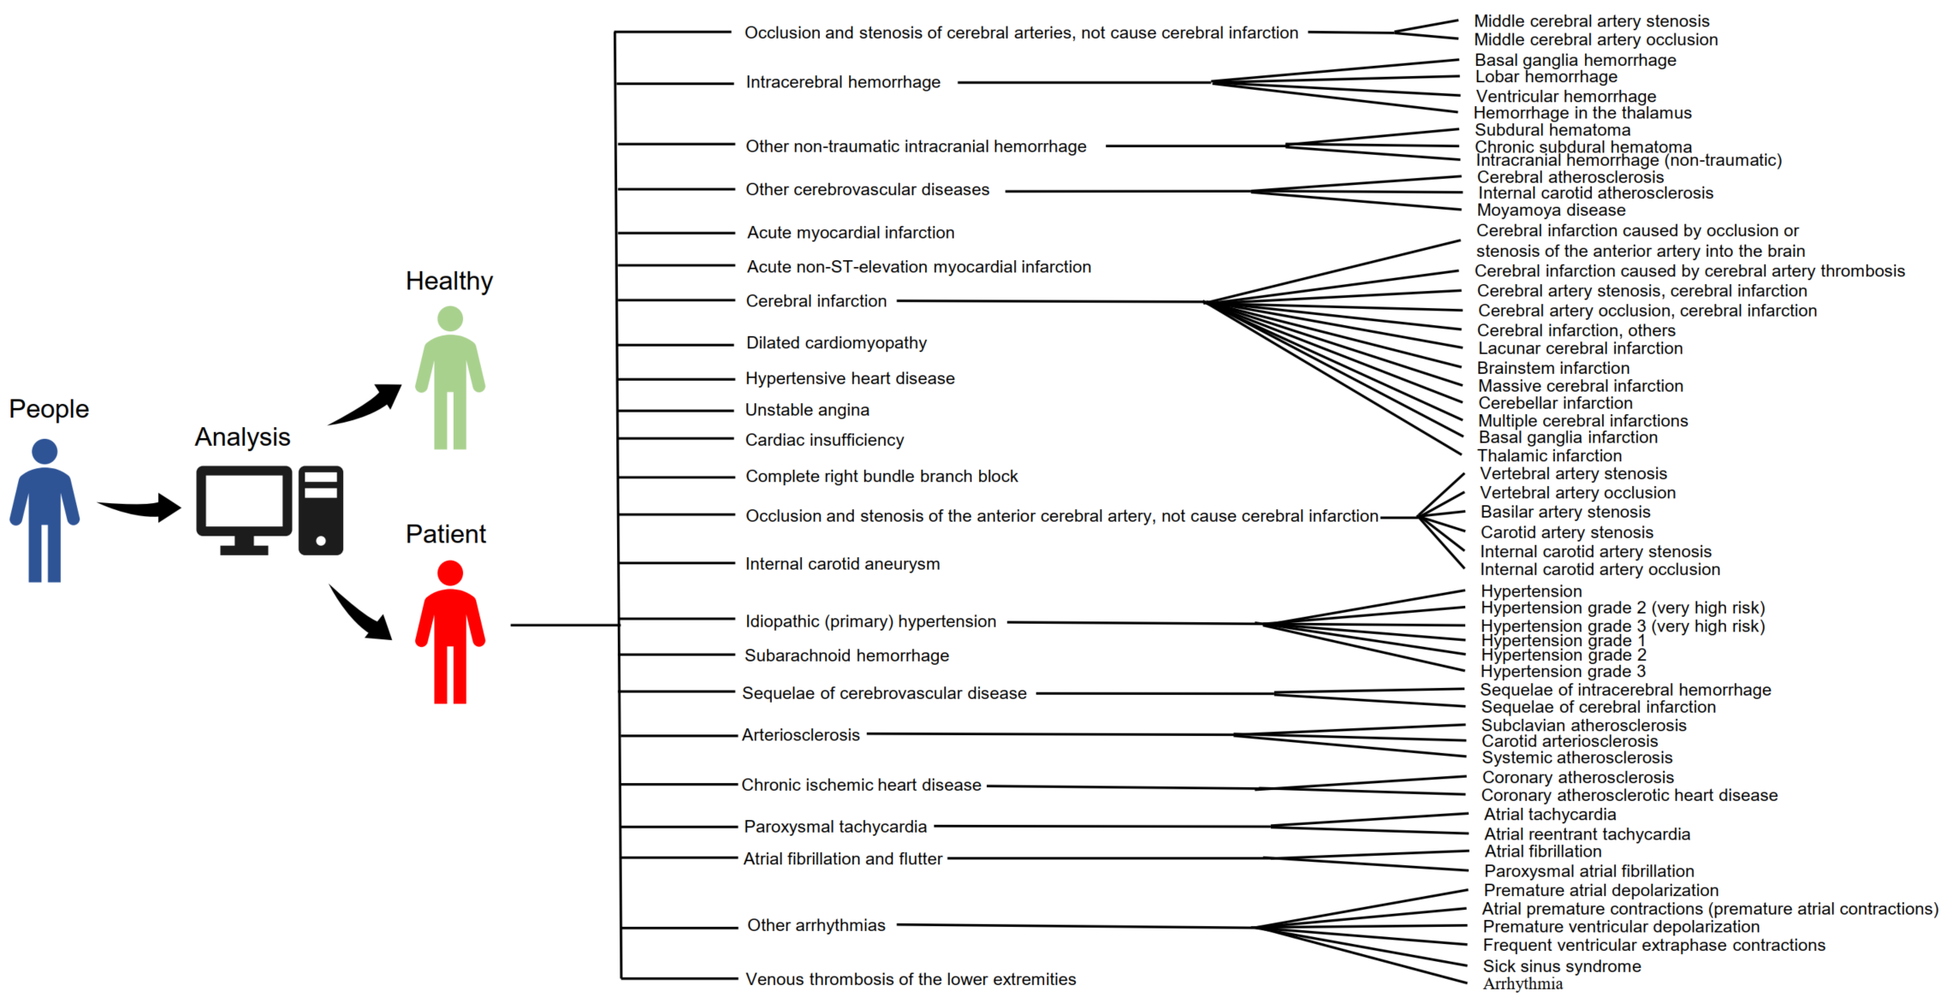

Supplementary Tables
Supplementary Table 1. 22 test indicators of blood routine.
Feature | Abbreviation | Unit | Reference
White blood cell count | WBC | ×10⁹/L | 3.5~9.5
Neutrophil percentage | NE% | % | 40~75
Lymphocyte percentage | LY% | % | 20~50
Monocyte percentage | MO% | % | 3~10
Eosinophil percentage | EO% | % | 0.4~8.0
Basophil percentage | BA% | % | 0~1
Absolute value of neutrophil | NE# | ×10⁹/L | 1.8~6.3
Absolute value of lymphocytes | LY# | ×10⁹/L | 1.1~3.2
Absolute value of monocyte | MO# | ×10⁹/L | 0.1~0.6
Absolute value of eosinophil | EO# | ×10⁹/L | 0.02~0.52
Absolute value of basophil | BA# | ×10⁹/L | 0~0.06
Red blood cell count | RBC | ×10¹²/L | 3.8~5.8
Hemoglobin | HGB | g/L | 115~150
Hematocrit | HCT | L/L | 0.35~0.50
Mean corpuscular volume | MCV | fL | 82~100
Mean corpuscular hemoglobin | MCH | pg | 27~34
Mean erythrocyte hemoglobin concentration | MCHC | g/L | 316~354
Red blood cell distribution width | RDW | % | 11~16
Platelet count | PLT | ×10⁹/L | 125~350
Plateletcrit | PCT | % | 0.11~0.27
Mean platelet volume | MPV | fL | 9.4~12.5
Platelet distribution width | PDW | fL | 9~17

Supplementary Table 2. 28 biochemical detection indicators.
Feature | Abbreviation | Unit | Reference
Alanine aminotransferase | ALT | U/L | 7~50
Aspartate aminotransferase | AST | U/L | 13~40
Aspartate aminotransferase/ Alanine aminotransferase | AST/ALT |  | -
Alkaline phosphatase | ALP | U/L | 35~150
Gamma-glutamyl Transferase | GGT | U/L | 7~60
Total protein | TP | g/L | 65~85
Albumin | ALB | g/L | 40~55
Globulin | GLO | g/L | 20~40
Albumin/Globulin | A/G |  | (1.2~2.4)：1
Potassium | K | mmol/L | 3.5~5.3
Sodium | Na | mmol/L | 137~147
Chlorine | CL | mmol/L | 99~110
Total bilirubin | TBIL | µmol/L | ≤ 26.0
Direct bilirubin | DBIL | µmol/L | ≤ 4.0
Urea | UREA | mmol/L | 2.6~9.5
Creatinine | CRE | µmol/L | 41~111
Calcium | Ca | mmol/L | 2.11~2.52
Phosphorus | IP | mmol/L | 0.85~1.51
Magnesium | Mg | mmol/L | 0.75~1.02
Cholesterol | CHO | mmol/L | 3.1~5.2
Indirect bilirubin | NBIL | µmol/L | ≤ 22.0
Triglycerides | TG | mmol/L | 0.4~1.82
Uric acid | UA | µmol/L | 155~428
Low-density lipoprotein cholesterol | LDL-C | mmol/L | ≤ 3.1
Glucose | GLU | mmol/L | 3.9~6.1
Apolipoprotein A1 | APOA1 | g/L | 1.0~1.6
Apolipoprotein B | APOB | g/L | 0.6~1.1
Carbon dioxide | CO2 | mmol/L | 21~31

