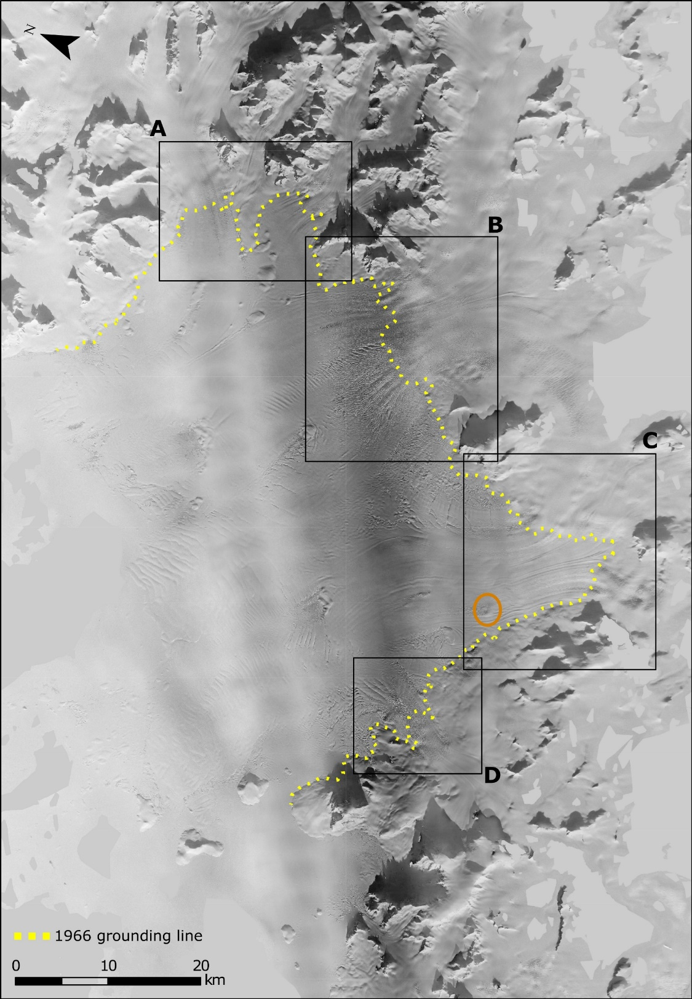
Supplementary figures
Fig. S1. November 28, 1966 orthophoto mosaic and grounding line. A), B), C), and D) highlights the tributary glaciers flowing into Wordie Bay forming the ice shelf. Zoom-ins of the A), B), C), and D) regions are shown in Fig. 3, with a detailed delineation of the 1966 grounding line position. The orange circle highlights the location of the pinning point shown in Fig S2.
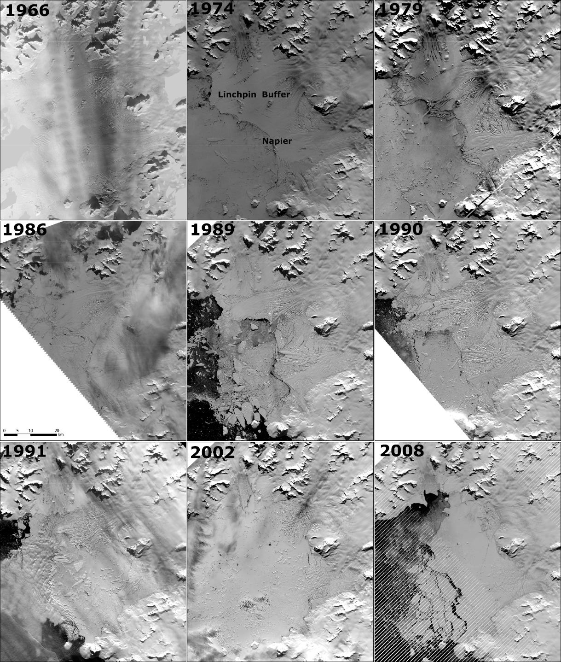
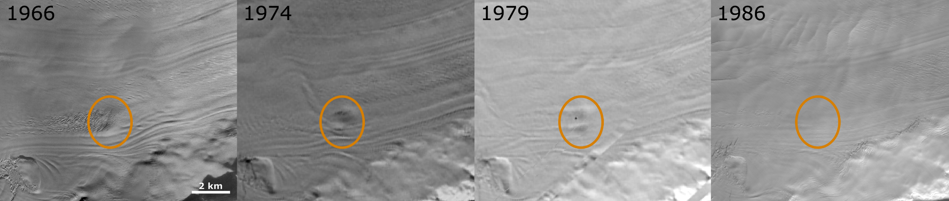Fig. S2. Disappearance of pinning points due to thinning of the IS. The location of the pinning point can be seen in Fig. S1.
Fig S3. Optical images of Wordie ice shelf 1966-2008. Linchpin, Buffer and Napier pinning points are marked on the 1974 image, as they are three of the biggest pinning points of the shelf.
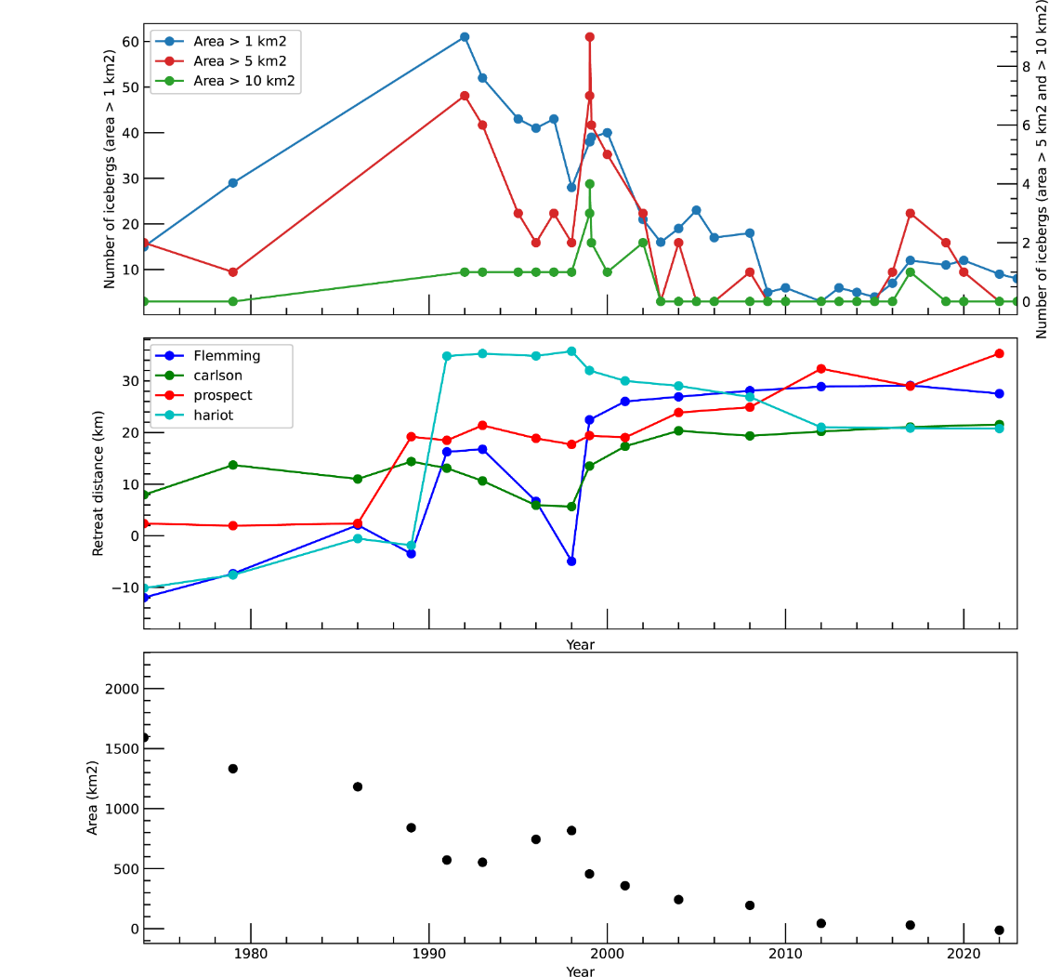
Fig S4. Time-series of iceberg production, retreat distance and shelf area at Wordie Bay.
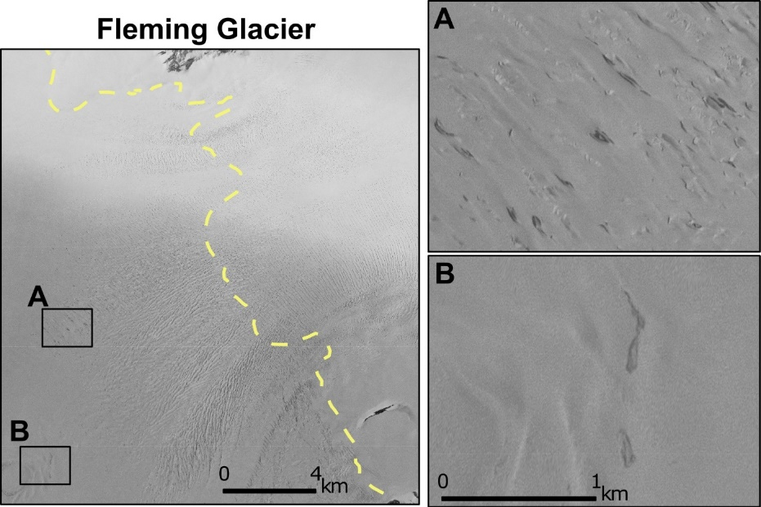
Fig S5. Small melt ponds (<0.025 km²) in front of Fleming Glacier 12 Jan. 1969.
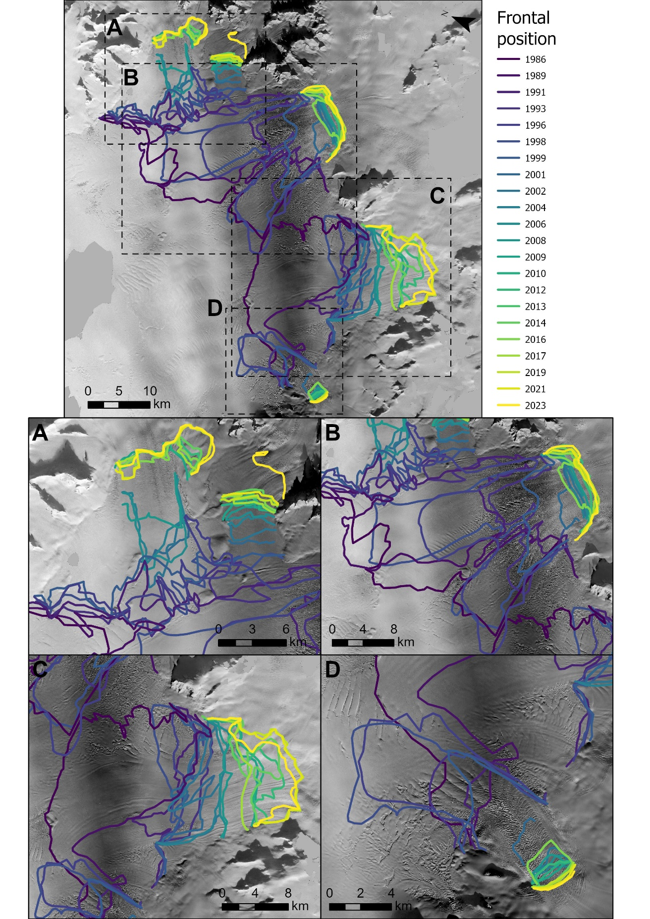
Fig S6. Frontal changes 1986-2023 of the tributary glaciers flowing into Wordie. A) Hariot and Unnamed Glacier, B) Fleming Glacier, C) FIP1, FIP2, and Prospect Glacier, and D) Carlson Glacier overlaid on the 1966 orthophoto mosaic.
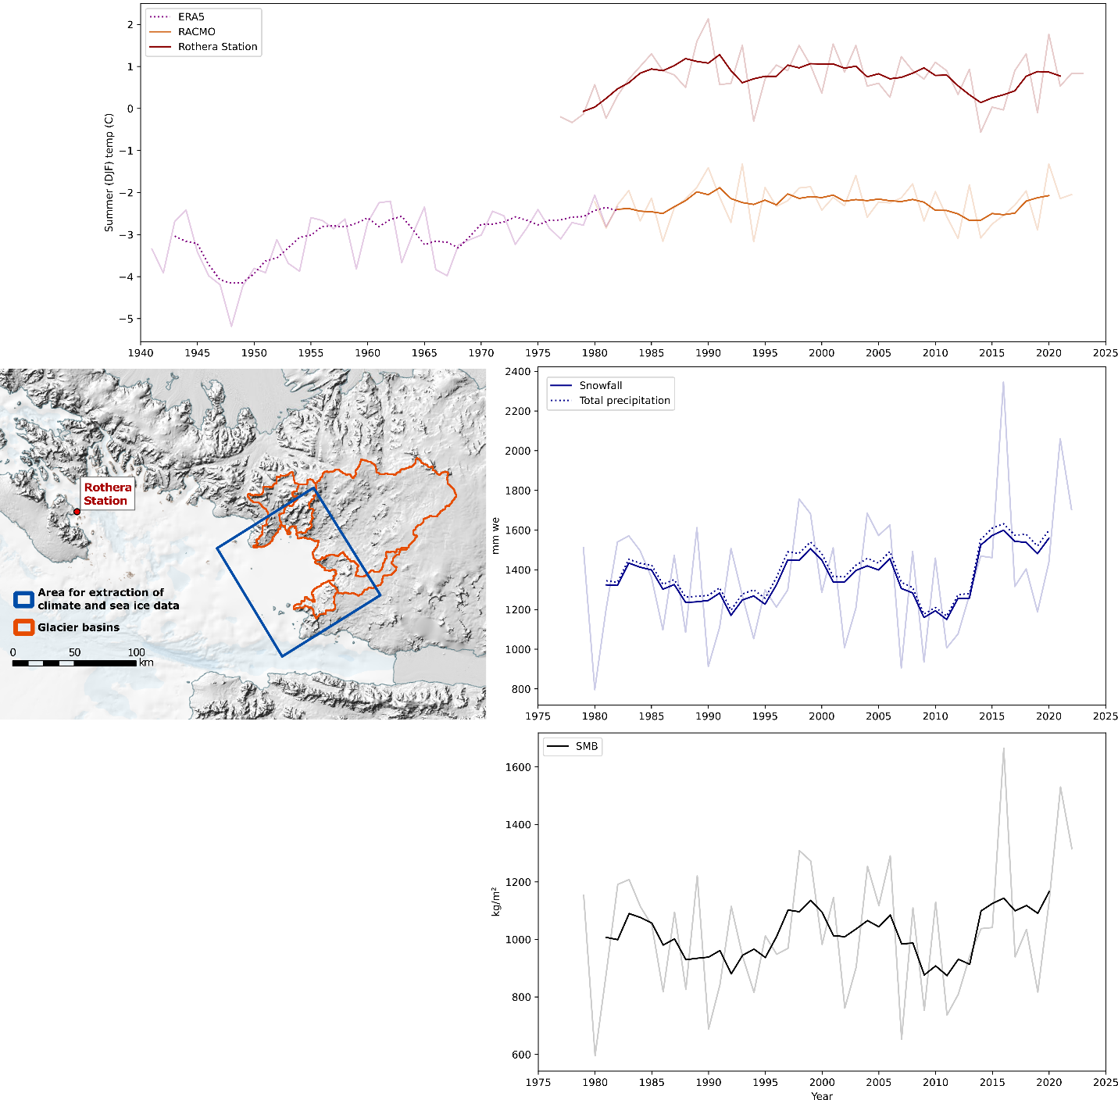
Fig. S7. Mean summer (DJF) air temperature, mean annual snowfall and precipitation, and mean annual SMB at Wordie. Mean summer temperature are calculated both using RACMO, ERA5 (Blue rectangle) and station data from Rothera station (Red circle). Mean annual snowfall and precipitation is extracted using the blue rectangle, whereas mean annual SMB is calculated using the glacier basins.
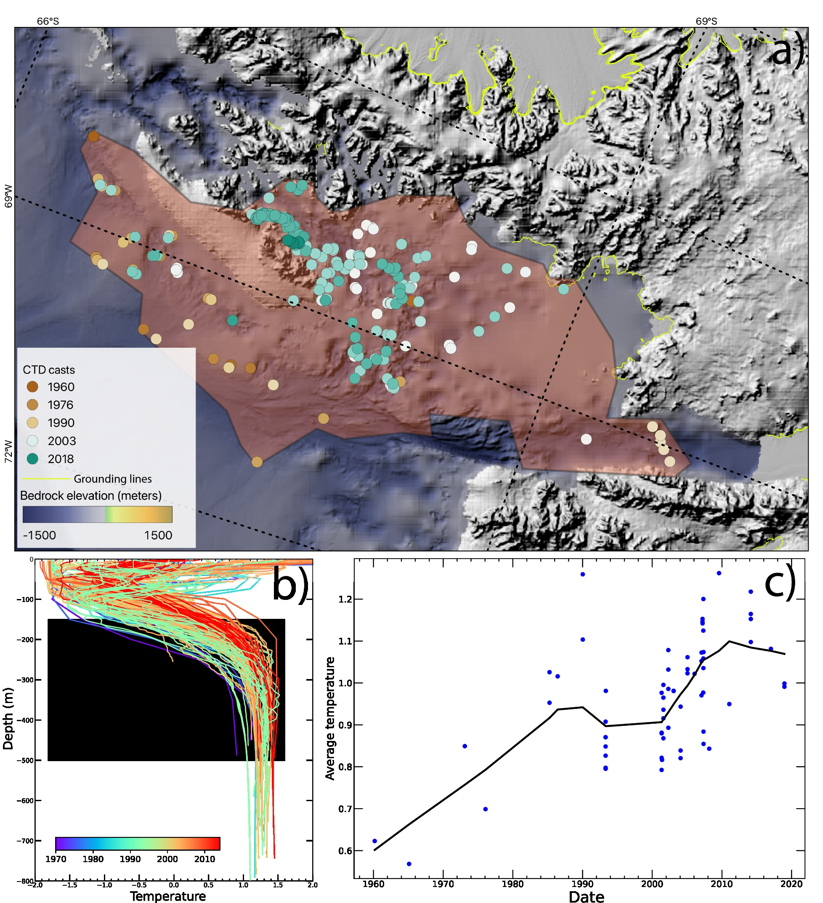
Fig S8. Measurements of average mid-ocean temperatures from CTD in Wordie Bay region 1960-2020. a) Position of all CTDs used for ocean temperature extraction. b) Temperature profile of all CTD, with the black box indicating the zone (-150 to -500 m) used for calculating the average mid ocean temperature. c) Temporal evolution of average temperature calculated using locally weighted scatterplot smoothing (Methods)
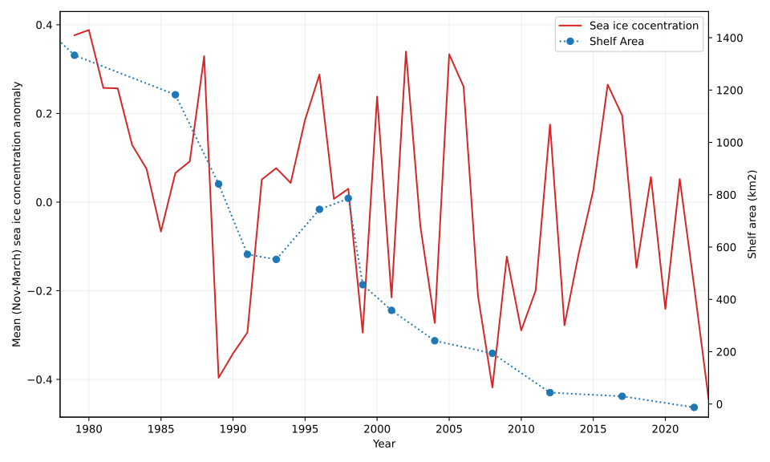
Fig S9. Mean November to March sea ice concentration anomaly and shelf area. The sea ice anomaly is calculated relative to the 1979-2023 mean.
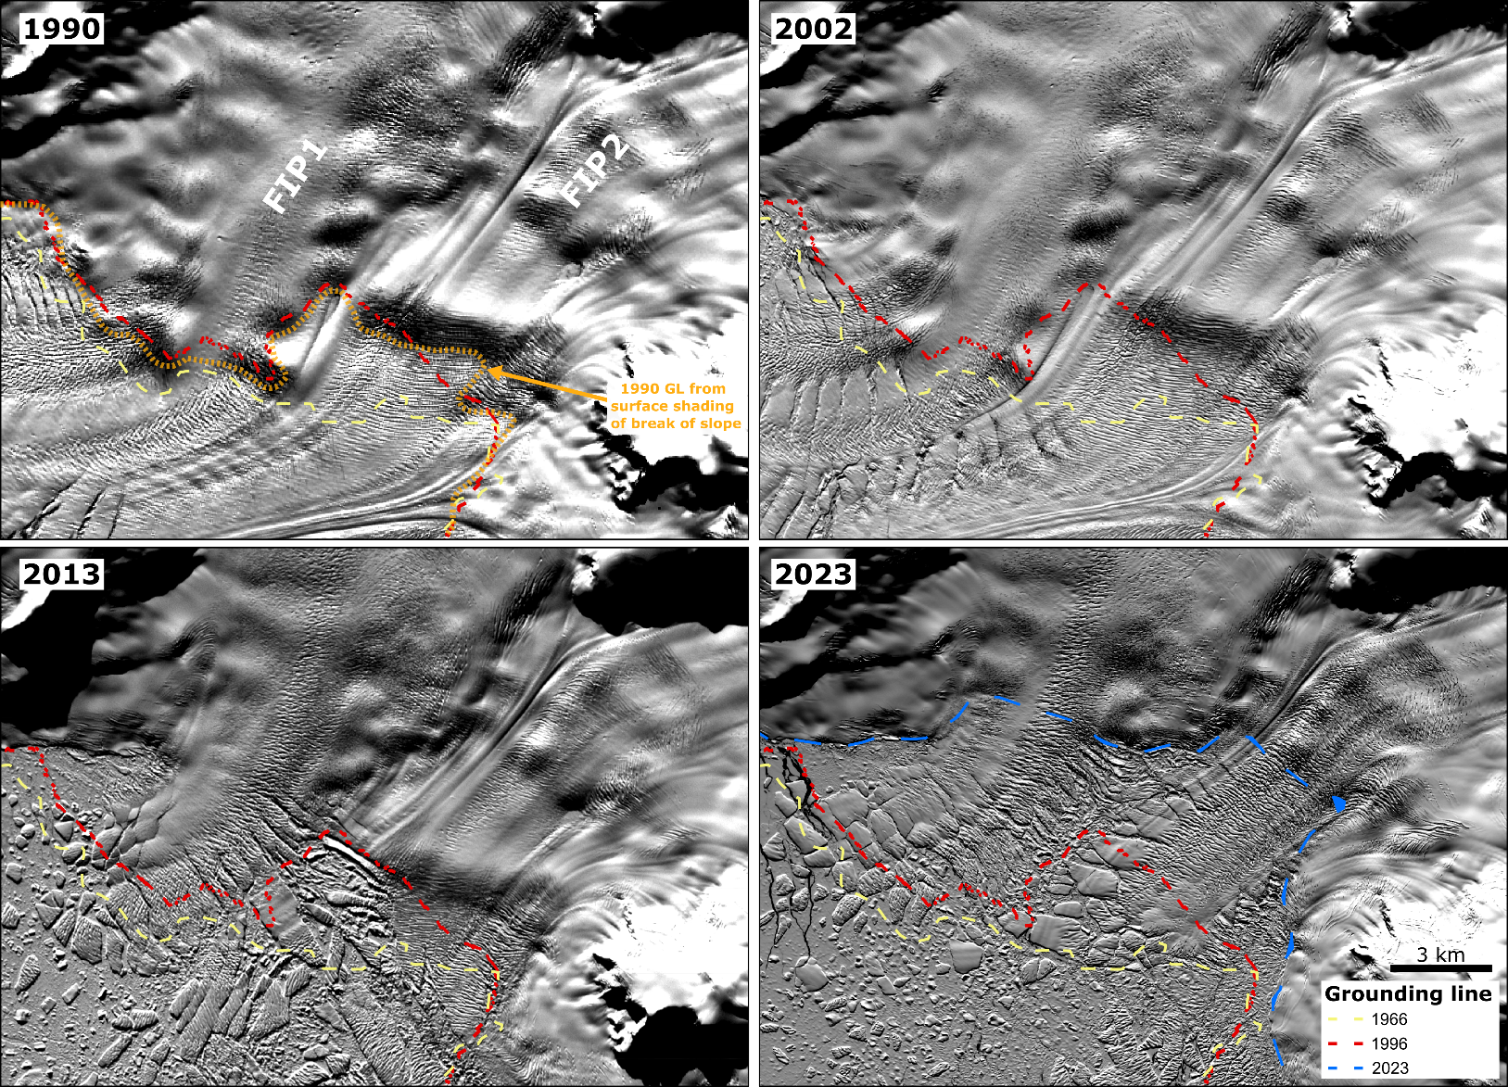
Fig. Grounding lines of FIP1, FIP2 at Prospect overlaid on Landsat images from 1990, 2002, 2013, and 2023. The 1966 GL is mapped using the break of slope method on the historical DEM, the 1996 GL is derived from DInSAR (MEaSUREs), and the 2023 GL is mapped from surface shading using optical Landsat images (Methods). In the 1990 image, the orange dashed line indicates the GLs mapped from optical surface shading and closely aligns with the 1996 MEaSUREs GL, with an average variation of ~300m.
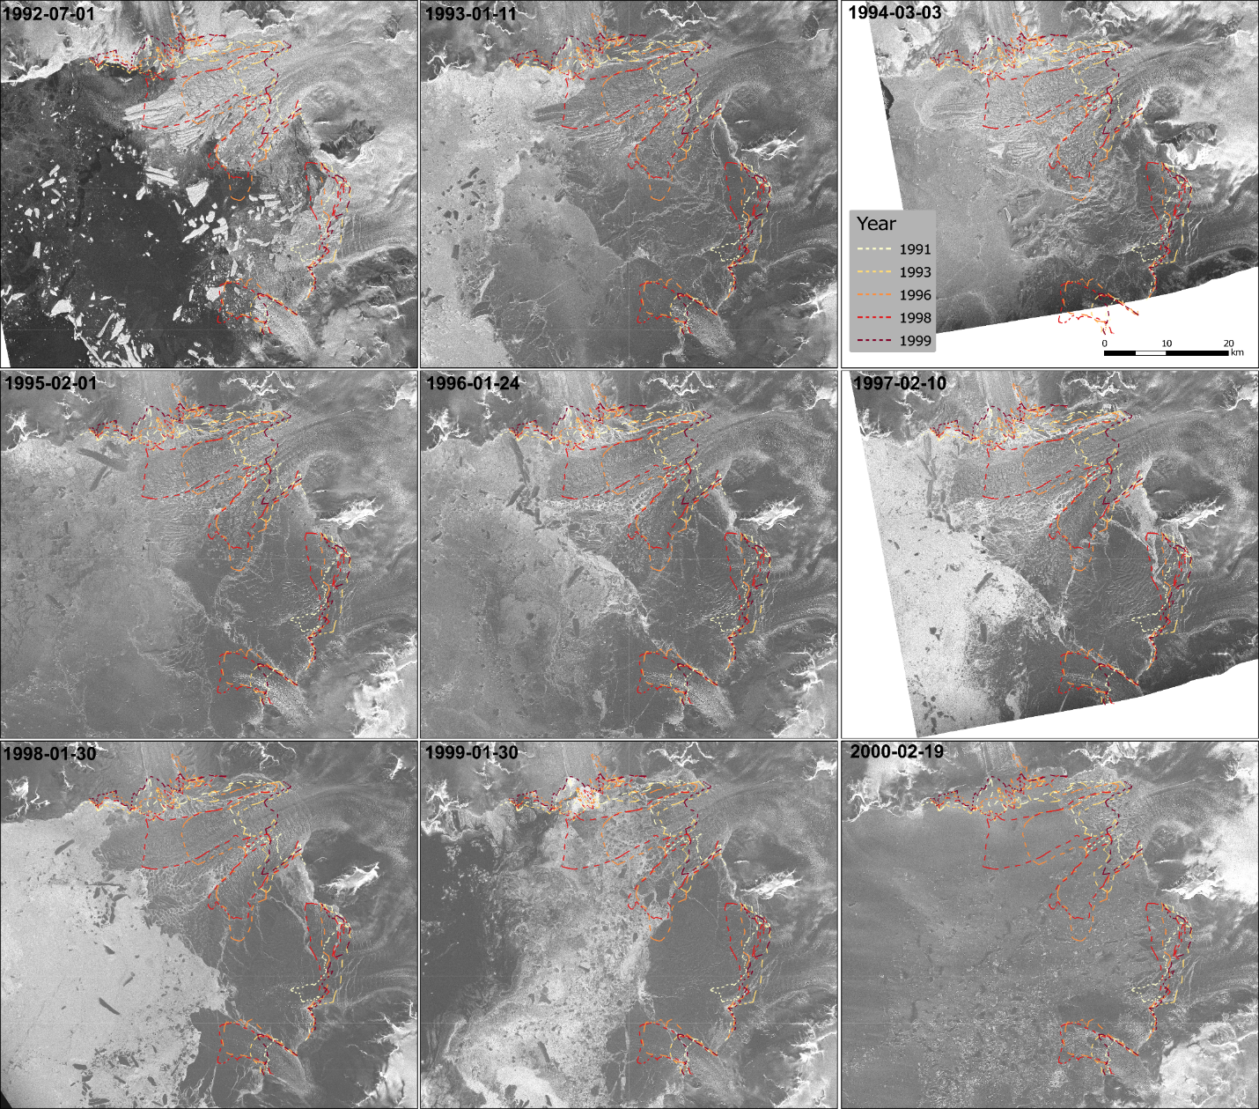Fig S11. Time-series of ERS Radar images of Wordie Ice Shelf 1992-2000.

