Supplementary Information

Methods

Sample Population
Our study population consists of 221 Australian children who were identified from the cohort of 550 twins/triplet families enrolled in the “Tooth Emergence and Oral Health” study. Most children were dizygous (DZ) twin pairs (57%), with one set of DZ triplets. At time point 1 (T1) 141 samples were collected (average age 6.7 ± 2.7 months), at T2 180 samples were collected (1.6 ± 0.4 years) and 214 samples were collected at T3 (8.5 ± 1.2 years old). One hundred and twenty children (55%) were sampled at all three time points, 73 were sampled at 2 time points and 28 participants sampled at one time point only. At T3, 68 children were diagnosed with caries (mean ICDAS II score 1 ±1.8) while the remaining 146 were caries free (CF). The exclusion criteria for the study was recent antibiotic use (within the past three months) which resulted in the exclusion of two children, 1136A (CF) and 1051B (caries affected, (CA)) from this study. The key population characteristics are outlined in Table S16. Parents/caregivers were required to complete a series of questionnaires as part of the study. A standard medical history was taken at the clinical examination at T3.

Oral biofilm collection and storage

Time points 1 and 2
Parents/carers collected the initial samples from the twins by following detailed instructions given in Fig S6. The samples were cultured within 7-10 days of reception to check for Streptococcus mutans. This was undertaken to check viability of the samples collected by the parents/carers.
Samples were plated on agar selective for Streptococcus mutans (TSYC20B) which was incubated for 72 hours at 37°C in an atmosphere of 95% nitrogen and 5% carbon dioxide. Following incubation S mutans was identified by characteristic colony morphology under a dissecting microscope. A sub-sample of positive colonies was confirmed by carbohydrate fermentation patterns. Each sample was assessed independently. After three contiguous positive cultures for S mutans it was assumed that S mutans have been acquired. The samples were then placed in black semi-solid transport media VMG II and stored at - 20^{c}C. The VMG II media was made up using a validated protocol¹. This study found that VMG was a suitable long-term storage medium for dental biofilm samples being subject to NGS as it stabilised the oral microbial DNA composition.

Time point 3
At the clinical visit, parents/carers and twins were instructed not to brush their teeth from 7 pm the previous evening until after the clinical visit and not to eat or drink in the half an hour before the appointment. Supra-gingival plaque biofilm samples were taken by a team of calibrated clinicians (registered dentist, oral health therapist or a supervised dental student) wearing sterile gloves. Oral biofilm samples were obtained using sterile Cultiplast® Tampone Swabs (LP Italiana, Milan, Italy). The labial/buccal surfaces and gingival margins of teeth in the maxillary and mandibular right-hand side were gently but thoroughly swabbed for 30 seconds per quadrant. The swab was inserted into a tube containing VMGII. The cotton tip was fully submerged, the wooden handle was broken so the swab was left in the media. The tube was sealed and Placed directly on dry ice at collection. All samples were transferred to -80oC freezer within 4 hours of collection.

Sequencing
An average of 60 million, 134-150 bp, paired-end reads per sample were sequenced. Sequencing metrics are summarised in Table S1. Validation of sequencing was assessed by calculating the interclass correlation coefficient (ICC) calculations of sequencing metrics between duplicate samples (n=12). There was good correlation between duplicate samples based on the number of filtered and assembled contigs (ICC=0.86, p=6.1x10⁻⁶) and level of host (human DNA) contamination (ICC=1.0, p=3.1x10⁻¹³).
The average level of contamination across all the samples was minimal at 13%, with 68% of samples having less than 10% contamination. No significant issues could be identified with either sample collection (done by calibrated clinicians) or extraction as all extractions were completed by the two scientists (CJA and GVB).

Bioinformatics processing
All scripts can be found at https://github.com/Sydney-Informatics-Hub/Shotgun-Metagenomics-Analysis²
The twin oral microbiome samples were of high DNA quality. The raw reads quality was assessed with FastQC v 0.11.7³ and MultiQC v 1.7⁴. FastQC analysis showed data with a Phred score above 36 and no evidence of adapter contamination. To assess the impact of conservative quality trimming and filtering, we assembled 10 randomly selected host-removed samples and detected ARGs before and after performing quality filtering and trimming. A greater number of ARGs were detected from assemblies produced from the unfiltered (raw) host-removed reads. For these reasons, no quality filtering, trimming or pair-merging was performed prior to commencing the pipeline. Raw read pairs ranged from 385,400 to 118,719,780 per sample, with a mean of 60, 066, 212 pairs. Target (host-removed) read pairs ranged from 339,702 to 117,369,122 pairs per sample, with a mean of 53,100,519 pairs.

Taxonomic identification
Speciation was performed with Kraken2 v. 2.08⁵ using the Kraken ‘standard’ database (build date 23 April 2020). Species abundance was estimated using contigs with Bracken v. 2.6.0⁶ using kmer length 35 and threshold 10. A total of 645 ARG carrying taxa across the three time points were identified, with a total of 356 representative species selected to reconstruct a species tree using 16S rRNA sequences (Table S5). These sequences were retrieved from 16S NCBI RefSeq database as of February 2022. Species not found in the 16S NCBI RefSeq database were obtained using NCBI genomes and blastn program with e value 1e⁻⁵⁰. 16S alignments were generated using MAFFT⁷ then trimmed with trimAl⁸ under "automated1". The 16S phylogenetic tree was generated using RAxML v8.0.0⁹ under options (-m GTRGAMMER -f a -x 123 -N autoMRE -P 12345). Annotation of the 16S phylogeny was performed using the Interactive Tree Of Life v6¹⁰, which incorporated the ARG carrying species over time. Strains belonging to the same species were collapsed for abundance calculation.
ARG abundance
To determine the abundance of ARGs in the bacteriome, we first generated a manually curated ARG list using the ABRicate v0.9.9 output from NCBI, CARD and Resfinder databases. For genes with multiple synonyms, one gene ID was selected as the symbol for that ARG. For each sample, curated ARG information was extracted from the ABRicate output and formatted as GFF. BAM files were created by first aligning the target reads back to the assemblies with BWA v0.7.17, sorting and indexing with SAMtools v1.10 and marking duplicate reads with GATK v4.1.5.0¹¹ using an optical pixel distance of 2500. The GFF and BAM files were used as input to htseq-count v0.12.4¹² with the following parameters: stranded no, min quality 20, type gene, mode union, non-unique none, secondary-alignments ignore and supplementary-alignments score. The htseq-count data was then normalised to transcript per million (TPM). This is calculated by dividing the read counts by the length of each gene in kilobases, which is the reads per kilobase (RPK) value. The RPK values in a sample are summed and then divided by 1,000,000. This is the per million scaling factor. TPM is calculated by dividing the RPK values by the scaling factor¹³.
Size of the resistome
To express the resistome (total number of ARGs) as a fraction of the microbiome (total number of genes), Prodigal v2.6.3 was used to predict protein coding sequences, per sample, from target contig assemblies obtained from MEGAHIT. DIAMOND’s blastp tool v2.0.11 was used to query sample coding sequence (CDS) against the NCBI non-redundant (NR) database (prepared for DIAMOND with the diamond makedb). Prodigal CDS sequences were annotated as genes after applying cut-offs of >= 75% identity, >=75% query coverage, 1E-6 evalue and an alignment length of at least 25¹⁴. Genes were classified as ARGs by position matching Prodigal CDS sequences and start or end gene positions to ABRICATE ARG gene positions, curated in a previous step for non-redundancy.

Statistical analysis
Scripts for resistome statistical analysis can be found at https://github.com/Sydney-Informatics-Hub/Shotgun-Metagenomics-Analysis².

Differential abundance analysis
Differential abundance analysis (DAA) was used to assess the impact of time point or stage of dental development and caries at T3. Prior to DAA, the data was filtered by removing low abundance ARGs (cut off: 0.01% counts) and ARGs present in only one sample. To assess the impact of time point, we used a linear-mixed effects model (MaAslin2¹⁵), where time point was treated as a fixed effect and individual as a random effect, to account for repeated sampling per person. Analysis was performed on ARGs present in at least 20% of the samples, that had been normalised by total sum scaling (TSS) and log transformed. To ensure robust biological interpretation^{16, 17}, we used two DAA methods (MaAslin2 and ANCOM-BC¹⁸), to investigate the impact of caries (mild, moderate, severe) on ARGs at T3. We then assessed if treating caries (restorations) impacted on ARGs where caries status (caries free or affected), restorative status (restored [yes] or unrestored [no]) were treated as fixed effects. Default parameters were used in both packages; however, alpha was adjusted to 0.25 in ANCOM-BC to be consistent with MaAsLin2.

Univariate twin analysis
Heritability was estimated for overall resistome diversity (Shannon) and individual ARGs abundances at each time point using a classic twin design, assuming: twins shared the same environmental effects regardless of zygosity; MZ twins shared 100% of their genes; DZ twins shared, on average, 50% of their genes. Under these assumptions, if there is a familial influence on a variable, the correlation within twin pairs will be greater than expected by chance; if the correlation is greater for MZ twins than for DZ twins, the presence of an additive genetic influence is supported; if the correlation within pairs is similar between MZ and DZ pairs, then a shared environmental influence is suggested. A formal heritability analysis was conducted using a variance components model approach for a quantitative trait¹⁹, again under the assumptions of the classic twin design. This model assumes a multivariate normal distribution for a given variable across twin pairs, with the mean being a function of covariates such as age and gender, and a residual variance. The variance is decomposed into an additive genetic variance, a, a common environmental variance, c, that is shared by twins within the same pair, and an individual environmental variance, e, speciﬁc to an individual, and these are assumed to be independent. These variances were then standardised with A (=a/(a+c+e)) representing the proportion of variance attributed to additive genetic factors (heritability), C (=c/(a+c+e)) representing the proportion of variance attributed to shared environmental factors, and E (=e/(a+c+e)) representing both the proportion of variance specific to individual environmental factors, and measurement error. The parameters in the model can be estimated by maximising the likelihood function, and the significance of estimated variance components can be tested using the likelihood-ratio test (e.g. ACE vs AE). In our application, however, only the full ACE model was fitted, using the package mets²⁰ in R (https://www.R-project.org), regardless of whether parameters were significant.

Supplementary Figures

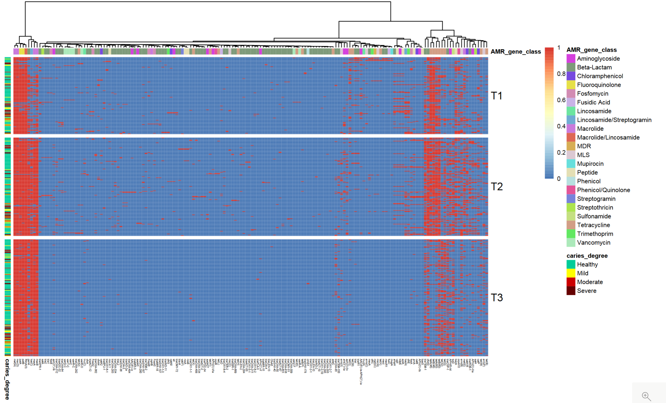

Figure S1. Heatmap showing distribution of antimicrobial resistance genes across all samples by time point.

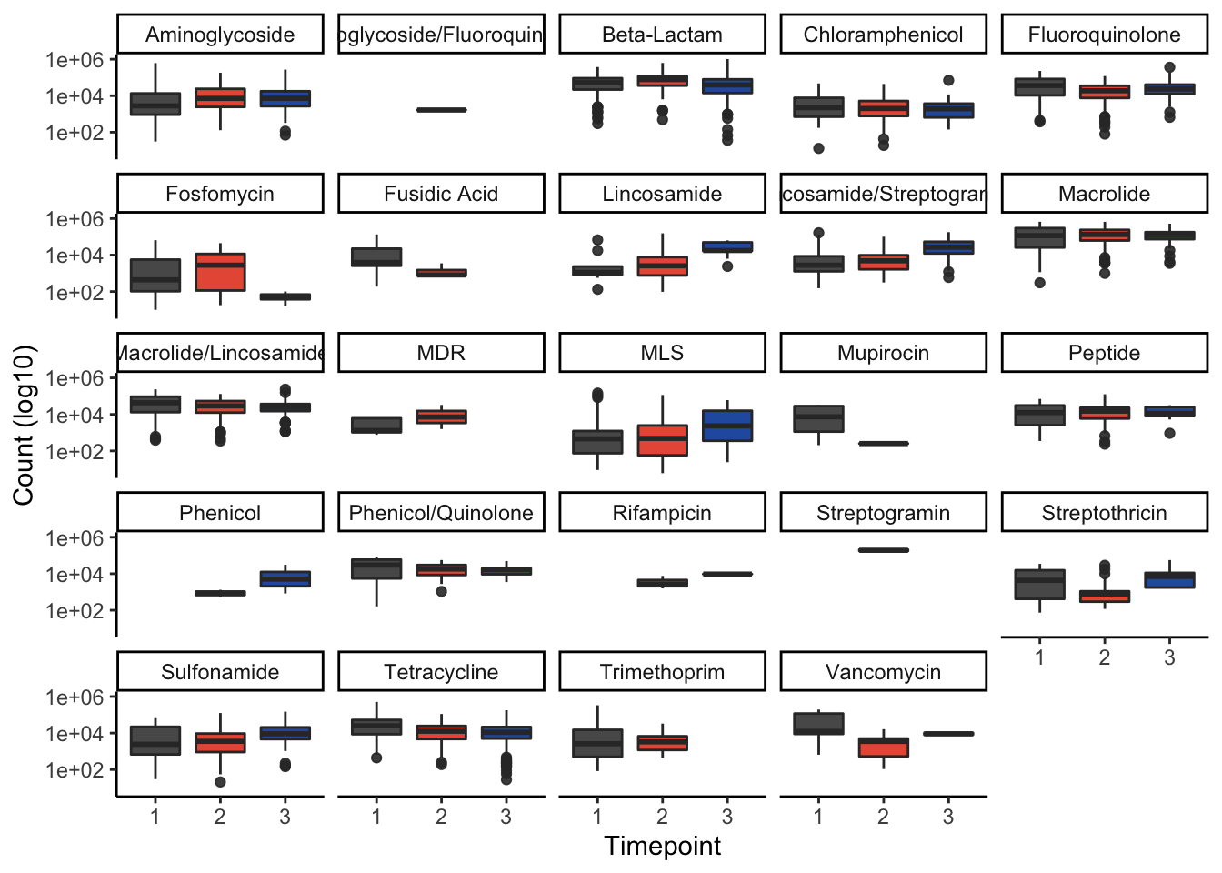

Figure S2. Composition of resistome stratified by antimicrobial resistance gene class.

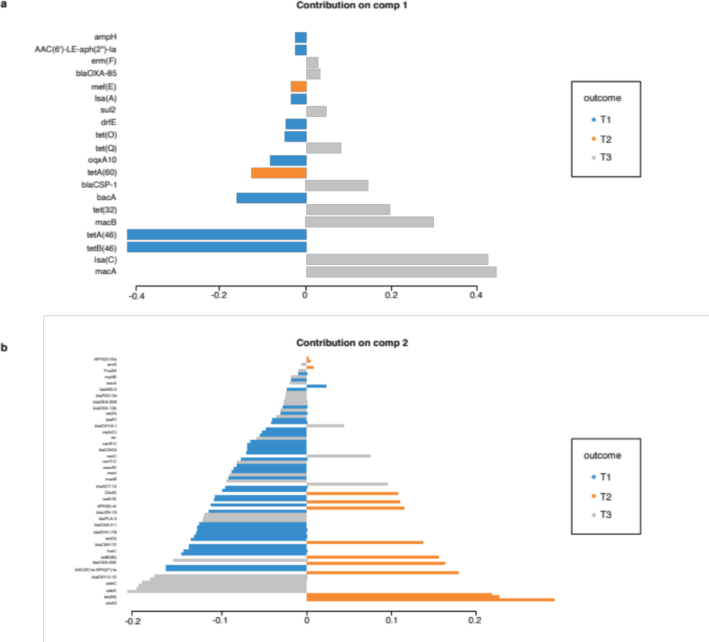

Figure S3. sPLS-DA component 1 and 2 loadings. Analysis was performed on ARGs above a minimum prevalence of 0.01% that had been normalised by total sum scaling (TSS) and center log ratio (CLR) transformed.

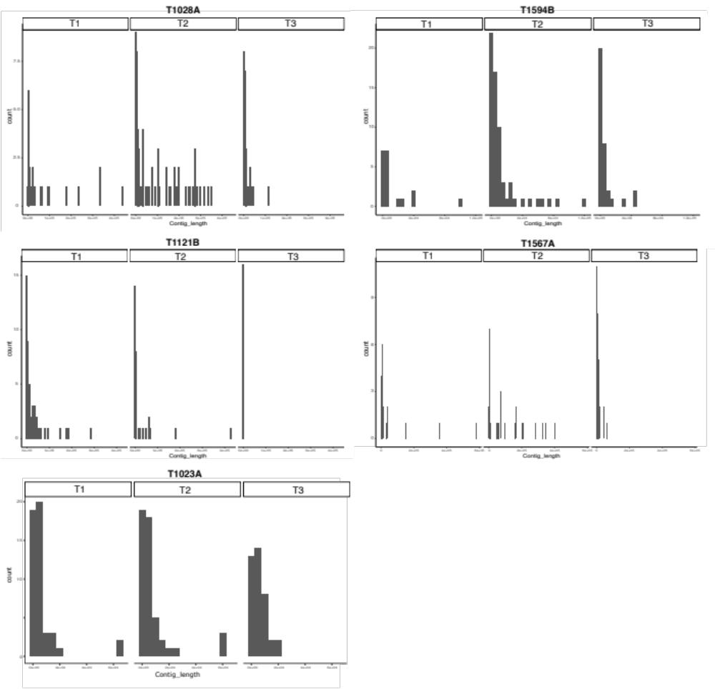

Figure S4. Distribution of lengths of ARG carrying contigs. The distribution was assessed from five randomly selected samples at T1 (7.2 mths), T2 (1.6 yrs) and T3 (8.8yrs). Bin width was set at 5000.

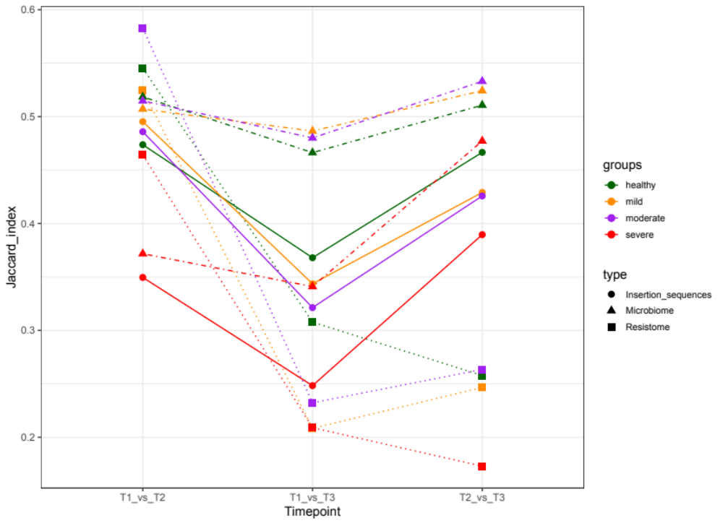

Figure S5. Jaccard index of the microbiome, insertion sequences and resistome, between each two time points based on oral health status. Samples were categorised into 4 oral health groups based on the whole mouth ICDAS score: 0- healthy; 1-2: mild caries; 3-4: moderate caries; 5-6: severe caries.

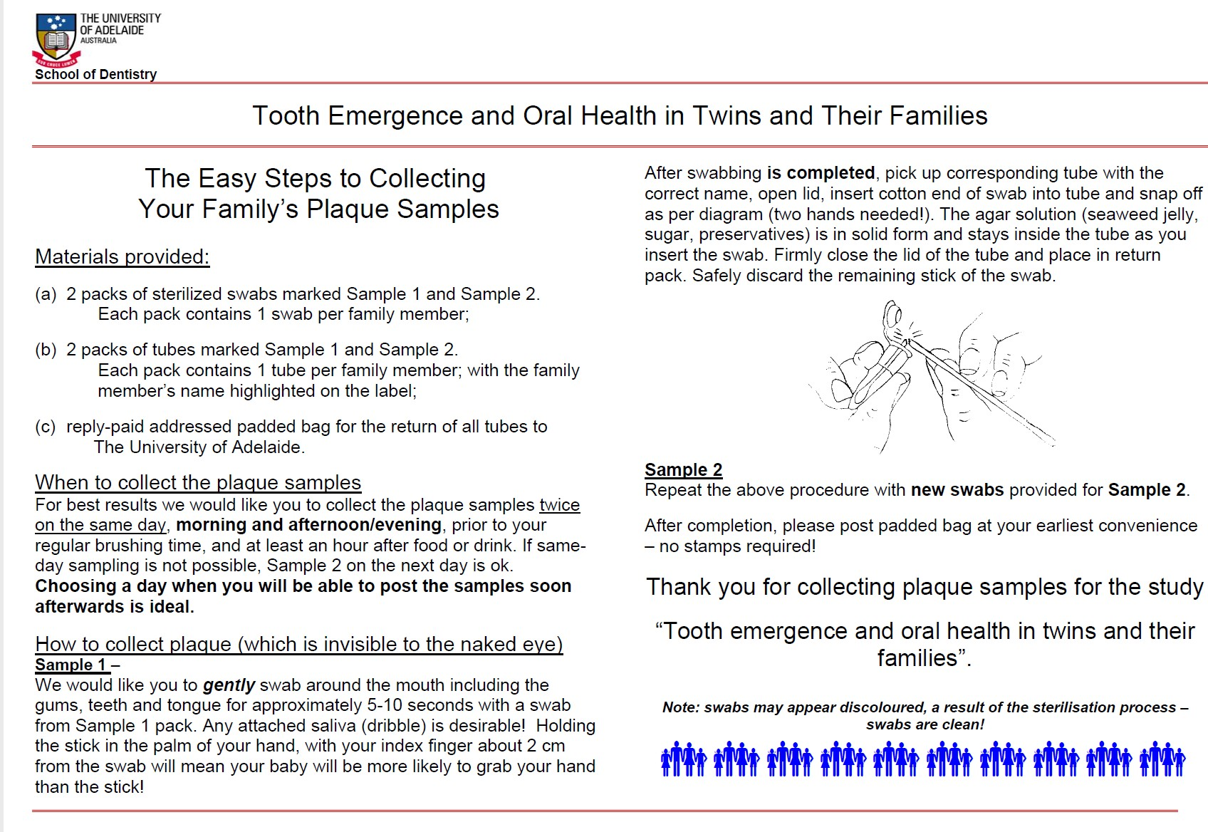
Figure S6. Instruction pamphlet provided to parents/care givers regarding collection of oral biofilm samples.

Supplementary Tables
 | Characteristic | Sample
Gender | Female | 124
Gender | Male | 97
Zygosity | Monozygous (MZ) | 93
Zygosity | Dizygous (DZ) | 128
Ethnicity | White | 207
Ethnicity | Asian | 6
Ethnicity | Mixed | 8
Mode of delivery | Vaginal | 45
 | Caesarean section | 176
Exclusively breast fed for 6 months | Yes | 36
 | No | 38
 | Breast and formula | 143
 | NA | 4
Caries status at T3 (n =214) | ICDAS II Score 0 | 146
 | ICDAS II Score 1 | 14
 | ICDAS II Score 2 | 14
 | ICDAS II Score 3 | 13
 | ICDAS II Score 4 | 6
 | ICDAS II Score 5 | 12
 | ICDAS II Score 6 | 8
Antibiotic Exposure | T1 (n = 141) | 120
 | T2 (n = 181) | 104
 | T3 | 92
Diet at T3 | Below | 77
 | Meets | 22
 | Above | 35
 | NA | 80
Table S16. Demographic and lifestyle characteristics of the study cohort (n=221). Ethnicity was defined using the NIH Racial and Ethnic Categories . Diet at T3 focuses on recommended meat, poultry and fish servings for Australian children age and sex matched for the cohort. NA = no information available.
References
1. Adler CJ, White A, Bockmann M, Browne GV, Townsend G, Hughes T. VMG II transport medium stabilises oral microbiome samples for Next-Generation Sequencing. J Microbiol Methods 144, 91-98 (2018).

2. Willet C, Martinez, E., Sukumar, S., Adler, C., Lydecker, H., Wang, F., Chew, T., & Sadsad, R. Shotgun-Metagenomics-Analysis.). 1.0 edn.

3. Andrews S. FastQC: a quality control tool for high throughput sequence data.). Babraham Bioinformatics, Babraham Institute, Cambridge, United Kingdom (2010).

4. Ewels P, Magnusson M, Lundin S, Käller M. MultiQC: summarize analysis results for multiple tools and samples in a single report. Bioinformatics 32, 3047-3048 (2016).

5. Wood DE, Lu J, Langmead B. Improved metagenomic analysis with Kraken 2. Genome Biol 20, 1-13 (2019).

6. Lu J, Breitwieser FP, Thielen P, Salzberg SL. Bracken: estimating species abundance in metagenomics data. PeerJ Computer Science 3, e104 (2017).

7. Katoh K, Misawa K, Kuma K, Miyata T. MAFFT: a novel method for rapid multiple sequence alignment based on fast Fourier transform. Nucleic Acids Res 30, 3059-3066 (2002).

8. Capella-Gutiérrez S, Silla-Martínez JM, Gabaldón T. trimAl: a tool for automated alignment trimming in large-scale phylogenetic analyses. Bioinformatics 25, 1972-1973 (2009).

9. Stamatakis A. RAxML version 8: a tool for phylogenetic analysis and post-analysis of large phylogenies. Bioinformatics 30, 1312-1313 (2014).

10. Letunic I, Bork P. Interactive Tree Of Life (iTOL) v5: an online tool for phylogenetic tree display and annotation. Nucleic Acids Res 49, W293-w296 (2021).

11. McKenna A, et al. The Genome Analysis Toolkit: a MapReduce framework for analyzing next-generation DNA sequencing data. Genome Res 20, 1297-1303 (2010).

12. Anders S, Pyl PT, Huber W. HTSeq—a Python framework to work with high-throughput sequencing data. Bioinformatics 31, 166-169 (2015).

13. Li B, Dewey CN. RSEM: accurate transcript quantification from RNA-Seq data with or without a reference genome. BMC Bioinform 12, 1-16 (2011).

14. Lee K, et al. Mobile resistome of human gut and pathogen drives anthropogenic bloom of antibiotic resistance. Microbiome 8, 2 (2020).

15. Mallick H, et al. Multivariable Association in Population-scale Meta'omic Surveys. Submission Available online: https://huttenhower sph harvard edu/maaslin2/(accessed on 4 May 2020), (2020).

16. Nearing JT, et al. Microbiome differential abundance methods produce disturbingly different results across 38 datasets. bioRxiv, (2021).

17. Calgaro M, Romualdi C, Waldron L, Risso D, Vitulo N. Assessment of statistical methods from single cell, bulk RNA-seq, and metagenomics applied to microbiome data. Genome Biol 21, 1-31 (2020).

18. Lin H, Peddada SD. Analysis of compositions of microbiomes with bias correction. Nature Commun 11, 1-11 (2020).

19. Neale M, Cardon LR. Methodology for genetic studies of twins and families. Springer Science & Business Media (2013).

20. Scheike TH, Holst KK, Hjelmborg JB. Estimating heritability for cause specific mortality based on twin studies. Lifetime Data Anal 20, 210-233 (2014).

