Supporting Information
“SequenceCraft: Machine learning-based resource for exploratory analysis of RNA-cleaving deoxyribozymes”
Eremeeva M., Din E., Shirokii N., Serov N. *
International Institute “Solution Chemistry of Advanced Materials and Technologies”, ITMO University, Saint-Petersburg, 191002, Russian Federation
* E-mail: serov@scamt-itmo.ru

Supplementary tables

Table S1. Full list of parameters from DNAmoreDB
Name | Type | Description
name | object | DNAzyme name given in original article
e | object | DNAzyme catalytic region (sometimes written along with the binding region or even the substrate)
length | int64 | DNAzyme sequence length calculated from the indicated catalytic region
n | object | The length of the random sequence region of the DNA pool that was subjected to the in vitro selection experiment
x | object | Non-canonical or modified nucleotides in the DNAzyme sequence
s | object | Nucleic acid substrates of DNAzymes are recognized by means of Watson-Crick base pairing.
reaction | object | This is the reaction the selected DNAzyme catalyzes in the reaction buffer, in the presence of its substrates and cofactors.
notes | object | Additional information from the database authors
fg1s | object | The functional groups or residues taking part in the reaction
fg2s | object
linkage | object | Type of bond involved in the reaction
buffer | object | Incubation conditions during the key selection step of the in vitro selection experiment
metal_ions | object | Cofactor on which the indicated DNAzyme depends
reported_in | object | The publication where a given DNAzyme was first reported
rate_constant | object | Kinetic characteristics of DNAzyme
yield | object | RNA cleavage reaction yield for the indicated DNAzyme
main_article_title | object | Information about the original article
main_article_first_author | object | Information about the original article
main_article_last_autor | object | Information about the original article
main_article_mid_authors | object | Information about the original article
main_article_pub_date | int64 | Information about the original article

Table S2. Cluster characteristics
Cluster | Number of samples | Median sequence length | log₁₀k_{obs} | Consensus (fast consensus sequence of the alignment with threshold = 0.7)
0 | 46 | 40 | -2,07 ± 1,15 | T - - - - - - - - - - A - - - - - - - - - - - - - - - - - - - - - - - - - - - - - - - - - - AAC -
1 | 55 | 52 | -1,39 ± 1,00 | - - C - - CA - TT - - - - - - - - - - - - - - - - - T - - - - - - - - - - - - - - - - - - - - - - - - - - - - - - - - - - - - - - - - - - - - - - - - - - - - - - - - - - - - - - - - - - - G - - - - - -
2 | 53 | 26 | -2,02 ± 0,79 | ACCACCA - C - - - - - - - - - - - - - - - G - - G - - - - - - - -

Tables S3. ML models performance metrics and parameters.
 | RFR | XGB | LGBM | CatBoost
Q² | 0,920811 | 0,893769 | 0,933402 | 0,923026
R²_test | 0,934441 | 0,933591 | 0,965401 | 0,945374
RMSE_test | 0,688366 | 0,692815 | 0,500078 | 0,628351
R²_val | 0,951636 | 0,936013 | 0,962027 | 0,945891
RMSE_val | 0,58345 | 0,671098 | 0,516983 | 0,617131
Hyper-parameters | {'n_estimators': 50, 'max_features': 'auto', 'max_depth': 6} | {'n_estimators': 100, 'max_depth': 12, 'learning_rate': 0.1} | {'n_estimators': 200, 'max_depth': 6, 'learning_rate': 0.1} | {'learning_rate': 0.1, 'iterations': 75, 'depth': 6}
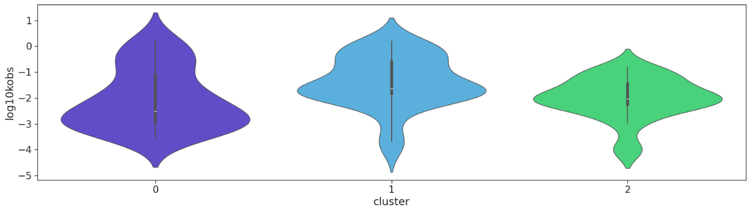
Supplementary figures
Figure S1. k_{obs} distribution within clusters.

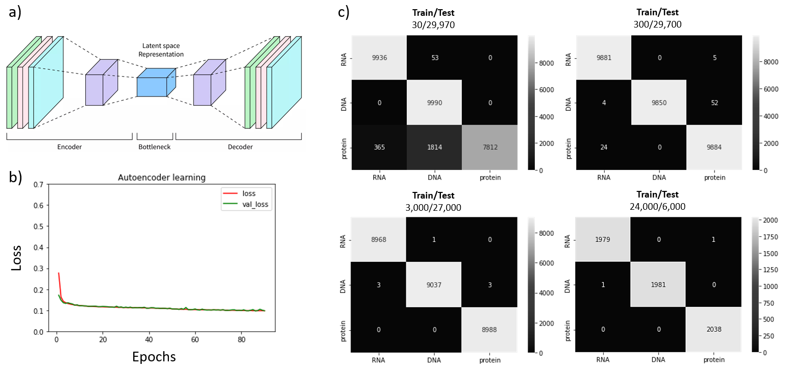
Figure S2. Autoencoder-based sequence representations: a) schematic architecture, b) learning curve, c) DNA / RNA / protein classification based on representations.

SequenceCraft web-resource

For the sake of ML models integration, the application is built with Python3 programming language on the stack of Django framework and PostgreSQL database, using some libraries such as biopython for sequence-related analysis. Source code is available on GitHub https://github.com/nebaskov/dnaZymeWeb
Functional description
SequenceCraft web-resource is dedicated to analyzing and predicting activity of DNAzymes. Home page contains information about the project as well as hyperlinks to the main functional pages e.g., Prediction, Database, and Generation. The web resource comprises distinct sections housing a comprehensive database of all samples utilized in training the final ML model, encompassing RNA-ligation DNAzymes and data extracted from graphs. For each sample, pertinent details such as the DNA sequence, initial name, observed rate constant, and original publication are documented.

The observed rate constant prediction model is conveniently accessible via the prediction section. Herein, users are prompted to input specific parameters including the DNA sequence, concentrations of NaCl and KCl salts, chemical symbol of the cofactor element, its concentration, as well as desired pH and temperature values. Subsequently, the platform autonomously computes the requisite descriptors for characterizing the sequence and cofactor, resulting in a brief summary of the proposed candidate under the specified buffer conditions (rendered in string format within the buffer section). This summary encompasses calculated properties such as molecular weight, melting point, and GC content. Additionally, the length of the specified sequence is determined, and leveraging pairwise Levenshtein distances, the number of clones of the specified DNAzyme within the database is ascertained, thereby facilitating an assessment of the potential "novelty" of the proposed candidate. A similar metric is employed for 2D visualization of the introduced nucleotide sequence among existing DNAzymes. The outcome parameter is displayed in the “Predicted kobs” field.

In conjunction with the primary characteristics, our web resource offers the determination of the secondary structure of the input DNA sequence utilizing the forgi library (1). The analysis of the secondary structure of the catalytic center holds significance in evaluating its conservation and potential modifications that could impact its properties. This assessment is crucial in candidate evaluation.

Certainly, with the development of a predictive model for assessing the catalytic activity of DNA sequences, there arises an interest in exploring the vast sequence space using diverse search algorithms to discover novel DNAzymes with potentially enhanced catalytic activity. This aspect is addressed in the generation section, where we present the outcomes of employing a genetic algorithm to optimize the observed rate constant through evolutionary modifications of the nucleotide sequence in physiological buffer conditions.

The web resource presented herein offers convenient access to the database and machine learning models detailed in this study, enabling researchers to utilize them in their investigations on DNAzyme discovery for an initial evaluation of their catalytic efficacy.

References

1. Thiel,B.C., Beckmann,I.K., Kerpedjiev,P. and Hofacker,I.L. (2019) 3D based on 2D: Calculating helix angles and stacking patterns using forgi 2.0, an RNA Python library centered on secondary structure elements. F1000Res, 8, 287.

