Fig. S7
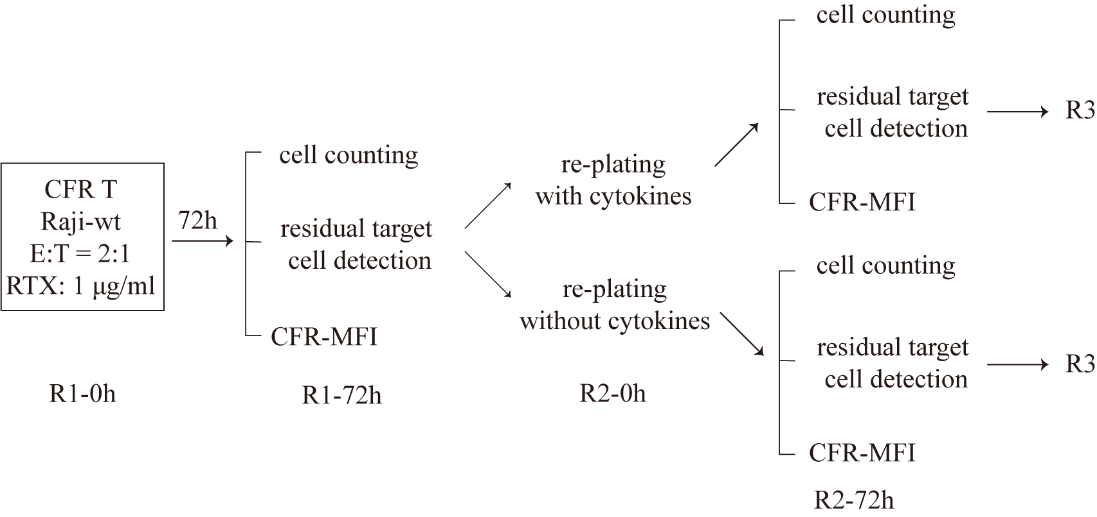
Supplementary Figure 7. The schematic flow of the repetitive antigen stimulation of 16s3 and 32-8a CFR T cells by Raji-wt cells.

