Fig. S3
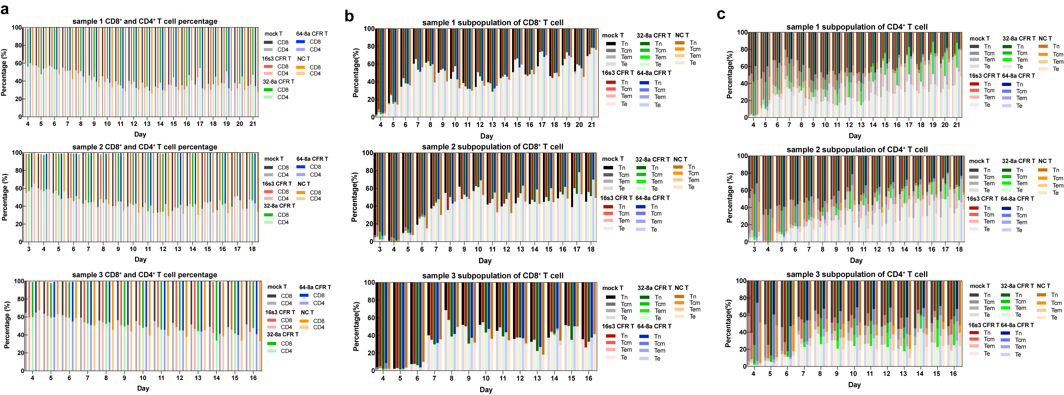
Supplementary Figure 3. The subpopulation differentiation of T cells after transduction. a The percentages of CD8⁺ and CD4⁺ subpopulations in 16s3, 32-8a, 64-8a CFR T, mock T and NC T cells during culture. Different subpopulations of T cells were distinguished by distinct colors; dark color represented CD8⁺ T cells while light color indicated CD4⁺ T cells. b, c The subpopulation percentages of CD8⁺ (b), CD4⁺ (c) naive T cells (Tn), central memory T cells (Tcm), effector memory T cells (Tem) and terminal effector T cells (Te) in 16s3, 32-8a, 64-8a CFR T, mock T and NC T cells during culture. Different subpopulations of T cells were represented by distinct colors. The transition from dark to light color indicated the differentiation from Tn, Tcm, Tem to Te as indicated.

