Fig. S2
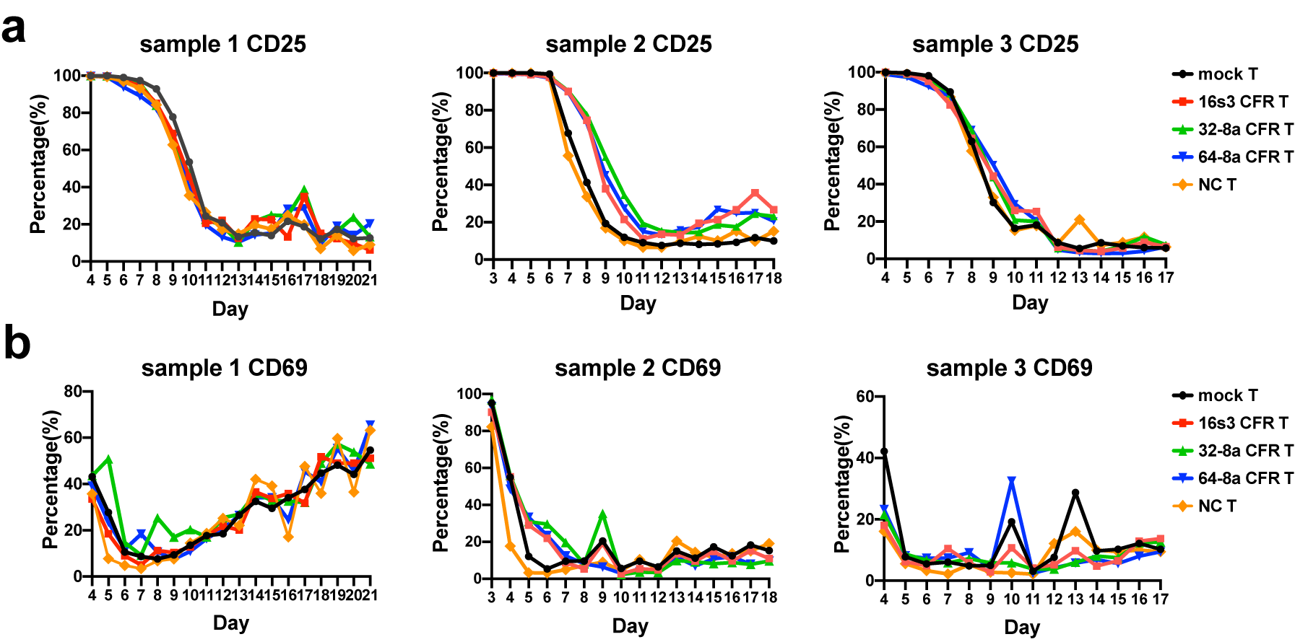
Supplementary Figure 2. The expression of activation markers on T cells. The expression levels of CD25 (a) and CD69 (b) on 16s3, 32-8a, 64-8a CFR T, mock T and NC T cells derived from three different samples during culture.

