Fig. S6
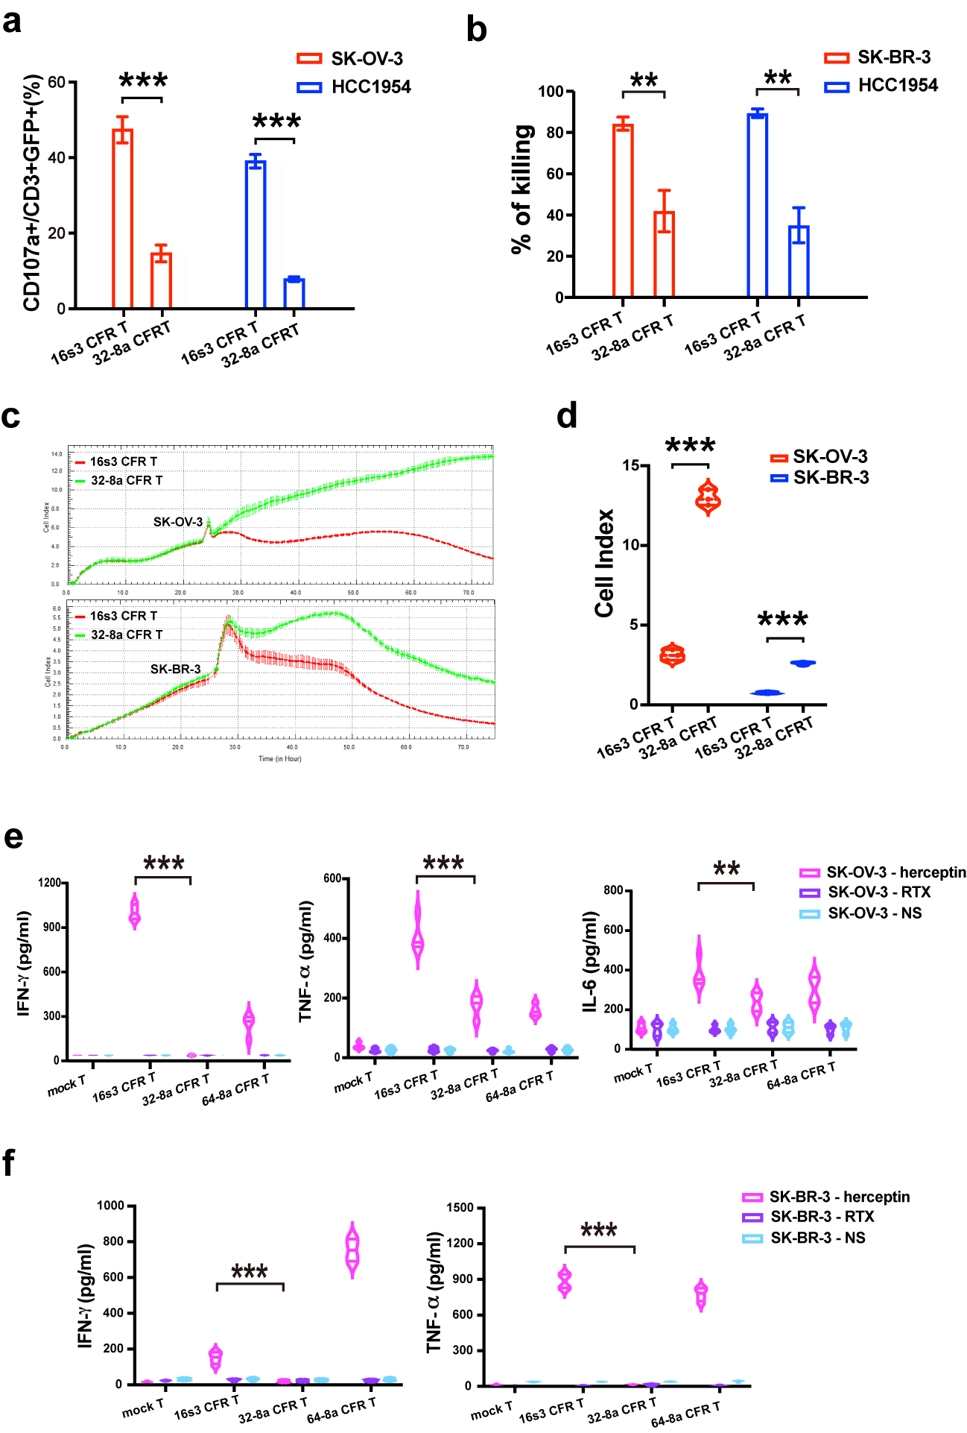
Supplementary Figure 6. The comparison of herceptin-mediated cytotoxicity of 16s3 and 32-8a CFR T cells. a The comparison of the percentages of CD107a⁺ cells in 16s3 and 32-8a CFR T cells co-cultured with SK-OV-3 (n = 5) and HCC1954 (n = 3) in the presence of herceptin (1 μg/ml) (* * *, P < 0.001). b The comparison of SK-BR-3 (n = 5) and HCC1954 (n = 3) lysis by 16s3 and 32-8a CFR T cells in the presence of herceptin (1 μg/ml) at 48 hours (E:T = 2:1; * *, P < 0.01). c The CI values displayed by the RTCA system of SK-OV-3 and SK-BR-3 co-cultured with 16s3 and 32-8a CFR T cells at the E:T of 2:1 in the presence of herceptin (1 μg/ml). d The comparison of CI values of SK-OV-3 (n = 3) and SK-BR-3 (n = 4) co-cultured with 16s3 and 32-8a CFR T cells (E:T = 2:1; 48 hours; * * *, P < 0.001). e The comparison of IFN-γ, TNF-α, and IL-6 levels secreted by 16s3 and 32-8a CFR T cells co-cultured with SK-OV-3 at 24 hours (n = 4; * * *, P < 0.001; * *, P < 0.01). f The comparison of IFN-γ and TNF-α levels secreted by 16s3 and 32-8a CFR T cells co-cultured with SK-BR-3 at 24 hours (n = 4; * * *, P < 0.001).

