Fig. S1
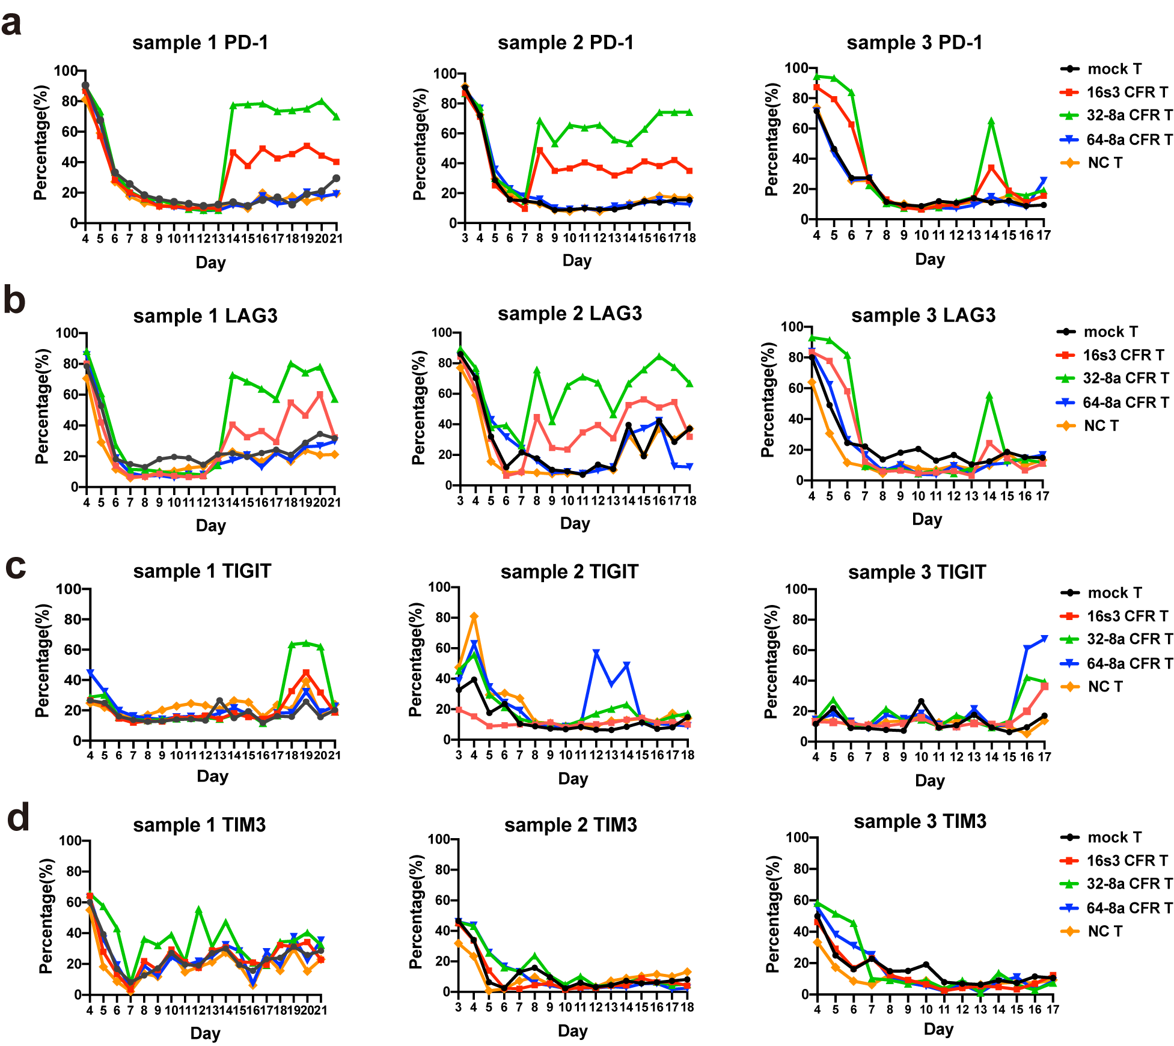
Supplementary Figure 1. The expression of exhaustion markers on T cells. The expression levels of PD-1 (a), LAG3 (b), TIGIT (c), and TIM3 (d) on 16s3, 32-8a, 64-8a CFR T, mock T and un-transduced negative control (NC) T cells derived from three different samples during culture.

