Fig. S5
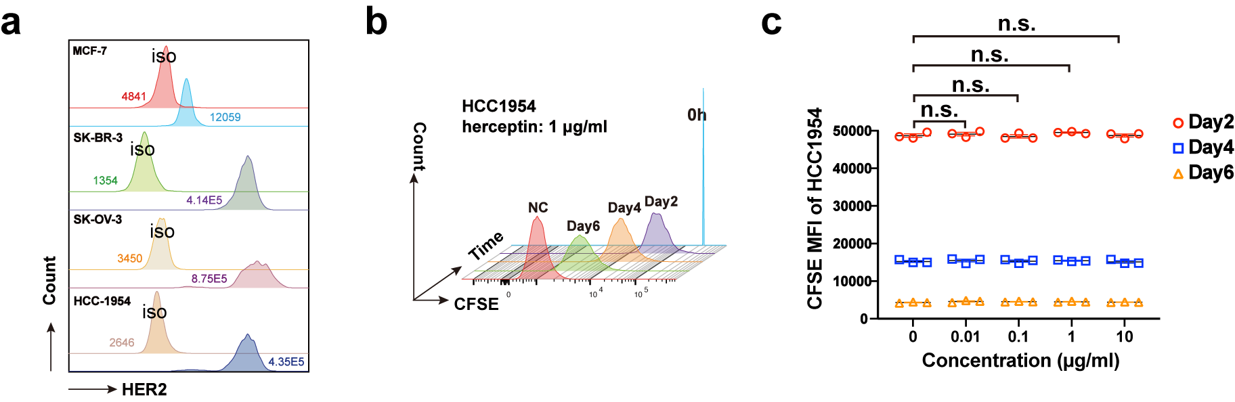
Supplementary Figure 5. HER2 antigen expression and the impact of herceptin on HCC1954 proliferation. a The the MFI of HER2 antigen on MCF-7, SK-BR-3, SK-OV-3 and HCC1954 cell lines. b The histogram by flow cytometry illustrating the CFSE attenuation of HCC1954 cells in the presence of herceptin (1 μg/ml) on Day 2, 4, 6 following CFSE staining (Day 0). e The CFSE MFI attenuation of HCC1954 cells during culture in the presence of different concentrations of herceptin (0, 0.01, 0.1, 1, and 10 μg/ml) on Day 2, 4, and 6 (n = 3; n.s., no significance).

