Fig. S4
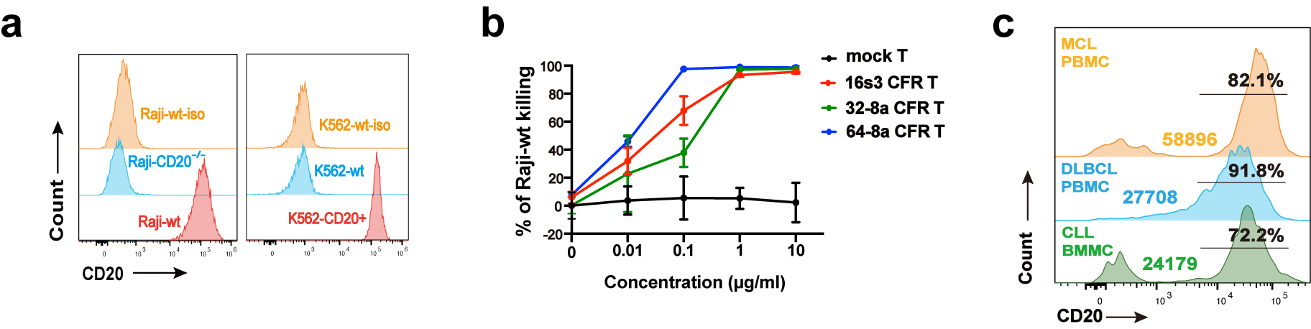
Supplementary Figure 4. CD20 antigen expression, specific killing mediated by different concentrations of RTX. a The CD20 expression of Raji-wt, Raji-CD20^{-/-}, K562-wt and K562-CD20⁺ cells. b The Raji-wt killing by 16s3, 32-8a, 64-8a CFR T and mock T cells in the presence of RTX at different concentrations (0, 0.01, 0.1, 1, and 10 μg/ml) at 24 hours (n = 3). c The percentages and MFI of CD20 expression in primary cells collected from patients.

