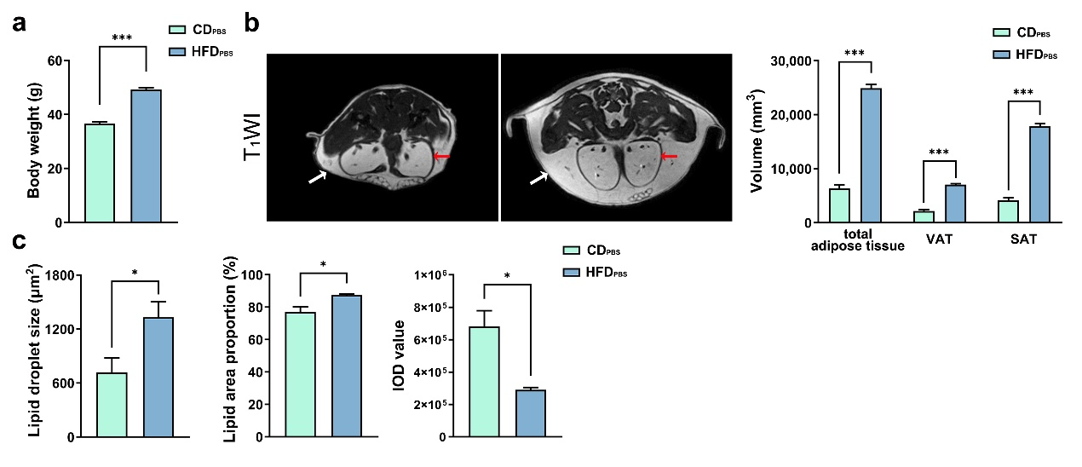
S1
(a) The average body weights of mice in CD_{PBS} and HFD_{PBS} groups (n = 6).
(b) The T₁WI images of VAT (red arrows) and SAT (white arrows) taken from CD_{PBS} and HFD_{PBS} groups. The volumes of total adipose tissue, VAT, and SAT were measured (n = 4).
(c) The averaged lipid droplet sizes and the lipid area proportions of H&E staining (n = 4), and the IOD values of IHC staining (n = 4).
* P < 0.05, ** P < 0.01, *** P < 0.001 by unpaired Student’s t test. Datas follow normal distribution represent as mean ± SEM. HFD, high-fat diet; PBS, phosphate buffered saline; VAT, visceral adipose tissue; SAT, subcutaneous adipose tissue; H&E, hematoxylin and eosin staining; IHC, immunohistochemistry; IOD, integral optical density.
S2
(a) The SUV of FDG in liver, muscle, kidney, eWAT and iWAT (n = 4).
(b-d) The averaged lipid droplet sizes and the lipid area proportions of H&E staining (n = 4), and the IOD values of IHC staining (n = 4).
* P < 0.05, ** P < 0.01, *** P < 0.001 by unpaired Student’s t test or One-way ANOVA followed by Bonferroni’s post hoc test. Datas follow normal distribution represent as mean ± SEM. HFD, high-fat diet; PBS, phosphate buffered saline; SUV, standardized uptake value; H&E, hematoxylin and eosin staining; IHC, immunohistochemistry; IOD, integral optical density.
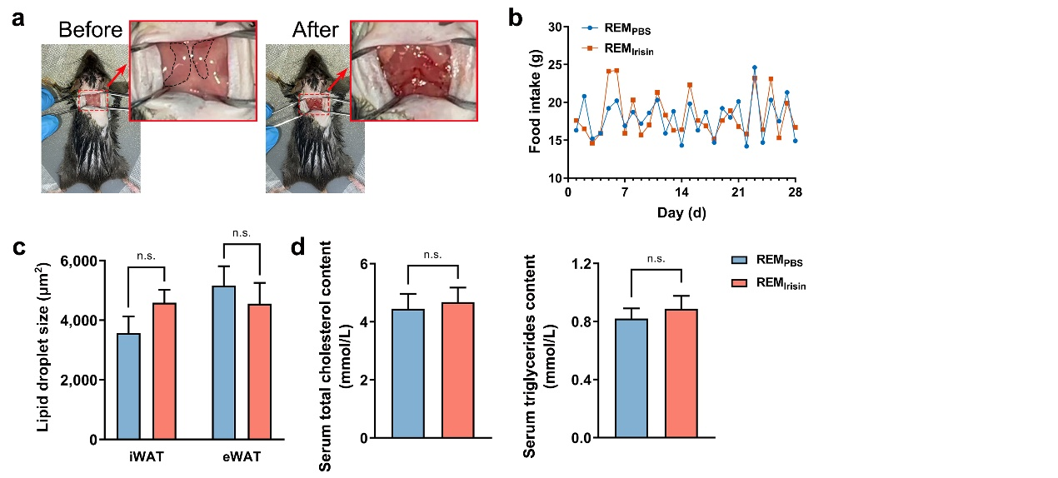
S3
(a) Pictures show the example of the surgical removal of iBAT. The dotted line
indicates the region where iBAT was present before removal.
(b) The average daily food intake of mice (n = 4).
(c) The averaged lipid droplet sizes of iWAT and eWAT in H&E staining (n = 4).
(d, e) The averaged levels of serum total cholesterol and triglycerides (n = 4).
* P < 0.05, ** P < 0.01, *** P < 0.001 by unpaired Student’s t test. Datas represent as mean ± SEM. REM, removal;iBAT, interscapular brown adipose tissue; PBS, phosphate buffered saline; iWAT, inguinal white adipose tissue; eWAT, epididymal white adipose tissue; H&E, hematoxylin and eosin staining.

