Supplementary material：
Lentivirus knockdown P53 fluorescence transfection efficiency：
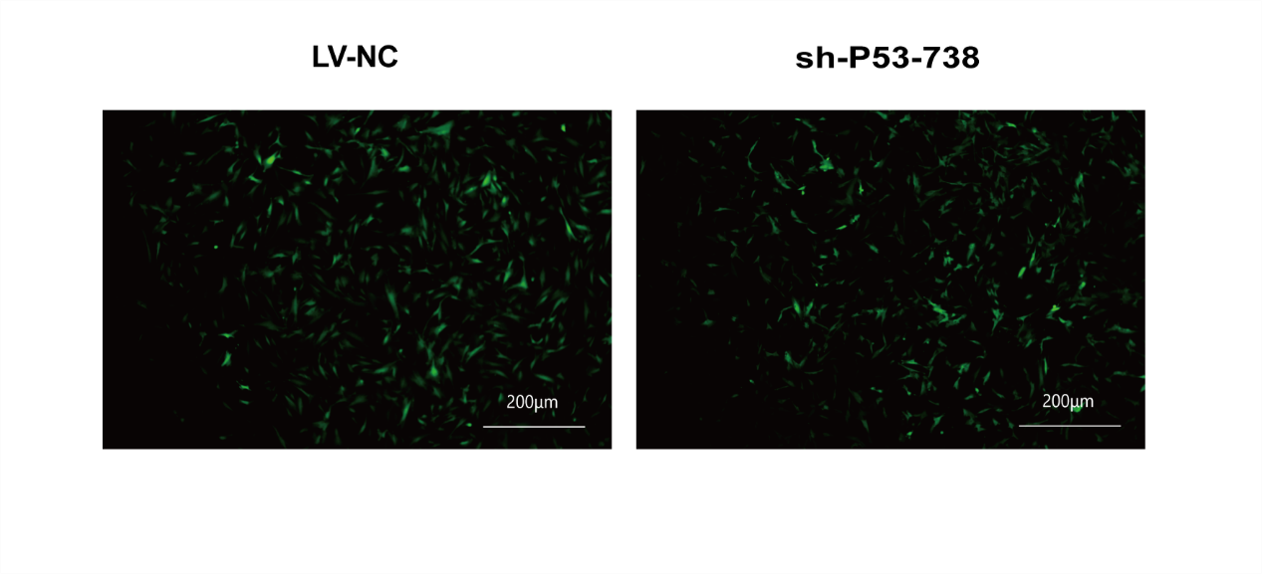
The efficiency of P53 knockdown was tested by qPCR：
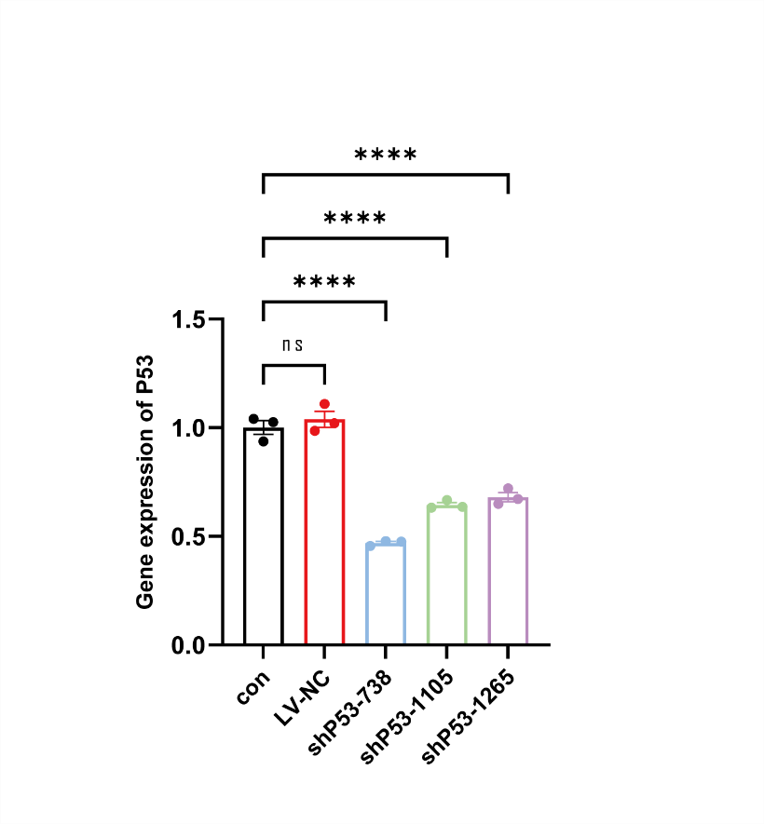
Fibroblast identification of HCFs:
