Supplementary Information
Antithrombotic Effects of Montelukast by Targeting Coagulation Factor XIa
Dong Wang^{a,c,#}, Yang Zhou^{a,b,#}, Yingying Qi^{b,#}, Meiru Song^{b} , Huiqiao Yao^{b}, Christopher Kai Liao^{d}, Haili Lin^{e}, Meijuan Huang^{f}, Dexiang Zhuo^{g}, Longguang Jiang^{b}, Cai Yuanª, Yuanzhong Chen^{f}, Mingdong Huang^{a,b}, Jinyu Li^{b,*}, Peng Xu^{a,*}
ª College of Biological Science and Engineering, Fuzhou University, Fuzhou, Fujian, China P.R.
^{b} College of Chemistry, Fuzhou University, Fuzhou, Fujian, China P.R.
^{c} School of Basic Medical Sciences, Weifang Medical University, Weifang, Shandong, China P.R.
^{d} Department of Chemistry, Columbia University, New York, USA
^{e} Department of Pharmacy, The Peoples Hospital of Fujian Province, Fuzhou, Fujian, China P.R.
^{f} Fujian Medical University Union Hospital, Fuzhou, Fujian, China P.R.
^{g} The Central Laboratory of Sanming First Hospital Affiliated to Fujian Medical University, Sanming, Fujian, China P.R.
#These authors contributed equally to this work.
Correspondence to:
Jinyu Li, College of Chemistry, Fuzhou University, No. 2, Xueyuan Road, New District, 350116, Fuzhou, Fujian, China P.R.; e-mail: j.li@fzu.edu.cn
Peng Xu, College of Biological Science and Engineering, Fuzhou University, No. 2, Xueyuan Road, New District, 350116, Fuzhou, Fujian, China P.R.; e-mail: pengxu@fzu.edu.cn

Table of Contents
Supplementary Methods 1
General 1
In silico screening 1
Molecular dynamics simulation 2
Chromogenic determination of the enzymatic activities 2
FXIa-induced clot formation in vitro 3
Animal experiments 3
Electricity-induced arterial thrombosis mouse model 3
FeCl₃-induced arterial thrombosis mouse model 4
LPS-induced pulmonary microvascular thrombotic mouse model 4
Tail transection experiment 5
Determination of PT and APTT of human plasma 5
Supplementary Figure & Tables 6
Table S1: the sources of chemicals, compounds, and instruments used in this study 6
Figure S1: The chemical structures of the compounds predicted by in silico screening 7
Figure S2: MD simulations of MK bound to FXIa, FX or PK 8
Figure S3: Flipping of W215 during the MD simulations of MK bound to PK 9
Table S2: The chromogenic substrate and their corresponding proteases used in this study 10
Figure S4: Scheme of the establishment of the LPS-induced septic model 11
Table S3: 20 clinical hypercoagulable plasma samples with shortened APTT and enhanced D-dimer levers. 12
Figure S5: The influence of 25 μM Apx on the clot formation in plasma samples 1-5 13
Figure S6: The influence of 25 μM MK on the clot formation in plasma samples 1-6 14
Figure S7: The influence of 25 μM MK on the clot formation in plasma samples 7-12 15
Figure S8: The influence of 25 μM MK on the clot formation in plasma samples 13-20 16
References 17

Supplementary Methods

General
MK, Apx, and Warfarin were purchased from TopScience (Shanghai, China). Other chemicals were purchased from Sigma-Aldrich (St. Louis, USA), Iris Biotech GmbH (Marktredwitz, Germany), or Rapp Polymere GmbH (Tübingen, Germany). Recombinant proteases were purchased from Molecular Innovation (Novi, MI, USA), Roche Applied Science (Penzburg, Germany), Maxygen (CA, USA), or ProSpec-Tany Technogene Ltd. (NJ, USA). Twenty hypercoagulable blood samples were collected from patients in different pathological conditions which were newly diagnosed in the Sanming First Hospital Affiliated to Fujian Medical University (Table S3). The use of these samples was approved by the Ethics Committees of Sanming First Hospital Affiliated to Fujian Medical University. Informed written consent was obtained from all patients.

In silico screening
Structural preparation, molecular docking, and consensus scoring were all carried out with Discovery Studio (DS 2017R2) package (BIOVIA, San Diego, USA). All compounds deposited in a customized drug repurposing library (3,727 compounds) provided by TOPSCIENCE were set up for molecular docking-based virtual screening. The high-resolution crystal structure of the catalytic domain of FXIa (PDB ID: 4CRG ¹) was retrieved from the Protein Data Bank (www.rscb.org). Based on the most representative structure of apo FXIa obtained from 500 ns-long molecular dynamics (MD) simulations (see details in following section), molecular docking calculations were performed using the CDOCKER module implemented in Discovery Studio with default settings. The compound with a positive CDOCKER energy was then evaluated with consensus scoring including a collection of 7 functions provided by Discovery Studio. Finally, 5 compounds (Figure S1) with consensus scores over 5 were selected for experimental validations. In order to investigate the mechanism of ligand specificity, we also performed molecular docking calculations on PK and FXa to generate the initial structures following simulations. The high-resolution crystal structures of the catalytic domains of PK (PDB ID: 2ANY ²) and FXa (PDB ID: 1G2L ³) were also retrieved from the Protein Data Bank and subsequently handled with MD simulations to generate the most representative structure of the apo states for docking.

Molecular dynamics simulation
Atomistic MD simulations in aqueous solution were performed on apo FXIa, PK, and FXa, and their holo complexes with MK in aqueous solution using Amber 16 package ⁴. The initial structures of the apo states were retrieved from the Protein Data Bank, and those of the complexes were obtained by molecular docking calculations (see above section). For each MD system, the starting structure was inserted into a 0.15 M NaCl water box with edge lengths of 80 Å, 80 Å, and 80 Å. The protonation states of residues were assigned according to the corresponding pK_{a} values calculated using the H++ webserver ⁵. Sodium ions were added to counterbalance the charge of the system. The AMBER-ff14SB force field ⁶ and general AMBER force field (GAFF) ⁷ were used for proteins and MK, respectively. The Åqvist potential ⁸ and TIP3P model ⁹ were used for the ions and for the water molecules, respectively. All of the bonds were constrained by LINCS algorithm ¹⁰. Periodic boundary conditions were applied. Electrostatic interactions were calculated using the Particle Mesh-Ewald (PME) method ¹¹, and van der Waals and Coulomb interactions were truncated at 10 Å. Each system first underwent 5,000 steps of steepest-descent energy minimization with 500 kcal·mol⁻¹·Å⁻² harmonic position restraints on the protein, followed by 5,000 steps of steepest-descent and 5,000 steps of conjugate-gradient minimization without restraints. The system was then gradually heated from 0 K up to 300 K in 20 steps of 0.2 ns. After that, 500 ns-long MD simulation was carried out in the NPT ensemble. Temperature and pressure controls were achieved by Nosé-Hoover thermostat¹² and Berendsen barostat¹³ with a frequency of 2.0 ps, respectively. The most representative structure was identified by cluster analysis with a cutoff of 1.0 Å from the last 200 ns-long trajectory. Hydrogen bond interactions were defined to be present if the atomic distance between the acceptor and donor atoms is below 3.5 Å and the angle among the hydrogen-donor-acceptor atoms is below 30 degree.

Chromogenic determination of the enzymatic activities
FXIa (10 nM) was pre-incubated with MK at concentrations ranged 0-100 µM for 15 min. 200 µM chromogenic substrate S-2866 (Chromogenix, MA, USA) was sequentially added and A405 was real-time determined by a plate-reader (Synergy™ 4, BioTek Instruments). The initial reaction velocities of the increase of A405 were used from the calculation of the IC₅₀ value by using the “Dose-response Inhibition” module of Graphpad Prism 7.0 (Graphpad Software. Inc, CA, USA). The inhibition of other serine proteases by MK, plasma kallikrein, tPA, uPA, matriptase, thrombin, plasmin, FXa, FXIIa and FVIIa, were tested in the same condition.

FXIa-induced clot formation in vitro
The in vitro clot formation experiment was performed in 96-well transparent plates with human plasma collected from healthy donors as described previously ¹⁴. 20 nM recombinant FXIa was pre-incubated with MK ranged 0-25 μM for 15 min at 37 °C in the buffer of 50 mM Tris-HCl, pH 7.4, 150 mM NaCl, 1% DMSO, followed by the addition of 25% (v/v) plasma. Coagulation was initiated by the addition of 10 mM CaCl₂. Clot formation and lysis was real-time monitored by determining A405 using a microplate reader at 37 °C.

Animal experiments
All animal experiments were approved by the Animal Ethics Committee of College of Biological Science and Engineering, Fuzhou University (2019-SG-006) and carried out in strict accordance with the guidelines. Male institute of cancer research (ICR) mice (6-week old, 20-25 g, purchased from SLAC Laboratory Animal Co. Ltd, Shanghai, China) were maintained in a controlled environment (25±1 °C) on a 12‐hr dark/light cycle with food and water available. All the surgical experiments and scarifications were carried out after mice were anesthetized by 1.5% sodium pentobarbital (30 mg/kg, i.p.).

Electricity-induced arterial thrombosis mouse model
Mice were administered (p.o.) with Saline, 2, 10 mg/kg MK, 4 mg/kg Warfarin and 2, 10 mg/kg Apx (6 mice per group) 3-h before the left common carotid artery was exposed and stimulated with 0.1 mA current to damage vascular wall resulting in the formation of mixed thrombi in vessels by an YLS-14B animal thrombus formation instrument (Ji’nan Yiyan Technology Development Co., Ltd, China). The occlusive rate (%) of carotid blood was recorded every 4 seconds by an infrared detector. The mean times to occlusion (vascular occlusive rate reached 95%) were recorded for comparison ¹⁵.

FeCl₃-induced arterial thrombosis mouse model
Mice were administered (p.o.) with Saline, 2, 10 mg/kg MK, 4 mg/kg Warfarin and 10 mg/kg Apx (6 mice per group), 3-h before the left common carotid arteries of the anesthetized mice were exposed and treated with a piece of a filter paper (2*2 mm²) saturated with 6 % of FeCl₃ to induce thrombosis. To insulate the artery and block exudate, a blacked silver paper was placed under the carotid artery ¹⁶. Once the filter paper was put on the carotid artery, the bloodstream was monitored by Laser Speckle Contrast Imaging System (SIM BFI HR Pro, Simopto, China). The occlusive rate (%) of carotid blood was recorded every 4 seconds by an infrared detector. The mean times to occlusion (vascular occlusive rate reached 95%) were recorded for comparison.

LPS-induced pulmonary microvascular thrombotic mouse model
LPS-induced pulmonary microvascular thrombotic mouse model was established by intraperitoneal (i.p.) injections with 250 μg/kg LPS and 500 mg/kg D-GalN in ICR mice ¹⁷. Mice were randomly divided into 6 groups (6 mice per group). One group was without stimulation was set for comparison (the normal group). The rest 5 groups were administered (p.o.) with saline, 2, 10 mg/kg MK, 4 mg/kg Warfarin or 10 mg/kg Apx 3-h before LPS-stimulation. 4-h after stimulation, mice were anesthetized and sacrificed. The blood and lungs were harvested for further investigation. Blood concentrations of IL-1β and TNF-α, were determined by ELISA kits according to the manual instructions. Lungs were resected and fixed in 10% buffered formalin and embedded in paraffin. 4-μm-thick sections were stained with hematoxylin and eosin (H&E). The histopathological sections were photographed at a magnification of 200× imaged by a Leica DMi8 inverted microscope (Leica, Heidelberg, Germany). The numbers of microthrombi were counted in 6 histopathological sections from 3 mice in each group, and the areas of the microthrombi were determined by the software of Image J.

Tail transection experiment
Tail bleeding time was determined as described previously with slight modifications ¹⁸. Mice were p.o. administered with Saline, 10, 50 mg/kg MK, 4 mg/kg Warfarin, 10 and 50 mg/kg Apx (6 mice per group), 3 h before the tails were transected 10 mm from the tip. The transected tails were immediately immersed in 10 ml isotonic saline at 37 °C. The bleeding time was recorded once the bleeding stopped. The blood loss was quantified by measuring the haemoglobin content collected in the 10 ml isotonic saline. After centrifugation, erythrocytes were collected and lysed with 2 mL lysis buffer (8.3 g/L NH₄Cl, 1 g/L KHCO₃, and 0.037 g/L EDTA). The A575 of each sample was determined.

Determination of PT and APTT of human plasma
Poor platelet plasma was prepared by collecting fresh blood from three healthy donors by centrifuged at 3000 rpm for 30 min. The plasma was mixed for the determination. MK ranged at 0-1000 μM was mixed with plasma collected before and some tests of routine coagulation screens were determined to estimate the influence of MK on the hemostatic system. Global coagulation tests were determined by automated coagulation analyser (CA-660, Sysmex, Japan).

Supplementary Figure & Tables

Table S1: the sources of chemicals, compounds, and instruments used in this study.
Chemicals/compounds/instruments/softwares | Manufacturers/addresses
Laser Speckle Contrast Imaging System | SIM BFI HR Pro, Simopto, (Shanghai China)
MK, Apx, and Warfarin | TopScience (Shanghai, China)
Other chemicals | Sigma-Aldrich (St. Louis, USA), Iris Biotech GmbH (Marktredwitz, Germany), or Rapp Polymere GmbH (Tübingen, Germany).
Recombinant proteins | Molecular Innovation (Novi, MI, USA)
Clinical blood samples | Sanming First Hospital Affiliated to Fujian Medical University, Sanming, China
Chromogenic substrates | Chromogenix, (MA, USA)
Synergy™ 4 Plate-reader | BioTek Instruments (Winooski, USA.)
Male ICR mice | SLAC Laboratory Animal Co. Ltd, (Shanghai, China)
YLS-14B animal thrombus formation instrument | Ji’nan Yiyan Technology Development Co., Ltd, (Xi’an, China)
Leica DMi8 inverted microscope | Leica (Heidelberg, Germany)
Automated coagulation analyser, CA-660 | Sysmex (Kobe, Japan)
Discovery Studio (DS 2017R2) package | BIOVIA (San Diego, USA)
Graphpad Prism 7.0 | Graphpad Software. Inc, CA, USA

Figure S1: The chemical structures of the compounds predicted by in silico screening.
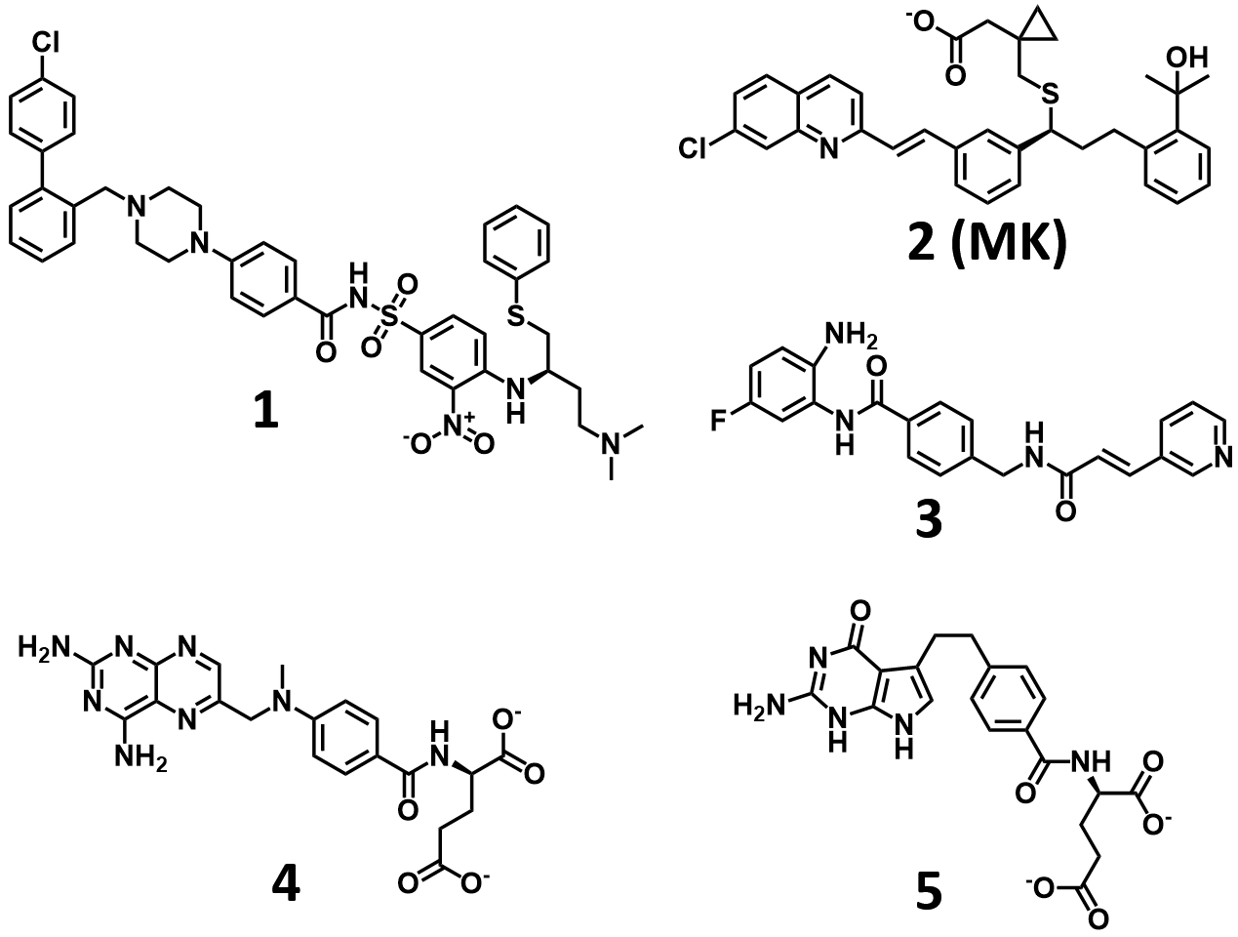

Figure S2: MD simulations of MK bound to FXIa, FX or PK. A: Time evolution of the root-mean-square deviations (RMSD) of MK heavy atoms. B: The centre-of-mass distances between MK and FXIa, PK or FXa.

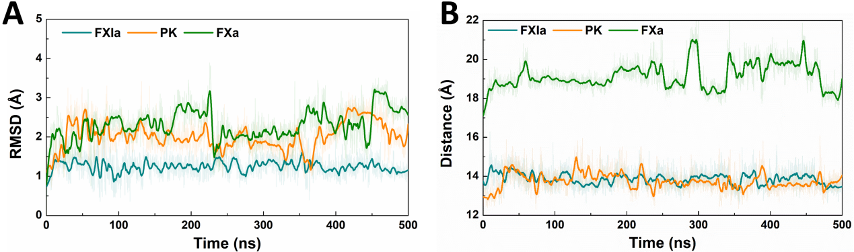

Figure S3: Flipping of W215 during the MD simulations of MK bound to PK. A: Time evolution of the dihedral angle among C-Cα-Cβ-Cγ of W215. B: Time evolution of the centre-of-mass distance between the phenyl ring of 2-phenylpropan-2-ol moiety of MK and the indole ring of W215. C: Representative structures of the two conformational states of W215.

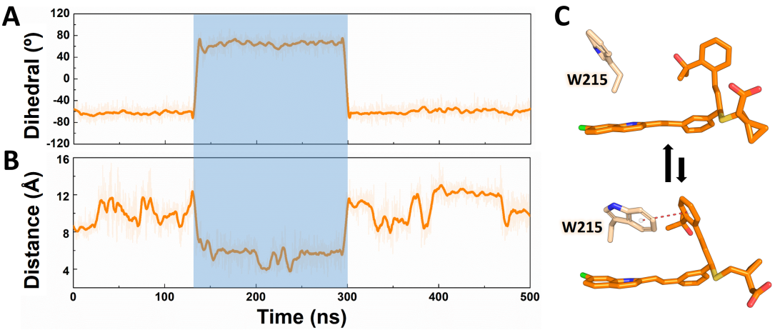

Table S2: The chromogenic substrate and their corresponding proteases used in this study. The K_{M} values were either from the manuals from the vendors (Chromogenix, Italy).
Enzyme | Substrate | K_{M} (M)
FXIa | S2366 | 4×10⁻⁴
Plasma kallikrein | S2302 | 2×10⁻⁴
tPA | S2288 | 3×10⁻⁴
uPA | S2444 | 9×10⁻⁵
Matriptase | S2765 | －
Thrombin | S2238 | 0.7×10⁻⁵
Plasmin | S2403 | 2.9×10⁻⁴
FXa | S2288 | 2×10⁻³
FXIIa | S2288 | 4×10⁻⁴
FVIIa | S2765 | －

Figure S4: Scheme of the establishment of the LPS-induced septic model. Mice in each group were administrated (p.o.) with saline, MK, Warfarin, or Apx at various concentrations 3 hours before the i.p. injection with LPS and D-GalN. 4 hours after stimulation, mice were sacrificed, the lungs and blood were harvested for histopathological analysis and determination of plasma levels of cytokines, respectively.

Table S3: 20 clinical hypercoagulable plasma samples with shortened APTT and enhanced D-dimer levers.
Sample No. | Age | Gender | Indication | APTT | D-dimmer level
1 | 59 | F | Abnormal defecation | 17.3 | 0.910
2 | 54 | F | Hydronephrosis | 19.3 | 0.8
3 | 71 | M | Stomachache | 30.4 | 7.020
4 | 18 | F | 28-week pregnancy | 24.6 | －
5 | 34 | F | 35-week pregnancy | － | 7.209
6 | 71 | F | Fatigue | 23.9 | 5.750
7 | 67 | F | AMI | 19.4 | 0.910
8 | 83 | F | Femur intertrochanteric fracture | 18.3 | 10.55
9 | 66 | F | Knee arthritis | 18.6 | 0.590
10 | 32 | F | 40-week pregnancy | 27.1 | 2.1999
11 | 68 | F | Vitreous hematocele | 18.0 | －
12 | 55 | F | Gallbladder space-occupying lesion | 14.4 | 0.190
13 | 87 | F | Femoral fractures | 21.9 | 2.030
14 | 56 | M | Spinal cord injury | 25.1 | 41.400
15 | 69 | F | Femur ischemic necrosis | 26.9 | 19.943
16 | 56 | M | Spinal cord injury | 21.1 | 31.707
17 | 30 | F | Twin pregnancy | 24.5 | 7.827
18 | 33 | F | 29-week pregnancy | 25.8 | －
19 | 20 | F | 37-week pregnancy | 28.4 | －
20 | 91 | M | Hypertension | 20.9 | 3.590

Figure S5: The influence of 25 μM Apx on the clot formation in plasma samples 1-5. The clot formation was triggered by 10 mM CaCl₂ and monitored by determining Absorbance at 405 nm every 0.5 min.

Figure S6: The influence of 25 μM MK on the clot formation in plasma samples 1-6. The clot formation was triggered by 10 mM CaCl₂ and monitored by determining Absorbance at 405 nm every 0.5 min.

Figure S7: The influence of 25 μM MK on the clot formation in plasma samples 7-12. The clot formation was triggered by 10 mM CaCl₂ and monitored by determining Absorbance at 405 nm every 0.5 min.

Figure S8: The influence of 25 μM MK on the clot formation in plasma samples 13-20. The clot formation was triggered by 10 mM CaCl₂ and monitored by determining Absorbance at 405 nm every 0.5 min.

References
1. Fjellstrom O, Akkaya S, Beisel HG, Eriksson PO, Erixon K, Gustafsson D, Jurva U, Kang D, Karis D, Knecht W, Nerme V, Nilsson I, Olsson T, Redzic A, Roth R, Sandmark J, Tigerstrom A, Oster L. Creating novel activated factor xi inhibitors through fragment based lead generation and structure aided drug design. PLoS One. 2015;10:e0113705
2. Tang J, Yu CL, Williams SR, Springman E, Jeffery D, Sprengeler PA, Estevez A, Sampang J, Shrader W, Spencer J, Young W, McGrath M, Katz BA. Expression, crystallization, and three-dimensional structure of the catalytic domain of human plasma kallikrein. J Biol Chem. 2005;280:41077-41089
3. Nar H, Bauer M, Schmid A, Stassen JM, Wienen W, Priepke HW, Kauffmann IK, Ries UJ, Hauel NH. Structural basis for inhibition promiscuity of dual specific thrombin and factor xa blood coagulation inhibitors. Structure. 2001;9:29-37
4. Casw DAB, R.M.; Botello-Smith, W.; Cerutti, D.S.; Cheatham, III, T.E.; Darden, T.A.; Duke, R.E.; Giese, T.J.; Gohlke, H.; Goetz, A.W.; et al. Amber 2016. 2016
5. Gordon JC, Myers JB, Folta T, Shoja V, Heath LS, Onufriev A. H++: A server for estimating pk(a)s and adding missing hydrogens to macromolecules. Nucleic Acids Res. 2005;33:W368-W371
6. Maier JA, Martinez C, Kasavajhala K, Wickstrom L, Hauser KE, Simmerling C. Ff14sb: Improving the accuracy of protein side chain and backbone parameters from ff99sb. J Chem Theory Comput. 2015;11:3696-3713
7. Wang J, Wolf RM, Caldwell JW, Kollman PA, Case DA. Development and testing of a general amber force field. J. Comput. Chem. 2004;25:1157-1174
8. Aqvist J. Ion water interaction potentials derived from free-energy perturbation simulations. J Phys Chem-Us. 1990;94:8021-8024
9. Jorgensen WL, Chandrasekhar J, Madura JD, Impey RW, Klein ML. Comparison of simple potential functions for simulating liquid water. J. Chem. Phys. 1983;79:926-935
10. Hess B, Bekker H, Berendsen HJC, Fraaije JGEM. Lincs: A linear constraint solver for molecular simulations. J Comput Chem. 1997;18:1463-1472
11. Toukmaji A, Sagui C, Board J, Darden T. Efficient particle-mesh ewald based approach to fixed and induced dipolar interactions. J Chem Phys. 2000;113:10913-10927
12. Hoover WG. Canonical dynamics - equilibrium phase-space distributions. Phys Rev A. 1985;31:1695-1697
13. Zhang YH, Feller SE, Brooks BR, Pastor RW. Computer-simulation of liquid/liquid interfaces .1. Theory and application to octane/water. J Chem Phys. 1995;103:10252-10266
14. Wang D, Yang Y, Wang Y, Proulle V, Andreasen PA, Hong W, Chen Z, Huang M, Xu P. Embelin ameliorated sepsis-induced disseminated intravascular coagulation intensities by simultaneously suppressing inflammation and thrombosis. Biomed Pharmacother. 2020;130:110528
15. Ma Y, Li L, Niu Z, Song J, Lin Y, Zhang H, Du G. Effect of recombinant plasminogen activator timing on thrombolysis in a novel rat embolic stroke model. Pharmacol Res. 2016;107:291-299
16. Li W, McIntyre TM, Silverstein RL. Ferric chloride-induced murine carotid arterial injury: A model of redox pathology. Redox Biol. 2013;1:50-55
17. Gao HF, Xiao GX, Ren JD, Xia PY. [reproduction of the murine endotoxin shock model in d-galactosamine-sensitized kunming mice]. Zhonghua Shao Shang Za Zhi. 2007;23:424-427
18. Gong L, Proulle V, Fang C, Hong Z, Lin Z, Liu M, Xue G, Yuan C, Lin L, Furie B, Flaumenhaft R, Andreasen P, Furie B, Huang M. A specific plasminogen activator inhibitor-1 antagonist derived from inactivated urokinase. J Cell Mol Med. 2016;20:1851-1860

