Supplementary Figures and Tables
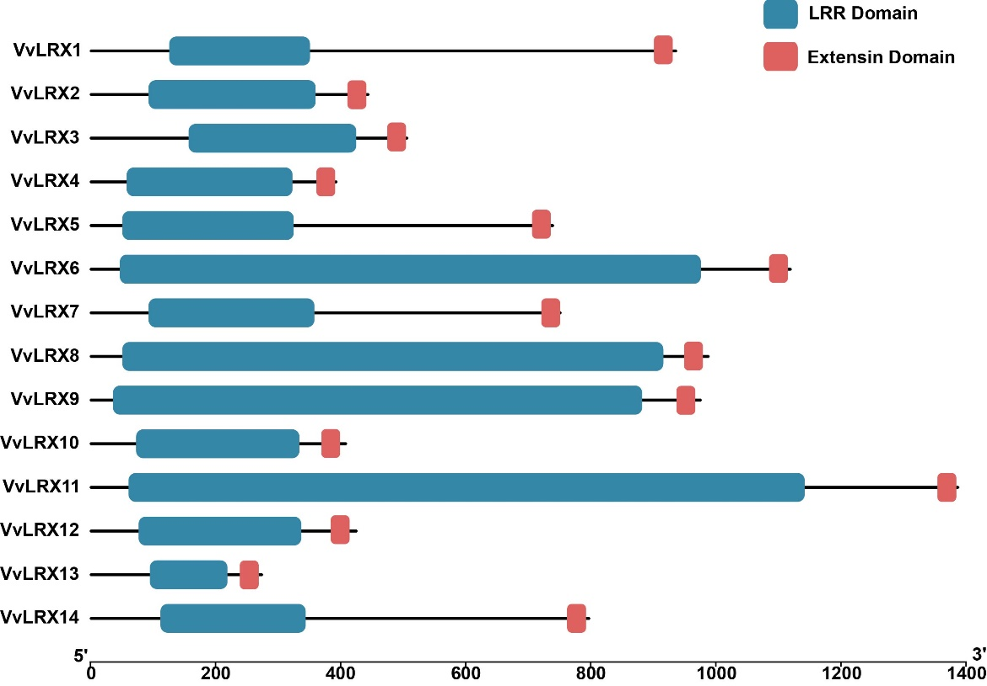
Figure. S1 Conserved domains analysis of VvLRXs.

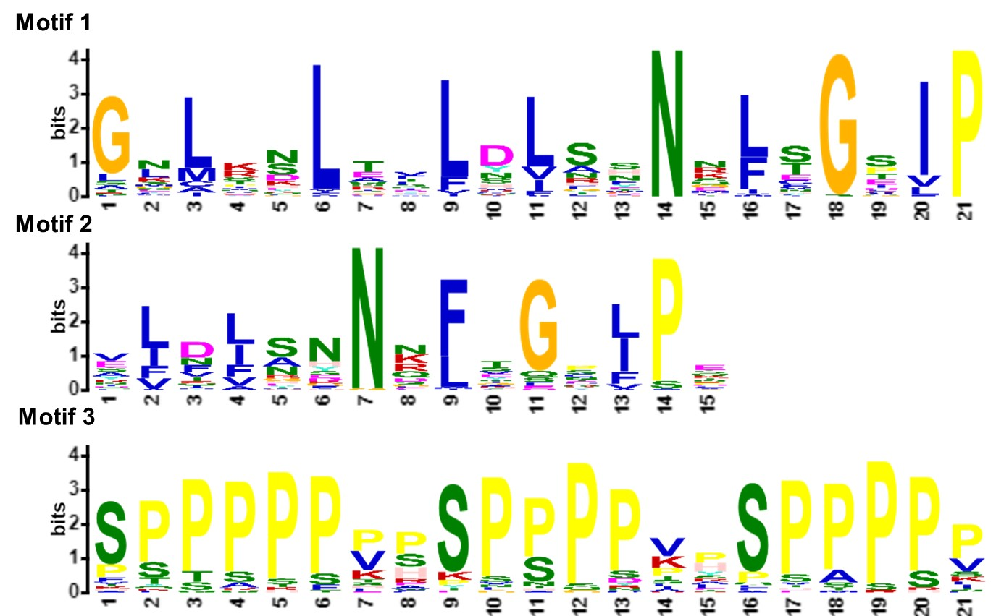
Fig. S2 Sequence logos of 3 conserved motifs detected in the VvLRX proteins. The overall height of each stack represents the degree of conservation at this position, while the height of the individual letters within each stack indicates the relative frequency of the corresponding amino acid.

Table S1 Sequence of primers used for expression analysis, F for the former primer, R for the rear primer.
Experiments | Primers | Sequence(5'→3')
qRT-PCR
VvLRX1 | VvLRX1-qPCR-F | GCTGCGGGTTCTAACTCCTT
VvLRX1 | VvLRX1-qPCR-R | ACTTGCAGATTCCGTCAGGG
VvLRX2 | VvLRX2-qPCR-F | ACTCGTTTTCCGGGTCTGTC
VvLRX2 | VvLRX2-qPCR-R | CCGGAGTGTTTCCGAAGTCA
VvLRX3 | VvLRX3-qPCR-F | GCCCCGTGAACCTTGACTTC
VvLRX3 | VvLRX3-qPCR-R | CCGCAACAAACCCCAATCAA
VvLRX4 | VvLRX4-qPCR-F | CAACGGGCCTTTTCGACTTG
VvLRX4 | VvLRX4-qPCR-R | AACTCGATGGAAGGCAACCA
VvLRX5 | VvLRX5-qPCR-F | CCGCCATTGGCAAGATGAAG
VvLRX5 | VvLRX5-qPCR-R | AGCACAAACAGGAGCCTCTC
VvLRX6 | VvLRX6-qPCR-F | TGGAACGCCTCTCATTCCAC
VvLRX6 | VvLRX6-qPCR-R | TGGCCGGATATTCCCAAACC
VvLRX7 | VvLRX7-qPCR-F | TTCTGCTGCTGCTGGTTTGT
VvLRX7 | VvLRX7-qPCR-R | ACGCAGCGAAATTAAGACACA
VvLRX8 | VvLRX8-qPCR-F | GCTAAACTCCTCAACCATTCTTCC
VvLRX8 | VvLRX8-qPCR-R | GCTAAACTCCTCAACCATTCTTCC
VvLRX9 | VvLRX9-qPCR-F | CCCATTCTTCCAATTCTATGGTCA
VvLRX9 | VvLRX9-qPCR-R | TCTCCTCCAACCAAAGGGGA
VvLRX10 | VvLRX10-qPCR-F | GAGCTCGGCTTCTGTAGTGG
VvLRX10 | VvLRX10-qPCR-R | ACAACCTGACAAGCTGGTGT
VvLRX11 | VvLRX11-qPCR-F | AATGCCGATGGCTGTGTCT
VvLRX11 | VvLRX11-qPCR-R | ACAGTTCCCGATGAAGATCCG
VvLRX12 | VvLRX12-qPCR-F | GCCAAGGACAAAAATATCCAACAC
VvLRX12 | VvLRX12-qPCR-R | TGGTTGACGTGGGAGAAGTG
VvLRX13 | VvLRX13-qPCR-F | TGGCTGCTTAGCCTTGTCATT
VvLRX13 | VvLRX13-qPCR-R | TGTAGCGGGGGTACTCAAAT
VvLRX14 | VvLRX14-qPCR-F | TCCTATAAGCAGCTCTGGGC
VvLRX14 | VvLRX14-qPCR-R | GGAATGGCTAAGAGTTGGCG
VvUBI | VvUBI-qPCR-F | GTGGTATTATTGAGCCATCCTT
VvUBI | VvUBI-qPCR-R | AACCTCCAATCCAGTTATCTAC
Expression vector
VvLRX7-PCambia1300 | VvLRX7-SalI-PCambia1300-F | CGGGGATCCTCTAGAGTCGACGTCGACATGAAGAAGAAGACCCATCTCCTC
VvLRX7-PCambia1300 | VvLRX7-SalI-PCambia1300-R | GAACGAAAGCTCTGCAGGTCGACTCAATAGAAGGGTGGTGGCG

Table S2 The numbers and genome size of LRX homologous genes found in indicated species
Specie | Number of HD-ZIP | Genome Size (Mb)
Arabidopsis thaliana | 11 | 125
Oryza sativa | 8 | 430
Zea mays | 2 | 2300
Lycopersicon esculentum | 5 | 799
Vitis vinifera | 14 | 495

Table S3 The duplication pairs of VvLRX genes in grapevine
Segmental duplication pairs
VvLRX1 | VvLRX14
VvLRX2 | VvLRX12
VvLRX9 | VvLRX11

Tandem duplication pairs
VvLRX2 | VvLRX3
VvLRX8 | VvLRX9
VvLRX12 | VvLRX13

