Supplementary
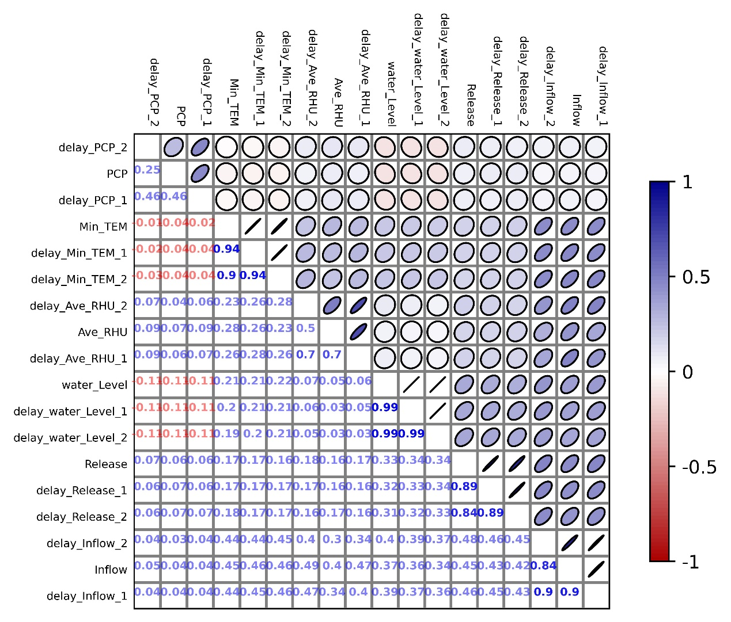
Fig. S1. Correlation coefficient diagram of FSB Reservoir.
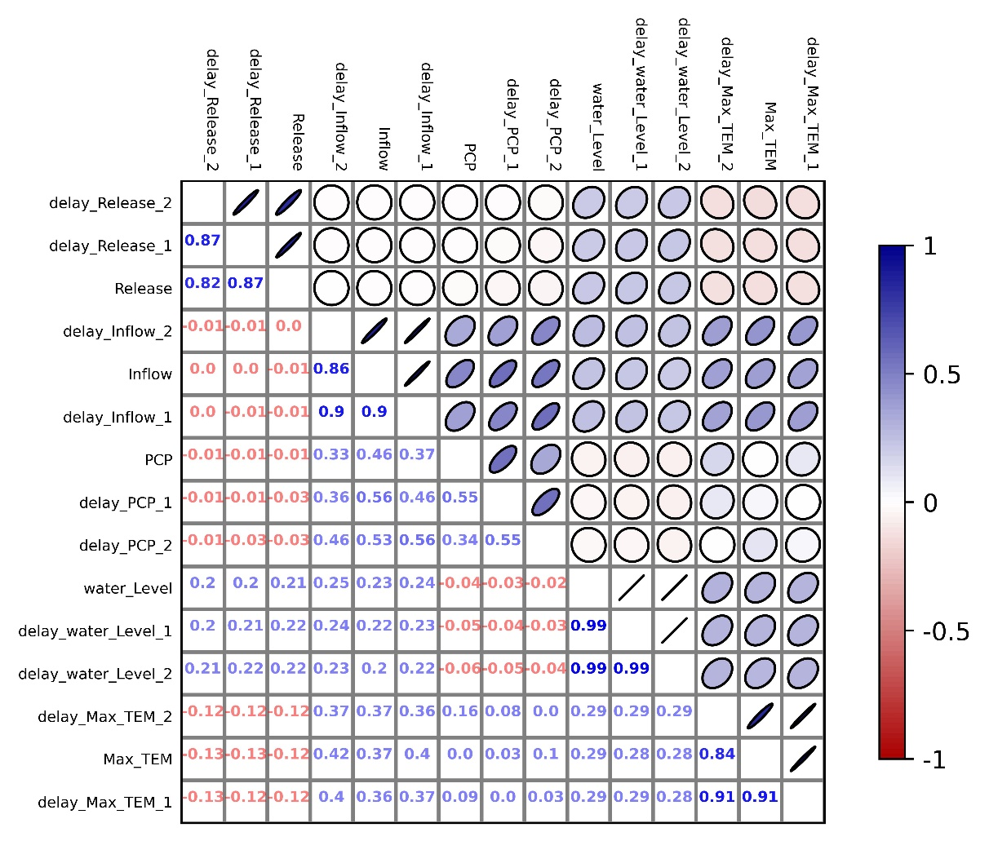
Fig. S2. Correlation coefficient diagram of XFJ Reservoir.
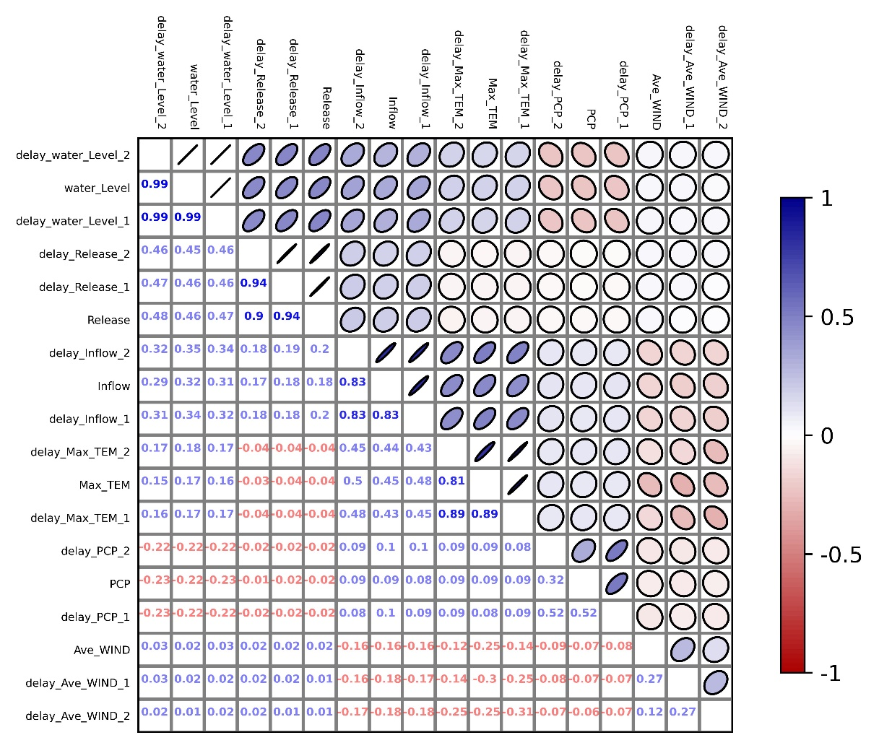
Fig. S3. Correlation coefficient diagram of BPZ Reservoir.
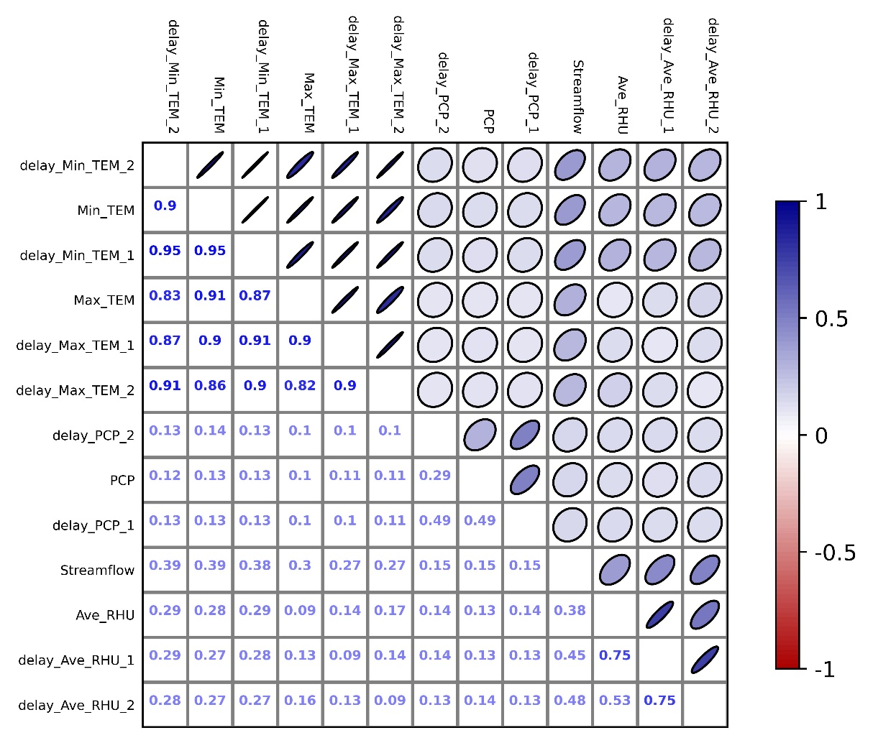
Fig. S4. Correlation coefficient diagram of Boluo station.
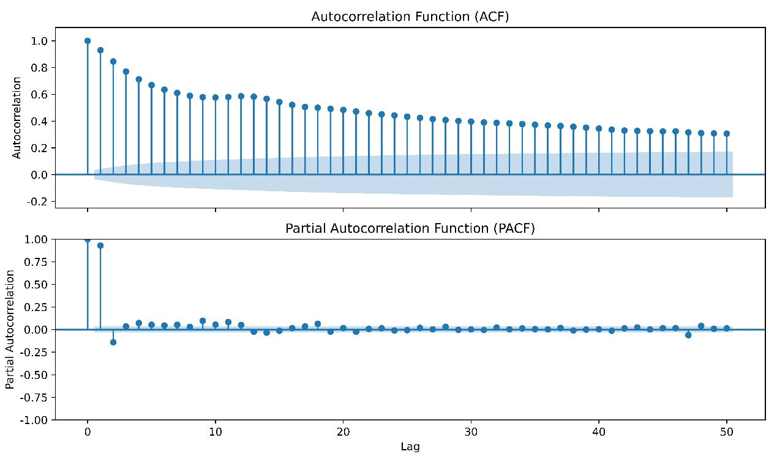
Fig. S5. Autocorrelation and partial autocorrelation diagram of FSB Reservoir.
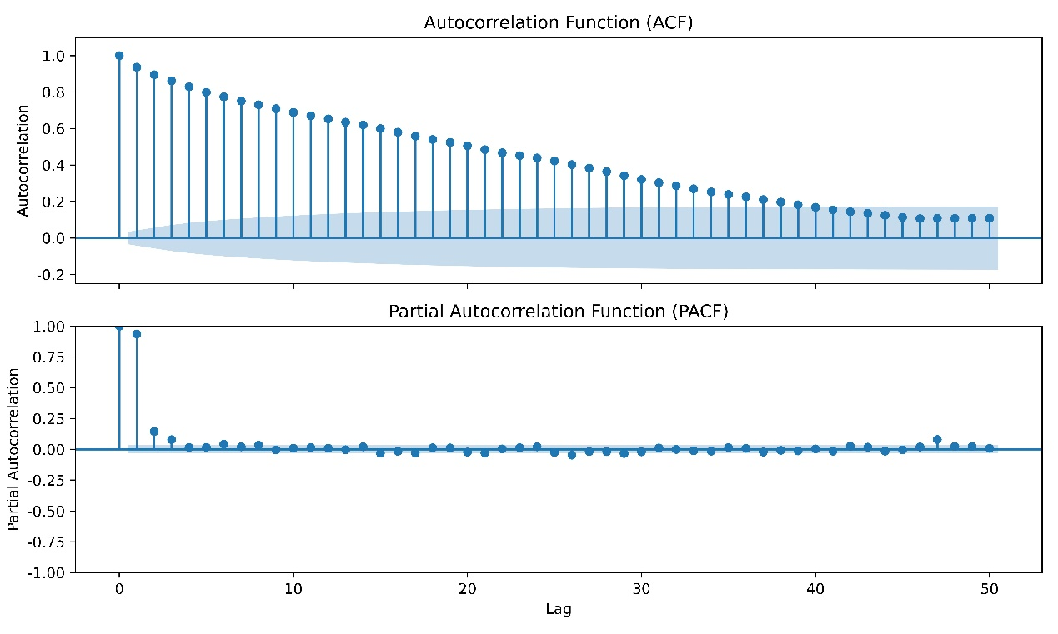
Fig. S6. Autocorrelation and partial autocorrelation diagram of XFJ Reservoir.
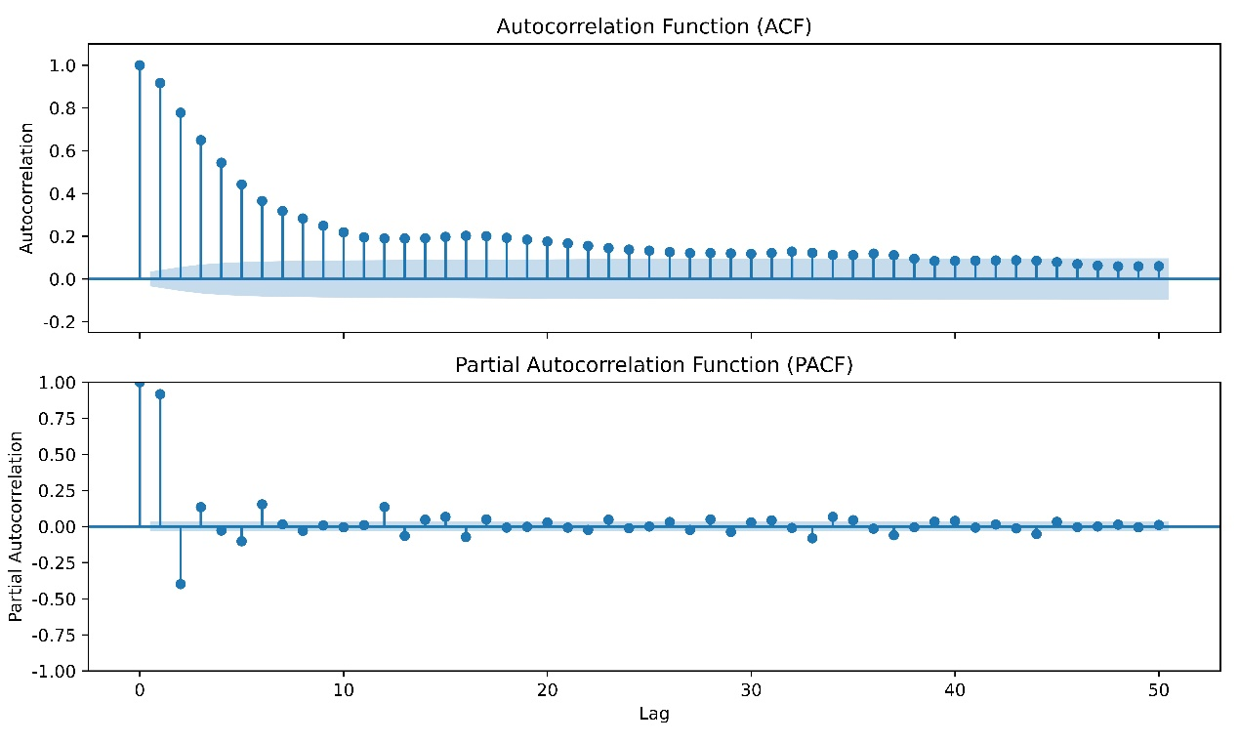
Fig. S7. Autocorrelation and partial autocorrelation diagram of BPZ Reservoir.

Table S1. Hyperparameter optimization results of different models.
Model | Station | Number of hidden layers | Number of hidden Size | Batch Size | Epochs | Learning rate | Dropout rate
Daily-release | FSB | 2 | 196 | 100 | 56 | 0.015 | 0.001
Daily-release | XFJ | 2 | 40 | 111 | 88 | 0.003 | 0.04
Daily-release | BPZ | 2 | 127 | 125 | 100 | 0.00036 | 0.056
MDF | FSB | 2 | 77 | 128 | 64 | 0.0015 | 0.001
MDF | XFJ | 2 | 33 | 49 | 95 | 0.0048 | 0.027
MDF | BPZ | 2 | 31 | 46 | 95 | 0.0009 | 0.0086
WDF | FSB | 2 | 40 | 91 | 36 | 0.0022 | 0.0155
WDF | XFJ | 2 | 125 | 98 | 39 | 0.00137 | 0
WDF | BPZ | 2 | 154 | 57 | 180 | 0.0002 | 0.02
Streamflow prediction | Boluo | 2 | 229 | 125 | 78 | 0.001 | 0.001

