Supplementary materials

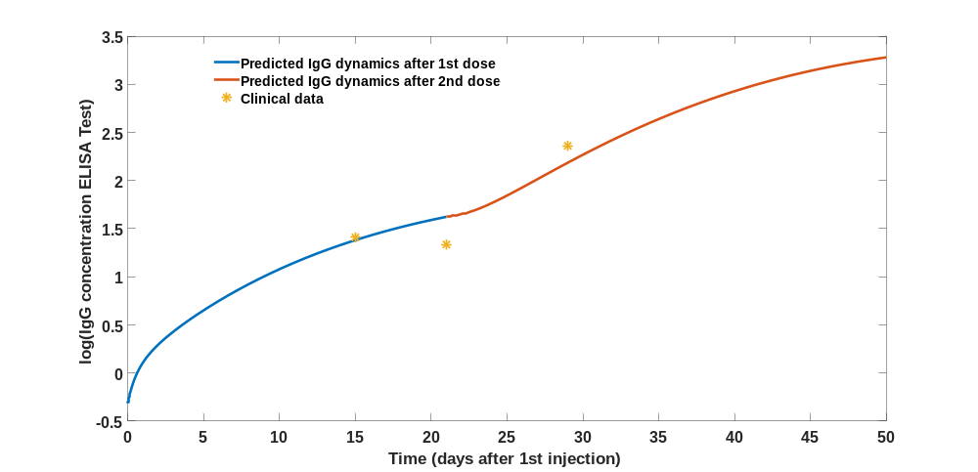
Figure S1: Fitted IgG dynamics of No1 patient (individual without pre-infection)
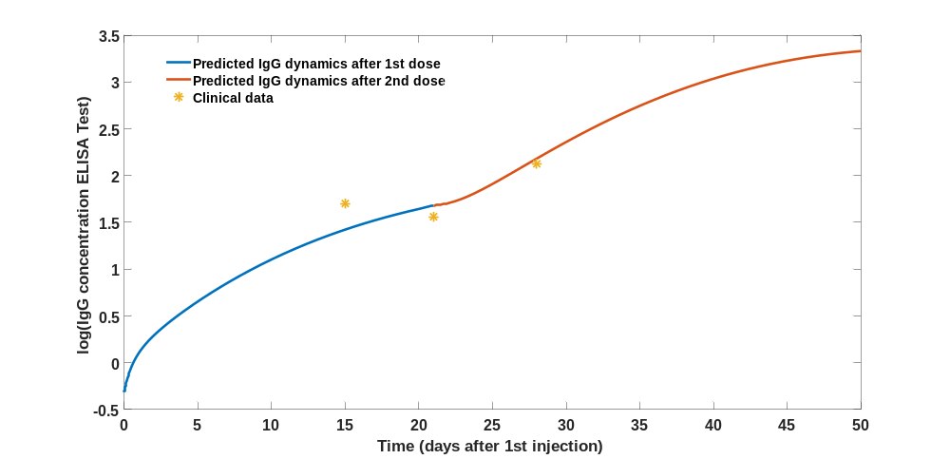
Figure S2: Fitted IgG dynamics of No3 patient (individual without pre-infection)
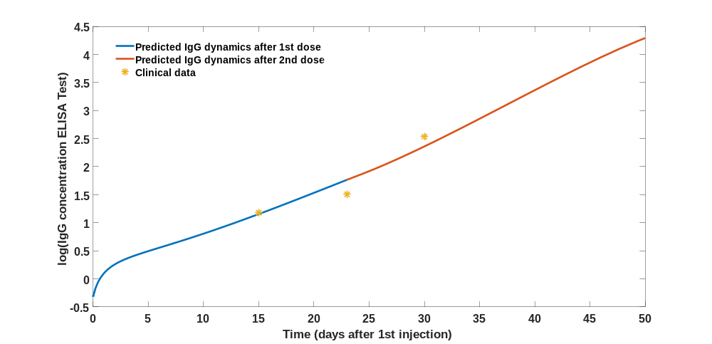
Figure S3: Fitted IgG dynamics of No4 patient (individual without pre-infection)
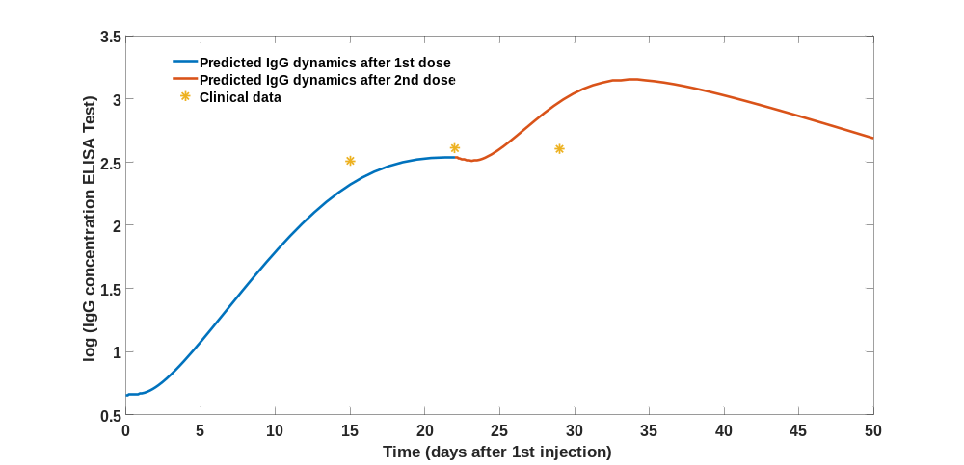
Figure S4: Fitted IgG dynamics of No5 patient (individual with pre-infection)
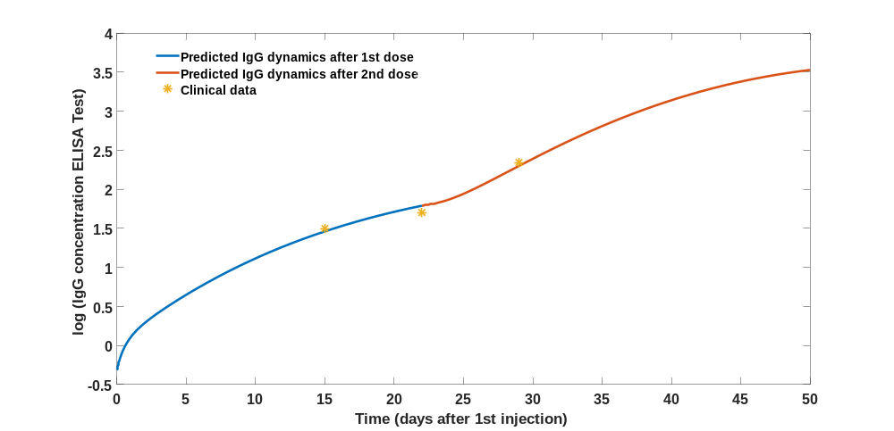
Figure S5: Fitted IgG dynamics of No6 patient (individual without pre-infection)
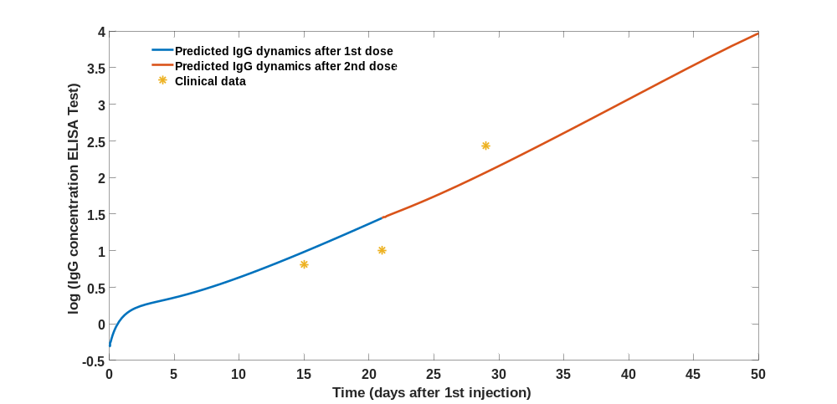
Figure S6: Fitted IgG dynamics of No7 patient (individual without pre-infection)
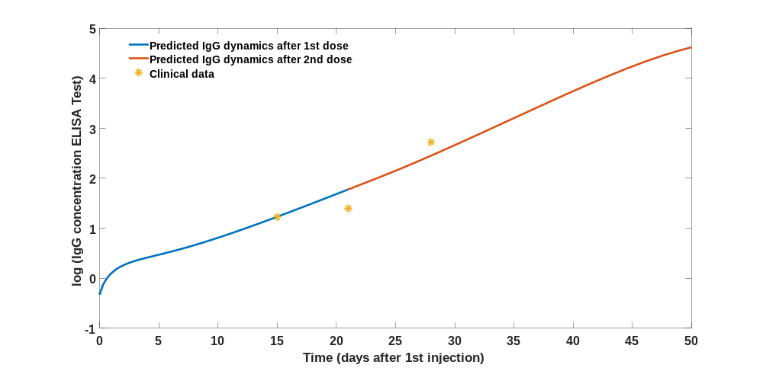
Figure S7: Fitted IgG dynamics of No9 patient (individual without pre-infection)
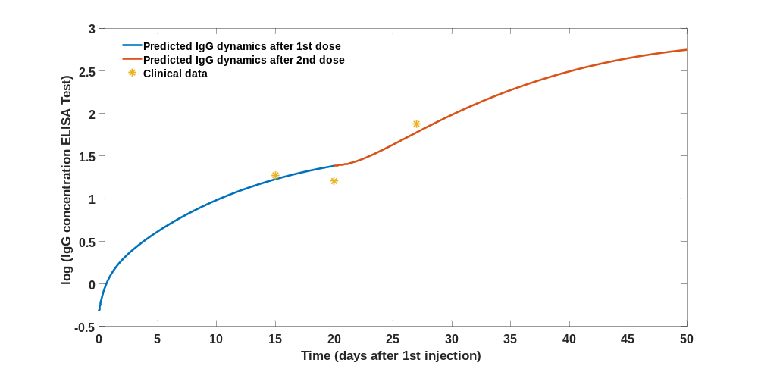
Figure S8: Fitted IgG dynamics of No12 patient (individual without pre-infection)
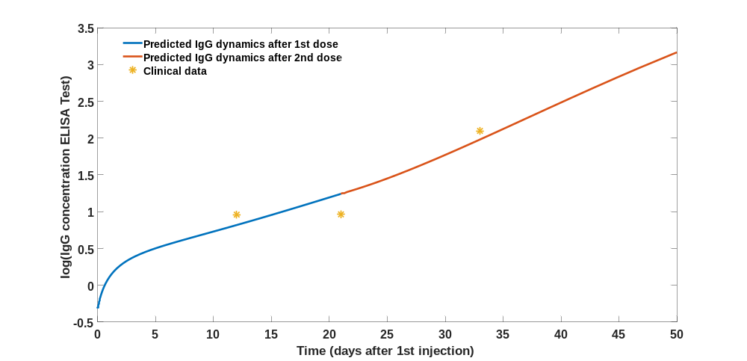
Figure S9: Fitted IgG dynamics of No13 patient (individual without pre-infection)
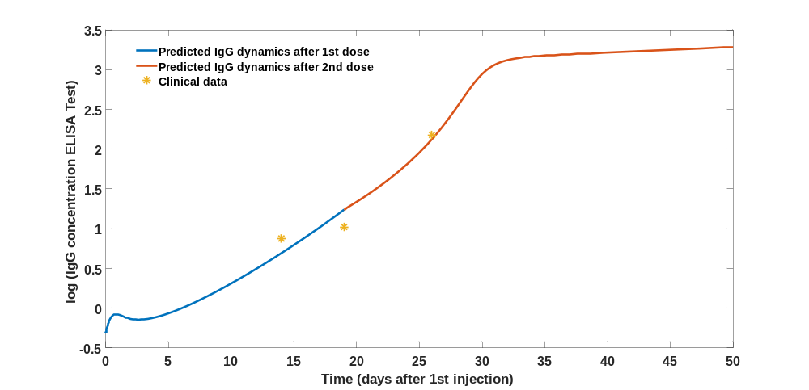
Figure S10: Fitted IgG dynamics of No14 patient (individual without pre-infection)
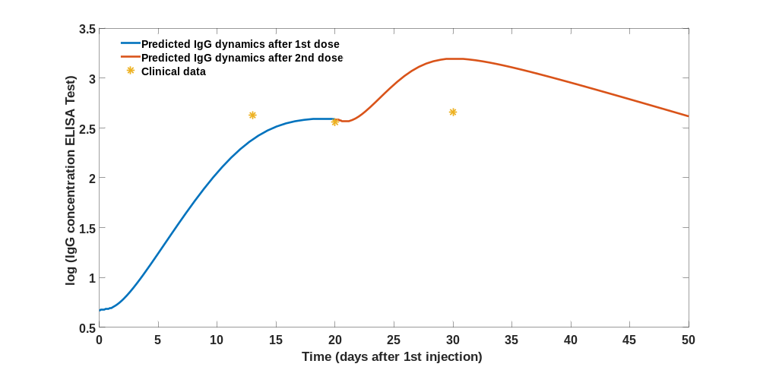
Figure S11: Fitted IgG dynamics of No15 patient (individual with pre-infection)
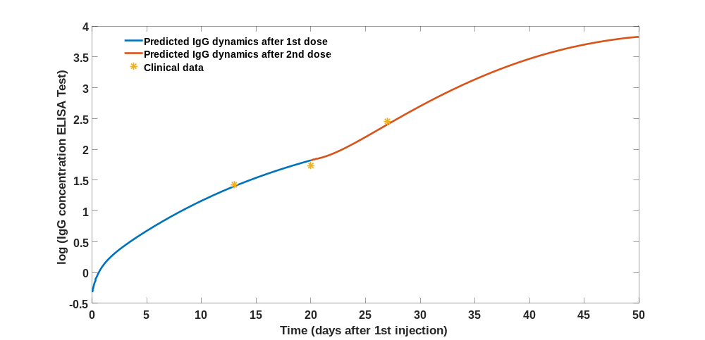
Figure S12: Fitted IgG dynamics of No16 patient (individual without pre-infection)
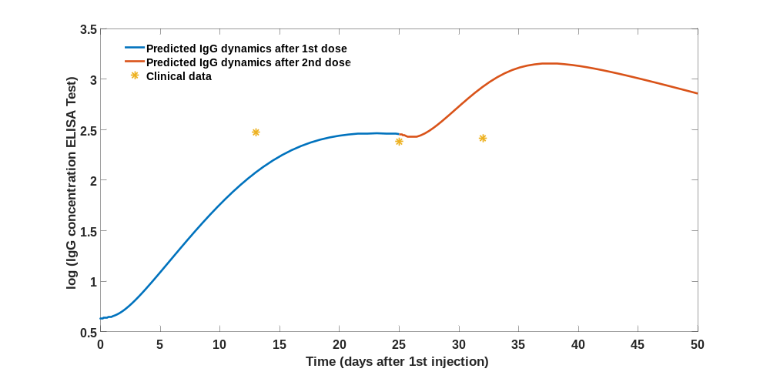
Figure S13: Fitted IgG dynamics of No17 patient (individual with pre-infection)
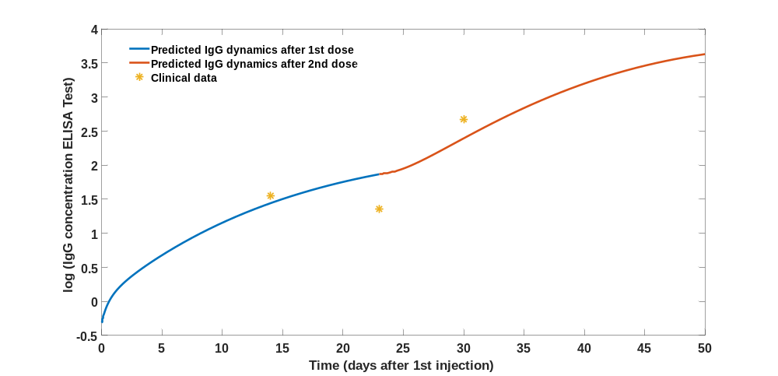
Figure S14: Fitted IgG dynamics of No18 patient (individual without pre-infection)

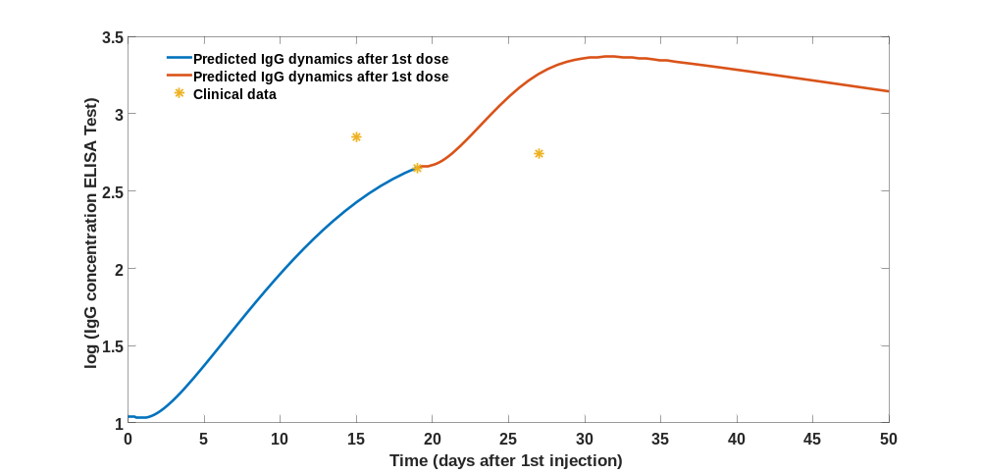
Figure S15: Fitted IgG dynamics of No19 patient (individual with pre-infection)
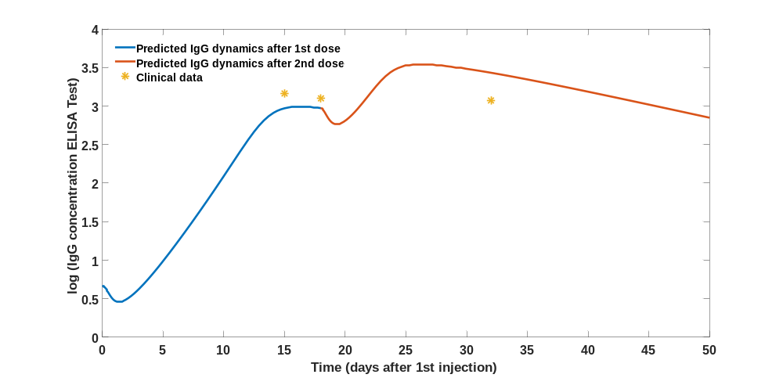
Figure S16: Fitted IgG dynamics of No20 patient (individual with pre-infection)
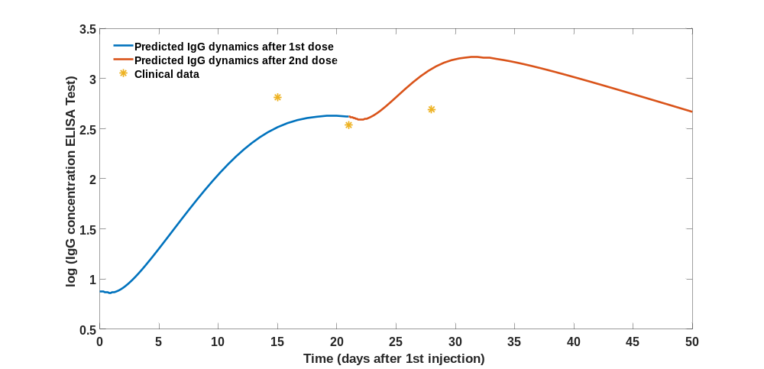
Figure S17: Fitted IgG dynamics of No22 patient (individual with pre-infection)
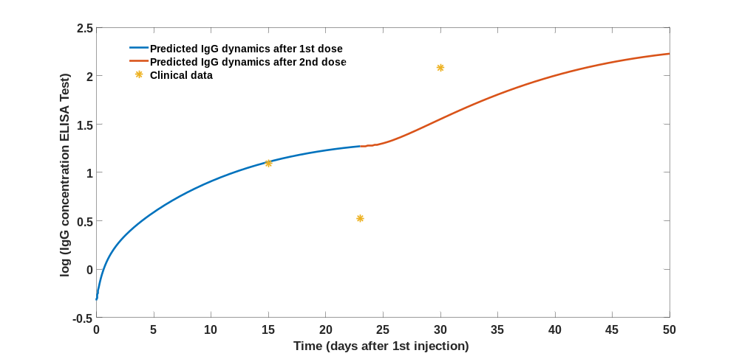
Figure S18: Fitted IgG dynamics of No23 patient (individual without pre-infection)
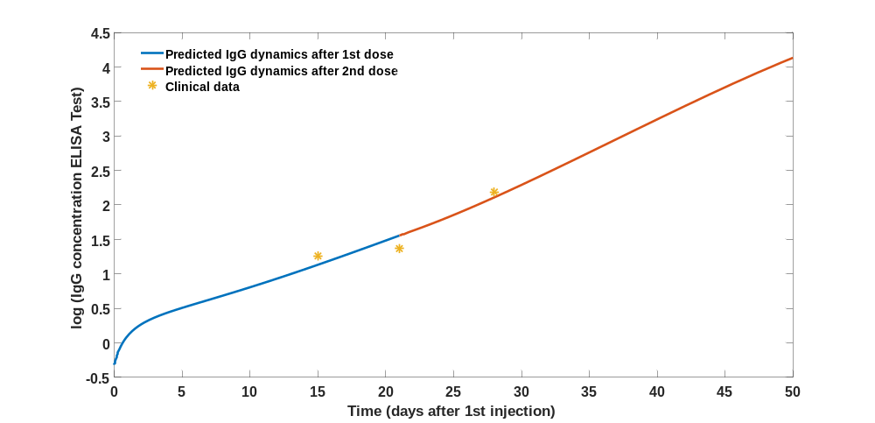
Figure S19: Fitted IgG dynamics of No24 patient (individual without pre-infection)
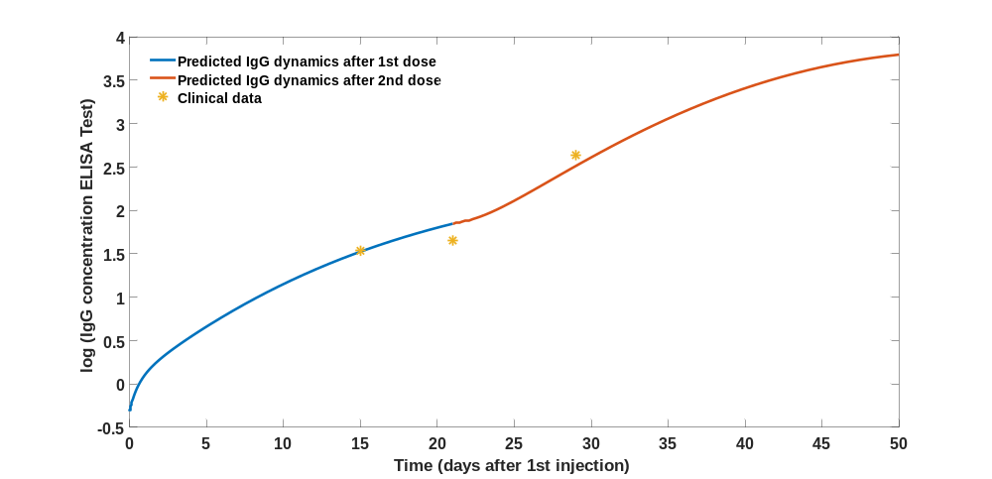
Figure S20: Fitted IgG dynamics of No25 patient (individual without pre-infection)
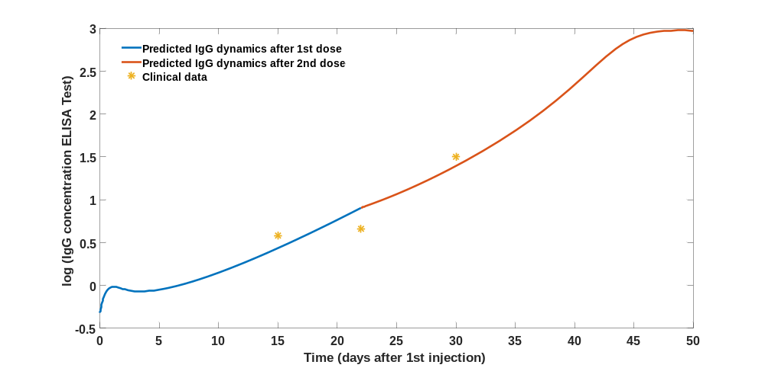
Figure S21: Fitted IgG dynamics of No26 patient (individual without pre-infection)
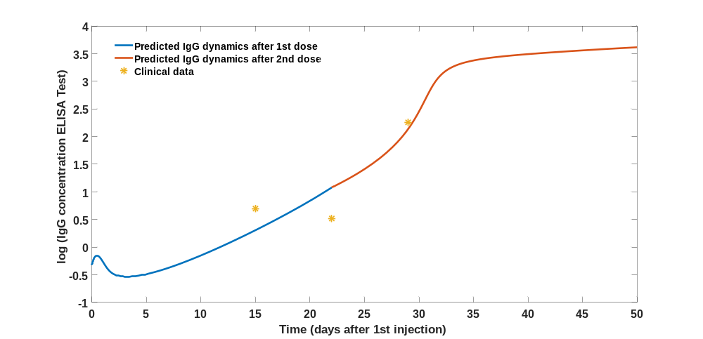
Figure S22: Fitted IgG dynamics of No27 patient (individual without pre-infection)
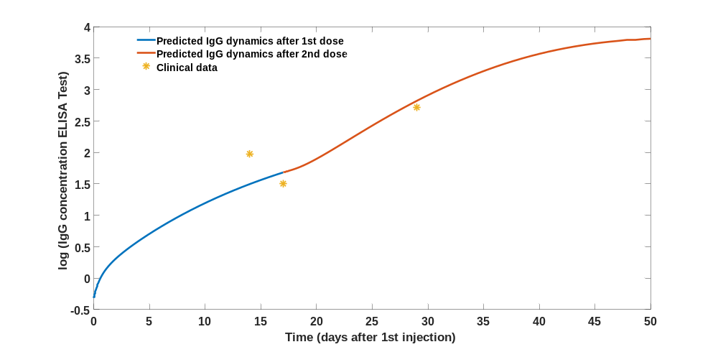
Figure S23: Fitted IgG dynamics of No28 patient (individual without pre-infection)
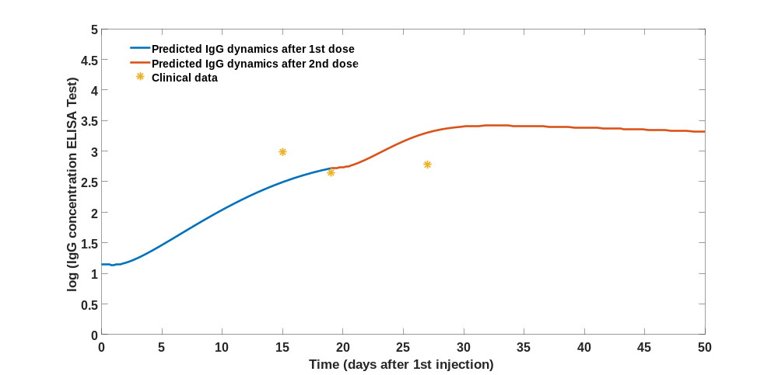
Figure S24: Fitted IgG dynamics of No29 patient (individual with pre-infection)
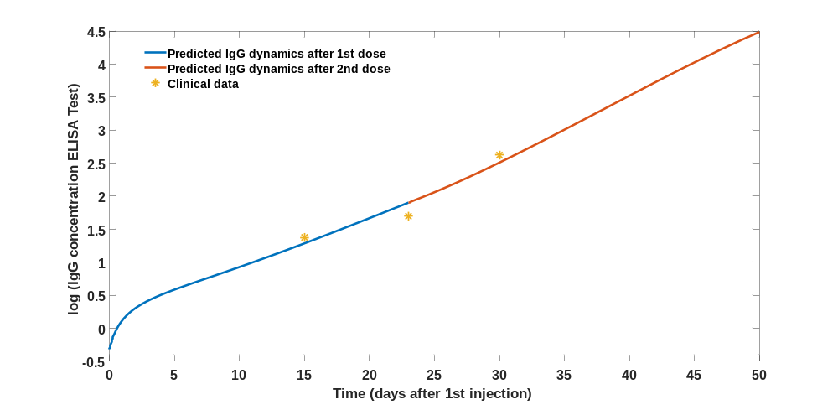
Figure S25: Fitted IgG dynamics of No31 patient (individual without pre-infection)
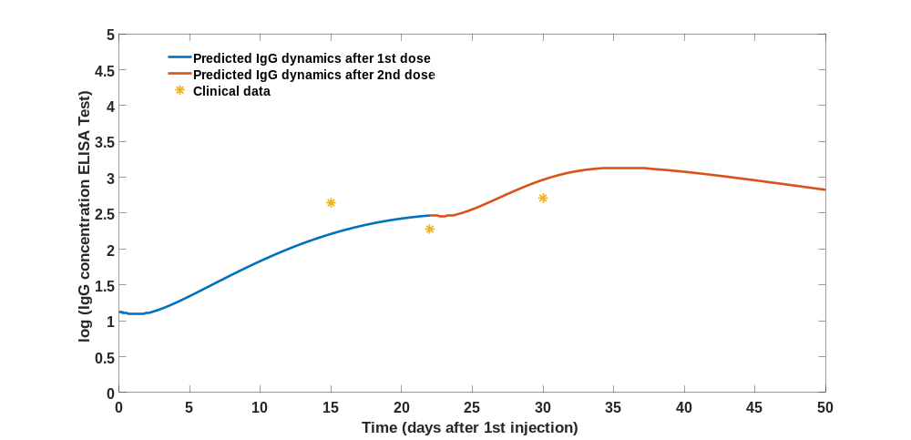
Figure S26: Fitted IgG dynamics of No32 patient (individual with pre-infection)
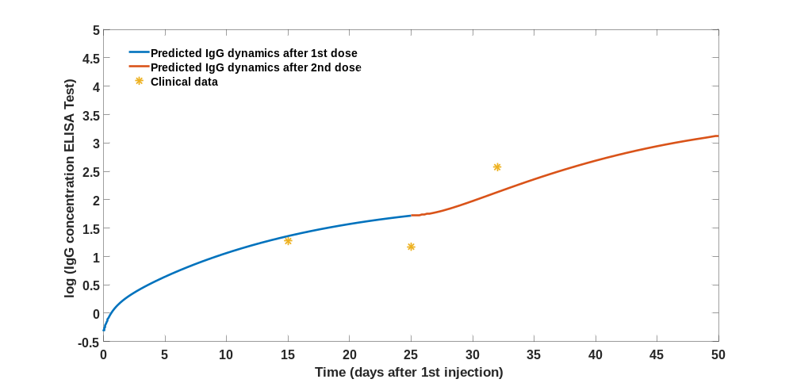
Figure S27: Fitted IgG dynamics of No33 patient (individual without pre-infection)
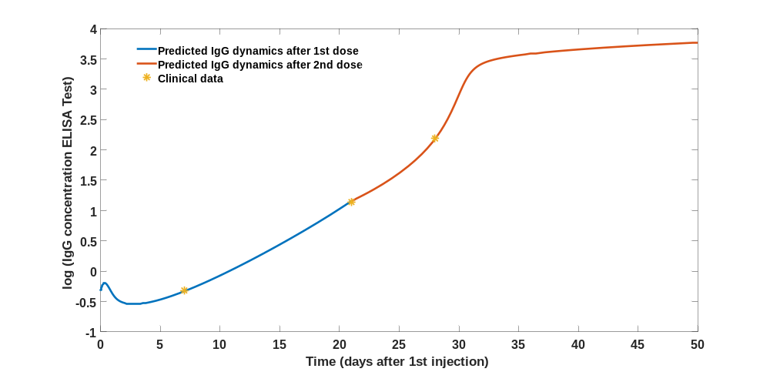
Figure S28: Fitted IgG dynamics of No34 patient (individual without pre-infection)
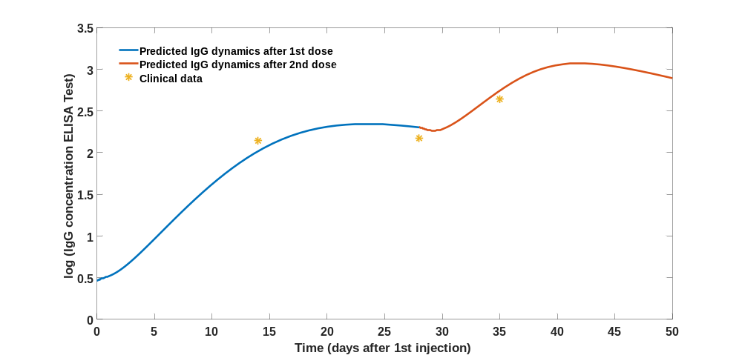
Figure S29: Fitted IgG dynamics of No35 patient (individual with pre-infection)
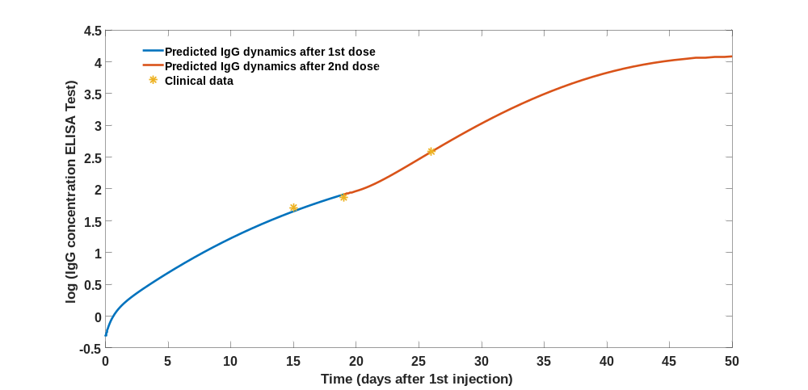
Figure S30: Fitted IgG dynamics of No37 patient (individual without pre-infection)
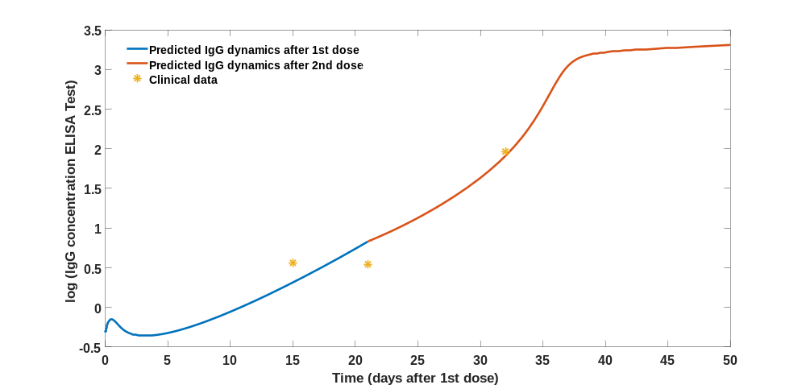
Figure S31: Fitted IgG dynamics of No38 patient (individual without pre-infection)
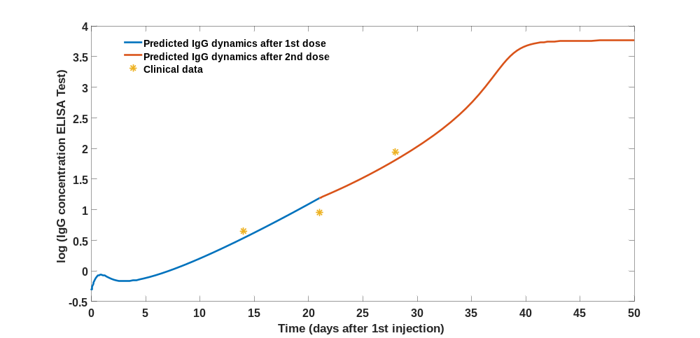
Figure S32: Fitted IgG dynamics of No39 patient (individual without pre-infection)
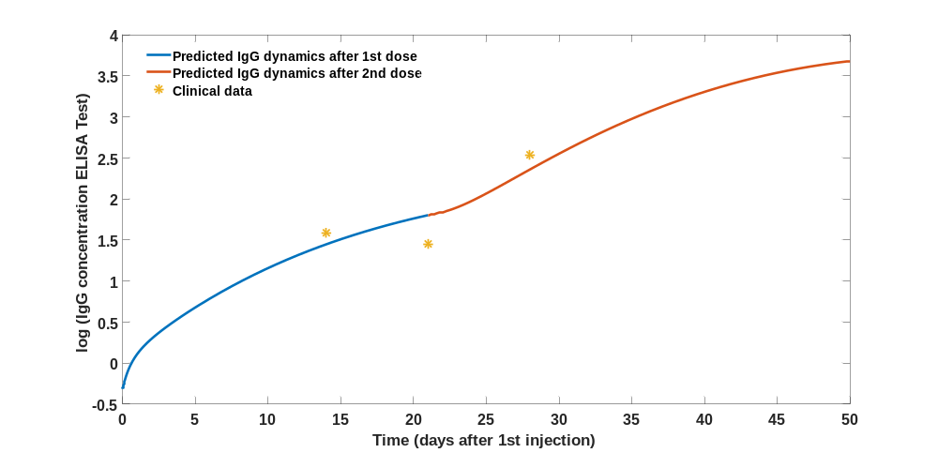
Figure S33: Fitted IgG dynamics of No40 patient (individual without pre-infection)
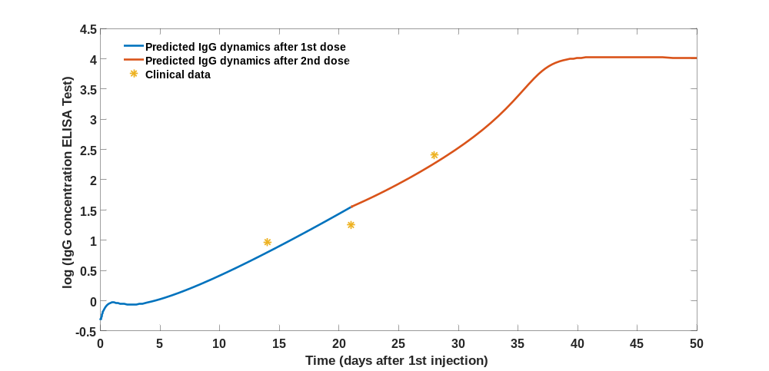
Figure S34: Fitted IgG dynamics of No41 patient (individual without pre-infection)
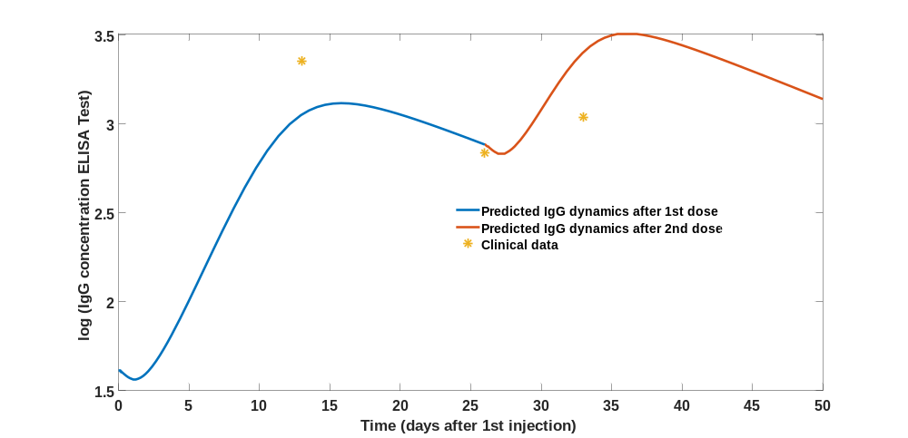
Figure S35: Fitted IgG dynamics of No42 patient (individual with pre-infection)
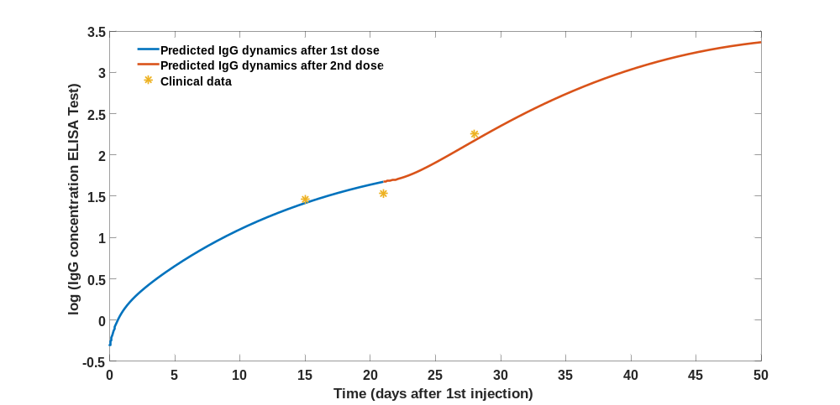
Figure S36: Fitted IgG dynamics of No43 patient (individual without pre-infection)
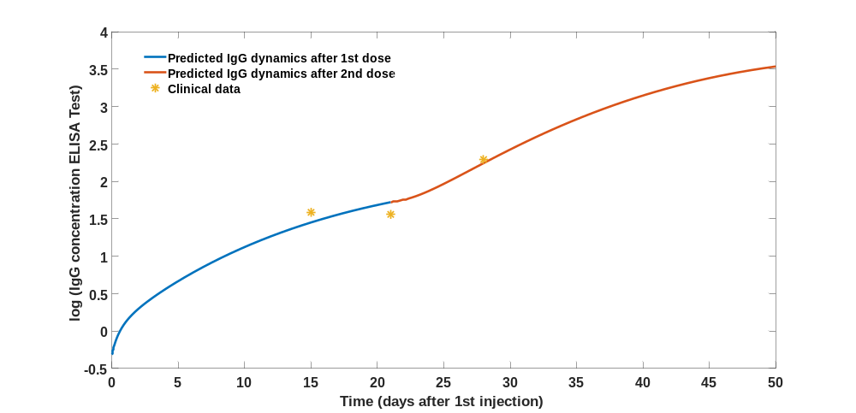
Figure S37: Fitted IgG dynamics of No44 patient (individual without pre-infection)
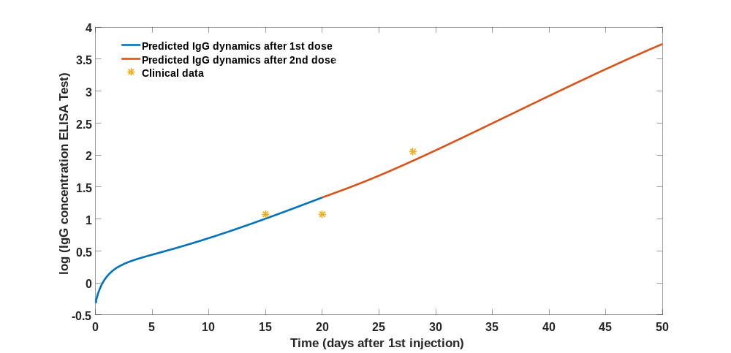
Figure S38: Fitted IgG dynamics of No45 patient (individual without pre-infection)
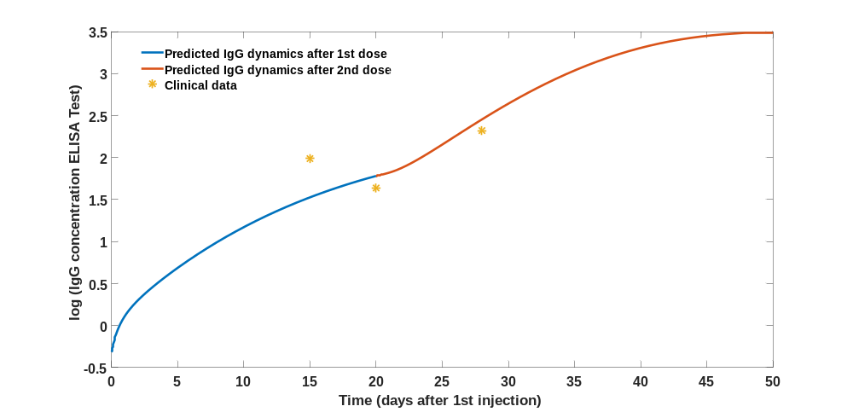
Figure S39: Fitted IgG dynamics of No46 patient (individual without pre-infection)

Patient No. | k₁ | k₂ | k₃ | k₁₆ | k₁₈ | k₁₉
1 | 3.38E-06 | 0.998962 | 1.989464 | 0.045184 | 0.084393 | 0.199967
3 | 6.46E-06 | 0.998209 | 1.960497 | 0.049946 | 0.050036 | 0.199987
4 | 1.68E-06 | 0.679798 | 1.158593 | 0.049998 | 0.081105 | 0.020001
5 | 9.99E-05 | 0.988275 | 1.597594 | 0.049958 | 0.010822 | 0.156146
6 | 4.23E-06 | 0.64395 | 1.593486 | 0.05 | 0.052805 | 0.199974
7 | 4.19E-06 | 0.313487 | 0.50124 | 0.048869 | 0.066964 | 0.020051
9 | 2.30E-06 | 0.125422 | 0.500043 | 0.045142 | 0.026684 | 0.020001
12 | 2.58E-06 | 0.949041 | 1.953299 | 0.049995 | 0.088575 | 0.199861
13 | 1.06E-06 | 0.975323 | 1.735519 | 0.049063 | 0.069608 | 0.020005
14 | 9.99E-05 | 0.635428 | 0.769703 | 0.048291 | 0.035913 | 0.020012
15 | 9.99E-05 | 0.997636 | 1.88668 | 0.049978 | 0.010075 | 0.199643
16 | 4.44E-06 | 0.729288 | 1.738637 | 0.037131 | 0.047872 | 0.181342
17 | 9.98E-05 | 0.989949 | 1.651725 | 0.044653 | 0.01053 | 0.198458
18 | 3.37E-06 | 0.967774 | 1.994715 | 0.04467 | 0.089661 | 0.199322
19 | 9.17E-05 | 0.993624 | 1.563809 | 0.022361 | 0.0113 | 0.198842
20 | 1.00E-04 | 0.999895 | 1.320509 | 0.043652 | 0.087671 | 0.199988
22 | 9.97E-05 | 0.977231 | 1.701234 | 0.049849 | 0.011111 | 0.189407
23 | 3.74E-06 | 0.998104 | 1.886078 | 0.047536 | 0.061619 | 0.19999
24 | 1.22E-06 | 0.562462 | 1.09959 | 0.044675 | 0.072546 | 0.020037
25 | 3.54E-06 | 0.769025 | 1.634431 | 0.044508 | 0.08218 | 0.186977
26 | 9.99E-05 | 0.592337 | 0.683015 | 0.048709 | 0.022468 | 0.020003
27 | 1.00E-04 | 0.379566 | 0.500003 | 0.044533 | 0.063848 | 0.02
28 | 6.17E-06 | 0.97988 | 1.999645 | 0.027391 | 0.046404 | 0.199997
29 | 9.96E-05 | 0.98815 | 1.529453 | 0.013039 | 0.010186 | 0.197885
31 | 1.00E-06 | 0.677746 | 1.429464 | 0.019989 | 0.062796 | 0.020005
32 | 9.94E-05 | 0.987273 | 1.502806 | 0.037845 | 0.010222 | 0.19842
33 | 5.63E-06 | 0.953759 | 1.823471 | 0.037399 | 0.050251 | 0.193543
34 | 6.89E-05 | 0.709298 | 0.838403 | 0.038666 | 0.161459 | 0.027155
35 | 9.94E-05 | 0.979938 | 1.596854 | 0.049751 | 0.010815 | 0.197544
37 | 3.32E-06 | 0.633915 | 1.508057 | 0.044394 | 0.085847 | 0.195704
38 | 9.57E-05 | 0.855291 | 0.956232 | 0.035735 | 0.076737 | 0.020768
39 | 2.87E-05 | 0.498648 | 0.618743 | 0.044177 | 0.106487 | 0.020985
40 | 2.97E-06 | 0.797665 | 1.999728 | 0.049989 | 0.072518 | 0.199993
41 | 1.51E-05 | 0.538553 | 0.681836 | 0.04868 | 0.164539 | 0.021948
42 | 9.99E-05 | 0.996219 | 1.720955 | 0.044916 | 0.013551 | 0.183651
43 | 4.91E-06 | 0.921968 | 1.953727 | 0.048617 | 0.053939 | 0.195693
44 | 2.50E-06 | 0.925598 | 1.999987 | 0.045936 | 0.1038 | 0.198564
45 | 2.15E-06 | 0.336204 | 0.630704 | 0.048058 | 0.05423 | 0.020002
46 | 1.04E-05 | 0.897406 | 1.999869 | 0.043775 | 0.025452 | 0.199993

Table S1: Fitted parameter for each individual receiving mRNA vaccine.

