Supplementary Figure

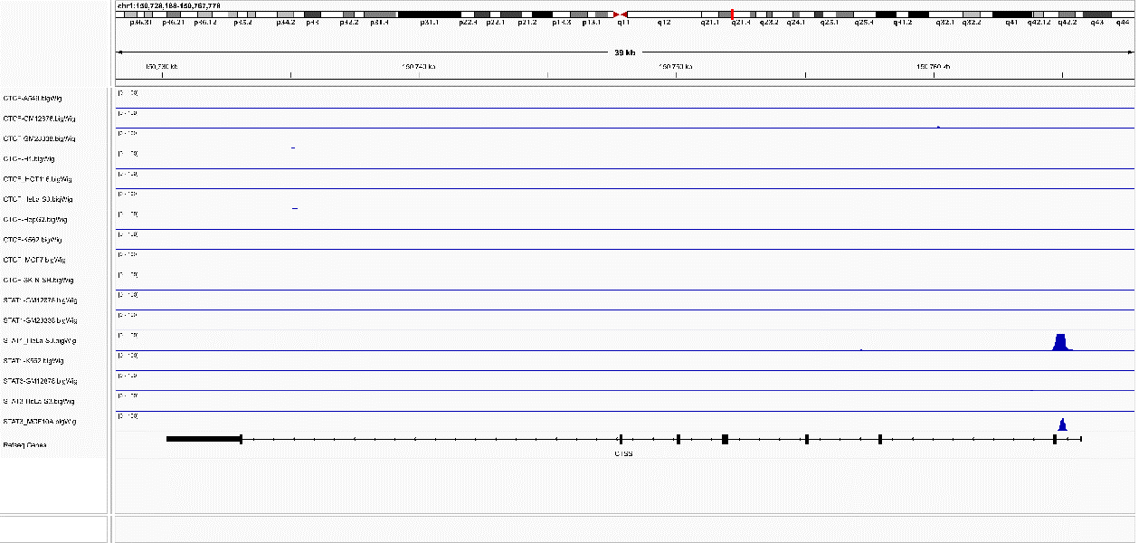
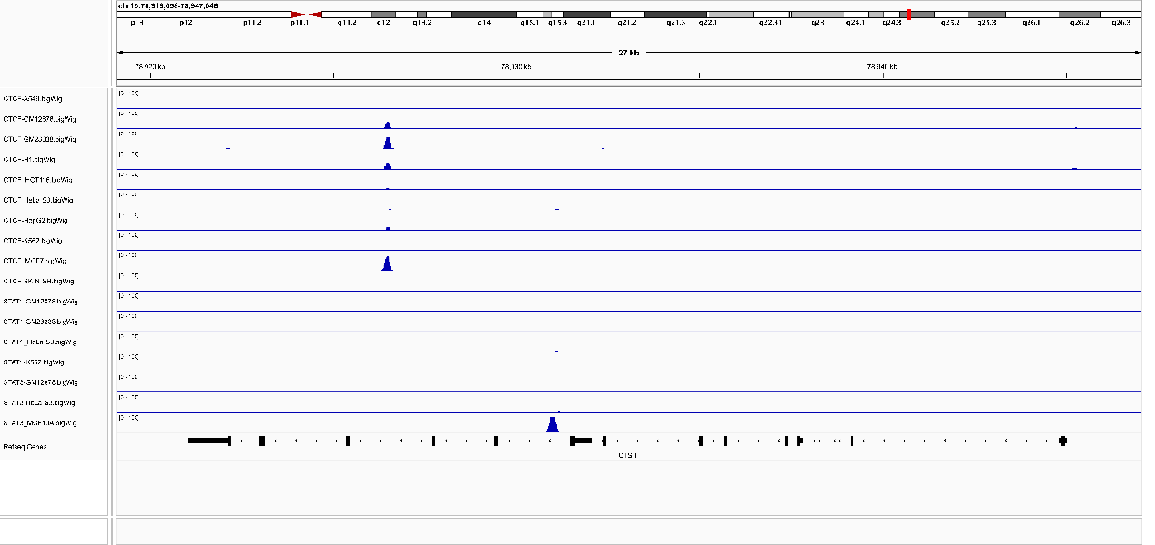
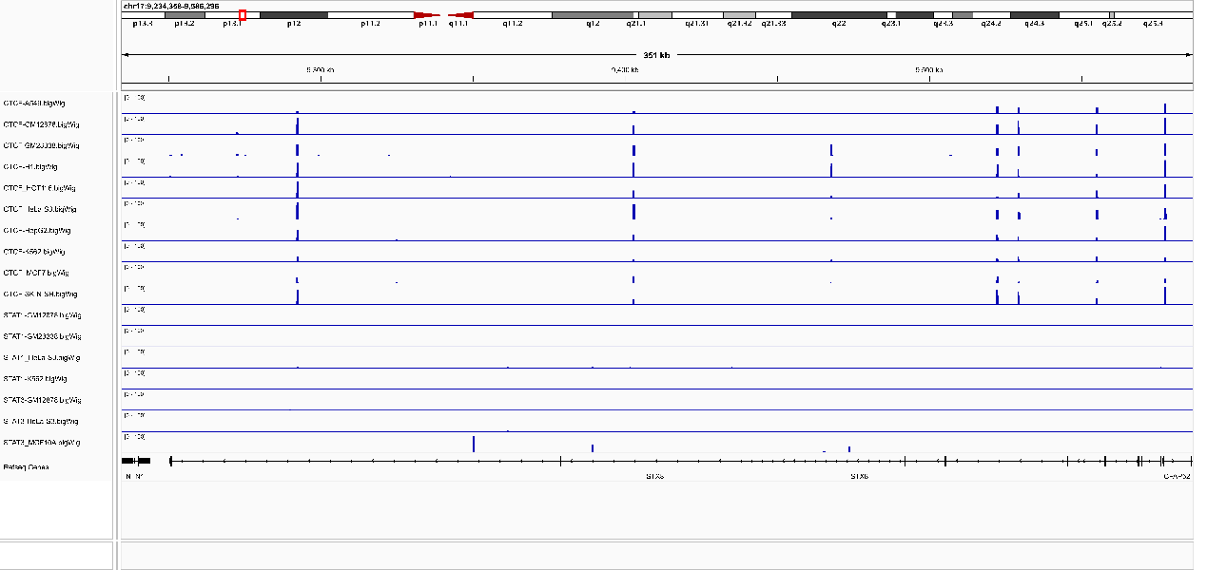
Supplementary Figure 1. The global view of CTSS, CTSH, and STX8 in the IGV software.

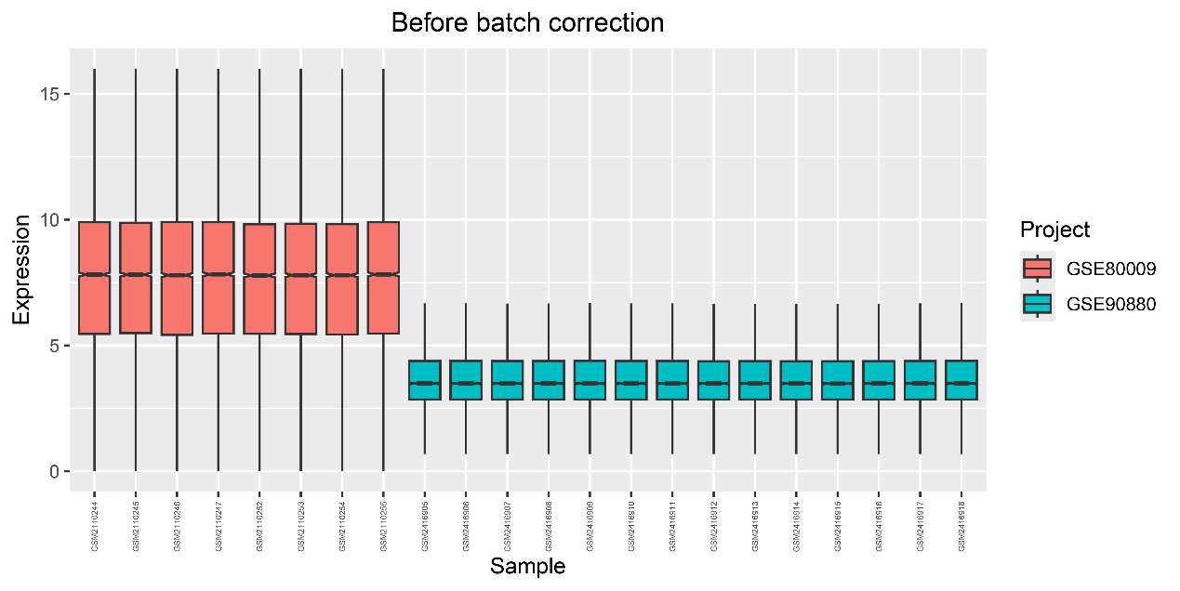
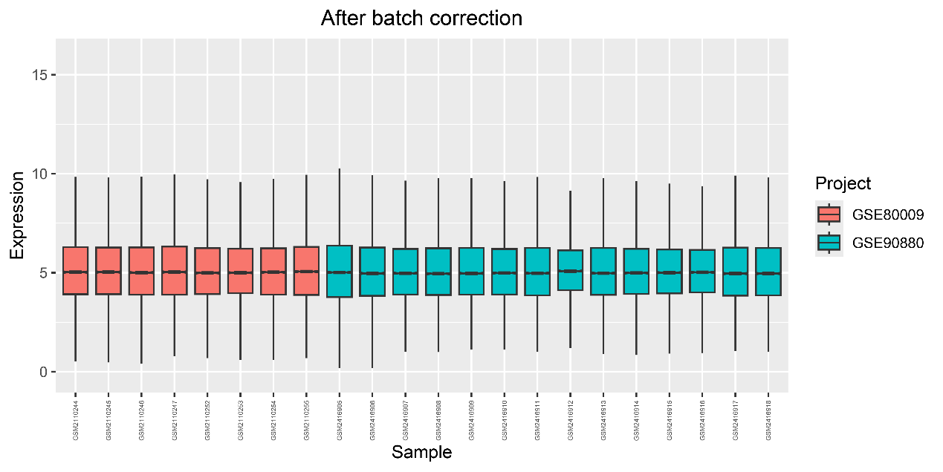
Supplementary Figure 2. Box plots before and after batch effect correction.

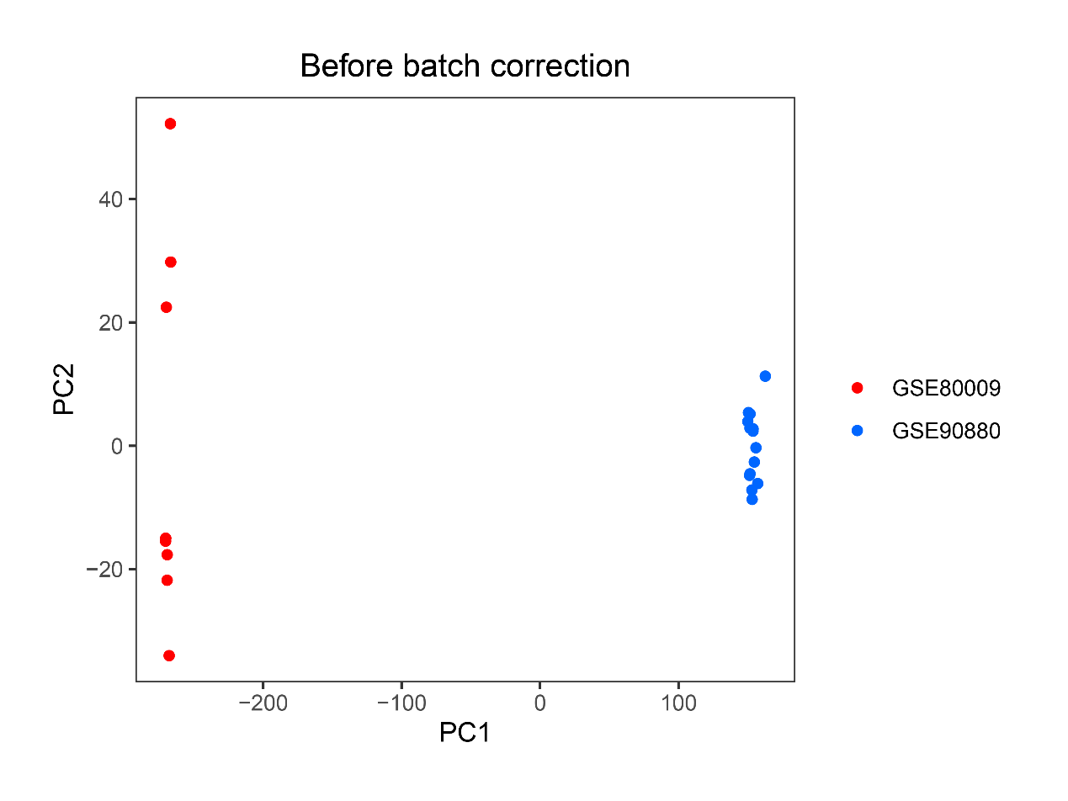
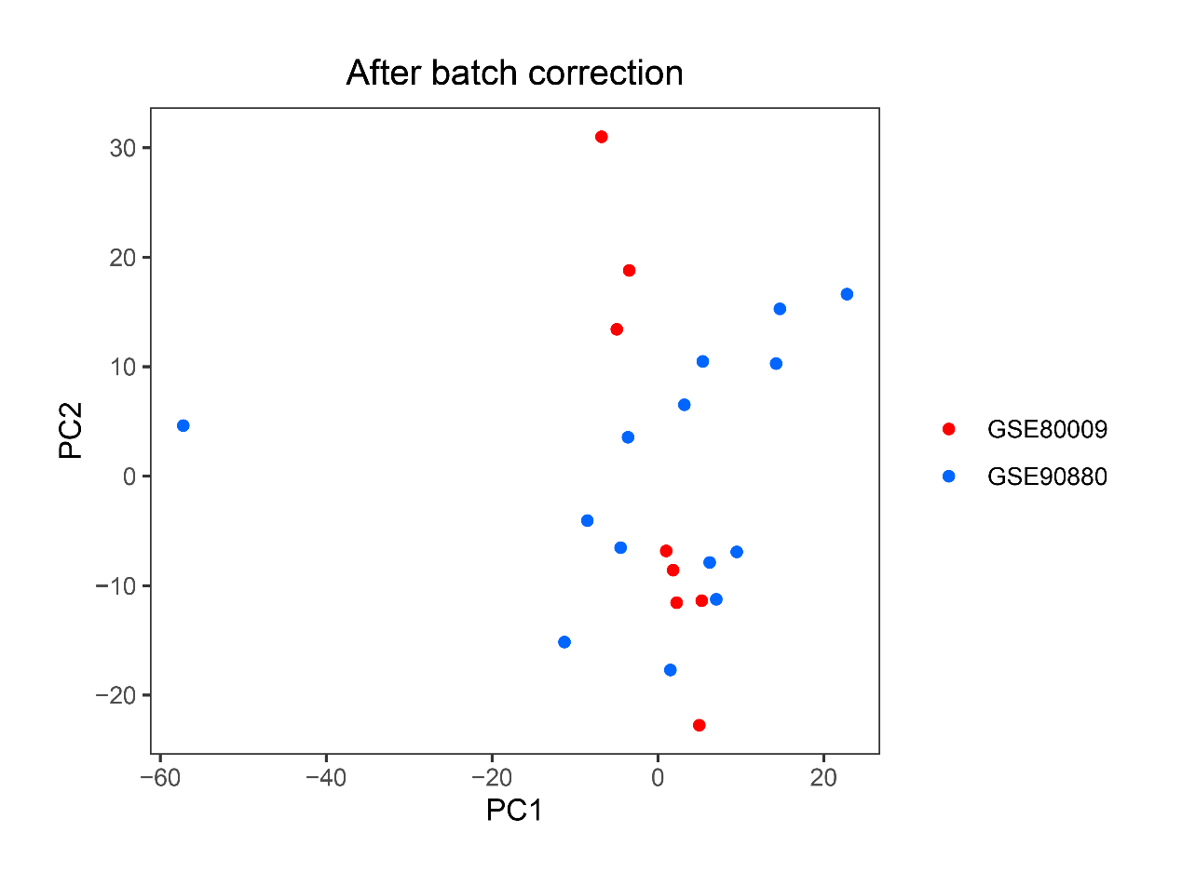
Supplementary Figure 3.Principal Component Analysis (PCA) plots before and after dimensionality reduction clustering.

